QFlashTool User Guide

September 7, 2017

## Install QFlashTool

1. Double-click the C:\Users\ADMINI~1\AppData\Local\Temp\WeChat Files\e4549eb650b9d108982b3609ea87ffe.png to launch the tool.
2. Click “Next” and Follow the instructions to install the QFlash Tool.

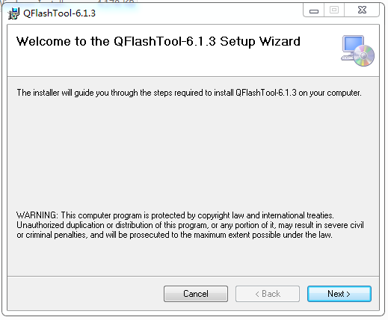

1. Click “Close” to complete the installation.

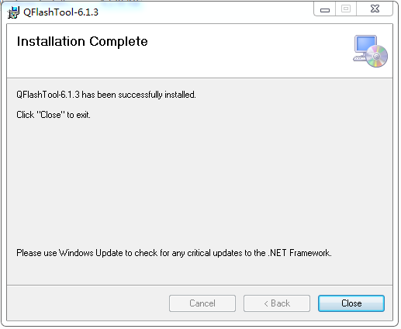

## 4 Download process

1. Double-click the QFlash tool 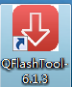to run it.
2. Click Load Content to load the contents.xml file.

Note: please try to keep shortest path for SW folder

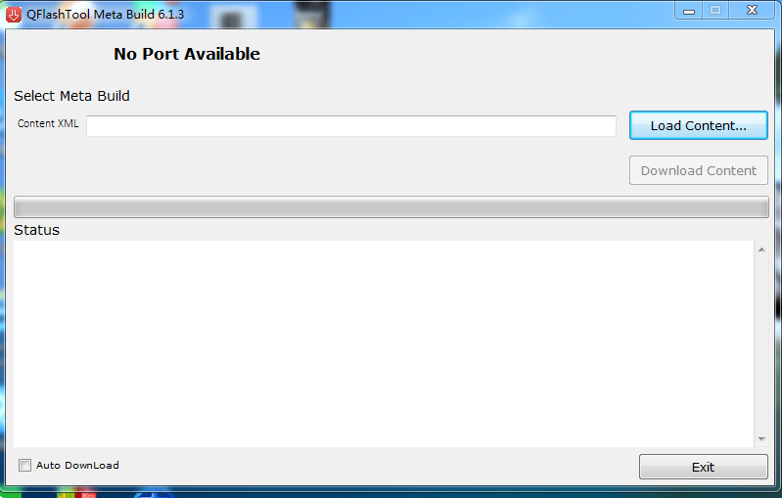

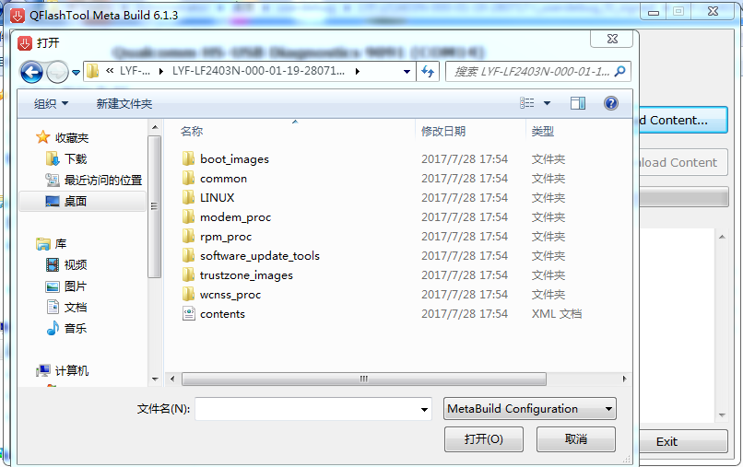

1. Connect device（in normal power on state） with PC by using usb cable. The device is detected as shown in picture below. Click Download Content to start the download.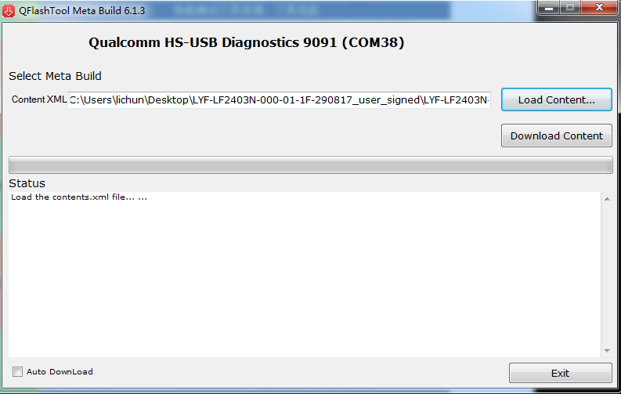

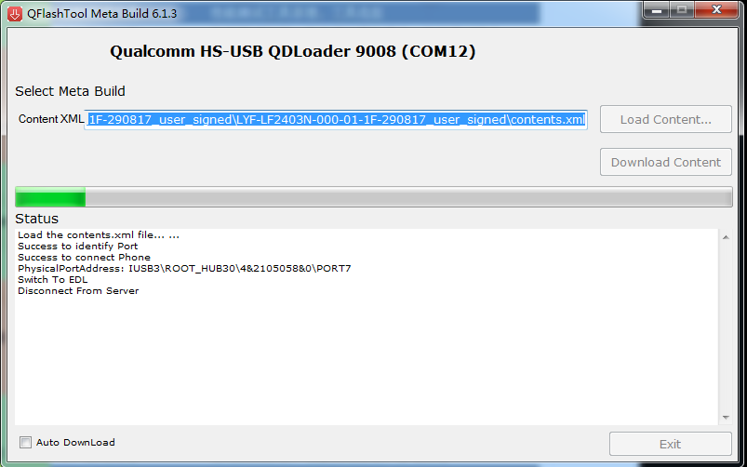

1. When the download has completed successfully, done and all Finished successfully messages display in the Status field.

