Hi,  
I have installed qpst and qxdm tool with correct configuration. And I have applied the .DMC Log mask file using Load configuration option, and i am getting all the screens accordingly. Now I want to take the logs, for the operation i am doing in my phone. but i dont know exactly how to take the logs from this point on. can anyone plz tell me how to take the qxdm logs?

You're method for determining if the cell modem is "working" is rather over complicated, for the vast majority of people. Most phones has a built in test interface that will show you the same radio variables that you see above, although without graphs etc. In addition there are many other tools that can take rudimentary RF measurements from QC devices. [CDMA Tool](http://www.cdmatool.com/download), [MDMA](http://mybroadband.co.za/vb/showthread.php/59080-MDMA-does-Connection-Management-amp-USSD-amp-Monitors-Signal-Strength-Windows) (may not work on all phones) etc... Also a simple AT command terminal port could easily establish proper modem functioning/connections!

The reason I did the OP was to solve a particular problem that Mazout360 and other developers had regarding determining the on/off status of the mdm6600 radio in the G2X and, hopefully, getting it to work with ICS. Until you showed up, rather late-in-the-game, no one else had contributed a definitive method for doing that with the mdm6600 which, although you have posted criticism and links to mostly irrelevant software and drivers, haven't done. I downloaded QXDM from the link you provided and it won't install because it stops with a message that it requires Internet Explorer version 6 or higher. That stop message is incorrect as the computer I tried to install it on is running [Windows 8](http://i.viglink.com/?key=d2e43d31777d6249cc7d4a64dada8bca&insertId=7d7be2793ba98519&type=H&exp=60%3ACI1C55A%3A9&libId=jv5g685i01000n4o000DAbq46jc38&loc=https%3A%2F%2Fforum.xda-developers.com%2Fshowthread.php%3Ft%3D1977221%26page%3D2&v=1&iid=7d7be2793ba98519&opt=true&out=https%3A%2F%2Fwww.amazon.com%2Fdp%2FB00CC0IRB0&ref=https%3A%2F%2Fwww.google.com%2F&title=How%20to%20use%20QPST%20and%20QXDM%20to%20verify%20if%20phone%20%E2%80%A6%20-%20Pg.%202%20%7C%20T-Mobile%20LG%20G2x&txt=%3Cspan%3EWindows%20%3C%2Fspan%3E%3Cspan%3E8%3C%2Fspan%3E) Pro and Internet Explorer 10. Apparently, it is incompatible so it is useless for anyone running Windows 8. How about posting something useful with a complete explanation, as I have done, about how to use it with the G2X to determine if the cell radio is working.

**It doesn't run on 64bit machines unless you're in 32bit compatibility mode.**  
  
Check [THIS](http://forum.xda-developers.com/showthread.php?t=2343432)out. I have it running on both Vista and Win7 (both 32 bit) and no problems whatsoever. And if it is a problem for you, just run it under a VM...  
  
BTW. I'm not attacking you in any way, in fact I appreciate your step-by-step guide. But I'm also showing you there are some much simpler solutions. In addition I'm making other members aware about the dangers of downloading random software...regardless if they are false positives or not.

getting the error about requiring ie5,6 or higher  
i tried setting IE as Default (that didnt work....same error)  
i then uninstalled IE 11 and rebooted and powered off too (same error)  
  
how do we get this to work on a win7 64bit machine?  
thanks

**Pass AT Commands to Modem (Nexus 5)**

Hi All,  
  
Host: Windows 7  
Device: Google [Nexus](http://i.viglink.com/?key=d2e43d31777d6249cc7d4a64dada8bca&insertId=7e7d6af1780d823a&type=L&exp=60%3ACI1C55A%3A9&libId=jv5g685i01000n4o000DAbq46jc38&loc=https%3A%2F%2Fforum.xda-developers.com%2Fshowthread.php%3Ft%3D1977221%26page%3D2&v=1&iid=7e7d6af1780d823a&opt=true&out=http%3A%2F%2Fwww.amazon.in%2Fdp%2FB00GC1J55C%2F%3Ftag%3Dvcomm150-21%26ascsubtag%3D34876_SUBID&ref=https%3A%2F%2Fwww.google.com%2F&title=How%20to%20use%20QPST%20and%20QXDM%20to%20verify%20if%20phone%20%E2%80%A6%20-%20Pg.%202%20%7C%20T-Mobile%20LG%20G2x&txt=%3Cspan%3ENexus%3C%2Fspan%3E) 5.  
  
**Objective : Pass AT Commands to the Modem in Nexus 5 Device.**  
My device doesn't get detected in QPST tool once connected.  
  
I'm looking for Modem port to pass AT commands to it by feeding Modem port value to Hyperterminal-like software.

However my device is not getting detected in QPST tool.  
I have tried most of the drivers for the device, but in vain.  
  
Can anyone guide how to get the Modem port details for Nexus 5.  
  
Any help would be appreciated.

Since a year there is no update.. Can you suggest me the easy and best way to test the GSM and live network testing. 

Quote:

Originally Posted by **Core Memory**

The URL embedded in "Check THIS out." in your post opens an OP which includes a post that contains a URL reference back to page one of this OP of mine. What's your point in doing that?

Hello, i'm gonna try the QPST/QXDM procedure because I hope there will be some NV parameters which control sensors activation.  
Some time ago i did something bad and i lost most sensors on my D802 (orientation, gyro, acceleration, magnetic).   
System see them but they return null values (checked from logs).  
I tried almost everything to solve this, but still i am sure it has something to do with NV parameters.  
I there someone who have some info about this?  
Thanks!

Nice write up!!  
  
but qxdm link at least is full of malicous shii, shame to see virus on xda ! .https://forum.xda-cdn.com/images/smilies/eek.gif I advise others- only download if you stupid, wanna take a risk, or got a spare machine to play with https://forum.xda-cdn.com/images/smilies/good.gif

YES today (10-12-2015 Monday) scan of QXDM31136.rar on VirusTotal is flagged as   
Detection ratio: 22 / 55   
  
SOME THREE YEARS LATER THAN YOUR INITIAL WARNING ! ! !  
YET HERE IT STILL IS - READY TO INFECT OUR COMMUNITY....  
Why XDA ? ? ?  
  
SOME OF THE POPULAR AND WELL TRUSTED AV CALLS ARE BELOW

Ad-Aware Trojan.Packed.Libix.Gen.3 20151012   
Avast Win32:Trojan-gen 20151012   
BitDefender Trojan.Packed.Libix.Gen.3 20151012   
DrWeb Trojan.Packed.650 20151012   
ESET-NOD32 a variant of Win32/Packed.Themida suspicious 20151012   
Emsisoft Trojan.Packed.Libix.Gen.3 (B) 20151012   
Kaspersky Packed.Win32.Black.a 20151012   
Microsoft VirTool:Win32/Obfuscator.XX 20151012   
Panda Trj/CI.A 20151012   
VIPRE Trojan.Win32.Generic!BT 20151012   
-----------------------------------------------------------------  
THIS ONE IS ON THE WEB AND HAS NO AV FLAGS   
SHA256: 6e2a4f22ecb5a5e769eee2b1f3f62375e923a6bd96620cfc28 cb9d5b4510f0c2   
File name: QXDM-3.12.714-www.getdriver.com-.rar   
Detection ratio: 0 / 54   
Scanned today also...

**Device Testing – Overview**

**What is Device Testing?**

* Testing the device for stability on either Over The Air (OTA) network like AT&T, Verizon, T-Mo and others or on call boxes recreating the live network in a lab. The equipments used for recreating live network scenarios are generally Anite, R&S, Anritsu and Spirent.
* Mobile-device testingfunctions to assure the quality of [mobile devices](https://en.wikipedia.org/wiki/Mobile_device), like [mobile phones](https://en.wikipedia.org/wiki/Mobile_phones), Tablets etc. The testing will be conducted on both hardware and software. And from the view of different procedures, the testing comprises R&D testing, factory testing and certificate testing.
* Device testing is performed by operators and OEMs (Original Equipment Manufacturer) both. Depending upon various operators like ATT, T- Mobile, Verizon and Sprint etc the product validation testing differs as per the operator’s requirements.

**How is it different for OTA network from drive testing?**

* Generally when testing OTA, it is done under static conditions unlike driving conditions in drive testing. Most of the times device’s stability is tested with sanity tests.

**What are sanity tests?**

* Sanity tests are tests performed to verify the general workability of a device. Usually the tests performed under sanity are : CS (Voice) call setup/end – Mobile Originated/Mobile Terminated, CS call maintenance (MO/MT) PS (data) throughput tests, Multi-RAB tests (CS+PS), SMS, MMS, Manual/Automatic network selection, Sleep mode (LP0) tests and flight mode tests among a few others.

**What is Device lab testing?**

* When tests are performed in labs on the aforementioned call boxes it is called Lab testing.

**What is done on these call boxes?**

* These call boxes regenerate the real world networks (like ATT, Verizon) inside the labs. These call boxes are directly connected to devices which helps overcome interference from other users. We can also vary the different parameters affecting the device in the real world like SINR, RSCP, handover, etc.

**Is there any other use?**

* The most important use is to do conformance tests on devices. Every network has a document which consists of a huge set of tests that the device needs to pass in order for it to qualify to be released on to the network. Every device that has been released into the market has passed these tests before being released.

**What if the device doesn’t pass these tests?**

* A device test Engineer’s responsibility is not to just execute the test cases but also to do a first hand analysis. While testing the device for conformance, the device’s logs are also being recorded. Each company which has a modem has its own proprietary logging tool for example Qualcomm’s QXDM. If a device fails a test a first hand analysis of the issue needs to be done to find out the root cause of the fail. Sometimes called root cause analysis.

**What is a call flow?**

* Call flow doesn’t just mean Voice (CS) call, it is a systematic sequence of steps the Device (Sometimes called UE) needs to follow in order for it to perform any kind of action on the network. The action may be a Attach procedure, CS/PS call, Paging response, handover or any other scenario imaginable that a device might have to execute to perform a particular action.

**Is call flow same for LTE, UMTS, 2G?**

* The basic idea is the same but the protocol messages, call flow, processes might vary a little bit between all three technologies.

**Device Testing – User Guide**

**The Modem/Device testing for any OEMs will go through the Following Life Cycle:**

1. Factory Release
2. Field, Lab Testing
3. PRA (project readiness Acceptance)
4. Lab Entry
5. IR (Issue Resolution)
6. FFW (Final Firm Ware)
7. TA (Technical Approval)
8. Launch (Unpacking)
9. MR (Maintenance Releases)
10. **Factory release:**

This will be Very first step being Protocol /Modem/Device Test Engineer you will be aware off.

In this Stage the device is called Lunch box because it will have shape of traditional Lunch box. It will have factory installed Software and Hardware version with Simple UI functions. Also in some Cases Modem will not have any UI (User Interface) and all the testing can be performed with either the specific Tools like (QXDM, XCAL,TEMS .. etc.) or AT Commands or ADB (Android debug bridge) procedures

1. **Field, Lab Testing:**

This stage will be very wide and diversified depends upon OEM, Operators and Platforms.FieldTesting will be mostly in live network to test the modem Hardware and Software Performance. Field Testing will have Live Network Active SIM Card.

Lab Testing is where the Network is emulated with different PLMN (MCC, MNC) ID using Network simulators like Spirent, R&S, Anritsu, and Agilent.

Note: For Lab Testing, device will have Test SIM and it is connected via RF cable to the simulators. Lab testing will be used to test the Modem With desired Network Conditions. Results from Lab test and Live Network Testing will be different.

There are Multiple Test cases designed especially for Lab Testing and Field testing by respective OEM’s. However there are standard test cases with all the OEM based on 3Gpp and 3Gpp2 Specification. Depends on the technology, some of the areas of testing are

1. Protocol (NAS ~PHY layer)
2. IMS, VOLTE.
3. LTE-Advanced.
4. Application layer.
5. RIL (Radio interface Layer).
6. Bluetooth, Wi-Fi.

***Few of the Protocol Test cases are listed below:***

1. **Cell selection:**

Purpose of this test is simple. This test is to check if UE shows following rules properly or not,

* UE should not camp if the cell around it does not satisfy Cell Selection Criteria
* UE should camp if the cell around it satisfy Cell Selection Criteria

Always for UE to camp to Cell   **SrxlevCell 1>0**

If UE Sends RRC Connection Request even if  SRXlevCell 1<0 then  UE Fails  (Collect the Logs)

If UE sends RRC Connection Request even if  SRXlevCell 1>0 then  UE Pass

1. **Cell reselection:**

Check if UE changes its serving cell from one cell to another when it scans a cell with better signal which meets cell reselection criteria.

Make sure that Cell 1 and Cell 2 has

* different Physical Cell ID
* different Tracking Area Code
* Same PLMN
* **Inter-RAT cell reselection / From E-UTRA RRC_IDLE to GSM_Idle/GPRS Packet_Idle:**

Check if UE changes it’s serving cell from a cell to another non-LTE cell (GSM/GPRS Cell) when it sees a cell with better signal which meets cell reselection criteria.

* Sub Test 1 : From LTE Cell (E-UTRA) to Higher Priority GERAN
* Sub Test 2 : From LTE Cell (E-UTRA) to Lower Priority GERAN.

1. **RACH parameters:**

TP1: This tests if UE act in the following manner or not.

1)  Now in Idle Mode

2) SS (Network) send Paging message

3) Check if the UE gets the Paging or NOT

TP2: This tests if UE act in the following manner or not.

1) Now in Idle State

2) SS send Paging

3) UE sends PRACH in response to Paging

4) SS send RAR (RACH Response).

5) UE sends RRC Connection Request

6) SS does not send ‘Contention Resolution’ within a certain time span(contentionResolutionTimer)

7) UE Retransmit PRACH

1. **Paging for connection in idle mode:**

Test Purpose: This is to check the following two behaviors.

1. i) UE should not respond to paging carrying the incorrect UE ID
2. ii) UE should respond to paging carrying the correct UE ID
3. **RRC connection release / Redirection to another E-UTRAN frequency:**

|  |  |  |  |
| --- | --- | --- | --- |
| 1 | UE <— SS | < RRC Connection Release with IE redirection Information including eutra-CarrierFreq of Destination Cell> |  |
| 2 | UE <—> SS | < Registration to the Destination cell > |  |

* **RRC connection establishment:**

Test Purpose: To see if UE can detect Paging message and establish the proper RRC Connection in response to the paging message.

* **T300 operation.**

UE has to start T300 right after it sends RRC Connection Request and stops the timer when it gets the response to the message from SS. But if the UE does not get any response until T300 expires, it should get back to IDLE mode.

T300 value is specified in SIB2.

1. **RRC connection reconfiguration:**

Radio bearer establishment, Radio bearer release.

1. **Measurement configuration control and reporting:**

Test Purpose: Check if,

1) UE successfully detects the condition for Event A3 and reports it through “Measurement Report”

2) UE successfully perform detect the SIBs of neighbor cell during the connected mode (connected mode DRX) and report the neighbor cell CGI through Measurement Report.

***Device Testing On Live Network, Exclusive Field Trials:-***

Device Testing is carried out with the product connected to a live network in real conditions. Field trials give confidence in end to-end product performance. This highlights software quality and stability issues and how the product performs for the customer. This testing can be carried out to customer-specific requirements or network operator requirements.

This testing is performed in both conditions, static and driving.

***Features Tested in Field In General Prospective:***

* Regression Testing (AP, CP Testing).
* Sanity Testing (AP, CP Testing).
* Interoperability Testing (IOT).
* Mobile Application Testing.
* KPI (Key Performance Indicator).
* Carrier Aggregation (CA) Testing.
* ThroughPut.
* Aging Test.
* Hand over (Inter & Intra HO)
* Issue Reproductions.

***Tools Used In Field Testing:***

For the chipset manufactured by Qualcomm, **QXDM** is used for logs collection & analysis (QXDM, QPST, QMICM).

* **Nnext**s used for Samsung Chipsets (For logs collection & Analysis)
* **Odin**(for software flashing).
* **Datum**for data throughput testing.
* **Wireshark**to capture traces of packets.
* **RDX tool**for AP issues (eg: Modem Crash, Kernal panic, power reset etc).
* Throughput testing with **Iperf**.
* **FTAT**for automation testing.

1. **PRA (Project readiness Acceptance):**

OEM will determine based on internal field and Lab testing, whether to Continue with the Project or discard the project

1. **LAB ENTRY:**

This is the Stage where OEM will submit their MODEM/DEVICE with updated software hardware version to the Operators (ATT, Verizon, TMO, Sprint, Mpcs, etc.). Operators will have their Separate test cases which they will perform in LAB on that MODEM to check the Stability of MODEM/DEVICE.

1. **IR (Issue resolution):**

This is the stage where if any issues are reported from Operators to OEMS. Then OEM will have their team of R&D, Developer to identify and Fix the issues.

1. **FFW (Final Firm Ware):**

Developer will fix the issues reported in IR stage and Change/Edit the Code in software and will release the new software, that software is consider as FFW, because it will have Issues fixed reported in LE.

1. **A (Technical approval):**

Operator will retest/validate the FFW with their standards  and if they are satisfied with the FFW they will give TA to the OEM’s.

1. **Launch (Unpacking):**

OEM will Launch (Unpack) the Actual Device in the Market officially.

1. **MR (Maintenance Release):**

In this stage the OEM’s will release the Software’s for any minor bugs reported by end user.Maintenance releases are usually through FOTA (firm ware over the Air) update.

**References:-**

Wikipedia

3GPP org

Test Case provided by:-

* OEM/ODM .
* Operator Acceptance.
* User Acceptance (UAT).

Compiled by Saad, Imran and Faiz for guiding the future ummah

# How to use QPST and QXDM to verify if phone is working.

The following instructions are to be used to determine if your cell phone's transmit and receive functions are working when your phone doesn't successfully make phone calls. In the instructions, I've included backing up your phone's NV memory settings in caseyou inadvertently change the phone's settings or brick your phone (assuming the phone wasn't already bricked). 1) Download QPST  
  
<http://hosting.ecap-droid.com/Droid/...pub=bxfo8sfkv6>  
  
2) Install QPST (set it to run as Administrator and pin it to the Start Menu)  
  
3) Download and install QXDM (set it to run as Administrator and pin it to the Start Menu)  
  
<http://www.mediafire.com/?tmzmngemgmm>   
  
4) Download LG Drivers  
  
<http://www.lg.com/us/support-mobile/lg-P999>  
  
5) Install LG Drivers  
  
6) In the phone’s Settings -> Applications -> Development -> enable USB debugging

7) Access the phone's hidden menu using the phone keypad (dialer), enter: 1809#*999#  
  
8) In Port Setting enable CP USB (do not enable Retain ...) then press: OK  
  
9) Plug your phone into the USB port and wait a few seconds until the USB drivers install.  
  
10) Access the LGE Mobile USB Modem driver through Control Panel -> Device Manager -> LGE Mobile USB Modem -> Advanced -> Advanced Port Settings  
  
11) Click on the box next to “Append to Log” so that a checkmark is in that box.  
  
12) Click on: Query Modem  
  
The window above “Query Modem” should fill up with (the following data is from my phone, your phone’s Revision may be and IMEI will be somewhat different):  
  
“ATQ0V1E0 - OK  
AT+GMM - 0  
AT+FCLASS=? - +FCLASS: (0-1)  
AT#CLS=? - COMMAND NOT SUPPORTED  
AT+GCI? - COMMAND NOT SUPPORTED  
AT+GCI=? - COMMAND NOT SUPPORTED  
ATI1 - Manufacturer: QUALCOMM INCORPORATED  
Model: 0  
Revision: M6600A-SCAUTNZ-2.0.9720T 1 [MAR 11 2012 10:00:00] MP:TRULGE_08.09.02R_MDM  
IMEI: 0127XXXXXXXXXXXXXXX (I’ve X’d out my IMEI for security reasons)  
+GCAP: +CGSM,+DS,+ES  
ETC…”  
  
If that doesn’t happen, then the Port Setting has probably reverted back to “AP USB” and will need to be changed back to “CP USB” or the LG drivers didn't install fully or correctly or the computer's usb connection or the usb cable has a problem. Check the phone’s screen and see if the Port Setting is still at “CP USB”. If it’s not (back on “AP USB”) redo step 8. If the setting is still at "CP USB" then reinstall the LGdrivers. If there's still a problem, it may be the computer's USB port or the USB cable.  
  
13) Click on: View log  
  
The phone’s current IMEI and other information is listed in the information.  
  
14) In the terminal port setting, get the LGE Mobile USB Modem COM Port number by accessing the USB driver through Control Panel -> Device Manager -> LGE Mobile USB Modem -> Advanced -> Advanced Port Settings -> COM Port Number  
  
Write down the port number.  
  
15) Close the LGE Mobile USB Modem Properties window.  
QPST  
  
16) Run QPST Configuration from QPST folder in the Start Menu  
  
17) In QPST Configuration, click on: Ports tab  
  
18) In Ports window, click on the Port which has the phone listed as FFA-QSC6295 (DEAD00D) with the USB Link  
  
19) Write down the COM port number with USB Link. For example: COM44 = 44 It should match the COM Port Number you previously wrote down in step 13.  
  
20) In QPST Configuration, click on: Phone tab  
  
21) In Active Phones window, click on the phone listed as FFA-QSC6295 DEAD00D ZRF6500 with the same COM port as you wrote down previously  
  
22) In the QPST Configuration menu, click on: Start Clients, and click on: Software Download  
  
23) In QPST Software Download, click on the: Backup tab  
  
24) A dialog box should appear with the same COM port number as you selected previously and there should be a name for the QCN File which has the ESN number in it (DEAD00D_1.qcn) and an SPC (Service Programming Code) number of 000000  
  
25) If you want to, add information to the QCN File name to make it more explanatory. For example:   
DEAD00D_1_My_Phone_NV_Backup.qcn  
  
26) Browse to a location you want to save the QCN backup file to  
  
27)Click on: Start  
  
28) Run RF NV Manager from the QPST folder in the Start Menu  
  
29) In the RF NV Manager menu, click on: Setting, and click on: Comport  
  
30) In the Comport Configuration dialog box, click on the arrow in the selection window and select the port number you wrote down from step and click on: OK  
  
31) In the RF NV Manager menu, click on: File, and click on: Read From Phone  
  
32) The RF NV Manager window should fill up with the NV items from your phone.  
  
33) In the QPST Configuration Window, Click on: Start Clients  
  
34) Select: Service Programming  
  
35) In the QPST Service Progamming Client window, click on the tab: Settings  
  
36) Click on: Read from Phone  
  
37) In the Codes section, Service Programming should show: 000000  
  
38) In the QPST Service Progamming Client window, click on the tab: UMTS System  
  
39) Click on: Read from Phone  
  
The phones radio band settings and other information should appear with checkmarks next to the bands enabled for the phone's cell radiochip. Even though a radio band is selected, it doesn't necessarily mean that the radio band will work because either the circuitry in the phone isn't connected to a particular radio band's port on the cell radio chip and/or the cell radio band's setup/operating parameters aren't in the phone's cell radio chip firmware. Selecting any/all of them and writing that to the phone will change the phone's cell radioband's settings and, even though bands which won't work are selected, that won't harm the phone (I have all of them selected).  
  
QXDM Professional  
  
40) Start QXDM Professional  
  
41) Click on: Communications  
  
In the Communications dialog box, in Target Port, select the COM port which you wrote down previously (the one that QPST is connected to).  
  
42) Click on: OK  
  
The window should now become active.  
  
43) In the View drop down menu, select: Status (Static) <F9>  
  
The window should fill with information about your phone.   
  
44) In the View drop down menu, select: UMTS Cell Reselection  
  
The window should change and various coloured lines with dots on them should appear which indicates that the phone is communicating with cell towers. If there's no activity, it means that the phone's cell radio is either not working/burnt out, faulty SIM card, or something is preventing the phone from communicating with the cell towers, or something else.  
  
45) In the View drop down menu, select: WCDMA Power  
  
The window should fill with a graph for Receive (RX) and Transmit (TX) power. At the bottom is a blue graph of the phone's received power. If you don't see the blue graph, it probably means that your phone's antenna isn't connected or the phone's cell radio chip is not working/burnt out, or something between the chip and the antenna isn't working. Make a phone call and, near the top at -0-, you should see a green graph of the phone's transmission power. If the green graph doesn't appear, it probably means that your phone's cell radiochip transmit section isn't working/burnt out. If the green graph does appear but your phone isn't able to successfully phone, something else is wrong such as the phone's antenna is disconnected or something is wrong between the cell radio chip and the antenna, or a faulty SIM card or something else.   
  
46) If finished, exit all QXDM, QPST, set your phone's Port Setting to AP USB, disconnect the USB cable, reboot your phone.

**LTE-Basic operation and application of QXDM(Qualcomm terminal software)**

Emerson Eduardo Rodrigues

Senior RF Engineer Optimization

When we do the DT in outfield, we often use a Qualcomm terminal software named “QXDM”.

Here, I will introduce the basic operation and application of the software.

QXDM is short for “Qualcomm Extensible Diagnostic Monitor”. It’s the diagnosis platform of Dual-Mode Subscriber Station (DMSS). After the installation of QXDM, click “QXDM Professional” and begin to register. As shown in the figure below:

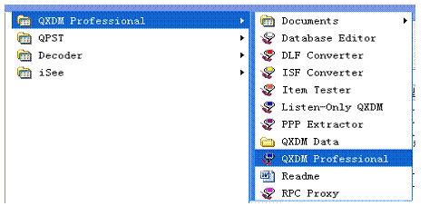

1. Add Port

   When the registration is completed, insert the terminal. As there is no relevant port number, generally, “Disconnect” will exist on the QXDM. And "Command" is not available in the toolbar. As shown in the figure below:

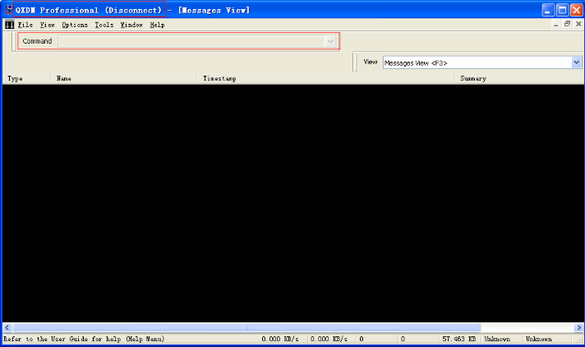

   Firstly, choose the port: Options—Communications. According to the testing results of the port,choose the port, and others remain the acquiescent configurations. And then, click “ok”. There will be “MDM9200” which is shown in the figure below:

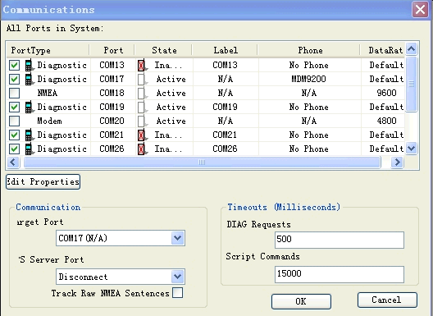

 If there is no Diagnostics port, we need to open QPST Configuration and add the port, which is shown as follow:

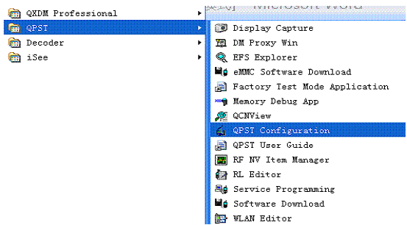

 In the Port part, click “Add New Port” . And then add the “Diagnostics port”. There will be “MDM9200” which is shown as follow picture:

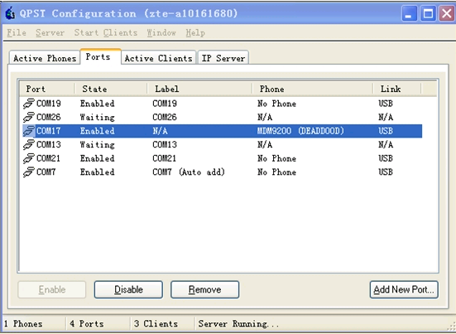

2.Common Ports:

       If the ports are loaded successfully,open the QXDM. The common windows are present as follow:

1)     (1) LTE ML1 Idle Serving Cell Measurements Display：Check the physical cell ID and frequency, check the RSRP and SINR.

2)     (2) LTE ML1 DL Throughput and BLER：Check L1 dataflow and BLER.

3)     (3) Filtered View{RRC&NAS}：Check the RA、RRC、NAS massages during the attachment of UE.

   (4) LTE RRC State Change Plot：Check RRC state during the attachment of UE.

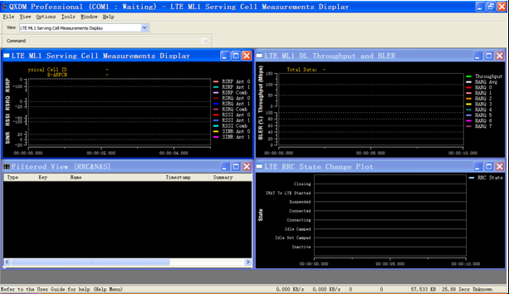

 The configuration files can be saved by shortcut “Ctrl+S” from the four above windows. For example, TD-LTE_IOT_Config.dmc, we can load the configuration files by shortcut “Ctrl+O”. What’s more, we can also check the detailed messages by “[right-hand button](app:ds:right-hand%20button)-Cursor”.

3. The way to check L1-L3 log

The First step: Click shortcut F12. And then, the window will turn out which is shown below. Click “right key” and Config or shortcut “Alt+G” to open the Window Filters.

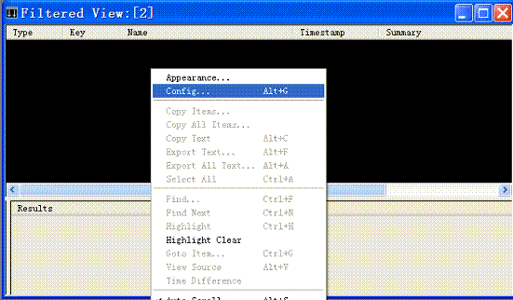

 The second step：Open the window Filters shown as follow.  Choose “Log Packets”、”Filter/Register On Target For Items”, you will get the log of L1-L3.

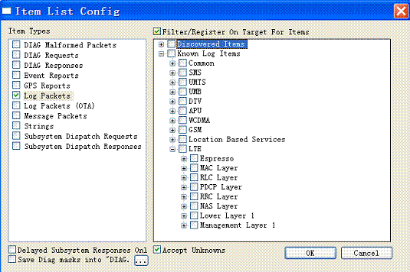

The third step: Choose the message which need to observe. Here we use the process of UE attaching as example. Shown as follow, choose the Msg1-4 of “RRC”、”NAS”、”ML1”, click “OK”.

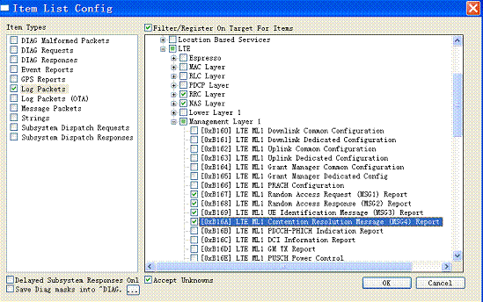

The four step: Insert and pull out the terminal, we can catch the process of UE attaching.

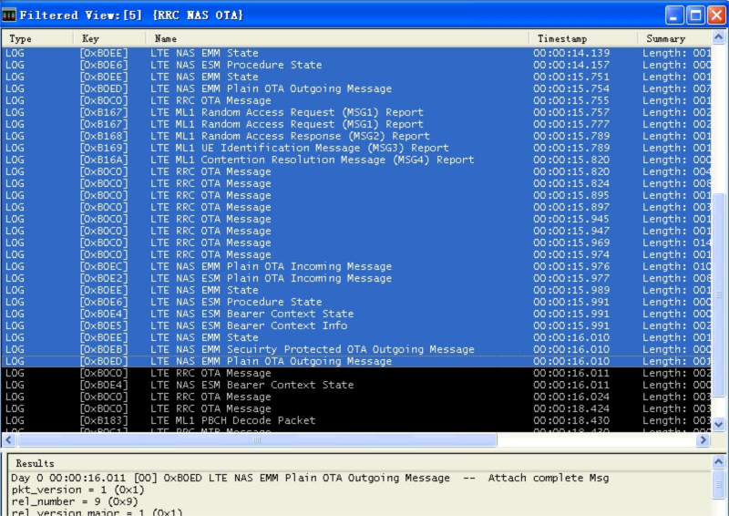

4. The shortcut key to save log

   Save all the logs: Ctrl+i

   Clear away the logs of all the windows: Alt+i

   Clear away the logs of the single window: shift+delete