**Game Addict**

**Website**

**&**

**App**

**By – Team 4**

Contents

Team Information 3

Background 4

Literature Review 4

Project Proposal 5

System’s Architecture 6

Workflow Diagram 7

# Team Information

|  |  |  |  |  |
| --- | --- | --- | --- | --- |
| **Name** | **Student ID** | **Role** | **Gmail Account** | **Centennial Email Address** |
| Avjot Kaur | 300872739 |  | kauravjot@gmail.com | akaur242@my.centennialcollege.ca |
| Jaspreet Boparai | 300862081 |  | jaspreetboparai007@gmail.com | jbopara6@my.centennialcollege.ca |
| Jaykumar Patel | 300813922 |  | pateljay1433@gmail.com | jpate351@my.centennialcollege.ca |
| Navjot Kaur | 300869349 |  | navjot304@gmail.com | nkaur173@my.centennialcollege.ca |
| Nitin Rai | 300860889 |  | nitin.ry9@gmail.com | nrai2@my.centennialcollege.ca |
| Sapreet Bhutta | 300857733 |  | sapreet0094@gmail.com | sbhutta@my.centennialcollege.ca |
| Shivam Patel | 300814125 |  | patelshivam3033@gmail.com | spate498@my.centennialcollege.ca |
| Taranjit Boparai | 300872737 |  | taranjitsinghboparai@gmail.com | Tbopara1@my.centennialcollege.ca |

Overview

# Background

Playing video games is one of the most entertaining way to spend leisure time in today’s modern era. However, there are three main problems for Video Game Players these days.

One is that they have to go to stores to buy the Game Discs. In today’s busy schedules, no one prefers to spend a lot of time to visit game stores especially in rush hours and buy the game discs.

Another is a risk of damaging the discs after several installs. We all know, the discs get scratched after using a few times. For sure, no one likes to spend a lot again and again, though that game is their favorite.

Next problem is that the players have to buy the discs to see how the game play look like and what features the game includes. What if someone buys a game disc by just looking at the images appearing on it and then finds it not reasonable as per his/her choice?

This showcases complete waste of time and money.

# Literature Review

However, many people still prefer going to shop for their favorite video games, but these days, everyone understands the importance of time in competent era. They look for online buying options for their entertainment. In fact, many web portals provide them a great collection of video games, but all other websites out there do not have many features such as posting reviews about games, displaying gameplay features, no mobile application support etc.

|  |  |  |  |
| --- | --- | --- | --- |
| **Website** | **Description** | **Strengths** | **Weaknesses** |
| Video Games Plus | VGP is a retailer and wholesaler of videogames operating through brick and mortar store as well as online to reach potential gamers with video games for different platforms. | * Offers preorder facility * 30-days warranty period * Refund or exchange option is available * Payment by cash or money order, Visa, Mastercard, American Express and Paypal | * 15% transaction charges in case of refund * Prices on store and website can be different * No reviews from users |
| EB Games | EB Games provide video games for distinct platforms online as well as they have stores in many countries. | * Different platforms-based video games * Membership plans | * No reviews for games |
| Gamers Gate | Gamers Gate provide a large catalog of games online to game lovers. | * Users can give reviews and can earn blue points * Chat functionality on the website * A large catalog of games * Game manual is provided * The game can be purchased and installed on different systems * Can send gifts and receive gifts from other users | * No categorization of games * Internet connection is required even if you download game on one PC and want to install it on another one. |

# Project Proposal

Game Addict is an eCommerce website and a mobile app which solves all the above discussed issues in literature review. This user-friendly website and mobile app will allow the users to buy games for different platforms. They can also search the games on web portal and on mobile app. The users have to create a free account on Game Addict. After logging in, they can use the search option and can buy available games at competent prices.

For sure, Game Addict eliminates most of the problems dealt by video game lovers. Now, they don’t need to visit brick and mortar stores to purchase game discs; even there is no risk of damage to game, as the users have it available online on their computers. Aside this, the users can post reviews about the games they have played and other users can see those reviews to get reliable information about it. Therefore, Game Addict is available to help all the video game lovers to refine their selection of games in a few moments on their fingertips.

However, alike other websites selling video games, Game Addict has strengths and weakness as given below –

|  |  |
| --- | --- |
| **Strengths** | **Weaknesses** |
| Availability of mobile app for more convenience | Registration with Game Addict is must |
| Users can post reviews and see others reviews | No free trial |
| Quick service at competent prices | Android app works only with Android devices |
| Customer service is available 24/7 | Internet connection is necessary |
| Search for games for different platforms |  |
| Users can pay by Visa, Paypal, Interac etc. |  |
| Details of games is available; it can also be checked before purchasing |  |
| No membership fee |  |

# System’s Architecture

We are going to develop the website and application based on client-server architecture. This architecture is a structure that how different tasks are managed by client (sender of request) and server (receiver of request or responder). This helps in storing data and updating it constantly, including details of customers, purchases and transactions. The complete processing and business logic is done on the server side.

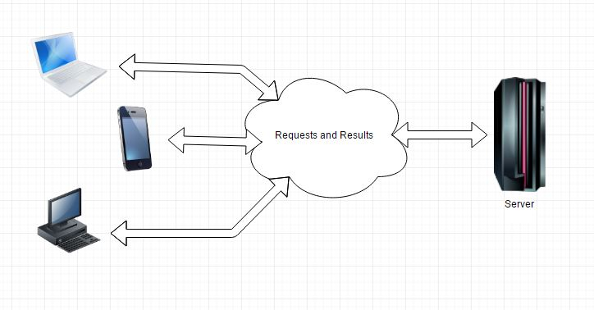

* Client sends request to the server
* Server receives the request and process it on the database
* Database provides required information to the server
* Server collects information from the database and responds to the client accordingly

# Workflow Diagram

