**6.16. Sedbio_toy test case - ROMS, test coupled sediment transport-biogeochemistry module.**

This test case highlights the coupled sediment transport-biogeochemistry modules in the COAWST framework. This model accounts for sediment transport processes (e.g. seabed erosion, deposition), as well as seabed and water column biogeochemical processes including particulate organic matter remineralization, and oxidation of reduced chemical species. The coupling between the sediment transport and biogeochemical modules accounts for resuspension and deposition of particulate organic matter; exchanges of porewater across the seabed-water interface due to diffusion, erosion, and deposition; diffusion of porewater and particulate organic matter in the seabed; and biogeochemical processes in the seabed based on Moriarty et al. (2017, 2018). Additionally, seabed organic matter may affect the properties of the seabed (e.g. seabed layer thickness and mass).

The test case uses a quasi-one-dimensional modeling approach, similar to sedbed_toy test, with a uniform 5-cell by 6-cell grid. To run the model, edit the ocean_sedbio_toy.in, sediment_sedbio_toy.in, and bio_sedbio_toy.in based on user preferences. For example, users may want to edit sediment parameters in sediment_sedbio_toy.h. Users may also want to edit parameters and parameterizations in portions of the code such as ana_wwave.h, sedtr_reactions_pom.F, or other files. Compile the code using ./coawst.bash with COAWST_APPLICATION set to SEDBIO_TOY). Run the code by using the input file “ocean_sedbio_toy.in”. An example matlab script for analyzing model output, plot_sedbgc_in_COAWST.m, is provided, and a figure of the model is below.

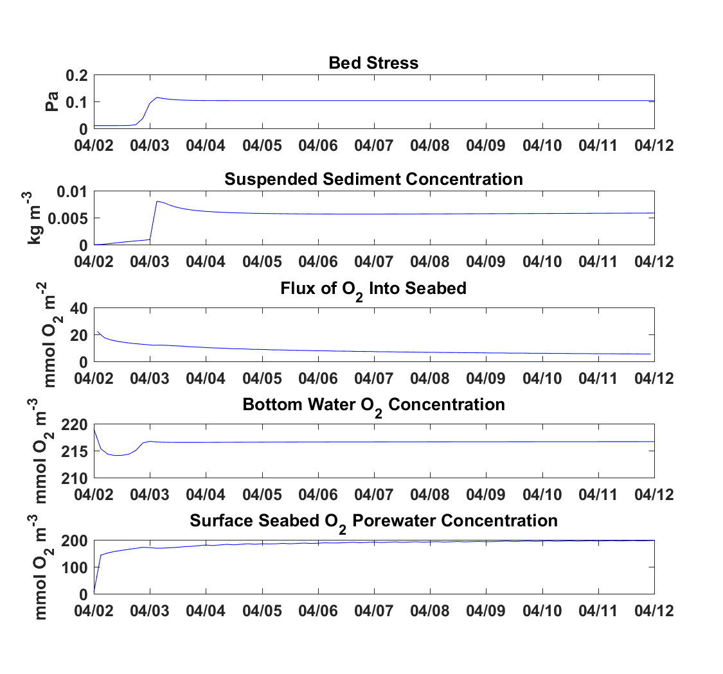

*Figure **: Time-series of model utput generated from Sedbio_toy simulation*

Refs:

Moriarty, J. M., Harris, C. K., Friedrichs, M.A.M, Fennel, K., and K. Xu (2018). *The Role of Seabed Resuspension on Oxygen and Nitrogen Dynamics in the Northern Gulf of Mexico: A Numerical Modeling Study.* Journal of Geophysical Research: Oceans, 123, 1-27. doi:10.1029/2018JC013950.

Moriarty, J. M., Harris, C. K., Rabouille, C., Fennel, K., Friedrichs, M.A.M, and K. Xu (2017). *The Roles of Resuspension, Diffusion and Biogeochemical Processes on Oxygen Dynamics Offshore of the Rhone River, France: A Numerical Modeling Study.* Biogeosciences, 14, 1919-1946. doi:10.5194/bg-14-1919-2017.