**QUESTION-1**

STEP 1: a. Open MySQL Command Line Client

b.Enter Password

STEP 2: Type following Queries:

a. create Database account;

b. use account;

c.create table account(acc_no int,acc_bl int);

d.insert into account values(301,2000);

e.insert into account values(303,3000);

f.select *from account;

g.delete from account where acc_no=301;

h.select *from account;

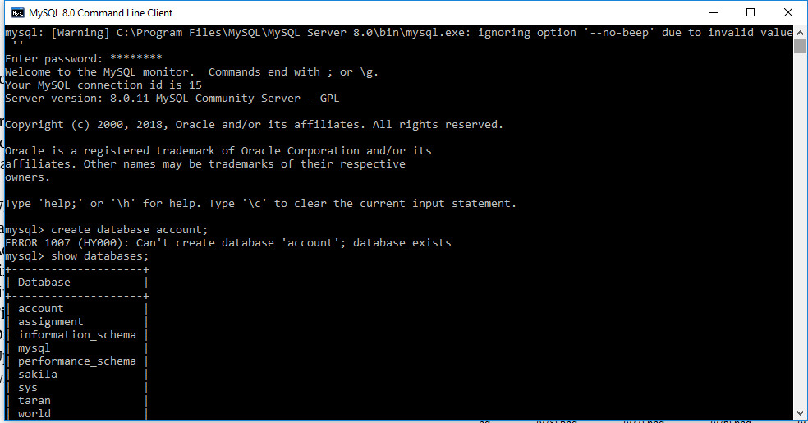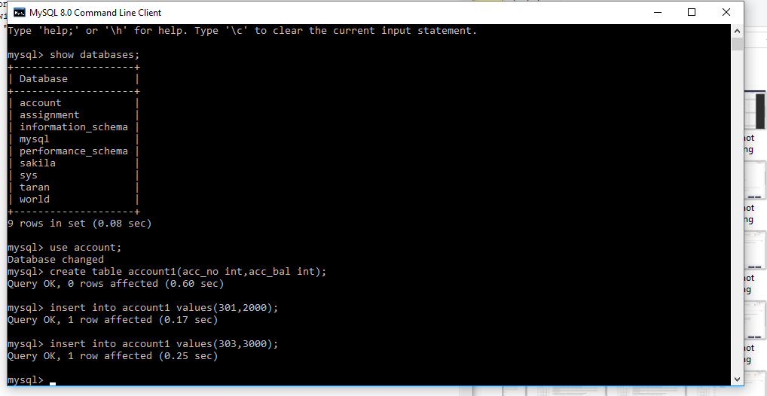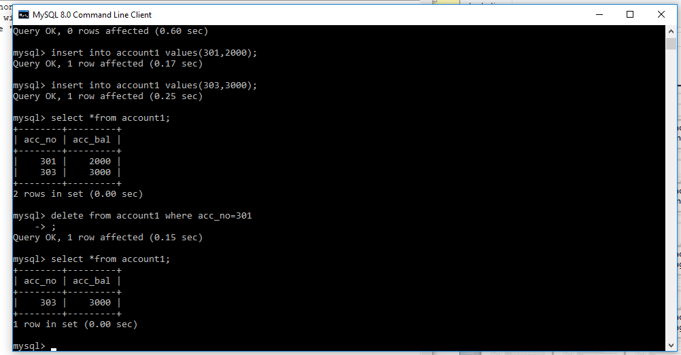

**Q U E S T I O N- 2**

1. create database student_details;
2. use student_details;
3. create table student(name varchar(20),roll_no int,age int,course varchar(20),attendance varchar(10));
4. insert into student values(“Taran”,1,19,’DA’,’P’);
5. insert into student values(“Karan”,2,19,’PA’,’P’);
6. insert into student values(“Jass”,3,19,’DA’,’P’);