MU Parking Permit — Payment Workflow
Methodist University | June 10, 2026
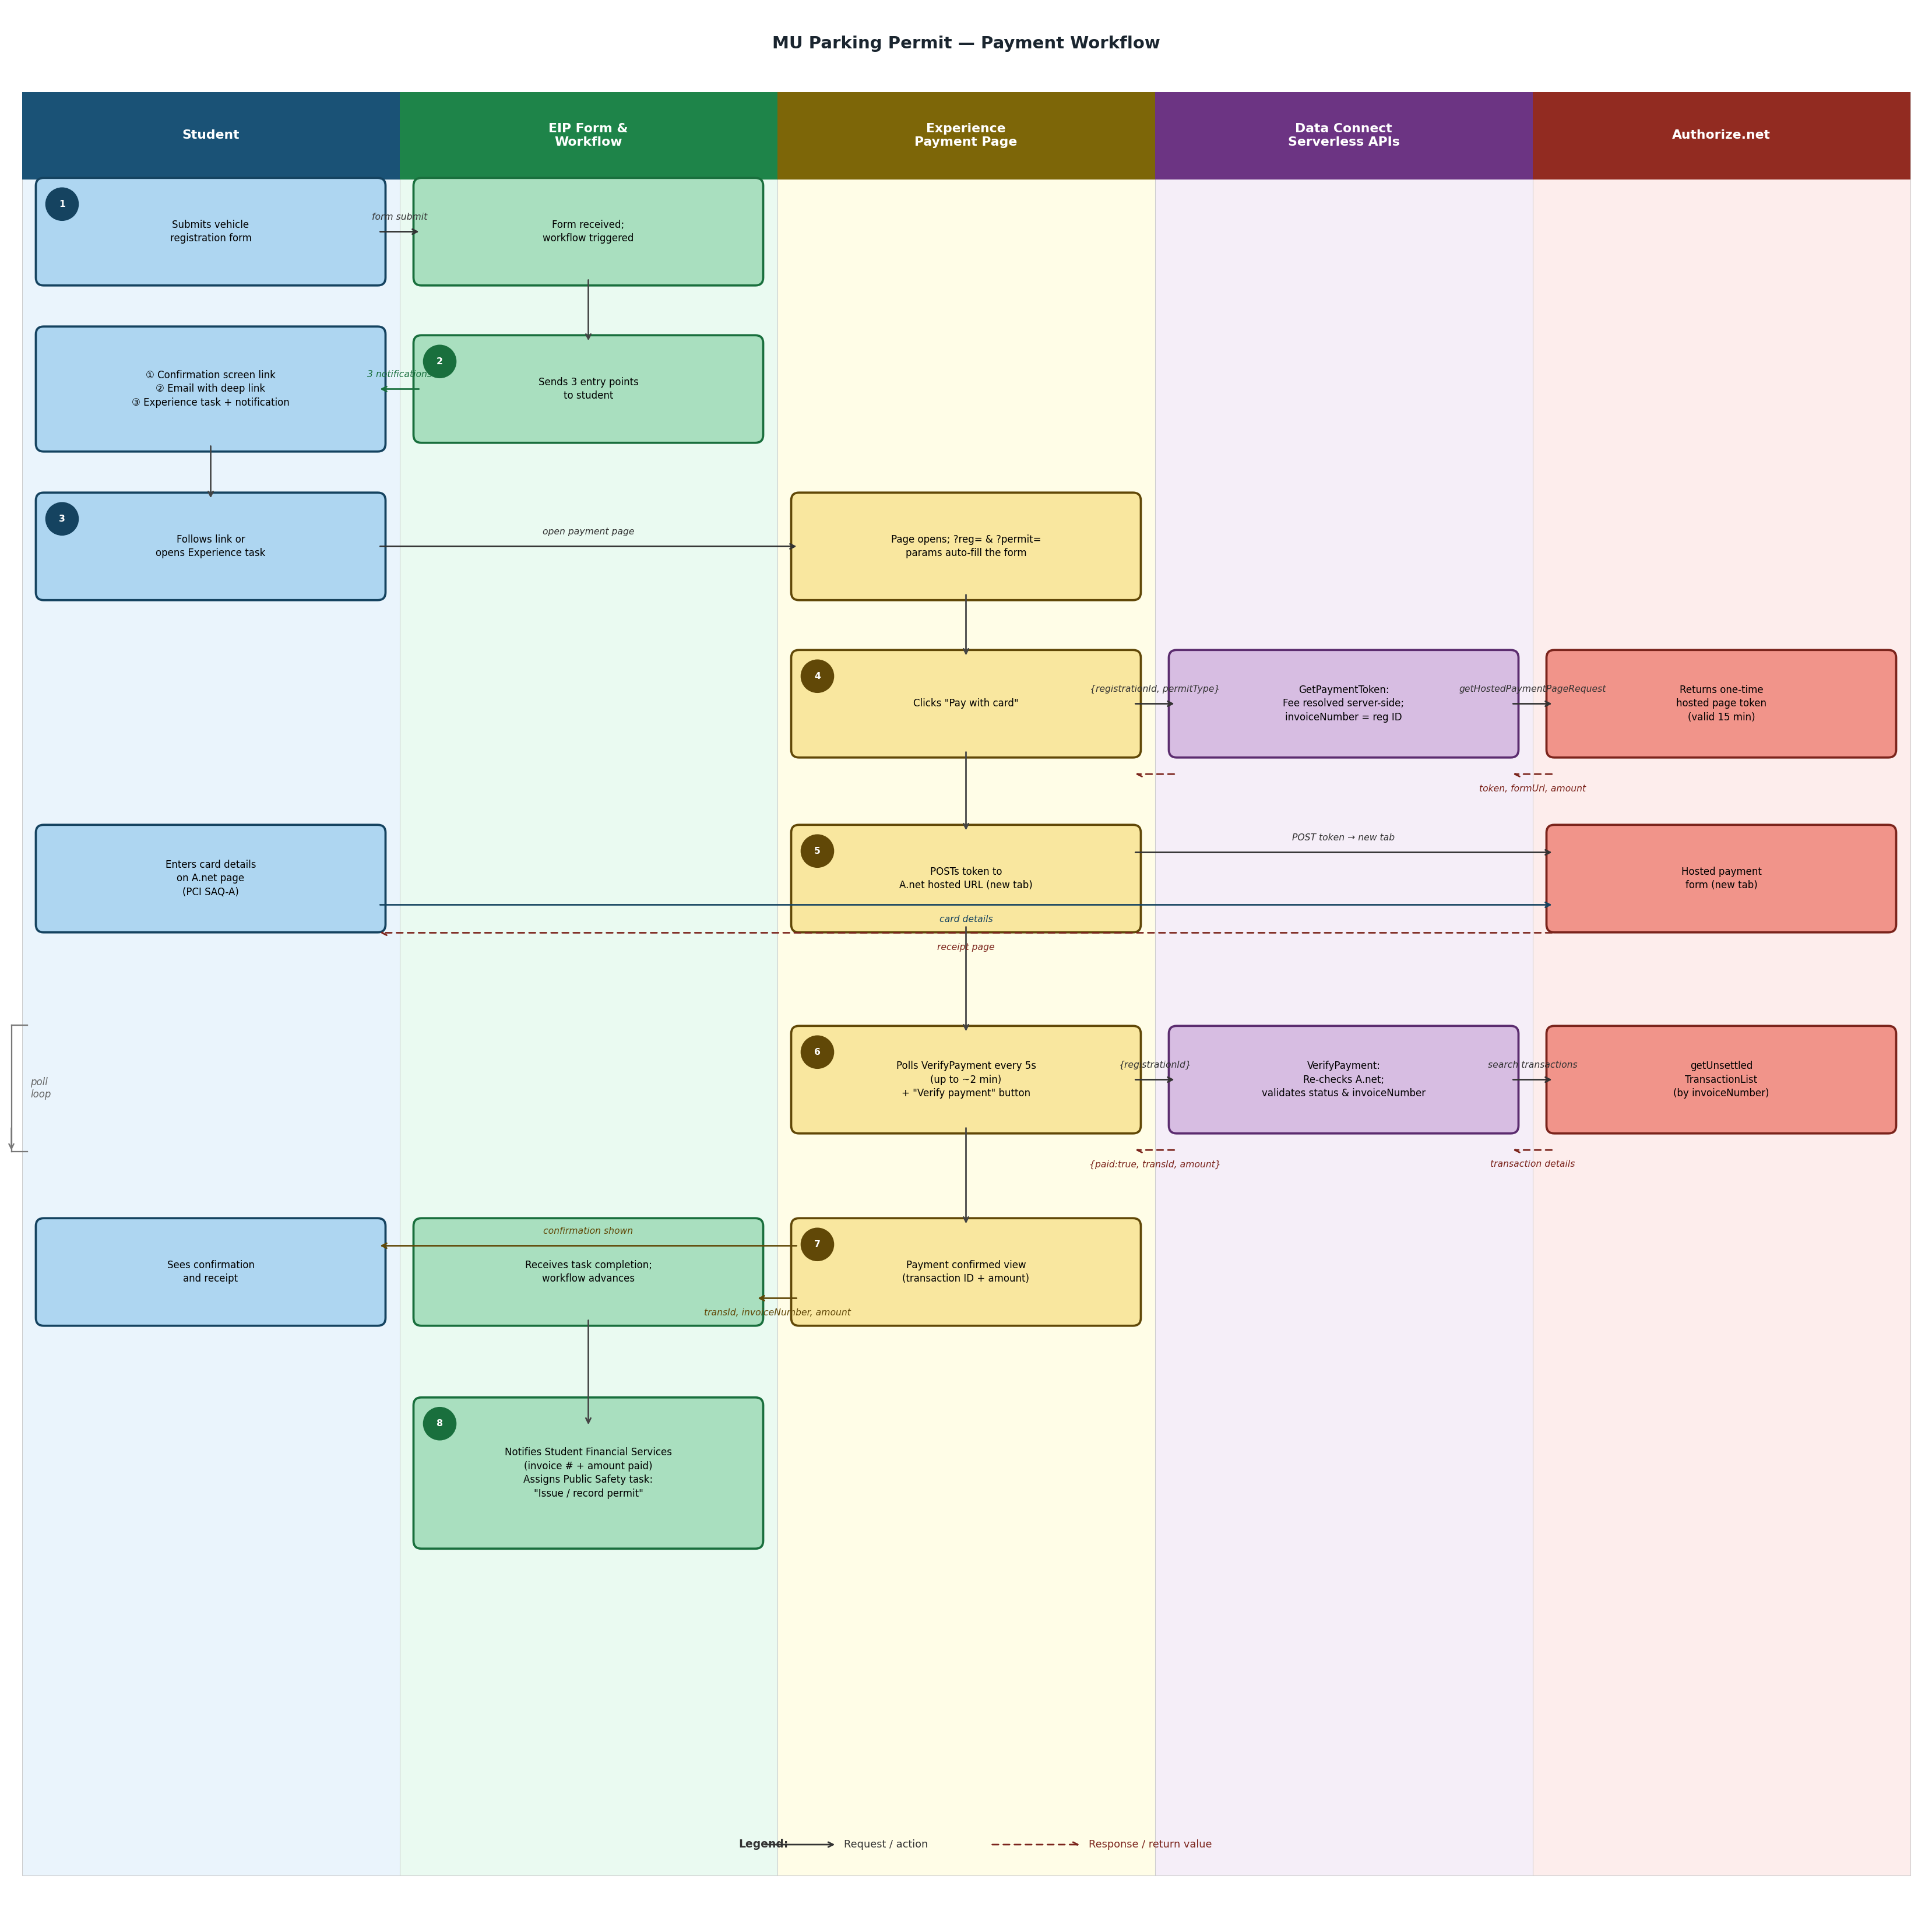

Workflow Steps
Step | Action | Actor(s) | Details
1 | Submit vehicle registration | Student | Student submits the EIP vehicle registration form. The form triggers the EIP workflow.
2 | Send 3 entry points | EIP Workflow | The workflow simultaneously: (①) shows a deep link on the confirmation screen, (②) sends an email with the same deep link, and (③) assigns an Experience task and notification. All three point to the same payment page URL with ?reg= and ?permit= params.
3 | Open the payment page | Student | Student clicks a link (from screen, email, or Experience task). The Experience payment page opens with the Registration ID and permit type already filled in.
4 | Mint the payment token | Experience Page → Data Connect → Authorize.net | Clicking "Pay with card" calls the GetPaymentToken serverless API. The API looks up the fee server-side, sets invoiceNumber = registrationId, and calls Authorize.net getHostedPaymentPageRequest. A.net returns a one-time token valid for 15 minutes, along with the hosted form URL and confirmed fee amount.
5 | Open the hosted payment page | Experience Page → Authorize.net | The page POSTs the token to Authorize.net's hosted URL in a new browser tab. The student enters their card details directly on Authorize.net's form — card data never touches MU systems (PCI SAQ-A). A.net shows a receipt page in the tab.
6 | Poll for payment confirmation | Experience Page ↔ Data Connect ↔ Authorize.net | While the student is in the payment tab, the Experience page calls the VerifyPayment serverless API every 5 seconds for up to ~2 minutes. The API re-checks Authorize.net (getUnsettledTransactionListRequest by invoiceNumber), validates that responseCode=1, status is capturedPendingSettlement or settledSuccessfully, and invoiceNumber matches the registrationId. The browser cannot short-circuit this check. A "Verify payment" button lets the student trigger a manual check if the poll expires.
7 | Show payment confirmation | Experience Page → Student + EIP Workflow | Once VerifyPayment returns paid:true, the page shows the confirmation view with the transaction ID and amount. Simultaneously, the page calls the EIP workflow to complete the external task, passing transId, invoiceNumber, and amount.
8 | Downstream notifications | EIP Workflow | The workflow notifies Student Financial Services with the invoice number and amount paid. It then assigns a "Issue / record permit" task to Public Safety.

