UNDERSTANDING THE BARRIERS AND FACILITATORS OF LIDAR ADOPTION IN THE PACIFIC NORTHWEST, U.S.

by

Tara Pozzi

A thesis

submitted in partial fulfillment

of the requirements for the degree of

Master of Science in Biology

Boise State University

May 2021

© 2021

Tara Pozzi

ALL RIGHTS RESERVED

BOISE STATE UNIVERSITY GRADUATE COLLEGE

**DEFENSE COMMITTEE AND FINAL READING APPROVALS**

of the thesis submitted by

Tara Pozzi

Thesis Title: Quantification of Individual and Collective Factors of Flood Risk Mitigation Behavior: A Case Study of Lidar Adoption in the Western U.S.

Date of Final Oral Examination: 29 April 2021

The following individuals read and discussed the thesis submitted by student Stephanie Stacey Starr, and they evaluated the student’s presentation and response to questions during the final oral examination. They found that the student passed the final oral examination.

Vicken Hillis, Ph.D. Chair, Supervisory Committee

Brittany Brand, Ph.D. Member, Supervisory Committee

Marie-anne de Graaff, Ph.D. Member, Supervisory Committee

Jesse Barber, Ph.D. Member, Supervisory Committee

The final reading approval of the thesis was granted by Vicken Hillis, Ph.D., Chair of the Supervisory Committee. The thesis was approved by the Graduate College.

# DEDICATION

This work is dedicated to all those it may come across whether it’s out of interest in lidar being super cool or because you are future graduate student writing your thesis. I hope this document leaves you with at least one new piece of knowledge.

# ACKNOWLEDGMENTS

With an endless stream of gratitude, I want to thank my graduate advisor Dr. Vicken Hillis for giving me an opportunity to learn from him and guide me along this process. The skills he has taught me about life and being a scientist will move with me as I take this next step in my career. A big thank you to all of the faculty in Human-Environment Systems research group who have never ceased to inspire me, challenge me, and make me laugh. I appreciate the countless hours of revisions, recommendation writing, and guiding that they all put into my journey at BSU. In addition, I would like to thank all the professors who I have learned from over the last couple years including Dr. Amy Ulappa, Dr. Kathryn Demps, and Dr. Alison Simler-Williamson. And a hug to my extremely supportive lab mates and colleagues at BSU for helping foster balance and friendship in my life these last two years. Last but not least, I wouldn’t be where I am today without the hard work and inspiration of my Dad, my number one supporter from the start.

# 

# ABSTRACT

The understanding of factors that influence technology adoption in emergency planners is foundational for ensuring resilient communities to hazards in the future. We explored these factors through an interdisciplinary, social-ecological science lens. In this thesis, we use cultural evolutionary theory to understand the facilitators and barriers of Light Detection and Ranging (lidar) adoption in flood risk management. We then disseminate our findings through three educational outlets: a webinar, a white paper (Appendix A), and a [Story Map](https://boisestate.maps.arcgis.com/apps/Cascade/index.html?appid=63fc0118b554441589d7793e1c38ff1d&edit). This thesis aims to add to our intellectual understanding of technology adoption, as well as provide information to minimize barriers to the uptake of lidar in Idaho.

In the first chapter of the thesis, we developed three educational outreach products with varying audience and intention in mind. These products addressed barriers identified in our semi-structured interviews and survey instrument from our mixed-methods empirical study. The first product was a webinar that had over 65 flood risk managers in attendance and had a panel of cross-sector participants. The second product was a white paper was made for the Idaho Geospatial Council-Executive Committee and Elevation Technical Working Group as a product that can eventually be used to ask for a sustainable lidar liaison position and lidar acquisition budget for Idaho. The Story Map accompanies the white paper and provides detailed account of various lidar applications throughout Idaho. The Story Map has over 10 contributors that provided content either through interviews and image and/or text creation. Both the white paper and Story Map exist in digital formats that are easily shareable and are considered living documents that can be updated as needed.

In the second chapter of the thesis, we used a mixed-methods empirical study to measure the facilitators of lidar adoption as a risk mitigation tactic in Idaho, Oregon, Washington, and Alaska. Previous studies have disportionately focused on individual predictors of risk mitigation behavior such as risk perception, without identifying the context and collective drivers of risk mitigation behavior. We address this gap by examining both the individual and collective predictors of lidar adoption regionally through a cultural evolutionary theory lens. We found that the proportion of lidar user’s in a respondent’s social network, communication with lidar users, and risk perception significantly increase the likelihood of an individual to adopt lidar. The findings of this chapter contribute to understanding the role of collective predictors in long-term risk mitigation behavior and provide a foundational basis for future disaster research.

The overarching goal of this thesis to understand the facilitators and barriers of lidar adoption and increase uptake of lidar adoption in Idaho. Chapter one is focused on applied scholarship with the greater lidar community. Chapter two is focused on the intellectual scholarship and is formatted as a manuscript for publication in the Climate Risk Management journal. Appendix A is the white paper. Appendix B is a copy of the semi-structured interview instrument and Appendix C is a copy of the survey instrument. Reference sections follow each chapter individually.

# TABLE OF CONTENTS

DEDICATION iv

ACKNOWLEDGMENTS v

ABSTRACT vi

TABLE OF CONTENTS viii

LIST OF TABLES xi

LIST OF FIGURES 1

CHAPTER ONE: PUBLIC SCHOLARSHIP -- KNOWING MORE, LOSING LESS THROUGH INVESTMENT IN HIGH-QUALITY ELEVATION DATA IN IDAHO 3

Abstract 3

Introduction 3

Case study: Lidar Use Barriers in Flood Risk Management 6

Applied Research 7

Objectives 7

Methods 8

Case Study Methodology 8

Communicating Results to Stakeholders 10

Results 12

Case Study Results 12

Communicating Results to Stakeholders Results 13

Discussion 14

Future Work 16

Conclusion 16

CHAPTER TWO: MANUSCRIPT DRAFT—QUANTIFYING SOCIAL INFLUENCES OF TECHNOLOGY ADOPTION FOR LONG-TERM FLOOD RISK MANAGEMENT: A CASE STUDY IN THE PACIFIC NORTHWEST, U.S. 19

Abstract 19

Introduction 20

Theory 23

Individual and collective predictors of risk-mitigation behavior 23

Methods 31

Case study description 31

Physical flood risk 35

Relevant predictors of lidar adoption 36

Survey design 40

Data collection 41

Data Analysis 42

Results 45

Descriptive Results 45

Estimation Results 48

Discussion 52

Implications 56

Limitations 57

Conclusion 57

CHAPTER TWO REFERENCES 59

APPENDIX A 65

APPENDIX B 67

APPENDIX C 68

# LIST OF TABLES

Table 2.1 Individual and collective constructs studied in flood risk management research. Definition of each individual and collective construct included in the analysis. The listed effect on behavior indicates the direction of the association between the listed construct and our outcome variable, risk mitigation. Supporting literature includes a non-exhaustive list of articles discussing the importance and effect of each construct on risk mitigation. 28

Table 2.2. First Street Foundation and FEMA flood risk predictions. Summary information about environmental and social differences between Idaho, Oregon, and Washington. 34

Table 2.3. Individual predictors of lidar adoption. This tables summarizes our hypothesis, survey question, reponse, options, and data structure for each predictor. 34

Table 2.4. Collective predictors of lidar adoption. This tables summarizes our hypothesis, survey question, response, options, and data structure for each predictor. 35

Table 2.5: Comparative survey distribution and collection. Summary of potential respondents, number of survey responses, and response rate for each state. 40

Table 2.6. Summary survey demographics. Comparative descriptive statistics for survey demographics across Idaho, Oregon, and Washington. 43

Table 2.7. Descriptive statistics predictors evaluated in our model. 43

Table 2.8. Estimation results from the model. 46

# LIST OF FIGURES

Figure 1.1. Project 2021 lidar coverage. QL represents quality level of lidar flown, where QL1 is the highest quality. 5

Figure 1.2. Survey question regarding barriers to lidar adoption. This question addressed six potential barrier flood risk managers may face and responses were collected on a likert scale. 8

Figure 1.3. Survey question regarding educational workshops of interest to respondents. Survey respondents had four pre-specified answer choices and an open response option. 9

Figure 1.4. Descriptive summary of barriers to lidar adoption for flood risk managers. 12

Figure 1.5. Descriptive summary of lidar training sessions of interest to survey respondents. Majority of respondents showed interest in all three trainings. 13

Figure 2.1. U.S. Interagency Elevation Inventory Map of the Pacific Northwest. Publicly-available lidar in our case study extents of Idaho, Oregon, and Washington. 30

Figure 2.2. Ego network structure. We used an open ego network analysis structure where the center represents an the ego and the lines represent the ties between the ego and their alters. 38

Figure 2.3. Summary of survey responses (n=206) of flood risk manager’s direct experiences with floods. This details varying levels of closeness of the experience. 44

Figure 2.4. Summary of survey responses (n=206) of flood risk manager’s perceived flood risk in the future. This details varying levels of closeness of the experience. 45

Figure 2.5. Posterior Predictive Distribution for each predictor variable. 47

Figure 2.6. Counterfactual plots shows the effect of a) the proportion of respondent’s social network using lidar, or peer influence, and predicted lidar adoption, b) net average frequency of communication with lidar and non-lidar users, or network strength, in flood risk manager’s network, and c) net average expertise of lidar and non-lidar users, or network expertise, in flood risk manager’s network. The dark grey and light grey represent the 50% and 95% confidence intervals, respectively. 48

Figure 2.7. Counterfactual plot of risk perception and predicted lidar adoption. The dark grey and light grey represent the 50% and 95% confidence intervals, respectively. 49

Figure 2.8. Displays a histogram, using the PPC function, that represents the number of individuals that do not use lidar (0) in the left column and use lidar (1) in the right column. The y histogram represents the actual data and the yrep represents the data generated from the posterior predictive distribution. Overall, the yrep is representative of the y, meaning our model has an accurate predictive ability. 50

# CHAPTER ONE: PUBLIC SCHOLARSHIP -- KNOWING MORE, LOSING LESS THROUGH INVESTMENT IN HIGH-QUALITY ELEVATION DATA IN IDAHO

## Abstract

Both natural hazards and urbanization alter the landscape in which they occur and therefore local and state planners, managers, and officials need access to accurate data regarding the earth’s topography, vegetation, and structures. Light Detection and Ranging (lidar) is remote sensing technology that provides high-quality topographic data. However, there has been variable uptake of raw lidar and lidar-derived products in Idaho. We conducted a case study with flood risk managers in Idaho to understand the barriers they face with lidar adoption. We gathered data through eight semi-structured interviews and a survey instrument that had 96 responses. We found that lack of funding, expertise, and political support were the top barriers flood risk managers faced. In response, we created three educational outreach products to address these barriers: a webinar, a white paper, and a Story Map. In addition, we expanded our findings from the survey to any application could benefit lidar in Idaho because we expect to find similar barriers to uptake in those fields. The varied forms of information dissemination will lead to increased knowledge about lidar and in turn will hopefully lead to increased uptake.

## Introduction

In recent years, Idaho has seen an increase in the number of dangerous heat days, drought threat, and number of large fires in conjunction with snowpack trending downward and precipitation increasing. These climate changes pose increased natural hazards threat. In addition, Idaho had the largest single-year population increase of the

entire U.S. with a 2.1% increase from 2019-2020 (Press, 2020). The Treasure Valley, alone, is expected to grow by almost 53%, amounting to over 1 million residents, by 2040 (COMPASS, 2012). The culmination of hazards and growth over the last year has amplified vulnerability in a way that requires active, dynamic planning in order to ensure a resilient future for Idahoans. Both human-caused and natural hazards, alongside urbanization, alter the landscape. Planners, managers, and officials need access to accurate data regarding topography, vegetation, and structures in order to respond to these landscape-level changes.

Light and Detection Ranging (lidar) is a remote sensing technology that provides high-quality elevation data. Light is able to penetrate small openings in canopy cover allowing for measurements of ground features below the canopy, and other topographic features. The data can be processed into Digital Elevation Models (DEM) which show the bare earth and Digital Surface Models (DSM) which show structures such as trees or buildings, on the surface. In addition to raster-layer products, the raw and processed lidar point clouds provide flexibility for a variety of applications. For example, the point clouds can be used in their native 3-D point cloud format or reprocessed into rasters that are tailored to assessing vegetation health. Raw lidar data and lidar-derived products have become widely-used across the United States for hazards, resource management, and urban planning, among other applications (e.g. Andersen et al., 2005; Chang et al., 2014; Clifton et al., 2018; Ellett et al., 2019; Muhadi et al., 2020).

In 2010, the U.S. Geological Survey (USGS) established the 3D Elevation Program (3DEP) as the first nationally-coordinated lidar acquisition program. The main goal of 3DEP is to have complete lidar coverage of the U.S. by 2023, given adequate funding (Sugarbaker et al., 2014) However, this project only provides seed funding and depends on additional funds and partnerships in order to acquire lidar. In 2013, the Idaho Lidar Consortium (ILC) was founded to provide a repository for publicly-available lidar, as well as provide a resource for state-level lidar acquisition and coordination in Idaho. In 2018, the Idaho Lidar Statewide Acquisition Plan (Plan) was created to establish an approach to acquire and recommend quality level standards of publicly-available statewide lidar data and lidar-derived products by 2026 (ILC, 2018). The ILC and the Plan have been instrumental in increasing lidar coverage from 18% in 2018 to 73% by the end of 2021. While the founding of ILC has been paramount for the initiation and upkeep of continued lidar data acquisition, there has been varying interest from potential users, in addition to varying resources to acquire lidar, resulting in a fragmented and incomplete lidar coverage of the state (Figure 1.1).

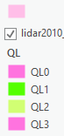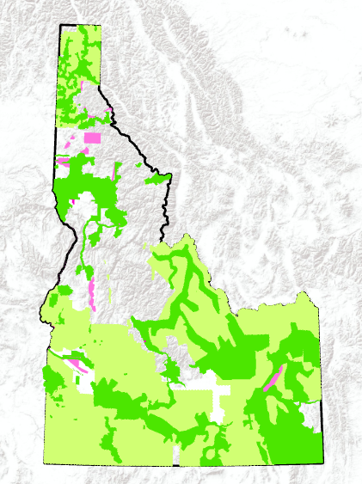

Quality Level 1

Quality Level 2

Quality Level 3+

Figure 1.1. Project 2021 lidar coverage. QL represents quality level of lidar flown, where QL1 is the highest quality.

### Case study: Lidar Use Barriers in Flood Risk Management

Historically, lidar is used in Idaho by a range of individuals including GIS technicians, emergency planners, engineers, academics, geoscientists, forensic investigators, and artists. In collaboration with the Federal Emergency Management Agency (FEMA) through the Risk and Mapping, Assessment, and Planning (RiskMAP) project, we focused specifically on gaining a more nuanced understanding a flood risk manager’s experience with lidar adoption.

Typically, flood risk managers know their risk by using FEMA floodplain maps that estimate the extent of flood hazards through hydrologic and hydraulic models. These analyses require topography, rainfall and run-off frequency distributions, and flood control structures (e.g. diversion dams, levees, bridges). Previous research confirms that high-resolution elevation data is critical for an accurate floodplain map (Ali et al., 2015; Cook & Merwade, 2009). This study examines potential barriers to lidar adoption in greater detail in an effort to tailor our educational outreach to address these barriers.

### Applied Research

In order to increase the use of lidar, this chapter aims to scale our case study findings to address these barriers across sectors (e.g. riverine ecosystem management, wildlife and habitat management, forest resource management) and scales (e.g. city, county, state). This approach is informed by innovation adoption theory. One way to elicit change in adoption is by identifying the facilitators and barriers correlated with adoption (Wisdom et al., 2014). This chapter of my thesis specifically focuses on the barriers of innovation adoption through a survey instrument. Some of the common barriers that prevent individuals from adopting are lack of awareness, familiarity, time, autonomy, and ability to access research (Wisdom et al., 2014). In compliment, the second chapter of this thesis delves into the facilitators of adoption.

### Objectives

There were two main objectives: (1) to understand the current barriers to lidar adoption by conducting a case study with flood risk managers in Idaho (2) create and disseminate three educational outreach products tailored to a specific audience and purpose across a wide-scope of lidar applications in Idaho. In order to do this, I worked closely with Dr. Nancy Glenn and Josh Enterkine from ILC to design and carry out an applied research project that aligned with the organization’s short-term and long-term goals for lidar adoption in Idaho.

## Methods

### Case Study Methodology

I wrote and submitted an application to the Social & Behavioral Institutional Review Board (IRB) at BSU. The project was approved on October 22nd, 2019 under IRB #090-SB19-212. Dr. Vicken Hillis and I conducted eight semi-structured interviews with case study stakeholders (e.g. flood risk managers, state officials, academics) in Fall 2019. The key themes from these interviews informed the survey instrument that we used to collect data. The survey, titled “Technology Adoption in Flood Risk Management” was distributed online through QualtricsTM to 385 potential survey respondents between May and June 2020. One section of the survey asked respondents about barriers to lidar adoption in flood risk management (Figure 1.2).

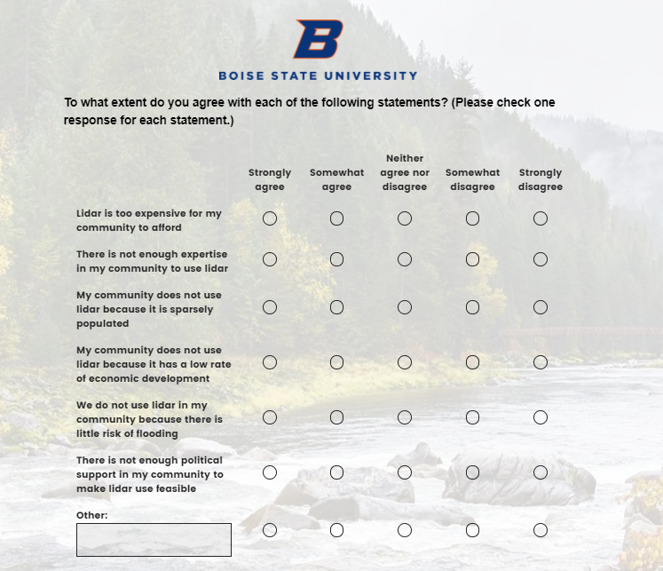

Figure .2. Survey question regarding barriers to lidar adoption. This question addressed six potential barrier flood risk managers may face and responses were collected on a likert scale.

In addition, we asked respondents about specific areas they would like training sessions regarding lidar to inform our educational outreach portion of this study.

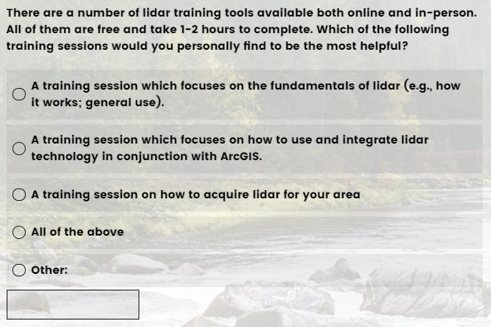

Figure 1.3. Survey question regarding educational workshops of interest to respondents. Survey respondents had four pre-specified answer choices and an open response option.

I used the programming language R to run descriptive statistics on these data that informed the next step of this study, educational outreach.

### Communicating Results to Stakeholders

Based on our research findings, we created three forms of sharing our results to community stakeholders. Each method of information dissemination was created with a specific audience, intention, and publishing format in mind. The three ways we did this were (1) a webinar summarizing our survey findings specifically for flood risk managers in Idaho, (2) a white paper for the Idaho Geospatial Council – Executive Committee and Elevation Technical Working Group, and (3) a Story Map for a broad audience of potential and current lidar users in Idaho.

The webinar titled, “Current State of Lidar in Idaho for Flood Risk Management”, was part of a series of webinars to engage the broader flood risk management community on lidar use. The intention of this webinar was to share our survey findings and discuss the implications of these findings on community stakeholders. This webinar was designed to incorporate best practices for engagement and learning including: tailored message for target audience, guest speaks from varied backgrounds, employed “mini-lectures,” incorporated audience engagement (e.g. introduction over chat, live discussion), and provided contact information of speakers for follow-up questions (Bedford, 2016).

The white paper, titled “Knowing More, Losing Less through Investment in High-Quality Elevation Data in Idaho,” was written for a very specific audience, the Idaho Geospatial Council – Executive Committee and Elevation Technical Working Group. The intention behind this document was to discuss the current state of lidar acquisition in Idaho, as well as a call to action to ensure the completion of the goals set forth by the USGS 3DEP and the Idaho Lidar Statewide Acquisition Plan. The white paper format provided a way to quickly identify the problem and provide a solution to the problem in a concise, engaging format and inform governmental policy (Stelzner, 2007).

The third form of educational outreach I conducted was through the Environmental Systems Research Institute Story Map (Story Map) application. Research has found that Story Map’s are an effective teaching tool for STEM subjects (Groshans et al., 2019). Another study found that Story Map’s increase accessibility and enhanced participation in sustainability-related activities (Austin, 2018). In addition, Story Map’s provide an integrative approach to science communication by combining concise text with engaging visuals. Considering these advantages, I created a [Story Map](https://boisestate.maps.arcgis.com/apps/Cascade/index.html?appid=63fc0118b554441589d7793e1c38ff1d&edit), titled “Mapping for Resilience.” It was written for a broad audience of potential and current lidar users. The intention behind this document was to educate the viewer about how lidar can be used to address a wide range of challenges posed by landscape change due to natural hazards and urbanization. This format provided an engaging and dynamic platform to display the versatility of lidar and complimented the goals of my white paper.

## Results

### Case Study Results

Around 50% of the survey respondents used lidar for flood risk management. When I examined this at a more granular level, I found that only 32% and 41% of flood risk managers at the City and County level, respectively, used lidar compared to 80% and 86% of flood risk managers at the Industry and State-level, respectively. This showed a clear discrepancy about who is using lidar. For the flood risk managers who did not use lidar, the survey asked about barriers that inhibited them. The top three barriers were lack of adequate funding, expertise, and political support with nearly 50% or more respondents selecting these barriers (Figure 1.4).

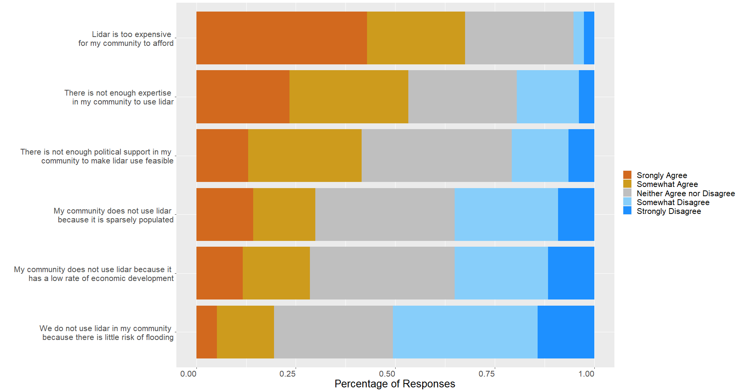

Figure 1.4. Descriptive summary of barriers to lidar adoption for flood risk managers.

In addition, we asked all survey respondents to answer the type of lidar training sessions they would like to attend in the future. 58% of respondents selected they would like to attend sessions about lidar fundamentals, lidar with ArcGIS, and lidar acquisition (Figure 1.5).

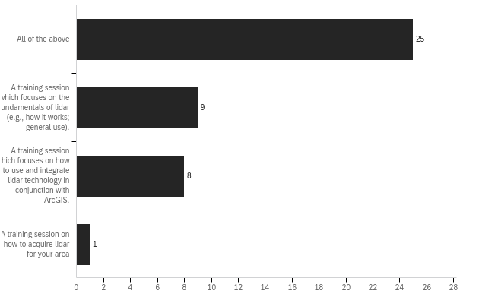

Figure 1.5. Descriptive summary of lidar training sessions of interest to survey respondents. Majority of respondents showed interest in all three trainings.

### Communicating Results to Stakeholders Results

The webinar shared the survey results in October 2020 over Zoom. We sent out the invitation to the webinar though multiple channels including the ILC website, the Idaho GIS listserv, and the Hazards and Climate Resiliency contact list. There were over 65 individuals in attendance and included flood risk management stakeholders such as government officials, industry professionals, and academics. The first part of the webinar was a presentation about the history of lidar coverage in Idaho, the findings from the project, and two guest speakers, Linda Davis, the GIS Manager at the Idaho Department of Water Resources, and Kristine Hilt, the Blaine County Floodplain Manager. The second part of the webinar was a panel discussion facilitated by Dr. Nancy Glenn and prompted by questions from the audience.

The white paper and Story Map were based on the survey results regarding the top three barriers of lidar adoption, which were lack of adequate funding, expertise, and political support. The white paper (Appendix A) primarily focused on formulating an argument for a sustainable, state-level lidar liaison position that could help facilitate funding opportunities, and provide a source of support for the community interested in lidar. The Story Map was created to speak to each of the lidar training session subjects that in turn could minimize the expertise barrier felt by over 50% of the respondents. The story begins with background information about lidar and how it works. Then it describes several primary Business Uses of lidar in Idaho including flood risk management, wildfire management, wildlife and habitat management, riverine ecosystem management, and forest management, among others (Dewberry, 2012). Finally, the story ends with a section about how to acquire lidar and additional resources to build community. These documents will be distributed June 2021 through the ILC website and the Hazards and Climate Resiliency Institute at Boise State University.

## Discussion

The three forms of educational outreach distribution played a key role in reaching a wide audience with tailored messaging to that audience. The first form, a webinar, was helpful for disseminating information specifically to flood risk managers, the focus of our case study. The live panel format allowed for an engaging discussion to occur and the online format over Zoom allowed for attendance of flood risk managers across the state. The white paper and Story Map were created for a broader lidar use audience, informed by the findings of our case study, since lidar is a technology that can be beneficial to multiple sectors and types of organizations. Furthermore, the online format of these products make the broadcasting of these materials easier.

The past year in Idaho has been greatly affected by the COVID-19 pandemic and likely lowered the number of survey responses we received. Specifically, we had a survey response rate of 25%, therefore we did not hear from a majority of the potential survey respondents. While this survey response rate is typical of an online survey, it is possible this number was lower this year because of flood risk manager’s involvement with emergency management in their communities (Sauermann & Roach, 2013). In addition, I was unable to hold in-person interviews and workshops because of COVID-19. While I was still able to complete the important components of the project, I feel as if I did not experience some of the benefits of in-person work such as growing a closer connection with the lidar community in Idaho. These richer connections could have led to increased education for me and community members.

In the future, I suggest sending out the survey again to see if lidar adoption rates have increased since this project was instituted. This could lead to a longitudinal study, which would better inform how we understand innovation adoption. I recommend expanding the survey beyond flood risk managers to all individuals and organizations that may use lidar. This would result in a greater understanding of the landscape of barriers that lidar adopters face. Finally, I recommend that the educational outreach products, specifically the white paper and Story Map, remain as live, dynamic documents that can be updated to reflect the current needs of lidar acquisition and coordination in Idaho.

## Future Work

The white paper and Story Map will first be distributed to the IGC-EC and ETWG. I plan to do this through a presentation and electronic dissemination of materials to relevant individuals. Once the committee has given feedback, I hope to submit the white paper and Story Map to state elected officials to get funded. In addition, the Story Map is a living document that I would like to keep up-to-date as lidar use increases throughout the State.

## Conclusion

Using a mixed-methods empirical study, we found that flood risk manager’s in Idaho experience several barriers to lidar adoption resulting in only 50% of managers using lidar. The top three barriers we found were lack of funding, lack of expertise, and lack of political support. In addition, we found that flood risk managers would like workshops in lidar fundamentals, lidar use with ArcGIS, and lidar acquisition. Considering these findings, we created three forms of educational outreach to create materials tailored for a specific audience and purpose. We held a webinar to share our survey results with flood risk managers in Idaho, wrote a white paper to advocate for a lidar liaison and permanent budget for lidar acquisition and coordination with support from state-level organizations, and we created a Story Map to educate current and potential lidar users about lidar fundamentals, applications, and acquisition. We found this work to be received well by the lidar community in Idaho and are hopeful that these educational materials will increase lidar uptake in Idaho.

CHAPTER ONE REFERENCES

Ali, A. M., Solomatine, D. P., & Di Baldassarre, G. (2015). Assessing the impact of different sources of topographic data on 1-D hydraulic modelling of floods. *Hydrology and Earth System Sciences*, *19*(1), 631–643.

Andersen, H.-E., McGaughey, R. J., & Reutebuch, S. E. (2005). Estimating forest canopy fuel parameters using LIDAR data. *Remote Sensing of Environment*, *94*(4), 441–449. https://doi.org/10.1016/j.rse.2004.10.013

Austin, B. (2018). Investigating the Influence of Esri Story Map Design on Partcipation in Sustainability-Related Activities. *Masters Theses & Specialist Projects*. https://digitalcommons.wku.edu/theses/2571

Bedford, N. (2016). *Webinar Best Practices*. Carleton University. https://doi.org/10.22215/cfice-2016-06

Chang, J. C., Findley, D. J., Cunningham, C. M., & Tsai, M. K. (2014). Considerations for Effective Lidar Deployment by Transportation Agencies. *Transportation Research Record: Journal of the Transportation Research Board*, *2440*(1), 1–8. https://doi.org/10.3141/2440-01

Clifton, A., Clive, P., Gottschall, J., Schlipf, D., Simley, E., Simmons, L., Stein, D., Trabucchi, D., Vasiljevic, N., & Würth, I. (2018). IEA Wind Task 32: Wind Lidar Identifying and Mitigating Barriers to the Adoption of Wind Lidar. *Remote Sensing*, *10*(3), 406. https://doi.org/10.3390/rs10030406

COMPASS. (2020). The Treasure Valley is Growing! *Communities in Motion 2040 2.0*. https://compassidaho.org/CIM2040-2.0/growth/

Cook, A., & Merwade, V. (2009). Effect of topographic data, geometric configuration and modeling approach on flood inundation mapping. *Journal of Hydrology*, *377*(1), 131–142. <https://doi.org/10.1016/j.jhydrol.2009.08.015>

Dewberry (2012). Appendix F- Benefit Cost Analysis Process. *NEAA Final Report.* Retrieved February 3, 2021 from <https://www.dewberry.com/docs/default-source/documents/neea_final_report_revised_3_29_12_appendix_f_benefit_cost_analysis_process.pdf?sfvrsn=2721bcb8_0>

Elevation Technical Working Group. (2018). Idaho Statewide Lidar Plan. Retrieved October 15, 2019, from <https://drive.google.com/file/u/2/d/1qsL5Ie1hGT46lRL-hP80P1Qy_kiOZZfT/view?usp=sharing&usp=embed_facebook>

Ellett, N., Pierce, J., & Glenn, N. (2019). Partitioned by process: Measuring post‐fire debris‐flow and rill erosion with Structure from Motion photogrammetry. *Earth Surface Processes and Landforms*, *44*. https://doi.org/10.1002/esp.4728

Groshans, G., Mikhailova, E., Post, C., Schlautman, M., Carbajales-Dale, P., & Payne, K. (2019). Digital Story Map Learning for STEM Disciplines. *Education Sciences*, *9*(2), 75. https://doi.org/10.3390/educsci9020075

Muhadi, N. A., Abdullah, A. F., Bejo, S. K., Mahadi, M. R., & Mijic, A. (2020). The Use of LiDAR-Derived DEM in Flood Applications: A Review. *Remote Sensing*, *12*(14), 2308. https://doi.org/10.3390/rs12142308

Press, T. A. (2020, December 24). US population growth smallest in at least 120 years. *Idaho Business Review*. https://idahobusinessreview.com/2020/12/24/us-population-growth-smallest-in-at-least-120-years/

Sauermann, H., & Roach, M. (2013). Increasing web survey response rates in innovation research: An experimental study of static and dynamic contact design features. *Research Policy*, *42*(1), 273–286. https://doi.org/10.1016/j.respol.2012.05.003

Stelzner, M. A. (2007). *How to Write a White Paper*. 10.

Sugarbaker, L., Constance, E., Heidemann, H., Jason, A., Lukas, V., Saghy, D., & Stoker, J. (2014). *The 3D Elevation Program Initiative—A Call for Action* (Circular No. 1399; Circular). https://pubs.usgs.gov/circ/1399/pdf/circ1399.pdf

Wisdom, J. P., Chor, K. H. B., Hoagwood, K. E., & Horwitz, S. M. (2014). Innovation Adoption: A Review of Theories and Constructs. *Administration and Policy in Mental Health and Mental Health Services Research*, *41*(4), 480–502. https://doi.org/10.1007/s10488-013-0486-4

# CHAPTER TWO: MANUSCRIPT DRAFT—QUANTIFYING SOCIAL INFLUENCES OF TECHNOLOGY ADOPTION FOR LONG-TERM FLOOD RISK MANAGEMENT: A CASE STUDY IN THE PACIFIC NORTHWEST, U.S.

## Abstract

Flood risk and damage are expected to increase in the Western U.S. due to climate change. Light Detection and Ranging (lidar) is a remote sensing technology that provides high-resolution topographic data and can therefore produce higher accuracy floodplain maps, an important tool that communities use to assess their flood risk spatially. While availability of lidar data varies across the U.S., uptake also varies even when lidar is available. For example, we found that only 50% of flood risk managers in Idaho are using the technology. Previous research investigated important factors in the role of technology adoption in reducing long-term environmental risk. However the current literature infrequently examined the social processes that impact an individual’s choices about how to manage risk. We used a mixed-methods approach to examine the adoption of lidar by flood managers for risk mitigation, as a function of individual (e.g. risk perception, direct experience) and collective predictors (e.g. peer influence, network communication). We conducted 8 semi-structured interviews with flood risk managers in Idaho and gathered 150 survey responses from flood risk managers in Idaho, Oregon, and Washington. We found that flood managers who share information with other flood managers using lidar are also more likely to use lidar themselves. Furthermore, the more frequently these flood managers communicate, the more likely a manager is to use lidar. This work provides a foundation for how to incorporate collective factors in mitigation behavior and reveals potential for increased lidar uptake through collaboration in the flood risk manager community.

## Introduction

Floods are one of the most frequent and destructive natural disasters in the United States (FEMA, 2020; Pralle, 2019). Flood events disrupt ecological, cultural, and economic landscapes causing incalculable expenses to our society. Often, resulting with vulnerable groups even more at risk in the future (Howell and Elliott, 2019). Flood events in the U.S. are increasing, some of those with unprecedented amounts of rainfall, since the National Centers for Environmental Information (NCEI) began tracking natural disaster events in 1980 (NCEI, 2021). This is because as temperatures rise, the amount of water vapor in the atmosphere increases, which exacerbates the potential for extreme rainfall events. In addition to growing flood risk from climate change, population growth rate and urbanization in coastal and inland floodplains is rising (Pralle, 2019; Schanze, 2006). In 2015, 21.8 million (6.87%) of the U.S. population were exposed to the chance of a 100-year flood; meaning they lived in a location that could be inundated by a flood event with 1 in 100 chance of happening each year (Qiang, 2019). In light of these challenges, understanding how to manage flood risk is critical.

Risk is defined based on the disciplinary domain in which the concept is being examined. In an everyday sense, risk can be considered the chance of a negative outcome occurring (Mishra, 2014). We see risk as inherently transdisciplinary and needs to encapsulate the full context of the topic for which it is being applied. Therefore we define risk, in a flood context, as the quantifiable chance of a flood event given the known, contextual (e.g. social, environmental, political) factors.

Communities understand their flood risk typically by using Federal Emergency Management Agency (FEMA) floodplain maps that estimate the extent of flood hazards through hydrologic and hydraulic models. These analyses require topography, rainfall and run-off frequency distributions, and flood control structures (e.g. diversion dams, levees, bridges). In addition, these floodplain maps are essential for communicating flood risk to vulnerable populations, helping communities mitigate and adapt to floods, and the functioning of insurance programs, such as the the FEMA’s National Flood Insurance Program (Pralle, 2019). However, recent reports estimate that approximately 25% of the flood damage claims occur outside of FEMA mapped floodplains each year because these maps can be outdated and inaccurate (Ludy and Kondolf, 2012). 100-year flood events are based on historical rainfall patterns, however this probability can change based on local land use, river impoundments, the amount of impervious surfaces, and long-term climate patterns (USGS, 2018).

Previous research confirms that high-resolution topographic data is critical for an accurate floodplain map (Ali et al., 2015; Cook and Merwade, 2009). In the past, flood risk managers typically used 10-meter or 30-meter resolution terrain models. However higher-resolution terrain models (e.g. 1-meter or smaller) are now available from technology such as Light Detection and Ranging (lidar). Lidar is a laser-based remote sensing technology that uses the reflection of light to measure elevation and features on the ground such as vegetation and structures. Raw lidar data points form a three-dimensional (3D) point cloud. These 3D point clouds are used in a wide-array of hazard applications such as wildfire fuel load calculation or wildlife habitat viewshed identification. In addition, lidar-derived products, such as high-resolution terrain models, are widely used in flood risk management to model different flooding scenarios (Muhadi et al., 2020).

Topographic and bathymetric lidar is variably available across the contiguous, lower 48 states. All but eight states have greater than 95% coverage and those eight states are all situated in the Western U.S, including Washington, Idaho, Montana, Oregon, Nevada, Utah, California, and Arizona. As lidar becomes more available and increasingly popular, it is important to understand the factors that influence a flood risk manager’s decision to adopt this new technology into their practice of long-term risk mitigation.

In order to address gaps in our understanding of new technology adoption for flood risk management, we conducted an empirical case study of lidar adoption in the Pacific Northwest of the U.S. In this study, we employed a mixed-methods approach, combining interviews and a survey, to understand the individual and collective factors driving adoption of lidar by flood risk managers. Historically-studied, individual predictors in flood risk management include risk perception, direct experience, knowledge, coping appraisal, trust, risk-taking attitude, and demographics (e.g. (Birkholz et al., 2014; Bubeck et al., 2012; Kellens et al., 2013; Poussin et al., 2014)). While there has been limited research in the collective predictors of flood risk management, this area of work could potentially illuiminate important predictors of risk mitigation behavior (Kuhlicke et al., 2020). Collective predictors can be drawn from a social network analysis and include factors such as peer influence, network strength, and network expertise to understand information dissemination.

While the field of hazards and disaster research is inherently multidisciplinary, recent, concerted effort focuses on convergence research to integrate knowledge across disciplines and organizational boundaries to reduce disaster losses and promote collective well-being (Peek at al., 2020). Our study is an example of convergence work because we draw from social-ecological science and engage study particpants from diverse organizational backgrounds including government officials, industry professionals, and academics. Furthermore, we employ cultural evolutionary theory (CT) to study lidar adoption because it considers both social and environmental influences of behavior that communities uniquely experience in regards to flood risk management.

Cultural evolutionary theory provides a strong theoretical background to our study because of it’s usefulness for quantification of collective beliefs and prediction of individual behavior, two important components for managing risk mitigation behavior. Our study provides a concrete example of how to implement this framework that could be used for other risk mitigation-type problems and bolster this area of work within the convergence research movement in hazards and disaster research.

In the next section we review cultural evolutionary theory in detail and explain how this theory is beneficial for understanding the underlying mechanisms that shape flood risk management behavior. Next, we apply this theoretical framework to our case study of lidar adoption for flood risk management. This is followed by the methods section that explains our survey instrument development process and statistical approach for analyzing the survey data. The results from our analysis and a discussion about significant trends will follow. Finally, we discuss the implications of these results and need for further research.

## Theory

### Individual and collective predictors of risk-mitigation behavior

Previous research identified the importance of several individual factors as a function of risk mitigation behavior, however research is limited in the role of collective action (Kuhlicke et al., 2020). It is important to look at the combined effects of both individual and collective predictors in predicting risk-mitigation behavior so that we can understand the relative contribution of each predictor (van Valkengoed and Steg, 2019). In this study, we examine the influence of a collection of individual and collective predictors on a flood risk manager’s adoption of lidar for long-term risk mitigation. The following section examines previous research into predictors of risk mitigation behavior and then explores how cultural evolutionary theory can help illuminate collective predictors of influence.

#### Topical Review

Previous flood risk management research focused on flood risk perception as a critical factor of developing effective flood risk management strategies (Birkholz et al., 2014). However, recent research re-examined risk perception’s role in behavior and decision-making because of the difficulty connecting risk perception with management and the challenge of parsing out the connection of risk perception with underlying contextual factors (Rufat et al., 2020). For example, a study by Bubeck et al. (2012) found risk perception to be a weak predictor of precautionary behavior and suggests shifting focus towards flood-coping appraisal for explaining flood risk management behavior. In addition, Kellens et al. (2013) reviewed 57 empirically based peer-reviewed articles on flood risk perception and communication to assess overall trends in flood risk research. The authors found that the majority of studies were exploratory and did not apply a theoretical framework to examine risk perception (Kellens et al., 2013). Of the studies that employed a theoretical framework, protection motivation theory (PMT) was the most common. PMT explains individual decisions about preparing for risk as a function of threat appraisal (e.g. likelihood of exposure to a flood, severity of exposure, and fear) and coping appraisal (e.g. self-efficacy, outcome efficacy, and outcome costs). The results of this review suggest future research should have more theoretical support and methodological openness; specifically, the use of a theoretical framework that emphasizes the effects of physical exposure and hazard experience (Kellens et al., 2013).

Collective factors of risk mitigation behavior are limited in the existing flood risk management literature, however initial evidence found the influence of social networks on risk mitigation behavior as important (Bojovic and Giupponi, 2020; Kuhlicke et al., 2020; Lechowska, 2021). Social networks are of particular interest for our study because they are a way of measuring peer influence, the diffusion of ideas, practices, or technologies through network ties from social interactions (Muter et al., 2013). Peer influence is a helpful tool for behavior prediction based on an individual’s position in a social network (Daraganova and Robins, 2012; Levin, 1992). Furthermore, the technology adoption literature applied network analysis to measure information exchange and diffusion through network relations (Peng and Dey, 2013). The application of social networks to flood risk management decision-making is still in its infancy, however the findings from previous research with respect to social networks and technology adoption provide a compelling baseline for using it to understand peer influence in our study.

Additionally, recent research suggests the importance of context, local power relations, constraints, and opportunities that affect risk mitigating behavior calling for convergence research to understand the underlying assumptions of decision-making (Rufat et al., 2020). Given the current gaps of understanding in flood risk management research and the push for convergence research, we employ cultural evolutionary theory to employ a comprehensive theoretical baseline for flood risk mitigation behavior research that can be used across disciplines and scales.

Secondly, the current literature is pre-dominantly focused on the public’s flood risk behavior, rather than flood risk managers themselves. Previous work focused on emergency manager decision-making, however this area is understudied (Brody et al., 2010; Roberts and Wernstedt, 2019). Our study is solely focused on addressing individual and collective predictors of risk mitigation behavior at the decision-maker level.

#### Culture and Risk

Culture is information acquired by individuals through social learning (Henrich and McElreath, 2002). Social learning is the observing, modeling, and imitating of behaviors, attitudes, and emotional reactions of others (Bandura, 1971). Social learning differs from individual learning, which is learned from the environment and non-social stimulus, but is not mutually exclusive (Perreault et al., 2012). The process of culture creates a shared set of beliefs and norms among a group of individuals. Several researchers believe social learning has improved human adaptability so much that we are able to inhabit such a wide range of habitats, unlike other animal species (Creanza et al., 2017).

Behavioral adaptations display the variation of culture as a result of the evolutionary dynamics of cultural systems. Cultural evolutionary theory describes this process as the selection and transmission of culture over time. The selection process leads to variation of culture across temporal, spatial, and institutional scales and the transmission leads to adaptation (e.g. adoption of new technology). Reminiscent of genetic evolution, human culture evolves through the process of natural selection. This evolution results in between-group variation of adaptive behavior and cooperation and can lead to increased fitness or utility (Henrich and McElreath, 2002; Richerson et al., 2016). Unlike genetic transmission, it is important to note cultural transmission can occur over a short time scale, within a generation, through social learning (Richerson et al., 2016). Cultural evolutionary theory and social learning are increasingly popular theories used to explain a wide range of phenomena in applications such as natural resource management, sports strategy, and institutional variation (Brooks et al., 2018; Mesoudi, 2019; e.g. Reed et al., 2010; Richerson et al., 2016).

In a similar vein, the cultural theory of risk is the transmission of risk information among a network of individuals through social learning (Douglas and Wildavsky, 1983). Previous flood risk management research has suggested the use of cultural theory of risk to contextualize the relationship of risk perception as a function of cultural adherence and social learning (Birkholz et al., 2014). This theory has been employed in a couple empirical flood risk management studies so far and provides an intriguing underpinning of risk perception research (Shen, 2009). Cultural evolutionary theory is similar to cultural theory of risk, however it more broadly offers a way to understand the complex dynamics of cultural change through interactions between individuals and populations, such as is needed for flood risk management (Brooks et al., 2018).

#### Predictor Literature Review

In order to select relevant individual and collective predictors of flood risk mitigation behavior *a priori*, we conducted a literature review of previous work that looked at the effect of the constructs outlined in Table 2.1 on flood risk mitigation.

Table 2.1 Individual and collective constructs studied in flood risk management research. Definition of each individual and collective construct included in the analysis. The listed effect on behavior indicates the direction of the association between the listed construct and our outcome variable, risk mitigation. Supporting literature includes a non-exhaustive list of articles discussing the importance and effect of each construct on risk mitigation.

|  |  |  |  |  |
| --- | --- | --- | --- | --- |
|  | Construct | Definition | Effect on Behavior* | Supporting Literature** |
| Individual | Risk perception | Subjective construct that reflects an individual’s perceived vulnerability to and consequence of a hazard. | +/- | Bubeck et al. 2012; Kellens et al., 2012; Lo, 2013; Birkholz et al. 2014; Poussin et al., 2014; van Valkengoed & Steg, 2019 |
| Experience (direct or indirect) | Represented by an individual witnessing a hazard and/or an individual who gathered information (e.g. social media, newspaper) from others who had direct experience. | + | Bubeck et al. 2012; Kellens et al., 2012; Poussin et al., 2014; Valkengoed & Steg, 2019 |
| Knowledge | An individual’s awareness of climate change and climate-related hazards. | + | Bubeck et al. 2012; Kellens et al., 2012; Valkengoed & Steg, 2019 |
| Coping Appraisal | Total response efficacy and self-efficacy considering costs of adopting response. | +/N.S. | Bubeck et al. 2012; Poussin et al., 2014 |
| Trust | Risk judgement by an individual regarding the ability for others (e.g. science, government) to effectively cope with a hazard | +/- | Kellens et al., 2012; Viglione et al. 2014; Valkengoed & Steg, 2019 |
| Risk-taking attitude | An individual’s general propensity to engage in risky behaviors. | +/- | Viglione et al. 2014; Roberts & Wernstedt, 2018; Poussin et al., 2014 |
| Age | An individual’s total years of life. | + | Bubeck et al. 2012; Poussin et al., 2014 |
| Gender | An individual’s self-described gender affiliation. | N.S. | Bubeck et al. 2012 |
| Education | Amount of formal education an individual experienced. | N.S. | Bubeck et al. 2012; Poussin et al., 2014 |
| Collective | Peer influence | Impact of an individual’s social network on an individual’s ideas, beliefs, and practices. | + | Lo, 2013; Viglione et al. 2014; Poussin et al., 2014; Birkholz et al. 2014; Roberts & Wernstedt, 2018; Bojovic & Giupponi, 2020 |
| Network Strength | Amount of communication an individual has with their network ties. | + | Lo, 2013; Haer et al., 2016; Bojovic & Giupponi, 2020 |
| Network Expertise | Individual perception of expert skills or knowledge of their network ties in their particular field of work. | +/N.S. | Bracken et al., 2016; Roberts & Wernstedt, 2018 |

## Methods

### Case study description

This study examines the adoption of lidar in communities throughout Idaho, Oregon, and Washington which are expected to see an increase in precipitation and higher temperatures earlier in the year and an increase in publicly-available lidar (Clark, 2010; Division, 2020; Emergency Management, 2018; Ralph et al., 2014; Slater and Villarini, 2016). While Idaho, Oregon, and Washington all reside in the same geographic region, yet each state’s flood risk challenges vary dependent on the differeing types of landscapes, levels of population growth and urbanization, and resource availability (e.g. funding for flood risk management, educational opportunities for flood risk managers). In addition, each state employs their own lidar coordination and acquisition program which contributes differential levels of lidar availability as seen in Figure 2.1

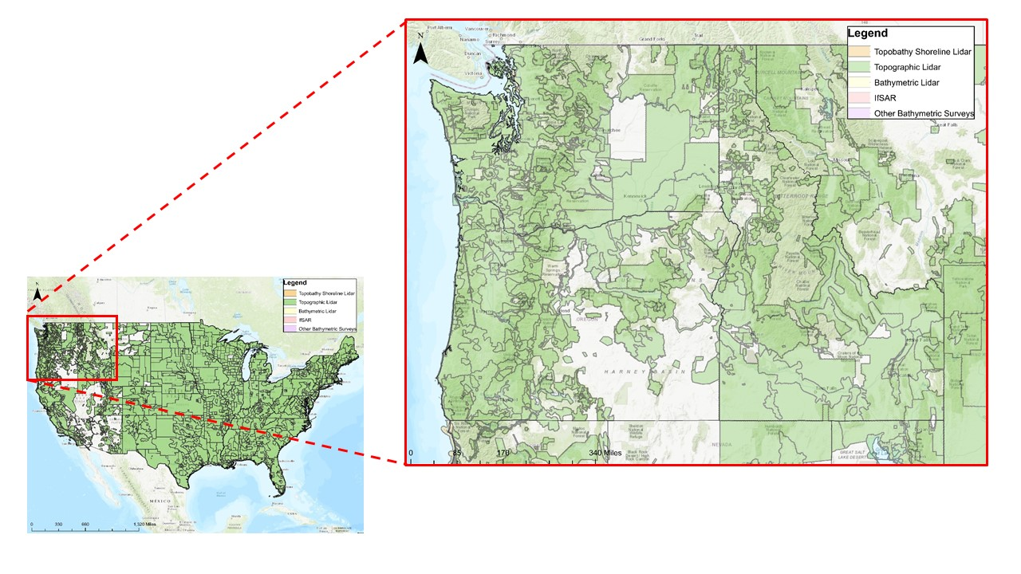

Figure 2.1. U.S. Interagency Elevation Inventory Map of the Pacific Northwest. Publicly-available lidar in our case study extents of Idaho, Oregon, and Washington.

#### Idaho

In 2019, Idaho was home to 1.79 million people across 82,643 square miles; 21.7 people per square mile (Bureau, 2020a). It is a land-locked state and can be broken down into three main areas: the panhandle in the north is filled with coniferous forests and lakes, the central section is filled with vast mountain ranges and alpine lakes, and the southern section, known as the Snake River Plain, is filled with sagebrush steppe and high desert environment. There is influence from the Pacific Ocean in the north and west side of Idaho, resulting in cloudy, humid, and wet winters, whereas the east is the opposite with wet summers and dry winters. Average annual rainfall ranges from 10" in the arid southwest regions to 50" at higher elevations in certain river basins (FEMA, 2020b). In addition, Idaho sees abundant amounts of snowfall in the mountains.

While most of the population is concentrated in the southern part of the state, there is flooding across the entire state that impacts people and structures. Idaho is prone to riverine flooding, ice/debris jam flooding, levee/dam/canal breaks, stormwater, sheet or areal flooding, and mudflows (Emergency Management, 2018). In 2021, Idaho had 145 NFIP participating communities across 44 counties (FEMA, 2020b).

Lidar acquisition is coordinated by Boise State University’s Idaho Lidar Consortium in conjunction with Idaho State University’s GIS Research and Training Center, which stores lidar data for public use. There is no state-approved funding set aside for lidar acquisition and therefore, communities rely on using local funding in addition to applying for funding from USGS and/or FEMA. By the end of 2020, Idaho had 25% of the state covered with publically-available lidar.

#### Oregon

In 2019, Oregon had over 4.2 million residents across 95,988 square miles; 43.8 people per square mile (Bureau, 2020b). Oregon can be broken down into six main areas: the Coast Range, the Willamette Lowland, the Cascade Mountains, the Klamath Mountains, the Columbia Plateau, and the Basin and Range Region. There is a maritime influence across the entire state due to the Pacific Ocean. The Coast range is predominantly evergreen forests with many small coastal lakes. The mountain regions are typically several thousand feet about sea-level and have a range of dense forests and lakes. Eastern Oregon contains high desert environment with few steep mountains.

Oregon’s population is concentrated in the coastal region of the state. Oregon has an extensive history of multiple types of flooding including riverine flooding, flash floods, ice/debris jam flooding, coastal flooding, shallow area flooding, urban flooding, and playa flooding (Layton et al., 2015). In 2021, Oregon had 228 NFIP participating communities across 36 counties (FEMA, 2020b).

Lidar acquisition is coordinated by the State of Oregon Department of Geology and Mineral Industries’ Oregon Lidar Consortium. By the end of 2020, Oregon had 98% of Oregon’s populated areas were covered with publically-available lidar, although eastern Oregon has much sparser coverage of lidar (Geology and Mineral Industries, 2020).

#### Washington

In 2019, Washington had over 7.6 million residents across 66,455 square miles; 114 people per square mile (Bureau, 2020c). Washington can be broken down into six main areas: the Olympic Mountains, Coast Range, Puget Sound Lowlands, Cascade Mountains, Columbia Plateau, and Rocky Mountains. Most of the areas in the western and northern parts of Washington are predominately evergreen forests, where the eastern and southern parts of Washington are semiarid where grasses, sagebrush, and scattered shrubs can be found. Annual precipitation on the Pacific side of the Olympic Peninsula exceeds 150 inches, but places on the northwest of the peninsula receive less than 20 inches a year and on the eastern side receive less than 8 inches (Augustyn, 2021).

More than three-fourths of the population lives in Puget Sound Lowlands (Augustyn, 2021). Flooding in Washington typically occurs on a seasonal basis due to rainfall from atmospheric rivers, rainfall on snow, flash foods from storms, and winter storms causing storm surges and high tide (Division, 2020). It is estimated that in 2021, Washington had 277 NFIP participating communities across 39 counties (FEMA, 2020b).

Lidar acquisition is coordinated by the Washington State Department of Natural Resources and receives funding from the Washington State Legislature to acquire and upkeep lidar data for the state. Over 50% of the state is flown with lidar data (Gleason and Markert, 2020).

### Physical flood risk

Since flooding is becoming an increasingly damaging and costly issue, there has been a rise in interest from non-governmental groups to predict flood risk at the property level for households and property owners to be aware of their physical flood risk. First Street Foundation, a non-profit organization of modelers, researchers, and data scientists, created the first publicly-available flood risk model for the lower 48 states. According to First Street, nearly 70% of properties have more substantial flood risk than previously predicted by FEMA floodplain maps (Foundation, 2020). In an effort to understand the nature of physical flood risk in our case study extent, we have compared the FEMA projections to the First Street projections as seen in Table 2.2. It is important to note that FEMA report’s Idaho with the least amount of risk compared to Oregon and Washington, however First Street reports it as having the most. This difference could be because there are still many locations in Idaho that are not mapped by FEMA and therefore urbanization in floodplain areas could be more likely.

Table 2.2. First Street Foundation and FEMA flood risk predictions. Summary information about environmental and social differences between Idaho, Oregon, and Washington.

|  |  |  |  |
| --- | --- | --- | --- |
|  | Idaho | Oregon | Washington |
| Total FEMA Properties at Risk (2020) | 38,047 | 97,918 | 121,528 |
| Percent FEMA Properties at Risk (2020) | 4.1 | 6.3 | 5.6 |
| Total FS Properties at Risk (2020) | 148,427 | 268,020 | 362,612 |
| Percent FS Properties at Risk (2020) | 17.6 | 17.3 | 16.4 |

## 

### Relevant predictors of lidar adoption

Given the previous literature and summary of our case study extent, we narrowed down our study to focus on eight constructs. Table 2.3 displays the five individual predictors that we selected for our study. We chose these factors because they aligned with repeated themes in our semi-structured interviews, in addition to each factor providing important information to help increase uptake of lidar adoption.

Table 2.3. Individual predictors of lidar adoption. This tables summarizes our hypothesis, survey question, reponse, options, and data structure for each predictor.

|  |  |  |  |  |
| --- | --- | --- | --- | --- |
| Construct | Hypothesis | Survey Question | Response Options | Data Type |
| Experience | Flood risk managers with direct flood experience are more likely to adopt lidar. | Have you ever experienced a flood that caused damage to property in your community? | Yes/No | Binary |
| Risk Perception | Flood risk managers with higher perceived risk are more likely to adopt lidar. | Thinking about your community in the next 30 years, how likely is it that a flood will cause damage to property in your community? | 0%/25%/50%/ 75%/100% | Ordinal categorical (5) |
| Knowledge | Flood risk managers with knowledge of increase flood severity are more likely to adopt lidar. | In the future, do you think the average severity of flood damage in your community will increase, decrease, or stay the same? | Increase/Decrease/Stay the same | Ordinal categorical (3) |
| Risk-taking attitude | Flood risk managers who are more risk-loving are more likely to adopt lidar. | Do you generally prefer to take risks or to avoid risks? | 0 (risk-loving) to 10 (risk-averse) | Integer |
| Trust | Flood risk managers who trust flood risk management scientific products are more likely to adopt lidar. | How much do you trust the accuracy of scientific products for flood risk management (i.e. topographic data, floodplain mapping, floodplain modeling)? | Strongly distrust/Somewhat distrust/Neither trust nor distrust/Somewhat trust/ Strongly trust | Ordinal categorical (5) |

In addition, we selected three collective factors reflected in Table 2.4.

Table 2.4. Collective predictors of lidar adoption. This tables summarizes our hypothesis, survey question, response, options, and data structure for each predictor.

|  |  |  |  |  |
| --- | --- | --- | --- | --- |
| Construct | Hypothesis | Survey Question | Response Options | Data Type |
| Experience | Flood risk managers with direct flood experience are more likely to adopt lidar. | Have you ever experienced a flood that caused damage to property in your community? | Yes/No | Binary |
| Risk Perception | Flood risk managers with higher perceived risk are more likely to adopt lidar. | Thinking about your community in the next 30 years, how likely is it that a flood will cause damage to property in your community? | 0%/25%/50%/ 75%/100% | Ordinal categorical (5) |
| Knowledge | Flood risk managers with knowledge of increase flood severity are more likely to adopt lidar. | In the future, do you think the average severity of flood damage in your community will increase, decrease, or stay the same? | Increase/Decrease/Stay the same | Ordinal categorical (3) |
| Risk-taking attitude | Flood risk managers who are more risk-loving are more likely to adopt lidar. | Do you generally prefer to take risks or to avoid risks? | 0 (risk-loving) to 10 (risk-averse) | Integer |
| Trust | Flood risk managers who trust flood risk management scientific products are more likely to adopt lidar. | How much do you trust the accuracy of scientific products for flood risk management (i.e. topographic data, floodplain mapping, floodplain modeling)? | Strongly distrust/Somewhat distrust/Neither trust nor distrust/Somewhat trust/ Strongly trust | Ordinal categorical (5) |

Several studies implement social network analysis to examine the the influence of social ties on communication in disaster management, however the effect of social networks on other topics in disaster management minimally explored (Bojovic and Giupponi, 2020). Bojovic et al. (2020) conducted a full network analysis on the diffusion of innovation and technologies for risk management, which was the first study of this topic in disaster management. The study focused on the identification of key actors to implement information dissemination through.

Our study uses an ego network analysis, which is helpful for understanding the variation of behavior of individuals through identification of local social structures unique to the individual of interest (e.g. flood risk manager) (Hanneman and Riddle, 2005). We used an open ego network and calculated the predictors peer influence, network strength, and network expertise from data collected in the survey questions in Figure 2.2. Peer influence was calculated as the proportion of the network’s ego alters that used lidar. Network strength was calculated as the net average communication with lidar users minus average communication with non-lidar users in an ego’s network. Network expertise was calculated as the net average expertise with lidar users minus average expertise with non-lidar users in an ego’s network.

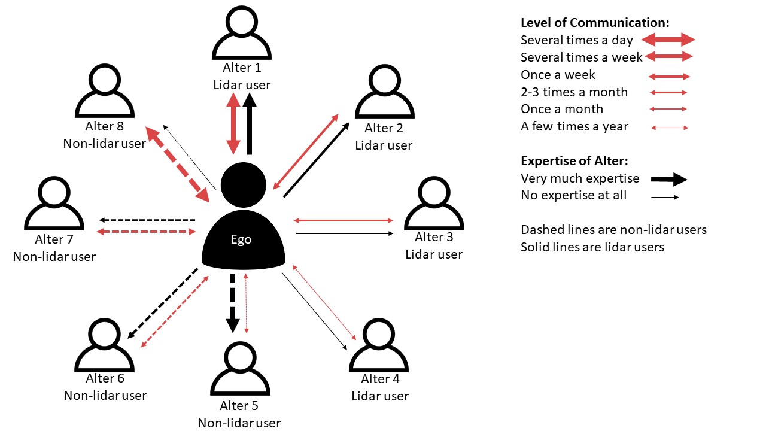

Figure 2.2. Ego network structure. We used an open ego network analysis structure where the center represents an the ego and the lines represent the ties between the ego and their alters.

### Survey design

Prior to finalizing our survey instrument, we conducted eight, semi-structured interviews with stakeholders including flood risk managers, government officials, industry professionals, and academics. The interviews lasted about an hour and were occasionally recorded. These interviews were used to identify common themes, ensure that our survey questions were relevant, and confirm that we were adequately identifying facilitators and barriers to lidar adoption.

Once we created our survey instrument, we conducted an expert review with eight university students and staff to give feedback about the appropriateness of the survey (e.g. length, difficulty, and readability), question fit to research questions, and survey structure (e.g. question order, section transitions, survey logic). Next, the survey was tested as a pilot survey with a flood risk manager, an industry professional, and a lidar academic to provide additional feedback from the perspective of a potential, target respondent.

The finalized survey consisted of four main parts (see Appendix B). The first part focused on gathering information about the respondent’s experience and beliefs about their flood risk management community. The second section was centered around the respondent’s relationship with lidar for flood risk management including if they used lidar, how they use lidar, and if they would like to take part in lidar workshops. The third part of the survey gathered information about the respondent’s flood risk management network. Lastly, the final part of the survey asked the respondent about their personal beliefs in risk-taking, trust, and demographic questions such as education and gender.

### Data collection

Our survey’s target population included floodplain managers and administrators in Idaho, Oregon, Washington, and Alaska. This also included individuals that may use lidar for flood risk management applications in conjunction with software applications such as Geographic Information System (GIS). The majority of sample respondents were municipal, state, and federal employees, as well as some private industry employees. We constructed our sample frame using several publicly available lists of managers including NFIP coordinators, Association of State Floodplain Managers (ASFPM) recognized Certified Floodplain Mangers (CFM), county-level GIS administrators, the five largest cities and tribal GIS administrators if present, county and tribal emergency managers, the Federal Geospatial Data Coordination Contacts by State, and additional, relevant contacts for the 2019 Northwest Regional Floodplain Managers Association Conference contact list.

We delivered the survey online using Qualtrics to 1,257 email addresses in our sample frame between May and July 2020. The survey took an average of 10 to 15 minutes to complete. We used Dillman et al. (2014) guidelines for web and mobile survey implementation. We initially set an introductory email that stated what was being asked of respondents, why they were selected, and information about the intent, purpose, and outcomes of the survey (Dillman et al., 2014). We sent three to five follow-up email correspondence messages over the course of four weeks to help increase our response rate. In addition, we stated the survey was anonymous and participant’s information would be kept confidential. Table 2.5 summarizes the potential respondents, number of survey responses, and response rate for each state.

Table 2.5: Comparative survey distribution and collection. Summary of potential respondents, number of survey responses, and response rate for each state.

|  |  |  |  |
| --- | --- | --- | --- |
|  | Potential Respondents | Number of Responses | Response Rate |
| Idaho | 385 | 96 | 24.9 |
| Oregon | 356 | 58 | 16.3 |
| Washington | 463 | 54 | 11.7 |
| Alaska | 53 | 6 | 11.3 |

We did not include Alaska in our final statistical analysis because of an insufficient number of responses. In addition, both Oregon and Washington had lower response rates than Idaho. Our response rates are within the typical bounds for online surveys of 10-25% (Sauermann and Roach, 2013).

### Data Analysis

We used a Bayesian Generalized Logistic Regression (GLR) to estimate the relationship between our predictors of interest and our response, lidar use, because it is binary. The results of this model allowed us to explore the effect of a multitude of predictors on lidar use in Idaho, Oregon, and Washington. We hypothesized that the model would be helpful for understanding the level of predictor influence, however we expected the predictive capacity of our model to be limited considering the large number of predictors and small sample size of our study.

The model followed a binomial distribution curve, where the distribution of lidar use, y_{ij}, was modeled as follows:

(1)

where , predictors, are the ith rows of the known design matrices x, and is a vector of regression parameters. This Bayesian approach allowed for adjustment of uncertainty associated with each parameter on the final outcome, lidar use. In order to do this, each parameter had to be assigned a prior belief of that parameter value. The values for these parameters are fit by sampling from these distributions to maximize the likelihood under this model (Kwon et al., 2008). The regression parameters, , are normally distributed,

. Additionally, the parameters of this distribution, and , also have prior distributions assigned to them that are constrained by 0 and a positive value. We used four Monte Carol Markov Chains (MCMC) with 2,000 iterations for warmup and an additional 2,000 iterations for the model. We assessed effective sample size and checked model convergence, indicated by R-hat statistics close to 1 and stable, well-mixed chains (Gelman et al., 2020).

#### Priors

We used a weakly informative prior distribution to provide modest regularization, reduce the chance of a Type I error, and improve the out-of-sample prediction for regression models (McElreath 2015). Gelman et al. (2008) suggests the use of a Cauchy distribution with center 0 and scale 2.5 for logistic regression models (Gelman et al., 2008). This study uses a Cauchy distribution as recommended for models with a low sample size (Lemoine, 2019).

#### Validation

We assessed the overall model performance through Leave-One-Out Cross-Validation (LOOCV). This process provides an absolute metric for the model’s predictive ability. Lastly, we plotted the predicted probability against the observed proportion using counterfactual plots to evaluate the effect of each predictor of interest on lidar adoption (Levy, 2012).

#### Error

We specified our model to compute 4,000 lidar use predictions based on our predictors. We interpreted the median of these results as the projected lidar use. In addition, we calculated the 50% and 95% uncertainty intervals around the median. We used Bayesian R-squared to measure our overall model accuracy. However, this can be unreliable for small sample sizes, so we also calculated the mean absolute error and root mean square error of our model.

## Results

We received the greatest number of responses from Idaho (Table 2.6). The results show slight differences in demographic factors. Washington had the highest percentage of female respondents, second highest percentage of respondents with a Bachelor’s degree or higher, and longest average length of flood risk manager experience.

Table 2.6. Summary survey demographics. Comparative descriptive statistics for survey demographics across Idaho, Oregon, and Washington.

|  |  |  |  |
| --- | --- | --- | --- |
|  | Idaho | Oregon | Washington |
| Sample Size | 96 | 58 | 54 |
| Female | 39% | 34% | 44% |
| University Education | 69% | 81% | 76% |
| Age (50+ years) | 50% | 43% | 43% |
| Average Flood Risk Experience (years) | 10.6 | 11.2 | 13.8 |

### Descriptive Results

We found that over 70% of flood risk managers, in all three states, had direct experience with flood damage in their communities (Table 2.7).

Table 2.7. Descriptive statistics predictors evaluated in our model.

|  |  |  |  |
| --- | --- | --- | --- |
|  | Idaho | Oregon | Washington |
| Direct experience with flood damage in community (%) | 79.2 | 72.40 | 85.20 |
| Direct experience with future flood damage in the community (%) | 97.9 | 96.60 | 98.10 |
| Perceived Increase in Flood Severity (%) | 38.5 | 41.40 | 57.40 |
| Average risk-taking attitude (0 to 10 with 10 being risk-loving) | 2.8 | 3.30 | 3.70 |
| Trust in accuracy of flood risk management scientific products (%) | 82.3 | 81.00 | 90.70 |
| Proportion of lidar users in flood risk management network (%) | 35.0 | 40.00 | 42.00 |
| Net average communication in respondent’s network | -0.6 | -0.04 | -0.02 |
| Net average expertise in respondent’s network (0 to 10 with 10 being of highest expertise) | 0.7 | 0.20 | 1.00 |
| Use lidar for flood risk management (%) | 50.0 | 62.10 | 64.80 |

Figure 2.3 describes, in finer detail, the types of experiences flood risk managers have had with flooding. Survey respondents reported experiences that ranged from damage in their communities to damage of their personal homes, deaths and injury to people in their community, and disruption of their utilities.

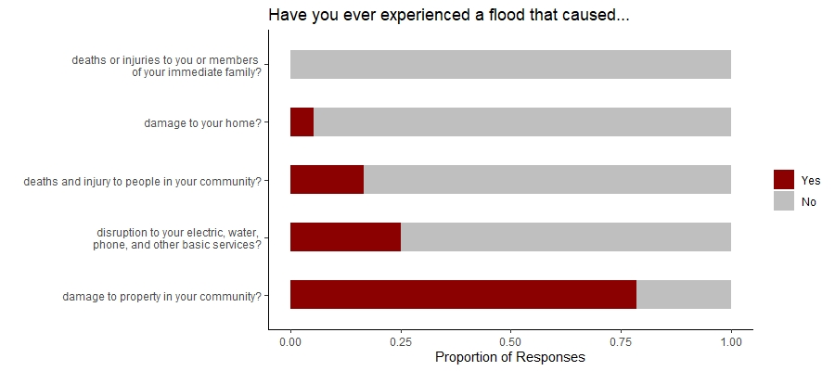

Figure 2.3. Summary of survey responses (n=206) of flood risk manager’s direct experiences with floods. This details varying levels of closeness of the experience.

We also asked respondent’s to report the likelihood of one of those experiences occuring in the next 30 years in their community. Over 90% of respondent’s were concerned with future flood damage in their community (Figure 2.4).

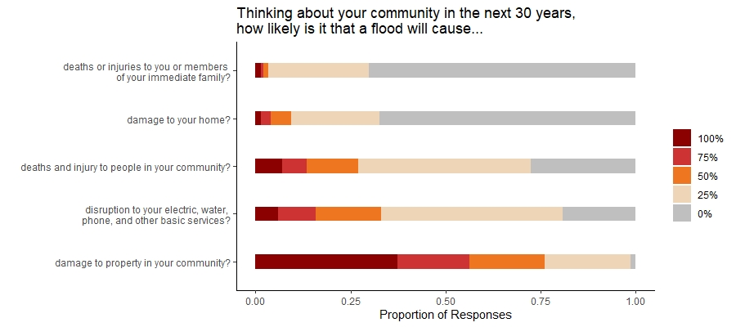

Figure 2.4. Summary of survey responses (n=206) of flood risk manager’s perceived flood risk in the future. This details varying levels of closeness of the experience.

In addition, between 38.5% - 57.4% of respondent’s expected an increase in flood severity. In addition, we found that flood risk managers in Washington tend to be less risk-averse than managers in Oregon and Idaho. All three states reported a high trust in the accuracy of flood risk management scientific products (e.g. topographic data, floodplain mapping, floodplain modeling) with Washington reporting the highest percentage of trust.

The collective predictors of lidar use varied slightly among the states. Respondents in Washington, on average, had 42% of the people a respondent reported sharing information with individuals in their network who also use lidar, which was higher than Idaho which reported 35%. These findings reflect a similar pattern in that Idaho had the least amount of communication, on average, in their flood risk manager network and Washington had the most. In all three states, respondent’s had slightly more communication with non-lidar users. Interestingly, all three states reported, on average, more expertise with lidar users in their network.

Washington reported the highest amount of lidar use in flood risk management with almost 65% of respondent’s using lidar. Idaho reported the lowest amount of lidar users, 50%.

### Estimation Results

Our GLR model allowed us to explore the effect of a multitude of predictors on lidar use in Idaho, Oregon, and Washington. We had item-nonresponse in the survey, in particular for the network section, and we dropped incomplete responses to conduct our statistical modeling. Of the 208 usable responses we received, 50 of them did not fill out the network section. Since our model considers both individual and collective predictors, and needs equal size data lengths for each predictor in order to run the model, we dropped almost 25% of our data responses, which may result in effect size underestimation (Langkamp et al., 2010).

Table 2.8 displays the results from our GLR model that considers the effect of individual and collective predictors on lidar use.

Table 2.8. Estimation results from the model.

|  |  |  |  |  |
| --- | --- | --- | --- | --- |
|  | Mean (log odds) | S.D. | 5% | 95% |
| Intercept | -0.9 | 1.7 | -3.7 | 1.9 |
| Direct Experience | 0.4 | 0.7 | -0.6 | 1.5 |
| Risk Perception | 1.2 | 0.8 | -0.2 | 2.6 |
| Knowledge | 0.2 | 0.4 | -0.3 | 0.9 |
| Risk-Taking Attitude | 0.1 | 0.1 | -0.1 | 0.3 |
| Trust | -0.2 | 0.3 | -0.8 | 0.3 |
| Peer Influence | 1.4 | 1.1 | -0.4 | 3.3 |
| Network Strength | 0.4 | 0.1 | 0.2 | 0.7 |
| Network Expertise | 0.1 | 0.1 | 0.0 | 0.2 |

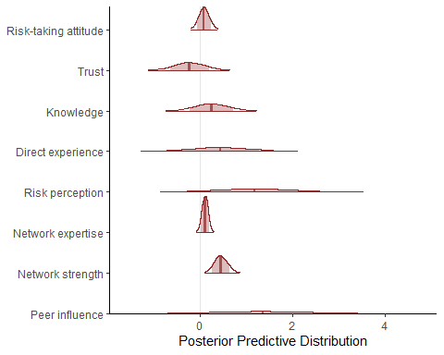

Figure 2.5. Posterior Predictive Distribution for each predictor variable.

From our analysis, we examined the Posterior Predictive Distribution for each predictor and the intercept (Figure 2.5). We considered predictors that had parameter estimates whose 90% credible interval did not overlap with zero to be important. These results suggest peer influence, network strength, and risk perception have a non-zero effect on lidar use.

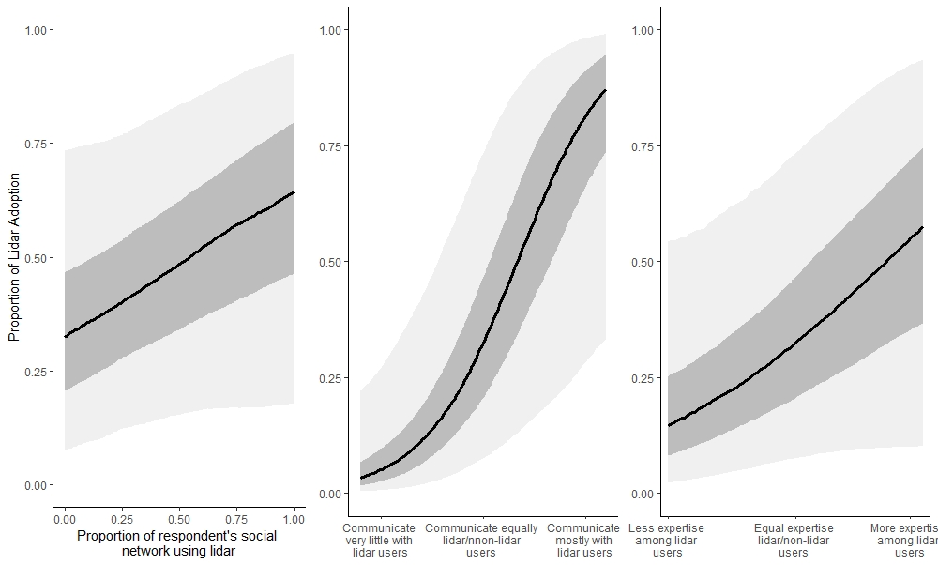

Figure 2.6. Counterfactual plots shows the effect of a) the proportion of respondent’s social network using lidar, or peer influence, and predicted lidar adoption, b) net average frequency of communication with lidar and non-lidar users, or network strength, in flood risk manager’s network, and c) net average expertise of lidar and non-lidar users, or network expertise, in flood risk manager’s network. The dark grey and light grey represent the 50% and 95% confidence intervals, respectively.

Figure 2.6 displays the effect, when holding all other variables at their minimum, of peer influence, which is the proportion of lidar user’s in a respondent’s network on lidar use by region. When every alter in a respondent’s network used lidar, 64.4% of flood risk manager’s were predicted to adopt lidar. Alternatively, when the proportion of lidar user in respondent’s network decreased to 0, 32.4% were predicted to adopt lidar. Both network strength and network expertise had positive correlations with lidar adoption. Network strength resulted in the largest increase in lidar adoption ranging from 3.3% for those who spoke only with non-lidar users to 87.2% for flood risk manager’s who speak with only lidar users. Network expertise also had a positive effect, although small. When a flood risk manager’s network was made up of expertise from non-lidar users, 14.7% were predict to adopt as opposed to 57.5% when a flood risk manager’s network was comprised of expertise from lidar users.

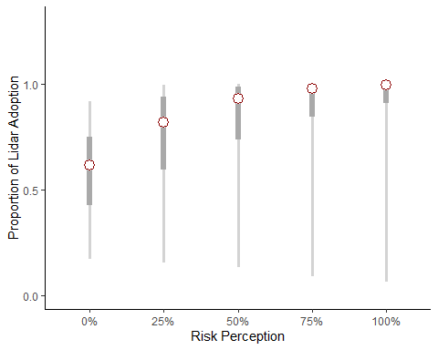

Figure 2.7. Counterfactual plot of risk perception and predicted lidar adoption. The dark grey and light grey represent the 50% and 95% confidence intervals, respectively.

Our model also suggests that risk perception was an important predictor of lidar adoption. Figure 2.7 displays the effect, when holding all other variables at their minimum, of risk perception on lidar adoption. We found that when flood risk manager’s expect 0% chance of future flood risk in their community, 59.9% of flood risk managers are predicted to adopt lidar, whereas flood risk manager’s who expect 100% chance of future flood risk in their community, 99.3% of flood risk managers are predicted to adopt lidar.

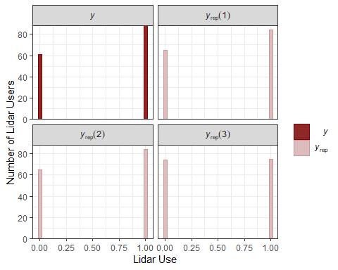

Figure 2.8. Displays a histogram, using the PPC function, that represents the number of individuals that do not use lidar (0) in the left column and use lidar (1) in the right column. The y histogram represents the actual data and the yrep represents the data generated from the posterior predictive distribution. Overall, the yrep is representative of the y, meaning our model has an accurate predictive ability.

Furthermore, we examined the out-of-sample predictive performance of our model. The Loo Information Criterion was 161.4 with standard error of 17.5. The predictive power of the model was assessed by using a Posterior Predictive Checking from the bayesplot package in R (Figure 2.8).

The Mean Absolute Error of our model was 1.45 and Root Mean Square Error was 1.75 therefore; therefore, our model had minimal variance in individual errors in our sample. Lastly, the Bayesian R-squared value for our model was 0.43, which represents a moderate effect size in social science data (Ferguson, 2009).

## Discussion

Our findings offer partial support for the trends we expected to uncover from our exploratory analysis. We expected to find a positive relationship between the various collective predictors and lidar use. As expected, respondents with a higher proportion of lidar users in their social network were indeed more likely to adopt lidar. This result is supported by existing technology adoption literature (e.g. Lo, 2013; Poussin et al., 2014; Viglione et al., 2014). Network strength had the largest effect on lidar adoption, increasing the proportion of lidar adoption over 80% from flood risk manager’s who communicate mostly with non-lidar users to those who communicate with mostly lidar users. While network expertise did not have as large of an effect, it still supported our hypothesis and followed the same trend as peer influence and network strength. These findings display the importance of social network connections on risk mitigation behavior. While we are able to identify these trends, our analysis is limited in understanding the causal inference of these collective predictors on lidar adoption. For example, we are unable to tease out if because a flood risk manager is in a network of lidar users, then they will use lidar, or rather they are in a network of lidar users because they used lidar themselves initially.

Despite that limitation, we are able to consider these findings as supportive of the idea that flood risk managers learn from peers, as hypothesized by social learning and cultural evolutionary theory. These findings support the themes that we encountered during our interviews prior to the survey as well. One interview we conducted, with a floodplain manager from Idaho at a regional conference, mentioned “I feel like we should do a lot more networking in the state of Idaho, but oftentimes I have to reach out to people in Washington for help or at the national level for help. And so that’s why coming to these conferences is really helpful for me because I meet peers outside of just our immediate, that have similar programs.” This is an intriguing point that highlights Washington as the source of lidar information for a flood risk manager in Idaho. Moreover, another interviewee stated “we’re all in the same kind of communities, which is helpful sometimes, but it also is a little bit of a silo thing… we are all stuck in the same point of view.” Social networks provide a key component of information dissemination and allow individuals to expand their knowledge base to accommodate a changing flood risk.

Additionally, we found mixed support for individual predictors of lidar adoption. While risk perception has had mixed results as a predictor of risk mitigation behavior historically, we hypothesized that we would see at least some positive effect on lidar adoption. Our results did support our expected findings. Direct experience had the next largest effect on lidar adoption. This shows that risk perception is still a relevant and important factor when assessing risk mitigation behavior, however it is not the most effectual factor in the decision making process. Direct experience has been studied extensively in the past as a significant predictor of individual risk perception and behavior (Lechowska, 2018). While our study found a moderate effect of direct experience, previous research found variable effects of experience on behavior and suggest that measuring the intensity of the event experience as a more informative measure.

Interestingly, both knowledge, risk-taking attitude, and trust had minimal effects on lidar adoption. While knowledge may be important, in relation to collective factors and risk perception, it does not seem to play as significant of a role. This finding could be helpful for flood risk management because oftentimes information availability is not the issue, but rather information dissemination.

We used the German Socio-Economic Panel Study risk question (SOEP) to measure general risk-taking attitude. The SOEP methodology is a direct question about how a respondent ranks their risk-taking attitude overall. This method of self-reported answering represents a valid, low-cost substitute for incentivized lottery schemes (Crosetto and Filippin, 2016). Due to our concern of incentivized risk elicitation methods causing mental fatigue and unneeded complication to our survey instrument, we chose to go with the SOEP method. Our results were inconclusive on the effect of risk attitude on lidar adoption. This is perhaps because of the duality of risk respondents face when adopting a new technology for flood risk management. There is an inherent risk in adopting a technology that they may not know how to use, but a pay off in managing the flood risk. Whereas, there may be others who are more willing to take the risk of potential flooding in order to minimize the risk of adopting a new technology. This inconclusive finding, suggests that we need to look into risk salience further to understand the layering of factors (e.g. technological risk, societal risk) in decision-making. For example, social influence might reduce the risk of adopting a new technology; if a trusted peer uses lidar, lidar could feel less risky. On the other hand, direct experience with flooding might enhance a person’s perceived environmental risk in a way that makes them overcome the risk of adopting a new technology.

In addition, our results suggested there was a minimal effect of trust in the accuracy of science on lidar adoption. This could be because lidar is well-established and trusted within the flood risk management community generally. This result is consistent with the finding that many interviewees reported about the trusting the lidar efficacy.

### Implications

Based on our findings, we suggest a more target focus on increasing collaboration across flood risk managers communities within states and between states. The need for more established networks was found in both our interviews and survey analysis. Federal, state, and local level authorities capitalize on the importance of peer influence and communication, not only for lidar adoption, but for general information dissemination of effective flood risk mitigation behavior and sustained best practices for flood risk management. For example, providing targeted networking events for the lidar community to gather and communicate about lidar.

Ultimately, Washington had 1.3 times more lidar users than Idaho. In addition to our model findings, this variation could be due to the lidar acquisition and coordination program in Washington. The Washington Geological Survey was granted funding from 2015-2021 for the collection and distribution of lidar data and lidar-derived products. Established in the Department of Natural Resources, the funding came from the Washington State General Fund and also provided funding for two permanent lidar positions, a lidar manager and a lidar specialist. In addition, Washington has focused on disseminating interactive (e.g. [Washington Story Map](https://wadnr.maps.arcgis.com/apps/Cascade/index.html?appid=b93c17aa1ef24669b656dbaea009b5ce_)) information on lidar to educate the public and advocate for sustained lidar investment at the state-level. Oregon and Idaho also have established lidar acquisition and coordination efforts, however they do not have a permanently funded position to manage lidar. Resource availability offers one explanation for the variation of lidar usage. Our analysis found that there could be more nuanced factors at play that contribute to this variation as well. In summary, the lidar model in Washington, which includes two full time positions and sustained state funding, could be one of the reasons we see a high lidar adoption rate in Washington. Following the model of Washington might promote increased use of lidar in the other states. This would require both policy and funding-level changes in Oregon and Idaho.

### Limitations

Our study could improve causal inference by conducting a longitudinal study to see how lidar adoption changes over time especially with target barrier reduction and increased channels for peer influence and resource sharing. A full network analysis could also help with identifying key stakeholders in the flood risk management community for target information dissemination and risk mitigation behavior in the flood risk management community. Additionally, our study does not account for or quantify the impact and efficacy of lidar use, we operate under the assumption that lidar is useful to flood risk managers. The USGS has broken down the benefit-cost ratio for each state to help state-level decision makers plan and manage lidar acquisition in their communities, however it would be helpful to directly link this work with lidar adoption (USGS, 2021). Lastly, we were unable to confirm if our survey sample demographics represented the full flood risk manager populations in Idaho, Oregon, and Washington. Since our survey was distributed during COVID-19, it is possible that flood risk managers may have been consumed by other responsibilities regarding the pandemic and therefore were unable to take our survey limiting our sample size and scope.

## Conclusion

Lidar provides flood risk managers with the technology needed to understand their communities flood risk in a changing environment. The variable adoption of this technology lends to an interesting case study of facilitators to technology adoption for long-term risk mitigation. We used an empirical study to understand the individual and collective predictors of lidar adoption. We found mixed support for our hypotheses with peer influence, network strength, and risk perception had the largest effect on lidar adoption. In the future, we suggest a longitudinal study to understand the change in lidar adoption over time, considering our findings. Furthermore, we would like to more explicitly quantify the causal inference between these predictors and lidar use. Overall, these findings can be used to bolster flood risk management collaboration networks to facilitate targeted risk mitigation behaviors in the future.

# CHAPTER TWO REFERENCES

Ali, A.M., Solomatine, D.P., Di Baldassarre, G., 2015. Assessing the impact of different sources of topographic data on 1-D hydraulic modelling of floods. Hydrology and Earth System Sciences 19, 631–643.

Augustyn, A., 2021. Washington State Capital, Map, History, Cities, & Facts [WWW Document]. URL <https://www.britannica.com/place/Washington-state> (accessed 2.9.2021).

Bandura, A., 1971. Social Learning Theory.

Birkholz, S., Muro, M., Jeffrey, P., Smith, H.M., 2014. Rethinking the relationship between flood risk perception and flood management. Science of The Total Environment 478, 12–20. <https://doi.org/10.1016/j.scitotenv.2014.01.061>

Bojovic, D., Giupponi, C., 2020. Understanding the dissemination and adoption of innovations through social network analysis: Geospatial solutions for disaster management in Nepal and Kenya. Journal of Environmental Planning and Management 63, 818–841. <https://doi.org/10.1080/09640568.2019.1614435>

Brody, S., Grover, H., Lindquist, E., Vedlitz, A., 2010. Examining climate change mitigation and adaptation behaviours among public sector organisations in the USA. Local Environment 15, 591–603. <https://doi.org/10.1080/13549839.2010.490828>

Brooks, J.S., Waring, T.M., Borgerhoff Mulder, M., Richerson, P.J., 2018. Applying cultural evolution to sustainability challenges: An introduction to the special issue. Sustain Sci 13, 1–8. <https://doi.org/10.1007/s11625-017-0516-3>

Bubeck, P., Botzen, W.J.W., Aerts, J.C.J.H., 2012. A Review of Risk Perceptions and Other Factors that Influence Flood Mitigation Behavior. Risk Analysis 32, 1481–1495. <https://doi.org/10.1111/j.1539-6924.2011.01783.x>

Bureau, U.S.C., 2020a. U.S. Census Bureau QuickFacts: Idaho; United States [WWW Document]. URL <https://www.census.gov/quickfacts/fact/table/ID,US/PST045219> (accessed 2.9.2021).

Bureau, U.S.C., 2020b. U.S. Census Bureau QuickFacts: Oregon [WWW Document]. URL <https://www.census.gov/quickfacts/OR> (accessed 2.9.2021).

Bureau, U.S.C., 2020c. U.S. Census Bureau QuickFacts: Washington [WWW Document]. URL <https://www.census.gov/quickfacts/fact/table/WA/AFN120212> (accessed 2.9.2021).

Clark, G.M., 2010. Changes in Patterns of Streamflow From Unregulated Watersheds in Idaho, Western Wyoming, and Northern Nevada1. JAWRA Journal of the American Water Resources Association 46, 486–497. <https://doi.org/10.1111/j.1752-1688.2009.00416.x>

Cook, A., Merwade, V., 2009. Effect of topographic data, geometric configuration and modeling approach on flood inundation mapping. Journal of Hydrology 377, 131–142. <https://doi.org/10.1016/j.jhydrol.2009.08.015>

Creanza, N., Kolodny, O., Feldman, M.W., 2017. Cultural evolutionary theory: How culture evolves and why it matters. Proc Natl Acad Sci USA 114, 7782–7789. <https://doi.org/10.1073/pnas.1620732114>

Crosetto, P., Filippin, A., 2016. A theoretical and experimental appraisal of four risk elicitation methods. Exp Econ 19, 613–641. <https://doi.org/10.1007/s10683-015-9457-9>

Daraganova, G., Robins, G., 2012. Autologistic Actor Attribute Models [WWW Document]. <https://doi.org/10.1017/CBO9780511894701.011>

Dillman, D.A., Smyth, J.D., Christian, L.M., 2014. Internet, Phone, Mail, and Mixed-Mode Surveys: The Tailored Design Method. John Wiley & Sons.

Division, W.E.M., 2020. Washington State Enhanced Hazard Mitigation Plan Risk and Vulnerability Assessment. Washington Emergency Management Division.

Douglas, M., Wildavsky, A., 1983. Risk and Culture: An Essay on the Selection of Technological and Environmental Dangers. University of California Press.

Emergency Management, I.O. of, 2018. State of Idaho Hazard Mitigation Plan.

FEMA, 2020b. NFIP Community Status Book [WWW Document]. URL [https://www.fema.gov/flood-insurance/work-with-nfip/community-status-book#](https://www.fema.gov/flood-insurance/work-with-nfip/community-status-book) (accessed 2.8.2021).

FEMA, 2020a. Risk Mapping, Assessment and Planning (Risk MAP) [WWW Document]. URL <https://www.fema.gov/flood-maps/tools-resources/risk-map> (accessed 2.3.2021).

Ferguson, C.J., 2009. An effect size primer: A guide for clinicians and researchers. Professional Psychology: Research and Practice 40, 532–538. <https://doi.org/10.1037/a0015808>

Foundation, F.S., 2020. The First National Flood Risk Assessment Defining America’s Growing Risk.

Gelman, A., Jakulin, A., Pittau, M.G., Su, Y.-S., 2008. A weakly informative default prior distribution for logistic and other regression models. The Annals of Applied Statistics 2, 1360–1383. <https://doi.org/10.1214/08-AOAS191>

Gelman, A., Vehtari, A., Simpson, D., Margossian, C.C., Carpenter, B., Yao, Y., Kennedy, L., Gabry, J., Bürkner, P.-C., Modrák, M., 2020. Bayesian Workflow [WWW Document]. URL <http://arxiv.org/abs/2011.01808> (accessed 12.15.2020).

Geology and Mineral Industries, O.D. of, 2020. Lidar [WWW Document]. URL <https://www.oregongeology.org/lidar/> (accessed 2.9.2021).

Gleason, A., Markert, J., 2020. Washington State Lidar Plan: A Plan for Statewide Lidar Coverage in Washington. Washington State Department of Natural Resources.

Hanneman, R.A., Riddle, M., 2005. Chapter 9:  Ego networks [WWW Document]. URL <https://faculty.ucr.edu/~hanneman/nettext/C9_Ego_networks.html> (accessed 3.24.2020).

Henrich, J., McElreath, R., 2002. Are Peasants Risk-Averse Decision Makers? Current Anthropology.

Howell, J., Elliott, J.R., 2019. Damages Done: The Longitudinal Impacts of Natural Hazards on Wealth Inequality in the United States. Social Problems 66, 448–467. <https://doi.org/10.1093/socpro/spy016>

Kellens, W., Terpstra, T., Maeyer, P.D., 2013. Perception and Communication of Flood Risks: A Systematic Review of Empirical Research. Risk Analysis 33, 24–49. <https://doi.org/10.1111/j.1539-6924.2012.01844.x>

Kuhlicke, C., Seebauer, S., Hudson, P., Begg, C., Bubeck, P., Dittmer, C., Grothmann, T., Heidenreich, A., Kreibich, H., Lorenz, D.F., Masson, T., Reiter, J., Thaler, T., Thieken, A.H., Bamberg, S., 2020. The behavioral turn in flood risk management, its assumptions and potential implications. WIREs Water 7, e1418. <https://doi.org/10.1002/wat2.1418>

Kwon, H.-H., Brown, C., Lall, U., 2008. Climate informed flood frequency analysis and prediction in Montana using hierarchical Bayesian modeling. Geophysical Research Letters 35. <https://doi.org/10.1029/2007GL032220>

Langkamp, D.L., Lehman, A., Lemeshow, S., 2010. Techniques for Handling Missing Data in Secondary Analyses of Large Surveys. Academic Pediatrics 10, 205–210. <https://doi.org/10.1016/j.acap.2010.01.005>

Layton, P., Zacharias, G., Christensen, D., Wiewel, A., Brightman, D., 2015. State Interagency Hazard Mitigation Team 1365.

Lechowska, E., 2021. Approaches in Research on Flood Risk Perception and Their Importance in Flood Risk Management (preprint). In Review. <https://doi.org/10.21203/rs.3.rs-214525/v1>

Lechowska, E., 2018. What determines flood risk perception? A review of factors of flood risk perception and relations between its basic elements. Nat Hazards 94, 1341–1366. <https://doi.org/10.1007/s11069-018-3480-z>

Lemoine, N.P., 2019. Moving beyond noninformative priors: Why and how to choose weakly informative priors in Bayesian analyses. Oikos 128, 912–928. <https://doi.org/10.1111/oik.05985>

Levin, S.A., 1992. The Problem of Pattern and Scale in Ecology: The Robert H. MacArthur Award Lecture. Ecology 73, 1943–1967. <https://doi.org/10.2307/1941447>

Lo, A.Y., 2013. The role of social norms in climate adaptation: Mediating risk perception and flood insurance purchase. Global Environmental Change 23, 1249–1257. <https://doi.org/10.1016/j.gloenvcha.2013.07.019>

Ludy, J., Kondolf, G.M., 2012. Flood risk perception in lands “protected” by 100-year levees. Nat Hazards 61, 829–842. <https://doi.org/10.1007/s11069-011-0072-6>

Mesoudi, A., 2019. Cultural evolution of football tactics: Strategic social learning in managers’ choice of formation (preprint). SocArXiv. <https://doi.org/10.31235/osf.io/wrx9f>

Mishra, S., 2014. Decision-Making Under Risk: Integrating Perspectives From Biology, Economics, and Psychology. Pers Soc Psychol Rev 18, 280–307. <https://doi.org/10.1177/1088868314530517>

Muhadi, N.A., Abdullah, A.F., Bejo, S.K., Mahadi, M.R., Mijic, A., 2020. The Use of LiDAR-Derived DEM in Flood Applications: A Review. Remote Sensing 12, 2308. <https://doi.org/10.3390/rs12142308>

Muter, B.A., Gore, M.L., Riley, S.J., 2013. Social Contagion of Risk Perceptions in Environmental Management Networks. Risk Analysis 33, 1489–1499. <https://doi.org/10.1111/j.1539-6924.2012.01936.x>

(NCEI), N.N.C. for E., 2021. U.S. Billion-Dollar Weather and Climate Disasters [WWW Document]. URL <https://www.ncdc.noaa.gov/billions/> (accessed 1.22.2021).

Peng, G., Dey, D., 2013. **Research** **Note** —A Dynamic View of the Impact of Network Structure on Technology Adoption: The Case of OSS Development. Information Systems Research 24, 1087–1099. <https://doi.org/10.1287/isre.2013.0494>

Perreault, C., Moya, C., Boyd, R., 2012. A Bayesian approach to the evolution of social learning. Evolution and Human Behavior 33, 449–459. <https://doi.org/10.1016/j.evolhumbehav.2011.12.007>

Poussin, J.K., Botzen, W.J.W., Aerts, J.C.J.H., 2014. Factors of influence on flood damage mitigation behaviour by households. Environmental Science & Policy 40, 69–77. <https://doi.org/10.1016/j.envsci.2014.01.013>

Pralle, S., 2019. Drawing lines: FEMA and the politics of mapping flood zones. Climatic Change 152, 227–237. <https://doi.org/10.1007/s10584-018-2287-y>

Qiang, Y., 2019. Disparities of population exposed to flood hazards in the United States. Journal of Environmental Management 232, 295–304. <https://doi.org/10.1016/j.jenvman.2018.11.039>

Ralph, F.M., Dettinger, M., White, A., Reynolds, D., Cayan, D., Schneider, T., Cifelli, R., Redmond, K., Anderson, M., Gherke, F., Jones, J., Mahoney, K., Johnson, L., Gutman, S., Chandrasekar, V., Lundquist, J., Molotch, N., Brekke, L., Pulwarty, R., Horel, J., Schick, L., Edman, A., Mote, P., Abatzoglou, J., Pierce, R., Wick, G., 2014. A Vision for Future Observations for Western U.S. Extreme Precipitation and Flooding. Journal of Contemporary Water Research & Education 153, 16–32. <https://doi.org/10.1111/j.1936-704X.2014.03176.x>

Reed, M.S., Evely, A.C., Cundill, G., Fazey, I., Glass, J., Laing, A., Newig, J., Parrish, B., Prell, C., Raymond, C., Stringer, L.C., 2010. What is Social Learning? Ecology and Society 15.

Richerson, P., Baldini, R., Bell, A.V., Demps, K., Frost, K., Hillis, V., Mathew, S., Newton, E.K., 2016. Cultural group selection plays an essential role in explaining human cooperation: A sketch of the evidence. BEHAVIORAL AND BRAIN SCIENCES 68.

Roberts, P.S., Wernstedt, K., 2019. Decision Biases and Heuristics Among Emergency Managers: Just Like the Public They Manage For? The American Review of Public Administration 49, 292–308. <https://doi.org/10.1177/0275074018799490>

Rufat, S., Fekete, A., Armaş, I., Hartmann, T., Kuhlicke, C., Prior, T., Thaler, T., Wisner, B., 2020. Swimming alone? Why linking flood risk perception and behavior requires more than “it’s the individual, stupid.” WIREs Water 7, e1462. <https://doi.org/10.1002/wat2.1462>

Sauermann, H., Roach, M., 2013. Increasing web survey response rates in innovation research: An experimental study of static and dynamic contact design features. Research Policy 42, 273–286. <https://doi.org/10.1016/j.respol.2012.05.003>

Schanze, J., 2006. Flood Risk Management- A Basic Framework, in: Schanze, J., Zeman, E., Marsalek, J. (Eds.), Flood Risk Management: Hazards, Vulnerability and Mitigation Measures, NATO Science Series. Springer Netherlands, Dordrecht, pp. 1–20. <https://doi.org/10.1007/978-1-4020-4598-1_1>

Shen, X., 2009. Flood Risk Perception and Communication within Risk Management in Different Cultural Contexts. a Comparative Case Study between Wuhan, China and Cologne, Germany.

Slater, L.J., Villarini, G., 2016. Recent trends in U.S. Flood risk. Geophysical Research Letters 43, 12, 428–12, 436. <https://doi.org/10.1002/2016GL071199>

USGS, 2018. Lidar Base Specification (Techniques and Methods No. 11-B4), Collection and Delineation of Spatial Data.

van Valkengoed, A.M., Steg, L., 2019. Meta-analyses of factors motivating climate change adaptation behaviour. Nature Clim Change 9, 158–163. <https://doi.org/10.1038/s41558-018-0371-y>

Viglione, A., Di Baldassarre, G., Brandimarte, L., Kuil, L., Carr, G., Salinas, J.L., Scolobig, A., Blöschl, G., 2014. Insights from socio-hydrology modelling on dealing with flood risk – Roles of collective memory, risk-taking attitude and trust. Journal of Hydrology, Creating Partnerships Between Hydrology and Social Science: A Priority for Progress 518, 71–82. <https://doi.org/10.1016/j.jhydrol.2014.01.018>

# APPENDIX A

[insert pdf of white paper]

# APPENDIX B

[insert pdf of interview]

# APPENDIX C