Bug report TC-F-14
Summary | Wrong search results
Project | http://www.superdry.com/
Component | Application
Version | 1.01
Severity:  - S1 (Blocker)  - S2 (Critical)  - S3 (Major)  - S4 (Minor)  - S5 (Trivial) | S4 (Minor)
Priority:  - P1 Высокий (High)  - P2 Средний (Medium)  - P3 Низкий (Low) | Manager fills
Status | NEEDS VERIFICATION
Reporter: | Taras Kolesnichenko
Assignee | Developer name
Description | 1. Open http://www.superdry.com/  2. Click SEARCH  3. Input -------------
Actual Result | Message appears: Your search results for '-------------' matched 3558 items:  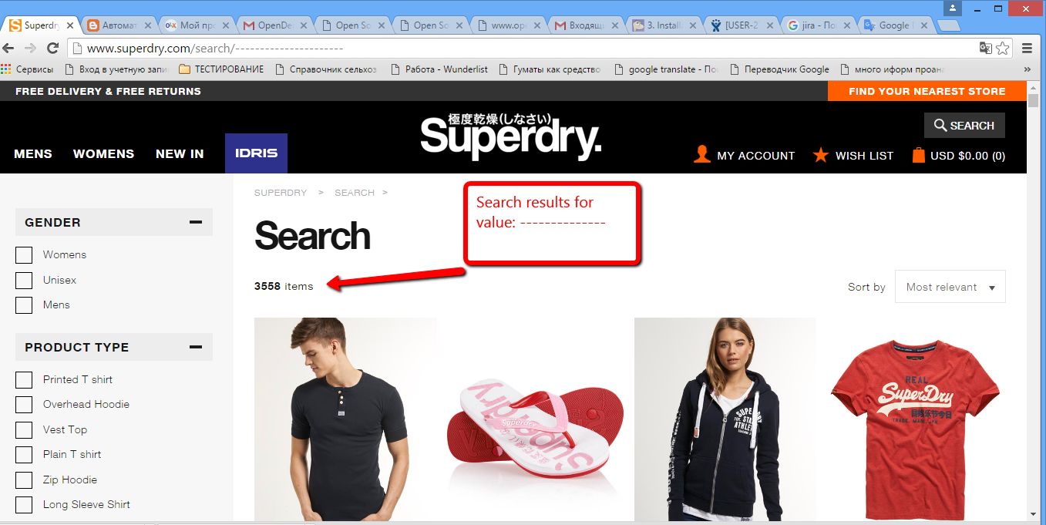
Expected Result | An application should not display results for such search criterium

