Bug report TC-F-4
Summary | HTML-errors were found in application
Project | http://www.superdry.com/
Component | Application
Version | 1.01
Severity:  - S1 (Blocker)  - S2 (Critical)  - S3 (Major)  - S4 (Minor)  - S5 (Trivial) | S4 (Minor)
Priority:  - P1 Высокий (High)  - P2 Средний (Medium)  - P3 Низкий (Low) | Manager fills
Status | NEEDS VERIFICATION
Reporter: | Taras Kolesnichenko
Assignee | Developer name
Description | 1. Start Nu Html Checker https://validator.w3.org/  2. Enter http://www.superdry.com/  3. Click "Check"
Actual Result | 4 HTML-errors were found  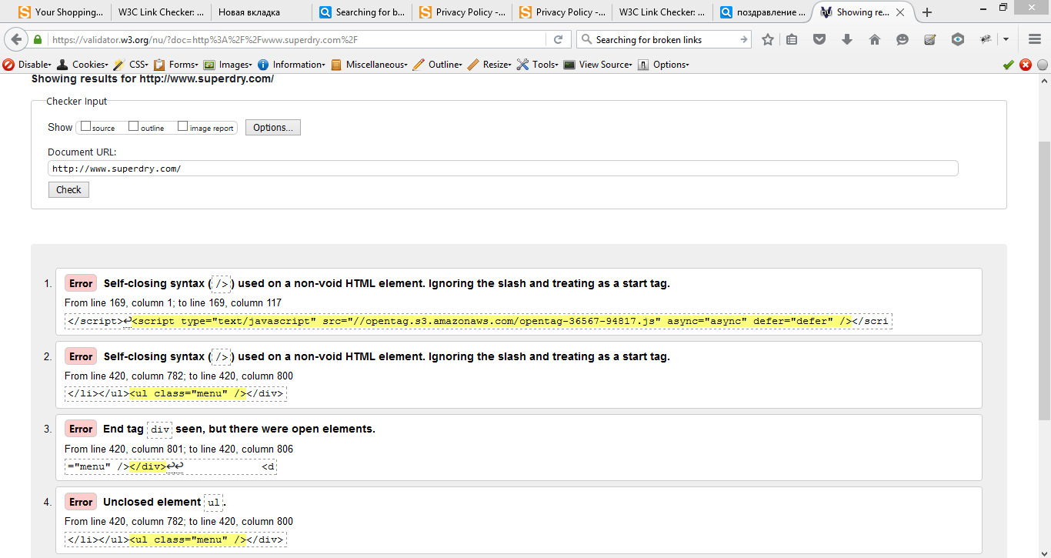
Expected Result | Nu Html Checker has to detect no errors

