**_________________________________________________________________**

**; ;**

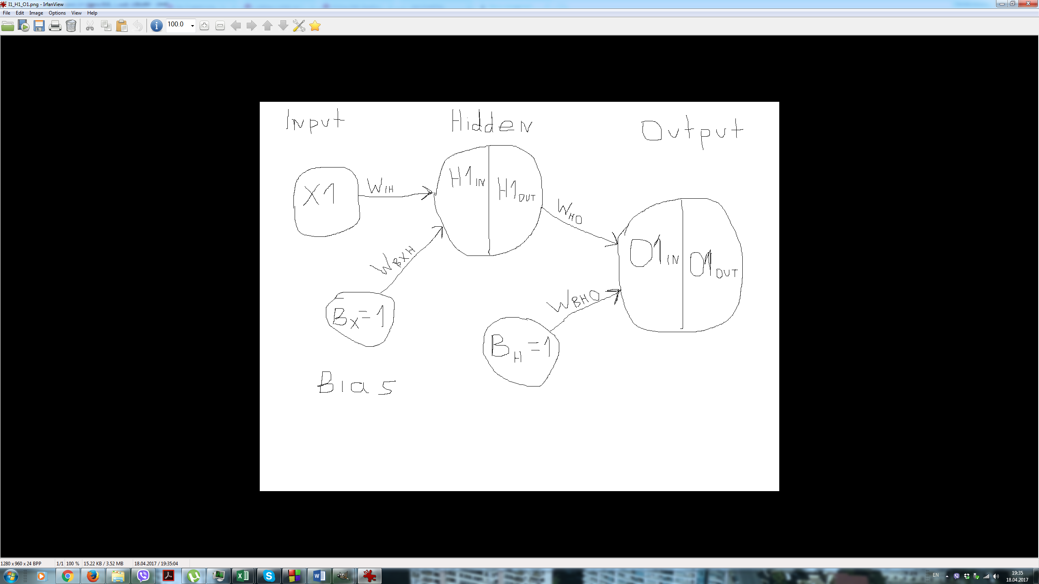

Forward Propagation:

= X1 + = X1 +

= () = (X1 + )

= + = +

= () = ( + ) =

=

Error E = =

where are the target values.

Gradient HO:

= =

= =

= =

=

=

=

=

=

= = =

=

=

Gradient IH:

= = =

=

=

=

= =

=

= =

= =

= =

=

=

= =

=

Now we calculate changes of the weights values as follows:

- LR

where LR = learning rate, M = momentum,

weight change from previous iteration (initially set to 0)

- LR

- LR

- LR

and obviously

**_________________________________________________________________**

**; ;**

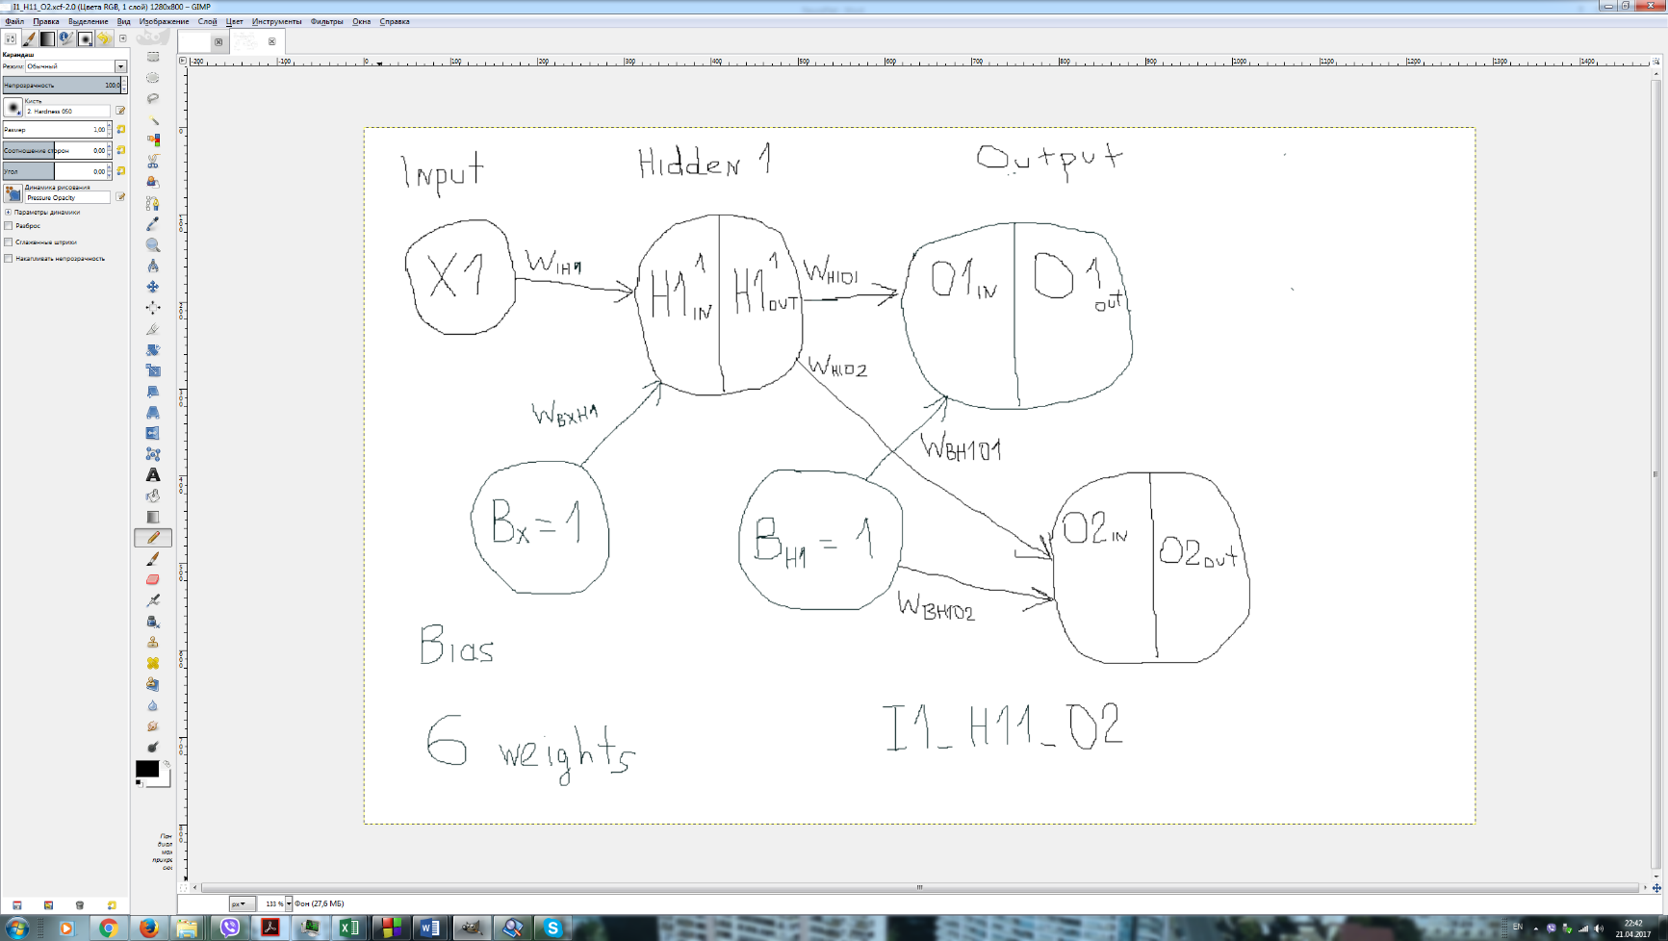

Forward Propagation:

= X1 + = X1 +

= () = (X1 + )

= + = +

= () = ( + ) =

= ( + ) =

= + = +

= () = ( + ) =

= ( + )

Error E = =

where are the target values.

Gradient H1O1:

=

= =

+

= =

=

=

=

=

=

**_________________________________________________________________**

**; ;**

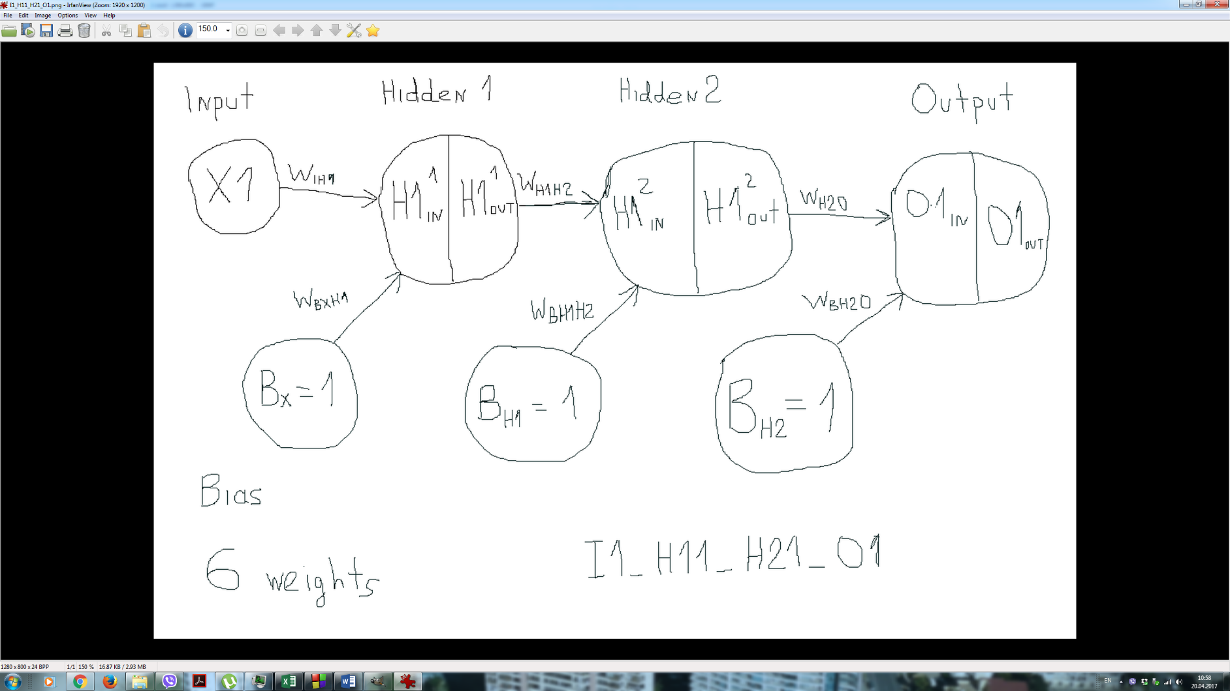

Forward Propagation:

= X1 + = X1 +

= () = (X1 + )

= + =

+

= () =

= + =

+

= () = ( + ) =

=

Error E = =

where are the target values.

Gradient H2O:

= = =

= =

=

=

=

=

= = =

=

Gradient H1H2:

=

= =

= =

=

=

=

= =

= =

=

= =

=

=

=

=

=

=

=

= =

Gradient IH1:

=

= =

= =

=

=

=

=

= =

= =

=

( =

=

=

=

= =

=

=

=

=

=

=

= =

=

=

=

Now we calculate changes of the weights values as follows:

- LR

- LR

- LR

- LR

- LR

- LR

and obviously

**_________________________________________________________________**