**Software Requirements Specification (SRS)**

**for**

**Printer Cartridge Inventory System**

CSC 214 - 401 | Delaware Technical Community College

**Version: 1.1**

**Prepared by:**

**TEAM 4**Eric Arnold

Matthew Chandler

Tara Mckaskle

Sean Roberts

**04 December 2018**

# **1 Table of Contents**

**1 Table of Contents** **1**

**2 Problem Statement** **3**

**3 Overview** **3**

3.1 Background 3

3.2 Overall Description 4

**4 Input Requirements** **4**

4.1 Printers.xlsx file 4

4.1.1 Barcode 4

4.1.2 Printer Description 4

4.1.3 Category Name 5

4.1.4 Location Name 5

4.1.5 Serial Number 5

4.1.6 Manufacturer Name 5

4.1.7 Division 5

4.1.8 Department 5

4.1.9 Campus 5

4.1.10 Active Status 6

4.2 Toner Database.xlsx Files 6

4.2.1 Printer Model 6

4.2.2 Brand 6

4.2.3 Model Number 6

4.2.4 Printers 6

4.2.5 Minimum Stock 7

4.2.6 Current Stock 7

4.2.7 Order More 7

4.2.8 Amount Needed 7

4.3 User Inputted Asset Tag Number 7

4.4 PrinterCartridge.csv file 8

4.5 User Inputted Room Number 8

**5 Process Requirements** **8**

5.1 Spreadsheet Access 9

5.2 Invalid Input 9

5.3 User Console Access 9

5.4 User-Created Data 9

**6 Output Requirements** **10**

6.1 Current Available Stock 10

6.2 JSON Output File 11

**7 Use Cases** **11**

7.1 Use Case: Technician Enters an Asset Tag 11

7.2 Use Case: Technician Enters a Comment 12

# 

# **2 Problem Statement**

The college spends roughly $4000 bi-weekly per campus on printer toner. A system work order process is in place for requesting a technician which is currently used for emergencies, but most of the requests are for changing printer toner. The instructors are forced to wait until the technician goes and checks the stock physically and the issue arises when there are none left in stock.

# **3 Overview**

## **3.1 Background**

The current process has a technician physically inspecting toner inventory stock weekly and then manually inputting into a spreadsheet to update the current stock. The technician emails the required minimum toner needed to replenish stock inventory. When a technician is requested for service they go to the site, and manually verify that they have the appropriate printer cartridge in stock. During this time, they are to return to customer service to verify stock which causes down time for students, instructors, and faculty members.

## **3.2 Overall Description**

The Printer Cartridge Inventory System will be providing a more efficient process for toner inventory management between Wilmington and Stanton campuses. This would maintain accountability and alleviate the wait time during inventory checks. This will also notify the technician when stock reaches minimum threshold and an order needs to be made. It will also allow commenting, by the user, for specific rooms.

# **4 Input Requirements**

## **4.1 Printers.xlsx file**

The software will require an .xlsx file of the printers used by Del Tech that will be used to create printer objects in the program. The Printers.xlsx file will contain the following data.

### **4.1.1 Barcode**

The barcode is the number found on the asset tag of each printer, and is used to identify each individual printer.

### **4.1.2 Printer Description**

The model of each printer, used to determine the required cartridges for each specific type of printer.

### **4.1.3 Category Name**

The type of printer such as ink printer or laser printer.

### **4.1.4 Location Name**

The location of the printer. Comments are tied to the location.

### **4.1.5 Serial Number**

The serial number for each printer, used as a secondary identifier for each printer.

### **4.1.6 Manufacturer Name**

The manufacturer of the printer.

### **4.1.7 Division**

The division of Del Tech the printer is located in, such as public safety or student affairs.

### **4.1.8 Department**

The department in Del Tech where the printer is located, such as nursing or marketing.

### **4.1.9 Campus**

The Del Tech campus the printer is located. The printers are split between Stanton campus and George campus.

### **4.1.10 Active Status**

Whether or not the printer is currently in use or if it is inactive.

## **4.2 Toner Database.xlsx Files**

The software will require two Toner Database.xlsx files, one for Stanton campus and one for George campus, to get a list of inventory for the toner available. The Toner Database.xlsx files will contain the following data

### **4.2.1 Printer Model**

The model of the printer the toner cartridge fits into.

### **4.2.2 Brand**

The brand the of the toner cartridge, such as Dell or Brother.

### **4.2.3 Model Number**

The model number of the printer.

### **4.2.4 Printers**

The number of printers of that type on campus.

### **4.2.5 Minimum Stock**

The minimum amount of stock in the inventory, of a specific type of toner, before being prompted to order more.

### **4.2.6 Current Stock**

The current stock of that type of toner currently in the inventory.

### **4.2.7 Order More**

A Boolean indicating whether or not more toner of that type is currently in need of being restocked.

### **4.2.8 Amount Needed**

The amount of that type of toner that needs to be ordered in order to get back to the minimum stock for that toner. Calculated as (Minimum Stock – Current Stock).

## **4.3 User Inputted Asset Tag Number**

The user will input a bar code found on the asset tag of each printer. This is used to find the specific printer to be evaluated.

## **4.4 PrinterCartridge.csv file**

The PrinterCartdridge.csv file will be used to link the printer with the cartridge type. It will contain the following data.

**4.4.1 Description**

The description contains a string corresponding to the model number of a specific printer make and model.

**4.4.2 Model**

The model contains the possible printer cartridge model that fit with a specific model of printer.

## **4.5 User Inputted Room Number**

In the event that the user wants to enter a comment, the user will be prompted to enter a room number to which the comment will be tied, such as W261, which will be saved as String.

# 

# **5 Process Requirements**

The following are requirements that the system must be able to handle.

## **5.1 Spreadsheet Access**

The system must be able to receive and process data from the inventory and PrinterCardridge spreadsheet, uploaded by the technician.

## **5.2 Invalid Input**

If the technician inputs an invalid barcode the program will notify the tech and prompt for re-entry.

## **5.3 User Console Access**

The system must have access to the user console in order to print relevant information. The console will also serve as a point from which users will be able to make comments tied to specific rooms. While the system will not be on a mobile device, as the costumer proposed, the user console created will fit the size of a smartphone.

## **5.4 User-Created Data**

The program will create a txt file, named after the inputted room number, in which it will store user comments tied to that specific room number. The comments will be marked by date and time.

# **6 Output Requirements**

## **6.1 Current Available Stock**

The technicians must be able to clearly see the current available stock of ink cartridges based on the printer the technician is searching for.

## **6.2 JSON Output File**

The program must output a .JSON file which contains current stock, the availability of the stock, and location information for later use by web applications.

# **7 Use Cases**

## **7.1 Use Case: Technician Enters an Asset Tag**

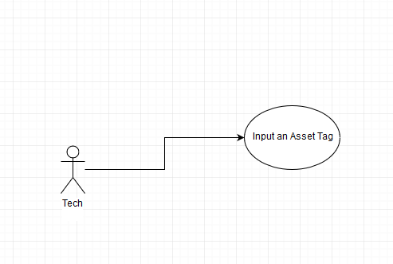

A Technician enters an asset tag for a printer upon being alerted that it is out of ink. The program then returns the cartridge type and amount in inventory. The technician is then allowed to leave a comment at the end of the program. The comment is then sent to a file tied to the specific room.

## 

## **7.2 Use Case: Technician Enters a Comment**

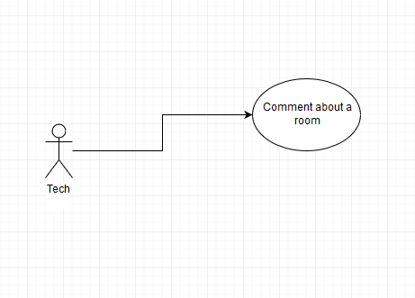

A tech enters a room number, and is then prompted to enter a comment. The comment is then sent to a file tied to the specific room.