**User Guide**

**for**

**Printer Cartridge Inventory System**

**Prepared by:**

**TEAM 4**Eric Arnold

Matthew Chandler

Tara Mckaskle

Sean Roberts

**29 November 2018**

# **Table of Contents**

**Table of Contents** **2**

Introduction 3

Getting Started 3

System Requirements 3

Using the Tab System 4

Looking up an Asset Tag 5

Adding a Comment 6

Clearing all Fields 7

## 

## **Introduction**

## The PCIS (Printer Cartridge Inventory System) allows you to easily search how much toner is available in inventory for any given printer, by inputting the barcode number for the printer you want to search. The PCIS also allows you to leave a comment which will be sent to a file associated with that room, by inputting a room number and a comment.

## **Getting Started**

## **System Requirements**

The PCIS requires JavaFX to use.

## 

## 

## 

## 

## 

## 

## 

## **Using the Tab System**

**Choose one of the following tabs from the application:**

Asset Tag Search for printer cartridge inventory

Comments Add comments associated to a room

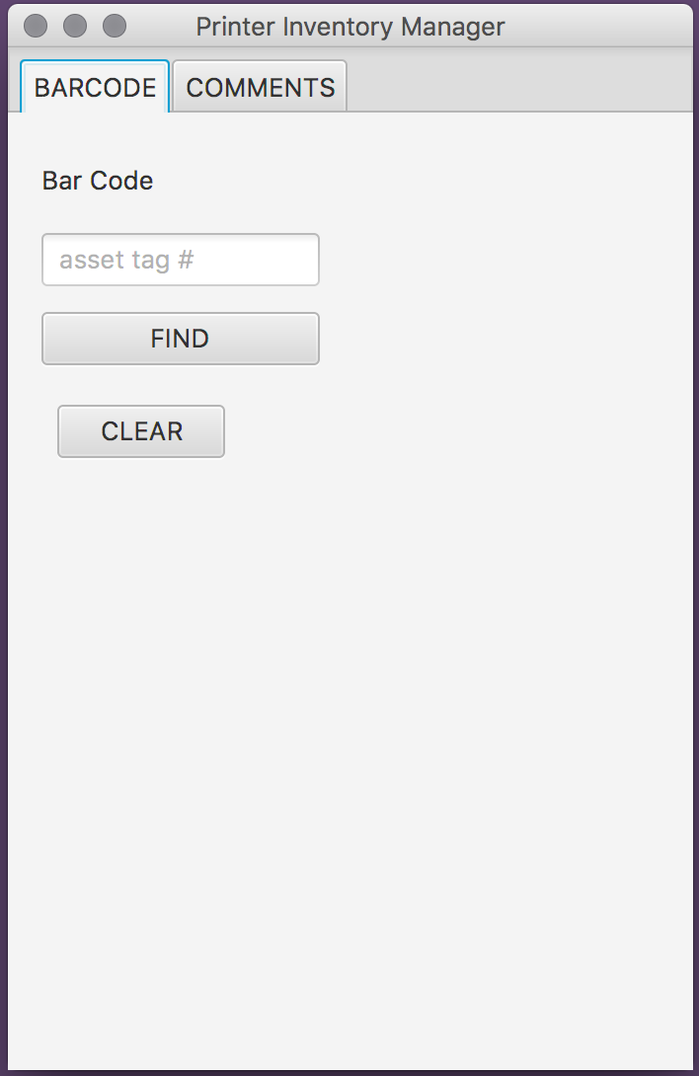 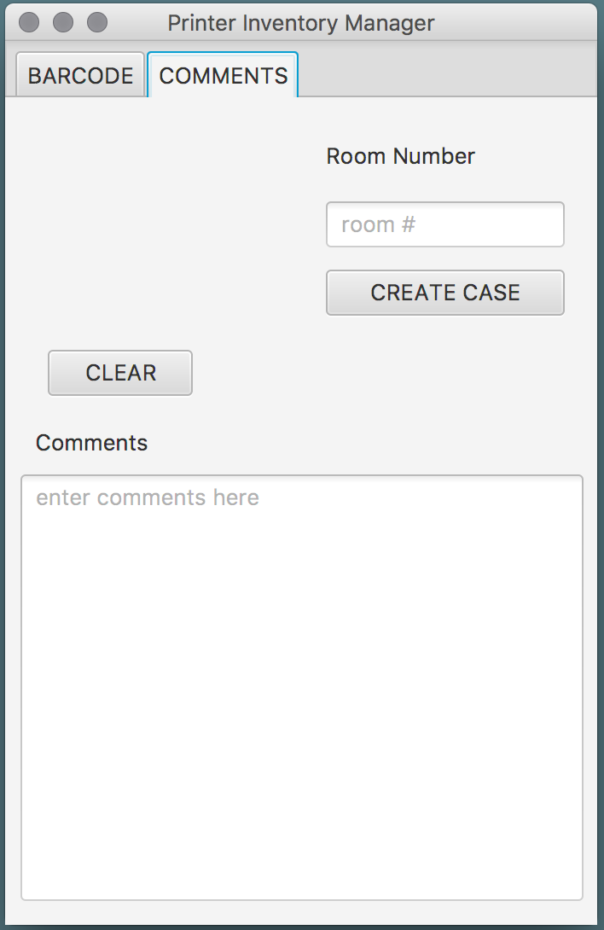

## **Looking up an Asset Tag**

To search for the current cartridge inventory for the printer,

enter the ASSET TAG into the “Barcode” text field and hit “FIND”.

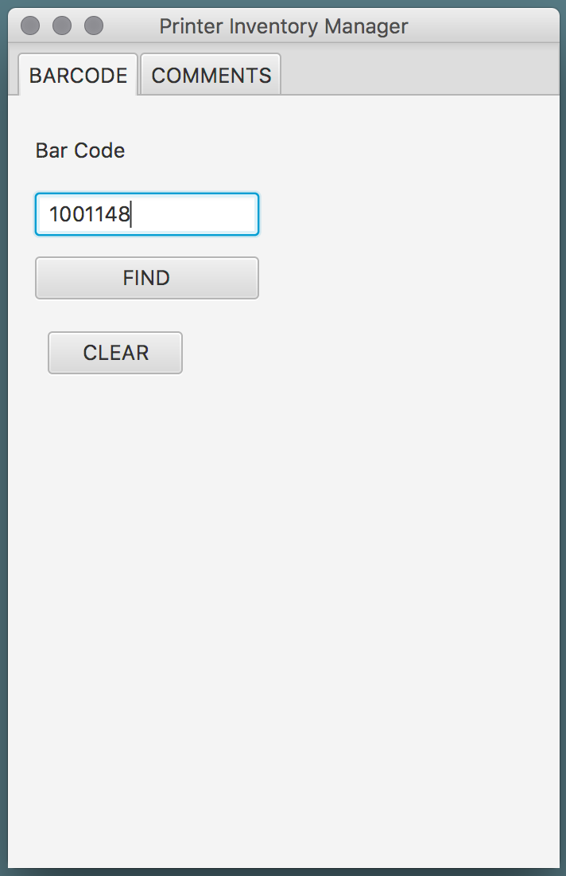

The program will show the current inventory of the printer’s cartridges. 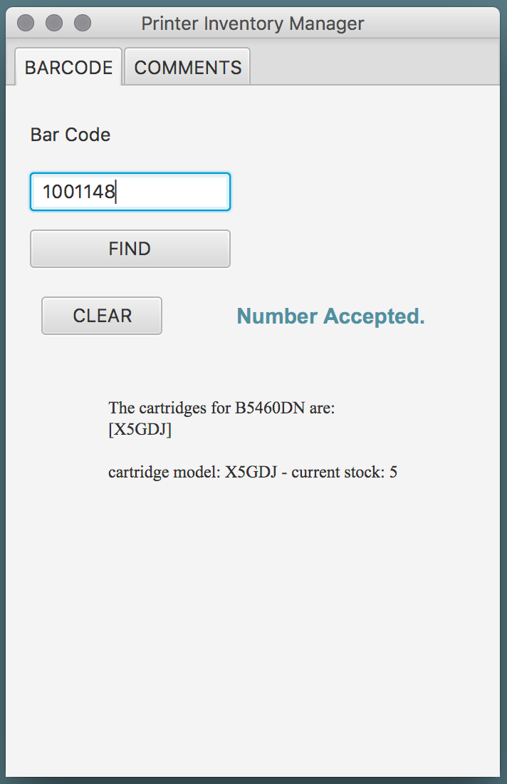

If the printer’s cartridges are not found in the inventory,   
this message will be displayed.

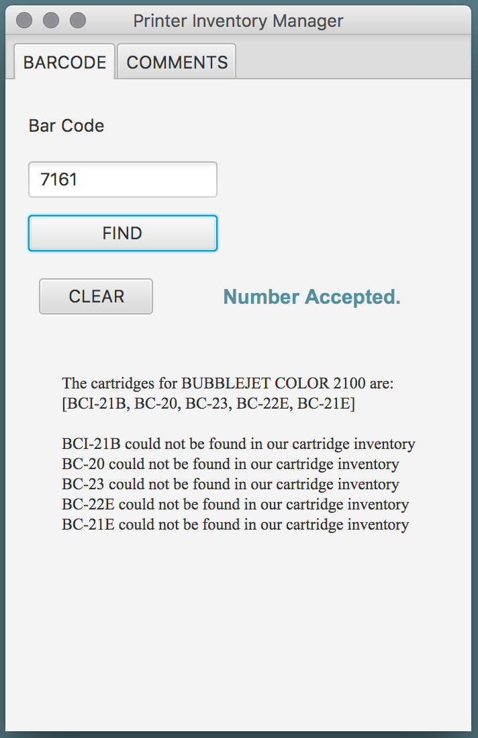

If an Asset Tag that is not valid, an error message will appear.  
  
  
 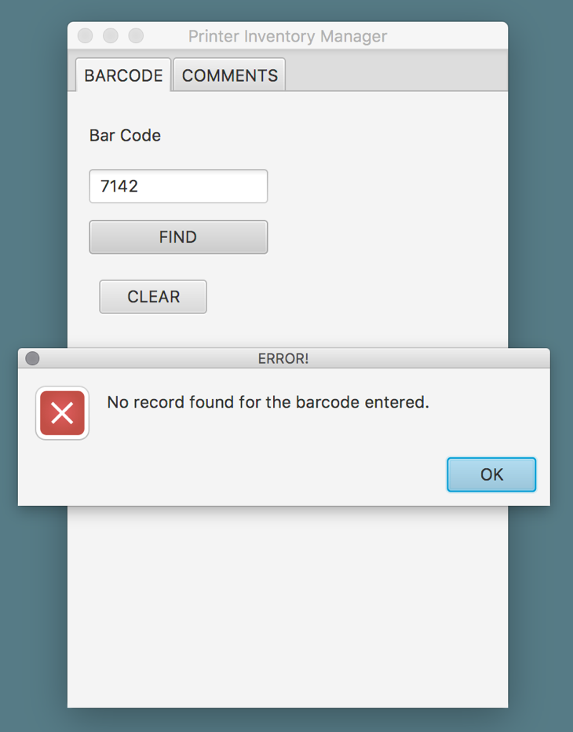

## **Adding a Comment**

To add comments, enter the room number into the ‘room number’ text field

and comments in the ‘comment’ text area then hit “CREATE CASE”.

NOTE: Both text fields must be filled.

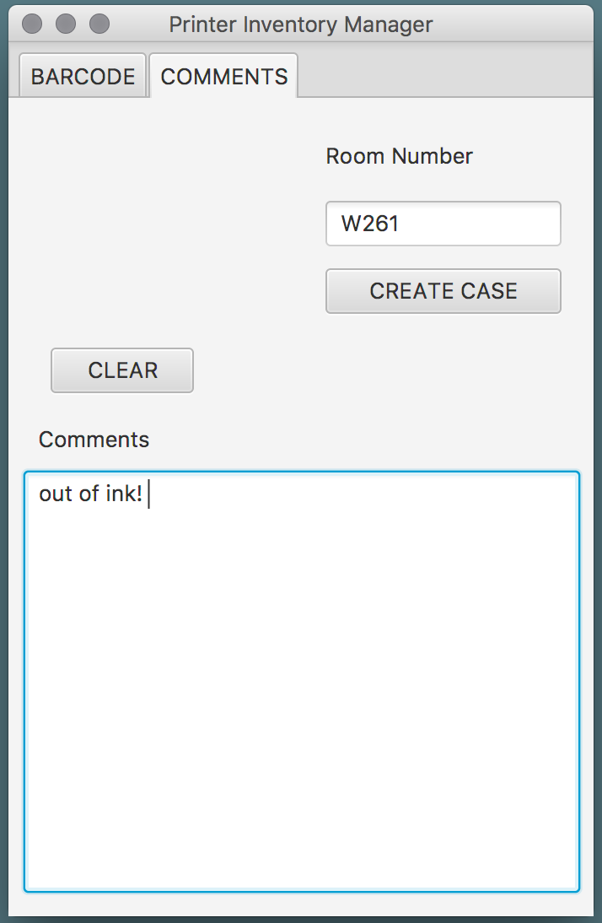

The comments will be saved under the room number entered,

and the content will be organized by date and time.

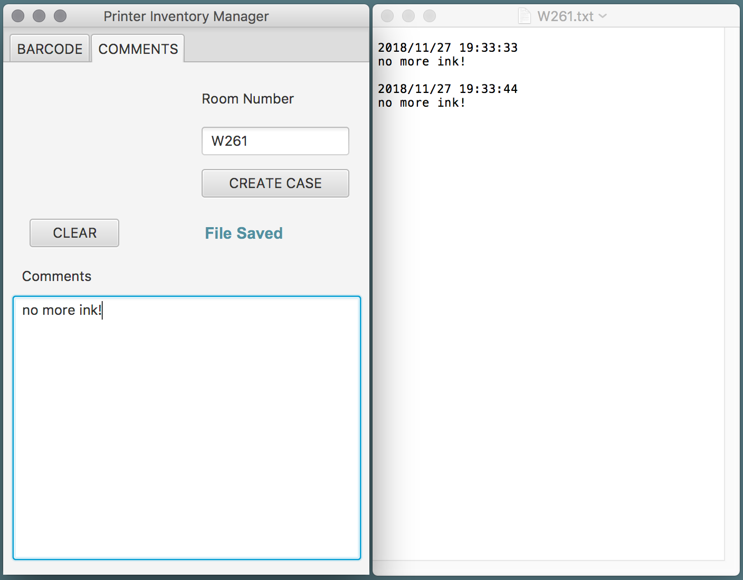

## **Clearing all Fields**

To clear all the text and prompts, hit “CLEAR”.

