# Introduction

Infectious diseases are one of the leading causes of mortality. Over the years, it has been repeatedly proven that one of the best strategies to protect against many diseases is an effective vaccination program. The primary challenge is not so much in obtaining the vaccines as it is in ensuring that the vaccines are shipped, stored, and delivered to the recipients at the end of the distribution chain in a cost-efficient fashion. During a pandemic, the distribution of millions of doses of vaccine becomes an essential process that needs to be developed to be efficient and scalable. With the advent of the Covid-19, it has become crucial for the companies to find an optimal route to minimize their cost of distributing the vaccines at various local centers. Considering these challenges, this project thus focuses and provides a solution on the optimized route for vaccine distribution at various local centers that will be beneficial not only to the vaccine manufacturers but also to the population worldwide.

The vaccines must be shipped in insulated containers and cold refrigerated trucks with temperatures maintained between 2 degrees to 8-degree Celsius and sometimes below zero degrees Celsius. Improper storage and transportation can put vaccine products at risk of degradation; hence, ensuring the product quality an effective vaccine supply chain and logistics system is essential. In terms of delivery, logistics plays a key role as they are relatively limited and straightforward, but it becomes very complicated when expanded to multiple sites. The cost associated with the transportation of vaccines to different geographical locations varies and is generally very high. The last mile delivery constitutes 41% of the total cost; hence it is crucial to use technology and develop a cost-effective distribution network for the last mile delivery from the regional centers to local clinics.

This project helps to understand the problem of route optimization for vaccine distribution. The discussion starts with describing the problem and then delves into the methodology used for solving the problem in terms of mathematical formulation.

The project majorly focuses on the Quebec region, where Montreal metropolitan area with approximately 4 million populations is the main regional distribution center. The problem is modeled as a variation of the traveling salesman problem where the distribution network is optimized to minimize the transportation cost. The area's population was considered to understand the demand and the number of vaccines that need to be supplied at each center.

The global vaccine market has grown from $49bn in 2018 to $59.2 bn in 2020, which is double the size of the 2014 market and is expected to grow and reach $104.87 billion by 2027. North America commanded the largest share of the global vaccines market in 2019, followed by Europe, Asia-Pacific, Latin America, and the Middle East & Africa (Figure 3 and 4 in Appendix). These statistics indicate that vaccination will remain one of the primary sources to save many lives on earth and bring the world closer to a return to normalcy.

Therefore, the vaccine distribution channel must be optimized to ensure less mortality rate worldwide and increase the revenue stream of vaccine manufacturers by minimizing their distribution cost.

# Problem description and formulation

In general, the vaccines are distributed via a four-tier hierarchical legacy medical network such as the one depicted in Figure 5 Typically, the vaccines are purchased in bulk and shipped in by air once or twice a year, then stored in a national distribution center in the capital (or another large city). Required vaccine volumes are transported every three months to regional distribution centers using a specialized vehicle such as a large cold truck. Each regional distribution center delivers vaccines to its surrounding district centers every month using 4x4 trucks with cold storage boxes. Finally, the vaccines are transported from district centers in a vaccine carrier/cooler using locally available means of transportation such as trucks, cars, motorbikes, bicycles, boats, or sometimes even by foot, to local clinics where infants, adults, children, and pregnant women come to receive vaccinations. This last step is typically a “pull” operation with monthly pickup by the clinic. A characteristic of vaccines is that they must be stored/transported while maintaining appropriate temperatures (2 degrees to 8 degrees Celsius), and some vaccines are required to be refrigerated at a temperature of below zero degree Celsius such as Covid-19 vaccines, according to World Health Organization (WHO); therefore, this vaccine distribution chain is often referred to as being a cold chain.

In this project, we have focused on the vaccine distribution channel in Quebec, where we have considered Montreal as the main regional distribution center since it has the highest population of approximately 4 million in the province. Since the middle stage of distribution carries its own set of challenges, including the need to book enough trucks and planes, we have considered that the vaccines are already at the regional distribution center, Montreal. The refrigerated truck starts from this center carrying vaccines, which need to be supplied to 10 other major cities in Quebec.

This capacitated truck first goes to the first local center and offload vaccines for 10% of the population there. It then moves to second Local Center, where it offloads vaccines for another 10% of the city population. Once the truck is empty that is all the vaccine has been offloaded, the truck finally comes back to the main regional hub for refill. The same process is repeated for other local centers.

Decision Variables:

|  |  |
| --- | --- |
| $$x_{i,j}= \left\{\begin{aligned}1 \\ 0\end{aligned}\right.$$ | (1) |

Where $x_{i,j}$ = 1, then route from city $i$ to $j$ is selected, $x_{i,j}$ = 0, otherwise

The decision variables in the vaccine distribution model in equation (1) are given by $x_{i,j}$ which represents the optimal routes that satisfy population demand and vehicle capacity requirements. The variables $x_{i,j}$ are binary variables and if $x_{i,j}=1$ then a route from city $i$ to city $j$ will be selected, otherwise if $x_{i,j}=0$ the route will not be selected. Since we are only considering ten cities in Quebec, there are 110 possible routes for the truck

Objective function:   
The objective function for a vaccine distribution model is to minimize the cost which varies based on weight and fuel consumption attributes; it can be described as follows:

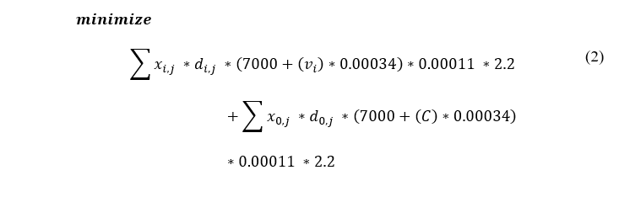In equation (2), $d_{i,j}$ represents the Euclidean distance from city $i$ to city $j$ based on location coordinates. The variable $v_{i}$ is the amount of vaccine left on the truck for a particular route, C is the truck capacity and for the purposes of this project it is assumed the truck can carry 80,000 units of vaccine at a time.

Non-linearity occurs in this model when decision variable $x_{i,j}$ is multiplied with variable $v_{i}$. Based on research, a typical empty truck weighs approximately 7000 kilograms, weight of one vaccine unit is 0.00034 in kilograms. The average fuel consumption for a truck is equal to 0.00011 ($\frac{L}{km/kg}$) and the cost per liter is equal to 2.2 $\frac{\$}{L}$. In this model $q_{i}$ represents the demand for a city ‘i’, in order to make the model more realistic only 10% of the population will receive a vaccine.

### Constraints

The model is subject to the following constraints:

|  |  |
| --- | --- |
| $$\sum_{i}{x_{i,j}=1}, for i ≠j$$ | (3) |
| $$\sum_{j}{x_{i,j}=1}, for j ≠i$$ | (4) |
| If $x_{i,j}=1$, then $v_{i}-q_{j}= v_{j}$ | (5) |
| $$0≤ v_{i} ≤C -q_{i}$$ | (6) |

Constraint in equation (3) ensures that the truck leaves city $i$ only one time.

Constraint in equation (4) ensures the truck enters city $i$ only one time.

Using constraint (5) we ensures that the demand of city $i$ is subtracted from number of vaccines left in truck for that route, if that route is selected.

Constraint in equation (6) eensures that the demand and the vehicle capacity requirements are met.

# Numerical implementation and results:

### Data

For this problem, the first step has been to gather demographic data about the province of Quebec, in order to determine the cities to deliver as well as their population and geographical coordinates. We ended up with an excel file containing 11 city names, population, geographical coordinates, and distance to the origin, which is Montreal. These distances ended up being unused as we decided to compute the distances to the origin using the geographical coordinates of the hospitals for precision purposes.

The numerical implementation of this problem has been very concise in terms of code but very challenging and demanding in terms of modeling and preliminary thinking. The main challenge has been to make the cost of going from the city $i$ to city $j$ dynamic, in a sense where it does not only depend on the distance between those cities but also on the quantity of the vaccines left in the truck during that trip, as that quantity will add weight to the truck and therefore influence the fuel consumption.

To overcome this problem, we introduced a new set of decision variables $v_{i}$, which will represent the number of vaccines left in the truck when it leaves city $i$. This will allow us to keep track of the number of vaccines dropped in the various cities visited since the last time the truck has been in the depot. This new set of variables also allows us to make sure there is no more vaccines in the truck than it can carry.

### Structuring the problem

After extracting the data from the excel file using the pandas library; we declare our data structures that will allow us to iterate over our variables later. N will contain the indices of every city we need to visit, V those same indices with the 0 added, which is the distribution center in Montreal, and A will be the cross product VxV and will represent the routes from a city to another, with the routes from a city to itself excluded.

Afterward, we declare our capacity equal to 80,000 and the demand equal to 10% of the population, as well as the distances between the cities using the function ‘hypot’ from the ‘numpy’ package and inputting the latitude and longitude of the hospitals in the parameters.

### Modelling

Our first decision variable is x, which is of size 110, and where $x_{i,j}=1$ means, we will take the route from city $i$ to city $j$. Therefore, the type is binary.

Our second decision variable is v, which is of size ten, and where the index I=k means that the truck will be carrying k vaccines the moment, it leaves city I+1.

In this problem, Montreal was selected to be the place of origin. The distribution center in Montreal will supply ten other major cities in Quebec. The data points, including city name, drop-off location, population, and distance to Montreal, were obtained through Wikipedia and Google Maps and are listed in Table 1.

In this model, the drop-off centers were considered to be the general hospitals of the selected cities. The total population to be served is equal to 3,967,322 however since it was assumed only 10% of the population will take a vaccine the total demand is equal to 396,732. The distribution of the drop-off centers with respect to the Montreal General Hospital are displayed in Figure 1.

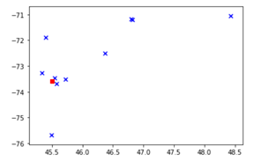

**Figure 1: Spatial representation of various local distribution center**.

According to the Figure 1, Saguenay is the furthest city from Montreal whereas Longueuil is the closest. The coordinates for the hospitals were also obtained to calculate the Euclidean distance between drop-off centers. The specifications for the chosen variables in this model including truck specifications, fuel consumption and cost per liter were obtained through research. The truck selected for this model has an empty weight of 7000kg, based on vaccine liquid volume plus syringe weight and box dimensions it was determined that the truck can carry 80,000 vaccine units at a time.

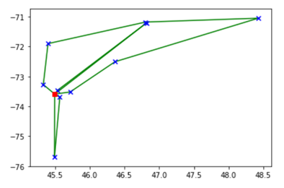

**Figure 1: Spatial representation of various local distribution center along with routes obtained.**

### Results

The vaccine distribution model is a non-linear problem and therefore Gurobi package was used on Python to optimize the model and obtain the following results:

The optimal minimal cost for distributing vaccines to ten cities in Quebec with one truck is equal to $3,150. For the given truck capacity, the truck must return to re-supply two times and therefore require three different journeys to satisfy demand requirement. The optimal routes for the truck are as follows:

* **Route 1**: Montreal > Laval > Gatineau >Montreal
* **Route 2**: Montreal > Longueuil > Quebec City > Montreal
* **Route 3**: Montreal > Saint-Jean-sur-Richelieu > Sherbrooke > Levi’s > Saguenay > Three Rivers > Terrebonne > Montreal

If the truck model was altered with new truck capacity equal to 150,000 vaccine units and empty truck weight equal to 8,845 kilograms, the new minimal cost decreases to $2,873. The truck now requires two journeys while re-supplying only once, the optimal routes are as follows:

* **Route 1** : Montreal > Longueuil > Laval > Gatineau > Montreal
* **Route 2**: Montreal > Terrebonne > Three Rivers > Saguenay > Quebec City > Levi's > Sherbrooke > Saint-Jean-sur-Richelieu > Montreal

# Problem extensions:

The solution to the optimal model is feasible however it can be more realistic if we add the following constraint to the problem. The probable problem extension to vaccine distribution problem are as follows:

1. **Higher demands and multiple vehicles with different capacities–**Usually, there are different types of vaccines, some are produced within the country, and some bought from overseas. Moreover, different types of vehicles can be used to supply different vaccines to multiple local centers. The vehicle might differ in their carrying capacities; for example, one big truck can be used if the supply quantity is high. Furthermore, in this project, we have considered that one local center's demand can be fulfilled by at least one vehicle; however, there are possibilities when the demand must be catered to using more than one vehicle. The problem then can be treated as VRP with split deliveries.
2. **Adding time constraints to the problem –** Rather than focusing on minimizing the cost during a Global pandemic, it might be a priority to minimize the total distribution time of vaccines. Moreover, some centers would have daily operational timings. Hence, in that case, keeping the constraint that ensures the delivery of the vaccine is within the local center's operational time would be crucial. Including the would be similar to vehicle routing problem with time windows.
3. **The problem for Low and Middle-income cities –**Sometimes, the distribution of these vaccines is a challenge in low and middle-income countries/cities. This is due to the lack of infrastructure in those places. This will add constraints for routes where a certain type of vehicle would not be feasible to move. For example, routes where there is no proper wide enough roads for a big vehicle, the vehicle has to take an alternative route to reach the destination. This also calls for the solution with multiple vehicles, for places that are inaccessible can be tapped using smaller vehicles.
4. **Combine the mid-level and last-mile distribution**- The problem's complexity level can be increased as the number of cities and trucks increases. Another extension of the problem could be including distributing the vaccine from the national center to the regional center and further achieving the last mile delivery. In that scenario, the clustering algorithms can be used to group cities in the same region and optimize each cluster's model to from routes.
5. **Others/Unforeseen Conditions –** Various other factors may hamper the pre-planned distribution efforts. There are few constraints which could be considered to extend the scope of the problem, for example, factors such as traffic problems, weather conditions, variable demands of the local center. Instead of fixing the demand, only 10% of the population will take the vaccine; instead, regression analysis can be performed to predict demand based on historical pandemic data/daily demands. Application of the problem in other cities could also be a problem, as different countries have different rules that limit the vehicle carrying capacity. Therefore, adding the above constraints will lead to a more robust model that can distribute vaccine in different places across the globe.

# Recommendations and Conclusions

Global pandemics are a threat to public health and vaccines provide an efficient solution to control diseases. Optimizing the supply routes can reduce the overall cost for distributing vaccines. This project explored methodologies to creating models to optimize the non-linear vaccine distribution problem while subject to realistic constraints. For future purposes, the model can be scaled for the entire country population and to supply different types of goods.

In this project we have considered only some constraints to keep the scope of the project within limits due to time constraint. As future work, if we have more time to work on this project, we can incorporate additional constraints as mentioned in the problem extension to make the problem more realistic and have the model which could be applied to various geographical areas with higher complexity.

# **References**

* Larissa P.G. Petroianu, Zelda B. Zabinsky , Mariam Zameer , Yi Chu,Mamiza M. Muteia, Mauricio G.C. Resende , Aida L. Coelho, Jiarui Wei,Turam Purty, Abel Draiva and Alvaro Lopes, 2020. A light-touch routing optimization tool (RoOT) for vaccine and medical supply distribution in Mozambique
* BIOTECanada 2010, Building on the legacy of Vaccines in Canada: Value, Opportunities, and Challenges
* Yuwen Yang, Hoda Bidkhori, Jayant Rajgopal, Optimizing vaccine distribution networks in low and middle-income countries. Department of Industrial Engineering, Univerisity of Pittsburgh
* Zahra Azadi, Harsha Gangammanavar, Sandra Eksioglu, Industrial Engineering Department of Clemson University. Stochastic Optimization of Vaccine Vial Replenishment
* Kavita GUPTA, Department of Mathematics, Kirori Mal College, University of Delhi, 2016. Inventory and transportation cost minimization in the delivery logistics of Swine Flu Vaccine
* S.H. Jacobson et al. (1999). An integer programming model for vaccine procurement and delivery for childhood immunization: a pilot study

# Appendix

|  |  |  |  |
| --- | --- | --- | --- |
| City | Hospital Names | Population | Distance to origin(km) |
| Montreal | Montréal General Hospital | 1,704,694 | 0 |
| Quebec | Hôtel-Dieu de Québec | 531,902 | 256 |
| Laval | City of Health Hospital | 422,993 | 25 |
| Gatineau | Hôpital de Gatineau | 276,245 | 194 |
| Longueuil | Hôpital Pierre Boucher | 239,700 | 17 |
| Sherbrooke | Hotel-Dieu De Sherbrooke | 161,323 | 157 |
| Saguenay | Hôpital De Chicoutimi | 145,949 | 461 |
| Levi's | Hotel Dieu Hospital of Lévis | 143,414 | 257 |
| Three Rivers | Centre Cloutier-du Rivage | 134,413 | 153 |
| Terrebonne | Pierre-Le Gardeur Hospital | 111,575 | 39 |
| Saint-Jean-sur-Richelieu | Hôpital du Haut-Richelieu | 95,114 | 37 |

**Table 1:** Local center/Clinics in different towns/cities in Quebec along with population and distance from Montreal.

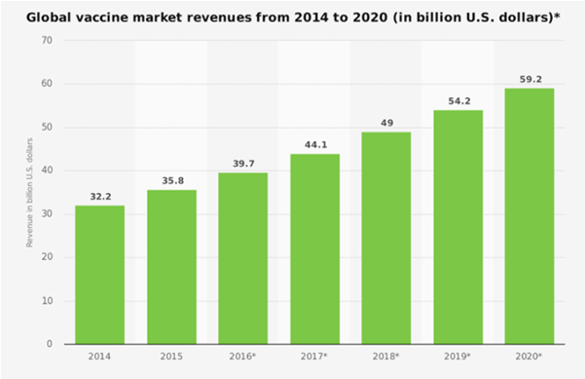

**Figure 3:** Global Vaccine Market Revenues (Source: Zion Market Research, Statista)

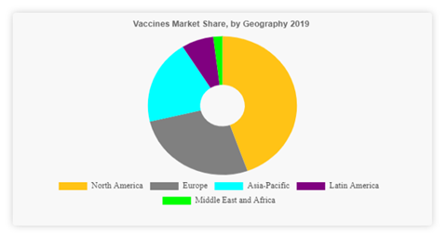

**Figure 4:** Vaccine Market Share by Geography 2019 (Source: [www.meticulous](http://www.meticulous)research.com)

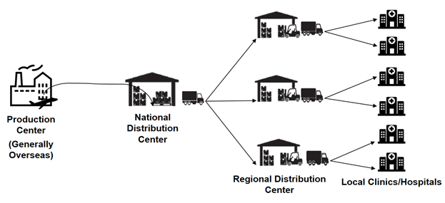

**Figure 5 :** Four Tier vaccine distribution channel

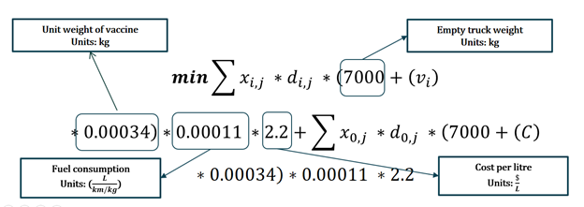

**Figure 6:** Objective Function with various component description