RF1000 Measuring Distance Mould
General Instruction：
This RF1000 is a Impulse type laser measure distance mould.The principle is by using laser emission one single or a bunch of laser burst to the object and receive the echo which back from the object under diffuse reflection and calculate and deal with by the round trip time Then the result will be sent to other equpment via serial communication.
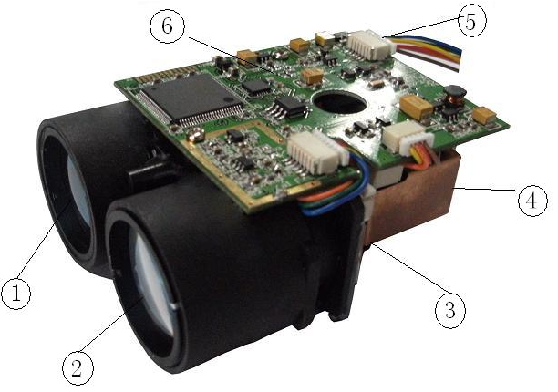
Digram:
1、Laser Emission Lens
2、Laser Receive Lens
3、Receive Electric Board
4、Emission Electric Board
5、Power and UART Connecter
6、Mother Board

Technology Parameters：
 |  | unit | Remark
Measuring Range | 5~1100 | m | When under bad reflective or some special object it will effect the distance and the accuracy a little
Accuracy | ±1 | m
Frequency | 0.5-3 | s | Normal ≤1s
Laser wavelength | 905 | nm
Wave Beam | 3.6 | mrad
Lens Diameter | 23 | mm
Input Voltage | 2.4-6 | V
Power Supply | Ext.power | －
Consumed Power | <500 | mW
Output Connector | UART | －
Working Temperature | -10～+50 | ℃
Weather Resistant | - | －
Size | 71x58x33 | mm
weight | <100 | g

Connecter Define:
Connecter | PIN Define | Line color | remark
Power (2.4-6V) | Power（V+） | Blue、Green
Power (2.4-6V) | Power（V-） | yellow、orange
Serial (UART) | Emission（TX） | red | UART port Voltage range: limited to 5V
Serial (UART) | Receive（RX） | brown | UART port Voltage range: limited to 5V

Operation Instruction:
1.1 The power is DC 3V, the Distance Mould worked in standby state when it powered on.
1.2 Once the Distance Mould received the command of measure distance, it worked in measure state, and the distance result transmited from UART interface. One command can only measure one time.

Communication Protocol：
Communication use interface of UART interface of 8051 MCU. Baud ratio is 9600bps. 8 bit data bits,1 start bit, and 1 stop bit. The data frame is as follows.
STX | parameter | data（2Bytes） |  | check
SBUF0 | SBUF1 | SBUF2 | SBUF3 | SBUF4
The data frame include: a star byte t(STX), a parameter byte, two data bytes, and a check byte..
STX: 02H start byte;
Parameter: 00H no use(reserved)
01H laser range finder measure instruction
10H laser range finder measured distance and the distance is effective
11H laser range finder can’t measure distance
Data: high byte before low byte
Check: the XOR of STX, parameter, and data. Check=SBUF0 XOR SBUF1 XOR SBUTF2 XOR SBUF3.

For example:
To send the instruction of measurement to the laser range finder, you need to send a data frame as follows.
02H, 01H, 00H, 00H, 03H
If the laser range finder measured the distance is 500M, so the laser range finder send back a data frame as follows:
02H, 10H, 01H, F4H, E7H
If the laser range finder can’t measure the distance, than it will send back a data frame as follows:
02H, 11H, 00H, 00H, 13H

