**A Novel Immediate Detection Method for Mild Traumatic Brain Injury (mTBI)**

### ECE4871 Senior Design Project

### ACE (Automatic Concussion Evaluation) Project Faculty Advisor, Dr. Jennifer Hasler

### Brian Sang, CmpE – [brian.sang@gatech.edu](mailto:brian.sang@gatech.edu) John Tarasidis, EE – [tarasidis@gatech.edu](mailto:tarasidis@gatech.edu) Jonathan Park, EE – [jpark832@gatech.edu](mailto:jpark832@gatech.edu) Joo Won Lee, CmpE – [jlee3368@gatech.edu](mailto:jlee3368@gatech.edu) Sean Kim, EE – [seankim307@gatech.edu](mailto:seankim307@gatech.edu)

Submitted November 13, 2020

**Table of Contents**

Executive Summary iii

1. Introduction 1
   1. Motivation 1
   2. Background 1
   3. Objective 2
2. Project Description and Goals 3
3. Technical Specification 5
4. Design Approach and Details 6
   1. Design Approach 6
   2. Preliminary Concept Selection and Justification 15
   3. Engineering Analyses and Experiment 17
   4. Codes and Standards 17
5. Project Demonstration 18
6. Schedule, Tasks, and Milestones 19
7. Marketing and Cost Analysis 20
   1. Marketing Analysis 20
   2. Cost Analysis 20
8. Current Status 22
9. Leadership Roles 22
10. References 23

Appendix A 26

Appendix B 27

Appendix C 28

# Executive Summary

Current detection methods of mild Traumatic Brain Injury (mTBI), like MACE 2, are slow, inaccurate, and qualitative. Despite these limitations, these qualitative examinations are the main methods employed in the military and high-contact sports, where brain injuries are pervasive. The team’s goal is to utilize the brain-sensing capability of an electroencephalogram (EEG) to detect instances of mTBI quickly and quantitatively with higher accuracy than current evaluations. mTBI detection accuracy could increase from 40-70% to ~86%. The prototype device will include non- invasive, dry EEG electrodes attached to the interior of a helmet. The signals will be amplified by an analog front end and digitized by an analog-to-digital convertor (ADC). An ARM (Advanced RISC Machine) Cortex-M chip will process the digital signal and determine if brain wave abnormalities constitute a brain injury. If the abnormalities reach a user-specific threshold, an LED will illuminate to signify the need for further assistance. The device will be powered by a coin cell battery and will conserve energy by only activating on a sufficiently high impact sensed by an accelerometer. The team expects a fully functional prototype to motivate more studies on the accuracy of quantitative sensing devices in the field. Increased early detection of mTBI will reduce the amount of potential mental health problems in the military and in high-contact sports. Specialized medical personnel will also not be needed to perform screening exams. Further work can involve more advanced methods, including machine learning algorithms, to determine the threshold between normal and abnormal brain activity more precisely. The development of the first device prototype will cost approximately $422.

#### Nomenclature

EEG – electroencephalogram

mTBI – mild Traumatic Brain Injury ACH – Advanced Combat Helmet

**A Novel Immediate Detection Method for Mild Traumatic Brain Injury (mTBI)**

# Introduction

A modified EEG implanted into a helmet will measure electrical activity in the brain and detect mTBI after a significant acceleration disturbance of the head. The team requests $1000 to fund a prototype of the EEG and helmet apparatus.

## Motivation

Blast-related mTBI is the most common injury sustained in recent wars, affecting 10.8% of soldiers [1]. Brain injuries are also common in high contact sports like football and hockey. Repeated mTBI has high association with PTSD, can lead to worse and longer concussion symptoms, and can also provoke CTE (Chronic Traumatic Encephalopathy) [2]. Many current tests exist that qualitatively determine if someone has a concussion; however, these tests are inaccurate and require medical personnel. There are no viable, current quantitative tests capable of immediately detecting concussions and need for further examination. This device meets the need for a quantitative screening device in these high-risk areas.

## Background

#### Current Concussion Tests

The current method of determining if someone has a concussion is a lengthy and inaccurate process. The process begins with a qualitative screening test such as a MACE 2 (Military Acute Concussion Evaluation 2) or BTBIS (Brief Traumatic Brain Injury Screen). These are both heavily used in the military and high contact sports, but these qualitative screening tests require personnel and miss between 30-60% of mTBI cases [3]. After the screening, affected individuals will undergo

neuroimaging, such as a CT scan or MRI scan, which require more personnel and are less available in the acute timeframe.

#### Electroencephalogram (EEG)

EEGs have been utilized as tools to determine if a person needs to go through further

screening if they have mTBI. Clinical EEGs have electrodes strapped invasively to patients to measure 86% of mTBI cases [4]. However, there are dry EEGs, which have electrodes capable of non- invasively reading brain waves through the patient's hair. The team’s device will mount a dry EEG inside the helmet frame to minimize the invasiveness of the sensors [5]. As a standalone unit, an EEG does not have the functionality to distinguish between normal and abnormal brain activity. Interfacing the EEG with an analog front-end integrated circuit and microcontroller will handle the data analysis necessary to compute the appropriate distinctions.

## Objective

The objective of this device is to quantitatively determine if a person wearing this device has sustained a concussion or mTBI after experiencing high acceleration force. Figure 1 shows how the device would function. The high impact sensor would act as a threshold to determine if there is significant acceleration to turn on the EEG and sense for a possible mTBI. The electrodes from the EEG would then read brain activity, passing signals to the analog front end where the signals are discretized. Frequency and power analysis of the discrete signals on a microcontroller will compare to baseline brain activity to detect abnormalities and recommend appropriate treatment.

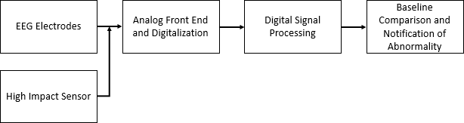

**Figure 1.** Proposed architecture for the modified EEG.

1. **Project Description, Customer Requirements, and Goals**

The goal of this product is to develop a helmet able to quantitatively detect a mild traumatic brain injury within a ten-minute window after the impact event occurs. The system consists of a physical helmet embedded with multiple dry EEG electrodes around the apparatus. The electrodes are connected to an analog front-end integrated circuit. Signals are routed from the analog front end through an ADC and to an ARM chip where the digital signal processing and analysis will occur. An Inertial Measurement Unit (IMU) will be mounted on the helmet to develop a low-power product that needs minimal charging. The IMU will be used to detect if a high impact event occurs to then trigger the processor and EEGs for data analysis of the impact on the user’s brain.

Table 1 is a stakeholder’s chart indicating those who are affected by the development of this product. Stakeholders are categorized based on varying levels of interest and authority in order to prioritize efforts effectively.

**Table 1.** Stakeholder Chart.

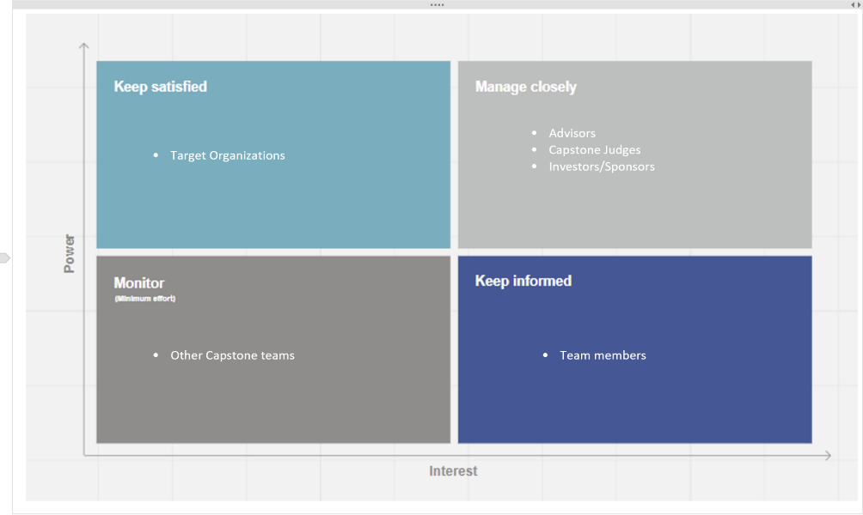

#### Customer Requirements

* *Price:* Cost of item must be below $2000
* *Convenience:* Product should not have to be charged more than once a week
* *Weight:* Product must weigh around the size of the average helmet of 4-6 lbs
* *Durability:* Item must be able to endure the average use of a helmet (includes drops, compressions, and contact hits)
* *Detection:* Must be able to correctly detect an mTBI with 75% accuracy
* *Response Time:* Must provide feedback within 10 minutes of the contact event
* *Order of Events:* Analysis should not be until after a large enough contact event occurs

#### Engineering Requirements/Functionality

* *Size:* The size of the product must match that of the average commercial helmet
* *Mechanical Design:* Components used must be able to handle high impact use cases as well as remain true to the desired form factor
* *Power Consumption:* Must be a low-power device that only turns on if an impact above a threshold is detected
* *EEG Accuracy:* Sensors must be able to provide sensitivity to cover the spatial mapping of the brain and detect shifts in the frequency spectrum
* *Computational Abilities:* Must be able to process the EEG sensory data followed by acquisition (includes bandwidth, response time and latency)

Figure 2 is a Quality Function Deployment chart used to determine critical links between the engineering and customer requirements previously listed. This provides insight to attributes that must be met in the design parameters.

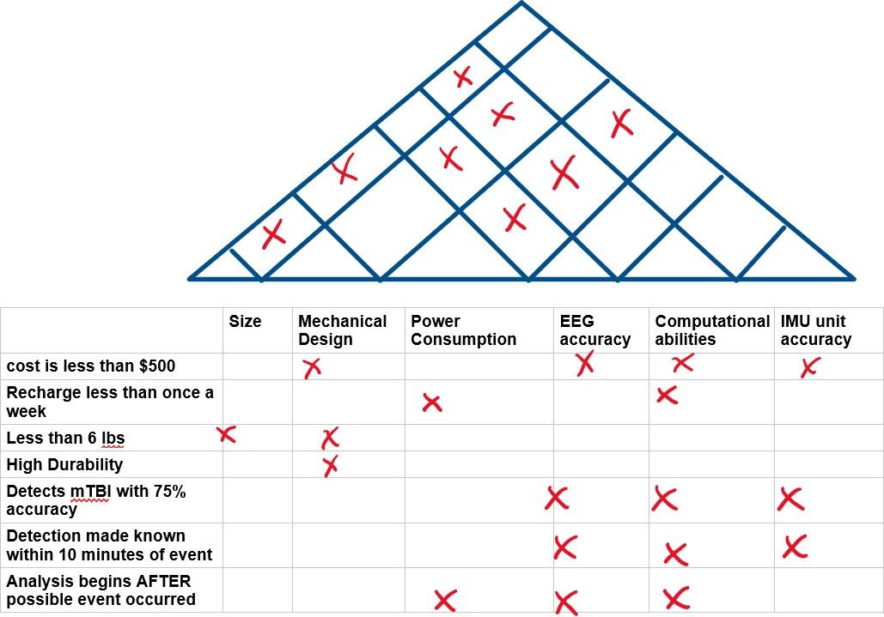

**Figure 2.** QFD Chart of Customer Needs and Engineering Requirements.

#### Constraints

* EEG constraints due to the American Clinical Neurophysiology Society guidelines
* Helmet standards by the Consumer Product Safety Commission (CPSC)
* Software may be limited to proprietary options such as MATLAB

1. **Technical Specifications**

A comprehensive table of specifications can be found in **Appendix A**. Important overall system requirements are at the bottom of the table in Appendix A and are also summarized in Table 2 below.

**Table 2.** Overall device specifications.

|  |  |
| --- | --- |
| **Feature** | **Specification** |
| Input Voltage Range | 1.8 to 5.0 V |
| Channels | 4 to 8 |
| PCB + battery size | 70 x 70 x 5 mm (W x L x H) |
| Normal operation battery life | 6-9 months |

# Design Approach and Details

* 1. **Design Concept Ideation, Constraints, Alternatives, and Tradeoffs**

In clinical use, an EEG typically involves a desktop amplifier and ADC, coupled with a PC via a serial communication protocol. The systems involve a high number of channels and are configurable to various applications. For example, an EEG used to detect seizures typically adopts the International 10-20 System for electrode placement, which uses 21 channels. For sleep studies, known as polysomnograms, around four to ten channels are used. These systems are modular and robust, capable of extremely low noise and compliant to the high bar of the FDA. The team’s focus on power saving and low profile are design considerations that are typically not considered in the design of an EEG device.

#### Base Functionality and Design Approach from a New Perspective

In an abstract sense, the device must be able to measure brain activity, compute the Fast Fourier Transform (FFT), extract data from that frequency representation, compare to a baseline, and decide on whether the acquired signal is abnormal or not. The task follows the simple architecture shown in Figure 3.

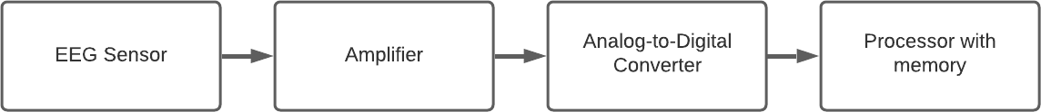

**Figure 3.** Simple Data Acquisition Scheme.

The implementation will mount all the hardware necessary to achieve this data acquisition inside a military helmet.

#### Military Helmets

Advanced Combat Helmets (ACH) are typically used by the U.S. Military for all deployed soldiers. They feature removable pads, which bodes well for the insertion of a thin profile device as shown in Figure 4.

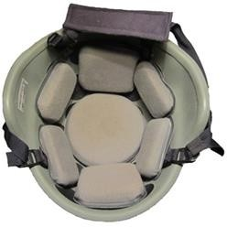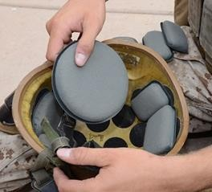

**Figure 4.** The inside view of an Advanced Combat Helmet.

Without a helmet or a detailed datasheet, values for physical size constraints are estimated that the pads are 2 cm thick. To ensure that the pads are not compromised, 5 mm is estimated as the maximum height required to house the PCB, components, and battery. A rigid PCB will be placed near the rear helmet pad because it appears to be the flattest region. This region is estimated to be an 8 cm by 8 cm square. By reducing a margin of 1 cm, the PCB, its components, and the battery must not exceed the volume of 70 mm x 70 mm x 5 mm (W x L x H).

#### EEG Electrode Type and Junction Compound

The number of electrodes is equal to the number of channels the system must support. Clinical EEGs typically feature wet electrodes, involving a dielectric gel at the electrode-scalp interface that provides a low impedance junction. Immediately, this type of electrode junction can be ruled out. The device once integrated into a helmet must require no setup to function.

The alternative is dry electrodes. This type of electrode creates a junction directly to the skin with no wet electrolyte involved. Market research shows that the best type for an EEG application involves the use of AgCl-tipped electrodes [6]. Depending on this junction compound, different DC offsets can be generated. Since EEGs are a DC system, these offsets are detrimental as they can saturate the amplifier. Another benefit of AgCl is its extremely low solubility in water. In this system, which may be exposed to sweat, this is particularly desirable.

In this project, the team will look at bipolar electrodes – that is where the potential difference is measured between a signal electrode and a reference electrode (placed somewhere constant on the body). Bipolar schemes require a differential input, and thus this is a requirement.

#### EEG Electrode Placement

The placement of EEG electrodes will affect the signal output as different regions of the brain respond differently to traumatic injury. In clinical use, the International 10-20 System is used to establish channels on most positions of interest in the brain. This system, shown in Figure 5, can analyze ‘focal slowing’ or ‘generalized slowing’ – typically in the care of those who suffer from seizures.

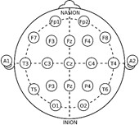

**Figure 5.** The International 10-20 System Electrode Placement.

If the user is unconscious for any amount of time, generalized slowing will be observed. If brain bruising occurs, focal slowing may be present in the injured region, but generalized slowing will not. For this project, only generalized slowing is investigated and analyzed.

While the International 10-20 System is the most comprehensive placement scheme, the mechanical constraints make it difficult to sustain a low-power, helmet-mounted, 20-channel system. Polysomnograms exemplify a more specific electrode localization. They inspect brain activity primarily at the occipital lobe, typically placing four to ten electrodes evenly around the crown region of the head. This is also where the rear helmet pad is located on the ACH. Several papers discuss the comparison of a single-channel EEG to a classical polysomnogram electrode layout, finding substantial agreement between the two methods based on Cohen’s kappa coefficient statistical analysis [7]. Based on these results, the team will implement between four and eight channels as shown in Figure 6.

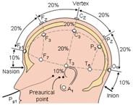

**Figure 6.** 10-20 Electrode Placement. Polysomnograms place around O and P.

#### The Analog Front-End

The analog front end will handle the amplification of the analog EEG data. To remove DC offset (~200mV for AgCl junctions) and drift introduced by the electrodes, the input signal to the analog front end will be AC coupled. EEG signals measured at the scalp typically have an amplitude of 100uV [8]. Frequencies of interest reside in 1-20 Hz, but rising edges are somewhat fast – leading the bandwidth of interest to be about 1 Hz to 50 Hz [8]. To capture these frequencies, the team will use an amplifier with minimum bandwidth of 1 kHz. EEG signals are small, and an injection of a few uV in the input can mask the real signal. The strongest signals can peak at 100 uV, but smaller ones exist and need to be analyzed. At this time, the team is considering amplifiers with an input referred noise of less than 5 uV.

In clinical applications, the PSRR (Power Supply Rejection Ratio) and CMRR (Common-Mode Rejection Ratio) are important factors in amplification, particularly when mains voltage can inject noise at 60Hz. Literature shows that a lot of care is taken in creating a 60Hz notch filter without infringing on the 1-50Hz bandwidth of interest [8]. For a battery-powered application, PSRR is not as critical. The team will likely use a switch-mode power supply, but these typically switch in the 100s of kHz range, far from our band of interest.

#### Digitization

Due to the low frequency nature of the signals of interest, digitization requirements are relaxed.

The max frequency in our band of interest is 50Hz, so an absolute minimum Nyquist rate must be 100Hz. In a high gain situation, a simply integrated microcontroller ADC with 10- or 12-bit resolution will suffice. Alternatively, if a lower gain is found to be desirable, perhaps a 20- or 24-bit resolution.

#### The Digital Core and Mass Memory

The digital core will handle all signal processing and notifications of abnormality. It must be able to communicate with the ADC, so typical serial communication peripherals are a must. For flexibility, we look to typical low-cost microcontrollers that commonly have a variety of peripherals. Since the exact protocol is not known, the team will filter by those that feature SPI, I2C, and UART.

Due to the physical space constraints and concerns about battery drain capability, the team is considering a low power ARM Cortex-M series chip. The chip will handle the digital signal processing of the EEG digital data. Before the analysis, the digital data from the ADC must be stored. Assuming substantiation of eight channels that acquire byte-sized data at a sample rate of 1 kHz, 2.4 MB of data will be collected over a five-minute span. This is above typical values for the internal flash of conventional microcontrollers, so external solutions must be explored. The team has aligned on a microSD card for extra storage, which will also allow transportation of data to an external PC for deeper data analysis.

#### Batteries and the Decision for an Event Based Trigger

Clinical battery powered EEGs, typically used for research, run on AA batteries without longevity in consideration. Within the volume constraints of the ACH, a larger battery is not an option. Button cells, found in watches, calculators, and remotes, have a lower capacity than AA batteries and a much smaller form factor. Power management advancements in chips, FPAAs (Field- Programmable Analog Array), and MEMs (Microelectromechanical systems) sensors make a button- cell-powered device feasible for a wearable EEG. The battery must be able to drain at least 20 mA according to rough estimates . For the field application of this device to be viable, the 100-500 mAh capacity of the button cell must be stretched by implementing a sleep/idle mode. These features already exist in most devices, with excellent single digit uA ratings.

#### Accelerometer for Event Based Trigger

The accelerometer triggers the system to wake up and record following a high impact event. During sleep mode, the system optimizes for low power by disabling the analog front-end and ADC. The digital core also enters a mode where it can only be brought back from an external event. All components will be in an idle state except the accelerometer, which will trigger the wake-up event by a pin interrupt to the microcontroller. Studies conclude that there is a chance of concussion at around 90 g’s of force [9]. An absolute minimum rating for the accelerometer of 100 g’s is selected in our criteria. The sensor will be programmed to trigger the wake-up event on g values above a threshold of around 60 or 80 g’s. Figure 7 below outlines the hardware components that will be placed on the PCB. The arrows show the flow of power and signals.

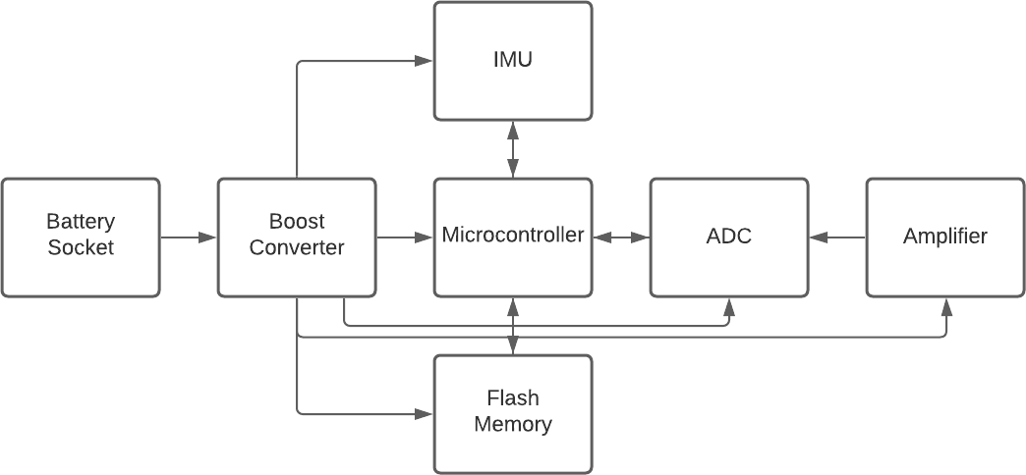

**Figure 7.** Block diagram of components on PCB

#### Firmware

Firmware on the microcontroller will handle memory transfers between the ADC and the flash memory and analyze the signal data. There are three main modes of operation: (1) a learning mode, (2) a sleep mode, and (3) an analysis mode. In the learning mode, the device continuously reads EEG data to determine the baseline brain activity specific to the user. The device will then enter a low-power sleep mode, only to be awakened by a significant disturbance as discussed in 4.1.9. If an impact is detected, the analysis mode will acquire data for five minutes, compute the FFT of the data, and search for peaks in that subset demonstrated in Figure 8. The detected peaks will constitute the primary frequencies of the brain activity measured. The sum of the frequency component values will be calculated, generating the power of the acquired data. These peak values and the power level will be compared to the baseline. If they reside outside of the predetermined safe region, an LED will turn on to note the presence an abnormality.

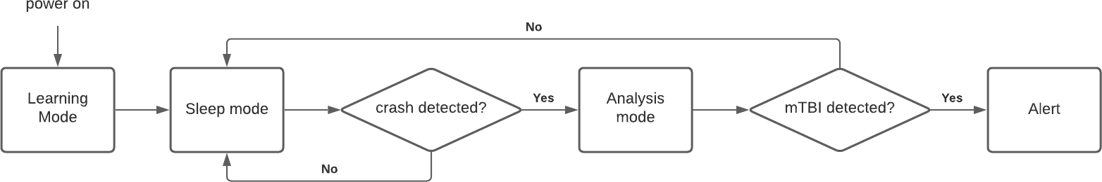

**Figure 8.** Flow diagram of firmware operation.

#### Constraints

The device is primarily constrained by power and space, which primarily constrains the acquisition and processing power of the device. With more space and power, the device could adopt the International 10-20 System, permitting the more detailed analysis of local changes. This will generally improve sensitivity to mTBI. Since this is exceedingly challenging, though, a fine balance must be found to support a desirable screen sensitivity.

In terms of processing power, this too is ultimately constrained by power. A longer acquisition time means a higher resolution FFT, but also a longer time in analysis mode – dramatically reducing battery life.

#### Alternatives

Rather than operating purely off battery power, the device could make use of solar power as well.

This would remove the need for the end user to replace the device’s battery as the solar cell’s ability to source current would exceed that of what the idling system is consuming. This could allow for more featured system with more relaxed power requirements. Another consideration would be the use of Bluetooth to transfer the EEG data to a separate computer for analysis. This could remove the need for a microSD card for on-board data storage, as well as offload the data processing to a faster and more powerful computer. One drawback of the Bluetooth approach would be the extra power cost of maintaining a Bluetooth connection, which would hinder the team’s goal of an ultra-low power device.

#### Tradeoffs

##### *Dry EEG Electrode Count and Cost*

One significant tradeoff to consider is the number of dry EEG Electrodes and the total cost. As the number of sensors increases, the spatial locality and accuracy of detection likewise increase. A clinical model of a device detecting brain activity using Dry EEGs has 21 leads; this allows the device to sense accurately, but at a prohibitively high cost. If the number of sensor pads is too low, however, the device will be unable to acquire significant data. Since the device will be used for detection rather than diagnosis of mTBI, the number of electrodes will be in the range of four to eight.

##### *Data Collection and Power Consumption*

Another significant tradeoff is the amount of data that can be collected, and the total power consumption of the device. Continuously acquiring and storing data in a buffer is useful for determining an accurate baseline of activity, but the continuous acquisition of data requires an always-on transmission from the EEG to the processing unit, which would take more power than an implementation that fills a short buffer then enters a low-power sleep mode. While the latter implementation would not allow for large amounts of data collection and robust analysis, the conserved power would be more energy efficient, reducing the power consumption and the need for a large battery or power supply. Once the device registers the baseline readings, the device will use a low-power IMU to trigger an EEG read only when a high impact event is detected.

## Preliminary Concept Selection and Justification

For the project, the team considered convenience, marketability, feasibility, and existing products as the guiding design considerations. Other products for detecting mTBI currently exist, but current methodologies require strenuous effort for medical personnel to complete a diagnosis.

However, the comfort and non-invasiveness of the device’s helmet apparatus will allow for a smoother

integration into the desired market space. Realistic objectives were heavily considered to determine product feasibility before the Expo. Maintaining low power and a 75% accuracy of mTBI detection are the primary design goals. Features such as alternative power sources are to be considered if extra time is available, but these additional features are not critical to the final prototype.

Potential features, such as being low powered, must be addressed in the development of the product. Further research can also be completed to find components with the required computational ability while also drawing low amounts of power to ideally require the modified EEG to be charged less than once every six months. Repeated tests must also be performed throughout the development phase to monitor if the system is achieving engineering requirements as well as maintaining a low powered portfolio. If unable to meet the six months mark, design specifications must be reevaluated by either using a larger battery or increasing the accelerometer threshold to activate the EEG. Another consideration is if the EEG sensor signal are too low in amplitude to monitor or contain a significant amount of noise. If this is the case, filtration and amplification techniques will be considered and tested to develop a front-end design capable of increasing the SNR.

##### *Engineering Design Specifications*

* Convenience: Form factor must match that of an ACH helmet or another commercial helmet, not contribute more than one pound of weight and be comfortable for people to wear.
* Mechanical Design: Components must be able to withstand greater than 95g’s of force to account for the forces experienced during a traumatic event.
* Power Consumption: Must be able to utilize a single 200 mAh coin cell battery to power the system and require less than one change of battery (or charge) quarterly.
* EEG Accuracy: Sensors must be able to provide sensitivity at various locations on the skull to determine shifts in the frequency spectrum and changes in amplitude. (Approximately 4-10 channels for a single location)
* Computational abilities: Must be able to process EEG sensory data and perform analysis. (latency, bandwidth, response time)
* IMU Accuracy: Must be low powered and able to detect >95 g’s of force.
* Filtration and Amplification: Must be able to increase the amplitude of EEG signals while filtering excess noise. (Gain on the order of 1000 if a resolution of 20 bits is utilized).

## Engineering Analyses and Experiment

To ensure the system is satisfying a low-power qualification, power analysis experiment will be utilized. The system will be connected to an ammeter and the current will be measured for when the system is in the idle state and active analysis state. If the idle state exceeds 50 μA and the active state exceeds 20mA of current, then the threshold for low power will be surpassed.

Threshold detection of brain waves will also be detected. After system has been developed, analysis will be performed by placing the helmet on users in a military training exercise and sports. The signals will be monitored in accordance with a given stimuli to determine if the helmet is properly reading waves.

To determine if the IMU can initiate the system to perform the analysis, the helmet will be held stationary and hit with a controlled force. If the force is greater than 95 g’s, then the helmet must power on the microcontroller. If not, then the unit will be considered inadequate and will have to be reevaluated.

## Codes and Standards

For the codes and standards of this proposal, the main aspects to be looked at are EEG sensors, the helmet, wireless communication, and low powered batteries.

#### EEG sensors

According to American Clinical Neurophysiology Society, it is important to record simultaneously from as many regions as possible for clinical studies. The minimum number to get a spatial

requirement for clinical studies is 16 channels [10]. However, this number can be decreased as the purpose of the EEG in this product to determine abnormalities in general, not specific locations.

#### Helmet

The helmet should pass the CPSC standard for different tasks and intended purposes. This includes NOCSAE ND002, ND006; ASTM F717. This indicates if the helmet is suitable for the intended purpose as well as outlines testing requirements. Other standard will need to be considered as more use cases are considered such as riding a bicycle [11].

#### Battery

CPSC has many recommendations as far as commercial products utilizing batteries [12]. This will have to be considered for the operation of the sensors and acquisition device.

Especially regarding battery management systems with short circuit protection.

# Project Demonstration

The device will be integrated into a helmet and will be designed to be portable and operate on battery power. Due to the infeasibility of simulating a real concussion in a lab setting, the project demonstration will consist of doing the following:

1. The helmet will be hit hard enough to simulate the force of a concussion-inducing blow (95 g’s).
2. Once the high impact event has been detected, the helmet will be equipped to start sensor readings.
3. The helmet will take readings for 5 minutes.
4. This data will be stored on a microSD card, which can then be read through a separate computer.

The device will demonstrate:

* **High impact event detection:** The device will remain in a low-power, idle state until the accelerometer detects a dramatic change in acceleration, indicating a high impact event.
* **Sensor data measurement:** The device will read sensor data for 5 minutes after the detection of a high impact event. In this case, the data will not be following a traumatic event, and will be akin to normal baseline data.
* **Abnormality alert:** If a reading following a high impact event deviates significantly from the baseline data, the user will then be notified by the helmet of an abnormality in brain activity.
* **Low power operation:** The device should be able to operate the entire duration of the demonstration with minimal power draw, being able to operate off a button cell.

# Schedule, Tasks, and Milestones

The Gantt chart in **Appendix B** shows the tasks that must be completed, the engineers assigned to it, and the timeline necessary to complete. The tasks highlighted in red on the Gantt chart are on the critical path for this project. The items on the critical path are the riskiest because they are required to be complete prior to moving on to the adjacent items.

The PERT chart in **Appendix C** shows the dependency of tasks relative to one another and the time necessary to move from one stage of the project to another. Each task indicates an optimistic time, realistic, and pessimistic time to complete (left to right respectively). Based on the PERT chart and assuming the senior capstone expo for Spring 2021 will be held on April 22, the probability to complete the project a week prior (April 15th) is 86.6%. The project is expected to take 66 days to develop.

# Marketing and Cost Analysis

## Marketing Analysis

There currently exists several products that also utilize EEG readings to diagnose mTBI. For example, the company BrainScope has developed a headset to perform similar functionalities but requires a separate proprietary device to perform the measurement and analysis of the system. Along with this, the product is not low power but instead requires regular charging [13]. iDETECT is another product used to diagnose mTBI but relies on methods other than EEG, such as eye tracking. Along with this, the product has a form factor like goggles rather than a helmet [14]. iDETECT is not a currently sold product but has an active patent until 2028. Compared to these devices, the team’s implementation of implanting the hardware directly into a helmet is a novel approach.

## Cost Analysis

The cost of materials for the device prototype is approximately $422 as shown in Table 3.

The greatest expenses accrued are from the development of a PCB and the ACH helmet apparatus. The PCB price may be circumvented in the future by utilizing makerspace facilities at the Georgia Institute of Technology. The cost of wiring, solder, and other miscellaneous materials will be estimated at $10 but can be acquired for free (for the prototype) at the Interdisciplinary Design Commons (IDC).

**Table 3.** Components Cost for Prototype.

|  |  |
| --- | --- |
| **Item** | **Cost** |
| EEG | $30 [15] |
| ARM Cortex-M Chip | $10 [16] |
| PCB | $140 |
| Helmet (ACH) | $200 |
| Battery (pack) | $12 |
| IMU | $20 |
| Wiring, solder, electrical misc. | $10 |
| **Total Cost** | **$422** |

Six engineers will be involved with the design and development of the final product. The total labor hours for each task are included in Table 4. Labor costs assume an hourly rate of $35 per

hour ($70,500 annual salary) [17].

**Table 4.** Labor Hours per Task

|  |  |
| --- | --- |
| **Task** | **Team Labor Hours** |
| Group and Advisor Meetings | 240 |
| Reports and Documentation | 120 |
| Hardware Development | 150 |
| Research | 50 |
| Data Collection | 100 |
| Data Analysis | 180 |
| Testing/Debugging | 120 |
| Expo Preparation | 40 |
| **TOTAL TIME** | **1000** |

Table 5 identifies the total cost of development assuming 30% fringe benefits and 120% overhead on material, labor, and fringe benefits.

**Table 5.** Total Development Costs

|  |  |
| --- | --- |
| **Component** | **Cost** |
| Labor | $35,000 |
| Parts | $422 |
| Fringe Benefits | $10,500 |
| Overhead | $55,106 |
| **TOTAL** | **$101,028** |

Table 6 indicates profit for each unit sold over a five-year period. It is assumed 1000 units will be sold each year (5000 units over 5 years), the sales expense will be approximately 10% of the total cost of the product, and the price of the product will decrease to $350 due to discounts for bulk orders. We aimed for a 40% profit margin for each item leading to $8,760,000 in profit over a five-

year period.

**Table 6.** Profit and Expenses per Unit over 5 years

|  |  |
| --- | --- |
| **Expense** | **Price** |
| Parts | $350 |
| Fabrication/Assembly Labor | $20 |
| Testing Labor | $10 |
| Fringe Benefits | $9 |
| Overhead | $467 |
| Sales Expense | $175 |
| Amortized Development Costs | $20 |
| *--- subtotal: All costs* | $1,051 |
| Profit | $701 |
| **Selling Price** | $1752 |

# Current Status

Currently, the team is in talks with the National Security Innovation Network (NSIN) under the Department of Defense for potential funding for this project. All the required parts are in the process of being planned and approved by the team’s faculty advisor for purchase and the team is waiting for possible donations from NSIN, such as an ACH. After all the parts are acquired, the team will begin building the system.

# Leadership Roles

For ECE 4781, Brian is the digital signal processing lead, John is the systems architecture lead, Jonathan is the hardware lead, Joo Won is the software lead, and Sean is the project management lead. Next semester, the team will be taking ECE 4783 as the team will become an interdisciplinary team with the addition of a Biomedical Engineering student, Dale. We will all be continuing with the leads from ECE 4781, and Dale will be the lead for human factors. To accommodate for the end of year expo, Joo Won will be the Webmaster lead, Sean will be the Expo Coordinator, and Brian will be the Documentation Coordinator.

# References

1. C. Hoge, D. McGurk, and J. Thomas, “Mild Traumatic Brain Injury in U.S. Soldiers Returning,” N. Engl. J. Med., vol. 358, no. 5, pp. 453–463, 2008.
2. B. Omalu, J. Hammers, J. Bailes, R. Hamilton, and I. Kamboh, “Chronic traumatic encephalopathy in an Iraqi war veteran with posttraumatic stress disorder who committed suicide,” Neurosurg Focus, vol. 31, no. November, pp. 1–10, 2011.
3. L. A. Brenner, R. D. Vanderploeg, and H. Terrio, “Assessment and Diagnosis of Mild Traumatic Brain Injury, Posttraumatic Stress Disorder, and Other Polytrauma Conditions: Burden of Adversity Hypothesis,” vol. 54, no. 3, pp. 239–246, 2009.
4. J. Ianof and R. Anghinah, “Traumatic brain injury An EEG point of view,” Dement Neuropsychol, vol. 11, no. 1, pp. 3–5, 2017.
5. H. Hinrichs, M. Scholz, A. K. Baum, and W. Y. K. Julia, “Comparison between a wireless dry electrode EEG system with a conventional wired wet electrode EEG system for clinical applications,” Nature, vol. 10, no. 5218, pp. 1–14, 2020.
6. S. Lee and J. Kruse, “Biopotential Electrode Sensors in ECG / EEG / EMG Systems,” Analog Devices, pp. 1–2, 2008.
7. B. P. Lucey et al., “Comparison of a single-channel EEG sleep study to polysomnography,” J Sleep Res., vol. 25, no. 6, pp. 625–635, 2017.
8. P. M. Abed, “Preamplifier Design for Active Electrodes in Single-Channel EEG Applications,” 2018.
9. J. T. Barth, J. R. Freeman, D. K. Broshek, and R. N. Varney, “Acceleration-Deceleration Sport- Related Concussion: The Gravity of It All,” J. Athl. Train., vol. 36, no. 3, pp. 253–256, 2001.
10. S. R. Sinha et al., “American Clinical Neurophysiology Society Guideline 1 : Minimum Electroencephalography,” J Clin Neurophysiol, vol. 33, no. 4, pp. 303–307, 2016.
11. United States Consumer Product Safety Commision, “Which Helmet for Which Activity?,” 2020. [Online]. Available: [https://www.cpsc.gov/safety-education/safety-guides/sports-fitness-and-](https://www.cpsc.gov/safety-education/safety-guides/sports-fitness-and-recreation-bicycles/which-helmet-which-activity)

[recreation-bicycles/which-helmet-which-activity](https://www.cpsc.gov/safety-education/safety-guides/sports-fitness-and-recreation-bicycles/which-helmet-which-activity).

1. United States Consumer Product Safety Commision, “Batteries,” 2020. [Online]. Available: <https://cpsc.gov/Regulations-Laws--Standards/Voluntary-Standards/Topics/Batteries/>.
2. BrainScope, “Our Solution,” 2020. [Online]. Available: [https://www.brainscope.com/products.](https://www.brainscope.com/products)
3. M. LaPlaca and D. W. Wright, “Display Enhanced Testing for Concussions and Mild Traumatic Brain Injury,” 8,568,311, 2013.
4. OpenBCI, “Dry EEG Comb Electrodes,” 2020. [Online]. Available: [https://shop.openbci.com/products/5-mm-spike-electrode-pack-of-](https://shop.openbci.com/products/5-mm-spike-electrode-pack-of-30?variant=8120433606670&currency=USD&utm_medium=product_sync&utm_source=google&utm_content=sag_organic&utm_campaign=sag_organic&utm_source=google&utm_medium=cpc&utm_campaign=9567225767&utm_content&gclid=CjwKCAiAtK79BRAIEiwA4OskBt_V4v8w6tveXZtEoBSiAeFbxJ0nMlE8sWKgCLV-8ifOustozqpLRRoCqg4QAvD_BwE)

[30?variant=8120433606670&currency=USD&utm_medium=product_sync&utm_source=google&](https://shop.openbci.com/products/5-mm-spike-electrode-pack-of-30?variant=8120433606670&currency=USD&utm_medium=product_sync&utm_source=google&utm_content=sag_organic&utm_campaign=sag_organic&utm_source=google&utm_medium=cpc&utm_campaign=9567225767&utm_content&gclid=CjwKCAiAtK79BRAIEiwA4OskBt_V4v8w6tveXZtEoBSiAeFbxJ0nMlE8sWKgCLV-8ifOustozqpLRRoCqg4QAvD_BwE)

[utm_content=sag_organic&utm_campaign=sag_organic&utm_source=google&utm_medium=cpc](https://shop.openbci.com/products/5-mm-spike-electrode-pack-of-30?variant=8120433606670&currency=USD&utm_medium=product_sync&utm_source=google&utm_content=sag_organic&utm_campaign=sag_organic&utm_source=google&utm_medium=cpc&utm_campaign=9567225767&utm_content&gclid=CjwKCAiAtK79BRAIEiwA4OskBt_V4v8w6tveXZtEoBSiAeFbxJ0nMlE8sWKgCLV-8ifOustozqpLRRoCqg4QAvD_BwE)

[&utm_campaign=9567225767&utm_content=&gclid=CjwKCAiAtK79BRAIEiwA4OskBt_V4v8](https://shop.openbci.com/products/5-mm-spike-electrode-pack-of-30?variant=8120433606670&currency=USD&utm_medium=product_sync&utm_source=google&utm_content=sag_organic&utm_campaign=sag_organic&utm_source=google&utm_medium=cpc&utm_campaign=9567225767&utm_content&gclid=CjwKCAiAtK79BRAIEiwA4OskBt_V4v8w6tveXZtEoBSiAeFbxJ0nMlE8sWKgCLV-8ifOustozqpLRRoCqg4QAvD_BwE)

[w6tveXZtEoBSiAeFbxJ0nMlE8sWKgCLV-8ifOustozqpLRRoCqg4QAvD_BwE](https://shop.openbci.com/products/5-mm-spike-electrode-pack-of-30?variant=8120433606670&currency=USD&utm_medium=product_sync&utm_source=google&utm_content=sag_organic&utm_campaign=sag_organic&utm_source=google&utm_medium=cpc&utm_campaign=9567225767&utm_content&gclid=CjwKCAiAtK79BRAIEiwA4OskBt_V4v8w6tveXZtEoBSiAeFbxJ0nMlE8sWKgCLV-8ifOustozqpLRRoCqg4QAvD_BwE).

1. Cypress, “CY8CKIT-059 PSoC® 5LP Prototyping Kit With Onboard Programmer and Debugger,” 2020. [Online]. Available: [https://www.cypress.com/documentation/development-](https://www.cypress.com/documentation/development-kitsboards/cy8ckit-059-psoc-5lp-prototyping-kit-onboard-programmer-and)

[kitsboards/cy8ckit-059-psoc-5lp-prototyping-kit-onboard-programmer-and](https://www.cypress.com/documentation/development-kitsboards/cy8ckit-059-psoc-5lp-prototyping-kit-onboard-programmer-and).

1. Georgia Institute of Technology, “Spring 2018 Career and Salary Data,” 2018. [Online]. Available: <https://academiceffectiveness.gatech.edu/category/surveys/commencement-survey/>.

# Appendix A – Comprehensive Technical Specifications

|  |  |
| --- | --- |
| Technical Specifications | |
| **Electrode Specification** | |
| Electrode-Skin Interface | Dry |
| Drive Type | Active |
| Junction Compound | AgCl |
| **Amplifier Specification** | |
| Minimum Bandwidth | 1 kHz |
| **Analog to Digital Converter Specification** | |
| Resolution | > 10 bit |
| Minimum Sampling Rate | 2 kHz |
| **Digital Core Specification** | |
| Architecture | ARM |
| Programming | Must have vendor supplied CMSIS |
| Sleep Mode Current Draw | < 20 uA |
| Wake-on-Interrupt Support | Yes |
| **Inertial Measurement Unit Specification** | |
| Minimum Impact Rating | 100 g’s |
| Sleep Mode Current Draw | < 10 uA |
| Wake-on-Threshold Feature | Yes |
| **Battery Specification** | |
| V_BAT | 3.0 V Nominal |
| Battery Type | Lithium Coin Cell |
| Drain Capability | 20 mA |
| Minimum Capacity | 200 mAh |
| **System Specification (Power, Mechanical)** | |
| Input Voltage Range | 1.8 V to 5 V |
| Channels | 4 to 8 |
| PCB + battery maximum size | 70 mm x 70 mm x 5 mm (WxLxH) |
| Normal operation battery life | 6-9 months |

**Appendix B – Project Gantt Chart**

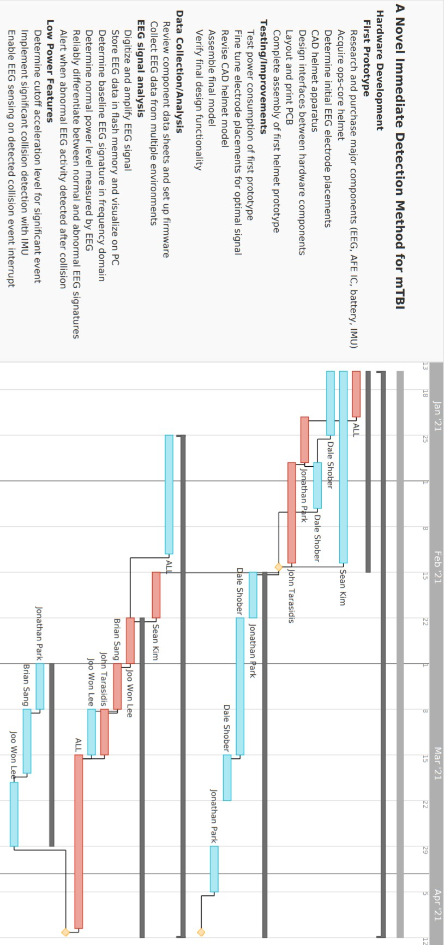

**Appendix C – Project PERT Chart**

