Improving live above ground carbon estimations of forests in Southern Appalachia

A Dissertation Presented for the
Doctor of Philosophy
Degree
The University of Tennessee, Knoxville

Tara Skiba
December 2026

DEDICATION

This dissertation is dedicated to Mother Earth, all her creations great and small.

ACKNOWLEDGEMENTS
This part will be filled in prior to final submission to the grad school.

ABSTRACT
Blah blah blah

TABLE OF CONTENTS
DEDICATION ii
ACKNOWLEDGEMENTS iii
ABSTRACT iv
TABLE OF CONTENTS v
LIST OF TABLES vii
LIST OF FIGURES ix
CHAPTER 1: INTRODUCTION 1
CHAPTER 2: forestspot: A FORESTER’S APP TO PERFORM POINT EXTRACTIONS FROM GOOGLE EARTH ENGINE 8
ABSTRACT 9
INTRODUCTION 9
METHODS 13
CASE STUDY 23
DISCUSSION 27
CONCLUSIONS 30
CHAPTER 3: COMPARING LIVE ABOVEGROUND CARBON MODELING TECHNIQUES UTILIZING STAND-LEVEL FOREST INVENTORY AND ENVIRONMENTAL DATASETS: A CASE STUDY ON NATIONAL PARKS AND FORESTS OF SOUTHERN APPALACHIA 32
ABSTRACT 33
INTRODUCTION 33
METHODS 37
RESULTS 50
DISCUSSION 63
CONCLUSION 69
APPENDIX 71
CHAPTER 4: PERFORMANCE EVALUATION OF EXTENDING A REGIONALLY TRAINED MODEL BEYOND THE TRAINING AREA: A CASE STUDY COMPARING AGAINST OFF-THE-SHELF CARBON PRODUCTS AND CARBON INVENTORY IN SOUTHERN APPALACHIA. 81
ABSTRACT 82
INTRODUCTION 83
MATERIALS AND METHODS 87
RESULTS 97
DISCUSSION 101
CONCLUSION 104
CONCLUSION 106
REFERENCES 111

LIST OF TABLES
Table 1: Accepted column names for user-provided list of coordinates. File must be saved as a CSV. 15
Table 2: WorldClim BIO variables and description 26
Table 3: Summary table of WorldClim BIO variables using protected FIA coordinates. Minimum, 1st quartile, median, mean, 3rd quartile, and maximums are calculated. 28
Table 4: Average percent and absolute differences of public, single buffered point, and 10 buffered points against raw data for all WorldClim BIO variables (raw data is used as the baseline or observed values. The average coefficients of variation within the 10 buffered points for each plot are shown for each WorldClim BIO variable. Units reported in Celsius are unscaled (i.e., results are calculated with raw returned values). See Table 2 for conversion factors. 29
Table 5: Summary table of predictor variables by region, with median values and standard deviations. WorldClim BIO variables are unscaled from raw queried data. Refer to Table 7 for conversion factors. Region abbreviations are as follows: Chattahoochee-Oconee (CO), Cherokee (C), Nantahala (N), Pisgah (P), George Washington-Jefferson (GWJ), Daniel Boone (DB), Monongahela (M), Wayne (W), Great Smoky Mountains (GSM), and Shenandoah (S). 45
Table 6: Summary table of forest type groups and observation count by region. 47
Table 7: List of stand and environmental variables compiled from U.S. Forest Service, Forest Inventory and Analysis database and WorldClim BIO variables. 49
Table 8: Evaluation statistics for the three modeling approaches fitted with stand-level variables for each region. R-squared, root-mean-squared-error (RMSE), and mean bias (MB) were calculated for in-bag (IB) training data and out-of-bag (OOB) testing data with median estimates and 95% confidence intervals. 53
Table 9: Evaluation statistics for the three modeling approaches fitted with stand and environmental variables for each region. R-squared, root-mean-squared-error (RMSE), and mean bias (MB) were calculated for in-bag (IB) training data and out-of-bag (OOB) testing data with median estimates and 95% confidence intervals. 55
Table 10: Median lambda values from 5-fold cross-validation optimization for each study region's LASSO bootstrapped models. 61
Table 11: Median coefficients of predictor variables produced from the 1000 bootstrap samples for linear mixed-effect models by region. See Table 7 for variable descriptions. σ_{fort} is the estimated coefficient of the forest-type random effect. 78
Table 12: Median coefficients of predictor variables produced from the 1000 bootstrap samples for LASSO models by region. See Table 7 for variable descriptions. σ_{fort} is the estimated coefficient of the forest-type random effect. 80
Table 13: FRREC’s 5 stratum used within the study. Additional stratum exist that were excluded. 89
Table 14: Summary statistics of predictors from the FRREC study areas Mean and standard deviation (in parenthesis) are provided. 96
Table 15: Summary statistics of plot-level estimates from the 2 AGBD products and 1 regional model tested. Average carbon ($C$ in MgC/ha), mean bias (MB) and root mean square error (RMSE) are provided. 101
Table 16: Stratum-level returned estimates (in MgC/ha) and bias between returned estimates and observed values (FRREC). Bias is calculated as observed – predicted. 101

LIST OF FIGURES
Figure 1: Diagram of package structure, broken into its two functions (coordinate buffering and point extractions). Each function has two modules, which differ in aggregation methods applied. 14
Figure 2: Demonstration of how data aggregations differ for the two point-extraction modules. 19
Figure 3: Demonstration of point creation differences for the two coordinate buffering modules 19
Figure 4: Examples of where randomized pixels may be created in pixels different from the original coordinate 20
Figure 5: Example of buffer_and_sample approach with r = 914.4 m and n = 10. Uploaded coordinates are marked red, and the 10 buffered coordinates are blue. 22
Figure 6: General framework for application use. Point extraction modules can be used alone, or coordinates can first be buffered using the buffer coordinates modules and fed into the point extraction modules. 24
Figure 7: Complete workflow options for module use. The workflow shows how the different modules can be combined in various ways to produce the desired results. For example, the buffer_and_sample module can be used in either point extraction module based off if returned data should be returned aggregated over common plot identifiers or not. 25
Figure 8: Median R-squared vs. sample size graph from LME, LASSO and GAMM models fit with stand-level variables the lower 2.5% and 97.5% confidence interval bars. Observation counts are as follows in order of smallest to largest: Shenandoah (169), Wayne (384), Great Smoky Mountains (392), Pisgah (469), Nantahala (515), Daniel Boone (576), Monongahela (1244), Cherokee (1335), Chattahoochee-Oconee (1681), George Washington-Jefferson (2491). 58
Figure 9: Median R-squared vs. sample size graph from LME, LASSO and GAMM models fit with stand+environmental variables the lower 2.5% and 97.5% confidence interval bars. Observation counts are as follows in order of smallest to largest: Shenandoah (169), Wayne (384), Great Smoky Mountains (392), Pisgah (469), Nantahala (515), Daniel Boone (576), Monongahela (1244), Cherokee (1335), Chattahoochee-Oconee (1681), George Washington-Jefferson (2491). 59
Figure 10: Predicted versus observed graphs of stand-only LME models for a poor OOB sample (Nantahala) and a well performing OOB sample (Daniel Boone). 63
Figure 11: Predicted versus observed graphs of stand+environmental LME models for a poor OOB sample (Pisgah) and a well performing OOB sample (Nantahala). 63
Figure 12: Predicted versus observed graphs of stand-only LASSO models for a poor OOB sample (Great Smoky Mountains) and a well performing OOB sample (Chattahoochee-Oconee). 64
Figure 13: Predicted versus observed graphs of stand+environmental LASSO models for a poor OOB sample (Pisgah) and a well performing OOB sample (Shenandoah). 64
Figure 14: Predicted versus observed graphs of stand GAMMs for a poor OOB sample (Shenandoah) and a well performing OOB sample (Daniel Boone). 65
Figure 15: Predicted versus observed graphs of stand+environmental GAMMs for a poor OOB sample (Cherokee) and a well performing OOB sample (Shenandoah). 65
Figure 16: Predicted and observed carbon per hectare (Mg C/ha) from out-of-bag samples for linear mixed-effects using stand-level variables. 71
Figure 17: Predicted and observed carbon per hectare (Mg C/ha) produced from linear mixed-effect models using stand-level and WorldClim BIO environmental variables. 72
Figure 18: Predicted and observed carbon per hectare (Mg C/ha) from out-of-bag samples for LASSO models using stand-level variables. 73
Figure 19: Predicted and observed carbon per hectare (Mg C/ha) produced from LASSO models using stand-level and WorldClim BIO environmental variables. 74
Figure 20: Predicted and observed carbon per hectare (Mg C/ha) from out-of-bag samples for GAMM models using stand-level variables. 75
Figure 21: Predicted and observed carbon per hectare (Mg C/ha) produced from GAMM models using stand-level and WorldClim BIO environmental variables. 76
Figure 22: Map of UTK FRREC’s Highland Rim region south of Tullahoma, TN with stratum and carbon plot locations. 89
Figure 23: Map of UTK FRREC’s Cumberland Forest North region with stratum and carbon plot locations. 89
Figure 24: Map of UTK FRREC’s Cumberland Forest South region with stratum and carbon plot locations. 90
Figure 25: Map of UTK FRREC’s Oak Ridge region with stratum and carbon plot locations. 90
Figure 26: Histogram of calculated stand-level carbon estimates from FRREC carbon inventory plots. 91
Figure 27: Map of FRREC properties and Daniel Boone National Forest, which the regional model was trained on. 95
Figure 28:Distributions of forest types present in Daniel Boone National Forest (above, as assigned by the FIA) and in FRREC (below, manually assigned using plurality of basal area). 96
Figure 29: Plot-level returned versus observed estimates of ESA CCI. 99
Figure 30: Stratum-level returned versus observed estimates of ESA CCI. 99
Figure 31: Plot-level fitted versus observed estimates of CTrees. 101
Figure 32: Stratum-level fitted versus observed estimates of CTrees. 101
Figure 33: Plot-level fitted versus observed estimates of the regional model. 103
Figure 34: Strata-level fitted versus observed estimates of the regional model. 103

CHAPTER 1: INTRODUCTION
Climate change is one of modern day’s largest threats on Earth, and global efforts to mitigate the global average atmospheric temperatures from rising over 2º C have been in progress for decades (United Nations Framework Convention on Climate Change 1994, Kyoto Protocol to the United Nations Framework Convention on Climate Change 1997, The Paris Agreement - Publication 2015). These climate accords provide guidance on ways to reduce current CO₂ levels in Earth’s atmosphere through various means, like green energy solutions and utilizing forests as vectors to store carbon (Pasternack et al. 2022, Lan et al. 2025). In order to utilize forests as carbon storage centers, we must understand how much carbon is currently being held and what patterns in carbon storage are present. Therefore, carbon estimations must be made either via a full-scale forest inventory with species-specific biomass equations or some alternate approach. Tracking forest carbon, either as a solution to offset atmospheric carbon or to monitor forest health, is an important but lengthy process. Estimates have to not only be accurate but also updated in a timely manner to ensure forest changes are able to be observed. To achieve these objectives of efficiency and accuracy, various steps along the development process can be reduced. Workflows can be streamlined and models improved to generate estimates faster to meet the needs of forest managers and others, but care should also be taken to preserve accuracy in the search of efficiency. This dissertation aims to demonstrate just that, helping to provide efficient alternatives where possible, but also demonstrating that sometimes some extra effort to produce estimates can result in much better accuracy.
Before any model can be fitted, training data must be acquired. Tree-level metrics can be obtained by national forest inventories such as the U.S. Forest Service Forest Inventory and Analysis (FIA) program’s permanent plot data, providing national scale tree-level data. These datasets serve as excellent validation data and ground-truthed estimates in forestry and other related fields, but they lack non-tree and forest information that affect forest growth and yields like environmental variables (Yang, Brandeis et al. 2022a). Other remotely sensed metrics like multispectral bands have also been helpful to monitor changes in forests, but cannot be added through traditional plot-based forest inventories (Maselli 2004, González‐Alonso et al. 2006, Chinembiri, Mutanga, and Dube 2022, Meneses-Tovar, n.d.). Environmental, multispectral, and even pre-calculated biomass and carbon estimates data are largely produced and managed by governmental organizations like the European Space Agency (ESA), which stores this information in the form of geospatial data, a unique data type to allow spatial features (Abdalla 2025). One example is the ESA’s Climate Change Initiative Biomass data (https://climate.esa.int/en/projects/biomass/data/), which is the product of international collaboration, highly studied, and utilized globally across fields of study (Wang et al. 2026).
While geospatial datasets provide additional model covariates or even pre-calculated carbon estimates, accessing geospatial data can be cumbersome enough to deter users, resulting in an underutilization of geospatial products. Issues with accessing geospatial data can be partially attributed to high technical barriers regarding specialized data handling and programming skills (Morgenroth and Visser 2013, Ziegler and Chasins 2023, Fassnacht et al. 2024). Geospatial datasets like environmental and multispectral data are also decentralized across various government databases, adding additional complexity to accessing this data. Repositories like Living Atlas from Esri or Google Earth Engine have been created to alleviate some of this decentralization, which are already integrated with compatible geospatial software like ArcGIS and packages like geemap (Wu 2020). These geospatial programs and software help with easier data accessing and handling, but significant technical barriers persist.
Chapter 2 documents a Python application and accompanying web application designed to reduce the technical skills required for simple geospatial processes. The objective was to optimize the process of performing basic pixel extractions by removing many of the technical steps required to perform this operation. To accomplish this, the forestspot Python application was developed as a widget-oriented approach to conduct pixel extractions of user-provided coordinates from Google Earth Engine datasets. Compared to other processes available, this application reduces the number of steps required to perform such operations, requiring minimal set up and user inputs. Designed to complement plot-based forest inventories through the application’s streamlined point extraction functions, the application also accounts for the sensitive nature of some forest inventory plots and provides buffering approaches to conceal true plot coordinates from Google servers. This application utilizes existing Python packages like numpy (Harris et al. 2020), geemap (Wu 2020), and ipywidgets (Jupyter Widgets — Jupyter Widgets 8.1.8 documentation, n.d.) to accomplish aforementioned goals. While the forestspot application is able to help make the process of conducting point extractions from Google Earth Engine datasets and point buffering easier than previously possible, the widget-based framework developed can be replicated to accomplish other desired geospatial tasks with minimal skills.
With the variety of forest, environmental, and remotely sensed data available, with an equally variable number of estimation methodologies possible, carbon estimates can vary greatly between products. Previous studies have compared estimates of the various carbon models and products available, showing that variability exists between approaches (Hudak et al. 2026). Despite these varying estimates, models are commonly validated using forest inventory data with species-specific biomass equations. However, this method is time intensive, from conducting full inventories to processing data. Therefore, there is a need to develop models that have high accuracy and precision with less effort. The development of these models allows for better and faster real-time forest monitoring and management, which then allows forest managers to make more informed management decisions. A previous study by Yang et al. (2025) produced models that were able to accurately produce stand-level carbon estimates using stand-level predictors and without extensive use of species-specific biomass equations.
Chapter 3 builds upon this study’s models by comparing predictive performance of live aboveground carbon using three different approaches either with stand-only predictors or combined stand and environmental variables. The objective was to identify advantages and limitations of each modelling approach, which were selected for qualities like simplicity, non-linearity, and feature selection. The three models tested are linear mixed-effect models, generalized additive mixed models (GAMMs), and mixed-LASSO regression, respectively, all with a random effect on forest type. Theis mixed-effect approach allows for handling multiple complex and varied forest compositions found over large contiguous areas like national forests and parks. Additionally, two different datasets were tested for each region and approach. One dataset consists solely of stand-level predictors calculated from the U.S. Forest Service Forest Inventory and Analysis permanent plots that are within the regions of interest. The second dataset uses the aforementioned stand-level variables in combination with WorldClim BIO climate variables, as previous research suggests that the inclusion of environmental variables increase prediction performance (Aguirre et al. 2021, Liepiņš et al. 2022, Yang, Brandeis et al. 2022a).
The study region for this chapter focuses on ten national parks and forests in southern Appalachia. As southern Appalachia is a hotspot of biodiversity and threatened by various invasives and changing climate, developing models for federal lands in southern Appalachia aid in the regions’ carbon and forest monitoring efforts. Furthermore, as predominantly mixed hardwood forests, being able to model live aboveground carbon is more challenging, and the efficient and accurate carbon modeling of mixed-species forests is valuable for forest monitoring efforts. Results from this study prioritized efficient and accurate modeling fitting, although other models were highlighted for their unique advantages that can be beneficial in some instances. Findings from this study can be further expanded to help with estimation and monitoring efforts conducted in other regions.
Finally, chapter 4 focuses on applying carbon models tested in chapter 3, extending the model beyond its trained region on a nearby forest. As other carbon models and products are available, understanding where chapter 3’s models fit into the current landscape of carbon estimation products is crucial to determining which model or product is better in certain cases. As forest systems expand beyond land boundaries, these models may be able to be extended beyond their training region, providing better estimates than carbon products producing estimates via a global model. If regional models are able to produce noticeably better estimates compared to other available carbon products, forest managers and practitioners may determine the extra effort of training regional models worthwhile to make more informed management decisions.
In this study, the Daniel Boone National Forest linear mixed-effects model with stand-only predictors from chapter 3 was used to estimate carbon on the nearby Forest Resources and AgResearch and Education Center (FRREC) at the University of Tennessee, Knoxville. This property serves as a working research forest, with shared management objectives with private landowners. Furthermore, the FRREC is already enrolled in a carbon inventory program with validation data available. Two alternative carbon products, the European Space Agency (ESA) Climate Change Initiative’s (Santoro and Cartus 2025) and CTrees’s (CTrees, n.d.) biomass maps, were selected to use as reference points where convenience supersedes accuracy. The ESA and CTrees products were selected for their public availability and differentiation in methodology, input data, and resolution. As resolution size impacts the scale at which products can best be applied at, estimates and biases were quantified at two aggregation levels: plot and stratum. Results from this study provide better understanding of error present when extending a model beyond its trained region and allows the ranking of this regional model’s performance against other available products at scale of landowner properties like those found in FRREC.
As described above, carbon modeling is a rigorous and time-consuming process due to complicated data handling, developing models that are efficient yet accurate, and determining which models are appropriate to achieve various objectives. Efficiency is crucial to actively monitor forests but often requires sacrifices in accuracy. To improve the efficiency of carbon modeling without sacrificing accuracy requires the optimization of workflows where possible and exerting extra effort when needed elsewhere in the process, such as model building. Through this approach, carbon estimations may be produced in a timely manner to meet the needs of forest managers and other natural resource professionals to help Earth’s forests adapt to a changing climate.

CHAPTER 2: forestspot: A FORESTER’S APP TO PERFORM POINT EXTRACTIONS FROM GOOGLE EARTH ENGINE

ABSTRACT
Technical challenges regarding handling geospatial data remain a major barrier that has prevented the uptake of geospatial data into forestry fields, despite the advantages that geospatial data can provide. Google Earth Engine, which is a large, publicly available database of popular geospatial data, can be leveraged along with existing geospatial technologies to remove many of the existing barriers to accessing and handling geospatial datasets, which will allow geospatial data to be more easily integrated into forest management workflows. To fill this gap, the forestspot Python and Streamlit web applications were developed to perform simple pixel extractions from Google Earth Engine’s geospatial datasets with minimized technical knowledge needed. By making the retrieval process easier, geospatial data available on Google Earth Engine becomes more accessible and easier to incorporate into forest studies. A case study was conducted using querying environmental data with a national forest inventory with an existing plot buffering method. Results showed that the forestspot application returned similar results to the true plot values compared to the inventory’s existing buffered methodology.

INTRODUCTION
Forests are complex, highly variable systems whose structure and dynamics are shaped by environmental conditions. These environmental conditions, like climate, temperature, and precipitation metrics, are often difficult to measure at meaningful spatial scales via the common plot-visit based forest inventories (Toledo et al. 2011, Itter et al. 2017, Wei et al. 2025). Operational forest inventories, such as national forest inventories and those used for landscape-scale forest management, are designed to capture tree and stand characteristics across large scales and at high resolution. However, they typically lack detailed environmental data, despite known relationships between environmental factors and forest growth.
As a result, forest modelers utilize geospatial data to provide environmental data for their research studies and management plans. Geospatial data provide continuous, long-term climate records, short-term environmental metrics, and other remotely sensed metrics that are best measured from satellite imagery. One case is the Normalized Difference Vegetation Index (NDVI), which is calculated from Landsat’s multi-spectral bands (Chi et al. 2016, Chinembiri, Mutanga, and Dube 2022, 2024, Yang, Brandeis et al. 2022b, Jha et al. 2024). As long-term climate change disrupts normal weather patterns, understanding how forests may adapt can be achieved by utilizing large operational forest inventories in tandem with geospatial imagery (Banskota et al. 2014, Lechner, Foody, and Boyd 2020, Leites and Benito Garzón 2023). Together, inventories and geospatial data can provide better forest monitoring at a macro scale. In turn, land managers can better observe and respond to changes in the forests.
Environmental data can be found in many publicly available databases, like government websites, and stored in a variety of data formats, like tabular, array, or geospatial data. Geospatial data can be stored as vector or raster datasets, and they combine location and attribute information into multi-dimensional spatial data that can be easily mapped. To handle these geospatial datasets are various geospatial technologies, like ArcGIS or geospatial applications written in the R programming language. However, there are many barriers that can arise when trying to utilize geospatial data due to the specialized technical knowledge needed. Existing technological barriers are significant enough to deter forest managers from utilizing geospatial data to its full potential (Ziegler and Chasins 2023, Fassnacht et al. 2024).
Existing geospatial processing technologies of the modern age are powerful but still highly technical, requiring geospatial literacy and possibly programming skills. Geospatial software like ArcGIS eliminates the majority of the programming knowledge needed through its program interface which makes it a popular software within natural resources, but users must still have geospatial data knowledge to perform many operations (Morgenroth and Visser 2013). In addition, licenses may have to be purchased, which can be expensive and deter potential users. Open-source programs like Python and R or applications like QGIS provide the most user flexibility with geospatial data handling, but the programming required is more challenging. Even if users have the required technical knowledge and software available, there are still more challenges.
One major obstacle is data decentralization, as geospatial datasets are collected and maintained by numerous domestic and international government agencies and private corporations, like Google. Datasets hosted on various public and private servers make data retrieval less efficient, both in locating and downloading the data. When datasets are especially large, handling them can be cumbersome. Such inefficiencies with geospatial data retrieval, handling, and processing can also deter potential data users.
A solution to the data decentralization problem can be found when using Google Earth Engine (GEE), which is a free, public repository of many popular remotely sensed and other geospatial datasets (Gorelick et al. 2017, Mutanga and Kumar 2019). GEE datasets are stored in a cloud server, which allows users to avoid having to download large datasets locally, which reduces data handling and processing time. GEE provides a Code Editor where users can work completely on a cloud server using JavaScript language (Amani et al. 2020, Ermida et al. 2020). For non-JavaScript users, GEE has been integrated into existing geospatial analysis software. The GEE Toolbox provides GEE integration in ArcGIS products (Google Earth Engine Community [2024] 2026). The R package rgee provides GEE integration into R environments by translating R code to Python and passing it to the Google Earth Engine API (Aybar et al. 2020). Meanwhile, earthengine-api (ee) in Python provides users the full processing flexibility similar to GEE’s Code Editor, and Python packages like geemap provides additional functionality to streamline workflows (Wu 2020, Google Earth Engine, n.d.). Such tools provide easier access to GEE and reduce set up and run time needed to perform geospatial analysis, but the technical threshold for manipulating geospatial data remains.
One way for geospatial data to be paired with operational forest inventories is to perform simple point extractions of the pixel value that contains an inventory plot’s coordinates. To accomplish this, users upload their coordinates, access GEE and select a dataset, perform any necessary data manipulations to ensure file compatibility, extract desired information, and return results. While point extractions are possible to produce with existing software, there is a need to make this process more efficient and less technically complicated. The entire workflow can be distilled down to only require users to provide the necessary input information and perform all other steps in the background. By integrating the streamlined workflow into a user-friendly interface with minimal coding, not only will foresters benefit from the increased accessibility, but experienced geospatial users are provided an efficient tool to perform simple point extractions.
Forest inventories often keep plot coordinates confidential in order to protect detailed information of public and private landowner information, as well as preserve plot and inventory integrity. Confidentiality agreements to protect plot coordinates may not allow data users to run actual plot coordinates through GEE without being modified. The U.S.’s national forest inventory, maintained by the USDA U.S. Forest Service’s Forest Inventory and Analysis (FIA) program, protects their permanent plot coordinates for the reason listed above. To compensate for the loss of coordinate data, the FIA program provides publicly available coordinates that are buffered using the methodology described in Burrill et al. (2024). However, proprietary or other public forest inventories may not have established buffering methodologies developed to conceal plot coordinates to use on unauthorized external servers like Google’s (Amani et al. 2020, Zhao et al. 2021, Alshehri, Zhang, and Liu 2025). Users with concerns with running protected coordinates through Google Earth Engine can benefit from a quick buffering approach that randomizes private coordinates prior to using GEE.
Currently, a streamlined workflow designed for forest practitioners to more efficiently perform point-extractions from GEE-derived raster data without advanced coding or software does not exist. In this study, the forestspot Python application was developed to build off geemap’s extract_values_to_points and incorporate other Python packages into a system that lowers the technical threshold otherwise needed. This project alleviates setup and performance time to conduct point extractions with the goal of helping integrate geospatial data more efficiently into forest studies and inventories.

METHODS

Software design
The forestspot Python application was designed to reduce technical barriers for accessing GEE and producing point extractions. As privacy concerns can arise with using sensitive plot coordinates in GEE, the application provides two coordinate buffering methodologies to conceal protected coordinates. Point-and-click widgets are used to outline the few user inputs needed, while all additional processing is performed behind the user interface. While these workflows were designed to prioritize reducing technical barriers, the workflows can also be efficient alternatives to existing approaches due to quick processing times for buffering and extracting data.
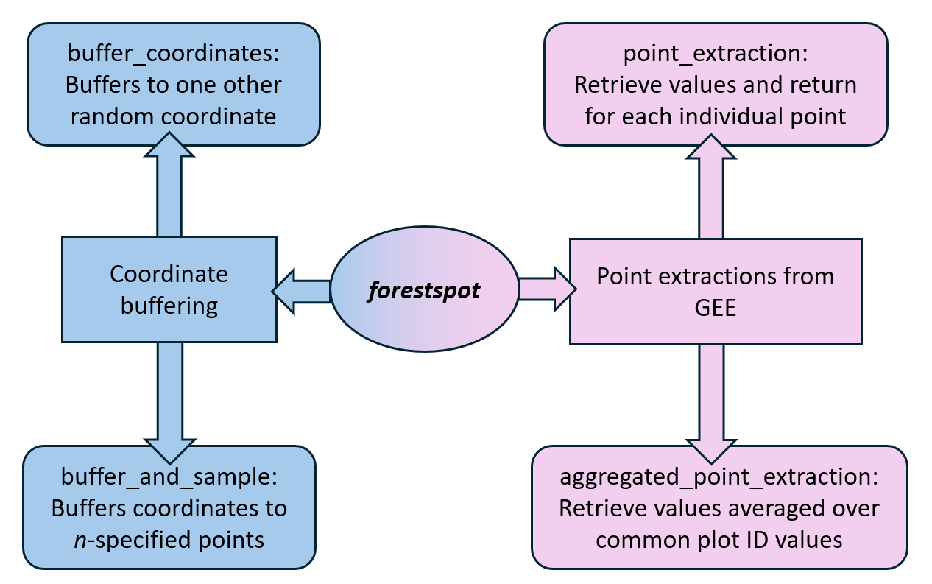
The application is divided into two task groups: point extractions and coordinate buffering, which can be visualized in Figure 1. The point extraction approaches access and retrieve information from GEE, while the coordinate buffering approaches provide the option to safeguard confidential plot coordinates prior to point extraction. Each task group contains two modules, for a total of four created modules. This application relies on a number of
Figure 1: Diagram of package structure, broken into its two functions (coordinate buffering and point extractions). Each function has two modules, which differ in aggregation methods applied.
dependencies. The ipywidgets package serves as the foundation for all modules to construct the front-end user interface to provide a point-and-click workflow without extensive data handling and coding (Martindale, Smith, and Linville 2024, Jupyter Widgets — Jupyter Widgets 8.1.8 documentation, n.d.). Pandas and geopandas are leveraged in each module to handle geospatial file handling throughout the algorithm (McKinney 2010, Jordahl et al. 2020). The ee and geemap Python packages are exclusively called within the point extraction modules to handle Google Earth Engine objects and retrieve pixel values (Gorelick et al. 2017, Wu 2020). In the buffering approaches, shapely, pyproj, and numpy help generate random coordinate points (Gillies et al. 2022, Snow et al. 2025, Harris et al. 2020). As the buffering modules’ packages do not access GEE, coordinate points run through these buffering modules are not run through Google servers.

Formatting for Plot Coordinates File
Users begin all created modules by providing a file of coordinate points to perform operations on. The user-provided file must be properly formatted to prevent data handling errors. This file must be saved as a CSV file and contain the three following columns: a plot identifier column, a latitude column, and a longitude column. Accepted naming conventions for these columns are shown in Table 1 (Additional columns may be present but will be ignored). The plot identifier column is used as a reference column that is grouped over in the point creation and averaging processes conducted in the buffer_and_sample and aggregated_point_extraction modules. Latitude and longitude columns should be formatted in decimal degrees. Coordinates will be internally set to coordinate reference system WGS84.
CSV Columns | Accepted Names
latitude | lat, latitude, y, LAT, Latitude, Y
longitude | log, long, longitude, x, LON, Longitude, Long, X
plot ID | id, ID, plot_ID, plot_id, plotID, plotId
Table 1: Accepted column names for user-provided list of coordinates. File must be saved as a CSV.

Point Extraction Modules
The point extraction modules contain the processes to perform pixel extractions from GEE datasets. The modules are built around geemap’s extract_values_to_points function, simplifying the process to perform extractions. As point extraction modules access Google Earth Engine internally, GEE must be initialized and authenticated as described in the GEE python documentation prior to running any query. The dropdown menu contains all available GEE datasets, updated daily from Open Geospatial Solutions’ master GEE catalog (https://github.com/opengeos). Two date picker widgets allow users the option to filter GEE datasets if desired or allowed.
The modules’ inputs have certain conditions. The file containing coordinate points must follow the formatting criteria described in the Data Formatting section above. Accepted GEE datasets must be classified as Images or ImageCollections but not FeatureCollections. Due to the design of the app’s data filtering process, the additional data filtering and handling capabilities needed to filter ImageCollections with additional properties or FeatureCollections are absent. Acceptable ImageCollections require start and end dates, which can be either the dataset’s entire availability or a specified time frame. Images do not require time filters due to their single image property. Information about a dataset’s classification as an Image, ImageCollection, or FeatureCollection, its temporal availability, and additional image properties can be found on the dataset’s GEE documentation page. The link to the documentation is conveniently provided once a dataset is selected from the drop-down menu.
Two point-extraction modules that follow this general framework were created: point_extraction and aggregated_point_extraction. Both modules perform the same extraction process but differ in aggregation technique. point_extraction returns the extracted data for each coordinate uploaded, whereas aggregated_point_extraction extracts the pixel values then averages over shared plot IDs. The aggregated_point_extraction can only be used when returned values are numerical, not categorical data (i.e., land cover). Differences between returned results are demonstrated in . The following Python script is used to initialize GEE and load the point extraction modules:

Coordinate Buffering Modules
Users who have concerns about operating GEE using sensitive plot coordinates can first run their coordinates through one of two buffering approaches created to quickly generate randomized coordinates within a defined radius. Randomized coordinates can then be applied in the point extraction functions. The buffering modules are called separately from the point extraction modules, and as they do not initialize GEE, coordinates are hidden from GEE. Like the point extraction modules, these buffering modules only require two steps: users provide a correctly formatted CSV file of raw coordinates, then set the buffer radius and optionally, the number of randomized coordinates to generate. The returned dataset is returned correctly formatted for the point extraction modules with the original coordinates removed.
Two modules were created to buffer sensitive coordinates. Both modules follow the same randomization process: buffered coordinates are randomly generated to achieve uniform spatial distribution within a circular area with radius r. The difference between the two modules lies in how many randomized coordinates are generated. The module buffer_coordinates produces one randomized coordinate for each user-provided coordinate; buffer_and_sample returns n random coordinates for each provided coordinate, where n is an integer provided by the user. A visualization comparing buffering approach is provided in Figures 2 and 3.
Setting buffer radius r for randomized points to be generated within can be determined by consulting the data’s user guide, the pixel size for the GEE dataset of interest, and user discretion. Additionally, if the plot radius is considerably large, it may need to be considered when determining an appropriate buffer radius. Note that pixel values extracted using buffered coordinates could return biased results as the raw and buffered coordinate may lie in different pixels of a raster dataset. Some visual examples of how buffered coordinates may lie outside of the original coordinate’s pixel are shown in. This is demonstrated in Figures 4 and 5, where some buffered coordinates lie in a neighboring pixel. Users may desire to repeat the buffering process and point extractions to compare differences in returned values and determine if the values are acceptable. The demonstration conducted later in the Case Study section quantifies the bias present for one example. The following script is used to load the point buffering modules:
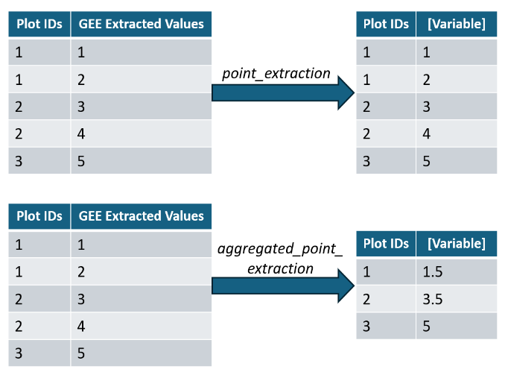
Figure 2: Demonstration of how data aggregations differ for the two point-extraction modules.
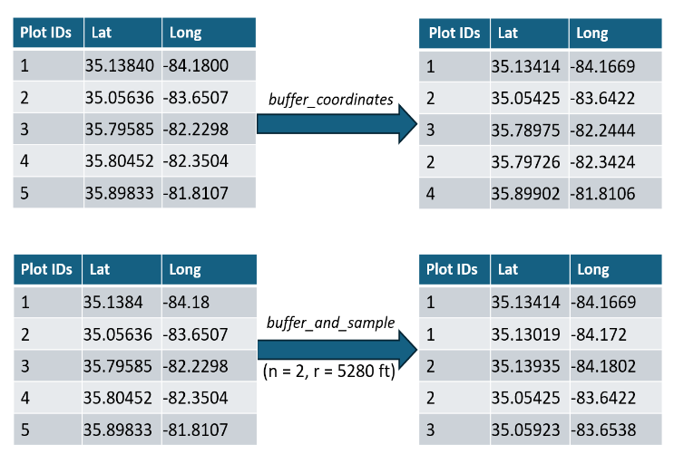
Figure 3: Demonstration of point creation differences for the two coordinate buffering modules.

Workflow
User workflows for the forestspot application depend on whether returned data is returned aggregated or not. The overall simple workflow is shown in Figure 6. The first step is whether or not to buffer the coordinates. While both buffering approaches protect the uploaded coordinates, the buffer_and_sample module can also be used to create random plot samples within a circular area with radius r. After the optional buffering is conducted, the point extraction method selected will depend on how the user wants the data returned. While the buffer_coordinates module was designed to complement the point_extraction module, and likewise, buffer_and_sample complements aggregated_point_extraction, users may be interested in examining the individual values returned by multi-point buffered coordinates. Therefore, coordinates buffered through buffer_and_sample can be used in point_extraction, and user-provided datasets that contain shared plot ID values can be run through aggregated_point_extraction to quickly aggregate results over the shared values. A diagram of all potential workflows is shown in Figure 7.
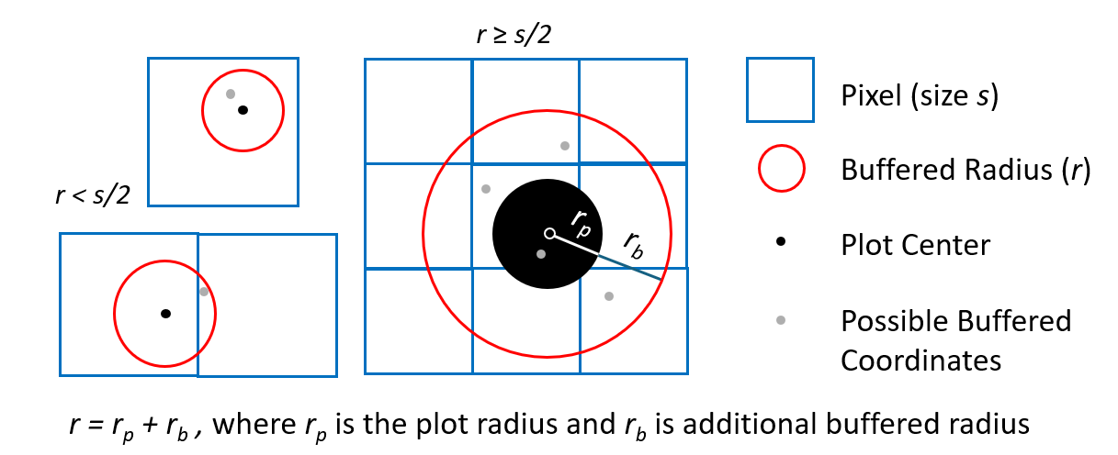
Figure 4: Examples of where randomized pixels may be created in pixels different from the original coordinate

Methodological limitations
Limitations exist regarding dataset compatibility. For example, WorldClim Climatology V1 (WORLDCLIM/V1/MONTHLY) and NEON Canopy Height Model (projects/neon-prod-earthengine/assets/CHM/001) are both ImageCollections, which are able to be handled by the created modules. However, both of these datasets contain metadata fields attached to the collection objects themselves called Image Properties, which are used to filter, sort, and select images. This changes the process for filtering GEE datasets and was not considered in the design process of the forestspot application. Therefore, GEE ImageCollections that contain Image Properties are incompatible with this application.

Streamlit web application
While the forestspot Python application removes many technical barriers and streamlines coordinate buffering and point extraction processes, the required Python skills needed to operate this application are enough to still deter users from utilizing this application. To remove any remaining coding requirements, a web application hosted on Streamlit (https://streamlit.io/) was created that contains the same modules as the Python application but with some differences in the back-end development.
While each of the four modules in the Python application described above are recreated in the web application, there are structural differences due to ipywidgets not being compatible with Streamlit. Streamlit offers its own collection of widgets, which was used to recreate the Python package in a Streamlit environment. This approach means that the forestspot Python package is not called within the web application. Limitations with this approach result in different functionalities between the Python package and web application. For example, if a mapping feature is added to the Python package, the same functionality will have to be developed specifically for the web application.
In addition, GEE is initialized through a pre-designated Google account held by the application maintainer, and web application users are not able to use their own GEE Project. This differs from the Python application, where GEE is manually initialized with a user-owned account. This is notable particularly when users with sensitive plot coordinates are only permitted to run raw coordinates through an approved Google account. Debugging error messages is also difficult since the detailed error codes are only visible to maintainers.
While limitations exist with the web application that can be improved in the future, the major advantages are that all coding requirements are removed. This, in turn, provides maximized accessibility to users with limited coding knowledge from any computer with internet access, sans Python environment.

CASE STUDY

Operational Forest Inventory
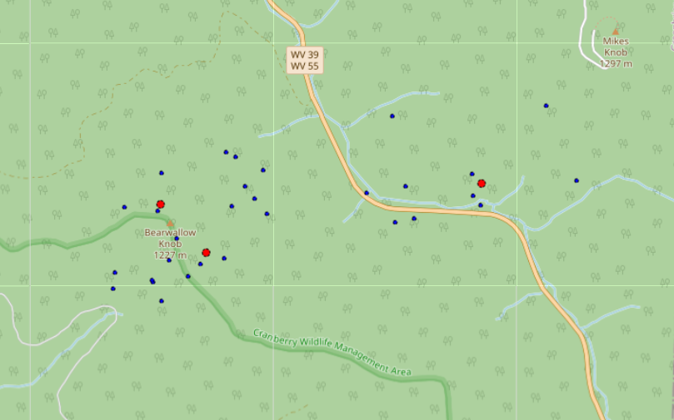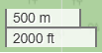
Figure 5: Example of buffer_and_sample approach with r = 914.4 m and n = 10. Uploaded coordinates are marked red, and the 10 buffered coordinates are blue.
The utility of the forestspot application is demonstrated by quantifying differences in returned values produced via the different buffering approaches developed. The FIA program’s long-term forest monitoring inventory provided plot coordinates and an existing buffering methodology that serves as our baseline performance.
The FIA’s forest monitoring program serves as the United States’ national forest inventory and has been used to provide stand-level metrics and as validation data (Cankaya and Radtke 2025, Jiang et al. 2025). The FIA’s long-term forest monitoring program consists of repeated permanent plot measurements, sampling approximately 0.41 ha and recording comprehensive tree and stand-level measurements. To preserve the integrity of the permanent plot data and protect private landowner information, exact plot coordinates are protected. Instead, coordinates that have been buffered following Westfall et al. (2022) are publicly available. Public FIA coordinates are located approximately half to one mile away from the actual plot location. Plots located on private land receive additional fuzzing by swapping plot identifiers. This case study used FIA plots located on federal lands in southern Appalachia which include the following lands: Chattahoochee-Oconee, Cherokee, Nantahala, Pisgah, George Washington-Jefferson, Daniel Boone, Monongahela, and Wayne National Forests; and Great Smoky Mountains and Shenandoah National Parks). As these regions are on federal lands, public FIA coordinates were only buffered within a mile and did not swap identifiers. For this case study, both public and protected plot coordinates were obtained. The private plot coordinates serve as the “true” value, and the public coordinates error with respect to the true value is the baseline. A total of 2,694 observations were used in this study.
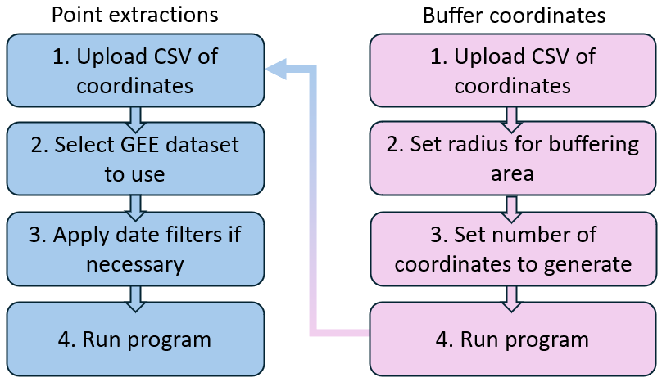
Figure 6: General framework for application use. Point extraction modules can be used alone, or coordinates can first be buffered using the buffer coordinates modules and fed into the point extraction modules.
While FIA provides public plot coordinates, running these coordinates through the point extraction modules may contain some amount of error depending on factors like pixel size compared to buffered radius. To determine how the buffering methods perform against the public coordinates, the various buffering approaches were used in tandem with the point extraction module to simulate supplementing FIA forest inventories with WorldClim BIO variables. The WorldClim BIO variables V1 dataset in GEE is commonly used to provide environmental data in existing forest studies, including supplementing FIA data (Marchi et al. 2019, Wertz and Wilczyński 2022, Yang, Brandeis et al. 2022b, Gou et al. 2025). WorldClim BIO has 19 variables containing various climate metrics relating to precipitation and temperature (Table 2). Summary statistics of WorldClim BIO variables used in this case study are found in Table 3. It is gridded at a spatial resolution of 927.7 m (3043.5 feet), with time availability from Jan. 1, 1960 – Jan.1, 1991. As the distances between public and private FIA plot coordinates typically range between 804.5 to 1609.3 m (0.5 to 1 mi), the public and private plot coordinates may lie in adjacent pixels. When this happens, the returned values may not accurately reflect the true conditions at the private plot location.
In this study, the bias of returned values between public and buffered coordinates against the private FIA coordinates datasets were calculated. These biases were used to determine if the buffered coordinates returned more accurate estimates, or if the public coordinates are sufficient. Four datasets were queried from the WorldClim data: one using raw FIA coordinates, one using public FIA coordinates, and one from each of the buffering approaches. Buffered coordinates from private FIA coordinates were generated within a 1609.3 m (1-mi) radius, similar to how the FIA’s public coordinates are generated. For this analysis, version 2.6.1 was used, with the seed set to 42. At this distance, the probability of buffered points landing within one pixel with 927.5 m (3,043 ft) is approximately 33%, but the probability of the buffered points being within the same pixel is even lower. One buffered dataset contains the coordinates from a single point buffer, and the other contains multi-point buffering using buffer_and_sample module with n=10. Using the raw dataset as the baseline, the average percent
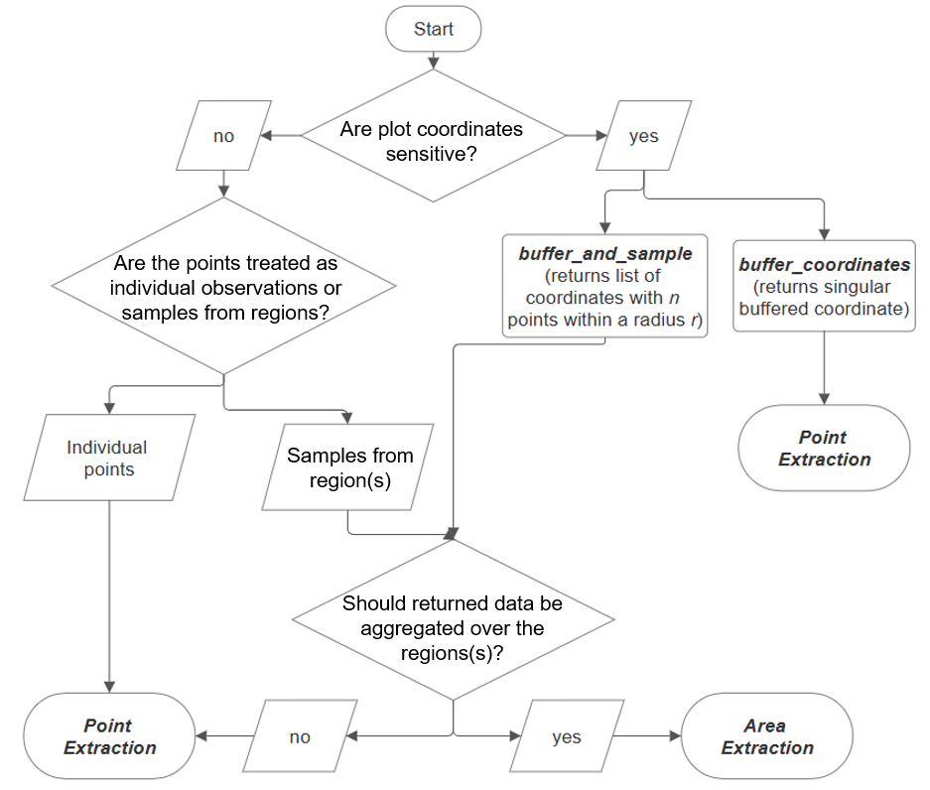
Figure 7: Complete workflow options for module use. The workflow shows how the different modules can be combined in various ways to produce the desired results. For example, the buffer_and_sample module can be used in either point extraction module based off if returned data should be returned aggregated over common plot identifiers or not.
differences and average absolute differences were calculated from the 2,694 plot coordinates for all 19 WorldClim bio-variables. Relative and absolute differences were calculated for each of the following: the public, single buffered, and 10-point buffered datasets compared to the raw dataset. In addition, the coefficients of variation calculated quantify the variance within the multi-point buffered points for each plot and is used to understand the range of values within each plot’s multi-point buffered coordinates.
Table 2: WorldClim BIO variables and description
Category | WorldClim BIO var | Label | Description
Temp. | bio01 | Ann_t | Annual mean temperature (°C, 0.1 scale)
 | bio02 | Diurnal_range | Mean diurnal range (mean of monthly (max temp - min temp)) (°C, 0.1 scale)
 | bio03 | Iso_therm | Isothermality (bio02/bio07 * 100) (%)
 | bio04 | Season_t | Temperature seasonality (Standard deviation * 100) (°C, 0.01 scale)
 | bio05 | Warm_mon_tmax | Max temperature of warmest month (°C, 0.1 scale)
 | bio06 | Warm_mon_tmin | Min temperature of coldest month (°C, 0.1 scale)
 | bio07 | Ann_t_range | Temperature annual range (bio05-bio06) (°C, 0.1 scale)
 | bio08 | Wet_qtr_t | Mean temperature of wettest quarter (°C, 0.1 scale)
 | bio09 | Dry_qtr_t | Mean temperature of driest quarter (°C, 0.1 scale)
 | bio10 | Warm_qtr_t | Mean temperature of warmest quarter (°C, 0.1 scale)
 | bio11 | Cold_qtr_t | Mean temperature of coldest quarter (°C, 0.1 scale)
Precip. | bio12 | Ann_ppt | Annual precipitation (mm)
 | bio13 | Went_mon_ppt | Precipitation of wettest month (mm)
 | bio14 | Dry_mon_ppt | Precipitation of driest month (mm)
 | bio15 | Season_ppt | Precipitation seasonality (Coefficient of variation)
 | bio16 | Wet_qtr_ppt | Precipitation of wettest quarter (mm)
 | bio17 | Dry_qrt_ppt | Precipitation of driest quarter (mm)
 | bio18 | Warm_qtr_ppt | Precipitation of warmest quarter (mm)
 | bio19 | Cold_qtr_ppt | Precipitation of coldest quarter (mm)
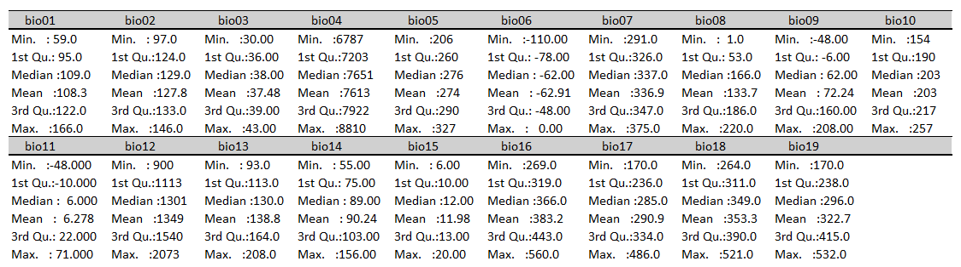
Summary statistics from 10 buffered coordinates dataset. Note: bio01 – bio07 are unscaled, as described in variable description table.

Results
Percent and absolute differences were calculated between the various buffered datasets, shown in Table 4. Both buffered datasets produced values similar to the baseline when r = 1609.3 m (5280 ft), as seen with the small percent differences and absolute differences. In some cases, the buffering methods on average produce values closer to true value than the public coordinates produced. Some instances are seen in the percent difference from single point buffer for bio01, bio08 and bio13, as well as the absolute difference for the multi-point buffer for bio01, bio07 and bio14. The single point buffer, however, did not produce average absolute differences smaller than the baseline. The 10-point buffer mostly produced percent differences equal to the baseline, with only one variable where the multi-point buffer performed better (bio14).
Percent differences for all variables across the three comparisons were all small, with most being less than 1%. Biovariables 08 and 09 had the largest percent differences (mean temperatures of wettest and driest quarters, respectively). Absolute differences were fairly equal across the comparisons. The differences lie in the range of values across the biovariables. While most absolute differences were under 5, biovariables 04 and 12 (temperature seasonality and annual precipitation) had average absolute differences around 20. However, biovariables 04 and 12 have unscaled values ranging from 6788 to 8784 and 917 to 2067, respectively. These value ranges are between one and two orders of magnitude larger than the values of other biovariables, seen in Table 3. Therefore, despite biovariables 04 and 12 appearing to be less accurate than other variables, the percent differences are still small.

DISCUSSION
The buffering methods returned results similar to public FIA coordinates, which is as expected, as the buffered coordinates are generated within the same radius as public coordinates. The reduced inaccuracies may be explained by two things. One, public coordinates are typically buffered within 804.5 to 1609.3 m (0.5 to 1 mi), while the created buffering methods produce coordinates within the full range from 0 to 1609.3 m. Two, as public coordinates may lie in a pixel adjacent to the private coordinates, the multi-point buffering approach can return values closer to the truth by sampling plots containing the true value.
Table 3: Summary table of WorldClim BIO variables using protected FIA coordinates. Minimum, 1st quartile, median, mean, 3rd quartile, and maximums are calculated.
bio01 | bio02 | bio03 | bio04 | bio05
Min. : 60 | Min. : 97.0 | Min. :31.00 | Min. :6788 | Min. :206.0
1st Qu.: 95 | 1st Qu.:124.0 | 1st Qu.:36.00 | 1st Qu.:7204 | 1st Qu.:260.0
Median :108 | Median :129.0 | Median :38.00 | Median :7645 | Median :275.0
Mean :108 | Mean :127.7 | Mean :37.46 | Mean :7611 | Mean :273.7
3rd Qu.:122 | 3rd Qu.:133.0 | 3rd Qu.:39.00 | 3rd Qu.:7922 | 3rd Qu.:290.0
Max. :166 | Max. :146.0 | Max. :43.00 | Max. :8784 | Max. :327.0
bio06 | bio07 | bio08 | bio09 | bio10
Min. :-110.00 | Min. :292.0 | Min. : 5.0 | Min. :-48.00 | Min. :154.0
1st Qu.: -78.00 | 1st Qu.:326.0 | 1st Qu.: 53.0 | 1st Qu.: -6.00 | 1st Qu.:190.0
Median : -63.00 | Median :337.0 | Median :166.0 | Median : 62.00 | Median :203.0
Mean : -63.09 | Mean :336.7 | Mean :133.3 | Mean : 72.09 | Mean :202.8
3rd Qu.: -49.00 | 3rd Qu.:347.0 | 3rd Qu.:186.0 | 3rd Qu.:160.00 | 3rd Qu.:216.0
Max. : 0.00 | Max. :374.0 | Max. :220.0 | Max. :207.00 | Max. :256.0
bio11 | bio12 | bio13 | bio14 | bio15
Min. :-48.000 | Min. : 917 | Min. : 94 | Min. : 56.00 | Min. : 6.00
1st Qu.:-10.000 | 1st Qu.:1114 | 1st Qu.:113 | 1st Qu.: 75.00 | 1st Qu.:10.00
Median : 6.000 | Median :1300 | Median :130 | Median : 89.00 | Median :12.00
Mean : 6.039 | Mean :1351 | Mean :139 | Mean : 90.39 | Mean :11.96
3rd Qu.: 22.000 | 3rd Qu.:1543 | 3rd Qu.:165 | 3rd Qu.:104.00 | 3rd Qu.:13.00
Max. : 70.000 | Max. :2067 | Max. :207 | Max. :155.00 | Max. :20.00
bio16 | bio17 | bio18 | bio19
Min. :272.0 | Min. :173.0 | Min. :266.0 | Min. :173.0
1st Qu.:319.0 | 1st Qu.:237.0 | 1st Qu.:311.0 | 1st Qu.:239.0
Median :366.0 | Median :284.0 | Median :349.0 | Median :296.0
Mean :383.7 | Mean :291.4 | Mean :353.7 | Mean :323.1
3rd Qu.:444.0 | 3rd Qu.:333.8 | 3rd Qu.:390.0 | 3rd Qu.:415.0
Max. :557.0 | Max. :483.0 | Max. :519.0 | Max. :530.0

There was not a singular data set that consistently produced the most accurate results, but differences between datasets were very small. On average, differences in percent differences between the public and buffered datasets were less than 0.05%. The small differences in performance between all testing datasets indicate public FIA coordinates captured values as accurately as buffering methods developed in the forestspot application. Therefore, the public FIA coordinates sufficient, similar to the reporting of other studies (Coulston et al. 2006, Gibson et al. 2013). However, this conclusion regarding the suitability of public coordinates cannot be broadly extended beyond this specific scenario, as environmental conditions tend to follow a gradient across the landscape. Topographic variables like elevation, aspect, and slope that can change drastically within a small range will produce different results between public and private FIA coordinates (Prisley et al. 2009)
As the analysis performed in this study was conducted using a specific radius and dataset, repeating this analysis with other radiuses and dataset resolutions will return different results and performance metrics. Reducing the radius may further reduce error, and users should minimize the buffering radius to as small as possible. In addition, the pixel size of the GEE dataset with respect to the set buffering radius should be considered to understand how likely the buffered coordinates will contain the true value. The ratio of buffer radius to pixel size can also help
Table 4: Average percent and absolute differences of public, single buffered point, and 10 buffered points against raw data for all WorldClim BIO variables (raw data is used as the baseline or observed values. The average coefficients of variation within the 10 buffered points for each plot are shown for each WorldClim BIO variable. Units reported in Celsius are unscaled (i.e., results are calculated with raw returned values). See Table 2 for conversion factors.
 | Percent Differences (%) |  |  | Absolute Difference |  |  | Coefficient of Variation
BIO var | Public vs. Private (baseline) | Single Point Buffer on Private vs. Private | 10-Point Buffer on Private vs. Private | Public vs. Private (baseline) | Single Point Buffer on Private vs. Private | 10-Point Buffer on Private vs. Private | Within Each Plot's 10-Point Buffer
01 | 0.45 | 0.43 | 0.48 | 2.51 °C | 3.46 °C | 2.40 °C | 3.57
02 | 0.18 | 0.19 | 0.21 | 1.56 °C | 2.14 °C | 1.53 °C | 1.84
03 | 0.08 | 0.09 | 0.11 | 0.30 | 0.39 | 0.34 | 1.28
04 | 0.03 | 0.04 | 0.03 | 20.12 °C | 27.43 °C | 18.89 °C | 0.37
05 | 0.21 | 0.21 | 0.23 | 3.56 °C | 4.92 °C | 3.39 °C | 1.94
06 | -0.37 | -0.40 | -0.38 | 1.88 °C | 2.56 °C | 1.77 °C | -4.87
07 | 0.08 | 0.07 | 0.08 | 1.76 °C | 2.48 °C | 1.74 °C | 0.78
08 | 1.80 | 1.64 | 1.89 | 3.46 °C | 4.67 °C | 3.51 °C | 5.88
09 | -0.93 | -2.67 | -1.32 | 4.10 °C | 5.91 °C | 5.10 °C | -15.62
10 | 0.23 | 0.23 | 0.25 | 2.79 °C | 3.86 °C | 2.64 °C | 2.05
11 | -0.36 | -2.23 | -0.97 | 2.34 °C | 3.23 °C | 2.24 °C | -5.33
12 | -0.17 | -0.17 | -0.17 | 22.02 | 29.63 | 20.76 | 2.36
13 | -0.13 | -0.12 | -0.12 | 1.68 | 2.26 | 1.61 | 1.78
14 | -0.19 | -0.21 | -0.18 | 1.91 | 2.54 | 1.80 | 3.02
15 | 0.34 | 0.45 | 0.48 | 0.27 | 0.35 | 0.30 | 3.67
16 | -0.14 | -0.14 | -0.14 | 5.11 | 6.85 | 4.84 | 1.94
17 | -0.17 | -0.20 | -0.18 | 5.66 | 7.58 | 5.33 | 2.81
18 | -0.15 | -0.15 | -0.15 | 4.91 | 6.70 | 4.74 | 2.00
19 | -0.14 | -0.17 | -0.15 | 5.24 | 6.91 | 4.87 | 2.45

inform the number of buffered coordinates to produce in the multi-point buffering approach. This can ensure the samples have a high enough point density to capture the true value. Future studies can investigate these remaining uncertainties with using this application.
The forestspot application reduces the number of steps to query data from GEE compared to what was previously required and for alternative querying approaches, like ArcGIS or rgee. Through the development of the forestspot application, the number of steps required to query data from GEE are reduced, increasing overall efficiency.

CONCLUSIONS
As forest management and research studies continue to cover larger spatial and temporal scales, geospatial techniques will be required to accomplish large-scale forest monitoring. Therefore, it is imperative to increase user-friendliness with accessing and utilizing the plethora of geospatial data available. The forestspot Python application was developed to remove technical challenges required to perform point extractions from GEE and buffer sensitive coordinates to run through Google servers. By developing a widget-oriented application, many of the technical skills needed to access and handle GEE raster datasets are removed. The supplemental web application on Streamlit removes the remaining coding skills needed in order to further increase user accessibility. This app has an open-source repository on GitHub and is downloadable from PyPI.
As this app is hosted on GitHub, users have the option to increase functionality to fit additional needs, such as expanded GEE dataset handling or complementary mapping features. Despite existing limitations, a framework has been established to demonstrate how to remove technical complexities with using geospatial data. This application can be further built on to increase user accessibility, adapting the framework and design to other languages like R, which will in turn, increase the uptake of geospatial data among foresters and other natural resource professionals.

CHAPTER 3: COMPARING LIVE ABOVEGROUND CARBON MODELING TECHNIQUES UTILIZING STAND-LEVEL FOREST INVENTORY AND ENVIRONMENTAL DATASETS: A CASE STUDY ON NATIONAL PARKS AND FORESTS OF SOUTHERN APPALACHIA

ABSTRACT
Accurately estimating live aboveground carbon through species-specific biomass and carbon equations can be rigorous in data collection and processing. Developing alternative carbon estimation models that are efficient but still accurate can allow for faster processing and better forest monitoring. This study compared three parametric and semi-parametric models with two input datasets to investigate stand-level estimation techniques, which can provide useful alternatives to best practices methodologies using species-specific biomass equations. The three parametric models were linear mixed-effects models, LASSO, and generalized additive mixed models, with a random effect added on assigned forest type to allow flexibility in modeling larges areas with different forest compositions. Models were fit on national forests and parks of southern Appalachia using either stand-level data collected by the USDA Forest Service, Forest Inventory and Analysis (FIA) program, or in combination with WorldClim BIO environmental variables. Results show that the three models produced accurate results, with an exception for Shenandoah National Park. Models fit with only forest inventory variables generally produced more accurate and less biased predictions compared to combined forest and environmental variables. Out of all modeling approaches, the linear mixed-effects model was the most efficient with the most accurate estimates. The accuracy and efficiency of methods tested can allow for easier large scale forest monitoring through reduced inventory needs and fast processing.

INTRODUCTION
Forest growth and yield models for mixed-species forests have lagged behind even-aged, single-species plantation counterparts, due to the increased complexity found in mixed-species forests. Forest growth and yield models are primarily developed as single tree species, as tree growth and forms can vary greatly between species (Harrison et al. 1986, Woodall, Miles, and Vissage 2005, Cao 2014, Yang, Brandeis et al. 2022a). To estimate tree-level carbon, single-species biomass and carbon equations can be utilized, which in turn can be aggregated to produce stand-level estimates. With softwood timber species and management regimes, stand-level estimates are easy to produce, but additional diversity within uneven-aged, mixed-species forests presents a bigger challenge (Bowling et al. 1989, Porté and Bartelink 2002, Yang, Cao et al. 2022). As each tree must be individually measured and fit to its specific biomass equation, this process becomes more time and resource intensive. While this process is necessary to produce accurate, ground truthed estimates and utilized by national forest inventories and vegetation simulators (like the Forest Vegetation Simulator, or FVS (Dixon 2026)), the intensity of this methodology can hinder production of updated estimates in a timely manner. Alternatively, grouping on similar characteristics or traits, like taxonomic rank and successional function types, has been studied to provide models that cover greater extents (Vanclay 1991, Phillips et al. 2002, Yang, Brandeis et al. 2022a). Despite challenges associated with modeling mixed-species forests, the development of stand-level growth and yield equations in mixed-species forests is necessary for forest health monitoring, particularly as existing and future threats jeopardize forest ecosystems.
The southern Appalachia mountains are an ancient mountain range with high biodiversity thanks to the range of climates present, with many endemic plant and animal species. Comprised primarily of mixed-species hardwood forests, southern Appalachia is threatened by both man-made and ecological disturbances, like logging, the introduction of invasive pests and species, and the effects of climate change. For example, Eastern hemlock (Tsuga canadensis) is a foundational species in southern Appalachia that has been in severe decline since the introduction of the hemlock wooly adelgid (Adelges tsugae), despite decades of efforts to combat the pest (Ellison et al. 2018). Because some tree species are critical for the survival of flora and fauna within these forest communities, the loss of any tree species can have devastating impacts. As pests and pathogens continue to spread, forests will change as the affected tree species will fall off the landscape and be replaced with others. As global temperatures continue to rise, species have been observed to move northward and to higher elevations, further changing the current forest landscape (McLaughlin et al. 1987, Potter, Hargrove, and Koch 2010, Rogers, Jantz, and Goetz 2017). As these forests undergo changes, the carbon storage and sequestration patterns will also change, highlighting the need to develop carbon prediction models (Keyser, Fearer, and Harper 2016) . Developing growth and yield models that can efficiently and accurately capture stand and level forests like those in southern Appalachia are critical for monitoring forest changes and adaptions in the face of these challenges, both now and in the future.
To study mixed species forests, mixed-effect models have been used as an alternative to previous data grouping techniques, which require the time-consuming process of using species-specific carbon equations and models. By deploying a mixed-effect model, which consists of fixed-effect predictors and a random-effect on forest type, stand-level estimations can be produced over large spatial areas without developing species-specific models. Applying a random effect on forest type builds a global model that can capture differences in forest growth between forest types. This mixed-effect technique was applied in Yang et al. (2025) to estimate stand-level carbon using a linear mixed-effect model and stand-level predictors. This chapter builds upon the aforementioned study by testing the existing approach along additional modeling approaches using stand and environmental covariates. The linear mixed-effect model performed well in previous studies has some limitations, such as inflexibility to non-linear relationships and overfitting when including a plethora of variables. Therefore, the two alternative modeling approaches were chosen in order to introduce non-linearity (generalized additive mixed models, or GAMMs) and perform feature selection to penalize and remove extraneous predictors (least absolute shrinkage and selection operation regression, or LASSO). The inclusion of environmental variables has been shown in previous studies to improve prediction performance (Aguirre et al. 2021, Liepiņš et al. 2022, Yang, Brandeis et al. 2022a). Therefore, predictors taken from the U.S. Forest Service, Forest Inventory and Analysis (FIA) forest monitoring program (Burrill et al. 2024) were combined with WorldClim BIO variables (Google for Developers, n.d.-b) dataset to investigate if predictive performance increased among the LME, GAMM, and LASSO models tested. Results provide insight on advantages, limitations, and tradeoffs in accuracy and efficiency for the various carbon prediction approaches among various southern Appalachia regions.
Despite complexities involved with modeling mixed species forests, there is a need to develop models to help monitor important yet vulnerable mixed-species hardwood forests, like in southern Appalachia. In particular, being able to quickly estimate carbon at the stand-level allows for better forest health monitoring and understanding of how forests respond to on-going and future threats. This study tests 3 prediction methodologies with 2 sets of variables for estimating stand-level carbon. An LME model is the simplest in form, utilizes a popular regression technique, and has been demonstrated in previous studies to be highly accurate. Adding environmental variables may improve predictions by providing information on the many unique climates that these forests developed under. LMEs are rigid in form, and other models that allow for non-linearity or perform feature selection may outperform LMEs in some way. GAMMs and LASSO models were selected as alternative modeling approaches that have these capabilities. Utilizing long-term national forest inventory data from the FIA long-term forest monitoring program and WorldClim BIO environmental variables, the modeling approaches and variable groups tested can be implemented to monitor forests for various purposes.

METHODS

Study Area
The Appalachian mountains were formed 1.1 billion years ago and reached elevations similar to the Alps and Rockies today, but natural erosion over time has produced unique features that are associated with Southern Appalachia (Clark, n.d.). The variety of characteristics seen today are vast, including lower elevation, flatter regions on the outskirts of the Appalachians to mountains standing at over 2,000 m in the center of the Appalachians. In between, ridges and valleys can be found, transitioning the mountainous region to surrounding flatter areas. This forms a wide gradient of climate conditions under which forests grow.
This study’s regions of interest include 8 national forests and 2 national parks: Chattahoochee-Oconee, Cherokee, Nantahala, Pisgah, George Washington-Jefferson, Daniel Boone, Monongahela, and Wayne National Forests; and Great Smoky Mountains and Shenandoah National Parks. These regions are described in Yang et al. (2025). The environmental gradients found across the regions vary greatly, contributing to the different forest types present within each region.
National parks and forests are protected forests and areas that often cover large contiguous areas, open to the public, and managed by various United States federal agencies. They are distinguishable in several ways. National parks are typically distinguished due to some unique feature or characteristic, which may or may not be forested (Stauffer and Porter 1943). National forests serve as public, forested lands that provide various outdoor recreation and undergo more intensive management regimes than national parks. National parks focus is conservation-oriented, with minimal forest management being conducted, whereas national forests can actively engage in timber harvests and allow hunting (and conduct the necessary forest stewardship programs to achieve these management goals). While management types can vary between parks and forests, they share similarities too. Forest types and compositions can be found across both classifications, even if forests can be more highly managed. For this reason, each region was fit individually.
Environmental conditions between the regions vary greatly. Regions like Wayne and Chattahoochee-Oconee National Forests are further out from the mountain range and are much flatter than the Great Smoky Mountains National Park or Cherokee National Forest, which are located in more mountainous regions. However, Wayne and Chattahoochee-Oconee are located at vastly different latitudes, with Wayne located in Ohio while Chattahoochee-Oconee is located in Georgia, much further south where average temperatures are higher. The different climates present, such as annual temperature and precipitation patterns, will therefore also vary and affect the species and forest compositions found in each respective region. This rationale for different climate conditions applies as well to mountainous and ridge-and-valley regions, where elevation, slope, and aspect can vary and influence which species inhabit each region.

TREE DATA
Tree and stand-level data for this study come from the FIA program’s long-term forest monitoring program, which serves as the United States’ national forest inventory. This inventory contains plot measurements, remeasured every 5-7 years in the Southeast. Each plot contains four fixed-radius subplots (7.3-m/24-ft radius), with all trees with diameter at breast height (DBH) greater than or equal to 12.7 cm or 5 in. recorded. Four fixed-radius microplots (2.1-m/6.8-ft) are nested within each subplot, and trees with diameters between 2.54-cm (1-in.) and 12.7-cm (5-in.) are recorded. The entire plot is divided up based off site condition classifications, like land use, ownership, forest type, stand size, and more. A plot can fall entirely in one distinct condition or divided into multiple condition classes that run across the subplot and microplot boundaries. Because of the similarities within a condition class, the condition class was treated as the sampling unit and is subsequently referred to as “stand-level”. Data was obtained following the data processing protocol described in Yang et al. (2025). Aboveground tree-level carbon estimates are provided within the FIA dataset using recent methodology of Westfall et al. (2024). The FIA attribute carbon_ag (3.1.96 in Burrill et al. (2024)), which is defined as aboveground carbon of wood and bark, was used to provide tree-level carbon estimates. This estimate is provided in pounds and excludes the foliage of live and dead standing trees. This tree-level value is multiplied by the tpa_unadj (unadjusted trees per acre, 3.1.92) to get stand-level estimates. By-region summary statistics are presented in Table 5.
The distribution of FIA forest compositions varies across and within the regions of interest, similar to Yang et al. (2025). Although the majority of observations were primarily classified as oak-hickory, each study region contains a variety of forest types with differing growth and yield patterns. Shenandoah National Park, the smallest region included, has only 14 distinct forest types present, while Cherokee and George-Washington National Forests (the two largest regions in this study) have 33 distinct forest types each (Table 6).

ENVIRONMENTAL DATA
Environmental variables like average annual precipitation and temperature play a strong role in determining how a forest ecosystem develops, both in structural complexity and growth rates (Fotis et al. 2018, Ali et al. 2020, Ehbrecht et al. 2021). The WorldClim BIO variable V1 dataset (Google for Developers, n.d.-b) was used to provide environmental data for this study due to its temporal compatibility with inventory data (January 1, 1960, to January 1, 1990) and 19 temperature and rainfall variables (listed in Table 7). The combination of time compatibility and abundance of variables provides a comprehensive picture of the environmental conditions that the forests of this study developed under. The spatial resolution is 927.67 m., which is larger than the FIA plot size.
The environmental data was queried using FIA private plot coordinates in the forestspot Python application, using the entire time availability which produces values from the median composite image (Skiba [2025] 2026, Google for Developers, n.d.-b). This approach captures how previous climate conditions influenced later carbon values. Table 5 shows the summary statistics (average and standard deviation) of environmental variables, by region. While the regions share many environmental characteristics, evidenced by the relatively small range within each variable, there are some differences that would result in different carbon stocking values. For example, the variation in average temperature between wettest and driest quarters (bio08 and bio09, respectively) show inverted relationships between regions. For example, Chattahoochee-Oconee, Cherokee, and Nantahala have low average temperatures in the wettest quarter and high temperatures during the driest quarter. Conversely, Pisgah, Washington-Jefferson, and Daniel Boone experienced high temperatures during the wettest quarter and low temperatures during the driest quarter. The Great Smoky Mountains National Park has the highest average slope, whereas Wayne National Forest is the flattest of all regions. Additionally, annual precipitation varied greatly between regions. Under the theory that resource competition drives forest development, these environmental differences can significantly change forest characteristics that appear in each region.
As the WorldClim BIO dataset contains an assortment of temperature and precipitation variables, many which are related to each other, it is unsurprising that multicollinearity is present (Pradhan and Setyawan 2021). This multicollinearity is the only violated model assumption observed. In the linear mixed-effects models, multicollinearity was not addressed as predictive power was prioritized over model interpretation. In LASSO, this multicollinearity is addressed via the model’s feature selection properties. In the generalized additive mixed models, multicollinearity was not specifically accounted for unless required. The presence of multicollinearity in these generalized additive models will likely cause instability within the models, but in order to reduce data cleaning prior to model fit, all environmental predictors were added when possible. In cases where models failed to fit with all variables included, environmental variables were removed only as needed to allow models to be fit.

MODELING APPROACHES
All analyses were performed in R statistical software (R Core Team 2026). Three modeling approaches were chosen for their various strengths when working with high-dimensional datasets with complex relationships: linear mixed-effect models (LME), least absolute shrinkage and selection operator regression (LASSO), and generalized additive mixed model (GAMM). The three modeling are simplicity, feature selection, and non-linearity strengths, respectively. The LME model is a simple methodology that has proven performance (Yang, Brandeis, and Skiba 2025). The LASSO model is one regularization technique that performs variable selection to prevent overfitting and increase model interpretability (although model interpretation was not conducted in this study as the focus was on prediction power) (Sohil, Sohali, and Shabbir 2022). GAMMs are a semi-parametric approach that can capture complex relationships between predictor and response variables and useful when prediction is the goal (Robinson, Lane, and Thérien 2011).
Each model was fit with stand-level variables alone and stand and environment variables combined.

Linear mixed-effects model
The linear mixed-effects model (LME) was built as the following:
$$C=\sum{xβ}+b+ϵ$$
( 1)
$\sum{xβ}$ is the linear combination of predictors $x$ and their coefficients $β$, $b$ is a forest-type- specific random effect, and error term $ϵ$. It was assumed that $b$ follows a normal distribution with forest-type-specific variance $σ_{forty}^{2}$ ($b\sim N(0,σ_{forty}^{2}$)), and $ϵ$ follows a normal distribution with
mean zero and variance $σ^{2}$ ($ϵ\sim N(0,σ^{2}$)). The “lmer” function from the lme4 R package was used to fit the linear mixed-effect models (Bates et al. 2015).

LASSO regression
The mixed-effect LASSO (least absolute shrinkage and selection operator) regression is similar to the linear mixed model in form, but with an additional penalty term that error is minimized on. This penalty term gives LASSO regression its most notable asset: feature selection (Faraway 2015). When using datasets with many correlated variables, as is the case for the stand-level and environmental variables used in this study, this feature selection identifies which variables do not aide in explaining the response variable. This process is an efficient alternative to traditional model optimization processes like stepwise regression while still using traditional techniques to perform model selection. Compared to LME models which keep all input variables, LASSO models shrink non-influential variables and retain the best predictors.
LASSO’s feature selection is possible due to the shrinkage penalty added to the error that is being minimized:
$$min(RSS+λ\sum{{|β}_{j}|​})$$
( 2)
where RSS is the residual sum of squares, and the second term is where the additional penalty is included. $λ$ (lambda) can be any positive value, with coefficients $β$ from $j$ equals 1 to $p$ number of predictors.
As lambda can be adjusted, LASSO models have an additional level of flexibility to optimize fitness. When lambda is 0, the model reduces down to least-squares regression. Lambda can either be chosen via previous knowledge and research or optimized through iterative processes to choose the best. Using an optimized lambda value ensures that non-influential predictors’ coefficients shrink to zero. For our analysis, a five-fold cross validation was used to tune lambda for each bootstrap iteration, with lambda being tested at increments of 5 between 0 and 500.

GAMM
GAMs (short for generalized additive models) are an extension of generalized linear models that allow for modeling non-linear relationships between dependent and independent variables, like those found in forest systems (Adhikari, Montes, and Peduzzi 2023). While linear models form relationships using linear functions, mixed GAMS (or GAMMs) create relationships using smooth functions. The generalized additive mixed model was built as the following:
$$g\left(μ_{i}\right)=X_{i}β+Z_{i}b+ϵ$$
( 3)
where $μ_{i}$ is the expected value, $g$ is a smooth monotonic ‘link function’. Fixed effects are contained in the first term, where $X_{i}$ is the $i^{th}$ row of a model matrix $X$, and $β$ is a vector of unknown parameters. The forest-type random effect has model matrix $Z$ and vector $b$, the latter which follows a normal distribution with mean expected value of zero and covariance matrix $ψ_{θ}$ (i.e., $b\sim N\left(0,ψ_{θ}\right)$, and unknown parameters in $θ$. Error $ϵ$ follows a normal distribution with mean 0 and variance $Λ_{θ}$, where $Λ_{θ}$ is a positive definite matrix used to model residual autocorrelation. The full theory and description are found in Wood (2017). The “gamm” function
Table 5: Summary table of predictor variables by region, with median values and standard deviations. WorldClim BIO variables are unscaled from raw queried data. Refer to Table 7 for conversion factors. Region abbreviations are as follows: Chattahoochee-Oconee (CO), Cherokee (C), Nantahala (N), Pisgah (P), George Washington-Jefferson (GWJ), Daniel Boone (DB), Monongahela (M), Wayne (W), Great Smoky Mountains (GSM), and Shenandoah (S).
Variable | CO | C | N | P | GWJ | DB | M | W | GSM | S
C | 73.5 (44.8) | 67.2 (47.1) | 73.6 (45.4) | 76.3 (57.4) | 69.7 (41.3) | 63.7 (45.1) | 88.7 (48.3) | 50.9 (41.7) | 90.2 (47.7) | 76.9 (42.0)
D | 23.2 (5.3) | 22.1 (6.2) | 23.2 (5.7) | 23.8 (6.4) | 22.4 (5.2) | 22.3 (5.5) | 25.8 (5.5) | 24.7 (5.4) | 24.9 (5.3) | 23.7 (6.2)
H | 18.1 (3.6) | 17.3 (4.6) | 17.6 (4.1) | 17.6 (4.6) | 16.0 (3.8) | 18.2 (3.9) | 18.1 (3.9) | 18.7 (3.7) | 18.6 (4.2) | 15.2 (4.1)
H-D | 88.6 (13.4) | 89.9 (15.8) | 88.1 (14.5) | 83.9 (16.2) | 81.0 (15.6) | 95.6 (14.5) | 77.9 (13.0) | 83.3 (13.0) | 87.3 (13.2) | 76.2 (10.6)
QMD | 25.9 (6.1) | 24.9 (7.1) | 26.3 (6.6) | 26.6 (7.3) | 25.1 (5.9) | 25.6 (6.1) | 28.5 (6.2) | 27.1 (6.2) | 28.4 (6.2) | 27.4 (7.0)
BA | 24.1 (11.7) | 23.0 (12.1) | 23.7 (10.9) | 25.8 (12.9) | 23.8 (10.4) | 20.1 (10.6) | 27.7 (11.7) | 16.8 (9.4) | 29.1 (12.7) | 25.2 (9.4)
TPH | 890.3 (757.3) | 897.8 (904.7) | 886.3 (890.6) | 846.4 (901.5) | 957.2 (801.0) | 897.8 (985.0) | 476.0 (752.2) | 327.2 (566.4) | 861.2 (709.6) | 886.9 (619.9)
SDI | 943.0 (570.5) | 920.9 (593.1) | 921.4 (570.2) | 921.8 (625.3) | 942.2 (561.0) | 960.7 (635.6) | 577.5 (653.8) | 385.7 (472.3) | 1061.0 (711.9) | 976.3 (495.5)
Aspect | 170.0 (112.9) | 184.0 (106.8) | 176.0 (99.6) | 205.0 (95.1) | 175.0 (104.3) | 176.5 (102.7) | 175.0 (107.3) | 160.0 (109.9) | 195.0 (107.4) | 171.0 (113.9)
Slope | 34.5 (20.2) | 45.0 (20.8) | 42.5 (19.5) | 42.0 (18.6) | 35.0 (18.2) | 35.0 (17.9) | 30.0 (18.5) | 26.0 (17.2) | 52.0 (19.0) | 34.0 (17.3)
Ann_t | 127.0 (11.5) | 121.0 (14.3) | 110.0 (11.5) | 115.0 (13.8) | 104.0 (11.0) | 123.8 (3.8) | 83.0 (9.1) | 110.0 (5.7) | 111.0 (16.2) | 97.0 (10.1)
Diurnal_range | 131.0 (4.1) | 134.0 (6.0) | 130.5 (8.0) | 132.0 (7.5) | 129.0 (6.0) | 132.0 (3.1) | 119.8 (7.3) | 129.0 (2.0) | 133.0 (9.1) | 116.5 (7.4)
Iso_therm | 40 (1.2) | 39 (1.0) | 40 (1.4) | 39 (1.3) | 37 (1.3) | 37 (0.9) | 35 (1.5) | 35 (0.5) | 40 (1.7) | 33 (1.5)
Season_t | 7093.0 (230.1) | 7403.5 (149.8) | 6984.0 (152.3) | 7091.0 (185.3) | 7871.0 (218.7) | 8028.5 (158.9) | 7912.0 (64.4) | 8547.0 (102.0) | 7133.0 (143.7) | 8072.0 (97.8)
Warm_mon_tmax | 285.5 (14.7) | 286.0 (19.1) | 267.0 (16.2) | 274.0 (20.3) | 276.0 (14.8) | 298.0 (3.1) | 247.0 (13.7) | 293.0 (5.1) | 270.0 (21.2) | 266.0 (15.1)

Table 5 (cont.)
Variable | CO | C | N | P | GWJ | DB | M | W | GSM | S
Cold_mon_tmin | -41 (10.2) | -49 (11.2) | -56 (7.6) | -52 (10.1) | -68 (11.1) | -57 (5.5) | -92 (7.2) | -73 (6.6) | -59 (11.4) | -78 (7.7)
Ann_t_range | 324.0 (6.7) | 334.0 (8.2) | 322.0 (9.8) | 325.0 (10.9) | 345.0 (10.1) | 352.5 (5.7) | 340.0 (6.9) | 365.0 (3.4) | 328.0 (10.4) | 343.0 (8.6)
Wet_qtr_t | 45 (10.9) | 56 (70.5) | 32 (18.5) | 126 (42.4) | 183 (17.8) | 205 (3.0) | 163 (9.3) | 198 (5.1) | 41 (42.4) | 177 (40.8)
Dry_qtr_t | 174 (17.2) | 148 (65.8) | 153 (18.4) | 48 (39.5) | 2 (26.6) | 182 (24.7) | -17 (50.6) | -6 (33.4) | 128 (22.2) | -12 (9.9)
Warm_qtr_t | 215 (13.4) | 214 (16.2) | 198 (12.8) | 204 (16.0) | 202 (12.0) | 224 (2.9) | 179 (10.0) | 217 (4.9) | 200 (17.6) | 197 (11.0)
Cold_qtr_t | 31.0 (10.6) | 23.0 (12.6) | 16.0 (10.5) | 19.0 (12.2) | 0.0 (11.4) | 15.0 (5.3) | -24.5 (9.0) | -6.0 (7.2) | 14.0 (14.5) | -12.0 (9.9)
Ann_ppt | 1678.0 (137.7) | 1455.0 (167.8) | 1778.0 (156.6) | 1396.0 (215.7) | 1058.0 (93.4) | 1265.0 (46.0) | 1320.8 (122.4) | 1063.0 (26.6) | 1542.0 (166.1) | 1131.0 (69.1)
Went_mon_ppt | 180 (11.2) | 154 (19.9) | 184 (13.2) | 136 (21.5) | 105 (8.5) | 129 (2.8) | 131 (12.1) | 114 (4.1) | 160 (14.9) | 111 (5.9)
Dry_mon_ppt | 109 (12.7) | 91 (10.0) | 117 (17.3) | 100 (19.4) | 72 (8.2) | 79 (3.5) | 93 (10.9) | 69 (3.7) | 94 (16.7) | 74 (5.0)
Season_ppt | 13 (1.9) | 13 (1.5) | 11 (2.0) | 9 (1.6) | 12 (1.8) | 12 (1.7) | 10 (1.6) | 16 (1.4) | 11 (2.1) | 14 (0.7)
Wet_qtr_ppt | 487 (31.4) | 416 (49.3) | 498 (33.3) | 377 (52.7) | 297 (23.7) | 359 (5.9) | 375 (31.5) | 318 (4.9) | 429 (40.0) | 320 (17.4)
Dry_qrt_ppt | 361 (38.8) | 303 (34.8) | 389 (47.0) | 309 (60.0) | 224 (26.3) | 274 (11.3) | 294 (33.9) | 222 (11.6) | 327 (48.6) | 227 (15.9)
Warm_qtr_ppt | 398.0 (37.6) | 362.0 (26.2) | 428.5 (38.8) | 372.0 (48.3) | 289.0 (21.0) | 338.0 (5.9) | 367.5 (30.2) | 313.0 (6.5) | 391.0 (39.1) | 312.0 (12.3)
Cold_qtr_ppt | 455.0 (32.5) | 391.0 (69.1) | 470.0 (32.9) | 314.0 (60.4) | 224.0 (28.5) | 303.0 (20.1) | 294.5 (34.8) | 222.0 (11.7) | 402.0 (38.7) | 227.0 (15.9)

Table 6: Summary table of forest type groups and observation count by region.
 | Aspen/ birch |  | Elm/ash/ cottonwood |  | Exotic HW |  | Loblolly/ shortleaf |  | Maple/beech/  birch |  | Oak/gum/ cypress |  | Oak/  hickory
 | Obs | FT | Obs | FT | Obs | FT | Obs | FT | Obs | FT | Obs | FT | Obs | FT
Chattahoochee-Oconee | 0 | 0 | 7 | 2 | 0 | 0 | 154 | 5 | 1 | 1 | 0 | 0 | 1152 | 15
Cherokee | 0 | 0 | 0 | 0 | 0 | 0 | 143 | 5 | 76 | 3 | 0 | 0 | 887 | 15
Nantahala | 0 | 0 | 0 | 0 | 0 | 0 | 15 | 5 | 19 | 2 | 0 | 0 | 417 | 13
Pisgah | 2 | 1 | 0 | 0 | 0 | 0 | 6 | 2 | 11 | 1 | 0 | 0 | 373 | 12
George Washington-Jefferson | 0 | 0 | 0 | 0 | 1 | 1 | 106 | 3 | 81 | 4 | 2 | 1 | 1990 | 15
Daniel Boone | 0 | 0 | 3 | 1 | 0 | 0 | 7 | 3 | 34 | 3 | 0 | 0 | 508 | 14
Monongahela | 2 | 1 | 2 | 1 | 0 | 0 | 4 | 3 | 607 | 4 | 0 | 0 | 510 | 13
Wayne | 10 | 1 | 25 | 3 | 0 | 0 | 6 | 1 | 31 | 2 | 0 | 0 | 275 | 13
Great Smoky Mountains | 0 | 0 | 1 | 1 | 0 | 0 | 16 | 5 | 58 | 3 | 1 | 1 | 221 | 13
Shenandoah | 0 | 0 | 1 | 1 | 0 | 0 | 0 | 0 | 0 | 0 | 0 | 0 | 164 | 11

Table 6 (cont.)
 | Oak/pine |  | Other HW |  |  | Spruce/fir |  | White/red/jack |  | Total
 | Obs | FT |  | Obs | FT | Obs | FT | Obs | FT | Obs | FT
Chattahoochee-Oconee | 279 | 5 |  | 14 | 1 | 0 | 0 | 74 | 3 | 1681 | 32
Cherokee | 145 | 5 |  | 17 | 1 | 1 | 1 | 66 | 3 | 1335 | 33
Nantahala | 32 | 4 |  | 10 | 1 | 0 | 0 | 22 | 2 | 515 | 27
Pisgah | 35 | 4 |  | 23 | 1 | 4 | 1 | 15 | 2 | 469 | 24
George Washington-Jefferson | 231 | 4 |  | 18 | 1 | 2 | 1 | 60 | 3 | 2491 | 33
Daniel Boone | 16 | 4 |  | 0 | 0 | 0 | 0 | 8 | 1 | 576 | 26
Monongahela | 18 | 3 |  | 28 | 1 | 51 | 1 | 22 | 3 | 1244 | 30
Wayne | 17 | 2 |  | 1 | 1 | 0 | 0 | 19 | 1 | 384 | 24
Great Smoky Mountains | 23 | 4 |  | 53 | 1 | 9 | 1 | 10 | 3 | 392 | 32
Shenandoah | 1 | 1 |  | 3 | 1 | 0 | 0 | 0 | 0 | 169 | 14

Table 7: List of stand and environmental variables compiled from U.S. Forest Service, Forest Inventory and Analysis database and WorldClim BIO variables.
Variable Group | Label | WorldClim BIO var | Description
Stand-level | D |  | Mean diameter at breast height (cm)
 | H |  | Mean height (m)
 | H-D |  | Mean height-diameter ratio
 | QMD |  | Quadratic mean diameter (cm)
 | BA |  | Basal area per hectare (m2/ha)
 | TPH |  | Number of trees per hectare
 | SDI |  | Site density index
 | Aspect |  | Aspect (° from due north)
 | Slope |  | Slope (°)
Environmental | Ann_t | bio01 | Annual mean temperature (°C, 0.1 scale)
 | Diurnal_range | bio02 | Mean diurnal range (mean of monthly (max temp - min temp)) (°C, 0.1 scale)
 | Iso_therm | bio03 | Isothermality (bio02/bio07 * 100) (%)
 | Season_t | bio04 | Temperature seasonality (Standard deviation * 100) (°C, 0.01 scale)
 | Warm_mon_tmax | bio05 | Max temperature of warmest month (°C, 0.1 scale)
 | Cold_mon_tmin | bio06 | Min temperature of coldest month (°C, 0.1 scale)
 | Ann_t_range | bio07 | Temperature annual range (bio05-bio06) (°C, 0.1 scale)
 | Wet_qtr_t | bio08 | Mean temperature of wettest quarter (°C, 0.1 scale)
 | Dry_qtr_t | bio09 | Mean temperature of driest quarter (°C, 0.1 scale)
 | Warm_qtr_t | bio10 | Mean temperature of warmest quarter (°C, 0.1 scale)
 | Cold_qtr_t | bio11 | Mean temperature of coldest quarter (°C, 0.1 scale)
 | Ann_ppt | bio12 | Annual precipitation (mm)
 | Went_mon_ppt | bio13 | Precipitation of wettest month (mm)
 | Dry_mon_ppt | bio14 | Precipitation of driest month (mm)
 | Season_ppt | bio15 | Precipitation seasonality (Coefficient of variation)
 | Wet_qtr_ppt | bio16 | Precipitation of wettest quarter (mm)
 | Dry_qrt_ppt | bio17 | Precipitation of driest quarter (mm)
 | Warm_qtr_ppt | bio18 | Precipitation of warmest quarter (mm)
 | Cold_qtr_ppt | bio19 | Precipitation of coldest quarter (mm)
from the mgcv R package (Wood 2017) was used to fit these models. Default parameters (i.e. k=10) were used for the stand-only model. In the stand+environmental variable model, environmental variables’ k parameters were set to 2 to constrain the flexibility of the smooth terms. This parameter was increased within the model to the minimum as needed. The maximum likelihood estimation method was used to prioritize unbiased fixed effects over unbiased random effects.

MODEL BUILDING AND EVALUATION STATISTICS
The various combinations of modeling approaches and variable groups (stand-level and stand+environmental) were built under 1,000 cluster bootstrap samples to approximate the sampling distribution of evaluation statistics (Murphy 2012).
Because of the repeated plot measurements, potential temporal autocorrelation was accounted for by splitting training and testing datasets (also referred to as in-bag and out-of-bag data) on the sampling unit in a 70-30 split between training and testing datasets, also referred to as in-bag (IB) and out-of-bag (OOB) samples, respectively. Using this approach, if a plot condition is sampled in the training dataset, all repeated measurements for that plot condition are grouped into the training dataset and will not be included in the testing dataset. Likewise, data included in the testing dataset will not have been used in the training dataset. As a specific example, if sampling unit A was selected for the in-bag data, its measurements in 2012, 2017, and 2022 are all in the in-bag data. Sampling unit B was selected for out-of-bag data, then its measurements in 2008, 2013, and 2018 are all contained in the out-of-bag data. For each bootstrap sample, R², mean bias (MB), and root mean square error (RMSE) were calculated for the in-bag and out-of-bag data using the following equations:
$$R^{2}=1-\frac{\sum{\left(e^{2}\right)}}{\sum{{\left(C-\overline{C}\right)}^{2}}}$$
( 4)
$$MB=\frac{\sum{\left(e\right)}}{n}$$
( 5)
$$RMSE=\sqrt{\frac{\sum{e^{2}}}{n}}$$
( 6)
$\overline{C}$ is the mean of $C$, $e=C-{\hat{C}}_{final}$, and $n$ is the total number of observations. Once the 1,000 bootstrap sample were trained, the median and 95% confidence intervals evaluation statistics were computed. In addition, for the LASSO models fit, coefficients of the fixed-effect variables were extracted from each bootstrap sample, and the median and 95% confidence intervals were calculated to determine significant predictors.
To visualize fit, one out-of-bag sample for each study area was used to plot predicted vs observed carbon values. A 1:1 diagonal line and LOESS smoothing curve with 95% confidence interval were added, using the ggplot2 R package (Wickham 2016).

RESULTS
Generally, all 3 modeling approaches fit using the nine stand-level predictors performed well but with important differences in stability across regions. Of the three models tested, the LME models produced the least biased predictions, followed by GAMMs, and lastly, LASSO (Table 8 and Table 9). The differences between the LME model with GAMMs and LASSOs are large enough to identify the LME model as the best predictive model with the highest stability, as GAMM and LASSO models have greater performance variability. Shenandoah National Park is one example of the model instability; the lower 2.5% of R-squared values produced by the stand+environmental LASSO bootstrapped models are smaller than 0.06. The notable difference between Shenandoah National Park, which presented many challenges throughout this study, and other study areas is that the former is the smallest, with the least amount of acreage and fewest number of observations (169 observations) (Table 6). To compare, the next largest region is Wayne National Forest, with 384 observations and greater predictive power.

Table 8: Evaluation statistics for the three modeling approaches fitted with stand-level variables for each region. R-squared, root-mean-squared-error (RMSE), and mean bias (MB) were calculated for in-bag (IB) training data and out-of-bag (OOB) testing data with median estimates and 95% confidence intervals.
STAND-LEVEL VARIABLES
 |  |  |  | R-squared |  |  |  |  |  |  |  | MB
 |  |  | IB |  |  | CI |  |  |  | OOB | CI |  |  | IB |  | CI |  |  |  | OOB | CI
LME | Chattahoochee-Oconee |  |  | 0.96 |  | 0.95 |  | 0.96 |  | 0.95 | 0.94 |  | 0.96 |  | 0.00 | 0.00 |  | 0.00 |  | -0.03 | -1.56 |  |  | 1.72
 | Cherokee |  |  | 0.96 |  | 0.95 |  | 0.96 |  | 0.95 | 0.94 |  | 0.96 |  | 0.00 | 0.00 |  | 0.00 |  | -0.07 | -2.20 |  |  | 2.13
 | Nantahala |  |  | 0.95 |  | 0.93 |  | 0.97 |  | 0.93 | 0.88 |  | 0.96 |  | 0.00 | 0.00 |  | 0.00 |  | -0.06 | -4.10 |  |  | 4.40
 | Pisgah |  |  | 0.96 |  | 0.95 |  | 0.97 |  | 0.94 | 0.90 |  | 0.97 |  | 0.00 | 0.00 |  | 0.00 |  | -0.36 | -4.58 |  |  | 3.90
 | George Washington-Jefferson |  |  | 0.96 |  | 0.95 |  | 0.96 |  | 0.95 | 0.94 |  | 0.96 |  | 0.00 | 0.00 |  | 0.00 |  | 0.03 | -1.27 |  |  | 1.39
 | Daniel Boone |  |  | 0.95 |  | 0.95 |  | 0.96 |  | 0.93 | 0.90 |  | 0.95 |  | 0.00 | 0.00 |  | 0.00 |  | 0.05 | -3.50 |  |  | 3.56
 | Monongahela |  |  | 0.94 |  | 0.93 |  | 0.95 |  | 0.93 | 0.91 |  | 0.95 |  | 0.00 | 0.00 |  | 0.00 |  | -0.01 | -2.34 |  |  | 2.24
 | Wayne |  |  | 0.93 |  | 0.91 |  | 0.95 |  | 0.90 | 0.85 |  | 0.93 |  | 0.00 | 0.00 |  | 0.00 |  | -0.05 | -4.12 |  |  | 4.54
 | Great Smoky Mountains |  |  | 0.95 |  | 0.94 |  | 0.96 |  | 0.93 | 0.89 |  | 0.95 |  | 0.00 | 0.00 |  | 0.00 |  | -0.15 | -4.52 |  |  | 4.29
 | Shenandoah |  |  | 0.98 |  | 0.97 |  | 0.99 |  | 0.94 | 0.88 |  | 0.97 |  | 0.00 | 0.00 |  | 0.00 |  | -0.25 | -5.10 |  |  | 4.37
LASSO | Chattahoochee-Oconee |  |  | 0.96 |  | 0.96 |  | 0.97 |  | 0.95 | 0.90 |  | 0.96 |  | 0.00 | 0.00 |  | 0.00 |  | -0.18 | -8.62 |  |  | 7.82
 | Cherokee |  |  | 0.96 |  | 0.95 |  | 0.96 |  | 0.94 | 0.88 |  | 0.96 |  | 0.00 | 0.00 |  | 0.00 |  | 0.10 | -9.94 |  |  | 9.67
 | Nantahala |  |  | 0.95 |  | 0.94 |  | 0.97 |  | 0.90 | 0.74 |  | 0.95 |  | 0.00 | 0.00 |  | 0.00 |  | -0.19 | -14.45 |  |  | 15.21
 | Pisgah |  |  | 0.96 |  | 0.95 |  | 0.97 |  | 0.89 | 0.63 |  | 0.94 |  | 0.00 | 0.00 |  | 0.01 |  | 0.17 | -20.32 |  |  | 21.14
 | George Washington-Jefferson |  |  | 0.96 |  | 0.96 |  | 0.97 |  | 0.95 | 0.92 |  | 0.96 |  | 0.00 | 0.00 |  | 0.00 |  | 0.01 | -6.31 |  |  | 6.73
 | Daniel Boone |  |  | 0.96 |  | 0.95 |  | 0.96 |  | 0.92 | 0.75 |  | 0.95 |  | 0.00 | 0.00 |  | 0.01 |  | -0.33 | -14.37 |  |  | 12.83
 | Monongahela |  |  | 0.94 |  | 0.94 |  | 0.95 |  | 0.92 | 0.87 |  | 0.94 |  | 0.00 | 0.00 |  | 0.01 |  | 0.28 | -9.05 |  |  | 9.15
 | Wayne |  |  | 0.95 |  | 0.95 |  | 0.96 |  | 0.90 | 0.63 |  | 0.94 |  | 0.00 | -0.01 |  | 0.01 |  | -0.25 | -15.16 |  |  | 14.64
 | Great Smoky Mountains |  |  | 0.97 |  | 0.96 |  | 0.97 |  | 0.92 | 0.72 |  | 0.96 |  | 0.00 | 0.00 |  | 0.01 |  | 0.07 | -18.92 |  |  | 16.65
 | Shenandoah |  |  | 0.98 |  | 0.96 |  | 0.98 |  | 0.86 | 0.19 |  | 0.96 |  | 0.01 | 0.00 |  | 0.03 |  | -0.63 | -25.29 |  |  | 23.20
GAMM | Chattahoochee-Oconee |  |  | 0.96 |  | 0.96 |  | 0.97 |  | 0.95 | 0.94 |  | 0.96 |  | 0.00 | 0.00 |  | 0.00 |  | -0.13 | -1.81 |  |  | 1.60
 | Cherokee |  |  | 0.96 |  | 0.95 |  | 0.96 |  | 0.95 | 0.93 |  | 0.96 |  | 0.00 | 0.00 |  | 0.00 |  | -0.02 | -2.09 |  |  | 2.02
 | Nantahala |  |  | 0.95 |  | 0.94 |  | 0.97 |  | 0.93 | 0.88 |  | 0.96 |  | 0.00 | 0.00 |  | 0.00 |  | -0.12 | -3.92 |  |  | 4.37
 | Pisgah |  |  | 0.97 |  | 0.96 |  | 0.98 |  | 0.95 | 0.90 |  | 0.97 |  | 0.00 | 0.00 |  | 0.00 |  | -0.39 | -4.29 |  |  | 4.13
 | George Washington-Jefferson |  |  | 0.96 |  | 0.96 |  | 0.96 |  | 0.95 | 0.94 |  | 0.96 |  | 0.00 | 0.00 |  | 0.00 |  | -0.02 | -1.29 |  |  | 1.24
 | Daniel Boone |  |  | 0.95 |  | 0.94 |  | 0.96 |  | 0.92 | 0.87 |  | 0.95 |  | 0.00 | 0.00 |  | 0.00 |  | -0.20 | -3.94 |  |  | 3.84
 | Monongahela |  |  | 0.95 |  | 0.94 |  | 0.95 |  | 0.93 | 0.91 |  | 0.95 |  | 0.00 | 0.00 |  | 0.00 |  | -0.06 | -2.35 |  |  | 2.11
 | Wayne |  |  | 0.93 |  | 0.91 |  | 0.95 |  | 0.89 | 0.82 |  | 0.93 |  | 0.00 | 0.00 |  | 0.00 |  | 0.05 | -4.30 |  |  | 4.79
 | Great Smoky Mountains |  |  | 0.95 |  | 0.94 |  | 0.96 |  | 0.92 | 0.88 |  | 0.95 |  | 0.00 | 0.00 |  | 0.00 |  | 0.01 | -4.82 |  |  | 4.38
 | Shenandoah |  |  | 0.98 |  | 0.98 |  | 0.99 |  | 0.93 | 0.85 |  | 0.97 |  | 0.00 | 0.00 |  | 0.00 |  | 0.16 | -5.99 |  |  | 5.28

Table 8 (cont.)
STAND-LEVEL VARIABLES
 |  | RMSE
 |  | IB | CI |  |  | OOB |  | CI
LME | Chattahoochee-Oconee | 9.01 | 8.54 |  | 9.46 | 9.71 |  | 8.66 |  |  | 10.79
 | Cherokee | 9.41 | 8.79 |  | 9.94 | 10.46 |  | 9.06 |  |  | 11.83
 | Nantahala | 10.21 | 7.26 |  | 11.48 | 11.95 |  | 8.32 |  |  | 16.29
 | Pisgah | 10.83 | 8.60 |  | 11.94 | 13.18 |  | 9.83 |  |  | 17.24
 | George Washington-Jefferson | 8.26 | 7.80 |  | 8.64 | 8.83 |  | 7.87 |  |  | 9.80
 | Daniel Boone | 9.49 | 8.43 |  | 10.39 | 11.39 |  | 9.12 |  |  | 14.09
 | Monongahela | 11.73 | 11.09 |  | 12.25 | 12.71 |  | 11.26 |  |  | 14.22
 | Wayne | 10.45 | 9.13 |  | 11.46 | 12.74 |  | 10.19 |  |  | 15.44
 | Great Smoky Mountains | 10.07 | 8.67 |  | 11.16 | 12.53 |  | 10.09 |  |  | 15.34
 | Shenandoah | 4.84 | 3.45 |  | 6.48 | 9.94 |  | 5.95 |  |  | 13.82
LASSO | Chattahoochee-Oconee | 8.69 | 8.20 |  | 9.13 | 10.22 |  | 8.62 |  |  | 13.95
 | Cherokee | 9.75 | 9.16 |  | 10.21 | 11.58 |  | 9.85 |  |  | 15.87
 | Nantahala | 10.24 | 7.89 |  | 11.22 | 14.09 |  | 9.60 |  |  | 22.70
 | Pisgah | 11.58 | 9.22 |  | 12.69 | 18.74 |  | 13.41 |  |  | 31.11
 | George Washington-Jefferson | 7.93 | 7.55 |  | 8.25 | 9.01 |  | 7.91 |  |  | 11.94
 | Daniel Boone | 9.41 | 8.27 |  | 10.16 | 12.95 |  | 10.27 |  |  | 21.02
 | Monongahela | 11.53 | 10.82 |  | 12.07 | 13.35 |  | 11.58 |  |  | 16.83
 | Wayne | 8.94 | 7.78 |  | 9.72 | 13.05 |  | 9.80 |  |  | 21.44
 | Great Smoky Mountains | 8.73 | 7.70 |  | 9.47 | 13.68 |  | 9.75 |  |  | 23.40
 | Shenandoah | 6.49 | 5.12 |  | 8.22 | 15.07 |  | 8.45 |  |  | 30.53
GAMM | Chattahoochee-Oconee | 8.68 | 8.18 |  | 9.13 | 9.73 |  | 8.45 |  |  | 11.08
 | Cherokee | 9.60 | 8.97 |  | 10.07 | 10.60 |  | 9.30 |  |  | 12.04
 | Nantahala | 9.92 | 6.98 |  | 11.10 | 11.34 |  | 8.33 |  |  | 16.13
 | Pisgah | 10.09 | 8.10 |  | 11.26 | 12.85 |  | 9.63 |  |  | 17.36
 | George Washington-Jefferson | 8.07 | 7.65 |  | 8.42 | 8.75 |  | 7.90 |  |  | 9.73
 | Daniel Boone | 9.87 | 8.61 |  | 10.86 | 12.40 |  | 9.58 |  |  | 15.75
 | Monongahela | 11.05 | 10.44 |  | 11.60 | 12.37 |  | 10.83 |  |  | 14.23
 | Wayne | 10.51 | 9.12 |  | 11.69 | 13.56 |  | 10.45 |  |  | 16.55
 | Great Smoky Mountains | 10.31 | 8.75 |  | 11.42 | 12.98 |  | 10.49 |  |  | 16.12
 | Shenandoah | 4.80 | 3.51 |  | 6.21 | 10.71 |  | 6.62 |  |  | 14.85

Table 9: Evaluation statistics for the three modeling approaches fitted with stand and environmental variables for each region. R-squared, root-mean-squared-error (RMSE), and mean bias (MB) were calculated for in-bag (IB) training data and out-of-bag (OOB) testing data with median estimates and 95% confidence intervals.
STAND-LEVEL & ENVIRONMENTAL VARIABLES
 |  | R-squared |  |  |  | MB
 |  | IB | CI |  | OOB |  | CI |  |  | IB |  | CI |  |  |  |  | OOB | CI
LME | Chattahoochee-Oconee | 0.96 | 0.96 | 0.97 | 0.96 |  | 0.96 | 0.96 |  | 0.00 |  | 0.00 |  | 0.00 |  |  | -0.01 | -2.61 |  | 2.46
 | Cherokee | 0.96 | 0.96 | 0.96 | 0.96 |  | 0.95 | 0.96 |  | 0.00 |  | 0.00 |  | 0.00 |  |  | 0.04 | -2.86 |  | 3.01
 | Nantahala | 0.96 | 0.95 | 0.97 | 0.95 |  | 0.93 | 0.95 |  | 0.00 |  | 0.00 |  | 0.00 |  |  | 0.06 | -4.28 |  | 5.33
 | Pisgah | 0.97 | 0.96 | 0.98 | 0.95 |  | 0.93 | 0.96 |  | 0.00 |  | 0.00 |  | 0.00 |  |  | -0.20 | -6.34 |  | 6.50
 | George Washington-Jefferson | 0.97 | 0.96 | 0.97 | 0.96 |  | 0.96 | 0.96 |  | 0.00 |  | 0.00 |  | 0.00 |  |  | 0.01 | -1.92 |  | 1.98
 | Daniel Boone | 0.96 | 0.96 | 0.97 | 0.95 |  | 0.94 | 0.96 |  | 0.00 |  | 0.00 |  | 0.00 |  |  | -0.04 | -4.48 |  | 4.49
 | Monongahela | 0.95 | 0.94 | 0.95 | 0.94 |  | 0.94 | 0.94 |  | 0.00 |  | 0.00 |  | 0.00 |  |  | -0.15 | -2.65 |  | 2.68
 | Wayne | 0.96 | 0.96 | 0.97 | 0.95 |  | 0.93 | 0.95 |  | 0.00 |  | 0.00 |  | 0.00 |  |  | -0.20 | -4.34 |  | 4.25
 | Great Smoky Mountains | 0.97 | 0.97 | 0.98 | 0.96 |  | 0.95 | 0.97 |  | 0.00 |  | 0.00 |  | 0.00 |  |  | -0.16 | -5.14 |  | 5.43
 | Shenandoah | 0.99 | 0.98 | 0.99 | 0.94 |  | 0.85 | 0.97 |  | 0.00 |  | 0.00 |  | 0.00 |  |  | -0.15 | -8.09 |  | 7.88
LASSO | Chattahoochee-Oconee | 0.96 | 0.96 | 0.97 | 0.94 |  | 0.89 | 0.96 |  | 0.00 |  | -0.01 |  | 0.01 |  |  | -0.22 | -8.53 |  | 8.79
 | Cherokee | 0.96 | 0.95 | 0.96 | 0.94 |  | 0.88 | 0.95 |  | 0.00 |  | 0.00 |  | 0.01 |  |  | 0.00 | -9.56 |  | 9.42
 | Nantahala | 0.95 | 0.94 | 0.97 | 0.90 |  | 0.72 | 0.95 |  | 0.00 |  | -0.01 |  | 0.01 |  |  | -0.79 | -15.91 |  | 16.35
 | Pisgah | 0.96 | 0.95 | 0.97 | 0.89 |  | 0.59 | 0.94 |  | 0.00 |  | -0.01 |  | 0.02 |  |  | -0.58 | -20.21 |  | 21.78
 | George Washington-Jefferson | 0.96 | 0.96 | 0.96 | 0.95 |  | 0.92 | 0.96 |  | 0.00 |  | -0.01 |  | 0.00 |  |  | -0.02 | -6.33 |  | 6.22
 | Daniel Boone | 0.96 | 0.95 | 0.97 | 0.91 |  | 0.70 | 0.95 |  | 0.00 |  | -0.01 |  | 0.01 |  |  | -0.56 | -15.02 |  | 13.64
 | Monongahela | 0.94 | 0.93 | 0.95 | 0.92 |  | 0.86 | 0.94 |  | 0.00 |  | -0.01 |  | 0.01 |  |  | 0.06 | -9.20 |  | 9.68
 | Wayne | 0.96 | 0.90 | 0.96 | 0.90 |  | 0.68 | 0.94 |  | 0.00 |  | -0.01 |  | 0.02 |  |  | -0.49 | -14.01 |  | 13.95
 | Great Smoky Mountains | 0.97 | 0.96 | 0.97 | 0.91 |  | 0.72 | 0.95 |  | -0.01 |  | -0.02 |  | 0.00 |  |  | -0.10 | -17.93 |  | 17.29
 | Shenandoah | 0.66 | 0.36 | 0.95 | 0.61 |  | -0.47 | 0.90 |  | 1.90 |  | -2.14 |  | 7.99 |  |  | 1.61 | -24.07 |  | 27.77
GAMM | Chattahoochee-Oconee | 0.96 | 0.96 | 0.97 | 0.95 |  | 0.93 | 0.96 |  | 0.00 |  | 0.00 |  | 0.00 |  |  | -0.12 | -1.77 |  | 1.49
 | Cherokee | 0.96 | 0.96 | 0.97 | 0.95 |  | 0.93 | 0.96 |  | 0.00 |  | 0.00 |  | 0.00 |  |  | 0.10 | -2.07 |  | 2.13
 | Nantahala | 0.96 | 0.95 | 0.98 | 0.91 |  | 0.86 | 0.95 |  | 0.00 |  | 0.00 |  | 0.00 |  |  | -0.07 | -4.80 |  | 4.40
 | Pisgah | 0.98 | 0.97 | 0.98 | 0.94 |  | 0.89 | 0.97 |  | 0.00 |  | 0.00 |  | 0.00 |  |  | 0.00 | -4.53 |  | 5.01
 | George Washington-Jefferson | 0.96 | 0.96 | 0.97 | 0.96 |  | 0.94 | 0.96 |  | 0.00 |  | 0.00 |  | 0.00 |  |  | 0.02 | -1.37 |  | 1.26
 | Daniel Boone | 0.96 | 0.95 | 0.97 | 0.91 |  | 0.86 | 0.94 |  | 0.00 |  | 0.00 |  | 0.00 |  |  | 0.28 | -3.79 |  | 4.55
 | Monongahela | 0.95 | 0.94 | 0.96 | 0.93 |  | 0.91 | 0.95 |  | 0.00 |  | 0.00 |  | 0.00 |  |  | 0.03 | -2.34 |  | 2.30
 | Wayne | 0.95 | 0.94 | 0.97 | 0.87 |  | 0.78 | 0.92 |  | 0.00 |  | 0.00 |  | 0.00 |  |  | -0.12 | -4.77 |  | 4.93
 | Great Smoky Mountains | 0.96 | 0.95 | 0.97 | 0.90 |  | 0.83 | 0.94 |  | 0.00 |  | 0.00 |  | 0.00 |  |  | -0.07 | -5.62 |  | 4.71
 | Shenandoah | 0.99 | 0.99 | 1.00 | 0.81 |  | 0.10 | 0.93 |  | 0.00 |  | 0.00 |  | 0.00 |  |  | 0.45 | -10.76 |  | 14.55

Table 9 (cont.)
STAND-LEVEL & ENVIRONMENTAL VARIABLES
 |  | RMSE
 |  | IB | CI |  |  | OOB |  | CI
LME | Chattahoochee-Oconee | 8.40 | 7.95 |  | 8.84 | 8.81 |  | 8.67 |  |  | 9.28
 | Cherokee | 9.37 | 8.75 |  | 9.86 | 9.90 |  | 9.74 |  |  | 10.46
 | Nantahala | 9.46 | 6.95 |  | 10.36 | 10.62 |  | 10.12 |  |  | 12.29
 | Pisgah | 10.42 | 8.13 |  | 11.46 | 12.65 |  | 11.75 |  |  | 15.18
 | George Washington-Jefferson | 7.70 | 7.35 |  | 8.03 | 8.00 |  | 7.91 |  |  | 8.30
 | Daniel Boone | 8.58 | 7.46 |  | 9.34 | 9.96 |  | 9.42 |  |  | 11.26
 | Monongahela | 11.32 | 10.54 |  | 11.93 | 11.88 |  | 11.69 |  |  | 12.28
 | Wayne | 7.89 | 6.84 |  | 8.54 | 9.44 |  | 8.87 |  |  | 10.94
 | Great Smoky Mountains | 7.55 | 6.60 |  | 8.45 | 9.44 |  | 8.73 |  |  | 11.06
 | Shenandoah | 4.29 | 3.35 |  | 5.40 | 9.98 |  | 7.28 |  |  | 16.40
LASSO | Chattahoochee-Oconee | 8.77 | 8.30 |  | 9.20 | 10.55 |  | 8.96 |  |  | 14.49
 | Cherokee | 9.73 | 9.12 |  | 10.22 | 11.86 |  | 10.15 |  |  | 15.83
 | Nantahala | 10.19 | 7.74 |  | 11.17 | 14.34 |  | 9.96 |  |  | 23.10
 | Pisgah | 11.52 | 9.16 |  | 12.72 | 19.04 |  | 13.76 |  |  | 32.81
 | George Washington-Jefferson | 8.10 | 7.70 |  | 8.45 | 9.34 |  | 8.17 |  |  | 11.69
 | Daniel Boone | 9.12 | 7.99 |  | 9.92 | 13.22 |  | 10.30 |  |  | 21.71
 | Monongahela | 11.71 | 11.02 |  | 12.33 | 13.73 |  | 11.73 |  |  | 17.29
 | Wayne | 8.63 | 7.53 |  | 12.64 | 13.13 |  | 9.96 |  |  | 21.05
 | Great Smoky Mountains | 8.67 | 7.62 |  | 9.51 | 13.93 |  | 10.09 |  |  | 23.35
 | Shenandoah | 23.79 | 8.63 |  | 33.96 | 26.39 |  | 12.21 |  |  | 40.14
GAMM | Chattahoochee-Oconee | 8.22 | 7.71 |  | 8.64 | 9.87 |  | 8.65 |  |  | 11.22
 | Cherokee | 9.00 | 8.46 |  | 9.48 | 10.81 |  | 9.49 |  |  | 12.22
 | Nantahala | 8.43 | 6.24 |  | 9.69 | 13.42 |  | 10.42 |  |  | 16.71
 | Pisgah | 8.36 | 6.52 |  | 9.63 | 13.87 |  | 10.24 |  |  | 17.87
 | George Washington-Jefferson | 7.65 | 7.29 |  | 7.95 | 8.73 |  | 7.93 |  |  | 9.52
 | Daniel Boone | 8.66 | 7.39 |  | 9.68 | 13.52 |  | 10.89 |  |  | 16.62
 | Monongahela | 10.47 | 9.86 |  | 11.04 | 12.46 |  | 10.92 |  |  | 14.38
 | Wayne | 8.17 | 6.86 |  | 9.35 | 14.64 |  | 11.78 |  |  | 18.27
 | Great Smoky Mountains | 8.41 | 6.92 |  | 9.90 | 14.92 |  | 11.67 |  |  | 18.52
 | Shenandoah | 3.08 | 2.07 |  | 4.14 | 17.55 |  | 11.53 |  |  | 34.29

The inclusion of environmental predictors did not drastically improve model performance across the three methodologies tested and produced more biased results than the stand-only models. This is counter to the findings of other studies (Yang, Brandeis et al. 2022a), with caveats. The only approach that improved when environmental variables were added was LME. With the other modeling approaches, the inclusion of environmental variables could severely reduce performance, as observed in Shenandoah with the LASSO and GAMM models. Again, the same issues with small sample size could be insufficient to fit models with more complex computations. This, combined with the increased number of predictors, may cause models to be highly unstable or fail altogether (Figure 3).

WORLDCLIM DATA CONDITIONS
Model failure was initially observed across all stand+environmental LASSO and GAMM models when WorldClim variable bio07 (annual temperature range) was included, likely due to bio07 being calculated as the difference of bio05 and bio06. In addition, the model summary produced from the LME model dropped bio07.
With bio07 removed, the LASSO model and almost all GAMMs were able to be fit, but the GAMM fit on Shenandoah continued to fail due to remaining multicollinearity. To identify problematic variables in the Shenandoah GAMM, a linear regression model was fit, and the model summary’s coefficient estimates were not available for bio07, 11, and 19 (annual temperate range, mean temperature of coldest quarter, and precipitation of coldest quarter, respectively). Upon further investigation, these variables had direct correlations with another variables. For example, bio09 and bio11 (mean temperature of driest quarter and coldest quarter, respectively) have a 1:1 relationship. Keeping bio09 within the model requires bio11 to be removed, and vice versa. From this investigation, bio07, 11, and 19 were removed from Shenandoah’s GAMM models. Coefficients from LME and LASSO models are provided in the appendix.

LME
Both variable sets of LME models performed well across all regions, as evidenced by high R² values in Table 8. No clear pattern was observed among performance between regions, based on sample size or area. Compared to Yang et al. (2025), model performance with similar across all metrics. Out-of-bag MB was slightly larger for this study, but the median and range of RMSE values were smaller than in Yang et al. (2025). The inclusion of environmental variables in the LME models produced slightly more accurate predictions than stand-only models, with increases in median, upper and lower 95% quartiles of R² values (Table 9). However, potential bias increased compared to stand-only models, with larger ranges of MB and RMSE values.

LASSO
Across variables sets and regions, LASSO performed considerably worse than either of the other modeling techniques. While the median values of all summary statistics do not appear to perform much worse than LME or GAMM, the lower 2.5% quartiles show that some bootstrap samples produced poor models. The worst performing region was Shenandoah, where the lower 2.5% of bootstrapped samples had R² values lower than .06 (stand + environmental predictors used). The 95% range of MB was multiple times larger than those of LME models, and upper 97.5% of RMSE values up to twice as large as the LME models.
In both stand-only and stand+environmental predictor models, it was observed that performance between regions was related to regional sample size, as regions with more observations had higher prediction performance than those with fewer observations (Figure 8 and Figure 9). A region’s number of forest types presents did not appear to have an effect on performance.

Figure 8: Median R-squared vs. sample size graph from LME, LASSO and GAMM models fit with stand-level variables the lower 2.5% and 97.5% confidence interval bars. Observation counts are as follows in order of smallest to largest: Shenandoah (169), Wayne (384), Great Smoky Mountains (392), Pisgah (469), Nantahala (515), Daniel Boone (576), Monongahela (1244), Cherokee (1335), Chattahoochee-Oconee (1681), George Washington-Jefferson (2491).

Figure 9: Median R-squared vs. sample size graph from LME, LASSO and GAMM models fit with stand+environmental variables the lower 2.5% and 97.5% confidence interval bars. Observation counts are as follows in order of smallest to largest: Shenandoah (169), Wayne (384), Great Smoky Mountains (392), Pisgah (469), Nantahala (515), Daniel Boone (576), Monongahela (1244), Cherokee (1335), Chattahoochee-Oconee (1681), George Washington-Jefferson (2491).
Furthermore, median values of the optimized lambda parameter showed different patterns between stand-only and stand+environmental variable model (Table 10). In stand-only models, the 4 regions with the most observations had median lambda values of 0, indicating no penalty was added. All remaining regions except Wayne and Shenandoah had median lambda values of 5, whereas Wayne and Shenandoah (the two regions with the fewest observations) had median lambda values of 25 and 10, respectively. For stand+environmental models, all median lambda values were 0 except for Wayne and Shenandoah, with median values of 5 and 500 (the upper limit of lambda values tested), respectively. When lambda is 0, the penalty term is dropped, indicating that LASSO’s feature selection was not used in many models fitted.
Table 10: Median lambda values from 5-fold cross-validation optimization for each study region's LASSO bootstrapped models.
 | stand-only | stand+  environmental
Chattahoochee-Oconee | 0.00 | 0.00
Cherokee | 0.00 | 0.00
Nantahala | 0.00 | 0.00
Pisgah | 5.00 | 0.00
George Washington-Jefferson | 0.00 | 0.00
Daniel Boone | 5.00 | 0.00
Monongahela | 5.00 | 0.00
Wayne | 25.00 | 5.00
Great Smoky Mountains | 5.00 | 0.00
Shenandoah | 10.00 | 500.00

GAMM
GAMMs fit with stand-level variables performed equally as well as LME. Median R-squared, MB and RSME values were approximately the same between the linear mixed-effect model and GAMMs. GAMMs were observed to have lower R² confidence intervals ranges (by around 1 to 4%). Average OOB MB values were mostly smaller, but with larger confidence intervals. Average OOB RMSE for GAMMs were larger than LME models for a few regions (Wayne National Forest and the Great Smoky Mountains and Shenandoah National Parks), with larger confidence interval ranges as well.
As for when environmental variables are added, the pattern changes. With environmental variables added, performance metrics of GAMMs dropped noticeably compared to LME models. While Chattahoochee-Oconee and Cherokee had similar performance compared to the LME models, all other models performed worse. The most notable decrease in performance is seen in Shenandoah National Park. While the average R-squared value was 0.82, the lower 2.5% of models had R-squared values less than 0.06. Shenandoah’s MB and RMSE are noticeably higher than for Shenandoah’s LME model.

Out-of-bag performance
While the metrics for these models can appear satisfactory, further investigation into models’ out-of-bag predicted versus observed values highlight further issues. For both stand-only and stand and environmental predictors, LME models struggled to accurately predict higher carbon values (C > 150 MgC/ha), consistently underpredicting in this range (Figure 10 and Figure 11). LASSO models’ predicted versus observed graphs further emphasize the modeling approach’s poor performance, with particularly rounded loess curves, further exacerbated when environmental variables were included Figure 12 and Figure 13). These stand + environmental models’ loess curves are so acute that predictions are overfit in the middle range of carbon values (50-100 MgC/ha) and severely underfit at higher carbon stocking level. GAMMs were able to capture the larger carbon values with both stand-only and stand+environmental models, as seen in the better performing OOB sample in Figure 14 and Figure 15, but these OOB fitted figures also demonstrate the instability of the models as seen in the stand+environmental model. In addition, GAMMs could overestimate larger carbon values, as observed in the stand-only fitted figure.
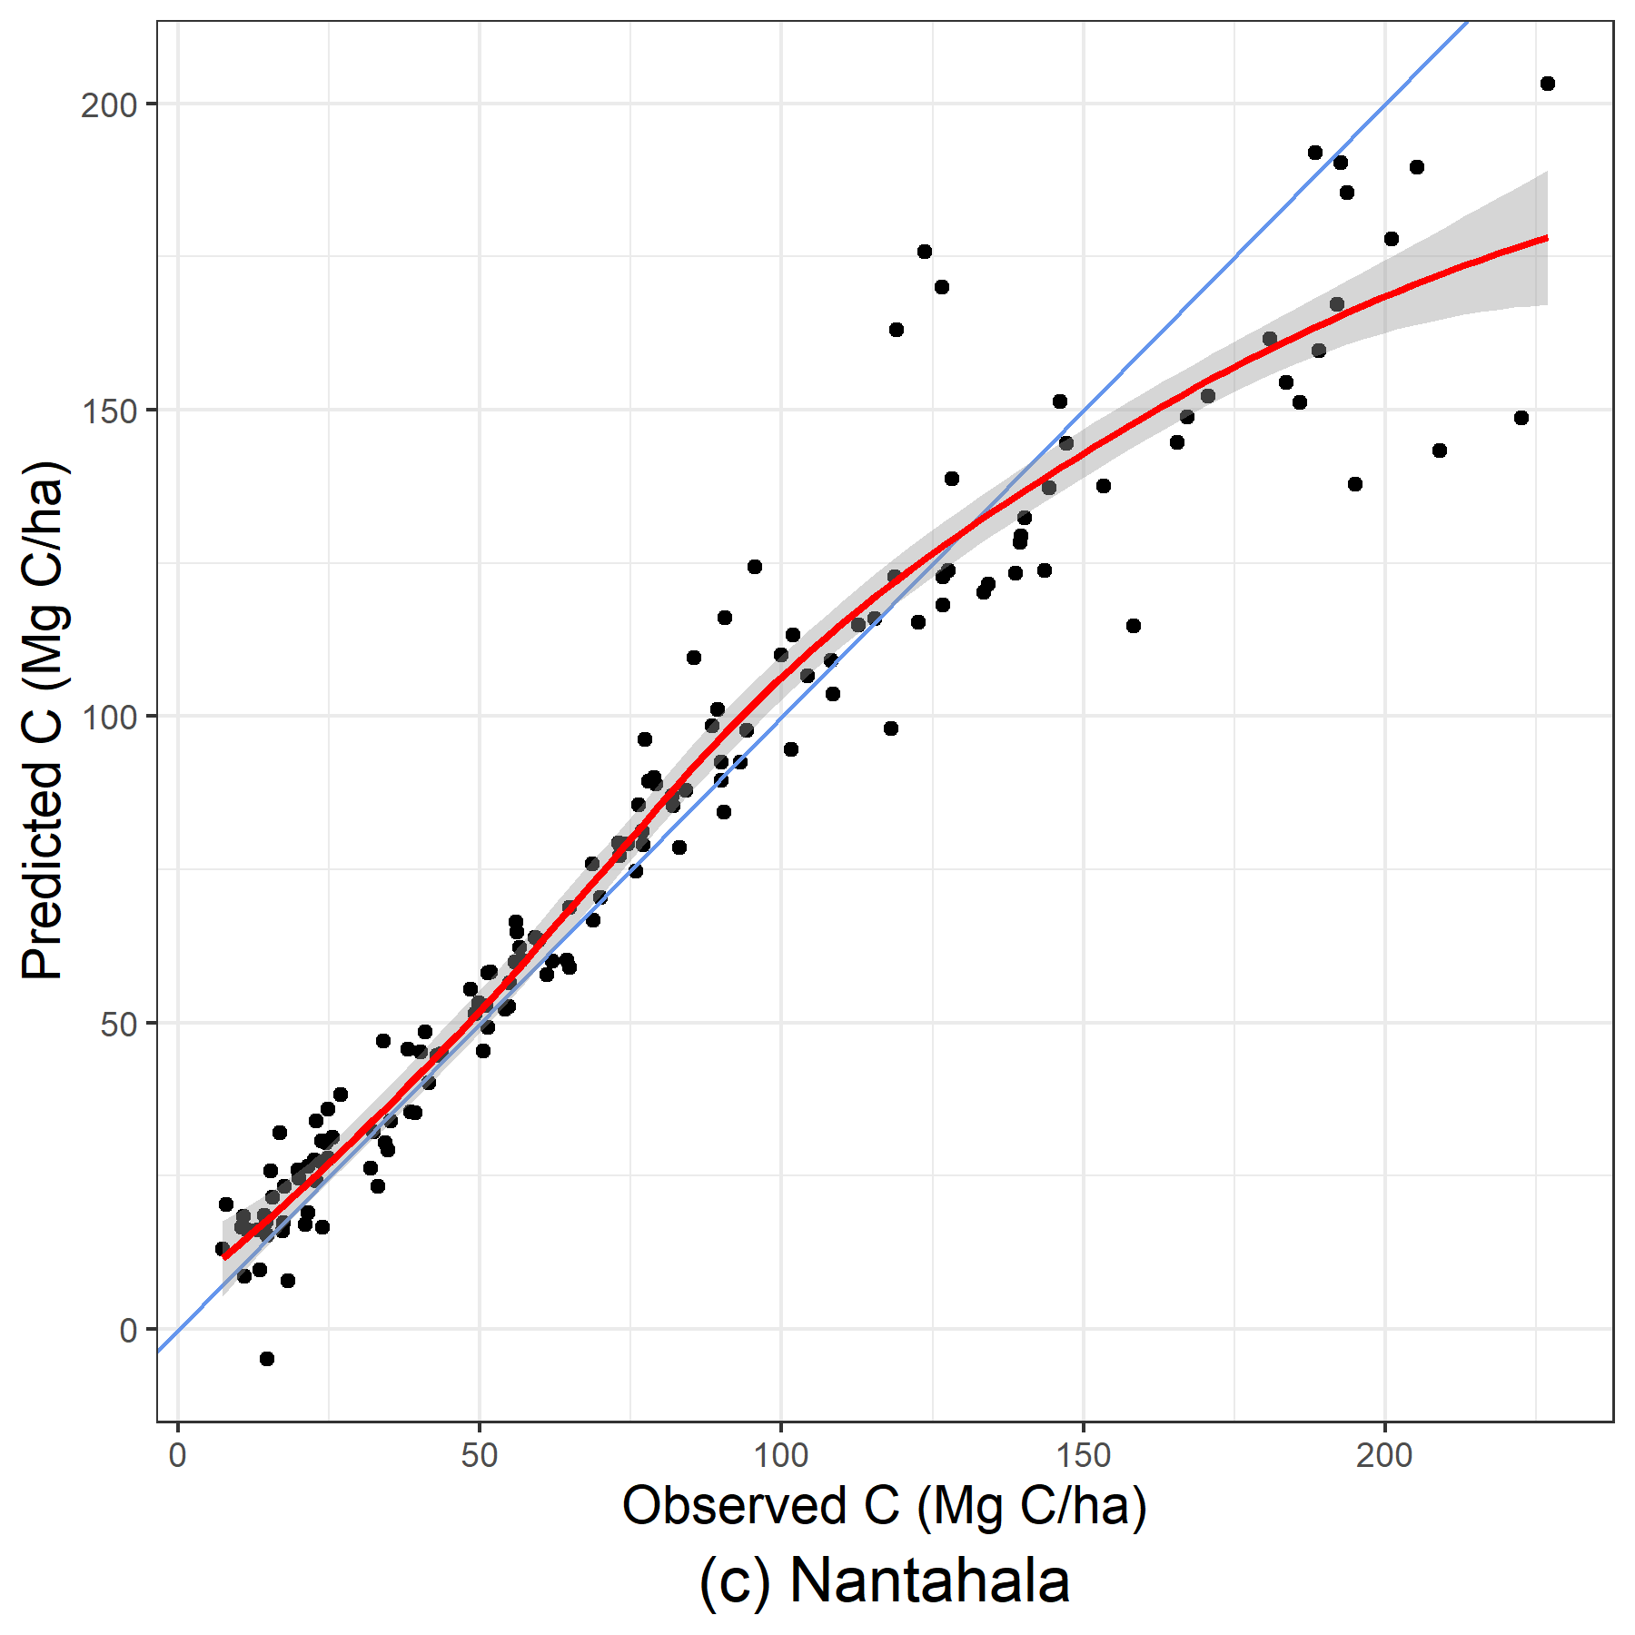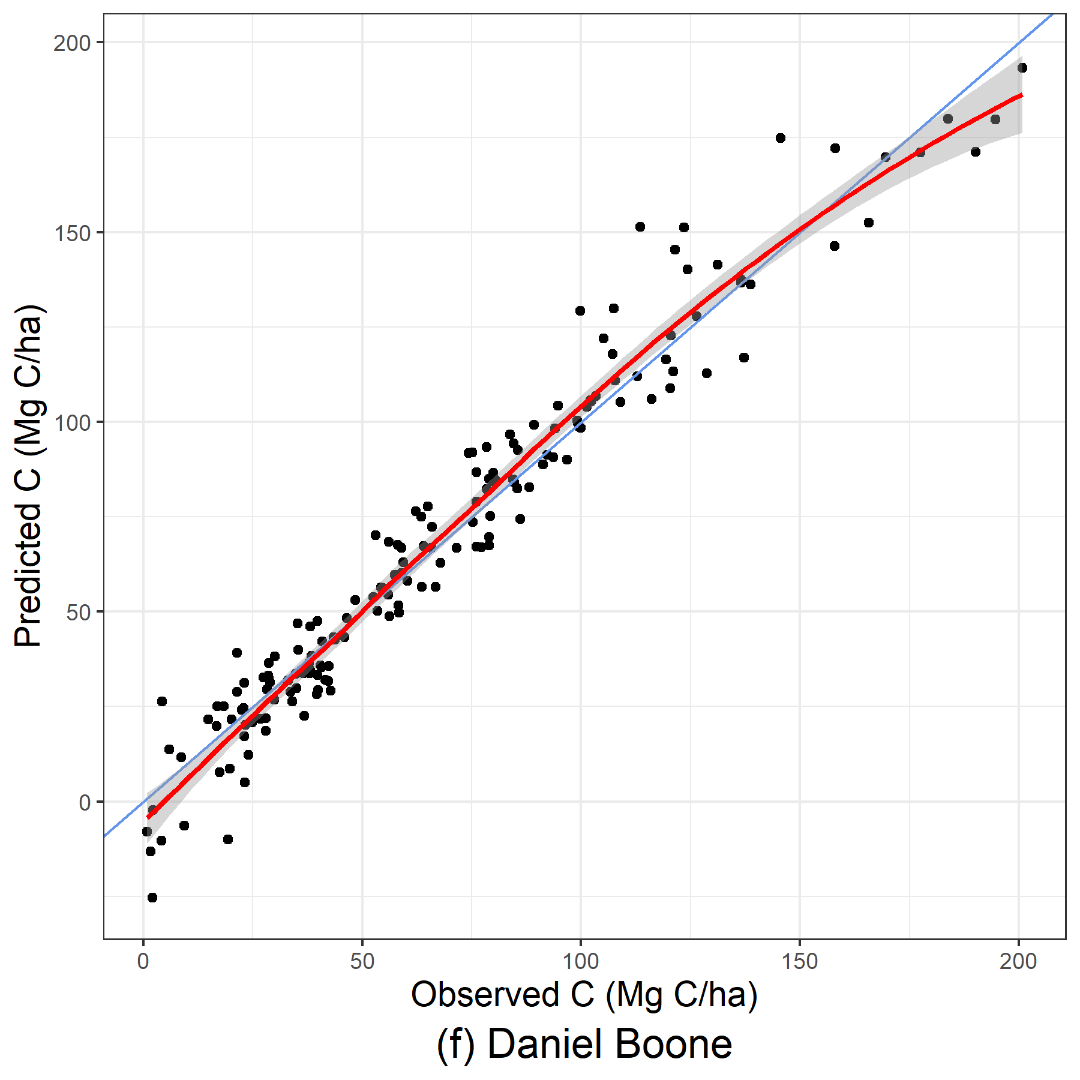
Figure 10: Predicted versus observed graphs of stand-only LME models for a poor OOB sample (Nantahala) and a well performing OOB sample (Daniel Boone).
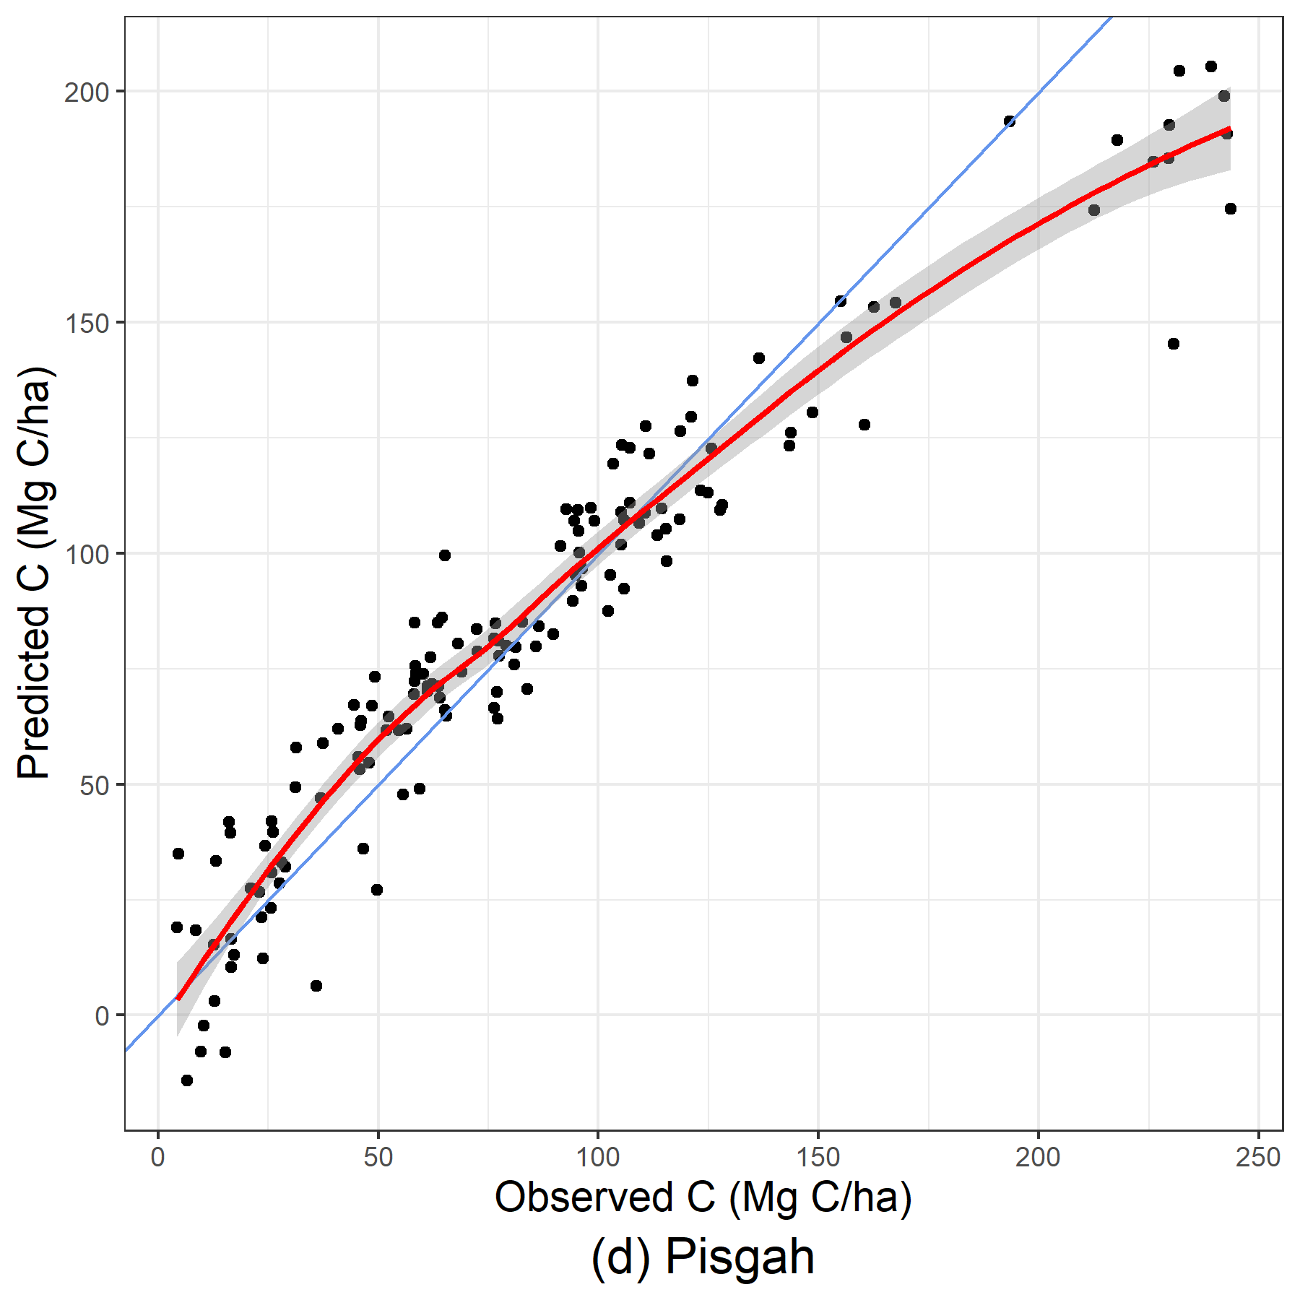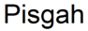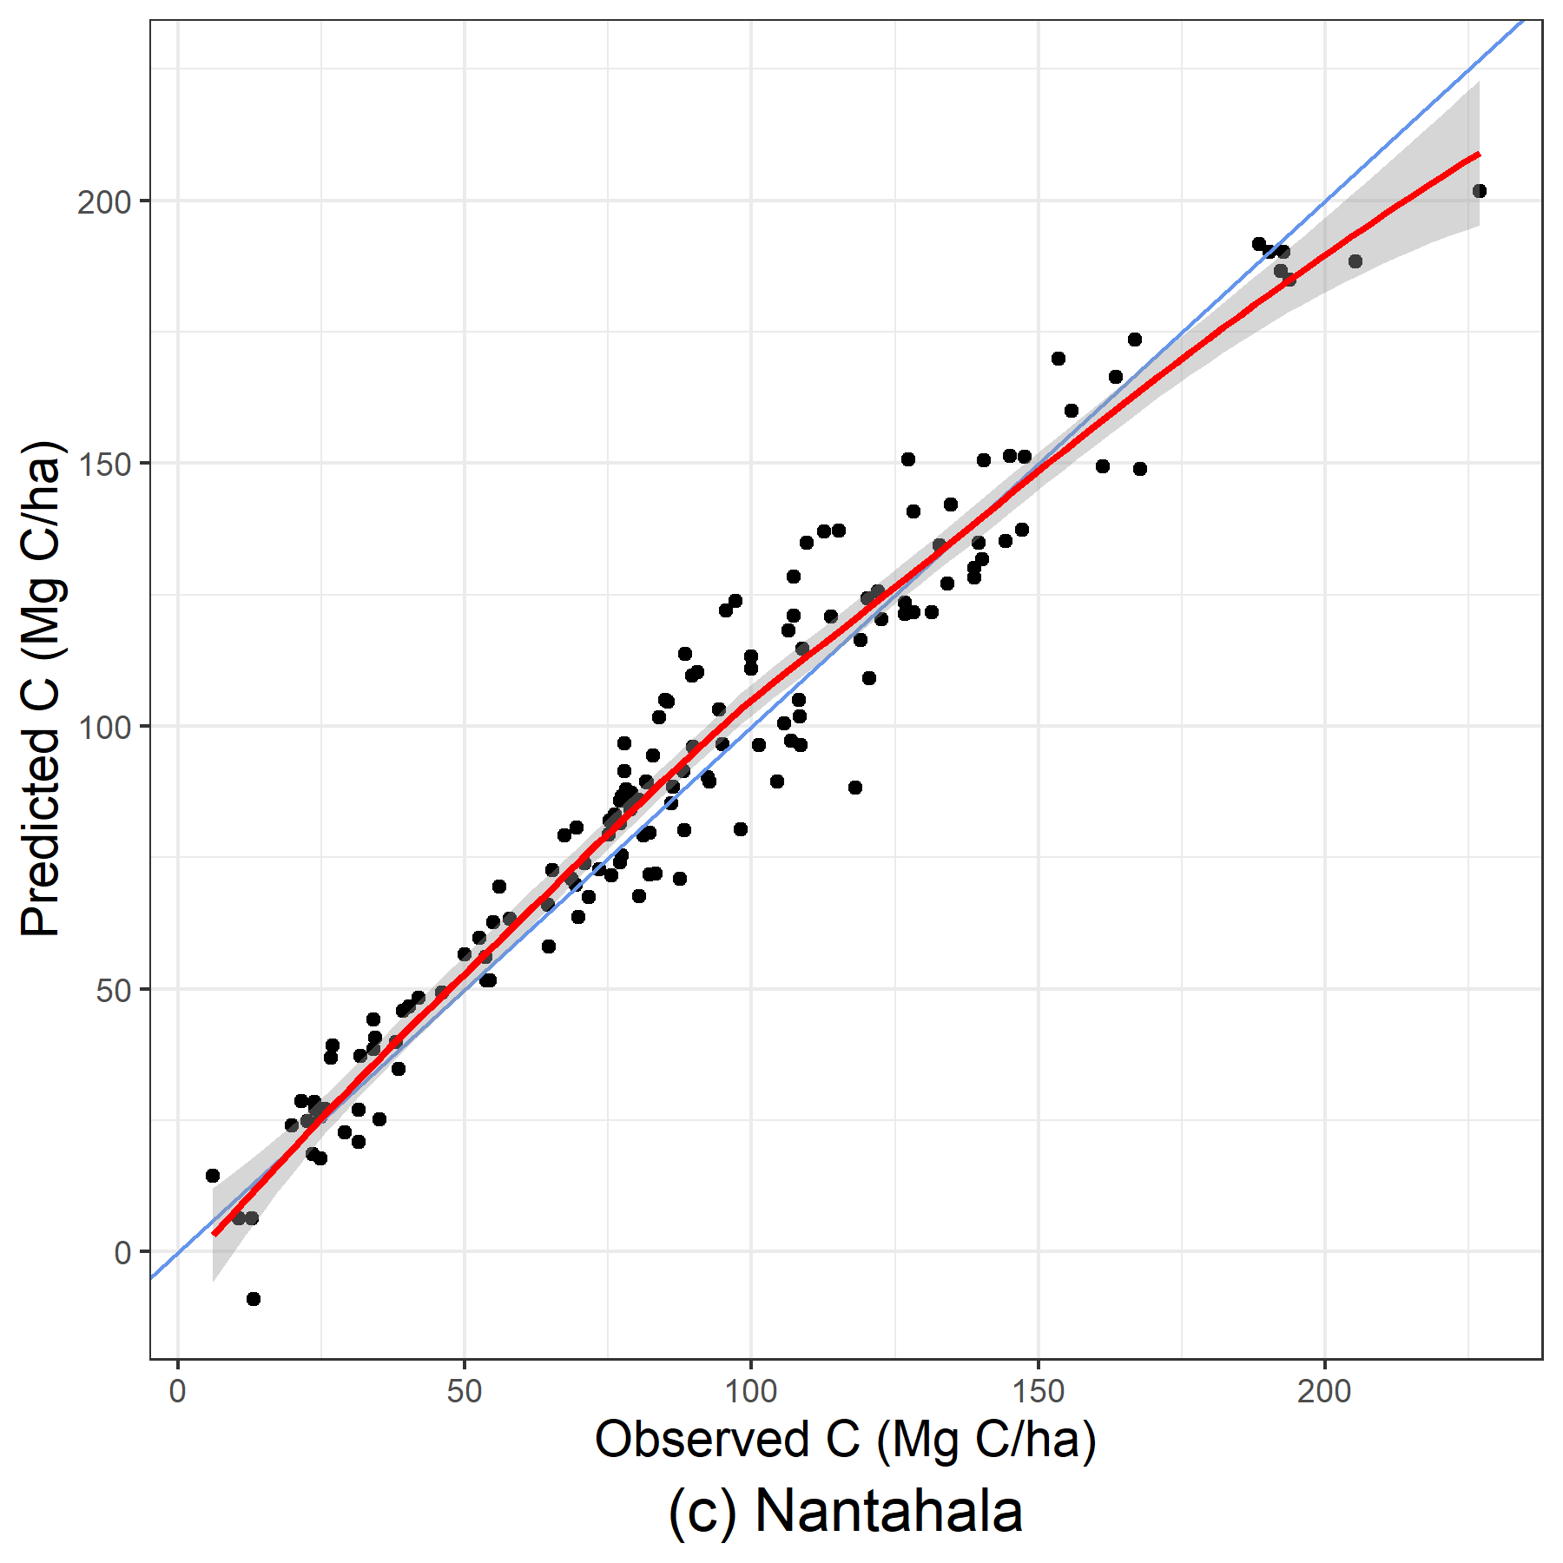
Figure 11: Predicted versus observed graphs of stand+environmental LME models for a poor OOB sample (Pisgah) and a well performing OOB sample (Nantahala).

DISCUSSION

EVALUATION OF DATASET COMBINATIONS
This study tested whether including environmental variables in three modeling approaches increased predictive power, as other studies have previously found (Aguirre et al. 2021, Liepiņš et al. 2022, Yang, Brandeis et al. 2022a). With the three modeling approaches tested, the inclusion of environmental variables resulted in model performance approximately as well as models fit without environmental variables. For the linear mixed-effect model, the inclusion of environmental variables improved model performance compared to only-stand variables, providing a stable, highly accurate prediction model for stand-level live aboveground carbon. For LASSO models and GAMMs, the inclusion of environmental variables did not improve predictive power, and was even detrimental in some regions, most clearly observed in

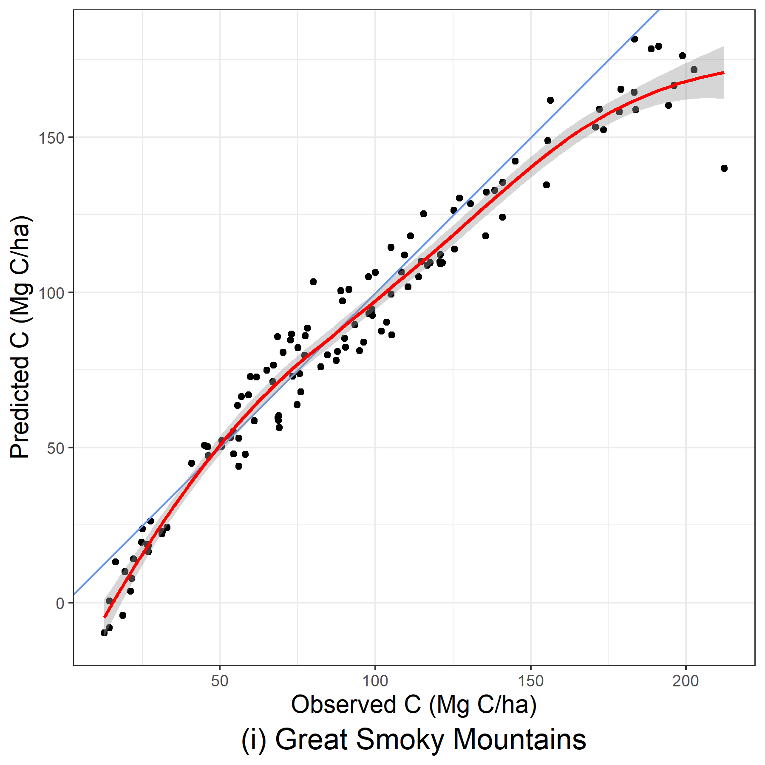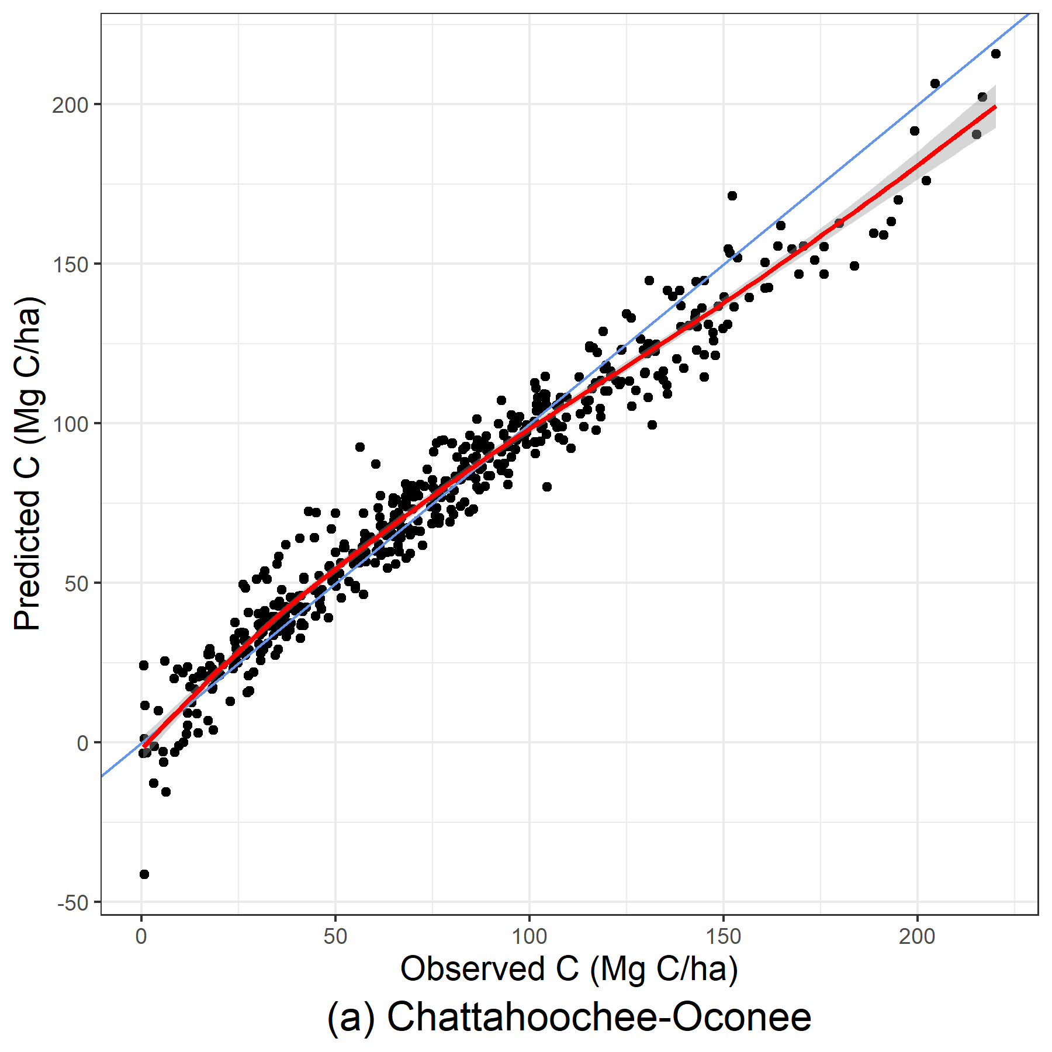
Figure 12: Predicted versus observed graphs of stand-only LASSO models for a poor OOB sample (Great Smoky Mountains) and a well performing OOB sample (Chattahoochee-Oconee).
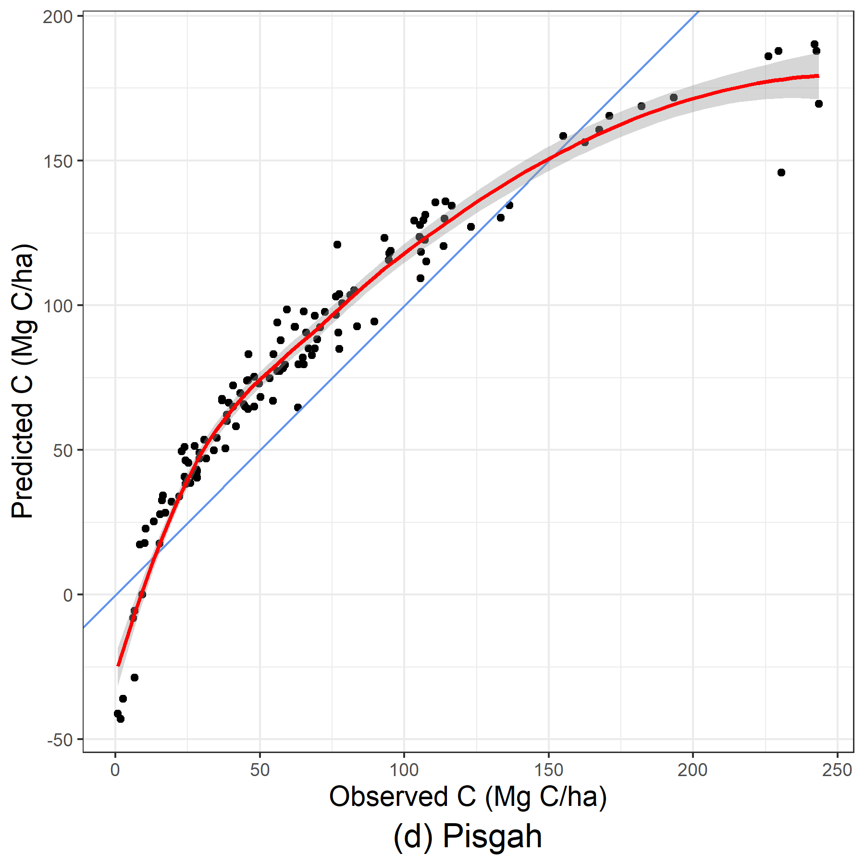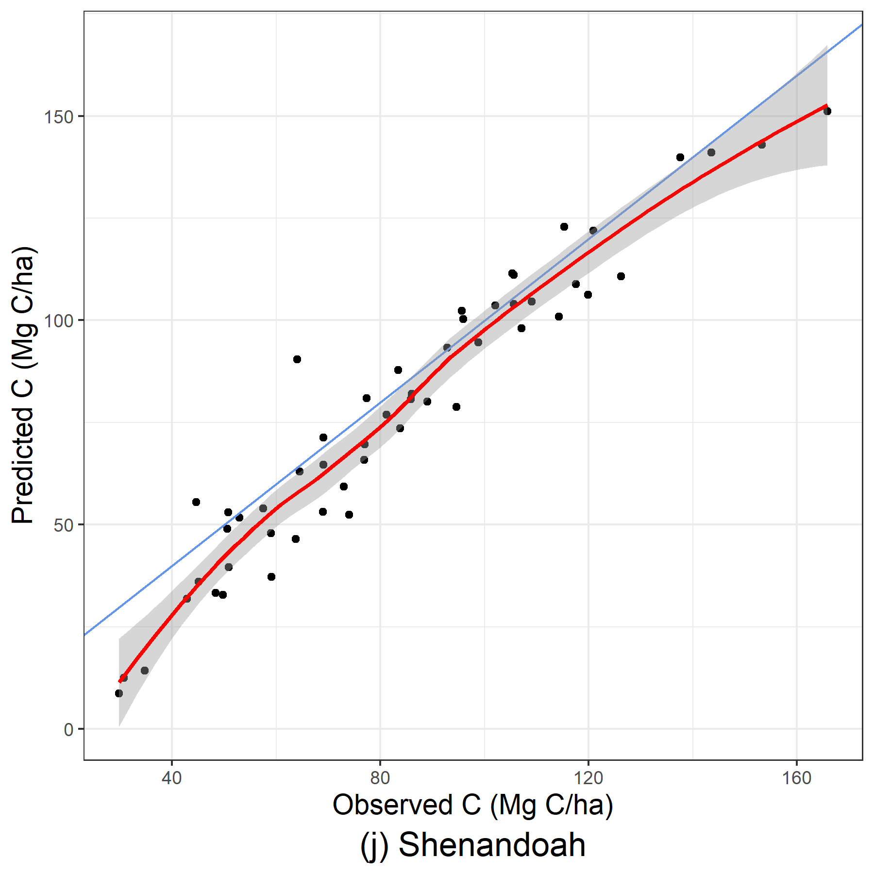
Figure 13: Predicted versus observed graphs of stand+environmental LASSO models for a poor OOB sample (Pisgah) and a well performing OOB sample (Shenandoah).

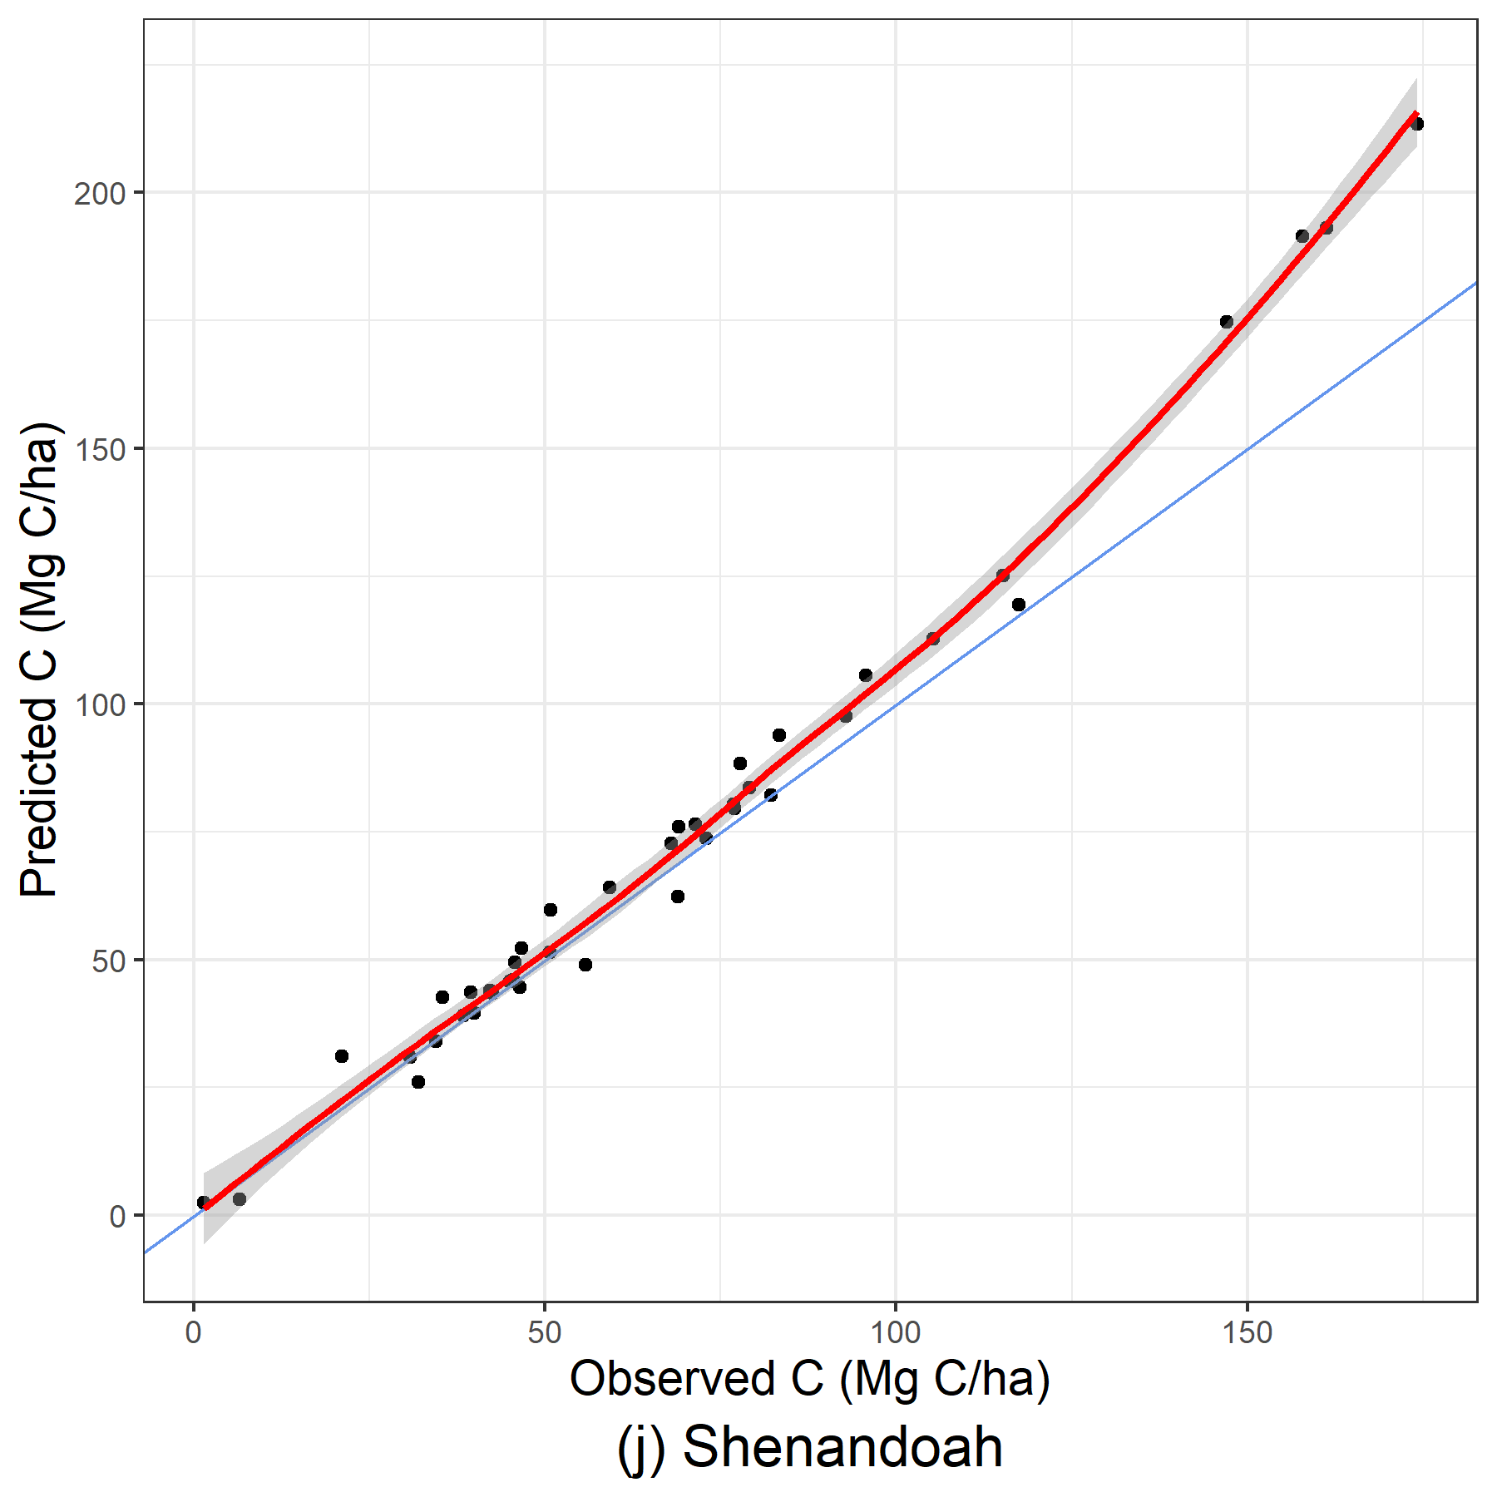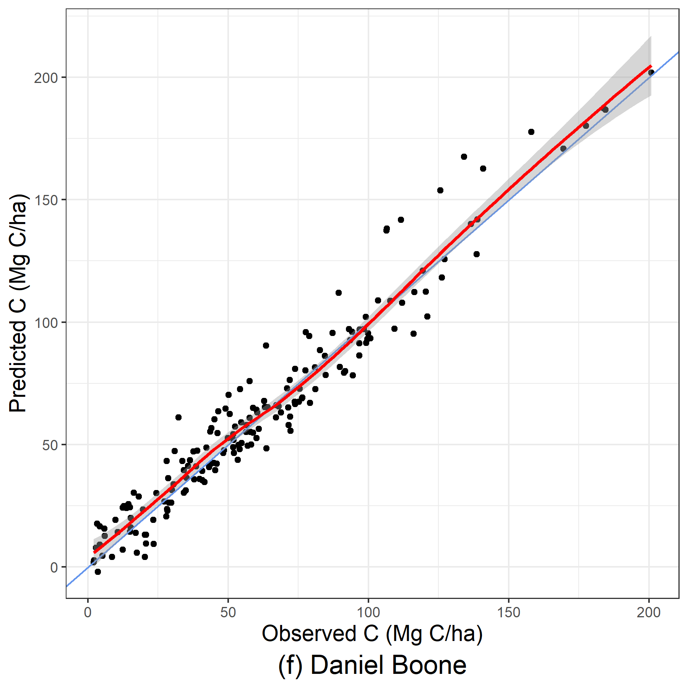
Figure 14: Predicted versus observed graphs of stand GAMMs for a poor OOB sample (Shenandoah) and a well performing OOB sample (Daniel Boone).
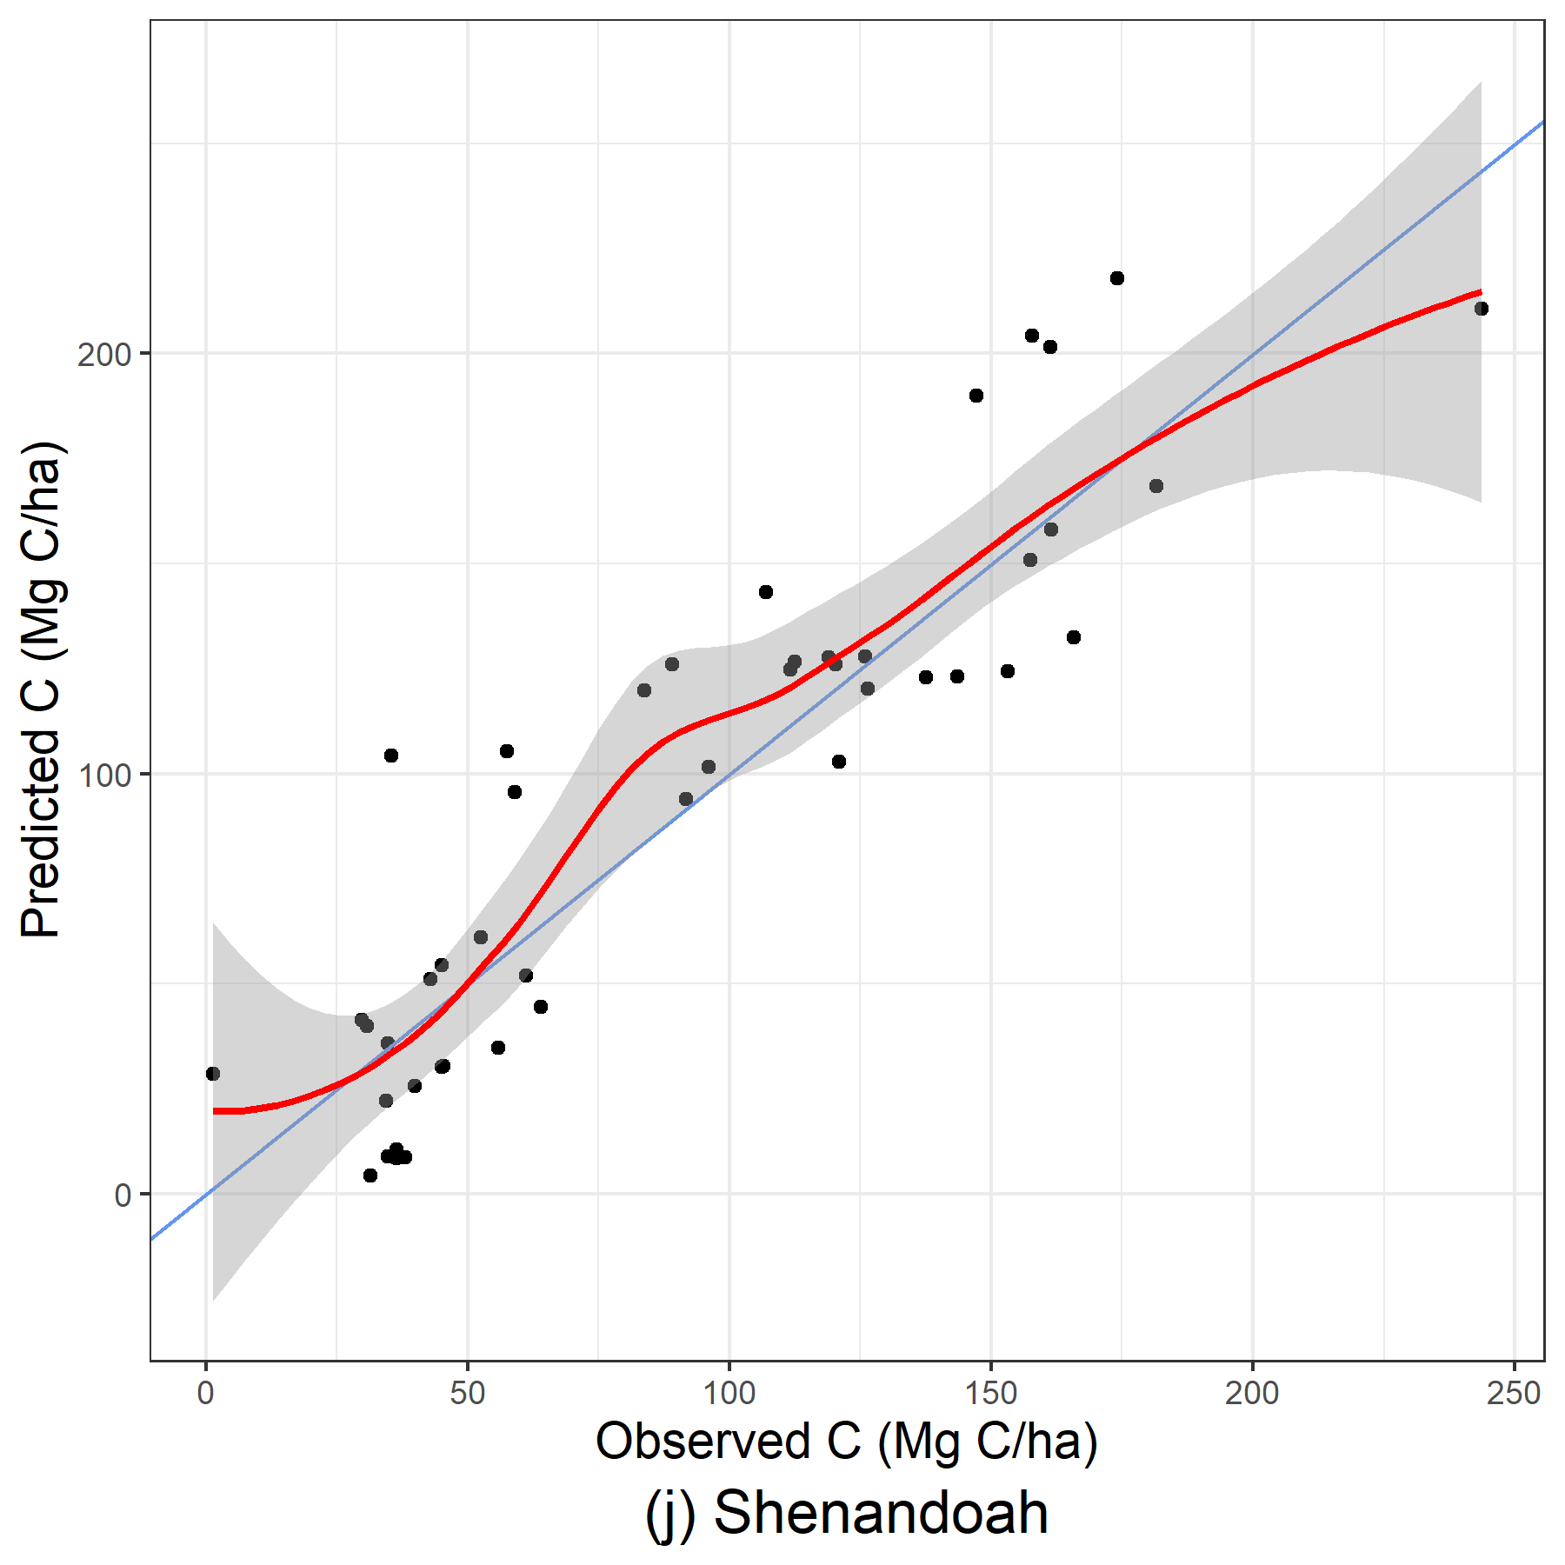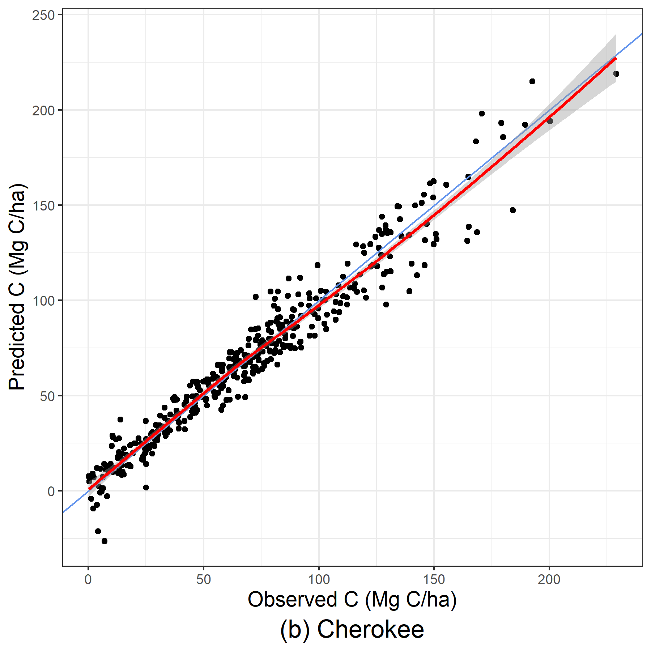
Figure 15: Predicted versus observed graphs of stand+environmental GAMMs for a poor OOB sample (Cherokee) and a well performing OOB sample (Shenandoah).
Shenandoah National Park. In addition, as previously mentioned, issues arose with including environmental variables in GAMMs, and additional data cleaning was required to identify and subsequently remove variables that prevented models from being fit. The inclusion of environmental variables in LASSO models and GAMMs reduced performance to the point that models could be unusable.
Compared to previous studies which demonstrated that the inclusion of environmental variables increased predictive accuracy, the number of stand-only variables used in this study sufficiently captured much of the variability to justify not including environmental variables. With 8 stand-level predictors already included, the environmental data was more likely to case model performance to decline, outweighing the small benefits observed in a few cases.

EVALUATION OF MODEL APPROACHES
Out of the three modeling approaches tested, LME models performed the highest and were the fastest due to its simple form. Its accuracy is similar to those reported in Mohd Zaki et al. (2017), which used multiple linear regression techniques combined with field and remotely sensed forest metrics. It consistently produced accurate estimates across all regions, even with smaller sample sizes. Compared to LME results presented in Yang et al. (2025), RMSE was similar in OOB performance, but MB from this study were non-zero. The increased bias may be due to overfitting the model with the extra variables, ultimately resulting in a poorer performing model.
GAMMs performed the second best; stand-only GAMMS produced as accurate estimates as stand-only LME models, but some regions had models that performed far worse and possibly unusable altogether. Sample size appeared to have an effect on performance, with larger samples having better estimates. While a specific threshold for improved performance was not identified in this study, this relationship in performance and sample size follows what has been previously documented in research and an tenet of the central limit theorem (Faraway 2015, Temesgen et al. 2015). Future studies can identify the effective sample size needed or investigate alternative causes of decreased performance. GAMMs were able to produce accurate estimates, but their inconsistent performance in smaller regions and additional data cleaning needed is more cumbersome than the LME models. The instability observed is likely due to the presence of multicollinearity, which can be further investigated in future studies through fitting GAMMs with more selective predictors. However, GAMMs should not be fully discounted, as predicted versus observed figures show that GAMMs can better estimate larger carbon values than LMEs, as evidenced by LOESS curves of OOB GAMMs closely following the 1:1 diagonal line and overlapping at high carbon values. The LME models’ LOESS curves, on the other hand, consistently fall under the 1:1 diagonal line. This improved fit at higher carbon values demonstrates one advantage of GAMMs’ flexibility in capturing non-linear relationships. In addition, GAMMs did not take considerably longer to compile than LMEs, which keeps GAMMs as a model contender for carbon estimation. Caution should be taken to ensure that the model is well trained before implementation in small regions covering similar areas as Wayne National Forest and Shenandoah National Park.
LASSO models consistently performed the worst, along with having the longest processing time. As stand and environmental variables were highly collinear, it was hypothesized that LASSO’s feature selection would be able to remove additional variables that do not aid in explaining the response variable should help with model overfitting and increase predictive power. However, the opposite was observed. Out-of-samples showed high enough variability, with average prediction performance and model stability that is lower than LME models and GAMMs. In regions with fewer observations, model error and bias varied greatly between each bootstrap model trained for certain regions; model metrics reported very low R-squared and much higher MB and RMSE at the 2.5% lower confidence intervals when compared to regions with more observations or LME results. Even in regions with better performance, model performance dropped enough to determine that LASSO models are generally inadequate for estimating live aboveground carbon. In addition, many samples’ optimized lambda parameter was zero, defeating the point of conducting LASSO regression. Due to the five-fold cross-validation approach used to optimize lambda, fitting the LASSO models expended a large amount of computational power. While the cross-validation approach can be removed to expedite processing time, the LASSO approach can be abandoned altogether for the more efficient LME approach.
While these LASSO models were not able to provide the most accurate estimates, the two regions when the median lambda estimate was not zero (stand-only variables in Great Smoky Mountains National Park as well as stand-only and stand + environmental variables in Shenandoah National Park) can be later studied to understand what differentiates these cases from the other regions and models. Further exploring lambda optimization and coefficient interpretation to identify notable predictors can be conducted, which can provide deeper insight into the influence of stand and environmental conditions on live aboveground carbon.
It should also be noted that all models produced estimates smaller than 0 MgC/ha, which has no biological meaning. These negative values are to be expected, as all the modeling approaches tested do not have constraints to bound prediction limits. Converting negative estimates to 0 was not performed in this study in order to highlight that negative estimates occur possible with methodologies tested and can be modified post-prediction. Other modeling approaches that constrain prediction values may be explored in future studies, such as constraining the intercept to pass through the origin.
All models tested in this study outperformed alternate carbon estimation methodologies for mixed-species models investigated in other studies (Li et al. 2019, Peng et al. 2019, Hudak et al. 2026). Compared to LME only model tested in Yang et al. (2025), median OOB MB values from this study were non-zero compared to the 0 median OOB MB shown in the aforementioned study. RMSE values were approximately the same when comparing these two studies. Yang et al. (2025) used 6 stand-level variables, which is a reduced number of predictors compared to this study, but with many of the same stand-level predictors used between the two studies. The increased median MB reported in this study could be caused by the addition of 3 additional stand-level variables that do not aide in explaining the variability present.

CONCLUSION
When implementing the results from study, LME models are able to be trained the fastest and with great accuracy, which fulfills the goal of efficient large-scale forest monitoring. However, larger carbon values were better estimated with GAMMs, but a large enough dataset is required to train the GAMMs to have enough stability to be usable. LASSO models had the worst performance metrics and demonstrated high instability as well. Despite the feature selection properties of LASSO models, lambda was optimized to be at zero in many samples, indicating that no penalty was applied and feature selection was not performed. Including environmental variables was able to slightly increase model performance for LME models but presented issues in model fitting and performance for LASSO and GAMMs that undermine the latter two approaches’ usability.
The mixed-effect approach used in each modeling type produces a global model capable of producing estimates across large, forested regions that contain many types of mixed-species forests. The development of these models allows forest managers to monitor forest changes and health at the scales needed more efficiently than through extensive forest inventories. Training models using a national forest inventory database allows for this study to be easily expanded to other regions to allow for efficient broad-scale forest monitoring.

APPENDIX
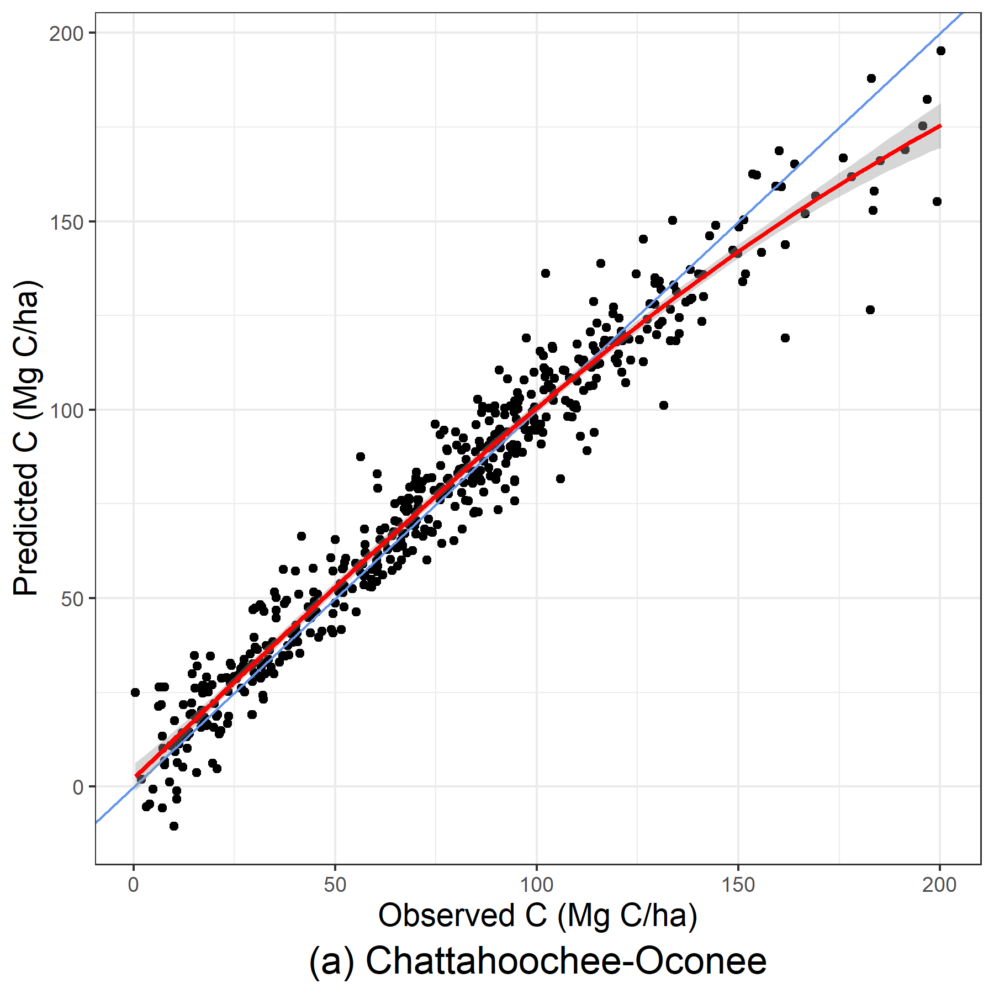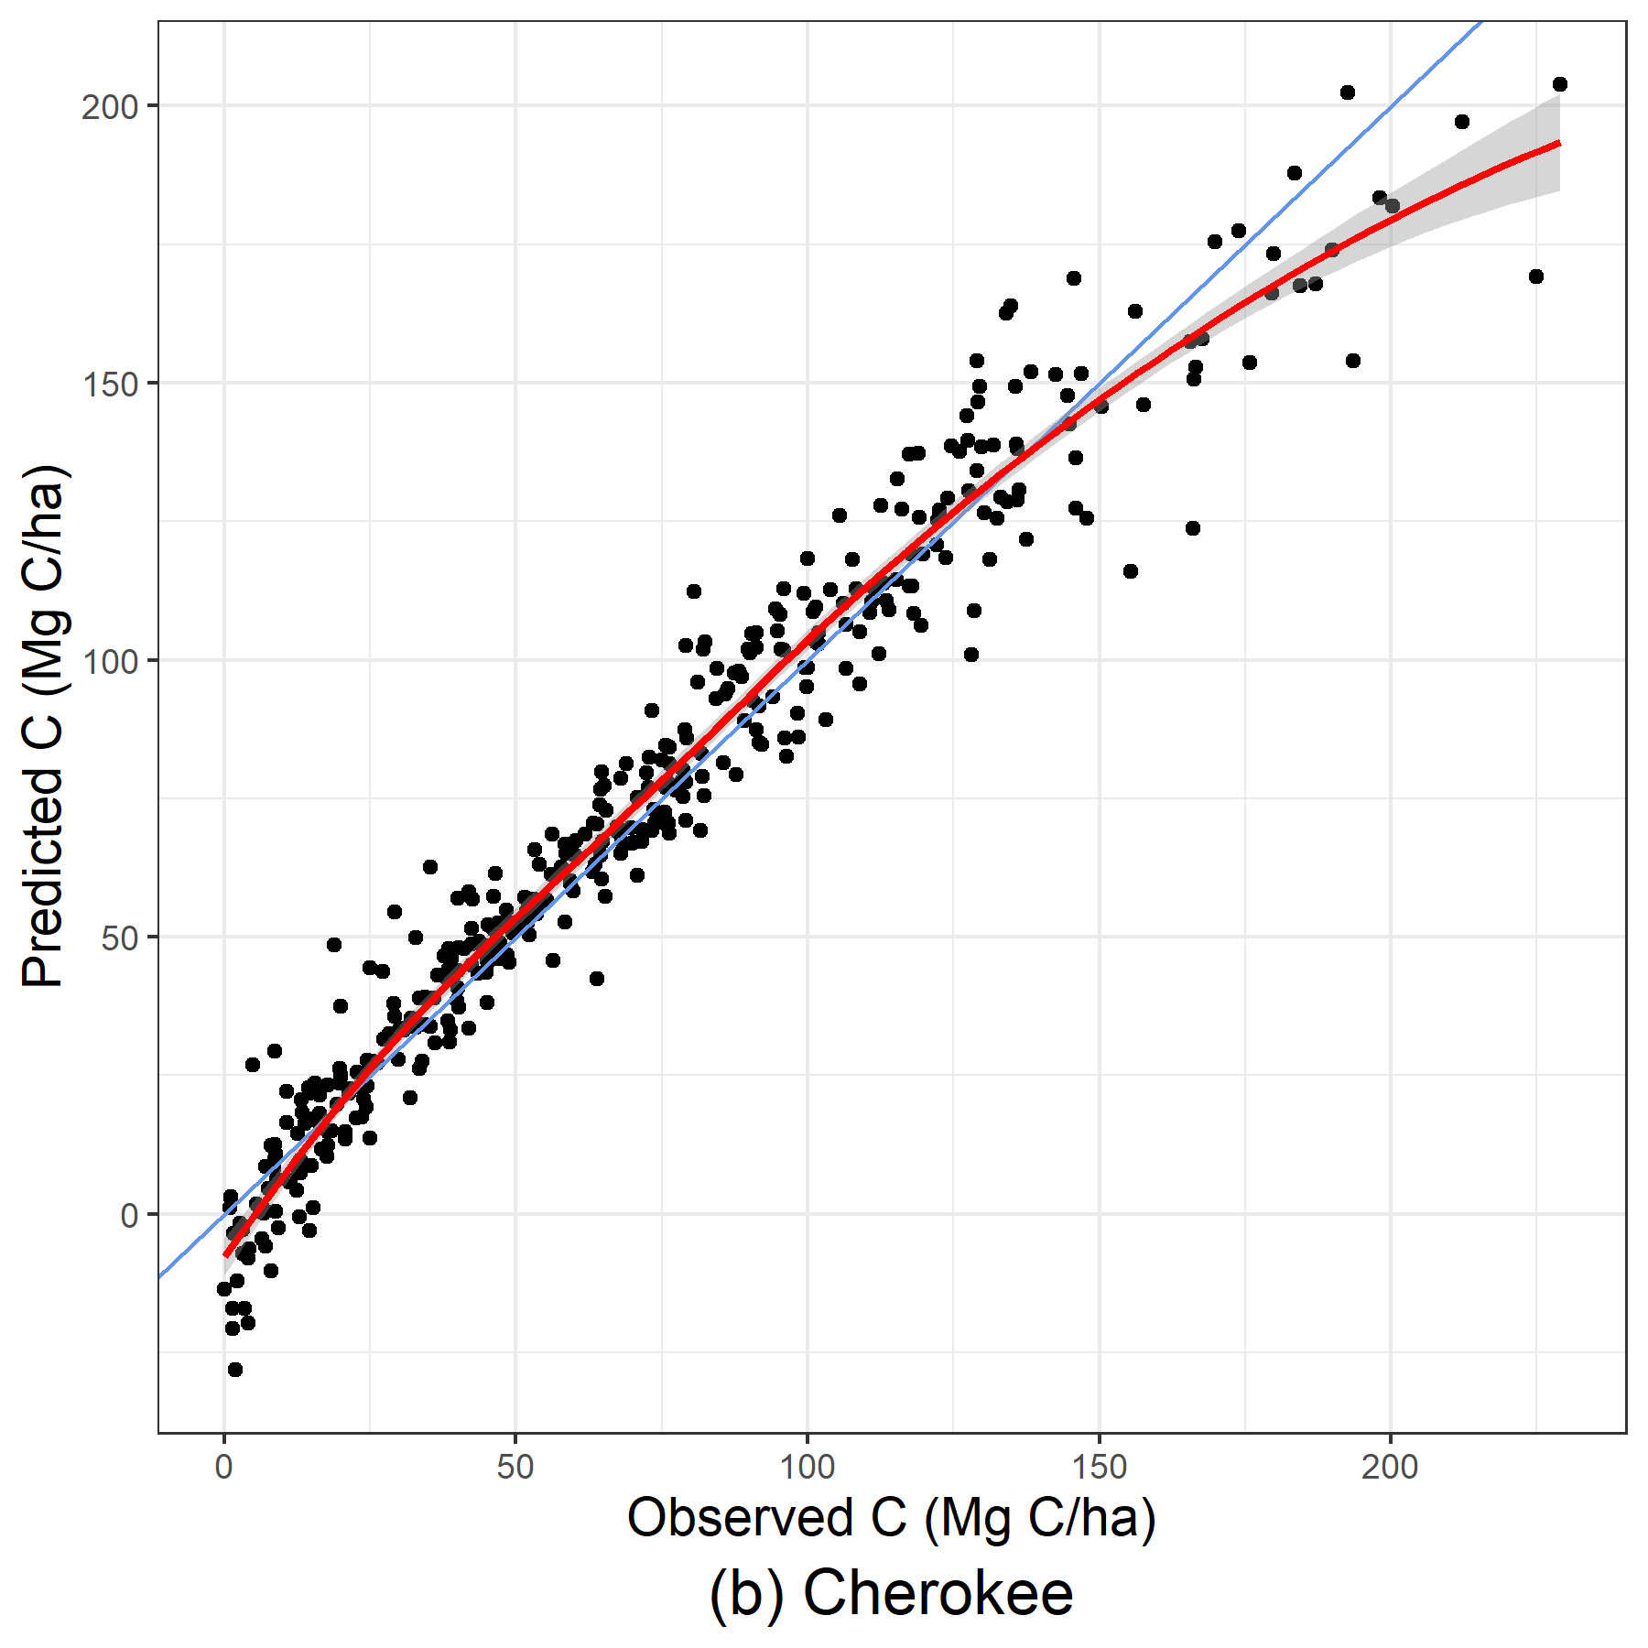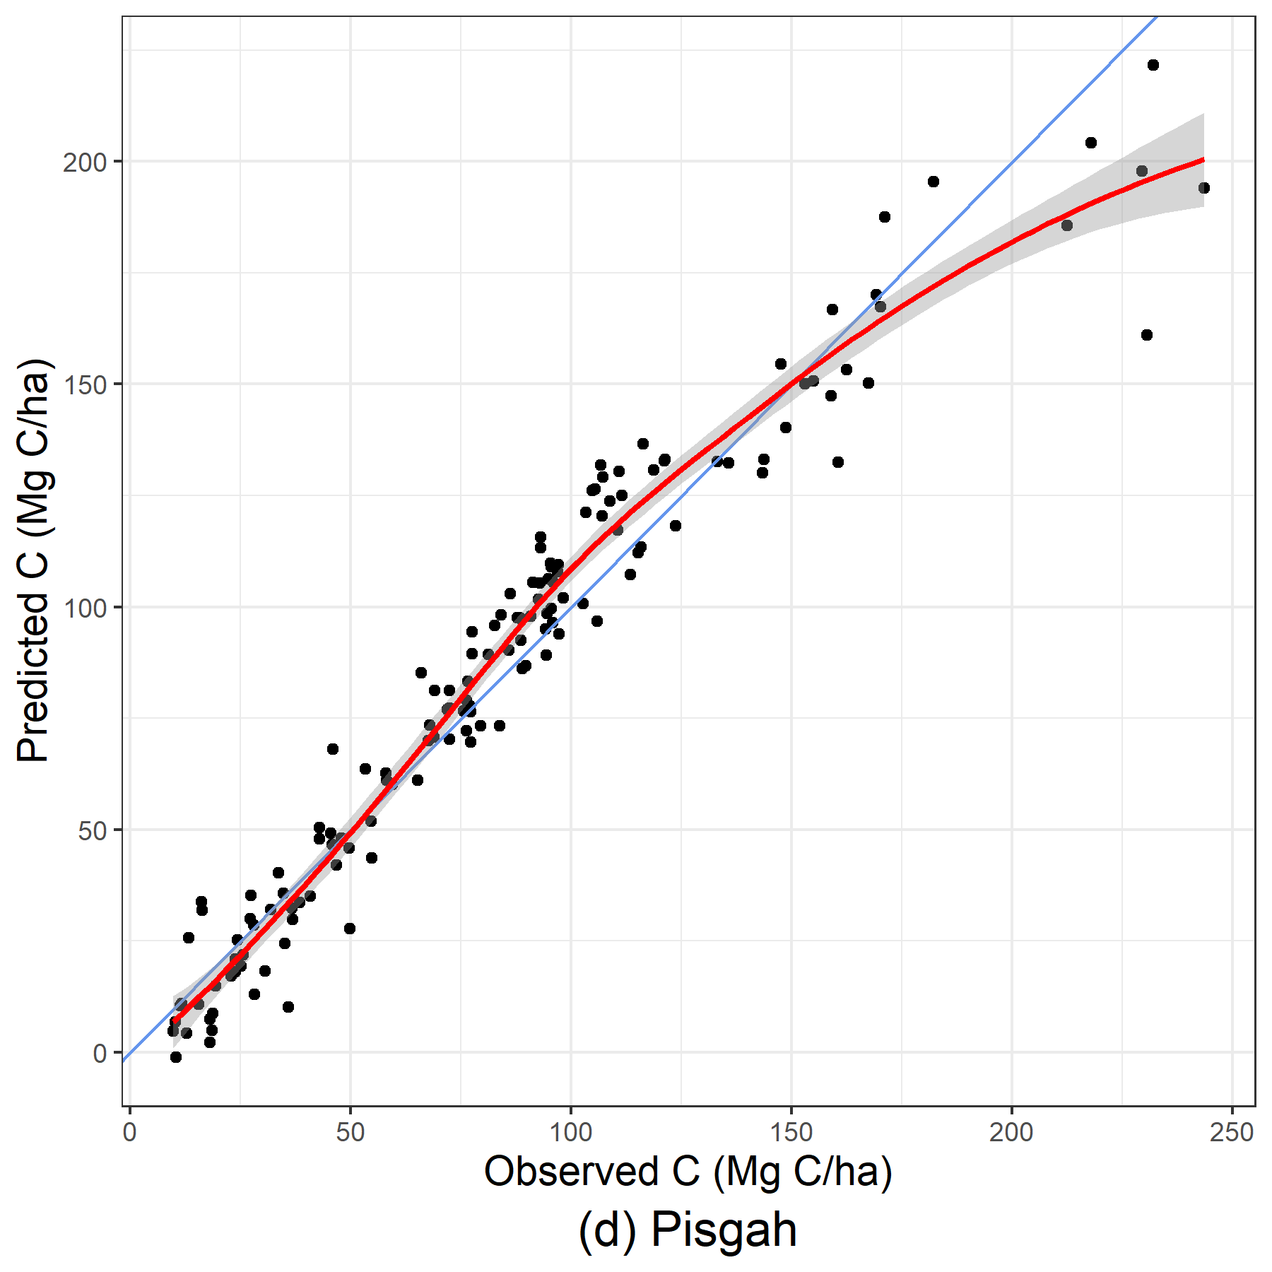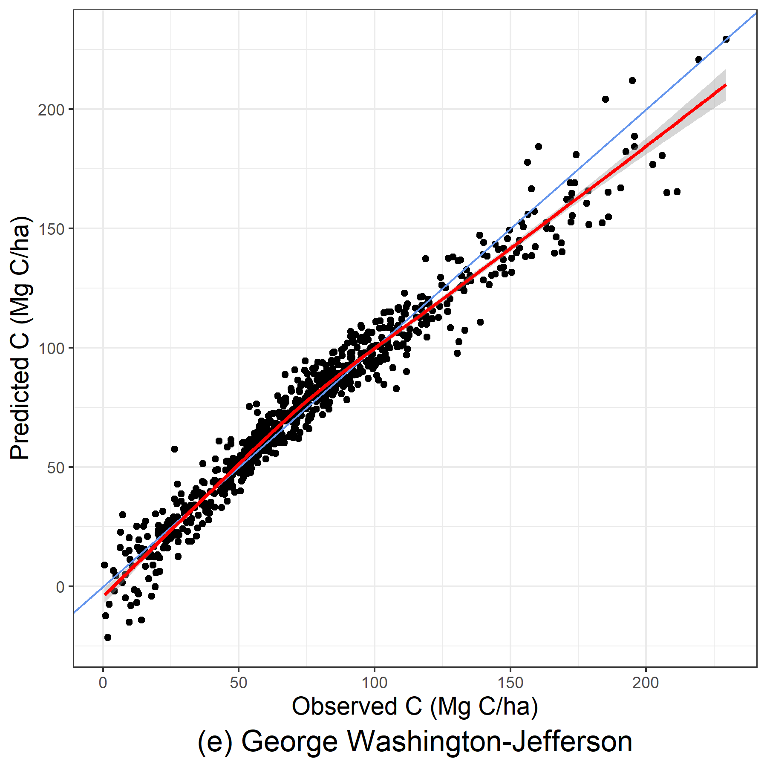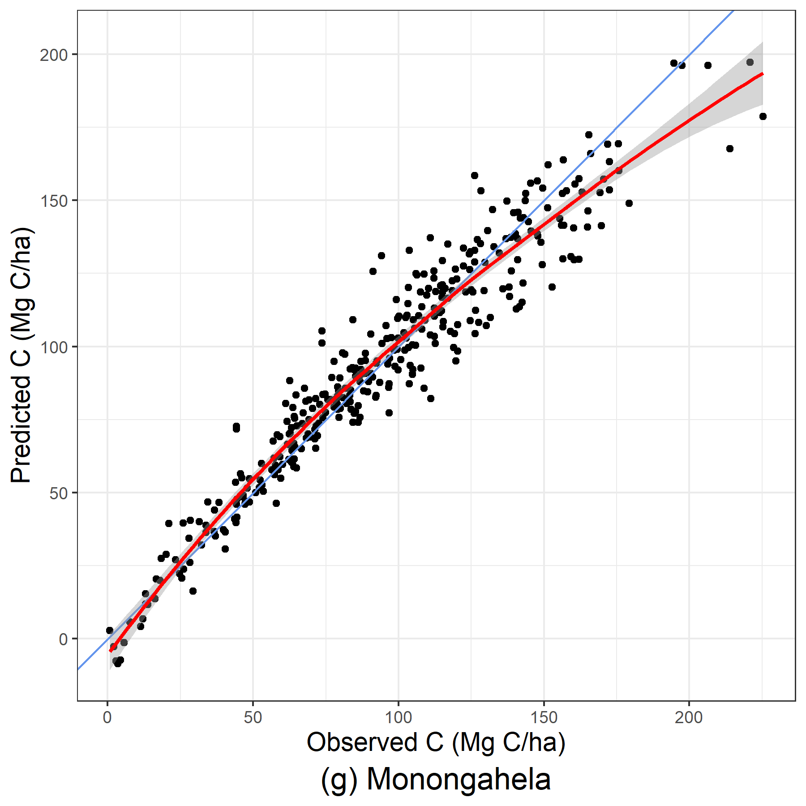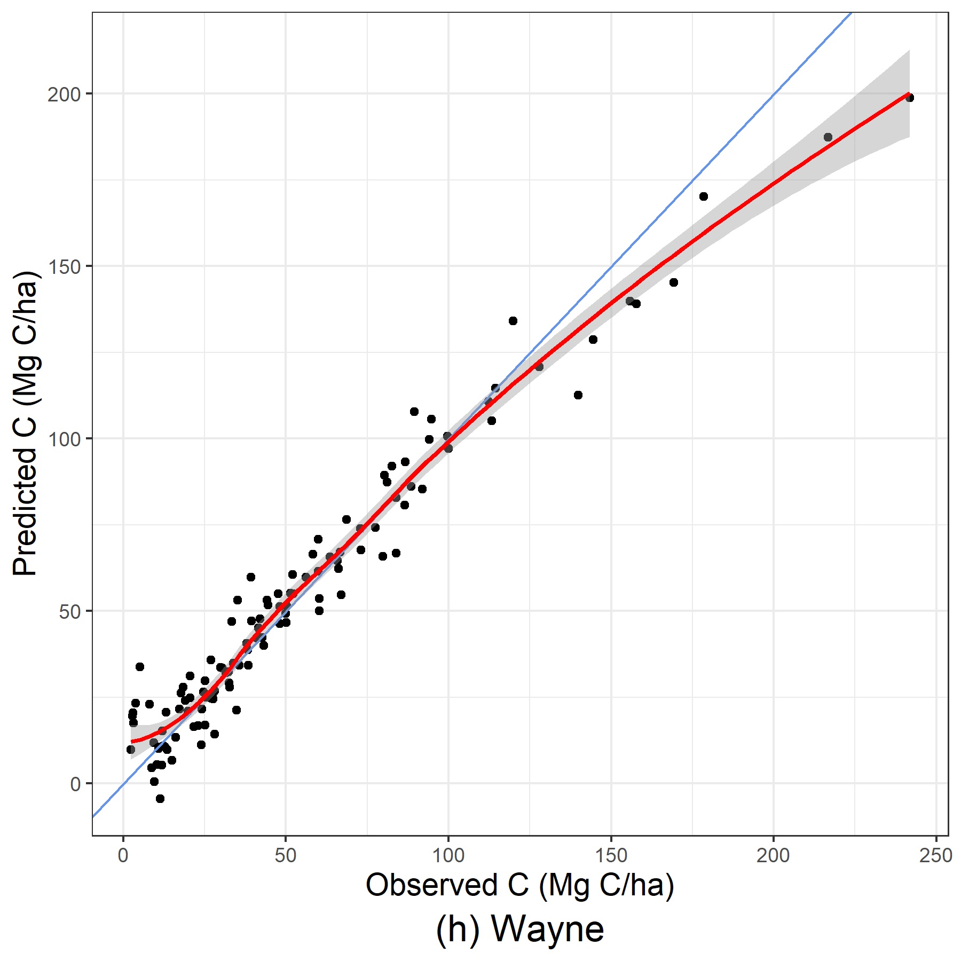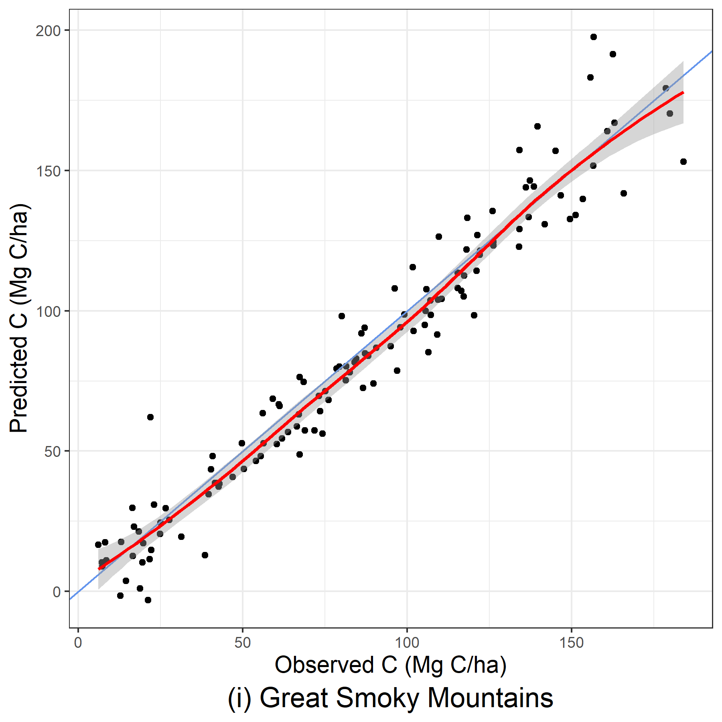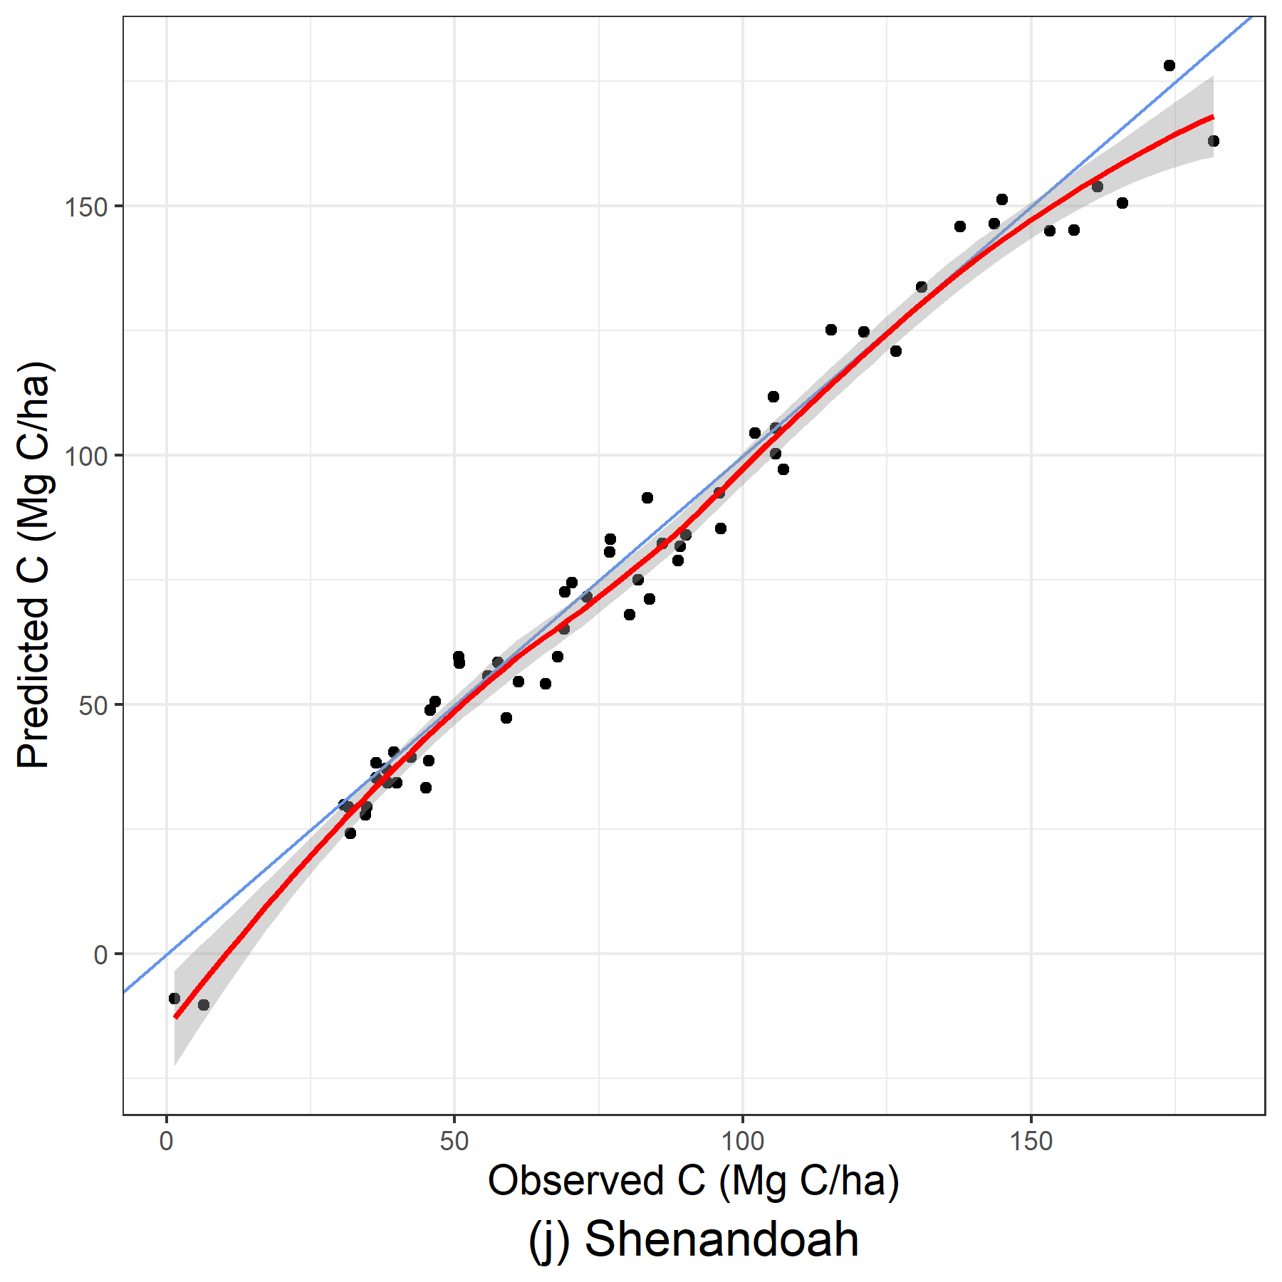
Figure 16: Predicted and observed carbon per hectare (Mg C/ha) from out-of-bag samples for linear mixed-effects using stand-level variables.
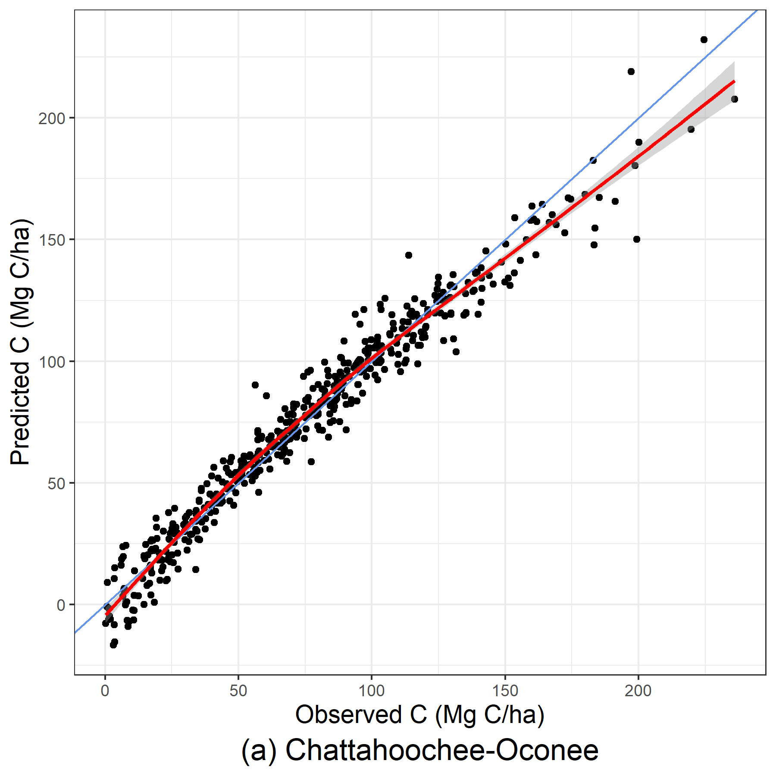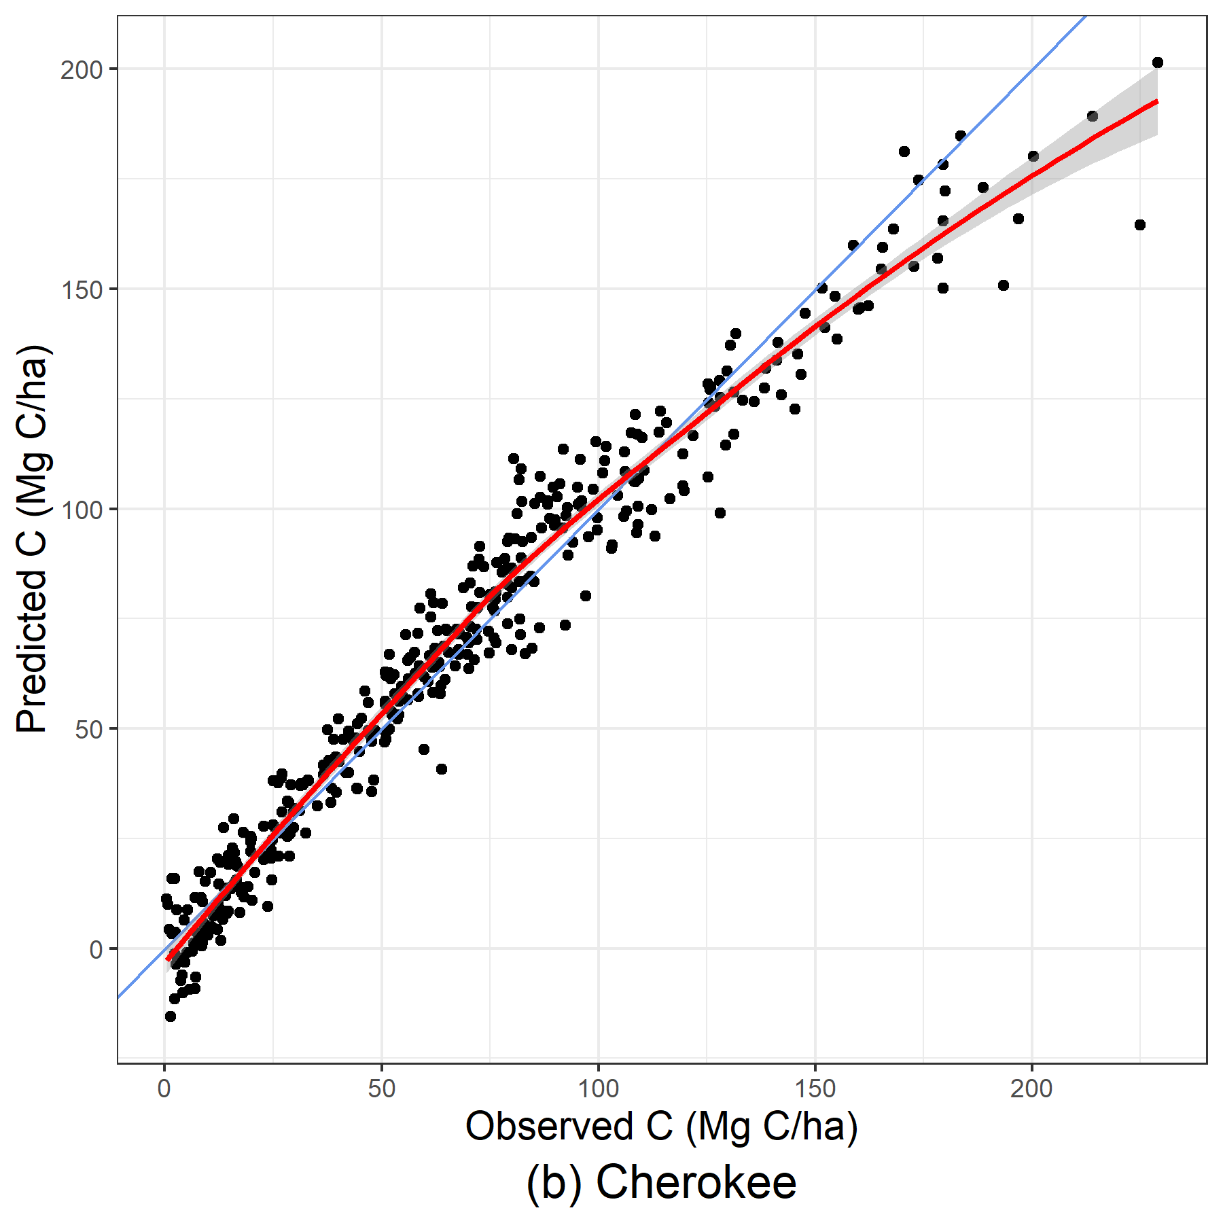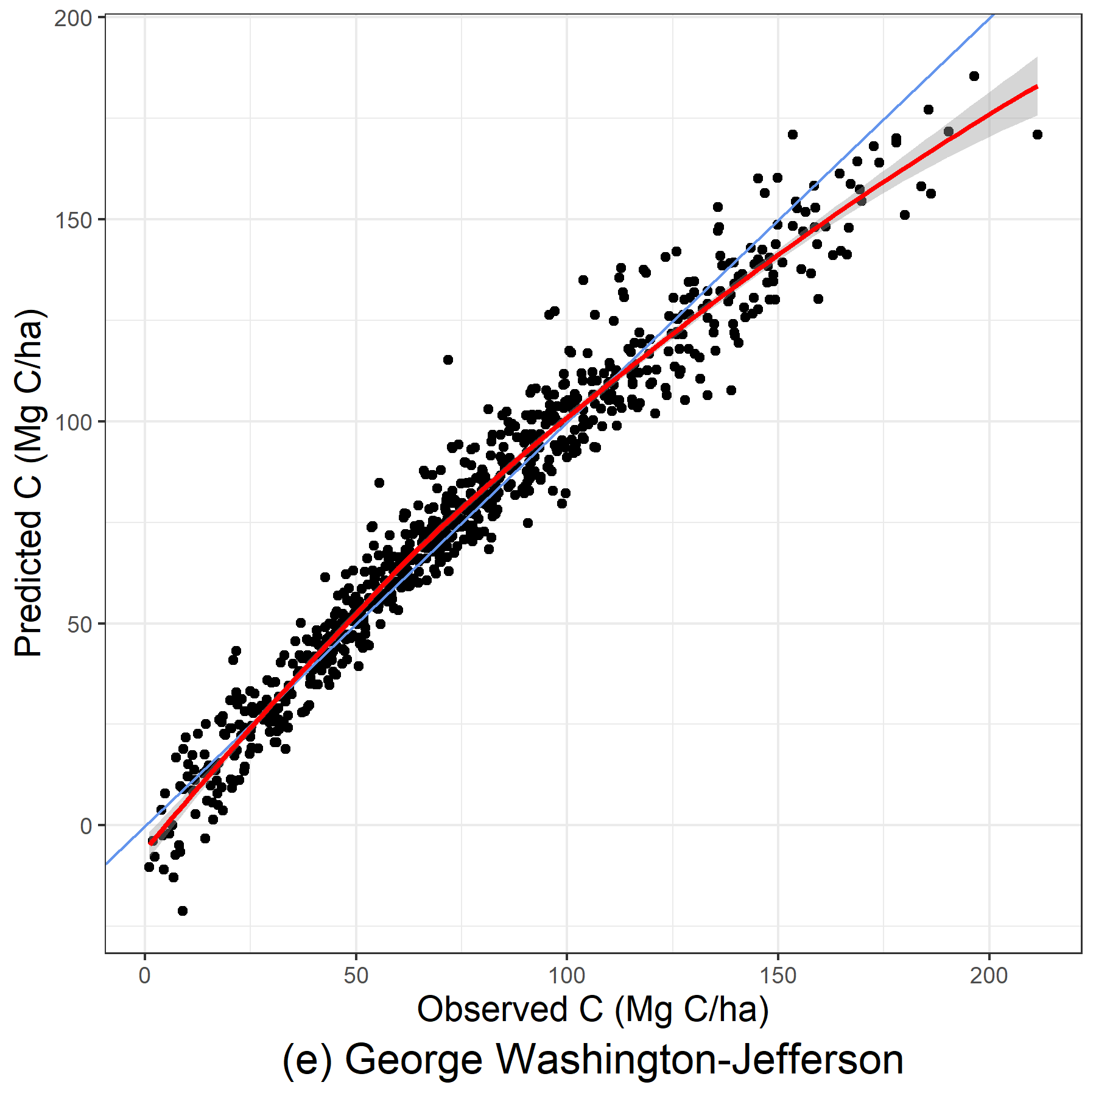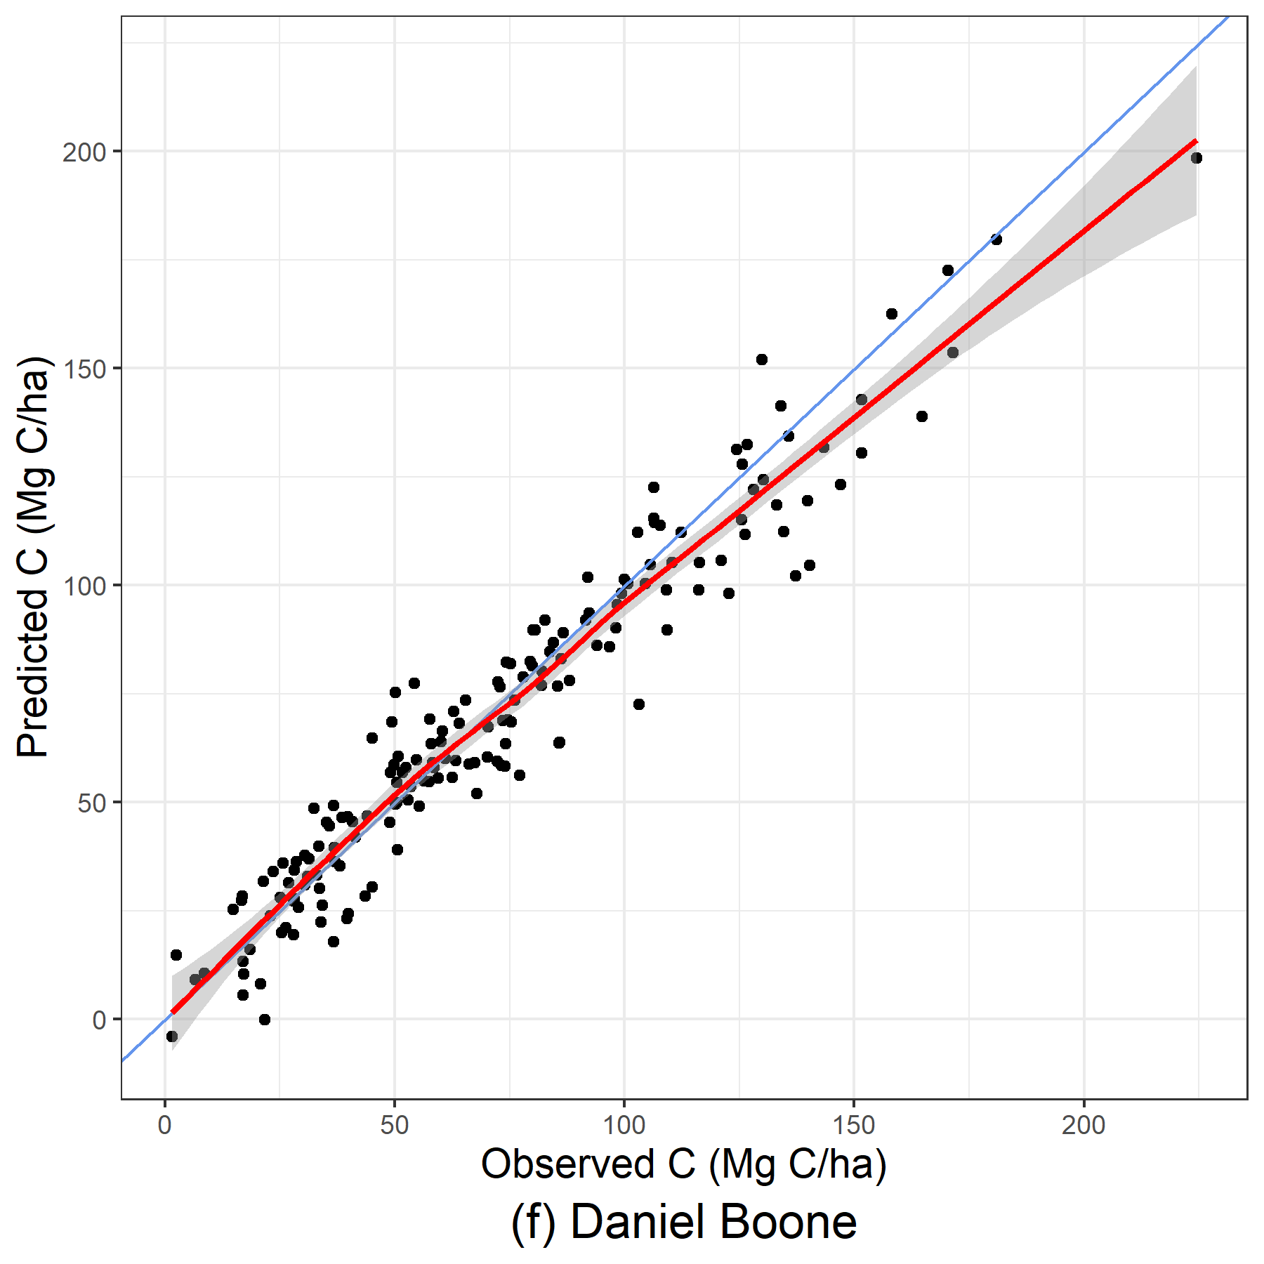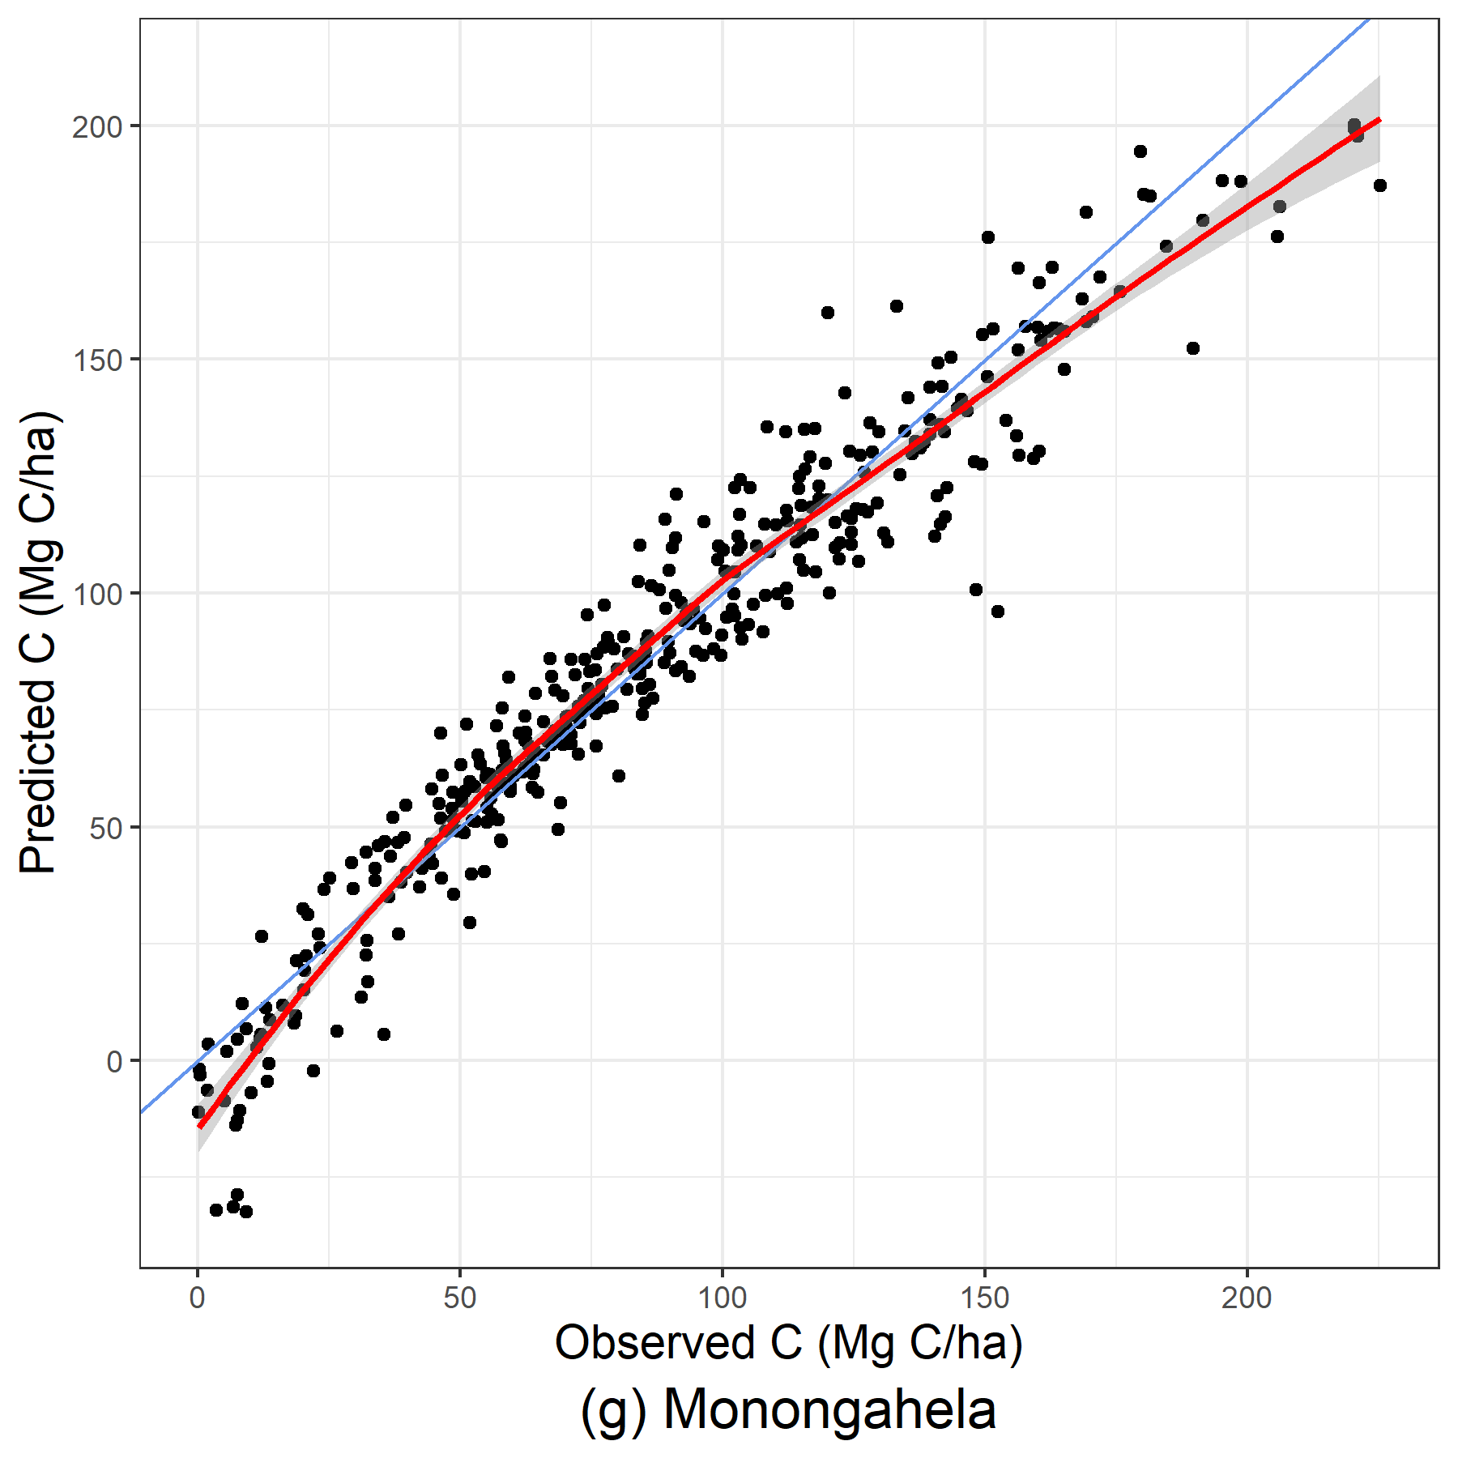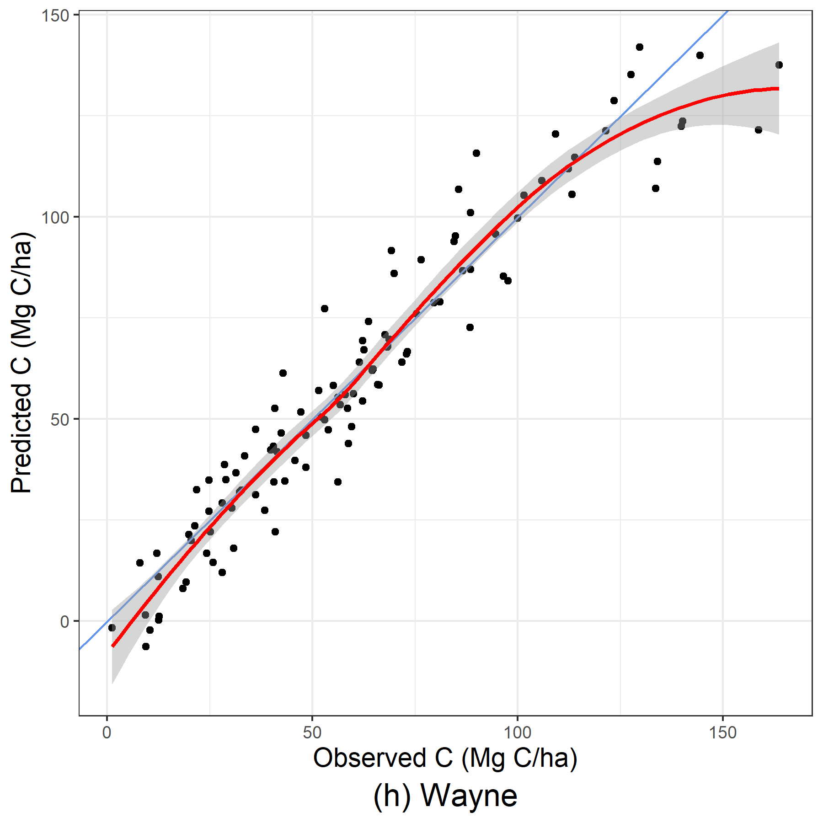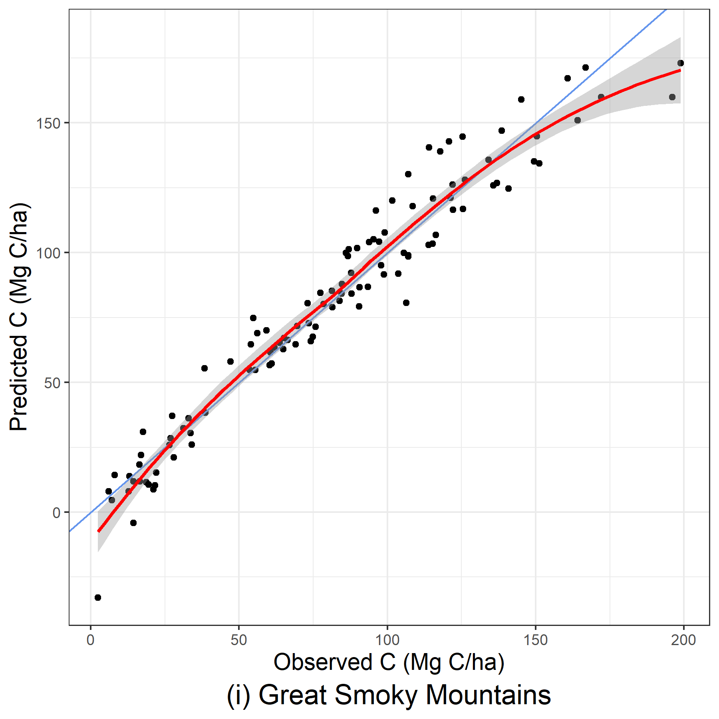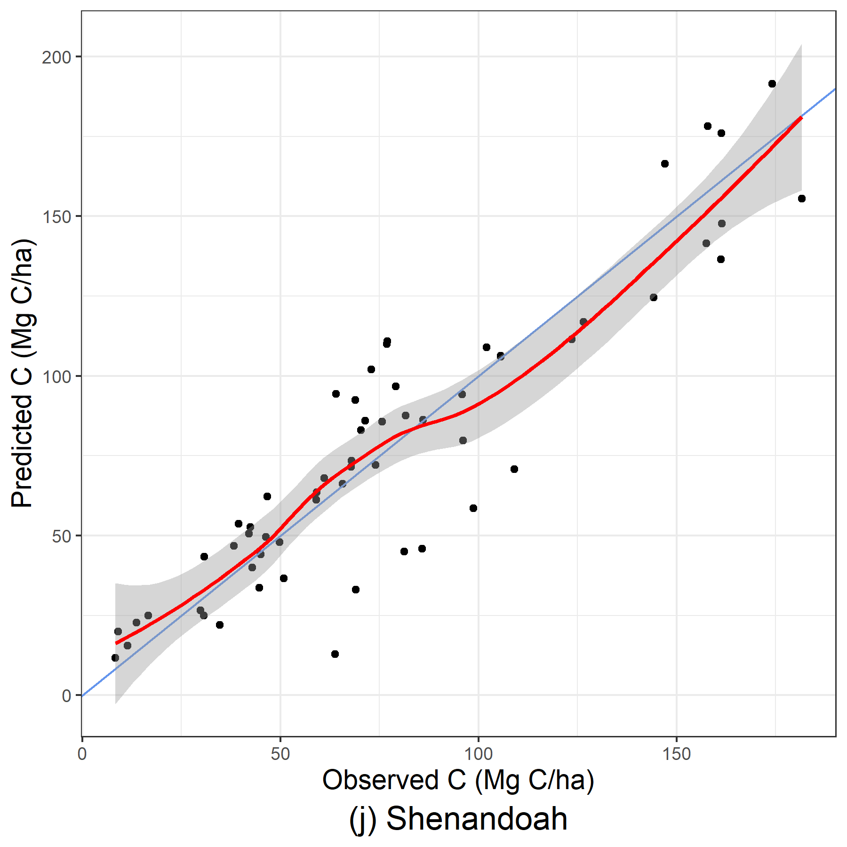
Figure 17: Predicted and observed carbon per hectare (Mg C/ha) produced from linear mixed-effect models using stand-level and WorldClim BIO environmental variables.
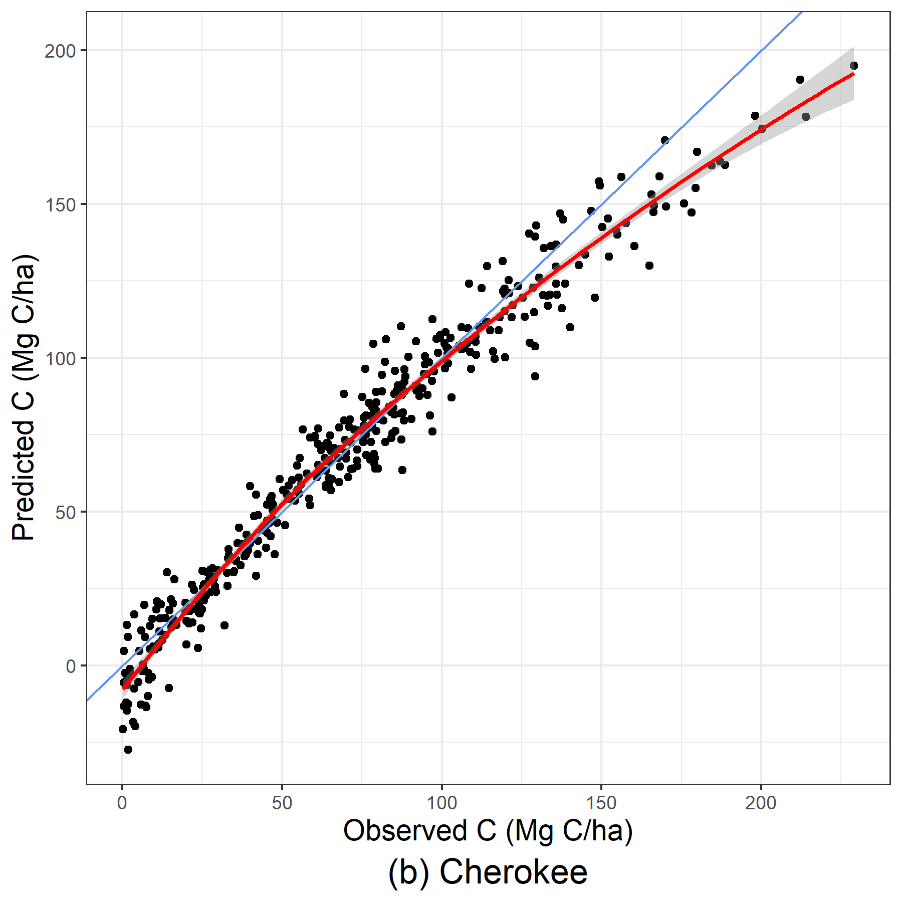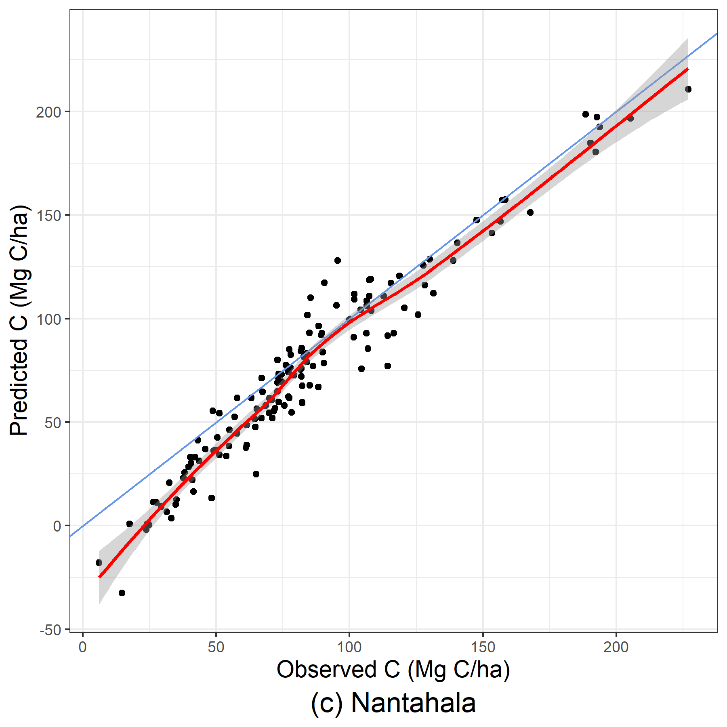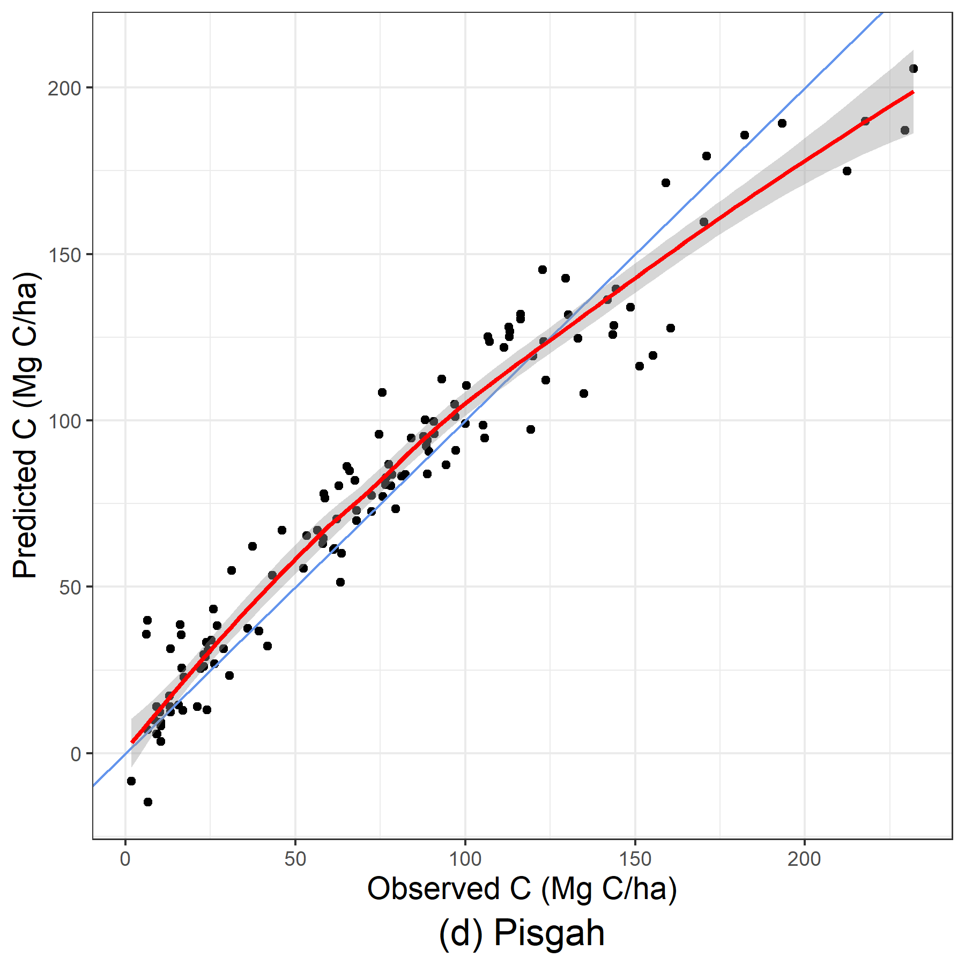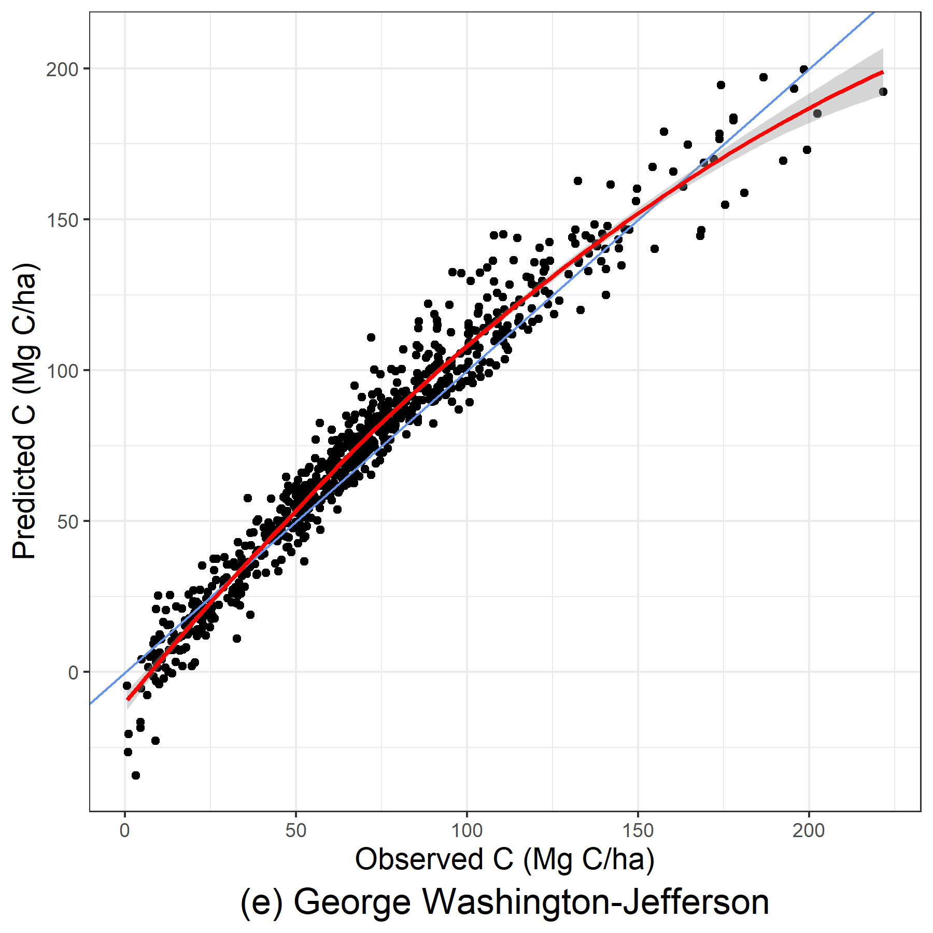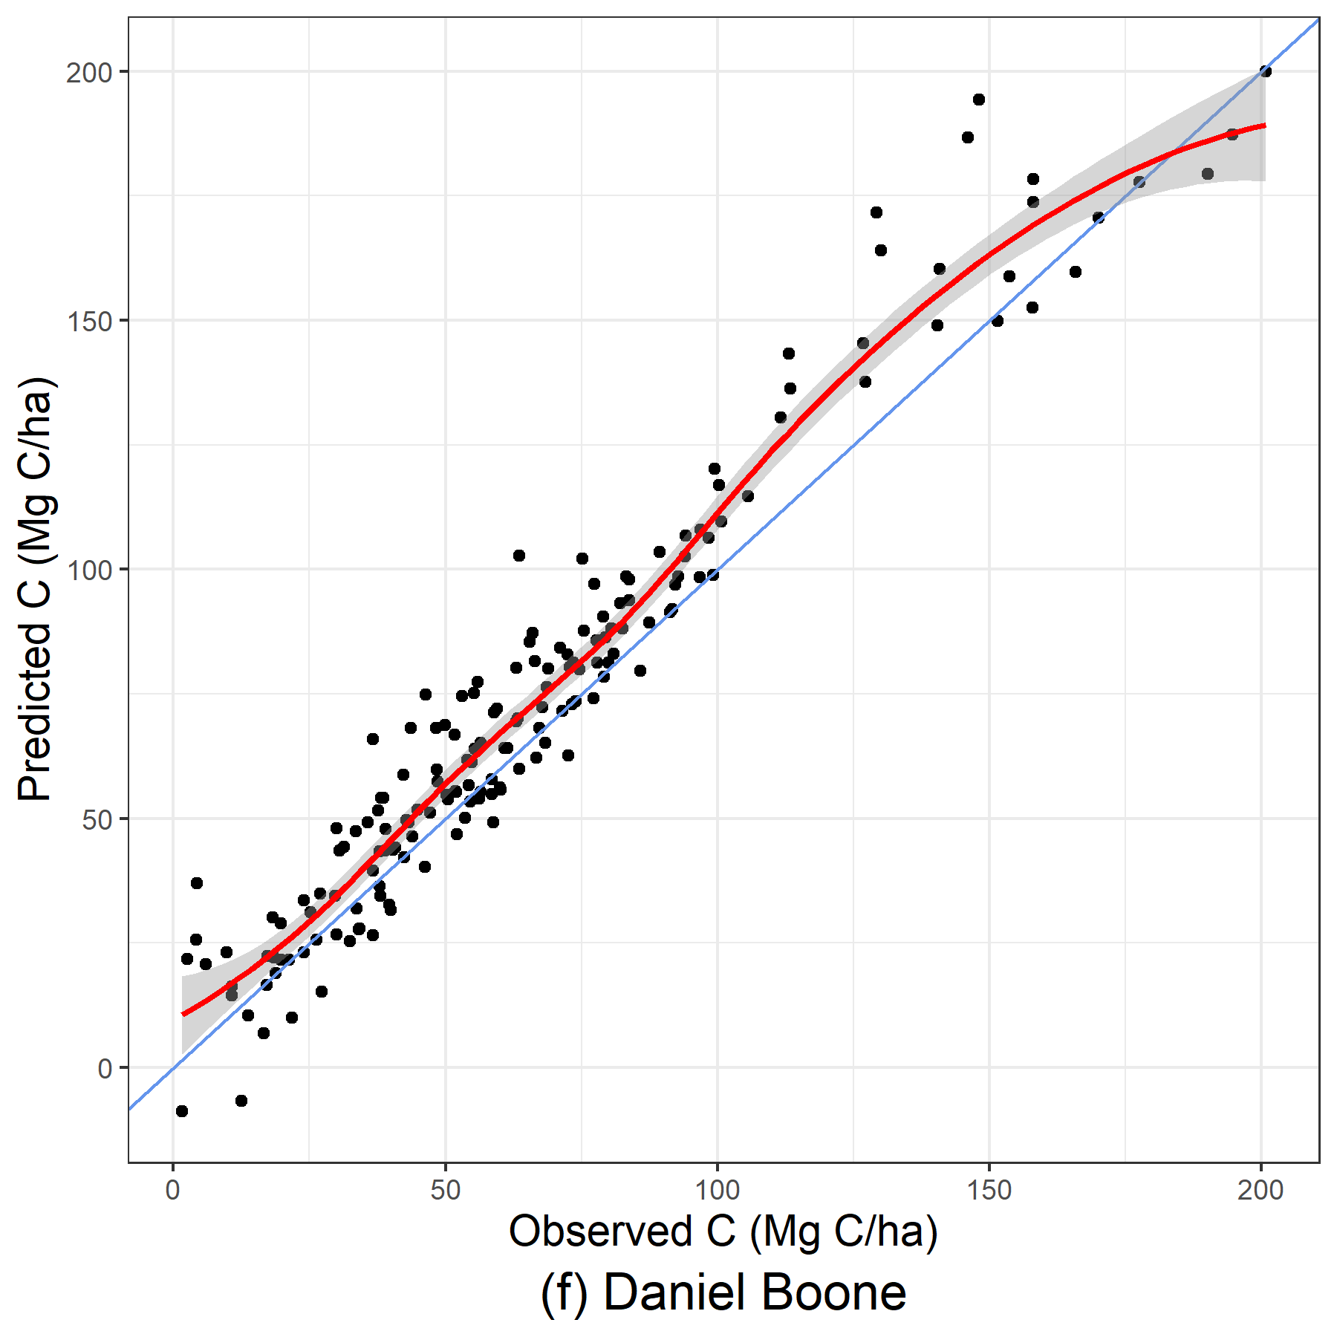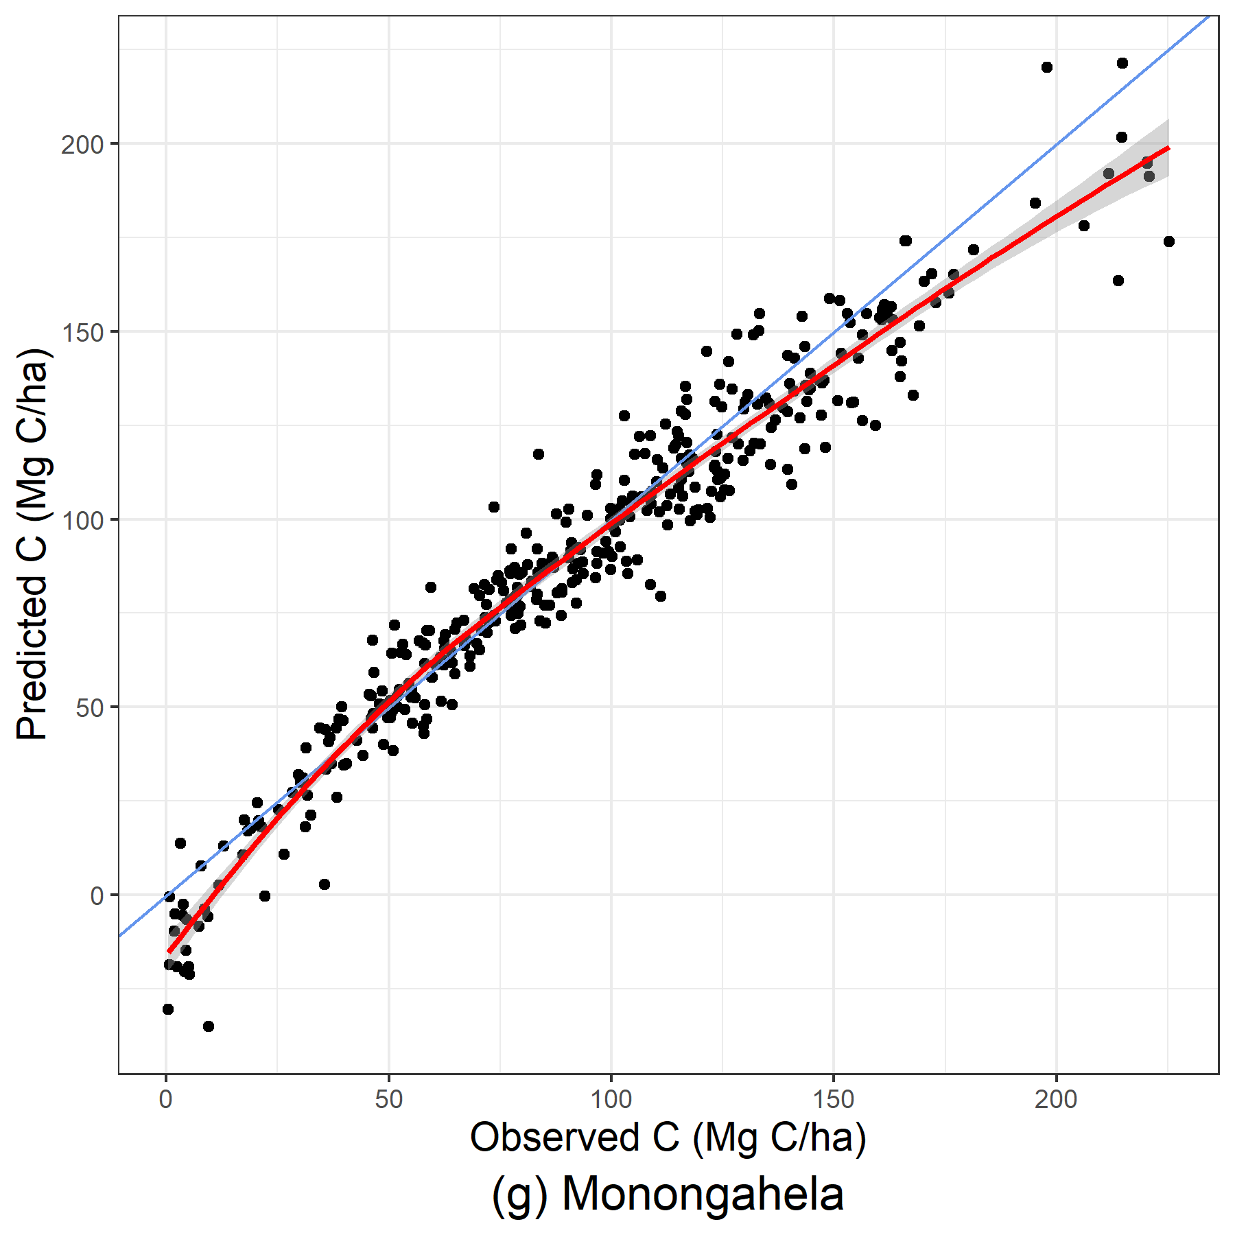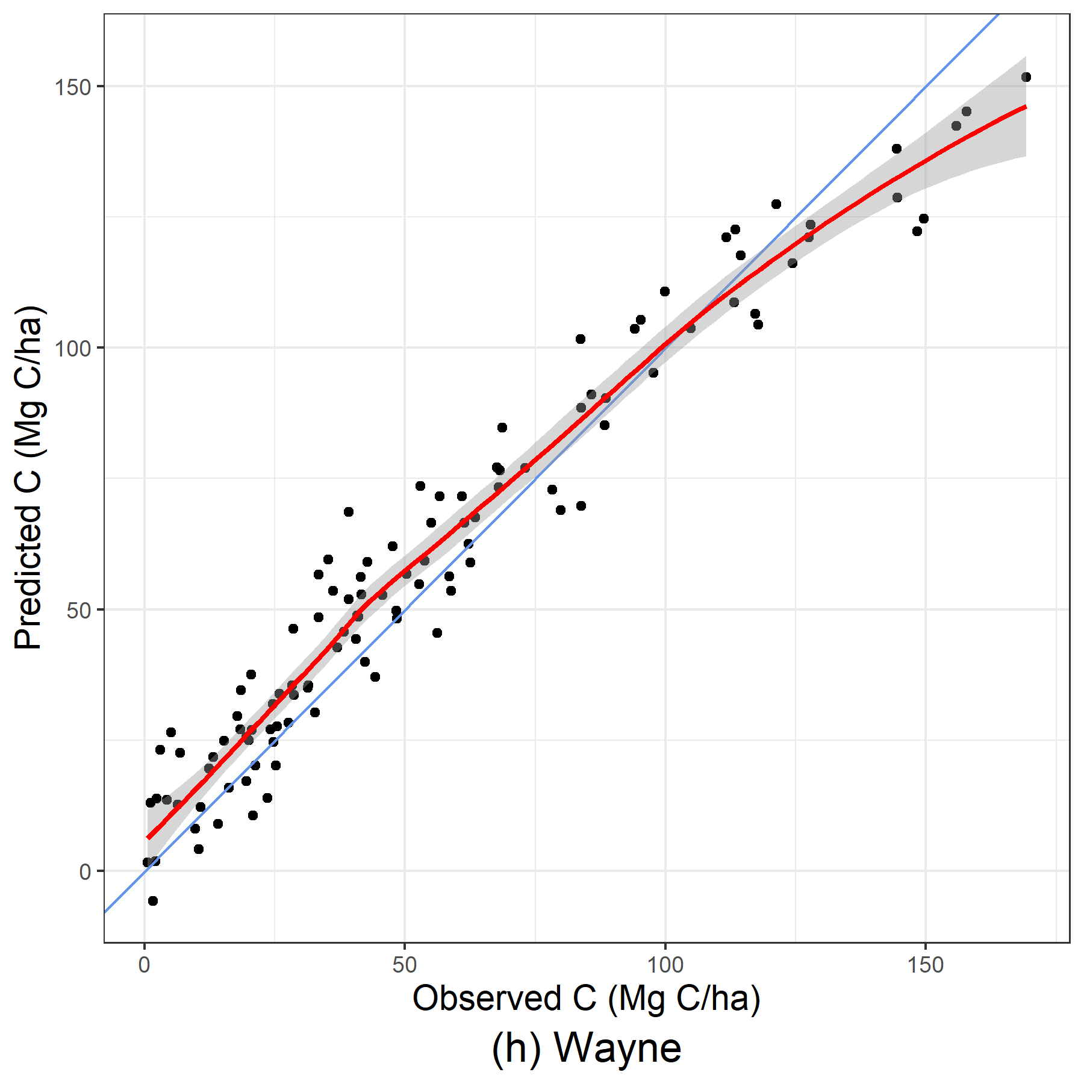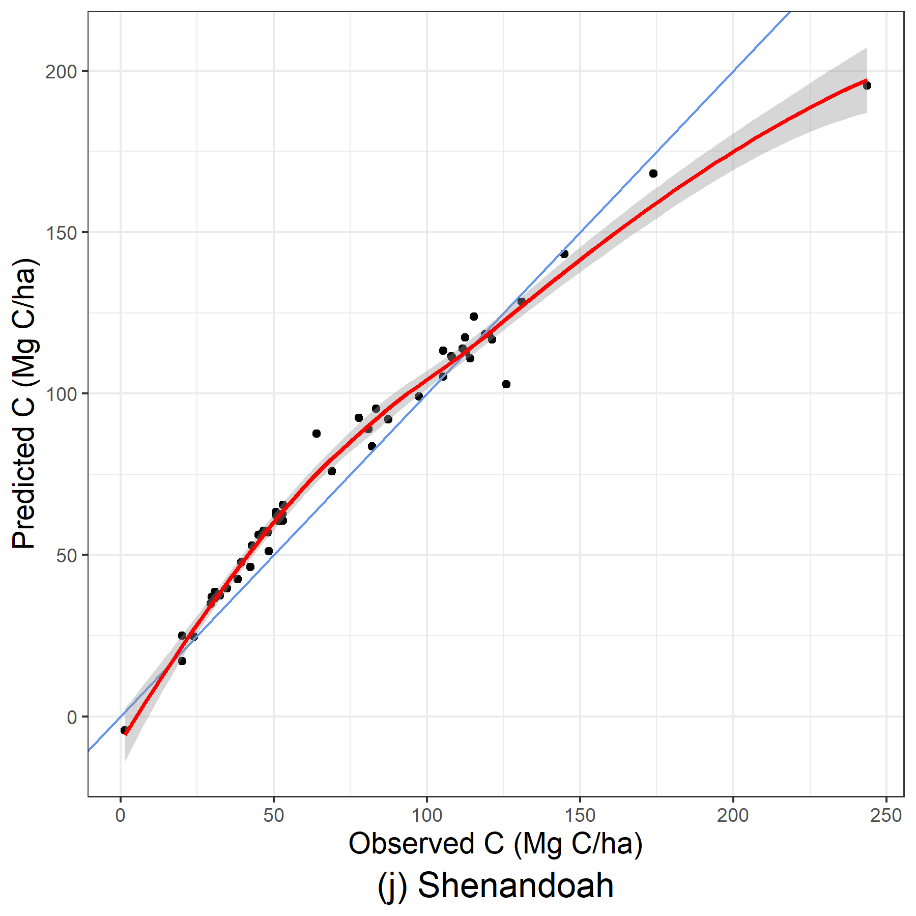
Figure 18: Predicted and observed carbon per hectare (Mg C/ha) from out-of-bag samples for LASSO models using stand-level variables.
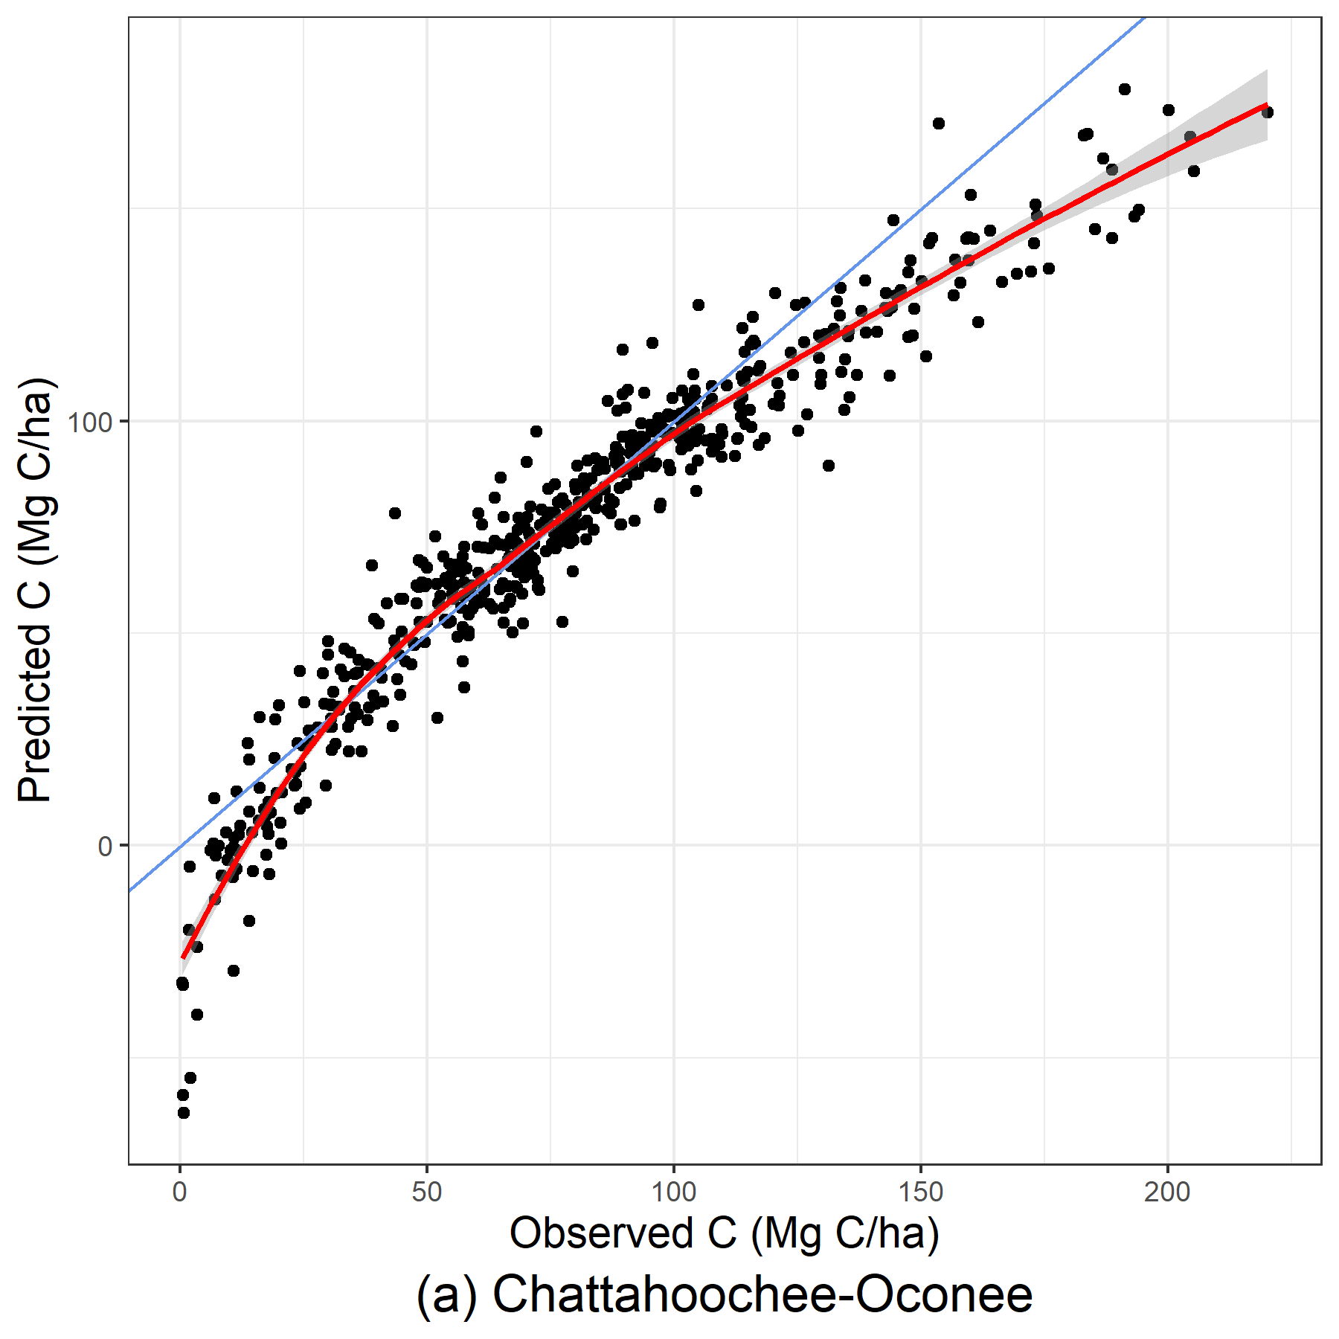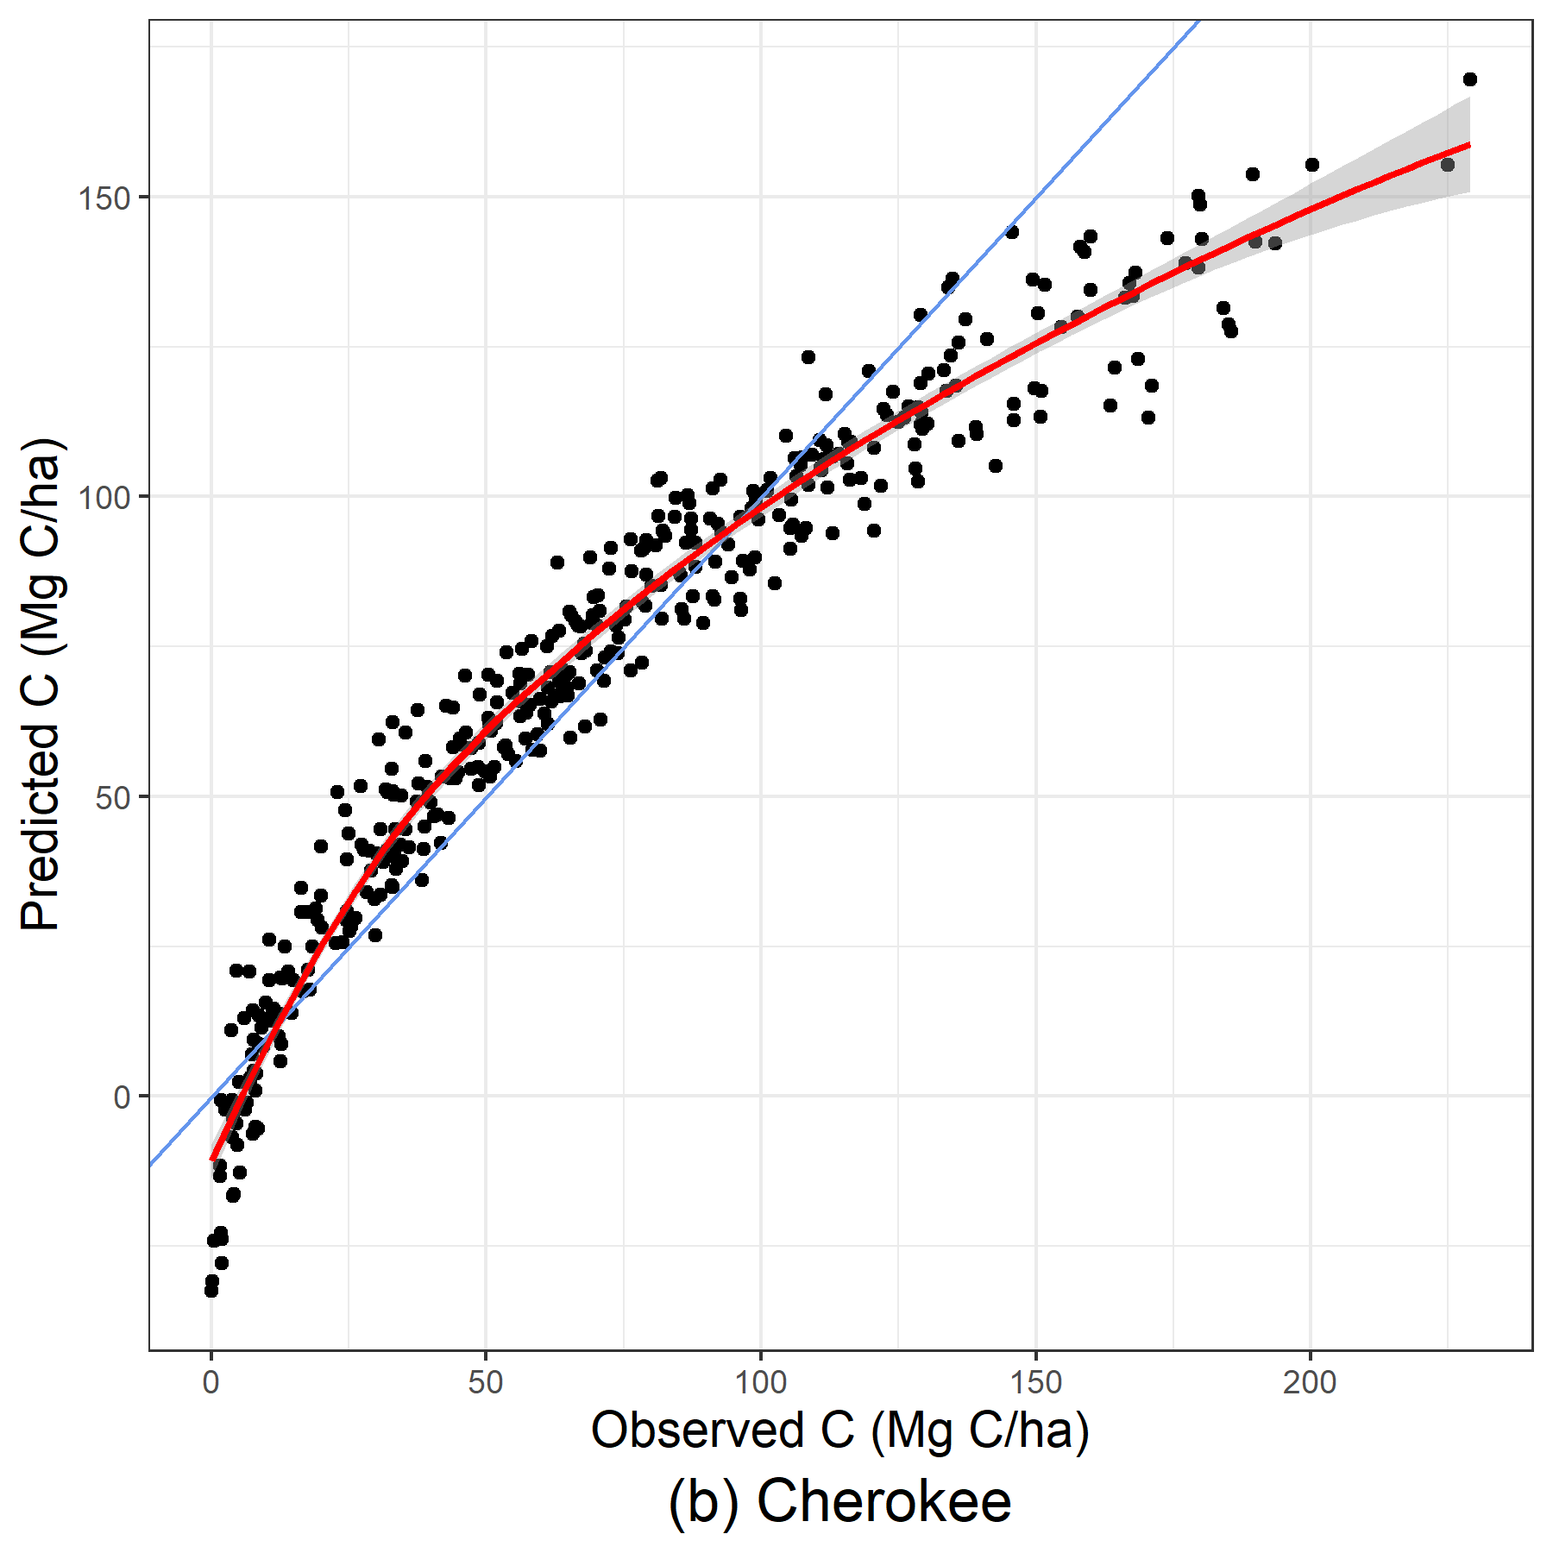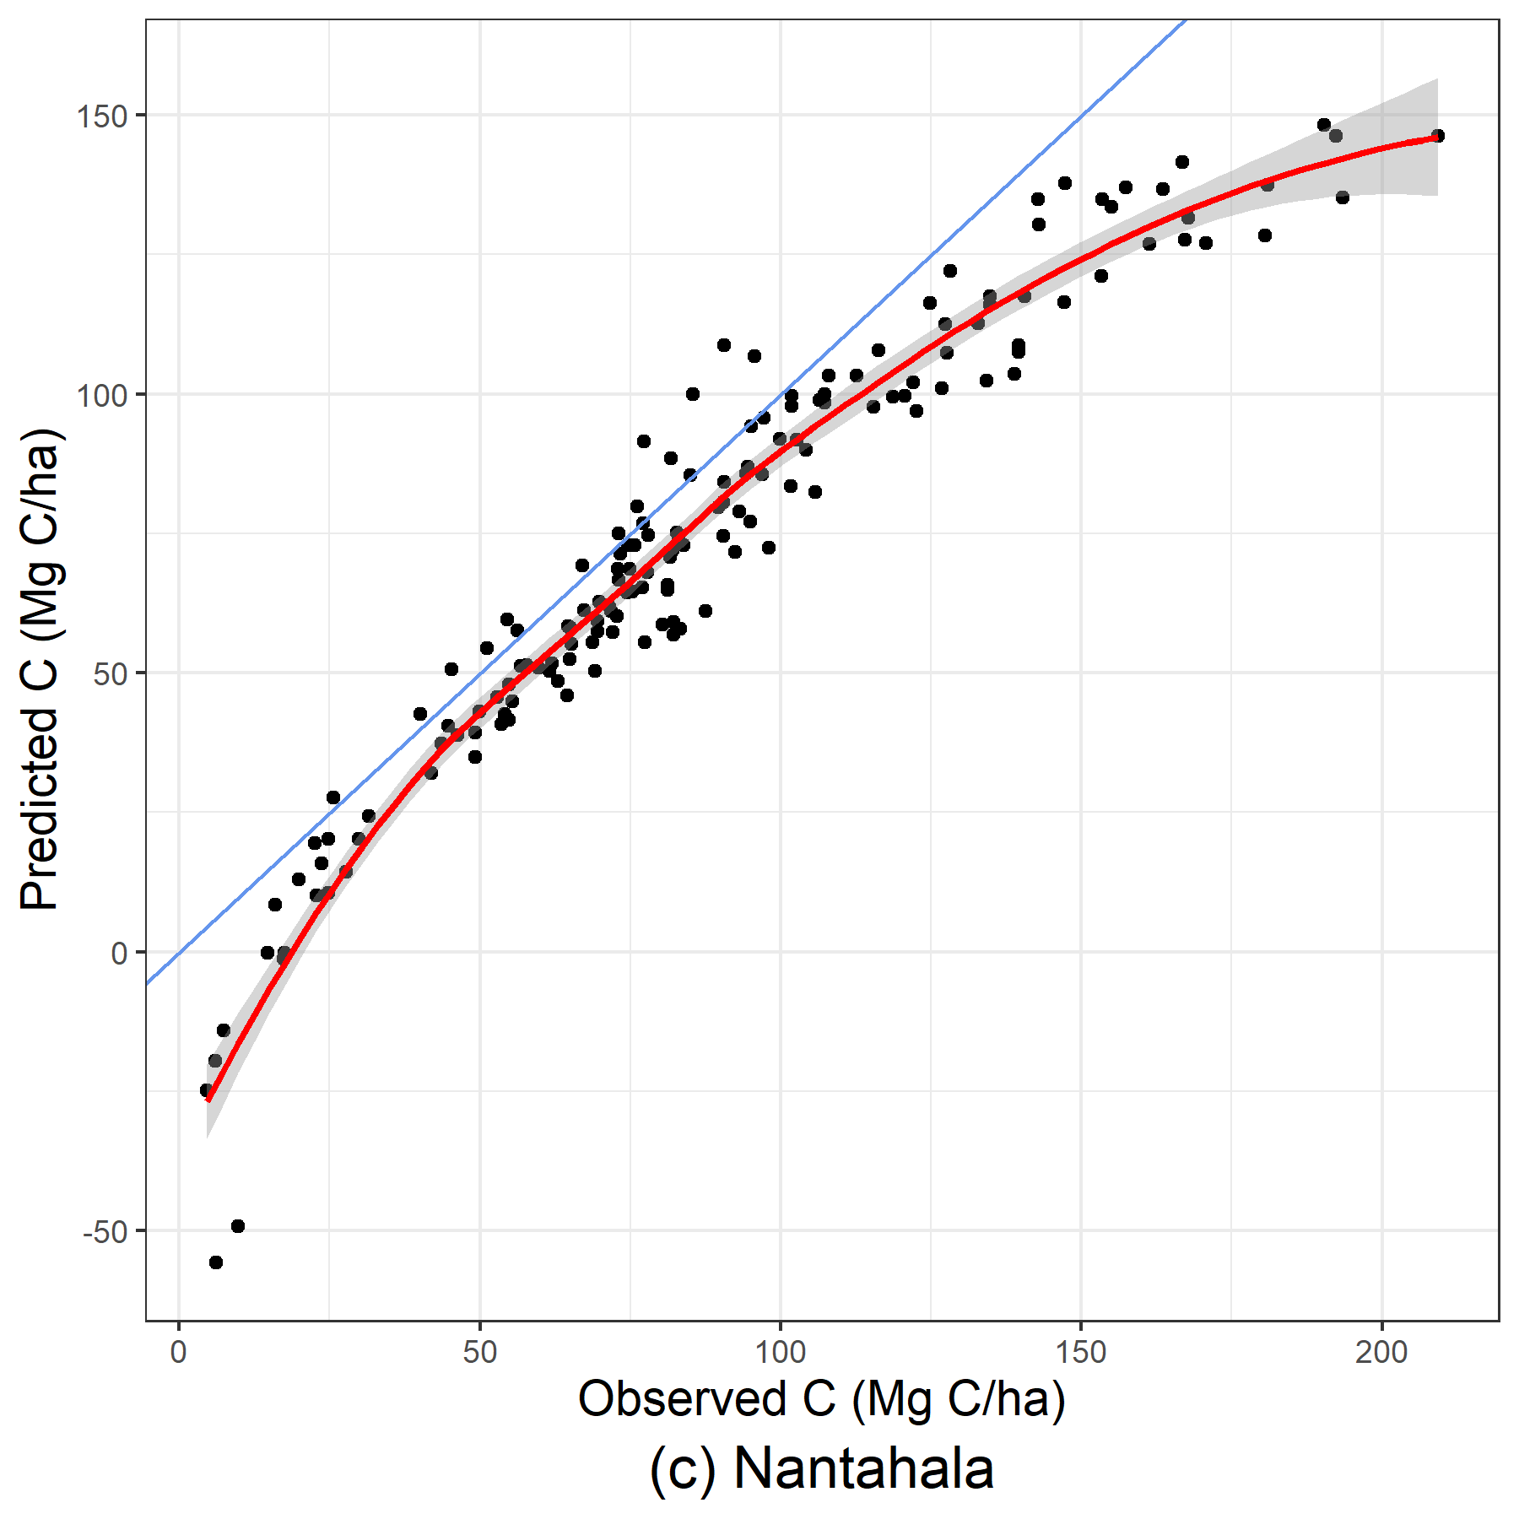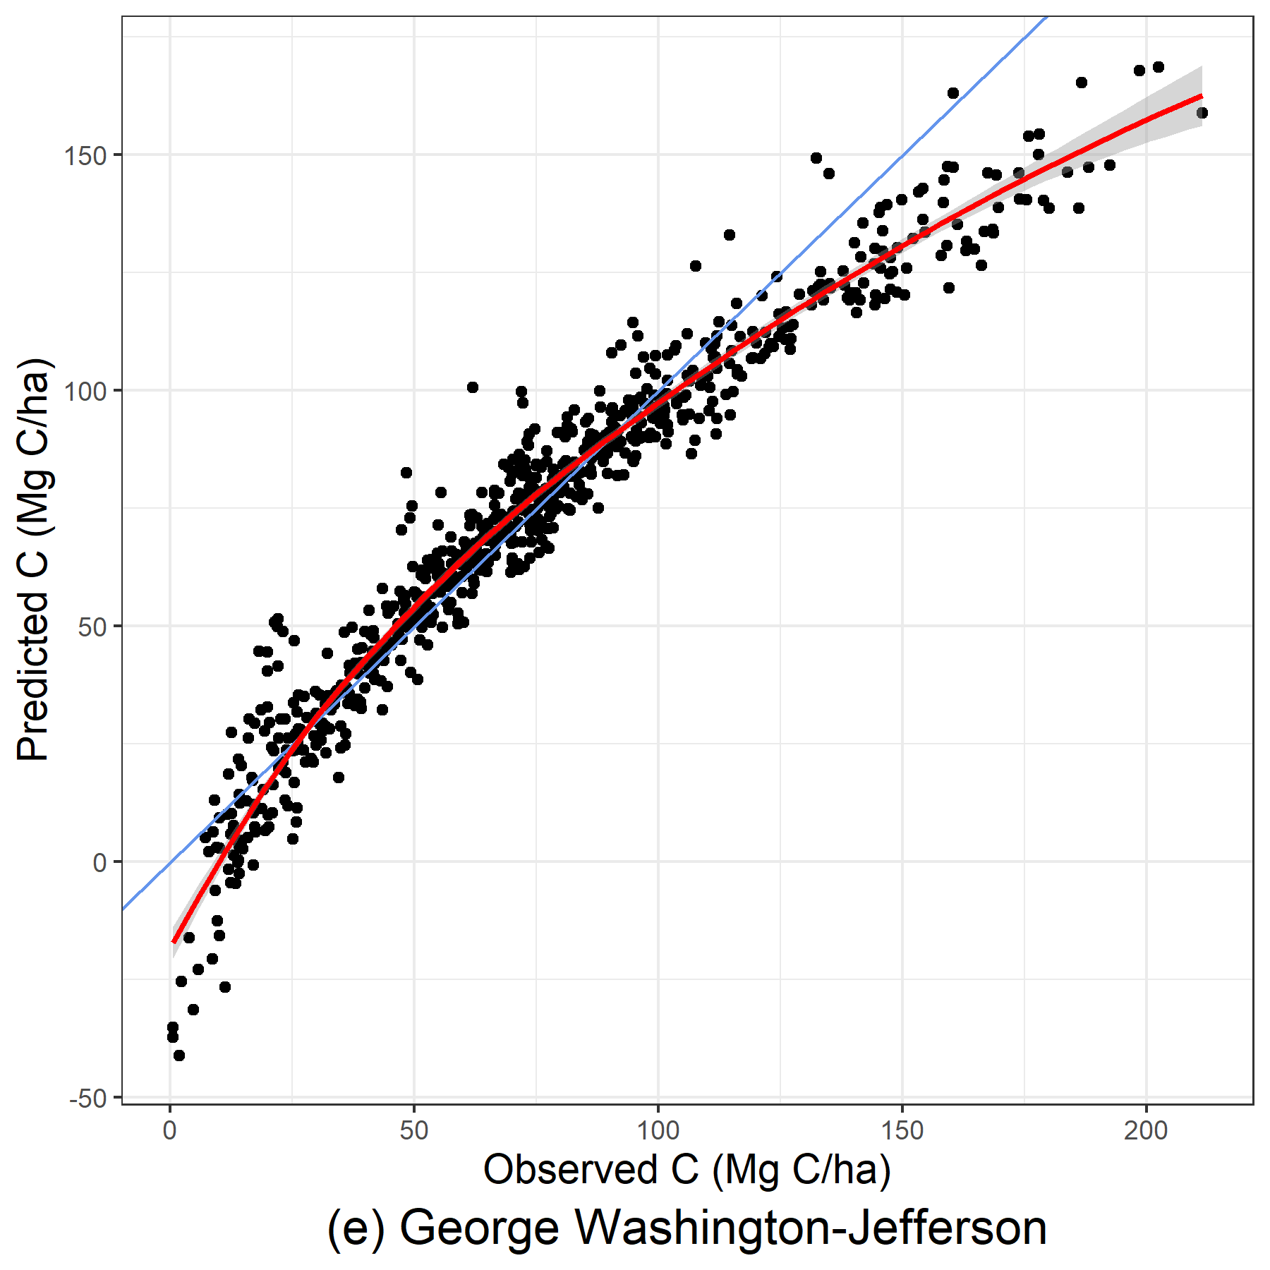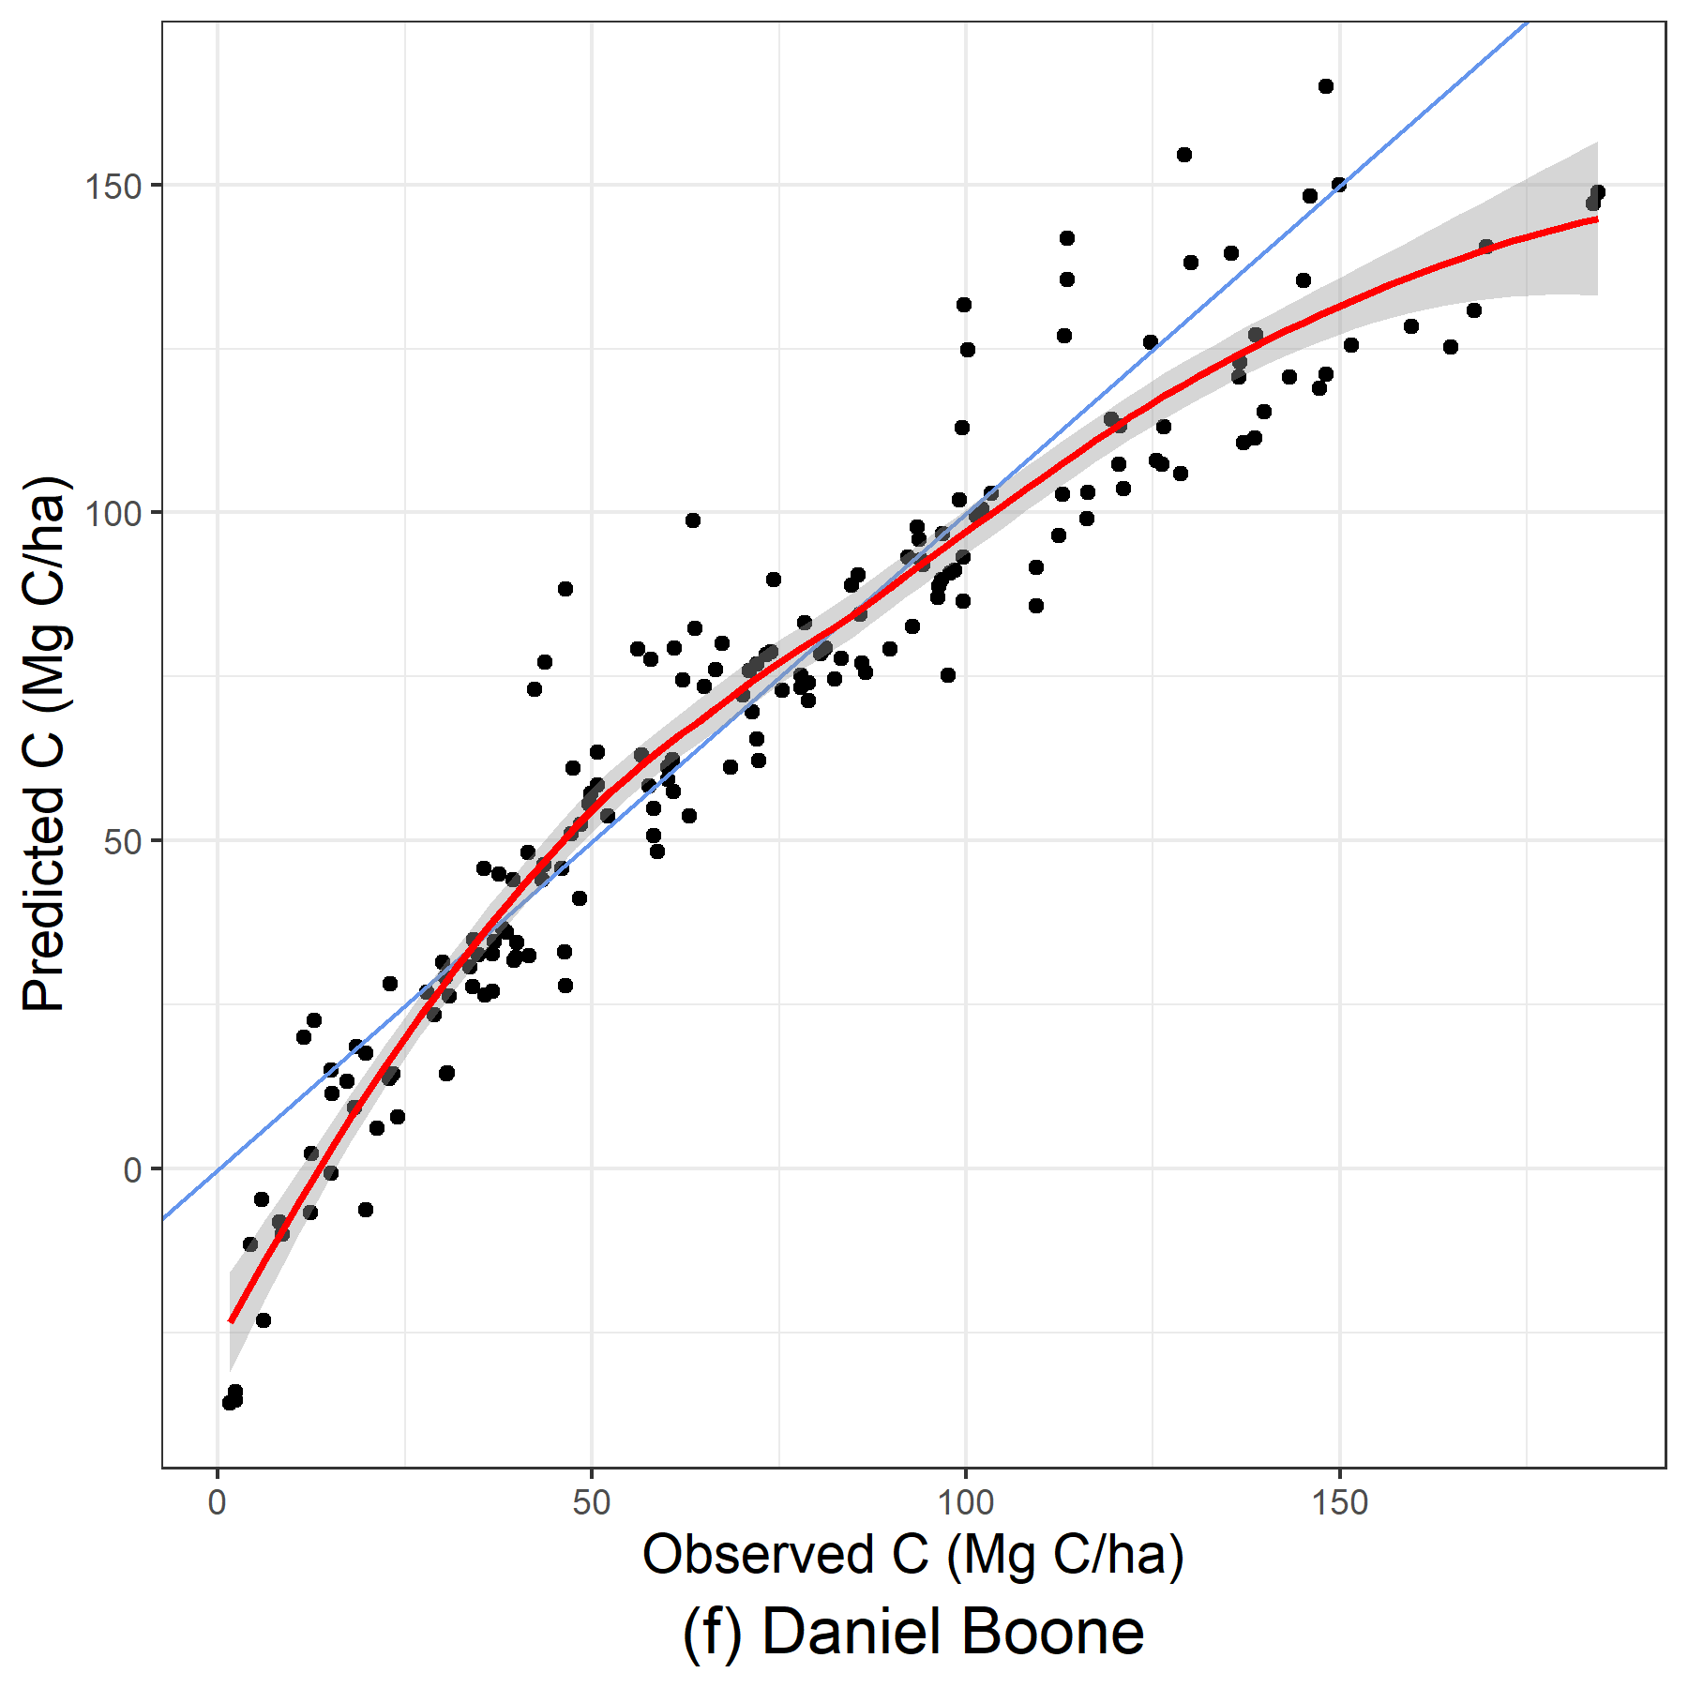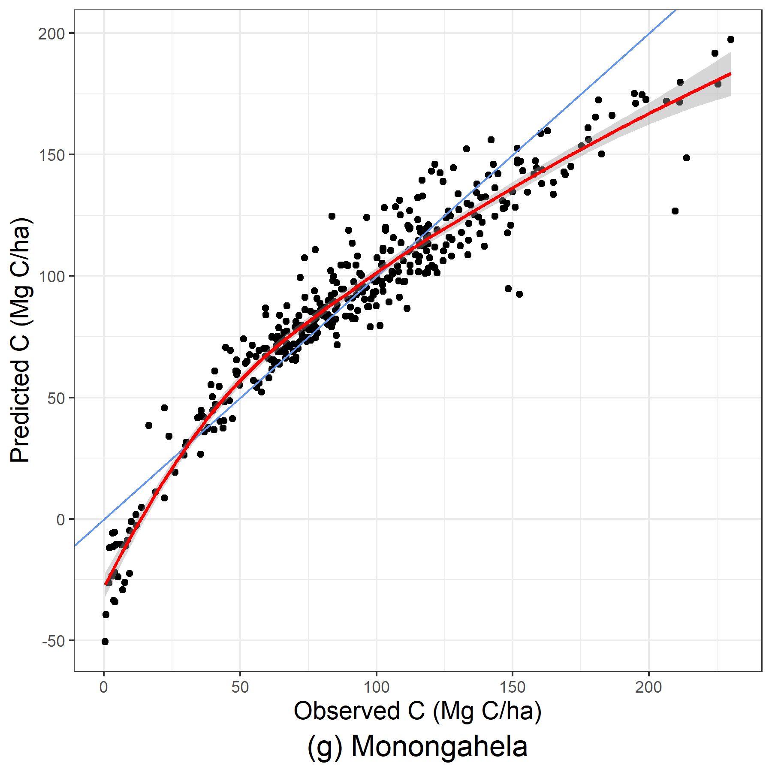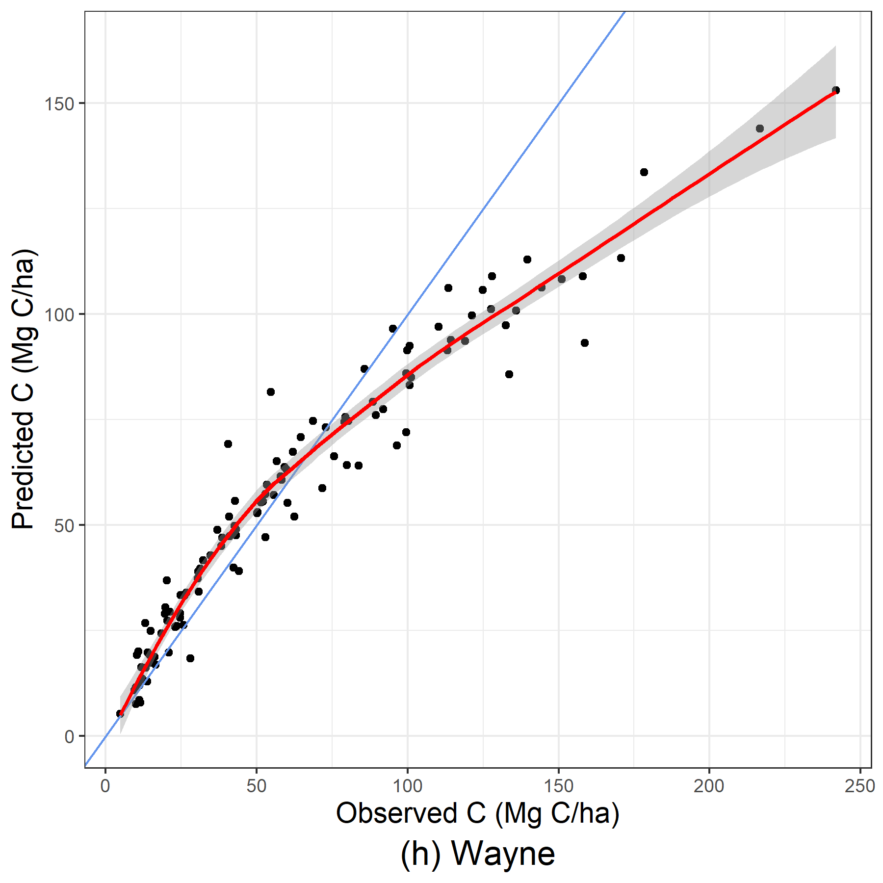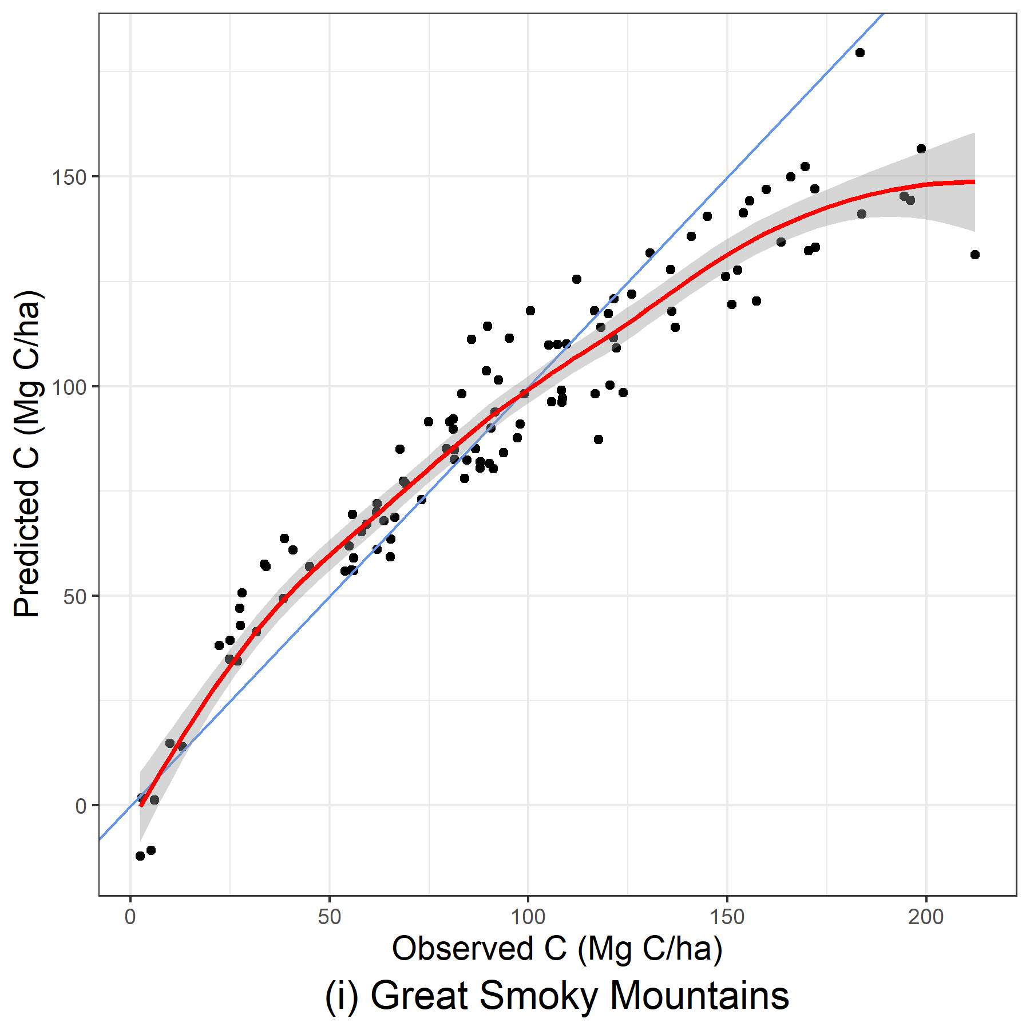
Figure 19: Predicted and observed carbon per hectare (Mg C/ha) produced from LASSO models using stand-level and WorldClim BIO environmental variables.
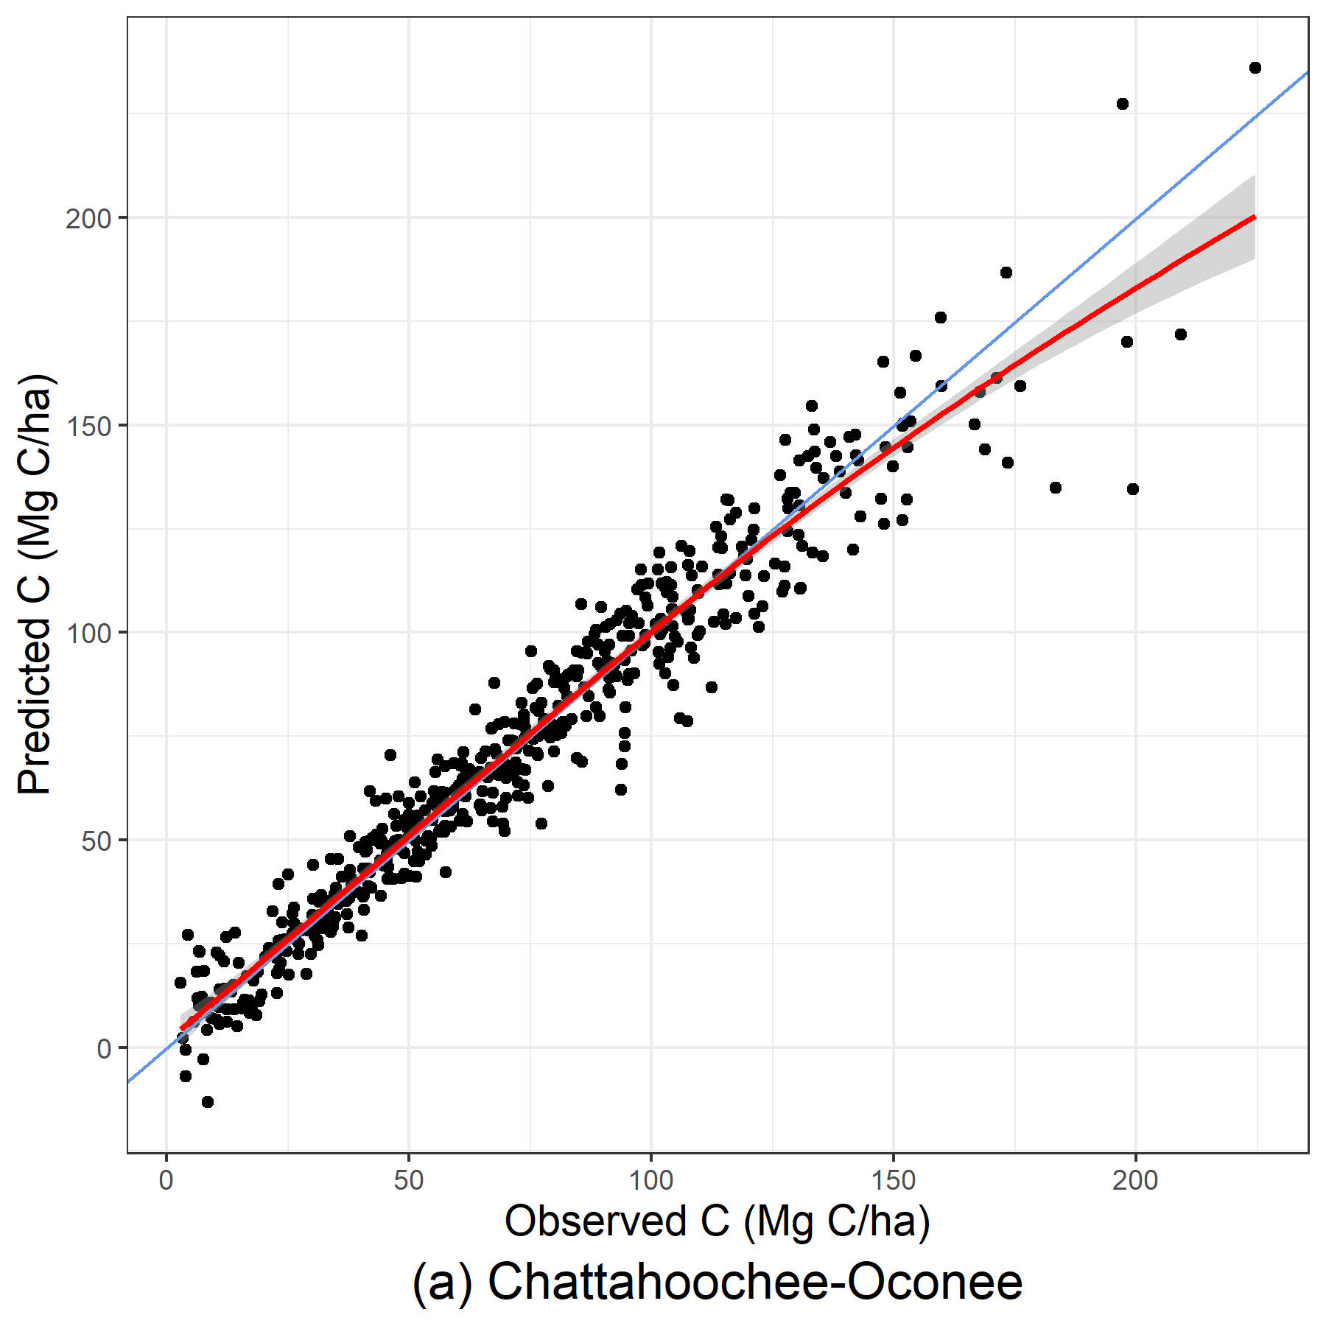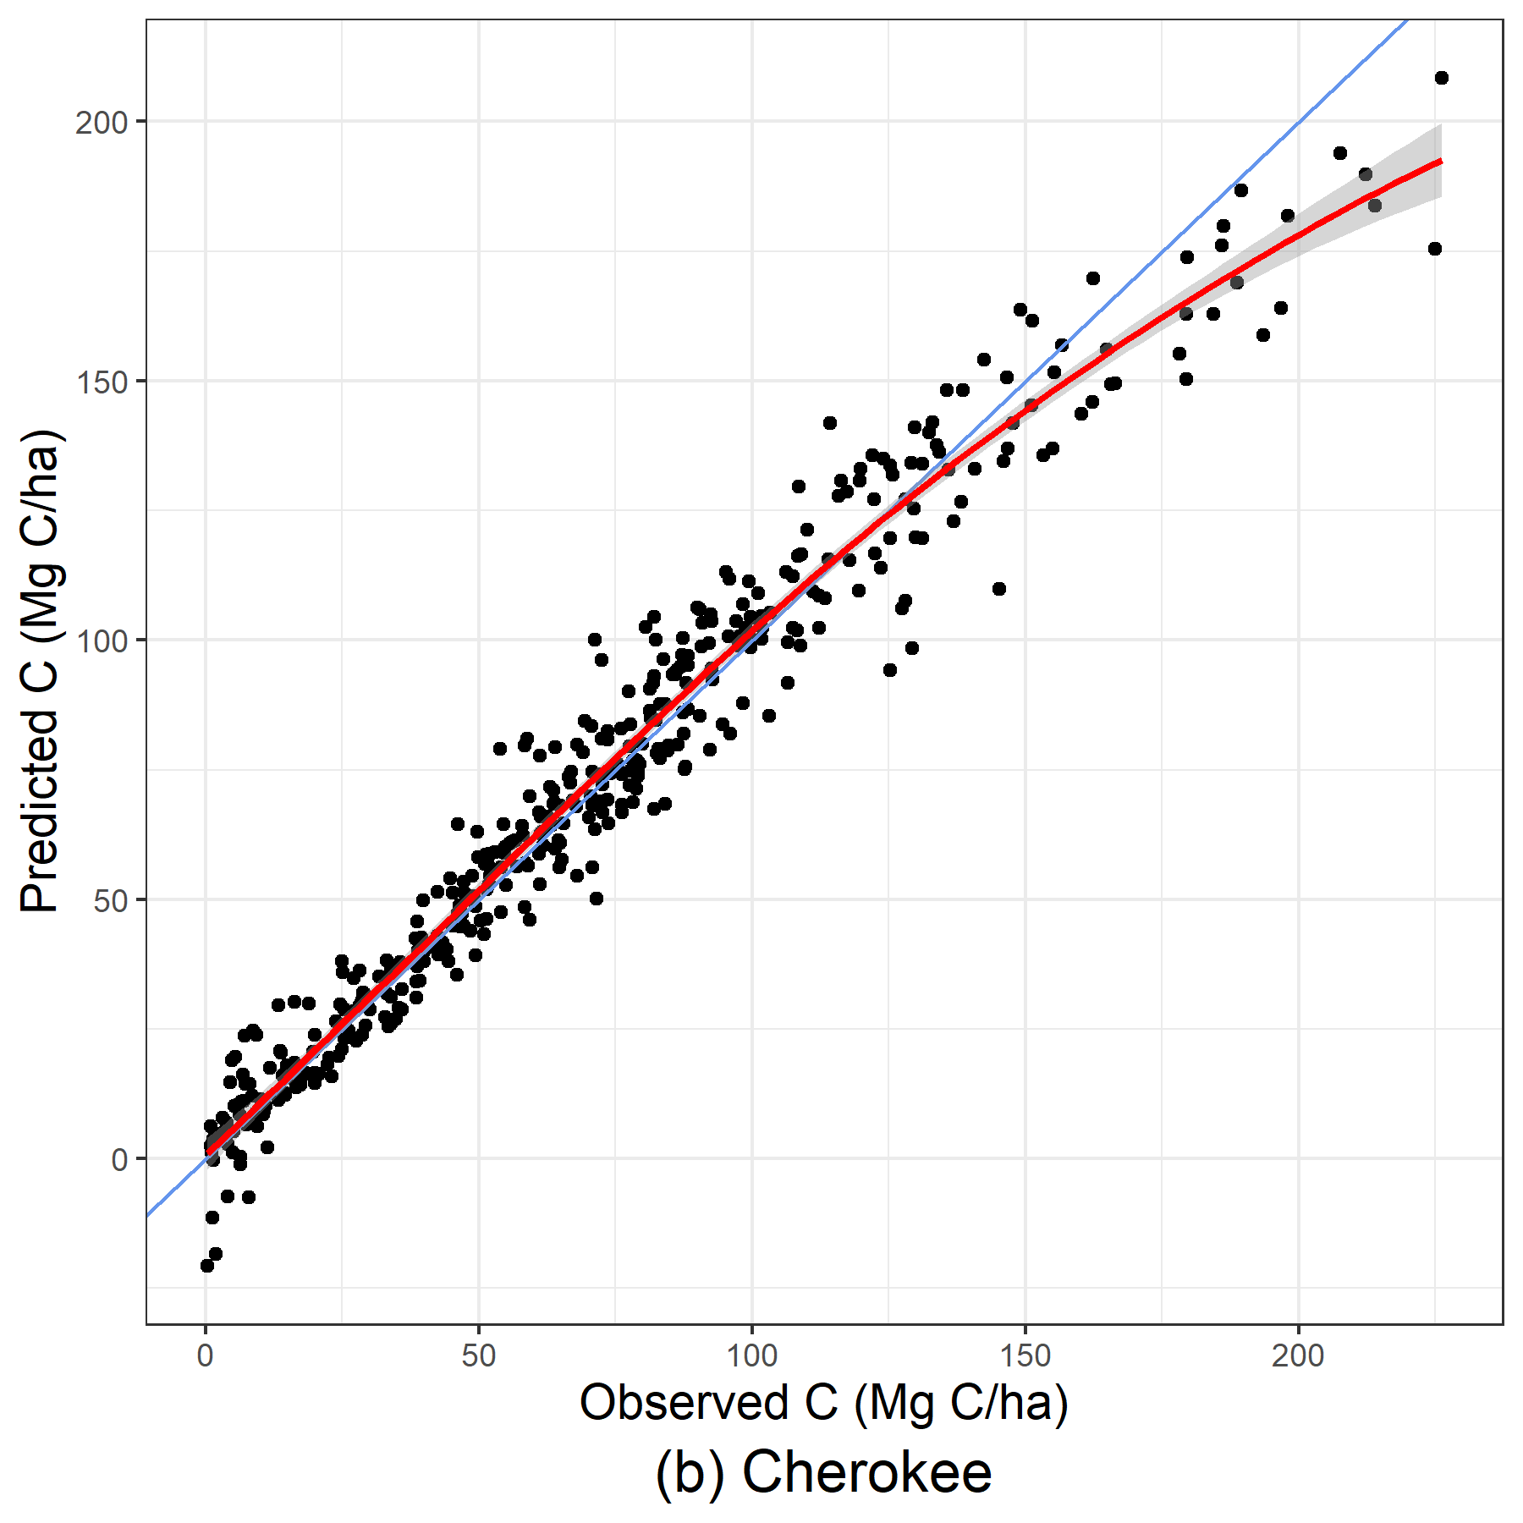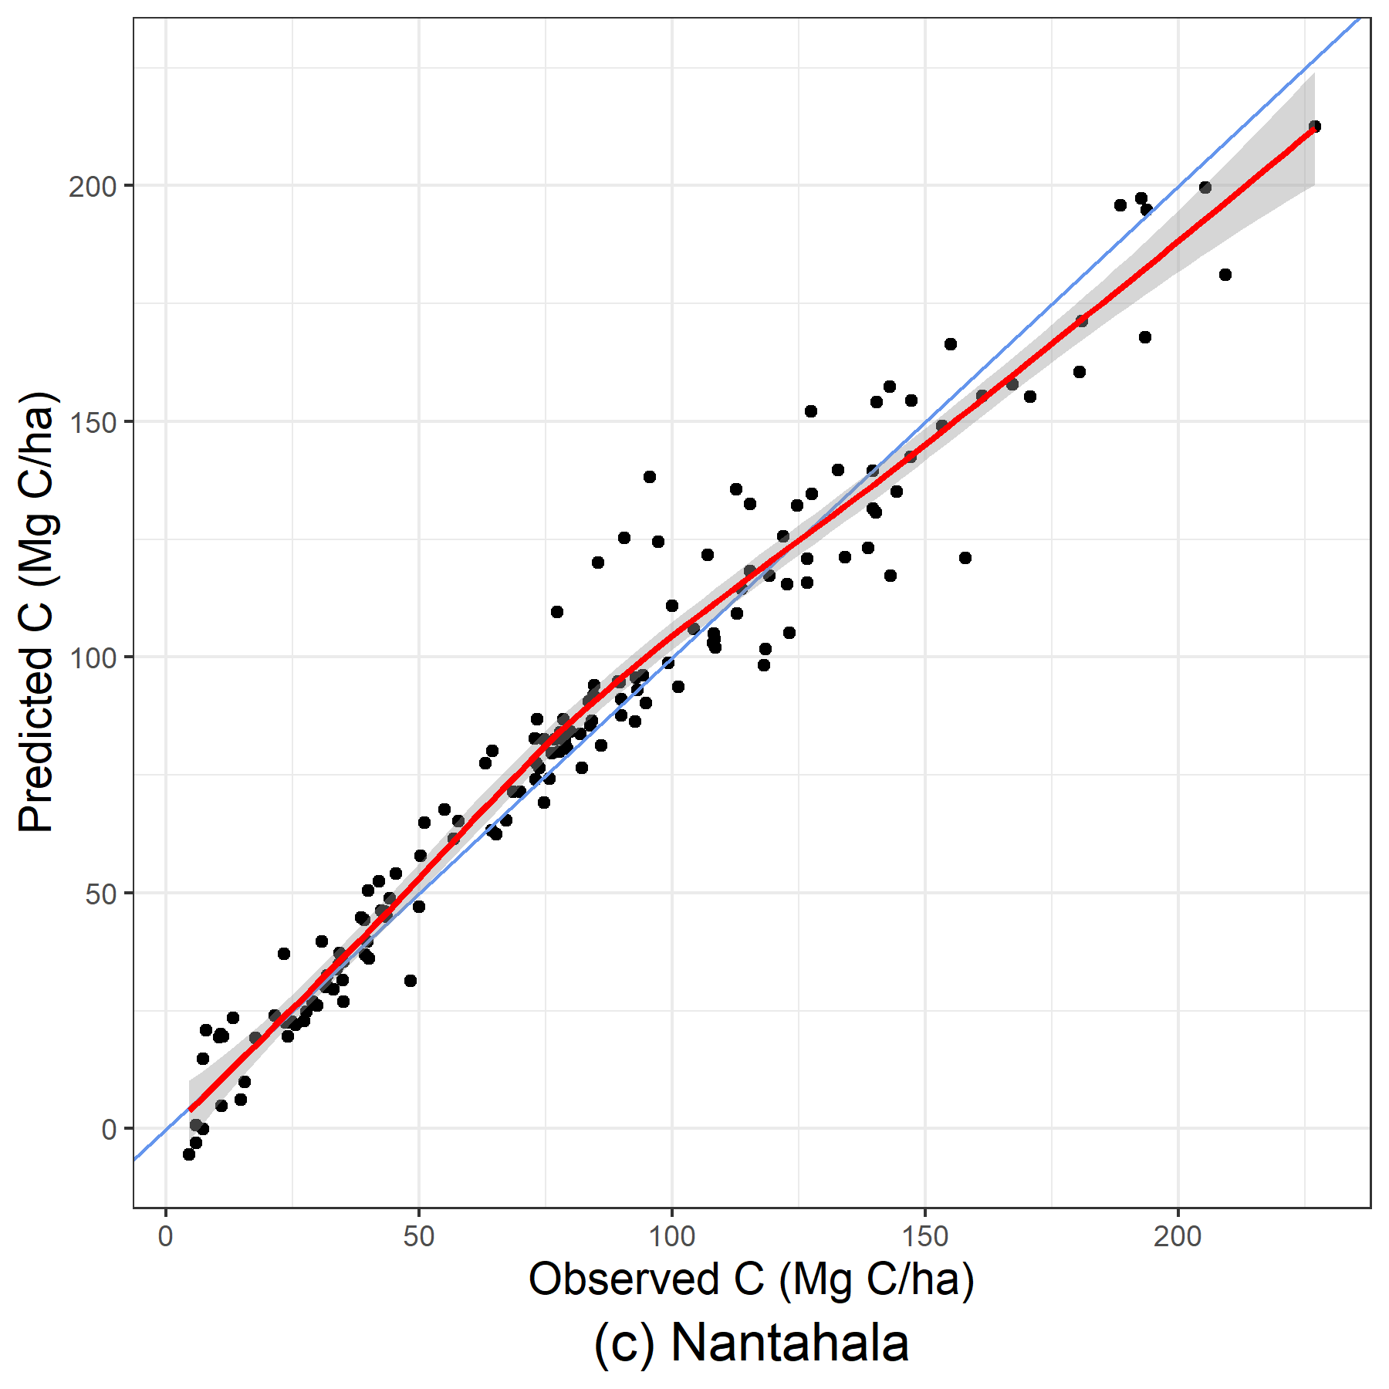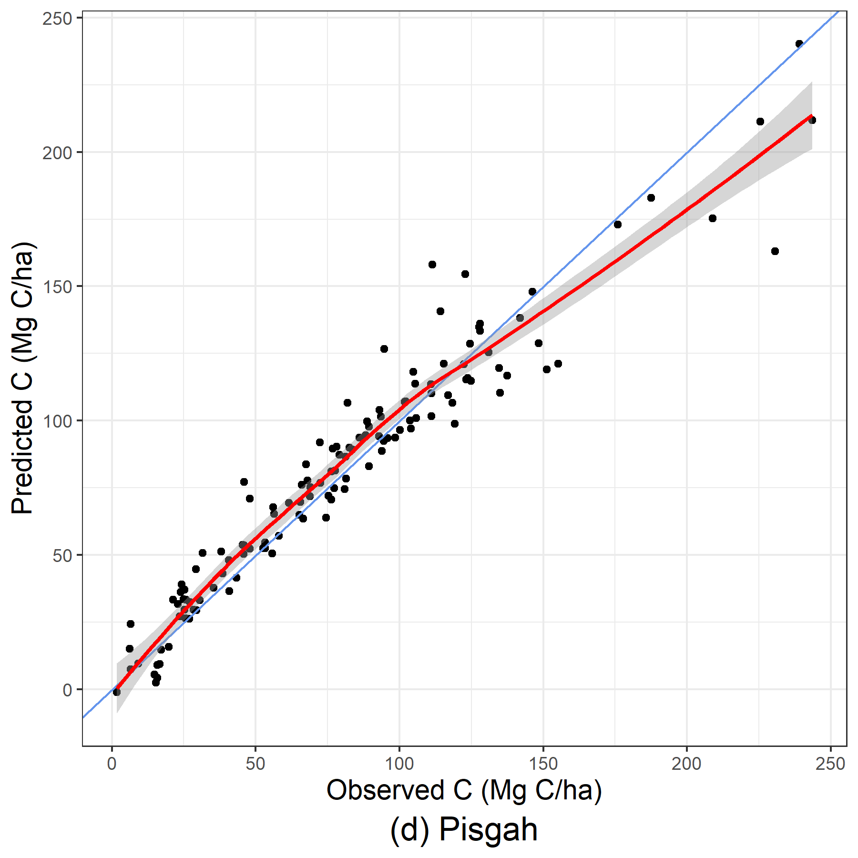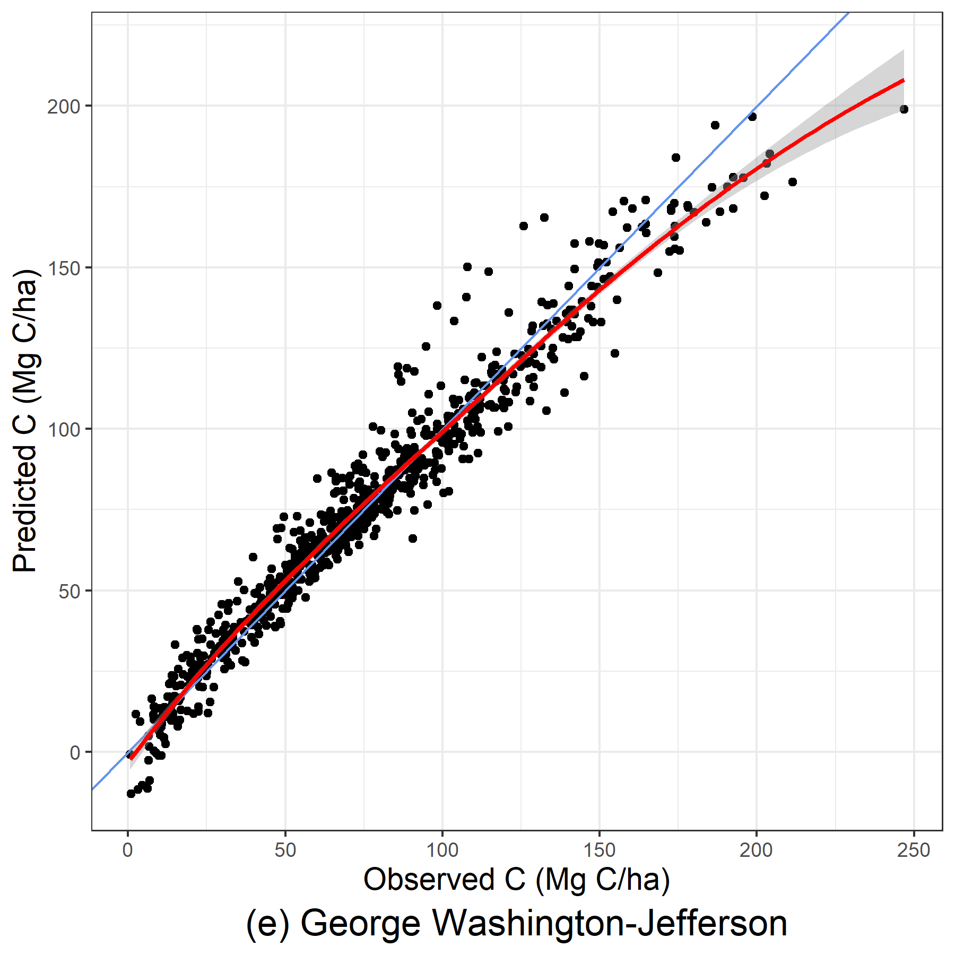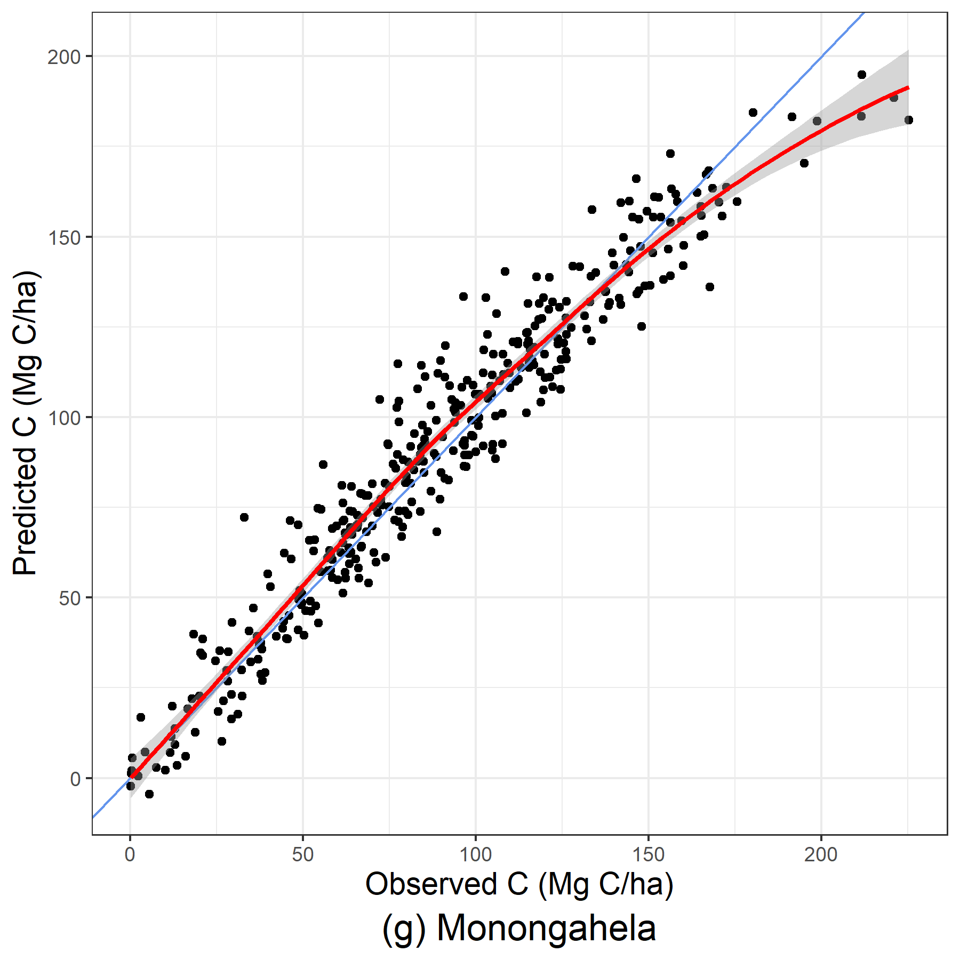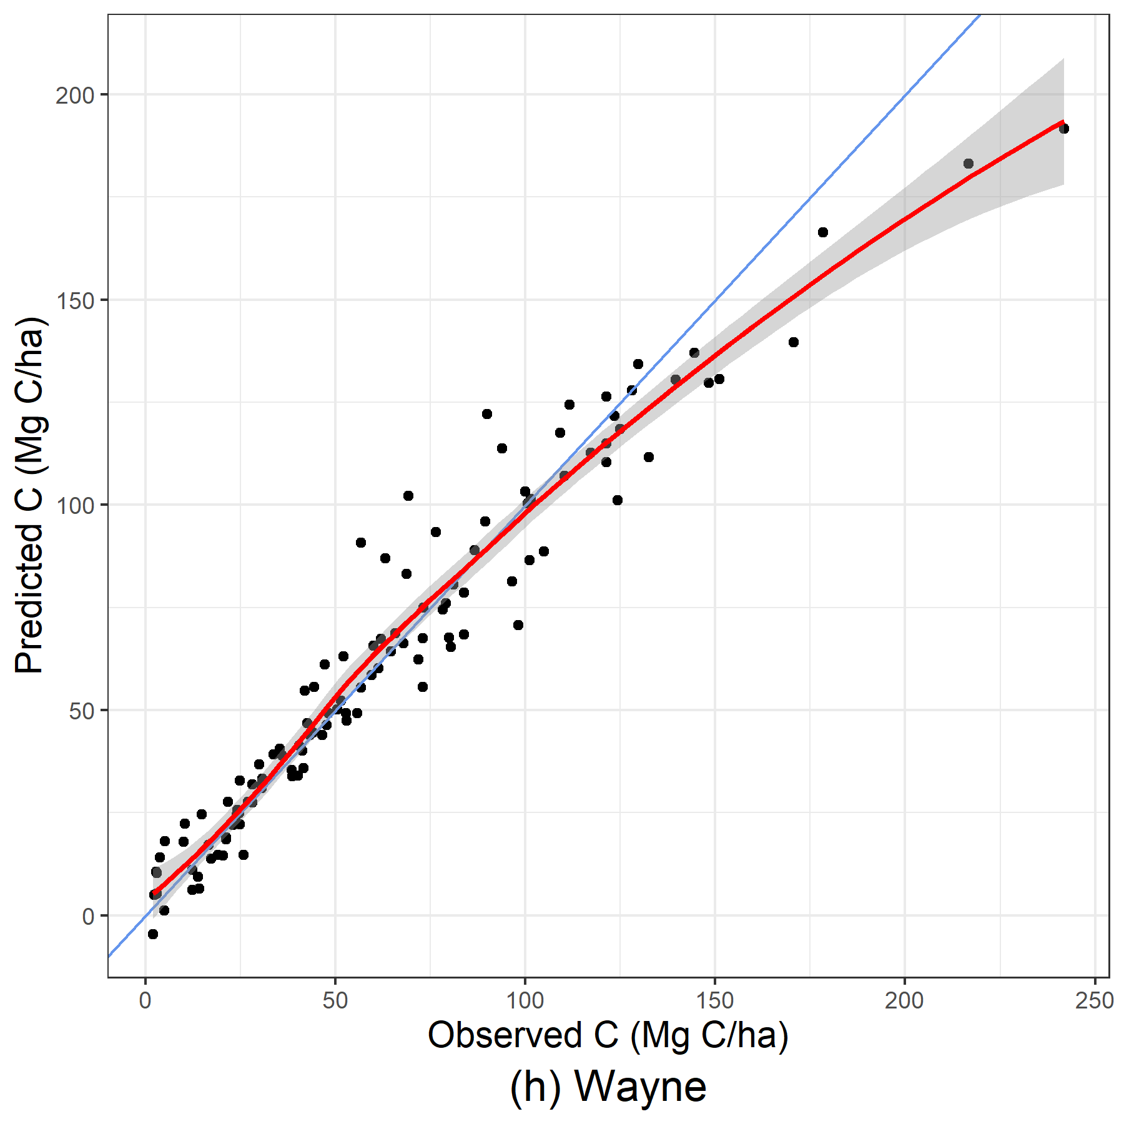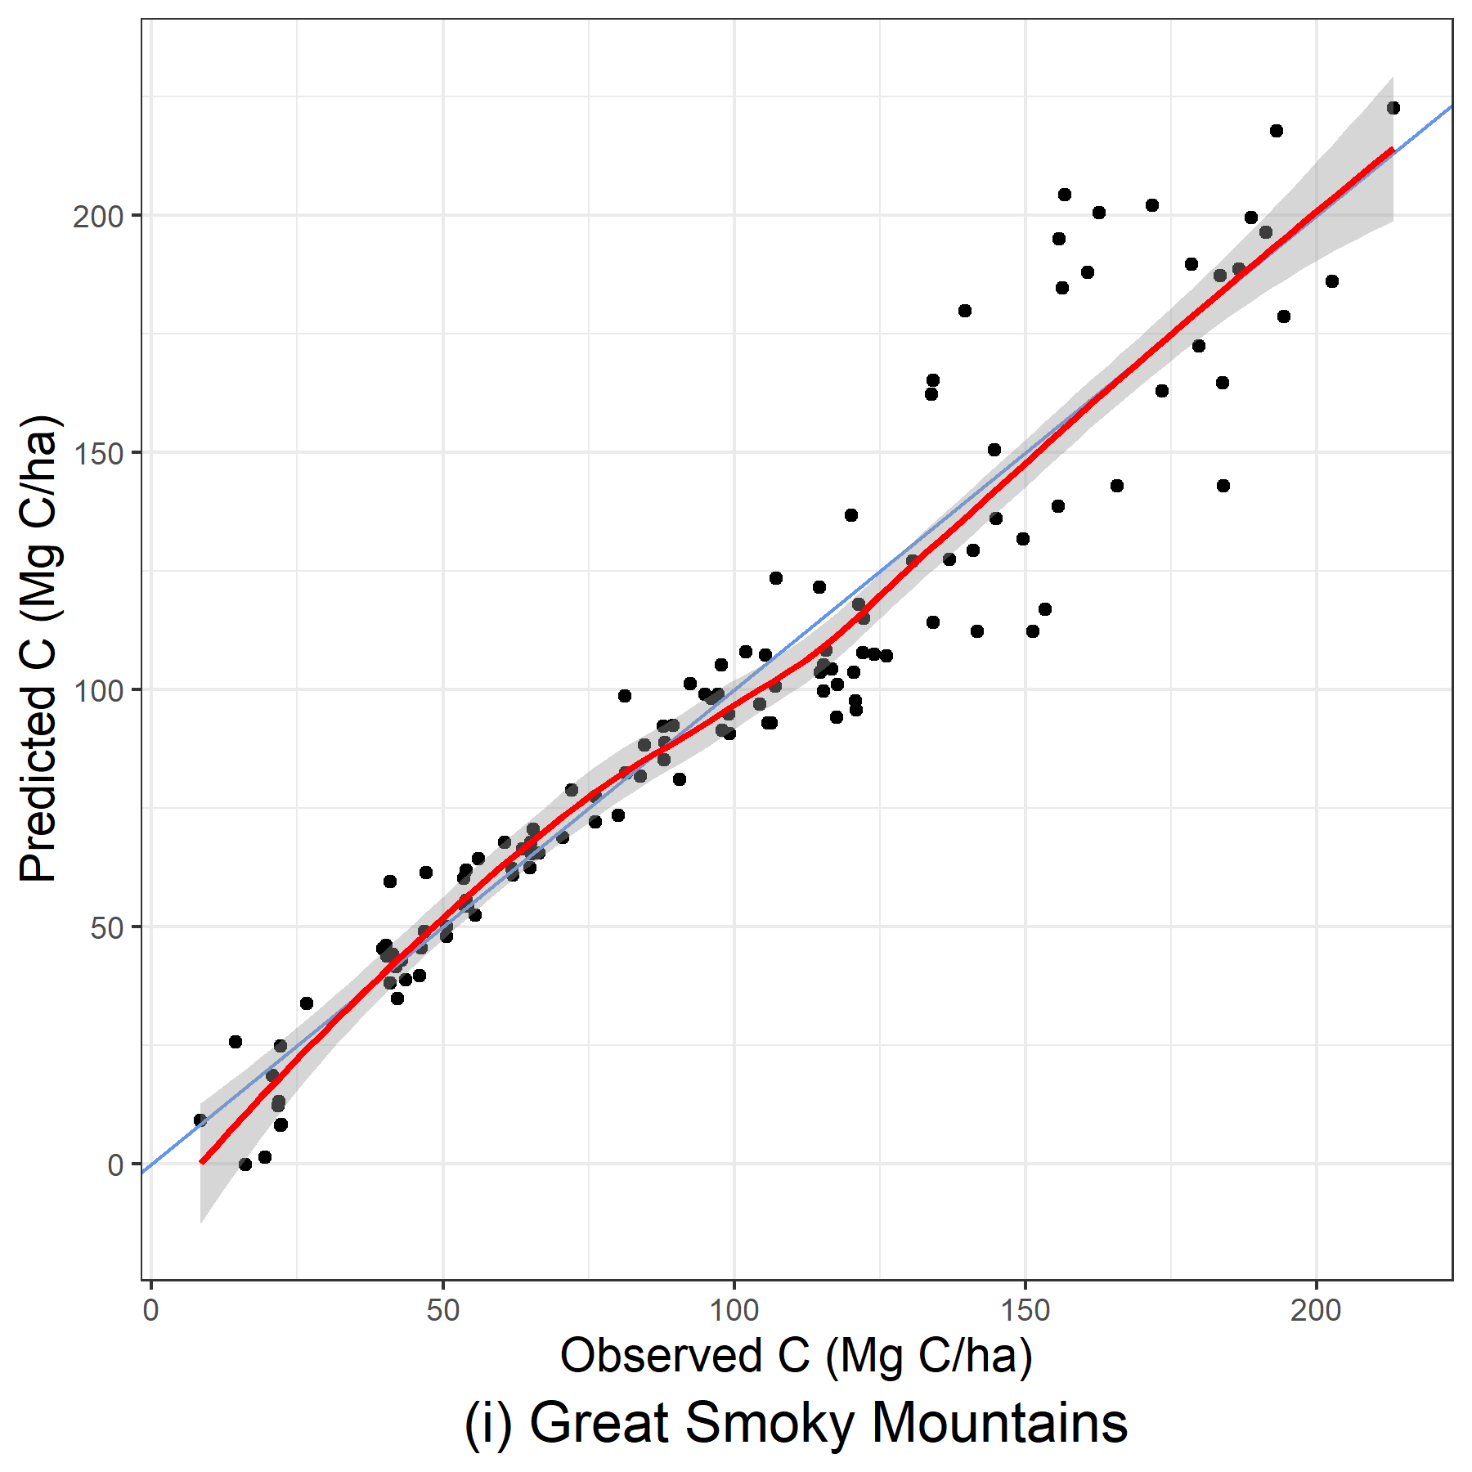
Figure 20: Predicted and observed carbon per hectare (Mg C/ha) from out-of-bag samples for GAMM models using stand-level variables.
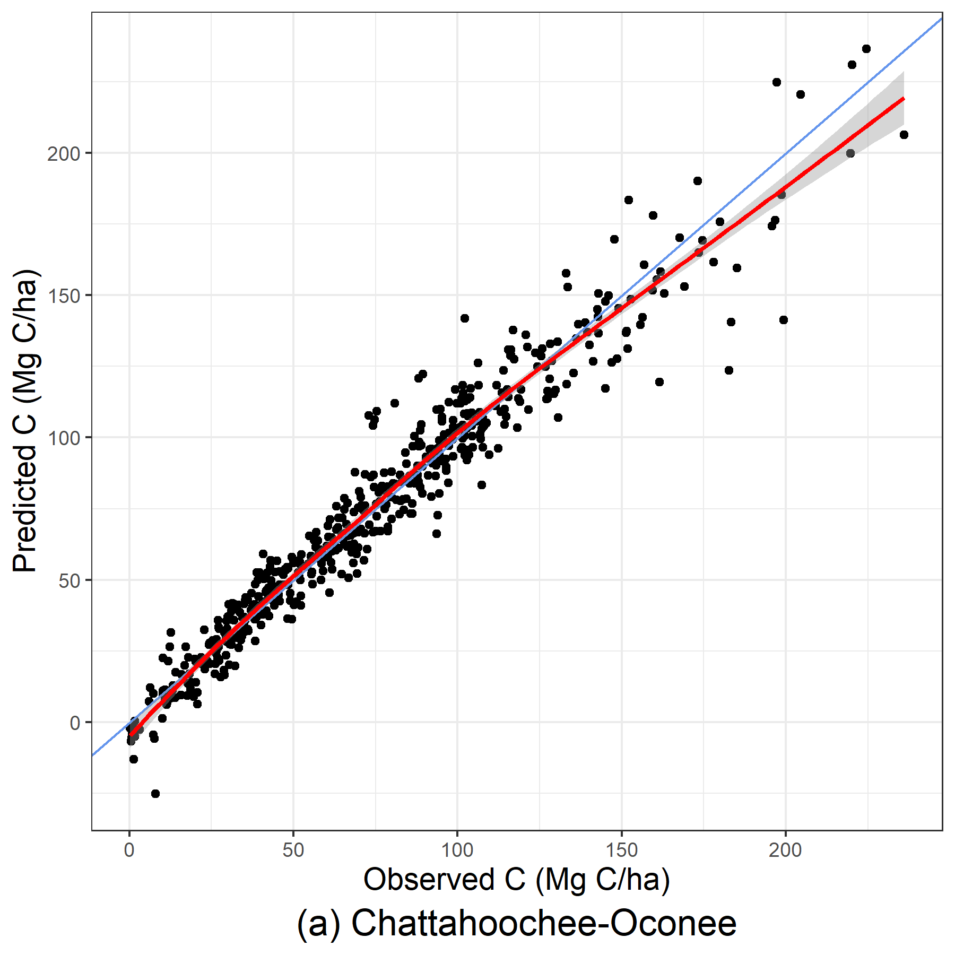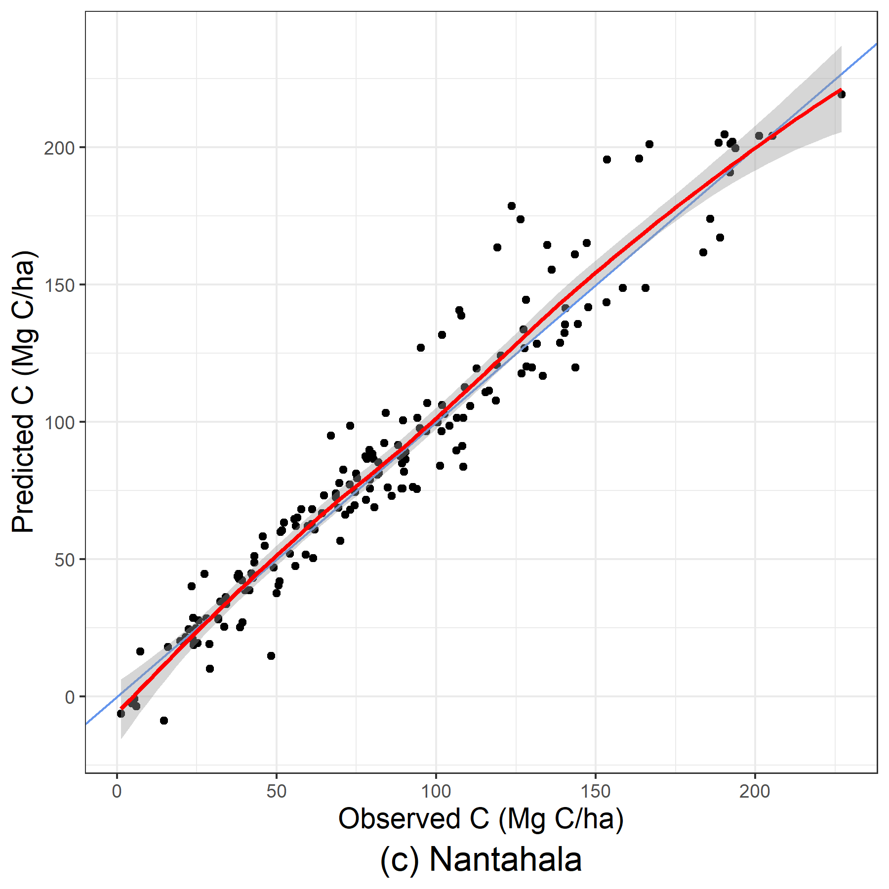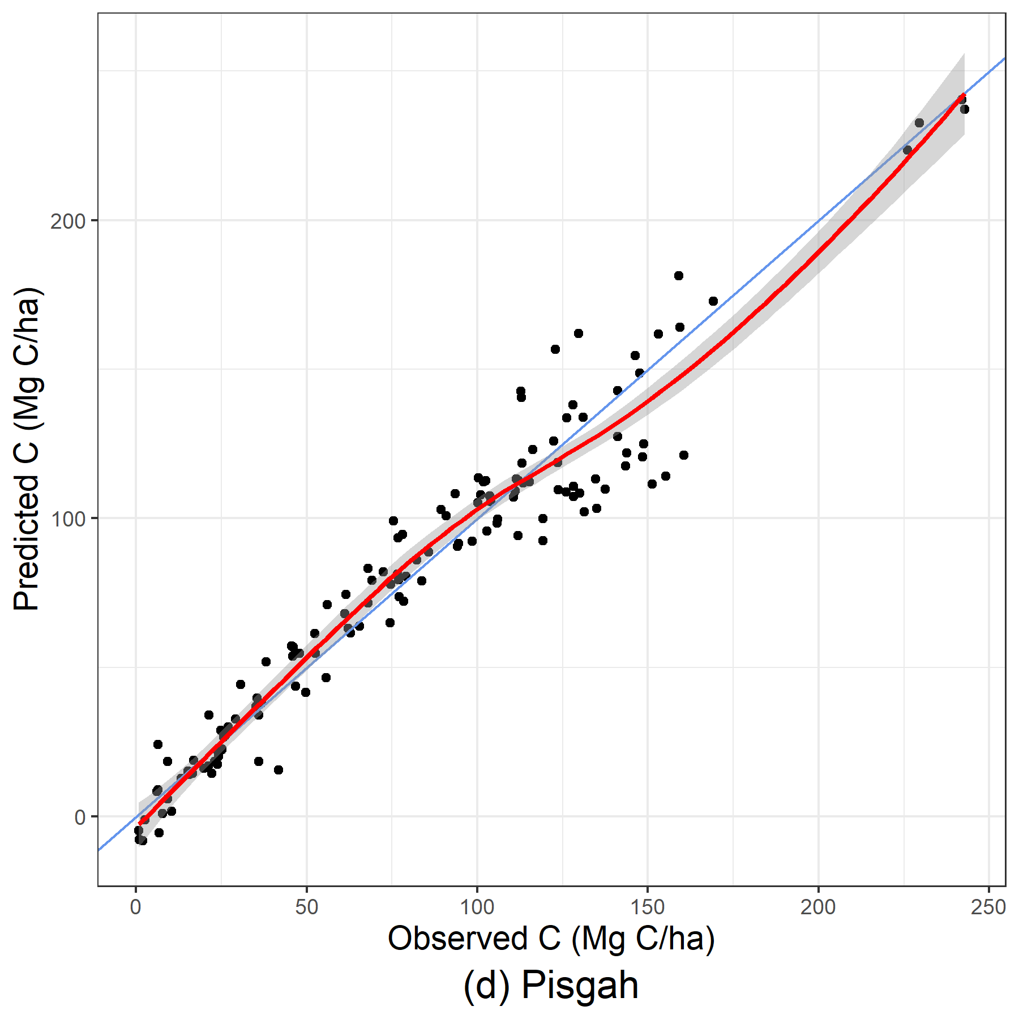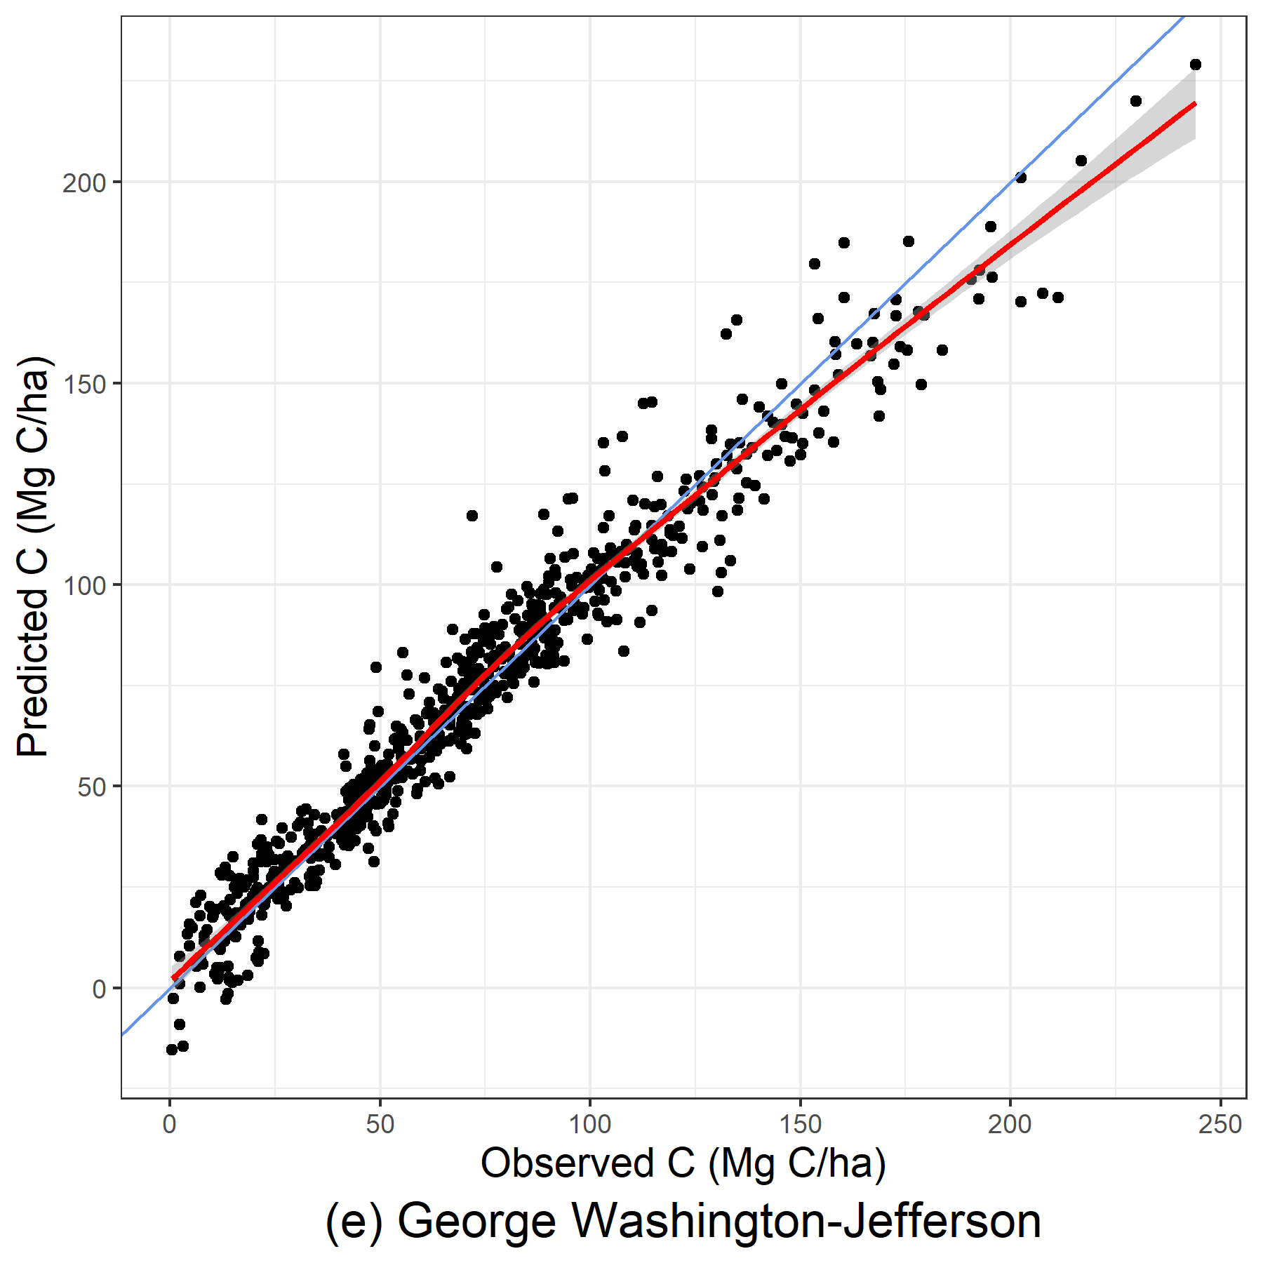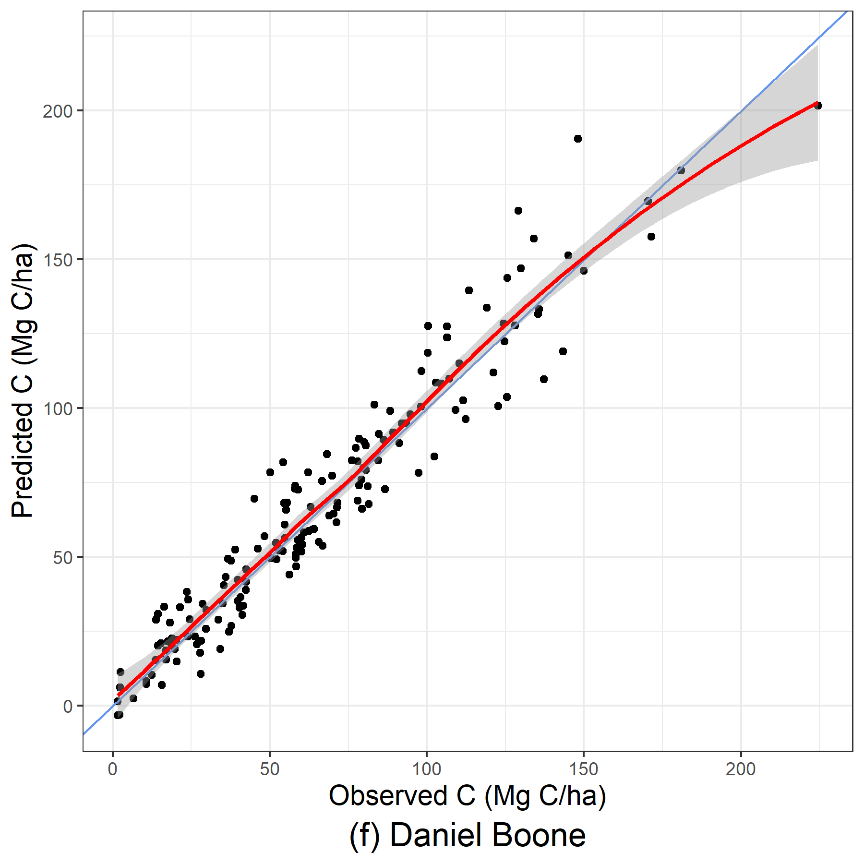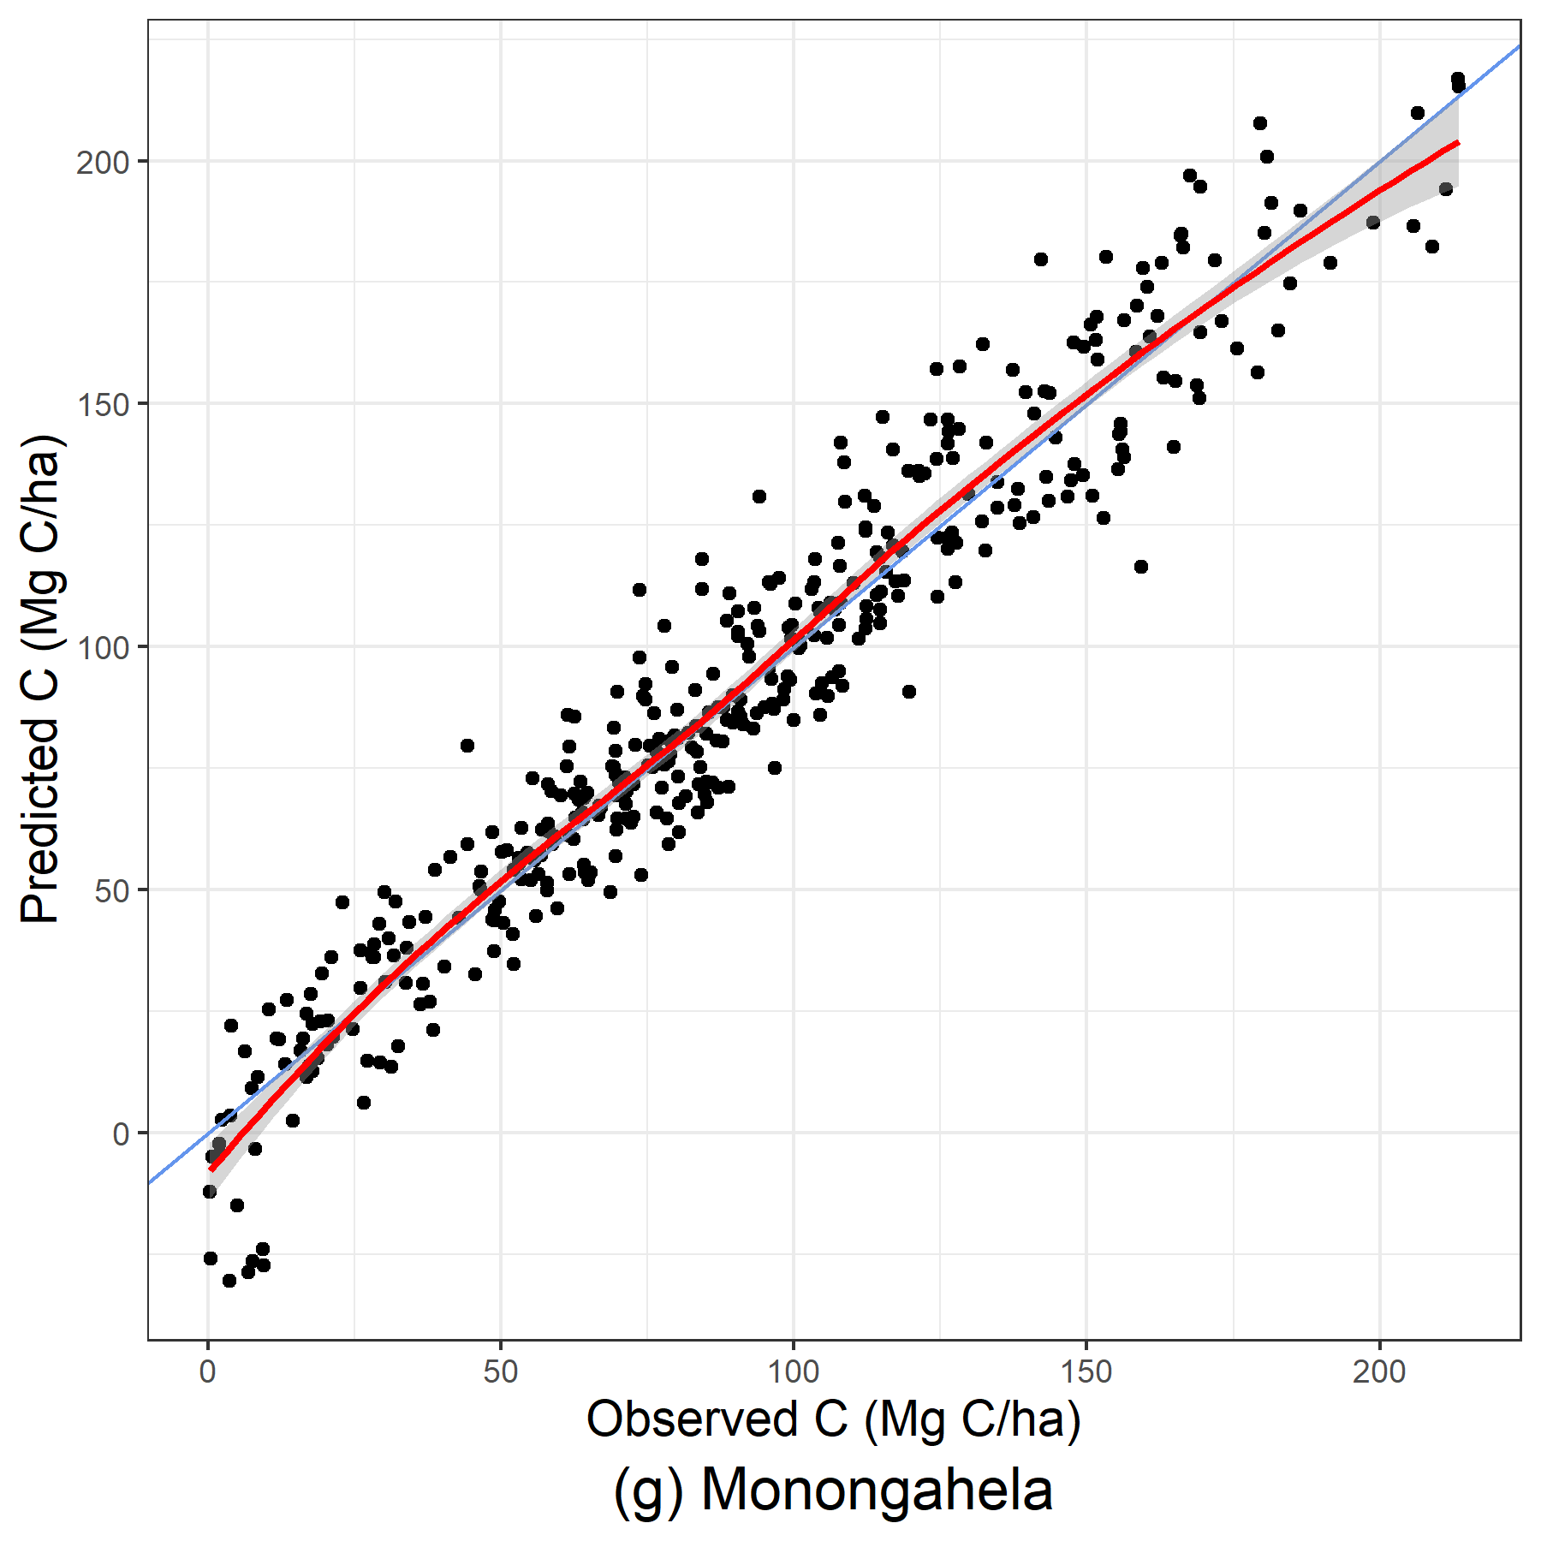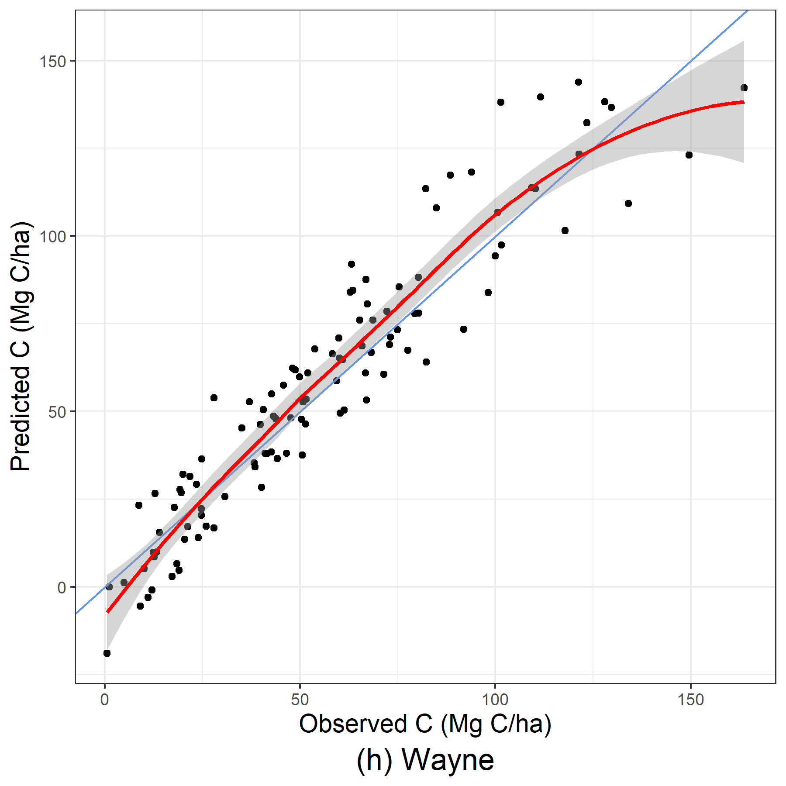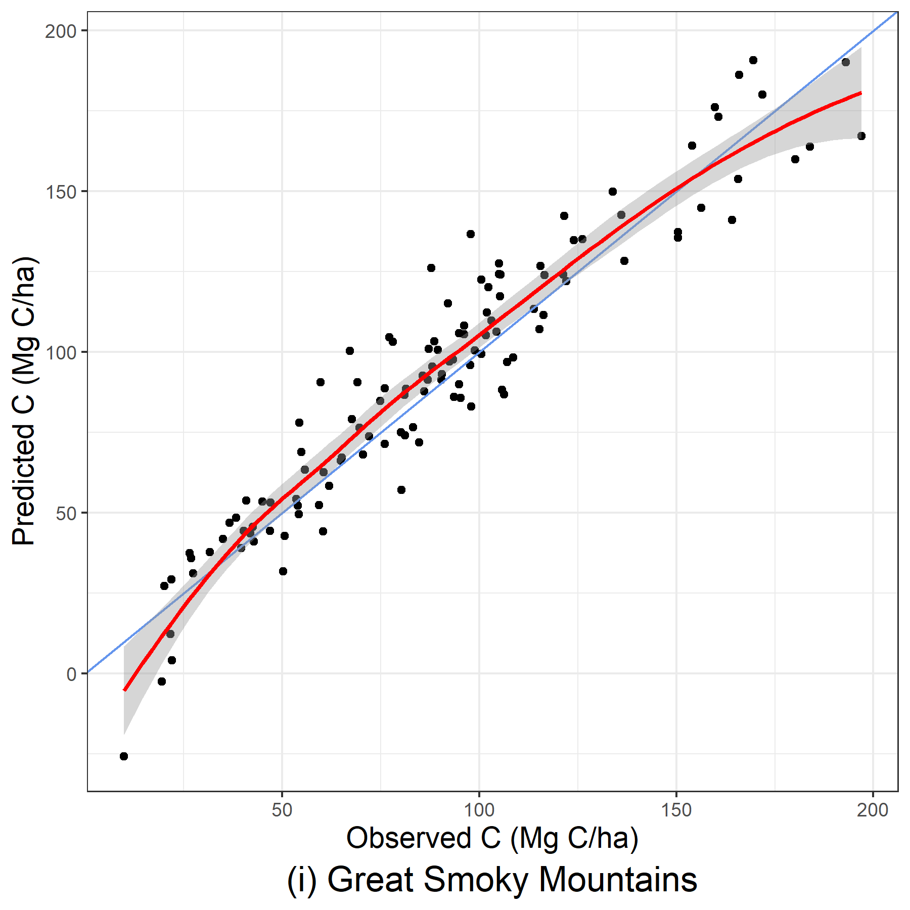
Figure 21: Predicted and observed carbon per hectare (Mg C/ha) produced from GAMM models using stand-level and WorldClim BIO environmental variables.

Table 11: Median coefficients of predictor variables produced from the 1000 bootstrap samples for linear mixed-effect models by region. See Table 7 for variable descriptions. σ_{fort} is the estimated coefficient of the forest-type random effect.
STAND-ONLY | D | H | H-D | QMD | BA | TPH | SDI
Chattahoochee-Oconee | 3.26 | -1.86 | 0.78 | -0.18 | 4.26 | -0.01 | 0.00
Cherokee | 2.48 | -1.06 | 0.52 | -0.26 | 4.50 | -0.01 | 0.00
Nantahala | 1.95 | -1.20 | 0.71 | -0.20 | 4.64 | -0.01 | 0.00
Pisgah | 4.38 | -3.19 | 0.86 | -0.52 | 5.72 | -0.01 | 0.00
George Washington-Jefferson | 2.41 | -0.87 | 0.73 | -0.15 | 4.12 | -0.01 | 0.00
Daniel Boone | 2.64 | -1.45 | 0.67 | -0.28 | 5.37 | -0.01 | 0.00
Monongahela | 2.99 | -1.60 | 0.94 | -0.45 | 4.88 | -0.01 | 0.00
Wayne | 3.17 | -2.20 | 0.74 | -0.38 | 5.15 | -0.02 | 0.00
Great Smoky Mountains | 2.04 | -0.64 | 0.71 | 0.12 | 3.01 | -0.01 | 0.00
Shenandoah | 2.83 | -2.02 | 0.90 | -0.33 | 4.68 | -0.01 | 0.00
 | Aspect | Slope | Intercept | σ_{fort}
Chattahoochee-Oconee | 0.00 | -0.02 | -104.83 | 5.50
Cherokee | 0.00 | 0.04 | -73.27 | 5.41
Nantahala | -0.01 | 0.01 | -76.92 | 5.02
Pisgah | -0.01 | 0.02 | -102.21 | 8.06
George Washington-Jefferson | 0.00 | -0.01 | -95.01 | 6.05
Daniel Boone | -0.01 | -0.06 | -87.41 | 7.81
Monongahela | -0.01 | -0.01 | -93.39 | 8.78
Wayne | 0.00 | -0.07 | -82.19 | 7.94
Great Smoky Mountains | 0.01 | 0.01 | -108.29 | 7.09
Shenandoah | 0.00 | 0.00 | -86.51 | 3.33
STAND + ENVIRONMENTAL | D | H | H-D | QMD | BA | TPH | SDI
Chattahoochee-Oconee | -8.66 | -0.98 | 6.06 | 19.31 | 40.80 | -7.45 | 0.86
Cherokee | -12.11 | -2.14 | 5.65 | 22.61 | 43.42 | -6.95 | -2.21
Nantahala | -1.92 | -1.81 | 6.80 | 12.06 | 43.79 | -8.12 | -1.10
Pisgah | -11.03 | 1.31 | 6.72 | 19.42 | 36.10 | -5.65 | -1.14
George Washington-Jefferson | -21.62 | 9.36 | 0.58 | 22.49 | 42.99 | -8.28 | 3.16
Daniel Boone | -9.87 | 0.94 | 6.57 | 18.85 | 38.90 | -8.94 | 5.06
Monongahela | -21.97 | 3.66 | 4.54 | 24.23 | 42.97 | -5.62 | -4.54
Wayne | -16.91 | -3.48 | 8.92 | 33.70 | 49.08 | -6.56 | -2.39
Great Smoky Mountains | -16.80 | 0.20 | 3.53 | 30.28 | 32.84 | -2.52 | -3.26
Shenandoah | 17.85 | -8.50 | 8.76 | -0.57 | 33.69 | -9.58 | 6.03
Table 10 (cont.)
STAND+ENVIRONMENTAL | Aspect | Slope | bio01 | bio02 | bio03 | bio04 | bio05 | bio06
Chattahoochee-Oconee | 0.27 | -0.28 | 13.45 | 1.42 | 0.47 | 7.11 | -15.55 | -0.69
Cherokee | -0.34 | -0.09 | -6.00 | -0.59 | 2.50 | -0.65 | 4.13 | 0.70
Nantahala | -0.22 | -1.18 | 1.88 | -3.55 | 3.02 | -17.78 | 9.58 | -1.21
Pisgah | -0.15 | -0.50 | 8.01 | -5.65 | 0.18 | -7.02 | 20.18 | -6.43
George Washington-Jefferson | 1.46 | -0.52 | 69.94 | -14.62 | 7.38 | -7.02 | -36.31 | -23.57
Daniel Boone | -0.46 | -0.14 | -11.34 | 5.02 | 0.85 | 3.05 | -11.56 | 5.59
Monongahela | -0.60 | 0.39 | 10.62 | -15.53 | 8.20 | -2.50 | 14.82 | -3.92
Wayne | -0.25 | -1.55 | 9.22 | 5.11 | 5.78 | -3.63 | 15.28 | 8.65
Great Smoky Mountains | -1.19 | 0.23 | 15.27 | 15.45 | 2.47 | 12.46 | 36.86 | 40.20
Shenandoah | 0.74 | -1.12 | 9.25 | -4.57 | 1.10 | -11.62 | 14.26 | -3.67
 | bio08 | bio09 | bio10 | bio11 | bio12 | bio13 | bio14 | bio15
Chattahoochee-Oconee | -5.07 | -0.65 | 2.39 | 0.46 | -85.91 | 18.60 | 9.34 | -2.19
Cherokee | 2.58 | 0.22 | 4.43 | -3.34 | 5.71 | 1.11 | 6.16 | 0.19
Nantahala | 0.11 | 10.89 | 9.04 | -30.75 | 25.78 | -1.71 | -1.63 | 5.66
Pisgah | 0.67 | 0.91 | -7.00 | -9.78 | -4.06 | 5.75 | -0.44 | 0.48
George Washington-Jefferson | 3.91 | 3.16 | 10.15 | -10.73 | -68.66 | 57.73 | 10.69 | -1.44
Daniel Boone | 2.98 | 0.56 | -5.19 | 6.92 | -13.04 | 11.74 | -9.50 | -2.40
Monongahela | -0.26 | 0.24 | -8.28 | -9.27 | -167.53 | 58.48 | 79.81 | -6.16
Wayne | -4.49 | -5.68 | 2.36 | -33.71 | -114.92 | 44.26 | 63.40 | -7.88
Great Smoky Mountains | -0.27 | 10.15 | -114.41 | 0.00 | -4.66 | 17.36 | -36.67 | -3.05
Shenandoah | -6.47 | 0.87 | 2.77 | -22.84 | -14.59 | -6.71 | 21.20 | 4.93
 | bio16 | bio17 | bio18 | bio19 | Intercept | σ_{fort}
Chattahoochee-Oconee | -17.69 | 10.82 | 22.25 | 42.78 | 74.56 | 5.27
Cherokee | 6.05 | -19.95 | 1.37 | 1.42 | 70.29 | 5.72
Nantahala | -10.84 | -2.87 | 8.09 | -14.47 | 68.17 | 7.68
Pisgah | -2.60 | 6.72 | -0.94 | -3.13 | 71.18 | 6.12
George Washington-Jefferson | -7.32 | -33.83 | 37.30 | -5.45 | 88.57 | 7.84
Daniel Boone | -28.57 | 0.00 | 23.58 | 10.14 | 91.07 | 8.37
Monongahela | 15.01 | -74.01 | 61.31 | 17.19 | 75.48 | 4.53
Wayne | 10.48 | -114.40 | 73.01 | 35.29 | 80.74 | 7.01
Great Smoky Mountains | -8.58 | 9.29 | 15.88 | 0.00 | 78.95 | 7.24
Shenandoah | 6.13 | -61.96 | -3.65 | 61.11 | 56.12 | 7.29

Table 12: Median coefficients of predictor variables produced from the 1000 bootstrap samples for LASSO models by region. See Table 7 for variable descriptions. σ_{fort} is the estimated coefficient of the forest-type random effect.
STAND-ONLY | D | H | H-D | QMD | BA | TPH | SDI
Chattahoochee-Oconee | -1.88 | -2.42 | 7.35 | 14.43 | 40.10 | -7.98 | 1.96
Cherokee | -2.00 | -3.23 | 7.04 | 14.25 | 42.30 | -7.70 | -0.21
Nantahala | -1.60 | -2.05 | 8.13 | 11.13 | 41.54 | -6.52 | -2.70
Pisgah | -0.61 | -9.01 | 11.97 | 23.45 | 49.17 | -8.37 | -0.10
George Washington-Jefferson | -6.98 | 0.94 | 7.84 | 15.82 | 35.89 | -6.40 | -0.24
Daniel Boone | 0.00 | -1.77 | 6.91 | 10.06 | 43.98 | -8.10 | -0.75
Monongahela | -1.64 | -0.82 | 8.08 | 12.89 | 39.14 | -9.65 | 6.04
Wayne | 0.25 | -0.19 | 4.34 | 9.03 | 33.64 | -6.83 | 3.39
Great Smoky Mountains | -1.05 | 2.72 | 5.32 | 8.32 | 42.37 | -8.22 | 4.78
Shenandoah | 0.19 | -0.01 | 4.27 | 11.07 | 30.77 | -1.46 | -1.50
 | Aspect | Slope | Intercept | σ_{fort} | λ
Chattahoochee-Oconee | 0.39 | -0.58 | 73.65 | 5.30 | 0.00
Cherokee | -0.33 | 0.23 | 69.37 | 5.79 | 0.00
Nantahala | -1.11 | -0.02 | 74.61 | 6.08 | 0.00
Pisgah | 0.08 | -0.88 | 80.18 | 11.87 | 5.00
George Washington-Jefferson | -0.15 | -0.40 | 69.79 | 6.29 | 0.00
Daniel Boone | -0.46 | -1.57 | 67.18 | 7.89 | 5.00
Monongahela | -0.54 | -0.43 | 89.49 | 9.08 | 5.00
Wayne | -0.02 | -1.50 | 54.92 | 8.24 | 25.00
Great Smoky Mountains | 1.35 | -0.10 | 88.65 | 7.58 | 5.00
Shenandoah | 0.10 | -0.47 | 78.99 | 6.13 | 10.00
STAND + ENVIRONMENTAL | D | H | H-D | QMD | BA | TPH | SDI
Chattahoochee-Oconee | -0.51 | -3.17 | 7.34 | 13.70 | 40.37 | -8.18 | 2.18
Cherokee | -1.55 | -4.26 | 6.68 | 14.19 | 42.78 | -7.87 | -0.19
Nantahala | -0.51 | -0.29 | 7.55 | 8.32 | 41.44 | -6.40 | -1.85
Pisgah | -0.53 | -8.44 | 11.67 | 21.92 | 49.19 | -8.65 | 0.00
George Washington-Jefferson | -3.36 | -0.54 | 8.21 | 13.22 | 35.98 | -6.86 | 0.40
Daniel Boone | 0.00 | -1.71 | 6.72 | 10.11 | 43.35 | -7.99 | -0.11
Monongahela | -1.16 | -1.00 | 8.10 | 12.31 | 39.09 | -9.79 | 6.33
Wayne | 0.18 | -0.95 | 4.11 | 10.22 | 33.34 | -6.57 | 3.32
Great Smoky Mountains | -0.75 | 2.24 | 5.06 | 8.38 | 41.98 | -6.97 | 4.03
Shenandoah | 6.82 | 6.95 | 0.00 | 6.75 | 11.46 | -0.79 | 0.92

Table 11 (cont.)
STAND+ENVIRONMENTAL | Aspect | Slope | bio01 | bio02 | bio03 | bio04 | bio05 | bio06
Chattahoochee-Oconee | 0.28 | -0.31 | 0.36 | 0.40 | 0.13 | 0.29 | -0.02 | -0.02
Cherokee | -0.45 | -0.12 | 0.02 | -0.09 | 2.08 | 1.04 | 0.01 | -0.02
Nantahala | -0.72 | 0.10 | -0.02 | -0.20 | 1.54 | 0.00 | -0.01 | 0.02
Pisgah | 0.17 | -1.49 | -0.14 | -1.10 | 3.40 | 1.18 | -0.06 | 0.00
George Washington-Jefferson | -0.19 | -0.59 | 0.07 | 0.74 | -0.35 | 0.19 | 0.25 | -0.23
Daniel Boone | -0.69 | -1.28 | -0.26 | -0.92 | 1.41 | 0.20 | 1.53 | 0.02
Monongahela | -0.48 | -0.29 | 0.01 | -0.03 | 0.56 | 0.36 | -0.30 | -0.11
Wayne | 0.00 | -1.10 | 0.00 | -0.31 | -0.04 | -0.07 | 1.64 | 0.09
Great Smoky Mountains | 1.72 | -0.56 | 0.24 | -0.30 | 1.53 | -0.56 | 0.00 | 1.04
Shenandoah | 1.15 | -0.10 | 0.00 | 0.00 | 0.00 | 0.00 | 0.00 | 0.00
 | bio08 | bio09 | bio10 | bio11 | bio12 | bio13 | bio14 | bio15
Chattahoochee-Oconee | -0.01 | -0.57 | 0.04 | 0.00 | -0.09 | 0.02 | 0.00 | -0.12
Cherokee | 0.61 | -1.24 | 0.03 | 0.00 | 0.00 | 0.02 | 0.17 | 0.87
Nantahala | -0.65 | -1.61 | 0.00 | -0.01 | 0.00 | 0.16 | 0.00 | -0.11
Pisgah | -1.54 | -1.84 | -0.02 | -0.87 | -1.18 | 0.02 | 1.29 | 1.24
George Washington-Jefferson | 0.29 | 0.72 | -0.01 | -0.01 | -0.88 | 1.61 | 0.06 | -0.08
Daniel Boone | -0.11 | 2.27 | 1.22 | -1.17 | 0.26 | -0.72 | 0.00 | 2.83
Monongahela | 0.00 | -0.04 | 0.00 | 0.05 | -0.06 | 0.65 | -1.24 | -0.32
Wayne | -0.01 | 0.95 | 0.01 | 0.00 | -0.24 | 0.00 | 0.20 | 1.73
Great Smoky Mountains | 2.15 | 1.40 | 0.08 | 0.25 | 0.03 | 0.37 | 0.26 | 0.03
Shenandoah | 0.00 | 0.00 | 0.00 | 0.00 | 0.00 | 0.00 | 0.00 | 0.00
 | bio16 | bio17 | bio18 | bio19 | Intercept | σ_{fort} | λ
Chattahoochee-Oconee | 0.06 | 0.00 | -0.77 | 0.07 | 74.30 | 8.07 | 0.00
Cherokee | 0.40 | -0.40 | 0.48 | -0.07 | 70.13 | 8.85 | 0.00
Nantahala | 0.23 | -0.02 | 0.00 | 0.03 | 74.84 | 7.58 | 0.00
Pisgah | -0.23 | 0.04 | 0.03 | -0.01 | 79.64 | 10.97 | 0.00
George Washington-Jefferson | -0.07 | 0.23 | -0.40 | -0.07 | 70.61 | 10.88 | 0.00
Daniel Boone | 0.05 | 0.28 | 0.38 | 0.00 | 67.16 | 8.05 | 0.00
Monongahela | 0.03 | -0.19 | 0.40 | -0.31 | 88.99 | 10.61 | 0.00
Wayne | 0.02 | 0.07 | -0.36 | 0.09 | 55.46 | 8.70 | 5.00
Great Smoky Mountains | 0.20 | 0.11 | 0.05 | 0.00 | 88.13 | 9.46 | 0.00
Shenandoah | 0.00 | 0.00 | 0.00 | 0.00 | 79.33 | 29.99 | 500.00

CHAPTER 4: PERFORMANCE EVALUATION OF EXTENDING A REGIONALLY TRAINED MODEL BEYOND THE TRAINING AREA: A CASE STUDY COMPARING AGAINST OFF-THE-SHELF CARBON PRODUCTS AND CARBON INVENTORY IN SOUTHERN APPALACHIA.

ABSTRACT
Quantifying live aboveground carbon is crucial to forest and carbon monitoring programs, but producing accurate estimates at large scales can be resource intensive. Aboveground biomass (AGB) products have cropped up over recent years to meet the needs of natural resource professionals and climate scientists who require large-scale carbon estimates to serve various purposes. As the number of carbon products such as model and aboveground biomass (AGB) maps continues to grow, natural resource professionals are faced with the tough decision on choosing a product, with accuracy being a trade-off for convenience in these products. Regionally trained stand-level carbon prediction models tested in chapter 3 showed high predictive performance among national forests and parks of southern Appalachia and may be able to retain high predictive power beyond the training region as forest characteristics exist beyond artificially assigned boundaries. However, this extended performance has not yet been tested or placed in the context of other AGBD products. If these regional models are able to be applied to forests beyond the training area, their utility increases. While building these regional models requires more effort than existing products, the improved predictive power can support the additional effort needed to produce these models.
In this study, a regionally trained linear mixed-effects model was tested against two AGB density (AGBD) products (ESA CCI biomass and CTrees carbon map) on a nearby forest to determine how much better the regionally trained model applied on an external region performs compared to available carbon products at the plot and stratum level. Results showed that AGBD products poorly captured plot-level estimates and consistently underpredicted at the stratum level, while the regional model performed well at the plot and stratum levels, producing prediction closer to observed values than the AGBD maps. The only instance in which the regional model performed worse was when predicting forest types absent from the training data. The high predictive performance of the regional model compared to the AGBD products provides a noticeable increase in accuracy at both plot and stratum levels that supports the extra effort needed to develop regional models.

INTRODUCTION
Forests occupy 31% of land area on planet Earth; at this scale, they are capable of storing enormous amounts of carbon (Reay et al. 2008, Wei et al. 2025). Accurately quantifying the amount of live aboveground carbon present in forests has received increased attention in recent decades, as estimates can be used to track offsets of atmospheric carbon and as a proxy for forest health. As a global issue, international agreements have been formed to monitor rising levels of atmospheric carbon from continued burning of fossil fuels, such as the United Nations Framework Convention on Climate Change (UNFCCC) (1994), the updated Kyoto Protocol to the United Nations Framework Convention on Climate Change (1997), and the most recent Paris Agreement (2015). To track global carbon patterns, global carbon estimation products have been created using combinations of methodologies and data to generate predictions . Products As a way to offset ever increasing emissions from ever increasing fossil-fuel usage and achieve the UN’s goal of net-zero emissions, carbon credit programs and cap-and-trade marketplaces have proliferated and incentivized private landowners’ enrollment (Charnley, Diaz, and Gosnell 2010, White et al., n.d.). Because of its importance in understanding global carbon patterns and monetary potential, many carbon and biomass estimation products have been developed to meet the needs of various users.
The gold standard of carbon and biomass estimates are produced through a rigorous and time-intensive process, using tree-level forest inventory data combined with species-specific biomass equations (carbon is generally accepted as the following: $c≈0.5*biomass$). Because carbon estimations are performed at the individual tree-level, these estimates are highly accurate and considered the “true” value. Despite the uncertainty still present from various sources like measurement and sampling error, this methodology is still considered best practice by forest monitoring programs like the United Nations Reducing Emissions from Deforestation and Forest Degradation (REDD) program and Verra (Verra, n.d.). However, given how rigorous the methodology is, completing inventories to this full extent can strain resources, particularly at large landscape levels. Alternative methodologies like maps and geospatial datasets have been developed to generate estimates more efficiently at large scales, but at the cost of error being introduced. The amount of error introduced varies, and previous research has focused on quantifying and comparing error present among various products (Hudak et al. 2026). Understanding systematic differences between estimates and ground truthed values. While these models will not be able to replace the detail and precision of boots-on-the-ground inventories, generating estimates can allow for easier monitoring between inventories. Comparing the estimates against a certified carbon program can help us quantify how much error exists at different spatial scales to make more informed conclusions. Previous research has investigated such questions by comparing multitudes of models. However, given how many products are available, many models remain untested.
As alternatives to this rigorous procedure, aboveground biomass density (AGBD) maps and products provide large-scale, such as national or global, estimates of biomass at varying resolutions. The number of products available continues to grow, varying by input and validation data and estimation approach. Mission purpose also differs, with some maps being the product of international and national efforts, like the U.S.’s National Aeronautics and Space Administration (NASA), the U.S. Forest Service Forest Inventory and Analysis (FIA), or the European Space Agency (ESA). While validation data normally uses forest inventory data, some products like the ESA’s Climate Change Initiative (CCI) biomass data is produced through a methodology consisting solely of remotely sensed data. A biomass map derived from both remotely sensed and ground inventory with a proprietary methodology has been released by CTrees, a non-profit organization. CTrees has 100 m resolution, while ESA was accessed at 1 km resolution; these products are efficient alternatives to best practices, not only having global scale data, but can also be updated more frequently than global estimates produced via national forest inventories (NFIs). However, there is a trade-off with increased error, and previous studies have quantified error present across several carbon products that differed in input data and methodology. Error also varied within products based on the spatial aggregation level, like county, stand, and plot level.
An intermediate alternative to the best practices and off-the-shelf global carbon products may lie in using a model trained on a nearby federal region, like national parks and forests. Training models on federal regions can capitalize on federal regions’ large contiguous areas, and they may even share management objectives with privately owned forests. Historical records can be accessed through NFIs to increase observations and study temporal changes. One methodology is described in Yang et al. (2025) and Chapter 2 that delivers highly accurate carbon estimates. Having the ability to expand these federally trained models beyond the training area has not yet been tested but may yield promising results. In southern Appalachia, which is the focus area of the two aforementioned studies, forests do not always follow human-created property boundaries, and nearby forests can be similar to those within the property line. These forest characteristics include but are not limited to stand age, composition, topography, and climate. The amount of diversity in southern Appalachia was previously an obstacle, as mixed-species models faced particular challenges (Yang, Brandeis et al. 2022a, Yang, Brandeis, and Skiba 2025). But, when using a linear mixed-effects model approach with a random effect on forest type, a global model can be produced to capture many forest types found across large regions as levels. Mixed models further allow information sharing when sample sizes are limited and generate predictions for levels absent from the training data. Ultimately, an accurate and stable global model is produced, as shown in Yang et al. (2022a, 2025), but its use beyond the training region remains untested.
Our hypothesis is that this regionally trained model will perform better than the global AGBD maps and worse than best practice estimates. As a model trained specifically for a nearby region, it is expected to be able to better capture estimates that products with global-level estimates. How much better this regional model performs is unknown. Using the maps and best practice as reference points helps rank this new methodology in terms of predictive power. The ability to use this regional model outside of the trained region may be more time-intensive to produce that using the AGBD products, but improved predictions can be more desired in some cases to warrant the extra effort needed. As the scale of ~1000 acre properties, this study’s areas of interest are smaller than conducted in other studies. Using a working research forest maintained by the University of Tennessee, the properties are at a similar scale to those of private landowners, demonstrating how the extension of this model can be applied beyond this study by other landowners and managers.
Although the three products described above all aim to quantify aboveground live carbon, estimates can vary greatly. For carbon monitoring programs, this uncertainty between products can have consequences, like failing to detect changes or determining appropriate management strategies. As the assumed “true” quantity of carbon is estimated using a combination of ground-based inventories with species-specific biomass equations, the University of Tennessee Forest Resources AgResearch and Education Center’s (FRREC) existing forest carbon inventory program serves as ground truthed validation data at spatial scales on par with private landowners. Quantifying how much error is present among and between the model and products tested at this aggregated spatial scale provides an updated understanding of which approach may be suitable as an efficient alternative to conducting full inventories. Comparing estimates from the various carbon products against a validated carbon inventory programs sheds light on how close estimates are to the accepted true value of the plot.

MATERIALS AND METHODS

STUDY AREA AND VALIDATION DATA
The areas of interest for this study are the regions of the University of Tennessee Forest Resources AgResearch and Education Center (FRREC) Forest Properties enrolled in a verified carbon monitoring program. These regions are spread across multiple strata in middle and east Tennessee, as shown in Figures 22, 23, 24, and 25. The strata considered for this study include two regions located in the Cumberland Mountains, one region within the Oak Ridge, Tennessee Arboretum, and two regions in the Highland Rim (shown in Table 13). The strata are further divided by forest composition, either as hardwood, softwood, or a mix of the two. Geographically, the Highland Rim strata are located the furthest west near Tullahoma, at an elevation of approximately 1000 ft. Similarly, the Oak Ridge Arboretum is at an elevation of 1000 feet, but it is located further east and situate in a valley surrounded by more mountainous regions. Both Cumberland Forest strata are located in the Cumberland Mountains west of the Appalachia mountains and are at higher elevations than other strata (approximately 2000 ft.).
To meet best practice standards as defined by the United Nations Reducing Emissions from Deforestation and Forest Degradation (REDD) program and protocol set by the American Carbon Registry (ACR), the sampling design was created to follow ACR methodology guidelines (The ACR Standard 2023). “[target] 0% uncertainty as assessed by the ACR methodology, corresponding to a 90% confidence interval less than or equal to +/-10% of mean forest carbon stock” (The ACR Standard 2023).The inventory process consists of 1/10 acre plots, with live and dead trees ≥ 5” diameter at breast height (dbh) measured. A nested 1/100th acre plot around the center record all live trees within 1-4.9’ dbh recorded. Species were recorded for all trees, and heights were measured for trees within the eastern hemisphere of each plot. The collected inventory information serves as a real-world scenario and the validation data used for this study. Individual tree carbon was calculated using Jenkins (2003) carbon and biomass equations and aggregated to produce stand-level estimates. A histogram of stand-level carbon is shown in Figure 26. A total of 142 plots located across all described regions were used for this study.
Table 13: FRREC’s 5 stratum used within the study. Additional stratum exist that were excluded.
Stratum (general forest type) | Abbr. | Obs. No. | Acres
Cumberland Forest North (hardwood) | CN | 56 | 4403.9
Cumberland Forest South (hardwood) | CS | 40 | 3996.0
Highland Rim (hardwood) | HR_HW | 8 | 514.0
Highland Rim (pine) | HR_PI | 9 | 255.4
Oak Ridge Arboretum (hardwood and pine) | OR | 37 | 2145.5
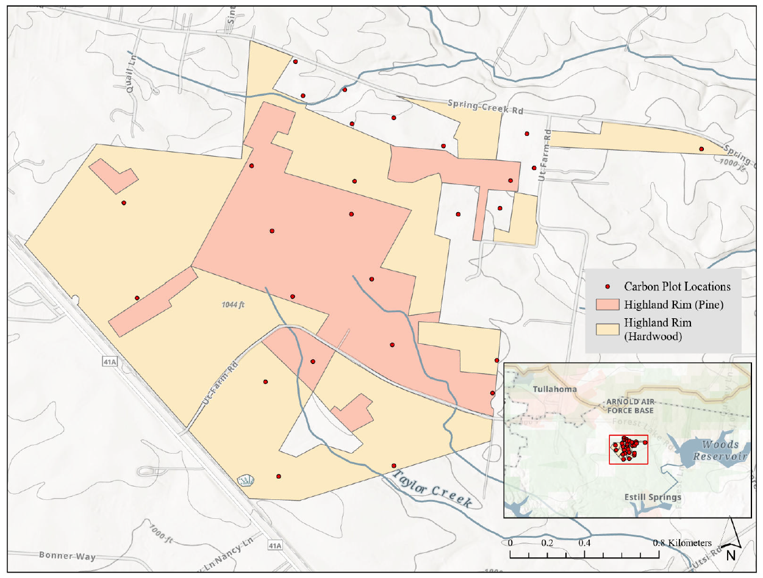
Figure 22: Map of UTK FRREC’s Highland Rim region south of Tullahoma, TN with stratum and carbon plot locations.
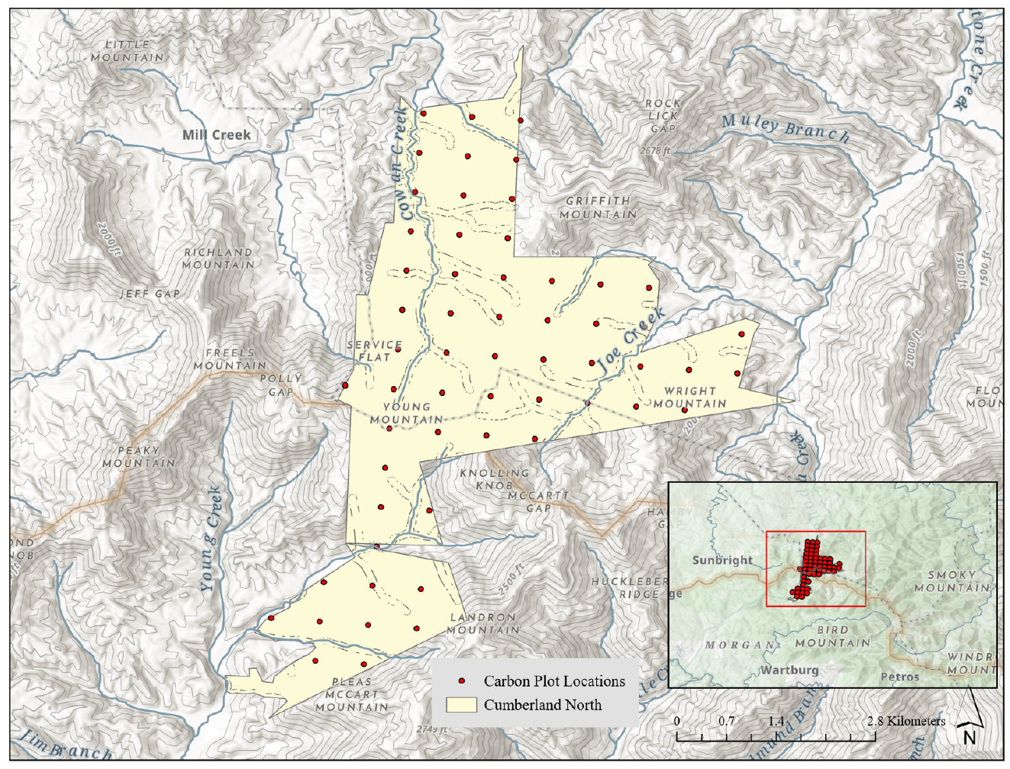
Figure 23: Map of UTK FRREC’s Cumberland Forest North region with stratum and carbon plot locations.
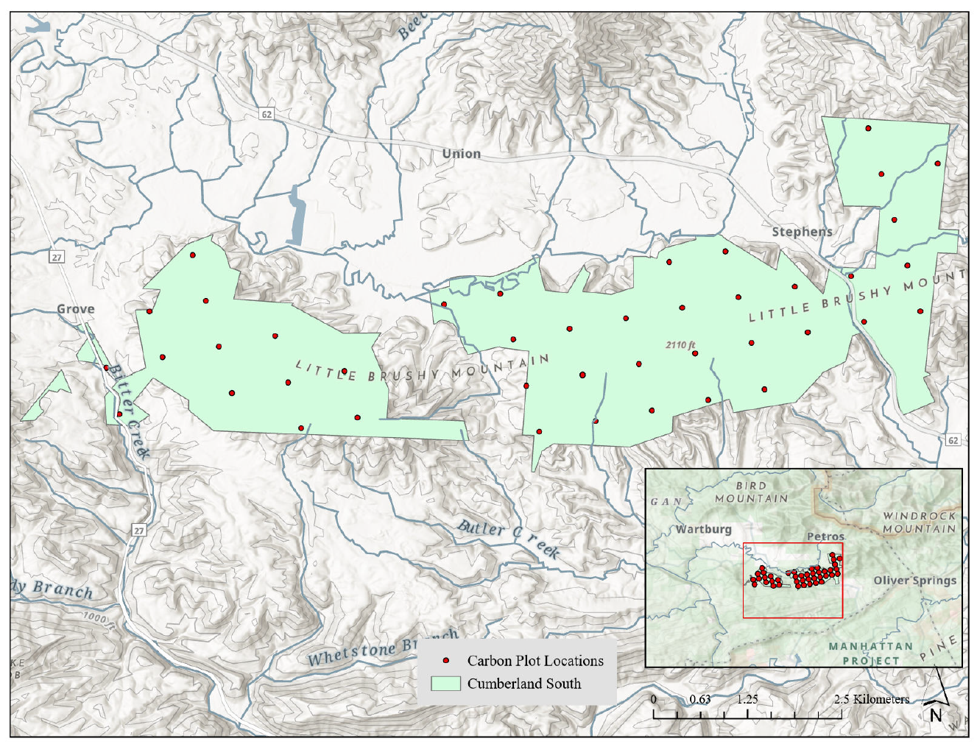
Figure 24: Map of UTK FRREC’s Cumberland Forest South region with stratum and carbon plot locations.
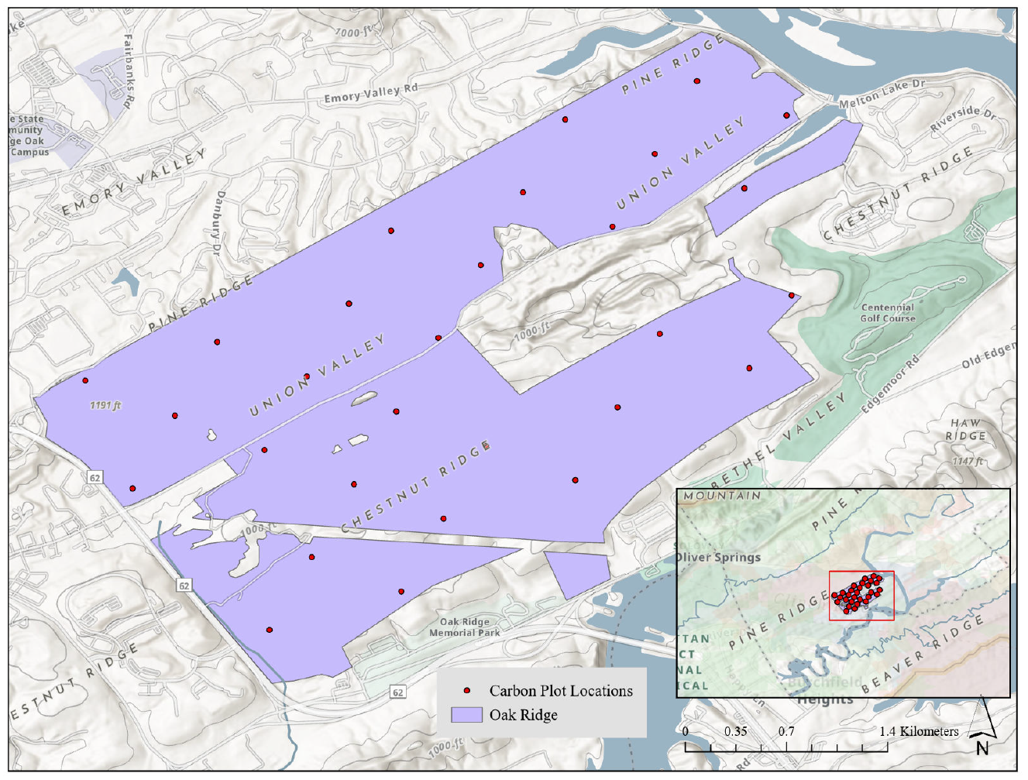
Figure 25: Map of UTK FRREC’s Oak Ridge region with stratum and carbon plot locations.
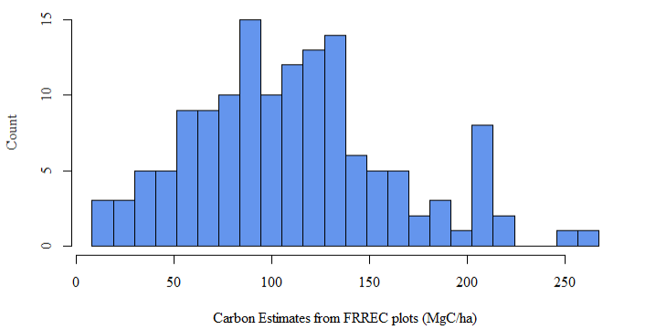
Figure 26: Histogram of calculated stand-level carbon estimates from FRREC carbon inventory plots.
To supplement slope and aspect variables into the FRREC dataset, the slope and aspect spatial analysis tools in ESRI’s ArcGIS software (version 3.6.0, https://www.esri.com/en-us/arcgis/geospatial-platform/overview) were used to calculate the two metrics from USGS’s 3DEP 1 m resolution data (Figure out how to cite).

ESA CCI
One AGBD map selected for this study was the European Space Agency’s (ESA) Climate Carbon Initiative (CCI) global biomass estimates at a 1 km resolution. ESA’s CCI aboveground live biomass map is produced through the combination of multiple remotely sensed products including but not limited to Sentinel-1, ALOS-2 PALSAR-2, Spaceborne LiDAR, Digital Elevation Models, and MODIS (Santoro and Cartus 2025) It is a popular dataset that has been widely studied, available through many popular geospatial repositories like ESRI’s Living Atlas and Google Earth Engine (GEE). Its data availability spans from 2005-2012 and 2015-2024 and is updated annually. This dataset was selected because of its use of solely remotely sensed input data and being a dataset produced by international government agencies, as well as its overlapping time availability with our validation data (from 2020).
The ESA CCI aboveground biomass dataset was accessed via ESRI’s Living Atlas repository, filtered for 2020 data. Estimates were extracted using the zonal statistics function in ArcGIS Pro for individual plots and for entire stratum.

CTREES
Another off-the-shelf carbon map selected for this study was produced by CTrees, a nonprofit to “monitor, report, and verify (MRV) carbon stocks and land-use activities for every ecosystem on land” (CTrees, n.d.). Along with differing objectives from ESA’s CCI mission, CTrees also produces estimates differently from ESA’s CCI biomass algorithm. Although CTrees’s estimation methodology is proprietary, they report that both ground-based forest inventories and remotely sensed are used to create estimates. This differs from ESA solely using remotely sensed data to generate their estimates. CTrees’s Land Carbon Map contains annual estimations from 2000 to 2025 at a 100 m resolution.
CTrees’s Land Carbon Map is available through EarthMover, which was filtered for only 2020 data. Extraction was produced following CTrees’s provided example code to handle and extract estimates.

REGIONAL MODEL
The regionally trained model was fit using FIA data from Daniel Boone National Forest from Chapter 3. This region was selected due to as a national forest that is near the study area and has similar characteristics and management objectives. National forests typically have more active management practices compared to national parks (Potter et al. 2026). FRREC forest landscapes often change as the results of active management, teaching lessons, and research studies conducted throughout the properties, which more closely matches the management plans of national forests. The Great Smoky Mountains National Park is also close to the FRREC regions, but it was not chosen due to a unique landscape that gives the park its designation and its reduced forest management compared to national forests. Furthermore, both are located at the edges of the Appalachian mountain range, with similar topological conditions (Figure 27). The regional model consists of a linear mixed-effect (LME) model with the following form:
$$C=\sum{xβ}+b+ϵ$$
$\sum{xβ}$ is the linear combination of predictors $x$ and their coefficients $β$, $b$ is a forest-type-specific random effect, and error term $ϵ$. Predictors used are listed in Table 14(all variables except for cph, the response variable). Model fitting was performed in R statistical software (Version 4.5.3, https://www.r-project.org/). To fit the model on FRREC data, some variables needed to be supplemented via height-diameter models, forest type assignment, and use of geospatial datasets. Chapter 3 also tested the inclusion of environmental variables on predictive performance, but due to the minimal improvements from the inclusion and the objective of prioritizing fast model fitting, the models were fit with only stand-level predictors.
As the FRREC data only measured tree heights on the eastern hemisphere of a plot, a non-linear model with a species-level random effect applied was used to predict missing heights. Heights of all trees were needed as average height of all trees in the plot was a predictor variable used in the regional model. The Pearl and Reed population growth was selected as it has previously been used to predict tree height, like oaks (Pearl and Reed 1920, Misik et al. 2016). This model takes the following form:
$$h=\frac{β_{0}}{1+β_{1}e^{(β_{2}DBH)}}$$
$h$ is height in meters, DBH is diameter at breast height in cm, and $β_{0}$, $β_{1}$, and $β_{2}$ are coefficients to be estimated. To fit models to the many species present, a species-specific random effect on $β_{0}$ was applied to allow flexibility for different species’ height-diameter relationships.
To assign a FIA forest type, plurality of basal area was calculated using trees greater than 5 in. DBH. Species with highest basal area(s) were used to match the plot’s composition with a FIA forest type. This allowed for better classification for the mixed-species forests found in this study. However, misclassification may still occur and could be further reduced by following the full FIA classification methodology (Burrill et al. 2024). Distributions of the forest types present within the Daniel Boone National Forest training dataset and the assigned forest types for the FRREC data are presented in Figure 28.

Table 14: Summary statistics of predictors from the FRREC study areas Mean and standard deviation (in parenthesis) are provided.
 | CPH | Mean D (cm) | Mean H (m) | Mean H:D | QMD | BAPH | TPH | SDI | Aspect | Slope
CN | 125.69 (51.21) | 31.13 (9.09) | 21.86 (4.79) | 78.92 (12.78) | 33.9 (9.72) | 33.2 (10.41) | 1264.21 (1094.29) | 1792.48 (1452.12) | 183.54 (78.59) | 32.63 (7.27)
CS | 115.84 (55.42) | 28.5 (6.51) | 21.66 (4.07) | 83.02 (10.23) | 30.97 (7.71) | 31.93 (11.71) | 1292.98 (1201.85) | 1593.29 (1077.13) | 168.28 (104.45) | 34.84 (6.47)
HR_HW | 85.53 (34.69) | 26.73 (8.44) | 20.44 (5.44) | 79.64 (8.46) | 27.81 (8.59) | 23.87 (8.73) | 1284.95 (653.11) | 1372.84 (694.37) | 241.24 (99.86) | 28.32 (9.21)
HR_PI | 91.3 (24.48) | 23.82 (6.22) | 18.24 (4.72) | 79.97 (5.98) | 24.57 (6.65) | 42.15 (10.48) | 2223.95 (1151.5) | 1910.77 (704.12) | 193.39 (60.97) | 32.41 (10.34)
OR | 86.96 (44.51) | 25.67 (8.38) | 19.35 (4.51) | 83.02 (13.14) | 27.45 (9.86) | 27.37 (9.05) | 2405.44 (2102.44) | 2140.04 (1420.33) | 161.82 (91.03) | 32.63 (7.05)

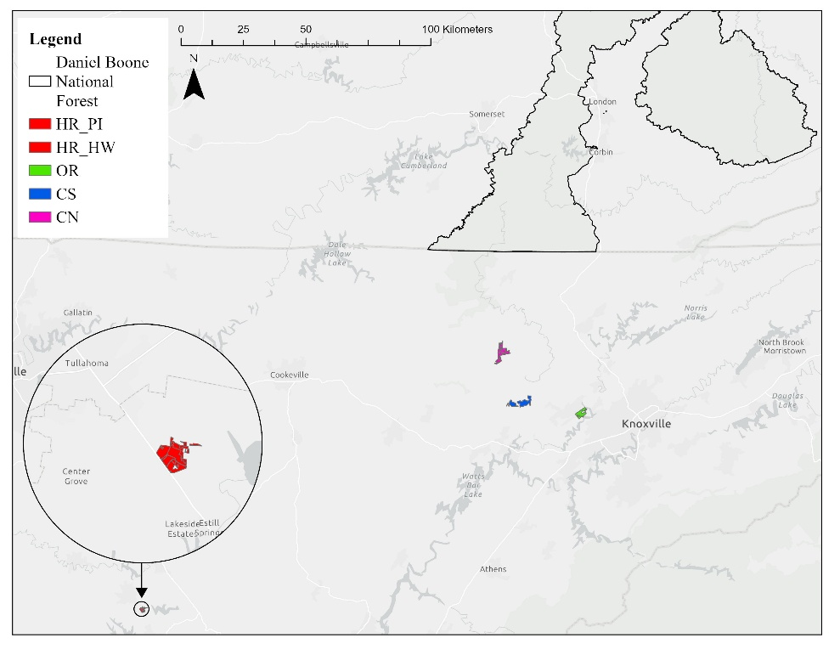
Figure 27: Map of FRREC properties and Daniel Boone National Forest, which the regional model was trained on.

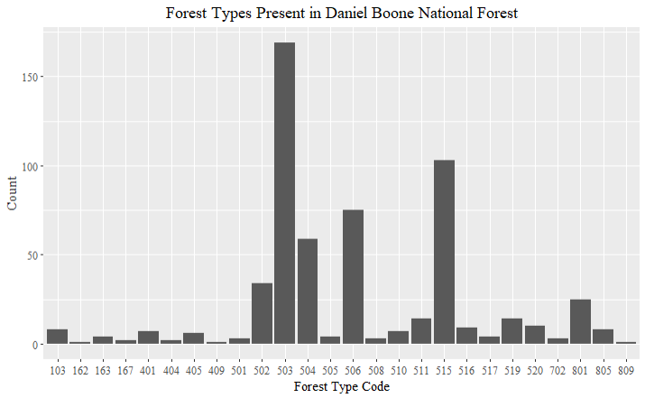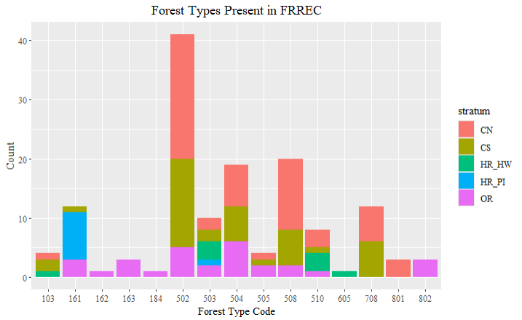
Figure 28:Distributions of forest types present in Daniel Boone National Forest (above, as assigned by the FIA) and in FRREC (below, manually assigned using plurality of basal area).

ANALYSIS
All analysis was completed in R statistical software (R Core Team 2026). For the analysis, estimates at plot and stratum level were produced and compared to study performance at these two scales. The plot-level estimates are consistent with the regional model, as the regional model produces carbon estimates at the plot-level, while stratum-level estimates are more compatible when utilizing geospatial data where resolution can be too course for plot-level estimates. As the regional model produced plot-level estimates, these estimates are aggregated to produce stratum-level estimates. For the AGBD maps that produced biomass estimates, a ½ factor was applied to convert to carbon. For plot-level comparisons, mean bias (MB) and root mean square error (RMSE) were calculated. At the stratum level, bias was calculated as observed minus predicted values. Fitted values were plotted against observed values with a 1:1 diagonal line using ggplot2 R package (Wickham 2016).

RESULTS

ESA
ESA’s performance varied by spatial aggregation level. At the plot level, more than half of all predictions were smaller than observed values. All observations in the Highland Rim (pine) and all but one observation of Highland Rim (hardwood) have estimates smaller than observed. When looking at the fitted versus observed plot-level graph (Figure 29), a distinct pattern can be observed between stratum. Although the values observed within each stratum spanned wide ranges between 0 and 200 MgC/ha, ESA estimates had narrow ranges within stratum, with the lowest returned value being only 28 MgC/ha. Additionally, none of the values exceeded 109.5 MgC/ha. For estimates extracted at the stratum level, Figure 30 and Table 16 show ESA underestimates between 20 and 40 MgC/ha. When extracting the average value from the entire stratum, the Highland Rim (pine) had the smallest difference between observed values, followed by Oak Ridge. The remaining three strata had approximately the same difference compared to observed values. Whether plot-level estimates were aggregated to stratum level or values were extracted across a stratum’s entire area, results were fairly similar and still smaller than observed.
A stratum’s estimate range appears to be related to acreage, with ranges increasing with study area size. Highland Rim (pine) is the smallest region (103.4 ha) and has the narrowest range (54.5 MgC/ha). While ranges increase as acreage increases, it is not necessarily a linear correlation. The average returned estimates of each stratum appears to better capture the stratum-level estimates, compared to average cph values in Tables 16 and 14. This is congruent with what was expected with the 1 km resolution of the ESA data used, with the courser resolution failing to capture detail needed at a plot level. Non-forested or other land use areas may be included within the 1 km pixel, affecting the summarized value returned for the pixel.

CTREES
Plot-level estimates of CTrees produced larger ranges and more varied estimates than the ESA dataset, which follows the expected pattern from CTrees’s finer resolution (100 m). However, even with finer resolution, plot-level estimates were not accurately captured (Figure 31). Similar to plot-level ESA estimates, the majority of values were underestimated. One extreme overestimation was observed at 154.75 MgC/ha, compared to the observed value of 13.0 MgC/ha, Figure 31. Other than this extreme outlier, the remaining estimates did not exceed 125 MgC/ha. There is not a noticeable pattern between the stratum like that observed in the ESA estimates. While the plot-level values didn’t accurately capture the true value, averaging these plot-level estimates to the stratum level produced values closer to observed values than the ESA dataset (Table 15). For stratum-level extractions, CTrees’s estimates were still lower than observed, approximately 20-50 MgC/ha less. These differences are similar to ESA differences.
At a 100 m resolution, these pixels cover 1 ha, which is larger than the measured plots’ area. Similar to the ESA dataset, this can include non-forested or other land use areas that will lower the pixels averaged value. At this scale, non-forested areas can be included within a pixel and affect the aggregated estimate. While plot level estimates are more varied, this did not result in more accurate estimates.
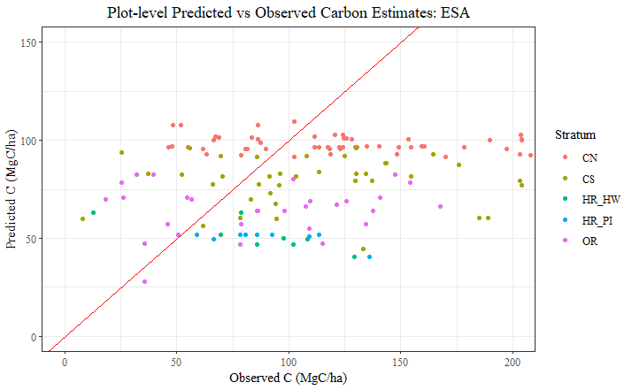
Figure 29: Plot-level returned versus observed estimates of ESA CCI.
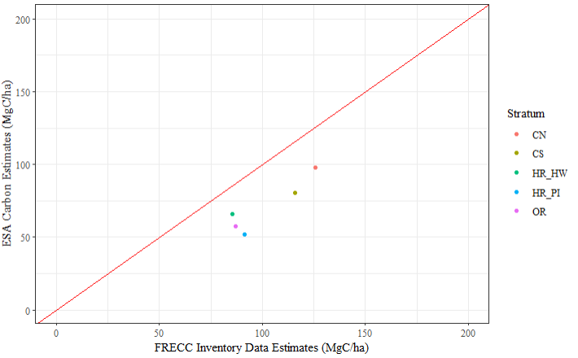
Figure 30: Stratum-level returned versus observed estimates of ESA CCI.

REGIONAL MODEL
The regional model produced the estimates at both plot and strata levels. Figure 33 shows that plot-level estimates produced by the model closely follow the 1:1 diagonal line to show model fit, generally with smaller underestimations than with the two AGBD products. When these plot level estimates are averaged by stratum, this regional model does produce some stratum-level estimates closer to observed values than aggregated ESA and some CTrees estimates. When comparing the stratum-level estimates, the regional model produces values closest to observed. The regional model was best able to capture larger values of carbon as well, while the AGBD maps were not able to produce estimates at this scale. The regional model produced plot-level estimates closest to observed for three out of five stratum; in the other two regions, CTrees’ averaged plot-level metrics produced estimates closest to the truth.
The one exception in improved performance occurs in the Highland Rim (pine) stratum, which shows the largest differences in plot and stand-level fitted versus observed values and in difference $Δ$ (Table 15, Table 16). It is also the only instance of an overprediction at strata level.
Table 15: Summary statistics of plot-level estimates from the 2 AGBD products and 1 regional model tested. Average carbon ($\overline{C}$ in MgC/ha), mean bias (MB) and root mean square error (RMSE) are provided.
 | FRREC | ESA |  |  | CTrees |  |  | Regional Model
Stratum | $\overline{C}$ (baseline) | $$\overline{C}$$ | MB | RMSE | $$\overline{C}$$ | MB | RMSE | $$\overline{C}$$ | MB | RMSE
CN | 125.69 | 98.08 | 27.61 | 58.61 | 72.12 | 53.58 | 75.73 | 122.39 | 3.30 | 12.31
CS | 115.84 | 78.80 | 37.04 | 67.23 | 82.15 | 33.69 | 65.96 | 114.67 | 1.17 | 15.28
HR_HW | 85.53 | 51.50 | 34.03 | 51.48 | 89.47 | -3.95 | 56.35 | 76.59 | 8.93 | 15.90
HR_PI | 91.30 | 50.33 | 40.97 | 48.26 | 80.03 | 11.28 | 31.68 | 139.41 | -48.10 | 57.17
OR | 86.96 | 64.72 | 22.23 | 49.26 | 81.07 | 5.89 | 46.84 | 81.97 | 4.99 | 20.72

Table 16: Stratum-level returned estimates (in MgC/ha) and bias between returned estimates and observed values (FRREC). Bias is calculated as observed – predicted.
 | FRREC | ESA |  | CTrees |  | Regional Model
Stratum | C (baseline) | C | bias | C | bias | C | bias
CN | 125.69 | 97.71 | 27.99 | 77.19 | 48.50 | 122.39 | 3.30
CS | 115.84 | 80.32 | 35.53 | 63.83 | 52.02 | 114.67 | 1.17
`HR_HW | 85.53 | 66.19 | 19.34 | 54.67 | 30.86 | 76.59 | 8.93
HR_PI | 91.30 | 52.00 | 39.30 | 58.37 | 32.94 | 139.41 | -48.10
OR | 86.96 | 57.50 | 29.46 | 70.01 | 16.95 | 81.97 | 4.99

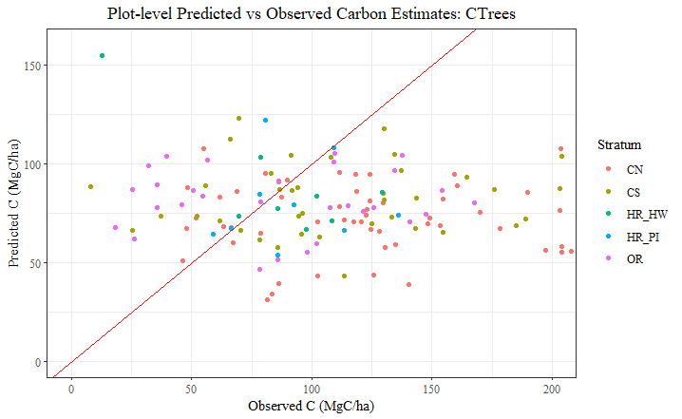
Figure 31: Plot-level fitted versus observed estimates of CTrees.
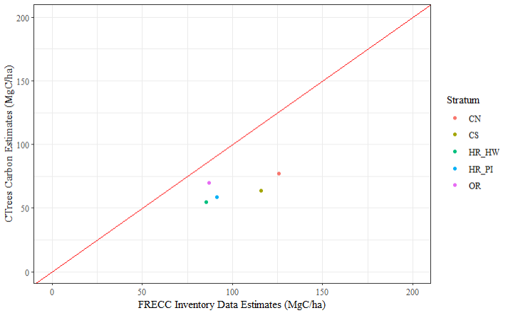
Figure 32: Stratum-level fitted versus observed estimates of CTrees.

DISCUSSION

MODEL PERFORMANCE AND COMPARISON
Overall, AGBD maps produced poorer estimates than the regional model, as expected. The one exception was for the Highland Rim (pine) stratum, which severely overestimated carbon values. These large overestimations can be explained by something that is both an asset and a limitation of mixed-effect models: predicting for a new level, or forest type. The Highland Rim (pine) stratum was assigned the forest type 161, which corresponds to loblolly pine. Primarily a species that is planted rather than naturally occurring in southern Appalachian federal lands, like Daniel Boone National Forest, loblolly pine forest type was not present in the training data (Figure 28). One benefit of using a random effect is the ability to still predict on new levels through information sharing between the random effect levels, these estimates can be inaccurate as witnessed in this study. One solution to this problem may be to refit the regional model to only the other pine forest types present (162, 163, and 167, which correspond to shortleaf, Virginia, and pitch pine, respectively) can constrain the model to better predict for pines by removing other forest types that demonstrate different carbon patterns from pines. When applying this model, users should be cautious about predictions for forest present in the testing data that are not present in the training dataset.

SPATIAL COMPATIBILITY
The two AGBD maps performed far worse at the plot level and somewhat worse at the strata level. Dataset resolution is the likely culprit for the temperamental use of the ESA CCI 1 km biomass dataset, as the large resolution size wasn’t able to capture the specifics of the plot-level. Specific limitations with AGBD maps being able to capture larger carbon values either due to the methodology or resolution scale can make them poor contenders to use at the scale of the properties used in this study. This applies more explicitly at the plot-level, whereas strata-level aggregations were closer to the observed values, although these estimates consistently underestimated true values.
When comparing this study to other quantitative studies investigating AGBD maps and products, study area size differs, with other studies investigating state-level performance than small properties. Even though other studies investigated stand and plot level performance, the overall area of the study region can heavily impact product performance because of how the map resolution fits over the aforementioned study area. This also affects sample size, or numbers of observations used.
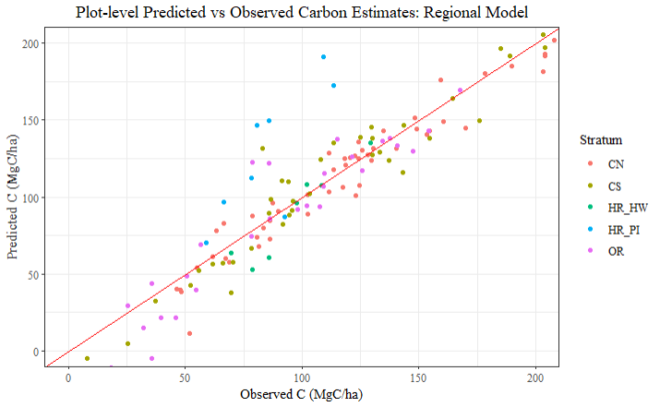
Figure 33: Plot-level fitted versus observed estimates of the regional model.
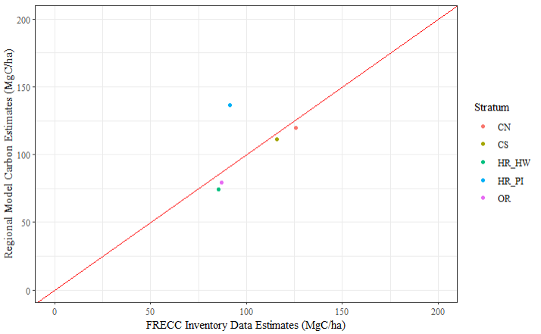
Figure 34: Strata-level fitted versus observed estimates of the regional model.

CONCLUSION
The comparisons investigated show that the regionally trained model performs the best on UTK’s FRREC properties. These results show that estimations can be generated with higher accuracy than the AGBD products tested and easier than best practices methodologies. Although the regional model performs extremely well, it still cannot completely capture estimates without error. Some sources error may be due to the usual contenders, like sampling, measurement, and allometric error, but error may have also been introduced through the forest-type classification procedure and estimating carbon for forest types assigned in FRREC but absent in Daniel Boone National Forest. While the ability to predict on new forest types, or levels, is an asset of using the mixed-effect approach, there can still be inaccurate predictions for the new forest types. Users may find that the simplicity of using the AGBD products trumps training a regional model, which can take significantly longer to use. In addition, as the CTrees carbon map was shown to perform well, and even better than the regional model for some regions, this helps keep the AGBD maps as contenders for carbon monitoring projects. However, no matter which of the products or model tested is implemented in the future, this study provides useful information for how much error is present within each method at the spatial scale tested.
The comparisons of AGBD products with the tested model are by no means an exhaustive study of all available products, and models and products will continue to improve over time. As more products become available and existing ones improve, additional comparisons can be made against methodologies tested in this study to reassess advantages and limitations of the various approaches. As of this time, though, the regionally trained model can serve as an adequate alternative to best practices methods to produce highly accurate carbon estimations at the scale of several to a few thousand acres. Forest managers may consider this model a viable contender for producing estimates of live aboveground carbon for their properties.

CONCLUSION

Accurately estimating live aboveground carbon is an intensive process, regardless of methodology, with the various steps of the process each requiring considerable amounts of time and effort. Acquiring data prior to even beginning to build any model is the hurdle addressed, as accessing geospatial data to provide environmental or remotely sensed metrics requires overcoming technical challenges regarding decentralized data and an understanding of geospatial data handling. Once data is on hand, carbon models produced must have high enough accuracy for forest managers to have confidence in using these models. These estimates can be used to track forest health and changes and inform what management regimes are used, which necessitates predictions to be accurate. However, accuracy often comes at the expense of efficiency, with best practices for carbon estimation requiring full forest inventories and species-specific biomass equations. Although best practices produce the most accurate estimates, it is also time-intensive and may struggle to capture real time changes within forests. Therefore, an alternate methodology that fulfills these objectives is needed. Once a model is developed that meets these requirements, it must compete with other existing models to establish its place among the ever-growing number of models. Models that are able to accurately predict in forests beyond the training regions further establish the alternative methodology’s usefulness and place within the saturated market of available carbon estimation methods. This dissertation accomplished these objectives through optimizing processes where accuracy is not greatly sacrificed but also highlights that advantages of applying extra effort in some steps to produce accurate estimates.
To begin, environmental data was desired to include in models tested, as previous studies have demonstrated that the inclusion of environmental covariates improved predictive performance of forest models. But, accessing environmental data typically requires specialized knowledge of geospatial data handling (Aguirre et al. 2021, Liepiņš et al. 2022, Yang, Brandeis et al. 2022a). Knowledge gaps with handling geospatial data have been documented as a deterrent and has prevented its accessibility to a broader audience (Morgenroth and Visser 2013, Ziegler and Chasins 2023, Fassnacht et al. 2024). An additional challenge is also presented as geospatial data is largely decentralized across various governmental agencies’ databases. Despite the plethora of geospatial data available today, it remains an untapped resource for foresters and natural resource practitioners alike. By utilizing the convenience of Google Earth Engine’s (GEE) centralized database of geospatial datasets in combination with existing Python packages and APIs ipywidgets (Jupyter Widgets — Jupyter Widgets 8.1.8 documentation, n.d.), geemap (Wu 2020)¸ and earth-engine (Google for Developers, n.d.-a), a point-and-click application was developed that removes many technical steps needed to perform point extractions of GEE Images and select ImageCollections. Designed to complement forest inventory designs, two of these point-and-click modules were designed to perform point extractions for given plot coordinates and differ in aggregation of returned results. Security concerns with using raw confidential plot coordinates were addressed by creating 2 complementary buffering modules that generate a user-defined number of randomized coordinates for each uploaded coordinate. Currently, this application is limited to performing only point extractions on a portion of GEE datasets, and its open-source repository provides a framework to expand on the package’s functionality in the future. Some additions are expanded file type handling for input files and access to GEE datasets currently incompatible with the application’s design. This application’s utility was demonstrated in chapter 3, where it was used to query WorldClim BIO variables from GEE to add environmental covariates to a national forest inventory dataset.
Once data was on hand, the process of building and testing carbon estimation models began. Generating observed carbon values requires a full forest inventory and the use of species-specific biomass equations, which is time-consuming and resource intensive. While at times, this full procedure is necessary to achieve the accuracy and precision needed for some forest monitoring efforts, faster, less intensive methodologies are desired to allow for large scale estimations. This efficiency often comes at the expense of accuracy, which dictates the need to continuously search for models that increase predictive power.
A previous study by Yang et al. (2025) utilized the U.S.’s national forest inventory to train a linear mixed-effects (LME) model using stand-level variables to generate stand-level carbon estimates on the scale of national parks and forests. A random effect on forest type allows for a global model that can handle and account for the diversity of forest types present within regions, and this mixed-effect approach was expanded on through testing two additional modeling approaches: LASSOs and generalized additive mixed models (GAMMs). These two approaches were selected for their ability to perform feature selection and model non-linear function, respectively.
Additionally, environmental variables from the WorldClim BIO variables dataset were tested in combination with stand-level variables (similar to stand-level predictors used in Yang et al. (2025) to determine if predictive performance performed. Results showed that LME models had the highest and most stable performance, although GAMMs were able to better capture higher carbon values (>150MgC/ha) despite the increased instability between regions. LASSO models performed the worst, both in performance metrics and out-of-bag fitted samples. The inclusion of environmental variables improved LME predictions only slightly, while it was prone to worsening predictions and introducing instability into models for GAMMs and LASSO models. In this case, enough stand-level variables were included to capture enough of the variability that environmental variables did not contribute much. It was also observed that regions with smaller sample sizes had reduced performance in GAMMs and LASSO models, particularly when environmental predictors were included. The results of this study show that different modeling approaches may be chosen for various cases, depending on range of carbon values to predict and sample size. LME models are fast, easy to fit, and stable, but GAMMs can be useful despite additional complications with model training. The development of these models provides both the accuracy and efficiency desired to be able to conduct large scale forest monitoring.
While models tested in chapter 3 were shown to perform well within the region, being able to extend its usability to nearby forests promotes the overall theme of balancing accuracy with efficiency. As forests extend beyond the artificial boundaries, models developed in chapter 3 can also accurately capture carbon estimates in surrounding forests. This capitalizes on the already developed models to improve efficient model predictions. Although training these regional models takes longer that using other available carbon products such as the European Space Agency’s Climate Change Initiative aboveground biomass and CTrees’s carbon products, the regional model was able to produce more accurate estimates overall and also capture plot-level estimates whereas the other products were unable to. While this chapter did not perform an exhaustive investigation of how regional models performed against many available carbon products, the study shows that sometimes shortcuts for efficiency can result in noticeable drops in accuracy, and at times, convenience should not be traded for accuracy.
To measure forest carbon at the speed and accuracy desired, different steps of the modeling process can be expediated. Technical barriers with geospatial data handling were reduced in a developed application to increase accessibility, but issues with geospatial data uptake in forestry remain (Fassnacht et al. 2024). To produce the carbon estimates, stand-level carbon models tested provide faster alternatives to current best practices methodologies, with linear mixed-effect models only having a slight trade-off in accuracy for fast model fitting. While efficiency did not come at the expense of accuracy in these linear models tested, this is not always true, as carbon products and maps that have pre-calculated carbon estimates and are relatively much faster to obtain that fitting a model were limited in predictive performance to the stratum level. This reinforces the notion that sometimes efficiency can introduce error that propagates down the line, affecting patterns observed and management decisions. By making some arduous steps within carbon modeling easier, the additional time and resources left over can be used to develop more accurate models that outperform global-scale products.

REFERENCES
Abdalla RM. Exploring Remote Sensing - Methods and Applications: Methods and Applications. n.p.: BoD – Books on Demand, 2025.
Adhikari A, Montes CR, Peduzzi A. A Comparison of Modeling Methods for Predicting Forest Attributes Using Lidar Metrics. Remote Sensing 2023;15(5). https://doi.org/10.3390/rs15051284.
Aguirre A, Río M del, Ruiz-Peinado R et al. Stand-level biomass models for predicting C stock for the main Spanish pine species. Forest Ecosystems 2021;8(1):29. https://doi.org/10.1186/s40663-021-00308-w.
Ali A, Sanaei A, Li M et al. Impacts of climatic and edaphic factors on the diversity, structure and biomass of species-poor and structurally-complex forests. Science of The Total Environment 2020;706:135719. https://doi.org/10.1016/j.scitotenv.2019.135719.
Alshehri B, Zhang Z, Liu X. A Review of Google Earth Engine for Land Use and Land Cover Change Analysis: Trends, Applications, and Challenges. ISPRS International Journal of Geo-Information 2025;14(11):416. https://doi.org/10.3390/ijgi14110416.
Amani M, Ghorbanian A, Ahmadi SA et al. Google Earth Engine Cloud Computing Platform for Remote Sensing Big Data Applications: A Comprehensive Review. IEEE Journal of Selected Topics in Applied Earth Observations and Remote Sensing 2020;13:5326–50. https://doi.org/10.1109/JSTARS.2020.3021052.
Aybar C, Wu Q, Bautista L et al. rgee: An R package for interacting with Google Earth Engine. JOSS 2020;5(51):2272. https://doi.org/10.21105/joss.02272.
Banskota A, Kayastha N, Falkowski MJ et al. Forest Monitoring Using Landsat Time Series Data: A Review. Canadian Journal of Remote Sensing 2014;40(5):362–84. https://doi.org/10.1080/07038992.2014.987376.
Bates D, Mächler M, Bolker B et al. Fitting Linear Mixed-Effects Models Using lme4. Journal of Statistical Software 2015;67:1–48. https://doi.org/10.18637/jss.v067.i01.
Bowling EH, Burkhart HE, Burk TE et al. A stand-level multispecies growth model for Appalachian hardwoods. Can J For Res 1989;19(4):405–12. https://doi.org/10.1139/x89-064.
Burrill EA, DiTommaso AM, Turner JA et al. The Forest Inventory and Analysis Database, FIADB user guides, volume: database description (version 9.4), nationwide forest inventory (NFI). U.S. Department of Agriculture, Forest Service, 2024.
Cankaya EC, Radtke PJ. Evaluating Local Calibration Methods for Improving Diameter Growth Predictions in the Southern Variant, Forest Vegetation Simulator (FVS-Sn). For Sci published online 6 Oct. 2025. https://doi.org/10.1007/s44391-025-00044-6.
Cao QV. Linking individual-tree and whole-stand models for forest growth and yield prediction. Forest Ecosystems 2014;1(1):18. https://doi.org/10.1186/s40663-014-0018-z.
Charnley S, Diaz D, Gosnell H. Mitigating Climate Change Through Small-Scale Forestry in the USA: Opportunities and Challenges. Small-Scale Forestry 2010;9(4):445–62. https://doi.org/10.1007/s11842-010-9135-x.
Chi M, Plaza A, Benediktsson JA et al. Big Data for Remote Sensing: Challenges and Opportunities. Proc IEEE 2016;104(11):2207–19. https://doi.org/10.1109/JPROC.2016.2598228.
Chinembiri TS, Mutanga O, Dube T. Landsat-8 and Sentinel-2 Based Prediction of Forest Plantation C Stock Using Spatially Varying Coefficient Bayesian Hierarchical Models. Remote Sensing 2022;14(22):5676. https://doi.org/10.3390/rs14225676.
Chinembiri TS, Mutanga O, Dube T. A multi-source data approach to carbon stock prediction using Bayesian hierarchical geostatistical models in plantation forest ecosystems. GIScience & Remote Sensing 2024;61(1):2303868. https://doi.org/10.1080/15481603.2024.2303868.
Clark SHB. Birth of the Mountains. n.d.
Coulston JW, Riitters KH, McRoberts RE et al. True versus perturbed forest inventory plot locations for modeling: a simulation study. Can J For Res 2006;36(3):801–7. https://doi.org/10.1139/x05-265.
CTrees. CTrees | Tracking every tree on Earth. n.d. https://ctrees.org (18 Aug. 2026, date last accessed).
Dixon G. Essential FVS: A User’s Guide to the Forest Vegetation Simulator. 2026.
Ehbrecht M, Seidel D, Annighöfer P et al. Global patterns and climatic controls of forest structural complexity. Nature Communications 2021;12(1):519. https://doi.org/10.1038/s41467-020-20767-z.
Ellison AM, Orwig DA, Fitzpatrick MC et al. The Past, Present, and Future of the Hemlock Woolly Adelgid (Adelges tsugae) and Its Ecological Interactions with Eastern Hemlock (Tsuga canadensis) Forests. Insects 2018;9(4):172. https://doi.org/10.3390/insects9040172.
Ermida SL, Soares P, Mantas V et al. Google Earth Engine Open-Source Code for Land Surface Temperature Estimation from the Landsat Series. Remote Sensing 2020;12(9). https://www.mdpi.com/2072-4292/12/9/1471 (2 Apr. 2026, date last accessed).
Faraway JJ. Linear Models with R. Second, n.p.: Taylor & Francis Group, 2015.
Fassnacht FE, White JC, Wulder MA et al. Remote sensing in forestry: current challenges, considerations and directions. Forestry: An International Journal of Forest Research 2024;97(1):11–37. https://doi.org/10.1093/forestry/cpad024.
Fotis AT, Morin TH, Fahey RT et al. Forest structure in space and time: Biotic and abiotic determinants of canopy complexity and their effects on net primary productivity. Agricultural and Forest Meteorology 2018;250–251:181–91. https://doi.org/10.1016/j.agrformet.2017.12.251.
Gibson J, Moisen G, Frescino T et al. Using Publicly Available Forest Inventory Data in Climate-Based Models of Tree Species Distribution: Examining Effects of True Versus Altered Location Coordinates. Ecosystems 2013;17(1):43–53. https://doi.org/10.1007/s10021-013-9703-y.
Gillies S, Wel C van der, Van den Bossche J et al. Shapely. published online 12 Dec. 2022. https://doi.org/10.5281/zenodo.7428463.
González‐Alonso F, Merino‐De‐Miguel S, Roldán‐Zamarrón A et al. Forest biomass estimation through NDVI composites. The role of remotely sensed data to assess Spanish forests as carbon sinks. International Journal of Remote Sensing 2006;27(24):5409–15. https://doi.org/10.1080/01431160600830748.
Google Earth Engine. n.d. https://earthengine.google.com (15 Sept. 2025, date last accessed).
Google Earth Engine Community. Gee-Community/Arcgis-Earthengine-Toolbox, Python. 30 July 2024, 6 Feb. 2026. https://github.com/gee-community/arcgis-earthengine-toolbox (2 Apr. 2026, date last accessed).
Google for Developers. API Reference | Google Earth Engine. n.d. https://developers.google.com/earth-engine/apidocs (16 July 2026, date last accessed).
Google for Developers. WorldClim BIO Variables V1 | Earth Engine Data Catalog. n.d. https://developers.google.com/earth-engine/datasets/catalog/WORLDCLIM_V1_BIO (12 Oct. 2026, date last accessed).
Gorelick N, Hancher M, Dixon M et al. Google Earth Engine: Planetary-scale geospatial analysis for everyone. Remote Sensing of Environment Big Remotely Sensed Data: tools, applications and experiences, 2017;202:18–27. https://doi.org/10.1016/j.rse.2017.06.031.
Gou M, Xu J, Zhu H et al. Predictive Framework Based on GBIF and WorldClim Data for Identifying Drought- and Cold-Tolerant Magnolia Species in China. Plants 2025;14(13). https://www.mdpi.com/2223-7747/14/13/1966 (8 Apr. 2026, date last accessed).
Harris CR, Millman KJ, Walt SJ van der et al. Array programming with NumPy. Nature 2020;585(7825):357–62. https://doi.org/10.1038/s41586-020-2649-2.
Harrison WC, Burkhart HE, Burk TE et al. Growth and Yield of Appalachian Mixed Hardwoods After Thinning. Publication No FWS-1-86, School of Forestry and Wildlife Resources, Virginia Polytechnic Institute and State University, Blacksburg, Virginia 24061, 1986 1986. https://research.fs.usda.gov/treesearch/1809 (12 Oct. 2026, date last accessed).
Hudak AT, Bakken JL, Lister A et al. A quantitative evaluation of forest aboveground biomass density map products in Oregon, USA. Environ Res Lett 2026;21(14):143007. https://doi.org/10.1088/1748-9326/ae8b04.
Itter MS, Finley AO, D’Amato AW et al. Variable effects of climate on forest growth in relation to climate extremes, disturbance, and forest dynamics. Ecological Applications 2017;27(4):1082–95. https://doi.org/10.1002/eap.1518.
Jenkins JC, Chojnacky DC, Heath LS et al. National-Scale Biomass Estimators for United States Tree Species. Forest Science 2003;49(1):12–35. https://doi.org/10.1093/forestscience/49.1.12.
Jha S, Yang SI, Hale DS et al. Quantifying Forest Aboveground Biomass Using Remote Sensing and Ground Measurements for Mixed Hardwood Forests in East Tennessee. 2024;274:51–7. https://doi.org/10.2737/SRS-GTR-274-Pap8.
Jiang P, Russell MB, Babcock C et al. Quantifying Western US tree carbon stocks and sequestration from fires. Fire Ecol 2025;21(1):22. https://doi.org/10.1186/s42408-025-00360-9.
Jordahl K, Bossche JVD, Fleischmann M et al. Geopandas/Geopandas: V0.8.1, version v0.8.1. Zenodo, 15 July 2020. https://doi.org/10.5281/ZENODO.3946761.
Jupyter Widgets — Jupyter Widgets 8.1.8 documentation. n.d. https://ipywidgets.readthedocs.io/en/latest/ (31 Mar. 2026, date last accessed).
Keyser PD, Fearer T, Harper CA (eds). Managing Oak Forests in the Eastern United States. Boca Raton: CRC Press, 2016. https://doi.org/10.1201/b19076.
Kyoto Protocol to the United Nations Framework Convention on Climate Change. 11 Dec. 1997. https://treaties.un.org/Pages/ShowMTDSGDetails.aspx?src=UNTSONLINE&tabid=2&mtdsg_no=XXVII-7-a&chapter=27&lang=en (28 Sept. 2026, date last accessed).
Lan K, Favero A, Yao Y et al. Global land and carbon consequences of mass timber products. Nat Commun 2025;16(1):4864. https://doi.org/10.1038/s41467-025-60245-y.
Lechner AM, Foody GM, Boyd DS. Applications in Remote Sensing to Forest Ecology and Management. One Earth 2020;2(5):405–12. https://doi.org/10.1016/j.oneear.2020.05.001.
Leites L, Benito Garzón M. Forest tree species adaptation to climate across biomes: Building on the legacy of ecological genetics to anticipate responses to climate change. Global Change Biology 2023;29(17):4711–30. https://doi.org/10.1111/gcb.16711.
Li Y, Li C, Li M et al. Influence of Variable Selection and Forest Type on Forest Aboveground Biomass Estimation Using Machine Learning Algorithms. Forests 2019;10(12):1073. https://doi.org/10.3390/f10121073.
Liepiņš J, Lazdiņš A, Kalēja S et al. Species Composition Affects the Accuracy of Stand-Level Biomass Models in Hemiboreal Forests. Land 2022;11(7):1108. https://doi.org/10.3390/land11071108.
Marchi M, Sinjur I, Bozzano M et al. Evaluating WorldClim Version 1 (1961–1990) as the Baseline for Sustainable Use of Forest and Environmental Resources in a Changing Climate. Sustainability 2019;11(11). https://doi.org/10.3390/su11113043.
Martindale N, Smith J, Linville L. Supporting Greater Interactivity in the IPython Visualization Ecosystem - SciPy Proceedings. 10 July 2024. https://proceedings.scipy.org/articles/GVHT1072 (1 Apr. 2026, date last accessed).
Maselli F. Monitoring forest conditions in a protected Mediterranean coastal area by the analysis of multiyear NDVI data. Remote Sensing of Environment 2004;89(4):423–33. https://doi.org/10.1016/j.rse.2003.10.020.
McKinney W. Data Structures for Statistical Computing in Python. 2010:56–61. https://doi.org/10.25080/Majora-92bf1922-00a.
McLaughlin SB, Downing DJ, Blasing TJ et al. An analysis of climate and competition as contributors to decline of red spruce in high elevation Appalachian forests of the Eastern United states. Oecologia 1987;72(4):487–501. https://doi.org/10.1007/BF00378973.
Meneses-Tovar CL. NDVI as Indicator of Degradation. n.d.;62.
Misik T, Antal K, Kárász I et al. Nonlinear height–diameter models for three woody, understory species in a temperate oak forest in Hungary. Can J For Res 2016;46(11):1337–42. https://doi.org/10.1139/cjfr-2015-0511.
Mohd Zaki NA, Zulkiflee AL, Suratman MN. Modelling above-ground live trees biomass and carbon stock estimation of tropical lowland Dipterocarp forest: integration of field-based and remotely sensed estimates. Taylor & Francis, 2017. https://doi.org/https://doi.org/10.1080/01431161.2017.1421793.
Morgenroth J, Visser R. Uptake and barriers to the use of geospatial technologies in forest management. New Zealand Journal of Forestry Science 2013;43(1):16. https://doi.org/10.1186/1179-5395-43-16.
Murphy KP. Machine Learning: A Probabilistic Perspective. Adaptive Computation and Machine Learning Series. Cambridge, MA: MIT Press, 2012.
Mutanga O, Kumar L. Google Earth Engine Applications. Remote Sensing 2019;11(5). https://www.mdpi.com/2072-4292/11/5/591 (2 Apr. 2026, date last accessed).
Pasternack R, Wishnie M, Clarke C et al. What Is the Impact of Mass Timber Utilization on Climate and Forests? Sustainability 2022;14(2):758. https://doi.org/10.3390/su14020758.
Pearl R, Reed LJ. On the Rate of Growth of the Population of the United States since 1790 and Its Mathematical Representation. Proc Natl Acad Sci USA 1920;6(6):275–88. https://doi.org/10.1073/pnas.6.6.275.
Peng D, Zhang H, Liu L et al. Estimating the Aboveground Biomass for Planted Forests Based on Stand Age and Environmental Variables. Remote Sensing 2019;11(19):2270. https://doi.org/10.3390/rs11192270.
Phillips PD, Yasman I, Brash TE et al. Grouping tree species for analysis of forest data in Kalimantan (Indonesian Borneo). Forest Ecology and Management 2002;157(1–3):205–16. https://doi.org/10.1016/S0378-1127(00)00666-6.
Porté A, Bartelink HH. Modelling mixed forest growth: a review of models for forest management. Ecological Modelling 2002;150(1):141–88. https://doi.org/10.1016/S0304-3800(01)00476-8.
Potter KM, Guo Q, Koch FH et al. U.S. National Forests Are More Diverse, Denser and Less Invaded than Neighboring Forests. Forests 2026;17(6):691. https://doi.org/10.3390/f17060691.
Potter KM, Hargrove W, Koch FHH. Predicting climate change extirpation risk for central and southern Appalachian forest tree species. In: Rentch, James S; Schuler, Thomas M, Eds 2010 Proceedings from the Conference on the Ecology and Management of High-Elevation Forests in the Central and Southern Appalachian Mountains 2009 May 14-15; Slatyfork, WV Gen Tech Rep NRS-P-64 Newtown Square, PA: US Department of Agriculture, Forest Service, Northern Research Station: 179-189 2010;p-64:179–89.
Pradhan P, Setyawan A. Filtering multi-collinear predictor variables from multi-resolution rasters of WorldClim 2.1 for Ecological Niche Modeling in Indonesian context. Asian Journal of Forestry 2021;5:111–22. https://doi.org/10.13057/asianjfor/r050207.
Prisley SP, Wang HJ, Radtke PJ et al. Combining FIA plot data with topographic variables: Are precise locations needed? In: McWilliams, Will; Moisen, Gretchen; Czaplewski, Ray, Comps Forest Inventory and Analysis (FIA) Symposium 2008; October 21-23, 2008; Park City, UT Proc RMRS-P-56CD Fort Collins, CO: US Department of Agriculture, Forest Service, Rocky Mountain Research Station 10 p 2009;56. https://research.fs.usda.gov/treesearch/33378 (20 Oct. 2026, date last accessed).
R Core Team. R: A Language and Environment for Statistical Computing. Vienna, Austria: R Foundation for Statistical Computing, 2026. https://doi.org/doi:10.32614/R.manuals.
Reay DS, Dentener F, Smith P et al. Global nitrogen deposition and carbon sinks. Nature Geosci 2008;1(7):430–7. https://doi.org/10.1038/ngeo230.
Robinson AP, Lane SE, Thérien G. Fitting forestry models using generalized additive models: a taper model example. Can J For Res 2011;41(10):1909–16. https://doi.org/10.1139/x11-095.
Rogers BM, Jantz P, Goetz SJ. Vulnerability of eastern US tree species to climate change. Global Change Biology 2017;23(8):3302–20. https://doi.org/10.1111/gcb.13585.
Santoro M, Cartus O. ESA Biomass Climate Change Initiative (Biomass_cci): Global datasets of forest above-ground biomass for the years 2007, 2010, 2015, 2016, 2017, 2018, 2019, 2020, 2021 and 2022, v6.0, with NERC EDS Centre For Environmental Data Analysis. NERC EDS Centre for Environmental Data Analysis, 2025, 11441 Files, 698903278165 B [application/xml, 11441 Files, 698903278165 B]. https://doi.org/10.5285/95913FFB6467447CA72C4E9D8CF30501.
Skiba T. Taraskiba/Forestspot, Python. 21 Feb. 2025, 14 Aug. 2026. https://github.com/taraskiba/forestspot (12 Oct. 2026, date last accessed).
Snow AD, Cochran M, Miara I et al. Pyproj4/Pyproj: 3.7.2rc1. published online 12 Aug. 2025. https://doi.org/10.5281/zenodo.16817340.
Sohil F, Sohali MU, Shabbir J. An introduction to statistical learning with applications in R: by Gareth James, Daniela Witten, Trevor Hastie, and Robert Tibshirani, New York, Springer Science and Business Media, 2013, $41.98, eISBN: 978-1-4614-7137-7. Statistical Theory and Related Fields 2022;6(1):87–87. https://doi.org/10.1080/24754269.2021.1980261.
Stauffer A, Porter C. The National Park Service Program of Conservation for Areas and Structures of National Historical Significance. The Mississippi Valley Historical Review, 1943. https://irma.nps.gov/DataStore/Reference/Profile/2204958 (12 Oct. 2026, date last accessed).
Temesgen H, Affleck D, Poudel K et al. A review of the challenges and opportunities in estimating above ground forest biomass using tree-level models. Scandinavian Journal of Forest Research 27 Feb. 2015:1–10. https://doi.org/10.1080/02827581.2015.1012114.
The ACR Standard. ACR 2023. https://acrcarbon.org/acr-program/acr-standard/ (2 Oct. 2026, date last accessed).
The Paris Agreement - Publication. Sesssion. COP21, Nov. 2015. https://unfccc.int/documents/184656 (28 Sept. 2026, date last accessed).
Toledo M, Poorter L, Peña-Claros M et al. Climate is a stronger driver of tree and forest growth rates than soil and disturbance. Journal of Ecology 2011;99(1):254–64. https://doi.org/10.1111/j.1365-2745.2010.01741.x.
United Nations Framework Convention on Climate Change. 21 Mar. 1994. https://treaties.un.org/Pages/showDetails.aspx?objid=08000002800431ce&clang=_en (28 Sept. 2026, date last accessed).
Vanclay JK. Aggregating tree species to develop diameter increment equations for tropical rainforests. Forest Ecology and Management 1991;42(3):143–68. https://doi.org/10.1016/0378-1127(91)90022-N.
Verra. VM0048 Reducing Emissions from Deforestation and Forest Degradation, v1.0. n.d. https://verra.org/methodologies/vm0048-reducing-emissions-from-deforestation-and-forest-degradation-v1-0/ (28 Sept. 2026, date last accessed).
Wang S, Yang H, Koirala S et al. A global dataset of forest disturbance regimes derived from satellite biomass observations. Earth System Science Data 2026;18(8):5895–913. https://doi.org/10.5194/essd-18-5895-2026.
Wei X, Hayes D, McHale G et al. PyFIA: analyzing and visualizing forest attributes using the United States Forest Inventory and Analysis database. Carbon Balance Manage 2025;21(1):18. https://doi.org/10.1186/s13021-025-00364-7.
Wertz B, Wilczyński S. Predicting Changes in Forest Growing Season (FGS) in the Transitional Climate of Poland on the Basis of Current Grid Datasets. Forests 2022;13(12). https://www.mdpi.com/1999-4907/13/12/2019 (8 Apr. 2026, date last accessed).
Westfall J, Coulston JW, Moisen G et al. Sampling and estimation documentation for the Enhanced Forest Inventory and Analysis Program: 2022. Gen Tech Rep NRS-GTR-207 Madison, WI: US Department of Agriculture, Forest Service, Northern Research Station 129 p published online 23 Dec. 2022. https://doi.org/10.2737/NRS-GTR-207.
Westfall JA, Coulston JW, Gray AN et al. A national-scale tree volume, biomass, and carbon modeling system for the United States. Gen Tech Rep WO-104 Washington, DC: US Department of Agriculture, Forest Service 2024;104. https://doi.org/10.2737/WO-GTR-104.
White AE, Lutz DA, Howarth RB et al. Small-Scale Forestry and Carbon Offset Markets: An Empirical Study of Vermont Current Use Forest Landowner Willingness to Accept Carbon Credit Programs. n.d. https://doi.org/10.1371/journal.pone.0201967.
Wickham H. Ggplot2. Use R! Cham: Springer International Publishing, 2016. https://doi.org/10.1007/978-3-319-24277-4.
Wood SN. Generalized Additive Models: An Introduction with R, Second Edition. n.p.: CRC Press, 2017.
Woodall CW, Miles PD, Vissage JS. Determining maximum stand density index in mixed species stands for strategic-scale stocking assessments. Forest Ecology and Management 2005;216(1):367–77. https://doi.org/10.1016/j.foreco.2005.05.050.
Wu Q. geemap: A Python package for interactive mapping with Google Earth Engine. Journal of Open Source Software 2020;5(51):2305. https://doi.org/10.21105/joss.02305.
Yang SI, Brandeis TJ, Helmer EH et al. Characterizing height-diameter relationships for Caribbean trees using mixed-effects random forest algorithm. Forest Ecology and Management 2022;524:120507. https://doi.org/10.1016/j.foreco.2022.120507.
Yang SI, Brandeis TJ, Helmer EH et al. Characterizing height-diameter relationships for Caribbean trees using mixed-effects random forest algorithm. Forest Ecology and Management 2022;524:120507. https://doi.org/10.1016/j.foreco.2022.120507.
Yang SI, Brandeis TJ, Skiba T. Quantifying Stand-level Carbon Using an Alternative Method: A Case Study of National Forests and Parks in Southern Appalachian Mountains. J For 2025;123(5):653–74. https://doi.org/10.1007/s44392-025-00044-x.
Yang SI, Cao QV, Shoch DT et al. Characterizing Stand and Biomass Tables from Diameter Distribution Models: A Case Study for Mixed-Hardwood Forests in Eastern Tennessee, USA. Forest Science 2022;68(1):8–16. https://doi.org/10.1093/forsci/fxab051.
Zhao Q, Yu L, Li X et al. Progress and Trends in the Application of Google Earth and Google Earth Engine. Remote Sensing 2021;13(18):3778. https://doi.org/10.3390/rs13183778.
Ziegler P, Chasins SE. A Need-Finding Study with Users of Geospatial Data. Proceedings of the 2023 CHI Conference on Human Factors in Computing Systems (New York, NY, USA) CHI ’23, 19 Apr. 2023:1–16. https://doi.org/10.1145/3544548.3581370.

