Calcium imaging

# Opening the program for calcium imaging data analysis

The upper part of the program’s start screen look like this:

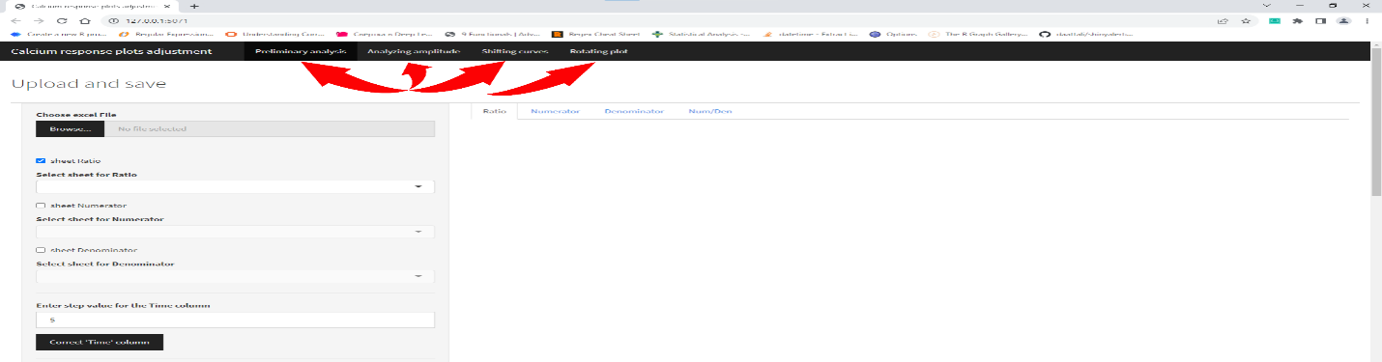

Altogether there are 4 tabs:

* Preliminary analysis (loading raw excel files, correct Time column, change column names, exclude traces, etc.)
* Analyzing amplitude (finding amplitude for curves that have 1, 2 or 3 major maximums)
* Shifting curves (shift plots automatically to the left using two algorithms)
* Rotating plot (rotating plots and their parts)

You can start using program after choosing any of these 4 (Preliminary analysis is chosen by default).

# TAB: Preliminary analysis

On this tab the main preview window (to the right from a sidebar) contains 4 internal tabs by default:

* Ratio – (fluorescence in channel 340/380)
* Numerator – (fluorescence in channel 340)
* Denominator – (fluorescence in channel 380)
* Num/Denominator – (custom ratio: values from Numerator are divided by values from Denominator)

In order to load your file and read sheets that contain information about Ratio, 340 or 380 channels you need to check necessary boxes on the left (user is allowed to do that either before the file was chosen and loaded or after):

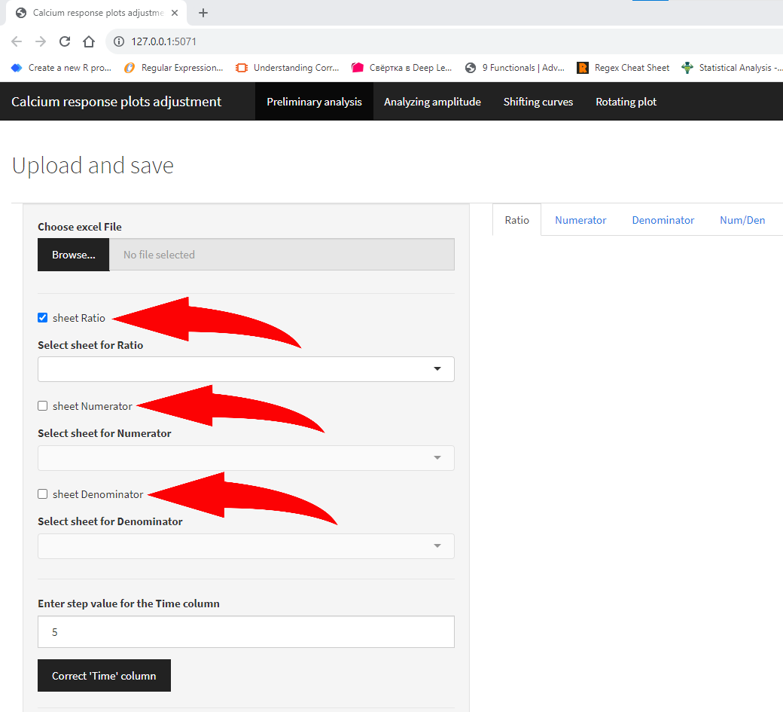

An excel file should contain at least one sheet if you checked the one box or more. After pressing “Browse” button and choosing an excel file: if the file has sheets with names “Ratio” or “ratio”, “340” or “380” – they will be automatically recognized and reflected in “Select sheet for …” boxes:

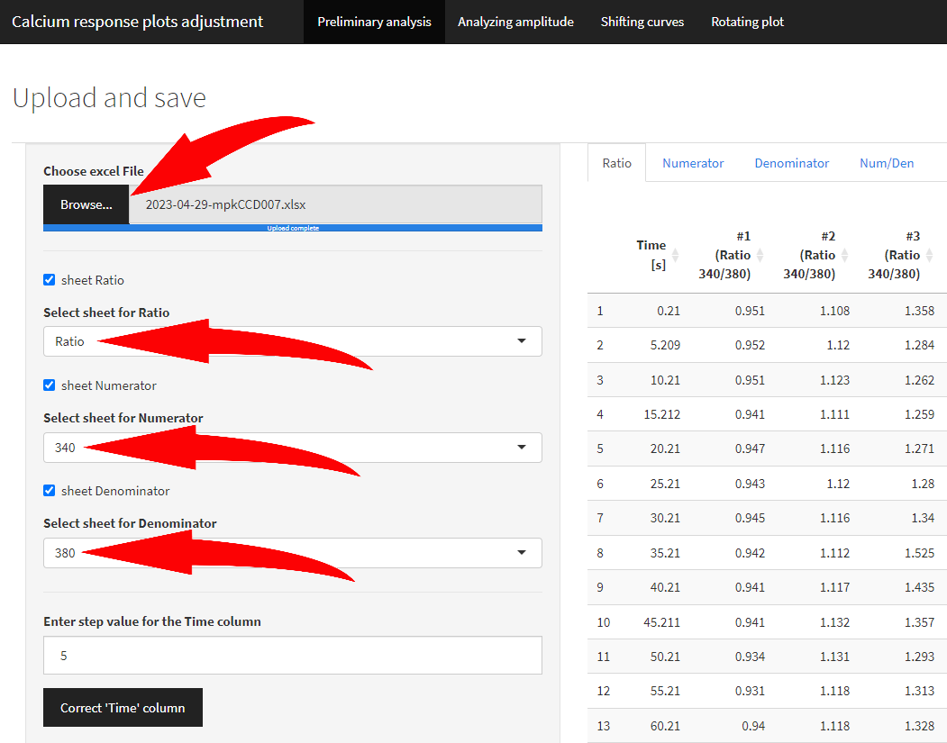

If names are different from reference, user can manually set any sheet name that corresponds to Ratio/Numerator/Denominator:

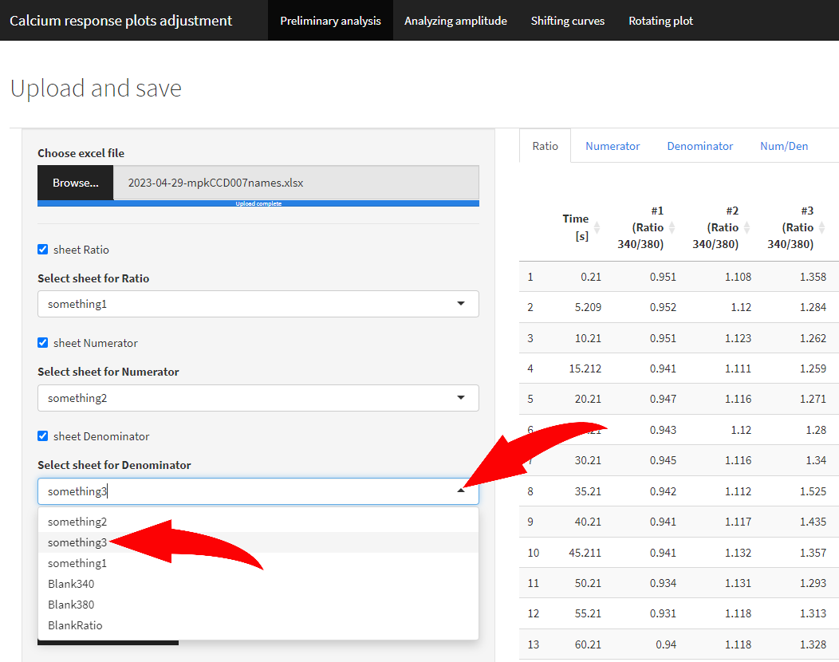

Next step allows you to correct the “Time” column and column names if necessary (but recommended).

To replace “Time [s]” column to “Time” and fill it with values with custom step (by default 5 sec), enter the step value into the box below (if different from default) and press “Correct ‘Time’ column”.

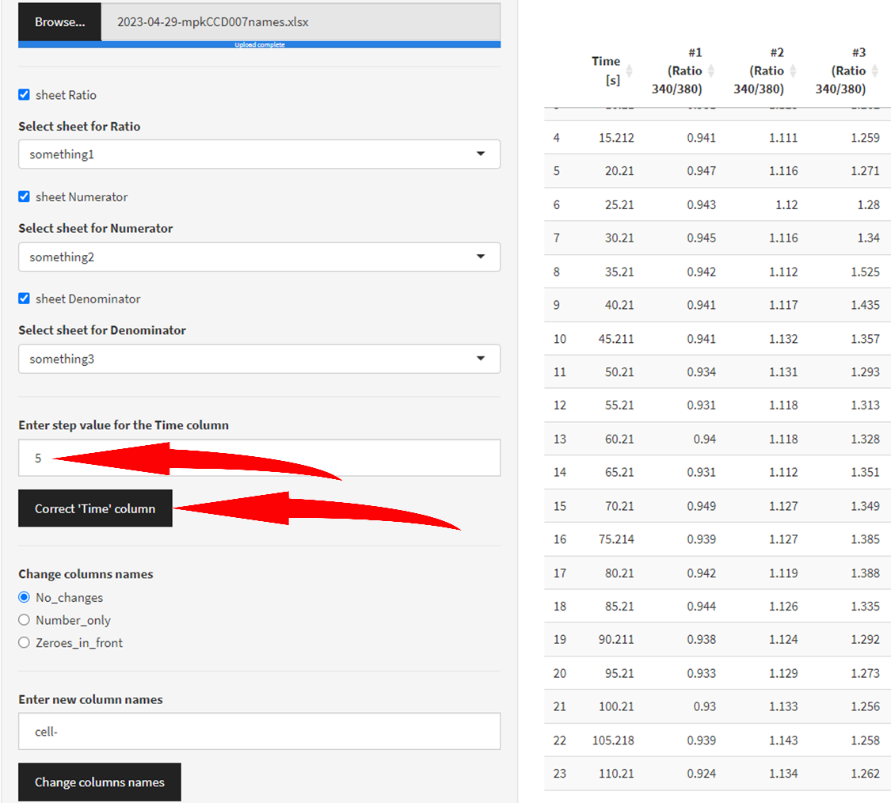

After pressing the “Correct ‘Time’ column” button it turns green indicating that action has been taken.

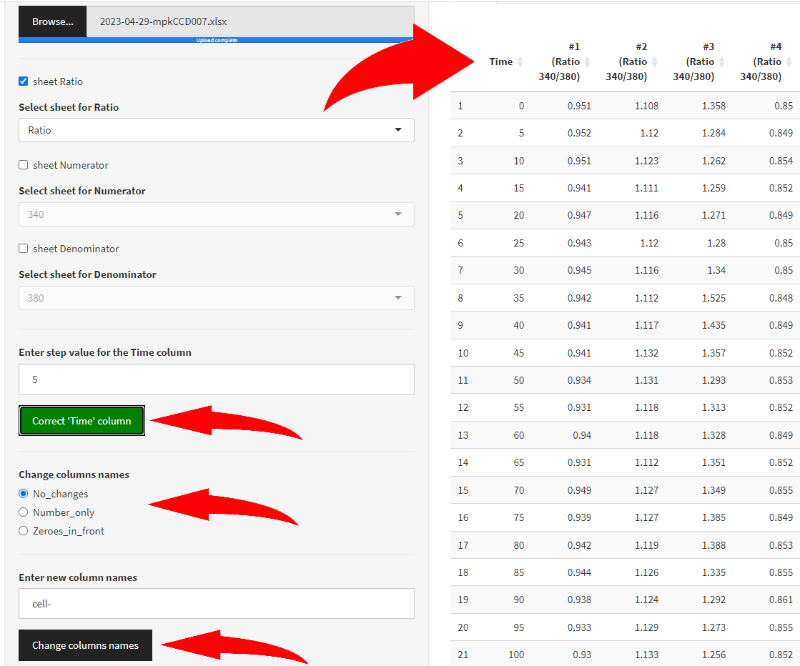

By pressing it again it turns grey and deny changes that have been made to the “Time” column.

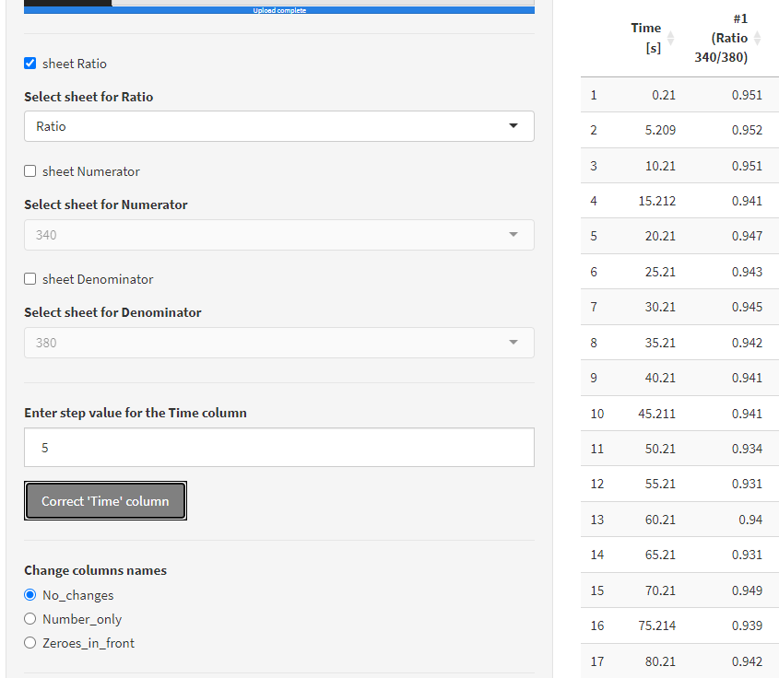

To change other column names there are two options for number conversion and option for custom prefix.



By choosing “Number_only” column, any number in a column name will be captured and column will be renamed using the following pattern: column name prefix (by default “cell-”) + captured number.

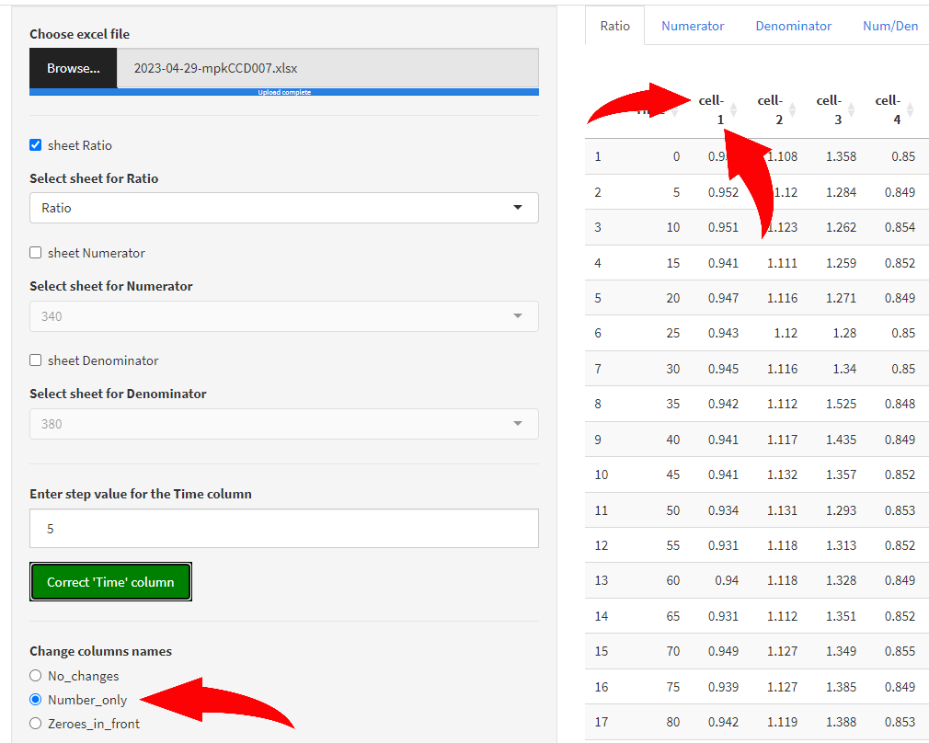

By choosing “Zeroes_in_front” option to any captured number a certain amount of zeroes will be added so the result number has fixed amount of all digits (this can help with sorting column names).

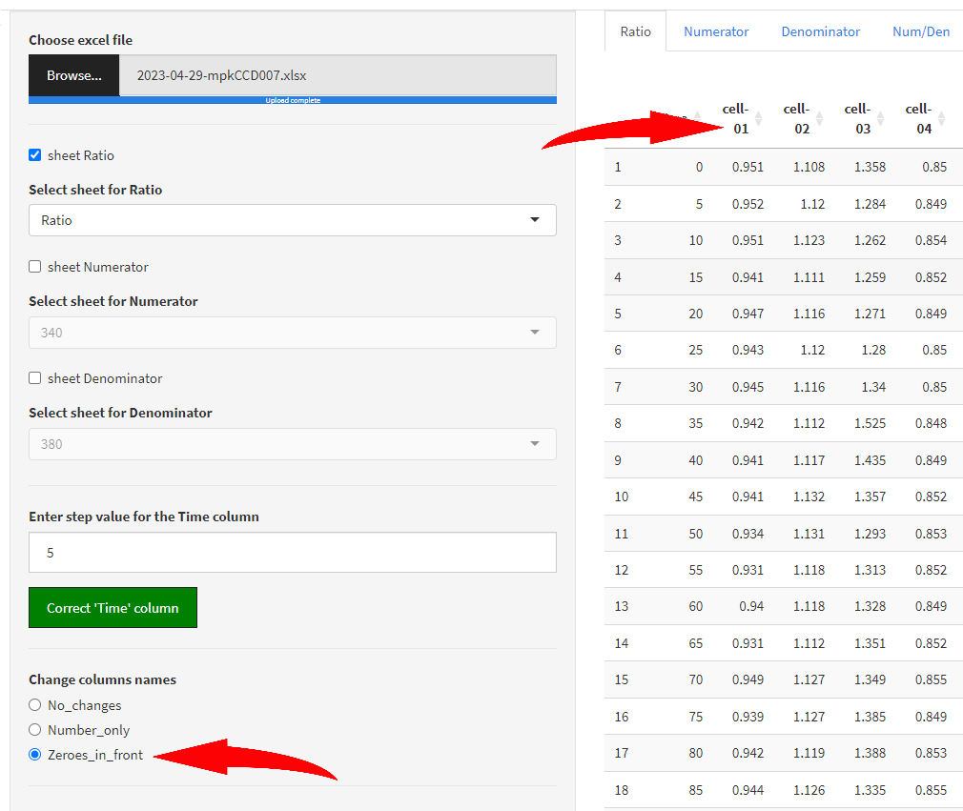

The amount of zeroes depends on the maximum number captured (maximum 9999, i.e. cell-9999). If maximum number has 4 digits and minimum number – only one, therefore the pattern is the following: “cell-0001, cell-0013, cell-0020, cell-0149, cell-1328”. The 2 digits maximum case is presented above.

If user wants to change the prefix from “cell-” to custom prefix, it can be done by entering the prefix in the “Enter new column names” box:

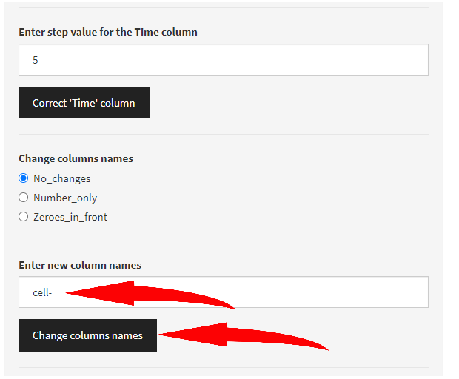

In this case if “No_changes” radio button is chosen “Change column names” button won’t cause any changes and just will turn green one time indicating that the button was pressed at least one time. As long as this is an action button there are no “grey” state for it, “green” only. User can discard changes by choosing “No_changes” radio button any time.

For changes to take effect user needs to choose first the column names style above (“Number_only” or “Zeroes_in_front”) – entered prefix will be used momentarily to change column names. For the custom prefix AFTER this action has taken place user can enter custom prefix value and press “Change column names” button to change the prefix in column names.

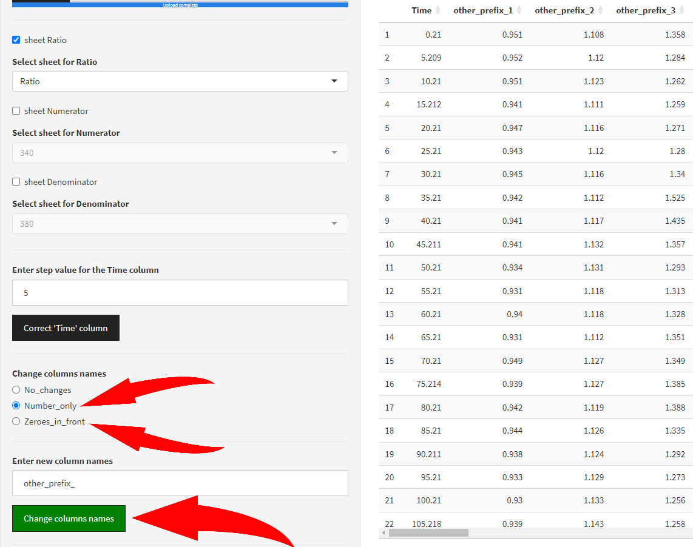

After choosing column names style or changing column names prefix “Time [s]” column also changes its name automatically to “Time” only (if you haven’t done it earlier) but no automatic changes to its values are applied though.

The last “Display” option allows you to just show several rows only in a preview table. It is relevant only for amount of traces > 500 to speed up the process of loading and previewing data.

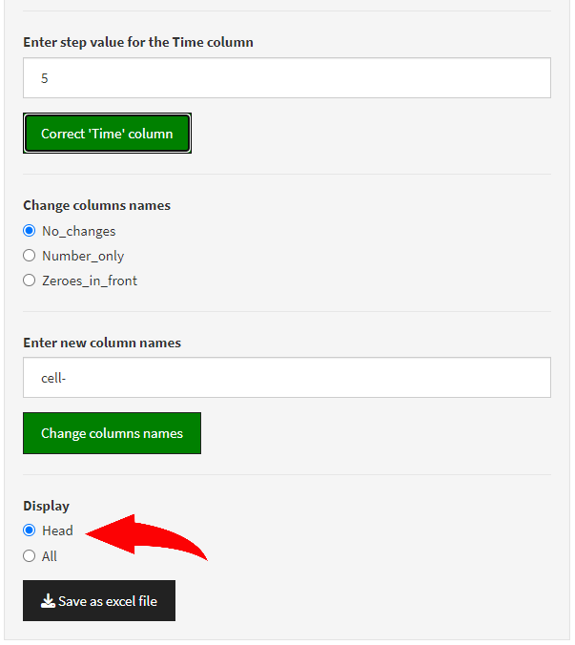

Finally, “Save as excel file” button allows to save an excel file (**{*initial name of the file}-*ProcessedTable.xlsx**) with data that match the preview’s format.

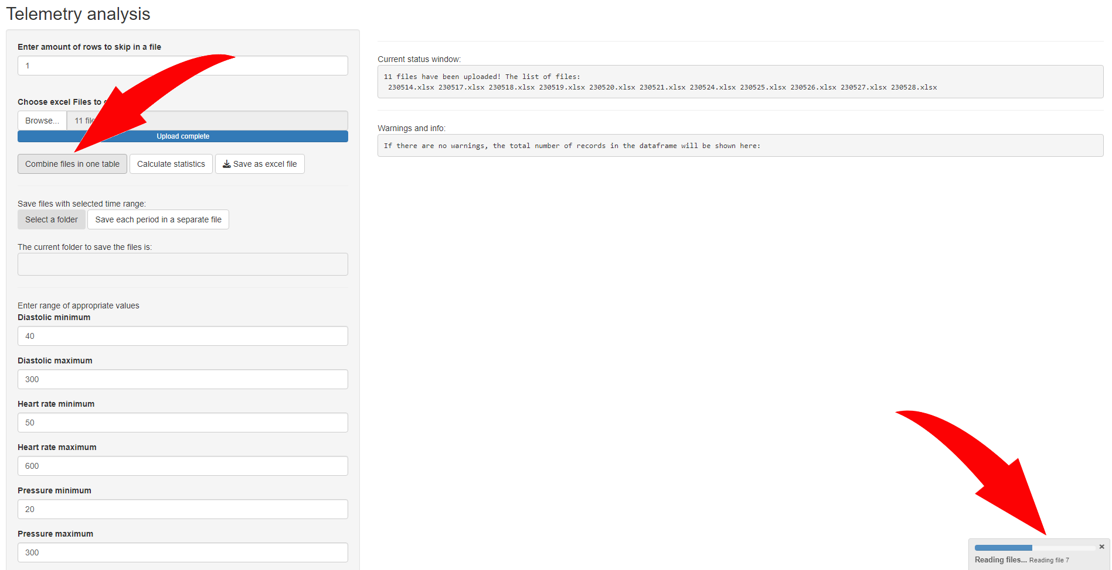

After pressing the button you need to wait until all files will be combined in one dataframe. Progress bar in the bottom-right corner indicates the current state. You need to wait until the notification with the green check mark appears:

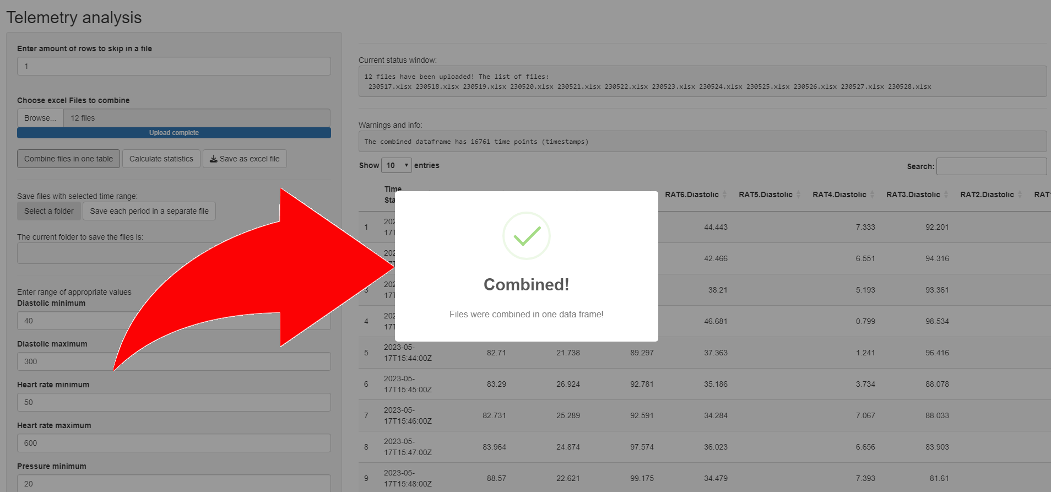

This message will disappear automatically within ~ 1 second or you can dismiss it by clicking left mouse button anywhere outside the message box or by pressing “Esc” button.

If everything alright, no issues were found, than “Warnings and info:” message box reflects the information about the total amount of unique records (all complete duplicates are excluded) in a combined dataframe and the following text is shown:

“*The combined dataframe has {****number****} time points (timestamps)*”.

Table underneath represents the combined dataframe that can be verified manually:

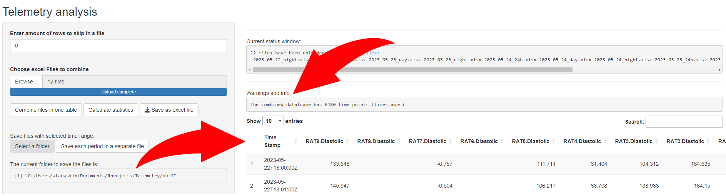

If some records are appeared to have the same **Time stamp** but different values (which is an indicator of an error or wrong data or records) - “Warnings and info:” message box contains:

“*In order to proceed delete one of each pair of duplicates in files!   
Check duplicates in the table below.*”

Table underneath in this case represents the duplicated records (with the same time stamp but different values in other columns):

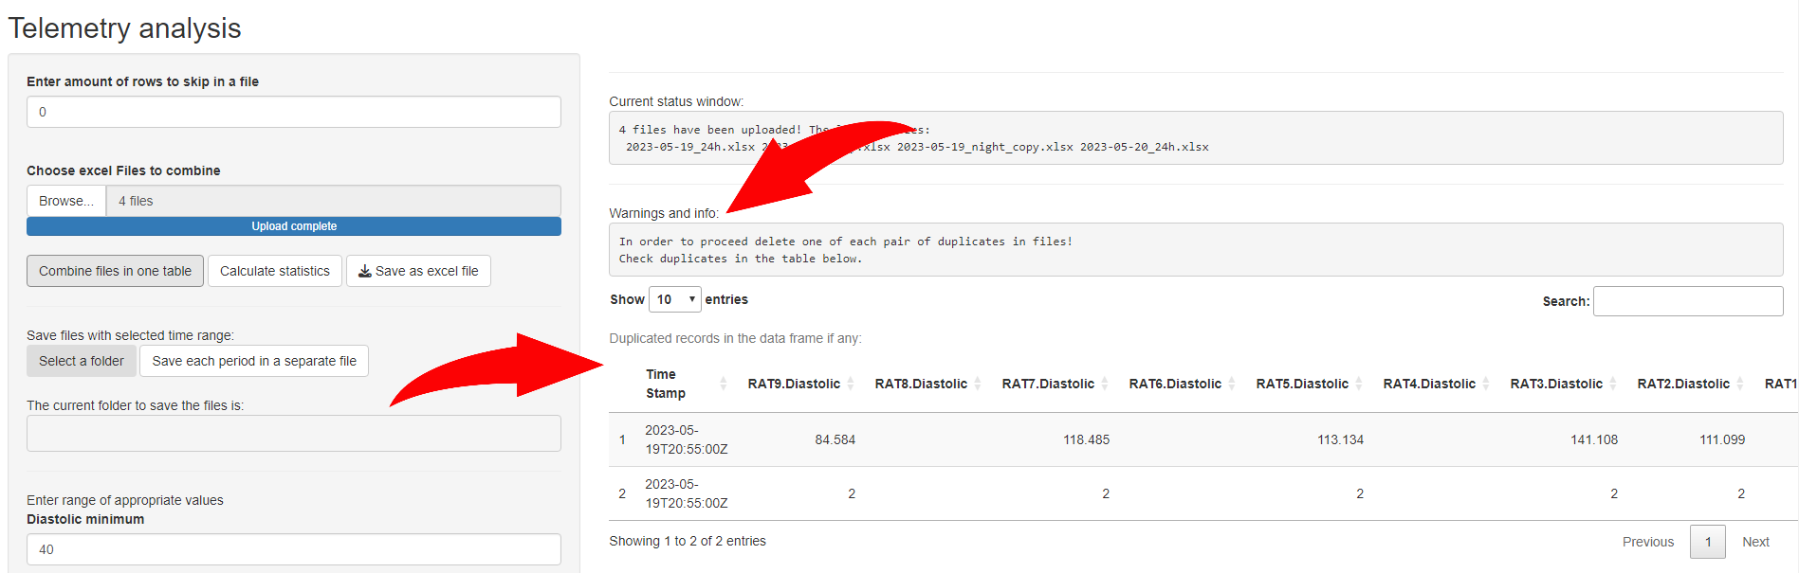

Unfortunately, these entries should be deleted manually in excel files. Except for a time stamp, table does not provide any other information about the location of these records. After removing wrong rows in files the whole procedure from the very beginning should be repeated (you should restart the program).

However it is possible to skip the step of deleting the duplicated entries and proceed further to calculate statistics. If one of two measurements of a single parameter outside the allowable range (see section b. ‘Calculate statistics’ for the range information) it won’t be taken into account anyway. Otherwise, both values will affect the result statistics calculations, as long as they are inside the time period of interest and ‘counts’ value will include both of them as two separate measurments. No further verification for duplicates will be processed.

1. ‘Calculate statistics’

Before this button is pressed make sure that all the range values for each parameter are valid and change default values if necessary (if you restarted the program you need to set this values again, you won’t be able to set custom values as default for the next launch of the program). All values outside the estimated ranges for each variable will be excluded from consideration, the algorithm will treat them as they were missing:

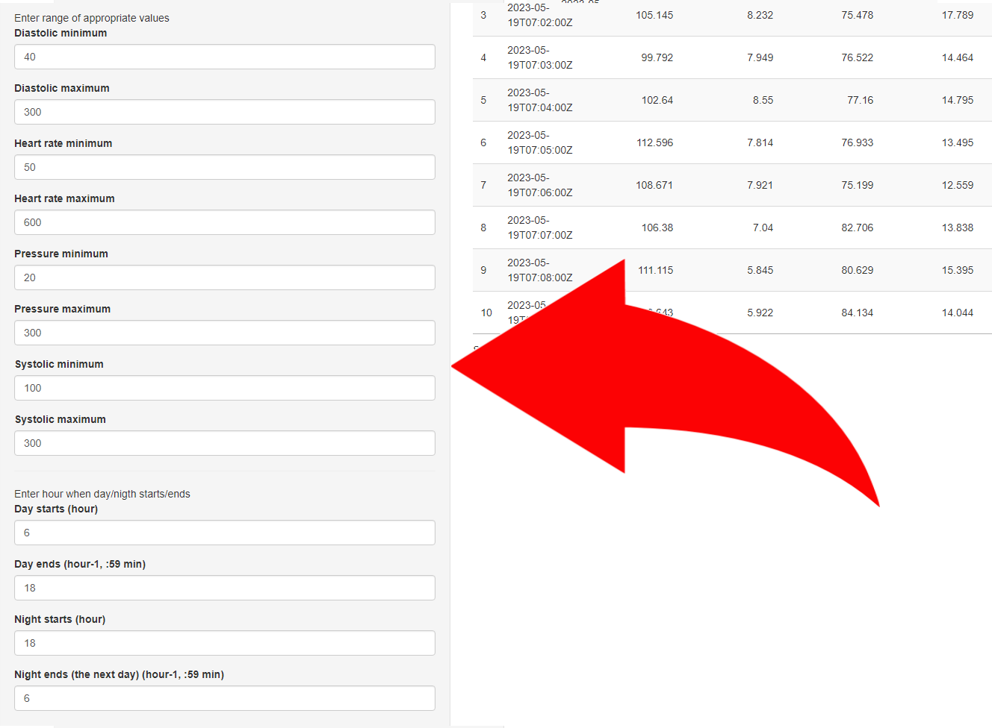

In the following example if **Day starts** at 6 a.m. it means that on the specific day starting from 6-00 until ‘day ends’ variable or the end of the same day (23:59).

If **Day ends** is set to 18 (which is 6 p.m.) pay attention to the following explanation in brackets (hour-1, :59) – it means that all time points from **Day starts** variable to 17:59 (5:59 p.m.) inclusively (the same day) will be taken into account, 18 - 00 time point will be excluded though.

Night should start at the SAME DATE when day starts. You cannot set **Night starts** variable for the next day after the midnight. So the range for the **Night starts** is 0 (0-00 a.m.) to 23 (23:00 (11:00 p.m.) inside the SAME DAY.

**Night ends** variable follow the same rule (hour-1, :59) but is refered to the NEXT DAY. If it is 6 (a.m.) it means that all the values from **Night starts** variable (the SAME DAY) to 5-59 (a.m.) inclusively (the NEXT DAY already) will be taken into account. **You cannot set Night ends variable to end observation at the same day!**

After that you can press ‘Calculate statistics’ button to apply all the range values. **Without pressing ‘Calculate statistics’ button even time ranges for the day and night won’t be affected.**

The same as for the previous step after pressing the button you need to wait for calculations to be performed. Progress bar in the bottom-right corner indicates the current state. You need to wait until the notification with the green check mark appears:

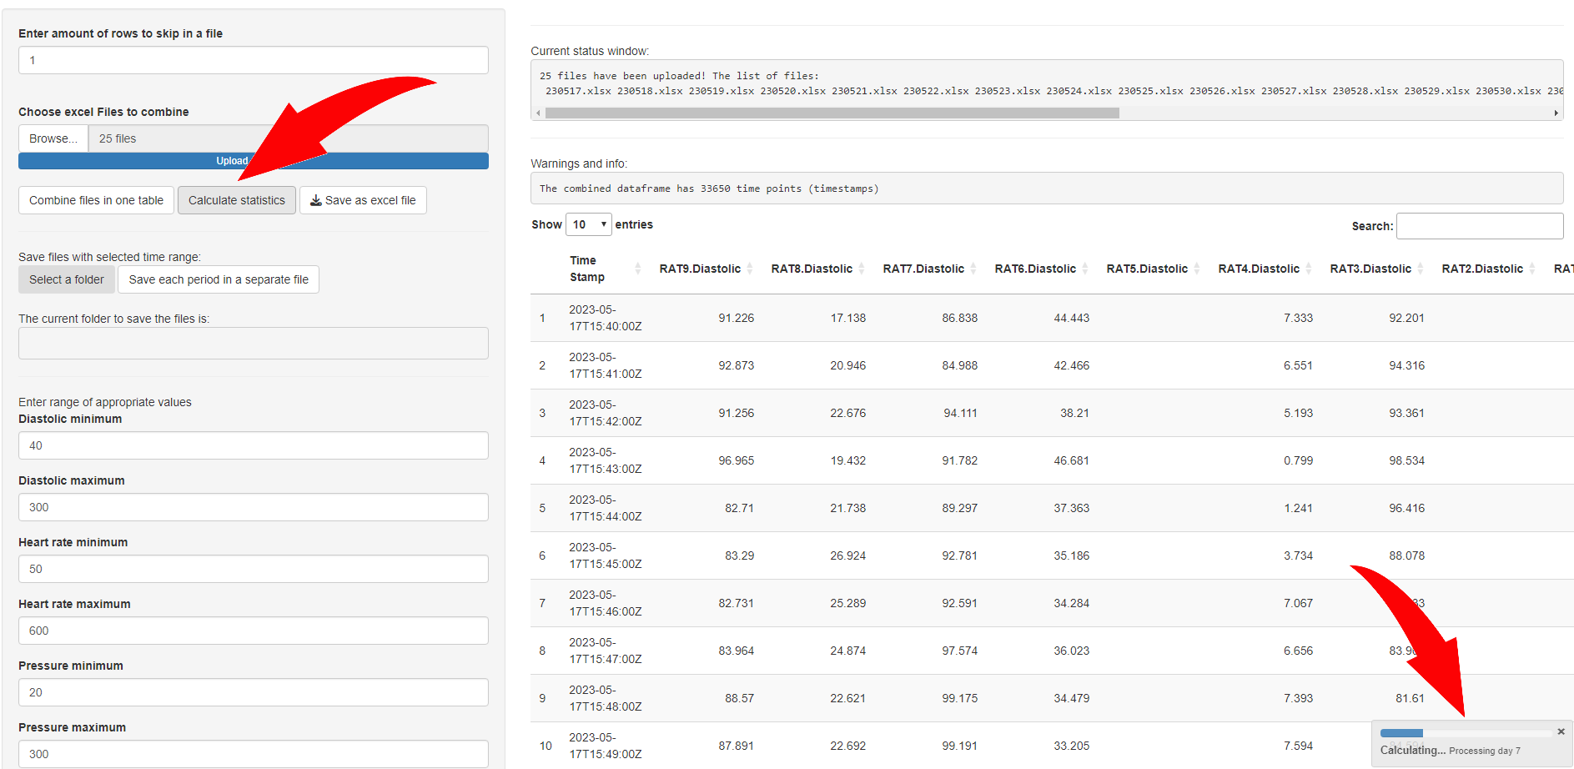

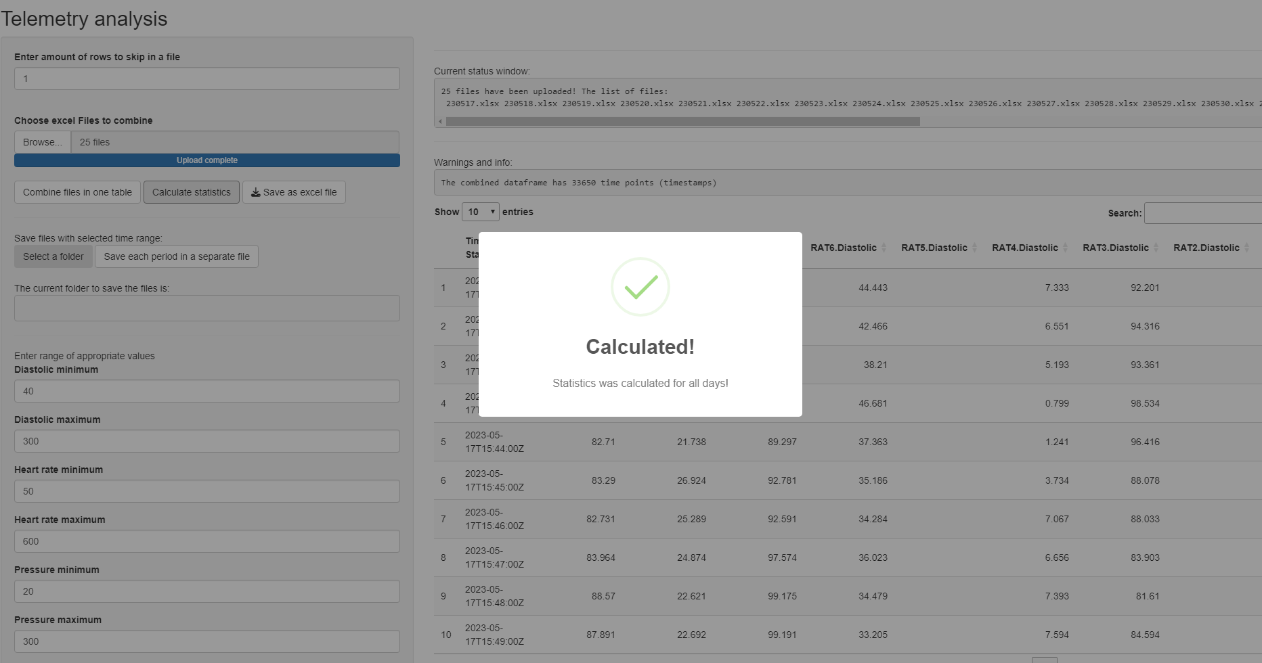

The second table will appear after pressing ‘Calculate statistics’ button with mean values calculated for each day and each sample:

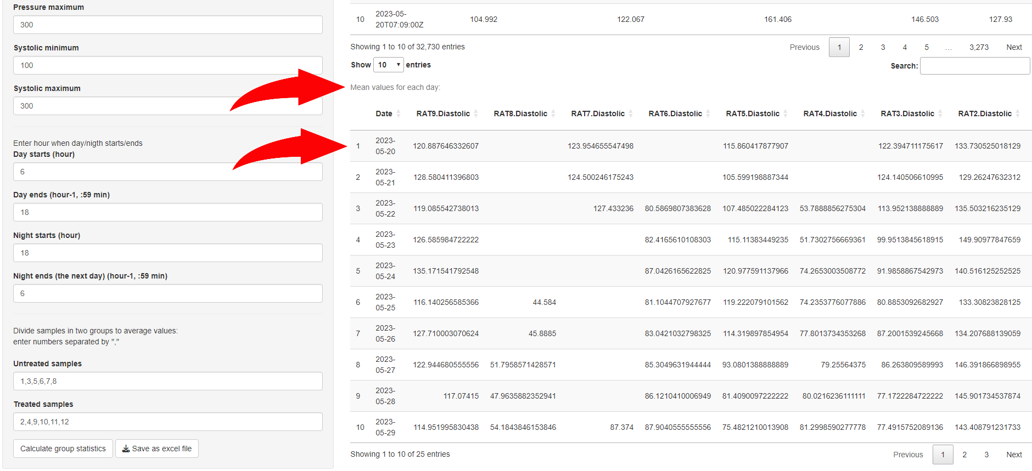

# Save statistics per day / per sample (mean, SD, SEM, counts, relative counts)

After that it is possible to save the telemetry_statistics.xlsx (or change its name) file by pressing the following button:

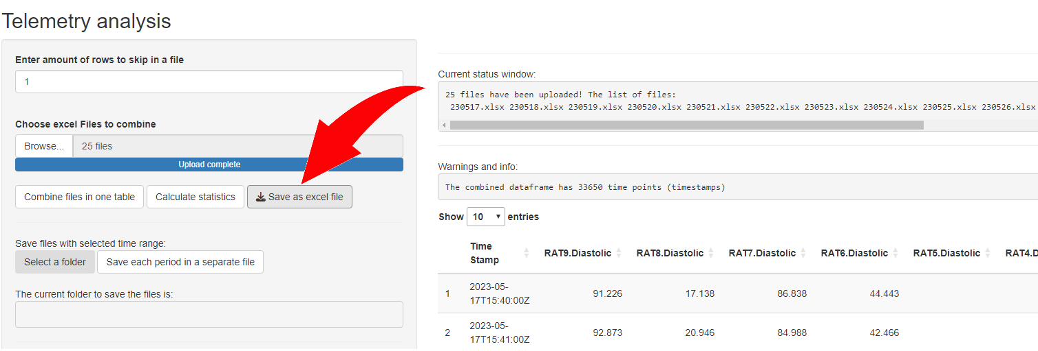

File telemetry_statistics.xlsx contains statistics per day/per rat (sample): for the day only period (…_day), night only period (…_night) and the whole day (…_every_day) which is: day only period + night only period.

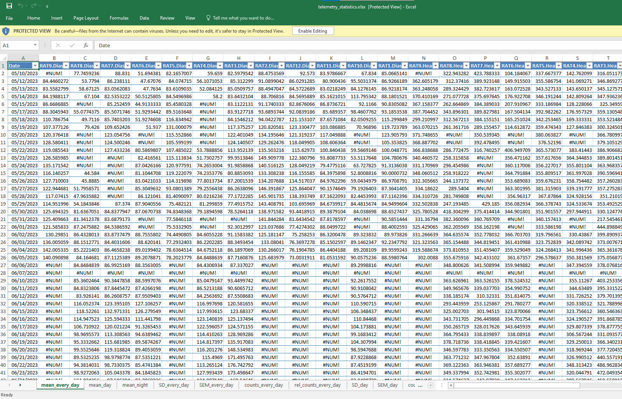

Altogether, there are mean values, SDs, SEMs, counts (the amount of time points per day or day period) and relative counts (rel_counts_...) – normalized values from 0 to 1 (the same meaning as percents from 0 to 100%), showing the relative amount of time points per day. For example, 0.86 means that 86% of maximum amount of points per period of observation exist or within the allowable range for this variable. Unfortunately, empty values for mean, SD, rel_counts_... could be presented as #NUM! values which can be inconvenient for further analysis. To replace them in excel one can press “Ctrl+H” enter “#NUM!” in the first field, press “options” to specify “Within: Workbook” and press “replace all” button to replace them in the whole document.

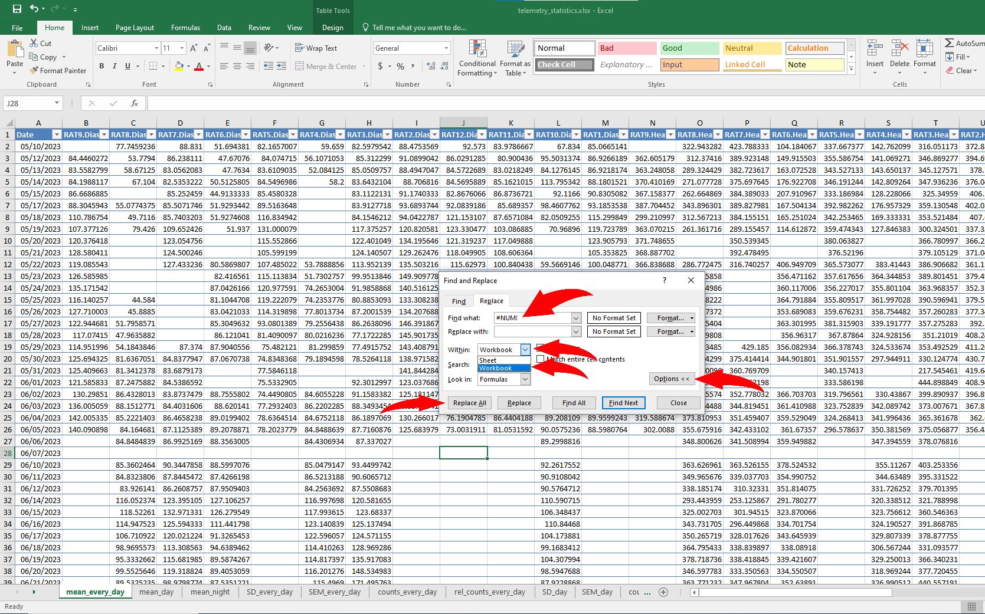

# Save raw data divided by day/day period/night period as separate files

It is possible to save the raw data divided by day/day period/night period as separate *.xlsx files. **It can be done only if all the previous steps were performed** (one doesn’t need to save statistics per day / per sample from **step 3**, other steps are mandatory)!

In order to do this you need to press “Select a folder” button, choose any folder inside “Documents” folder in Windows (by default two levels up from script directory) or create one by entering the name of the new folder and pressing ‘+’. Eventually, ‘Select’ button should be pressed.

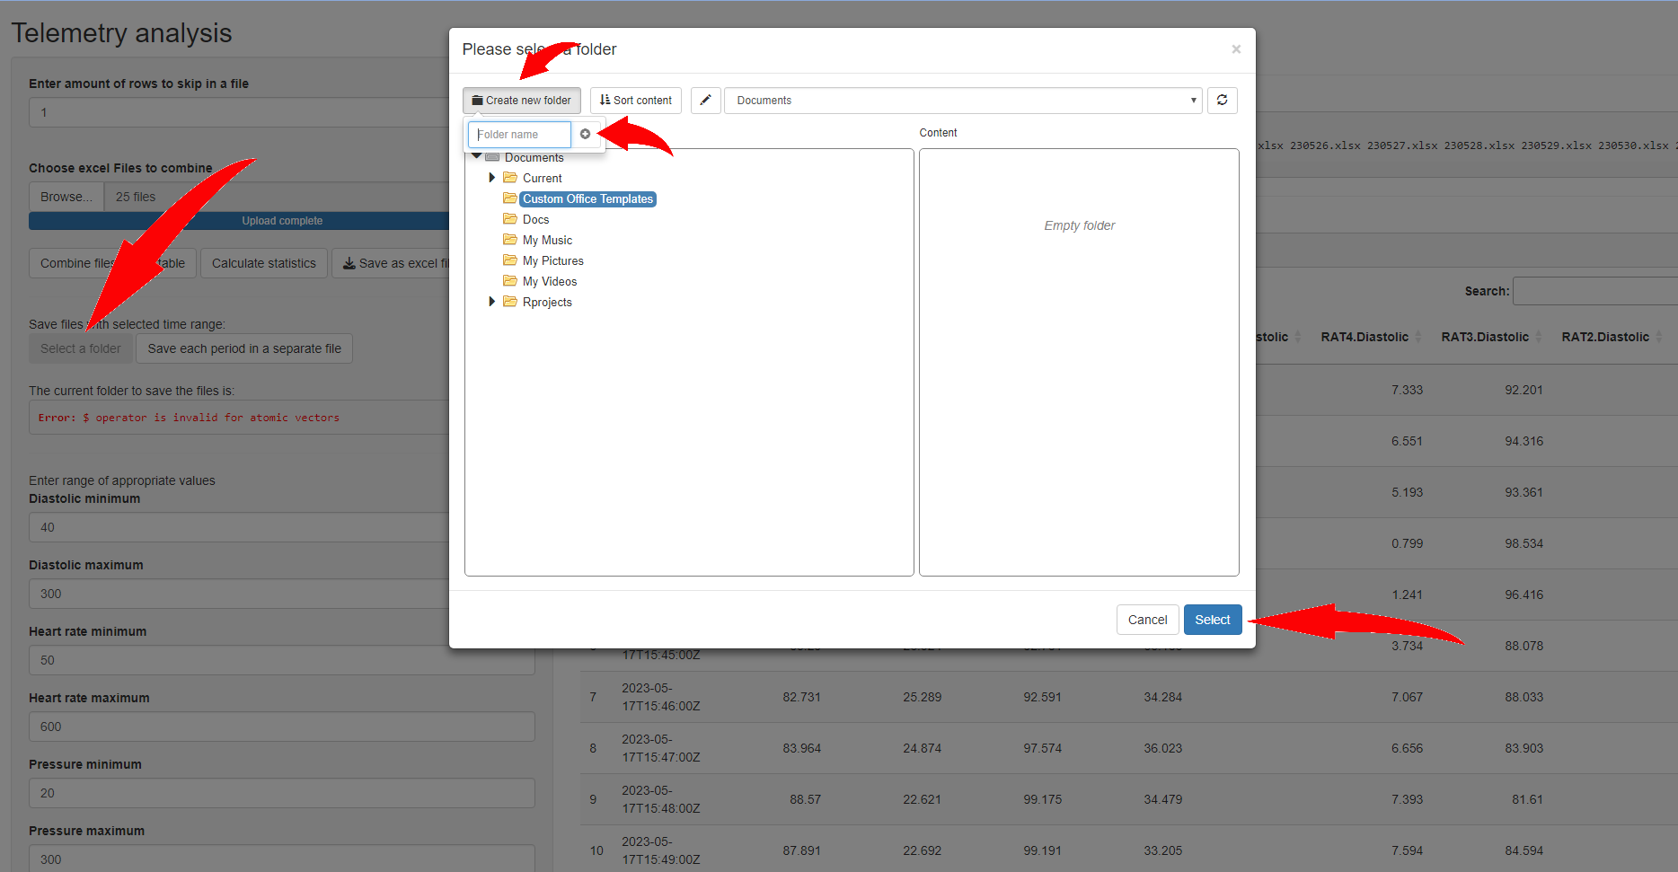

The chosen folder path should be written in the box below:

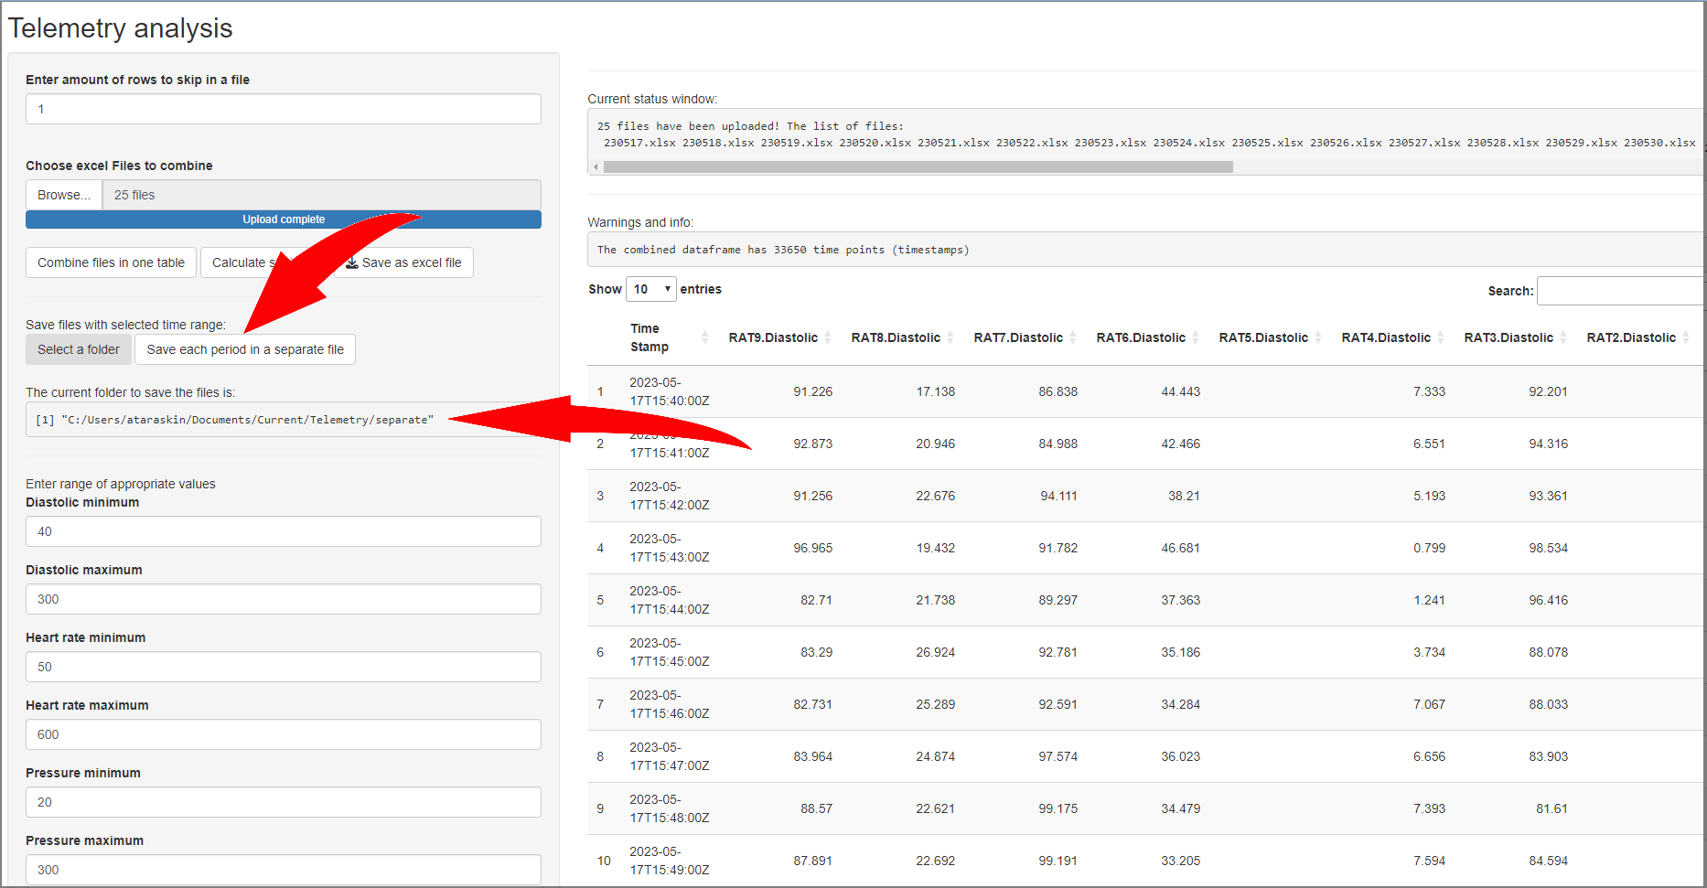

All separate excel files will be stored in a folder specified after pressing “Save each period in a separate file” and waiting for the process to be completed:

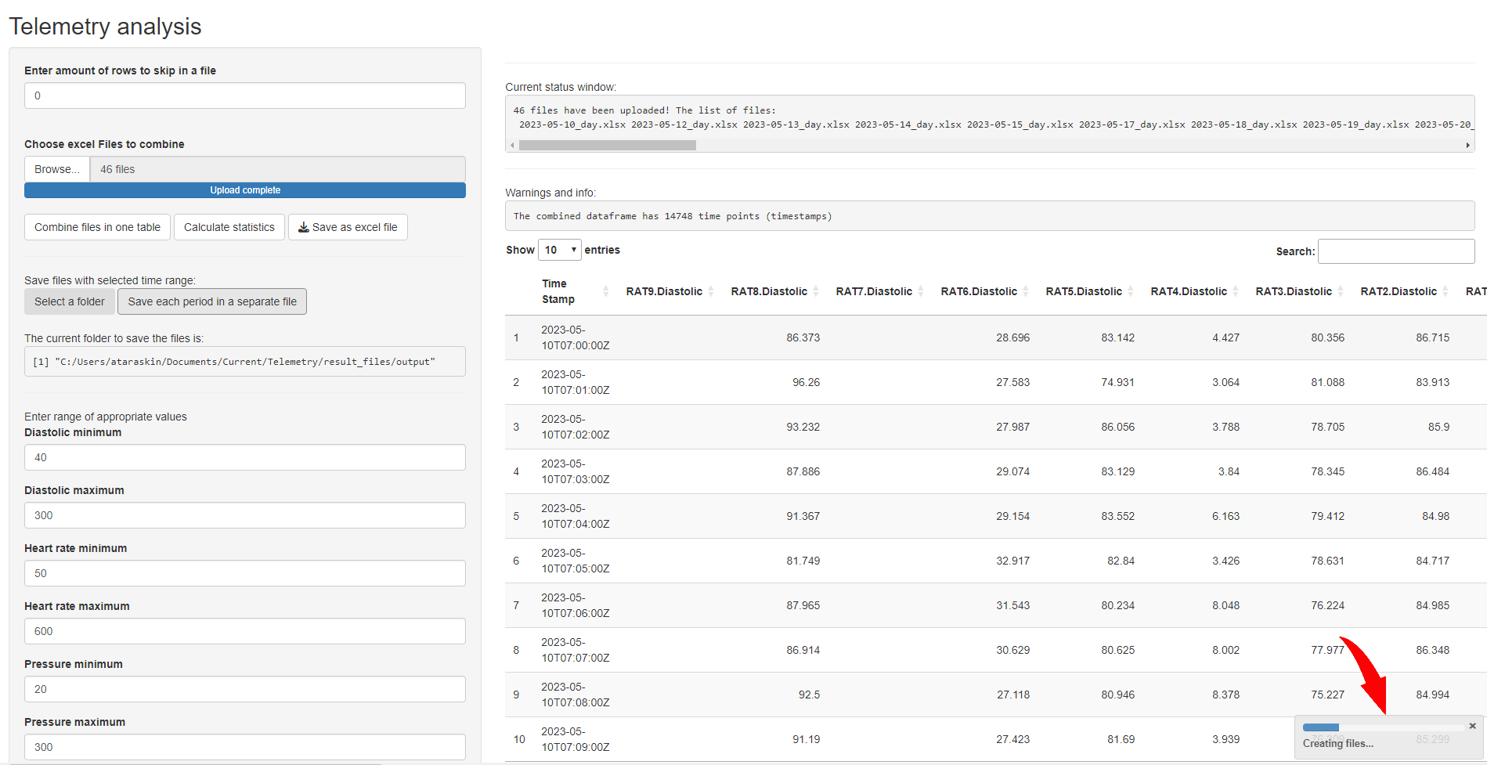

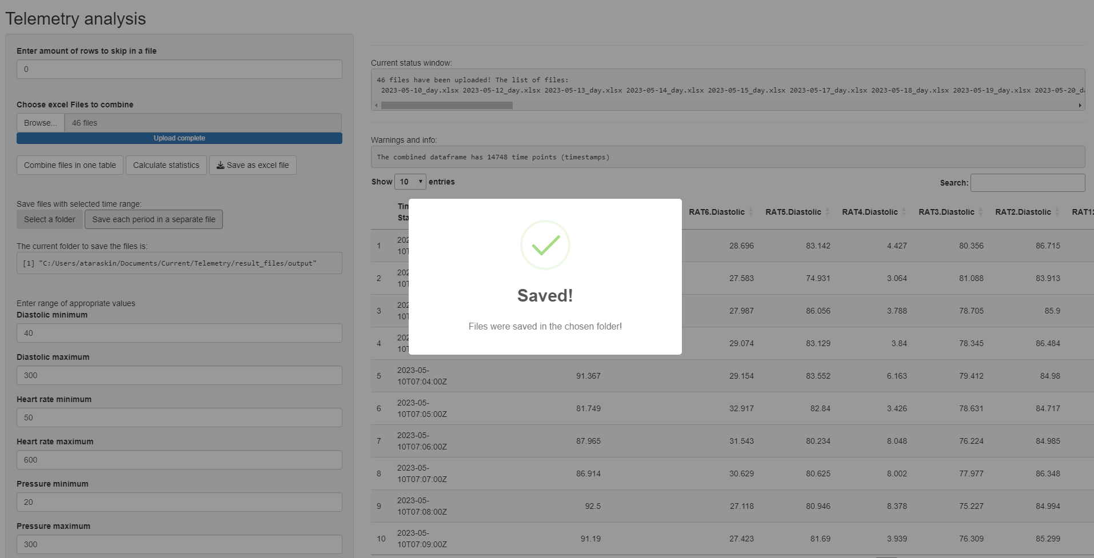

# Group statistics

It is possible to calculate group statistics – combine values for several samples (rats) in two different groups and calculate group means, group SDs, SEMs and group counts. In order to refer each sample to a specific group (in general: treated or untreated) you need to enter numbers of samples in each box for numerical values, separated by comma (!):

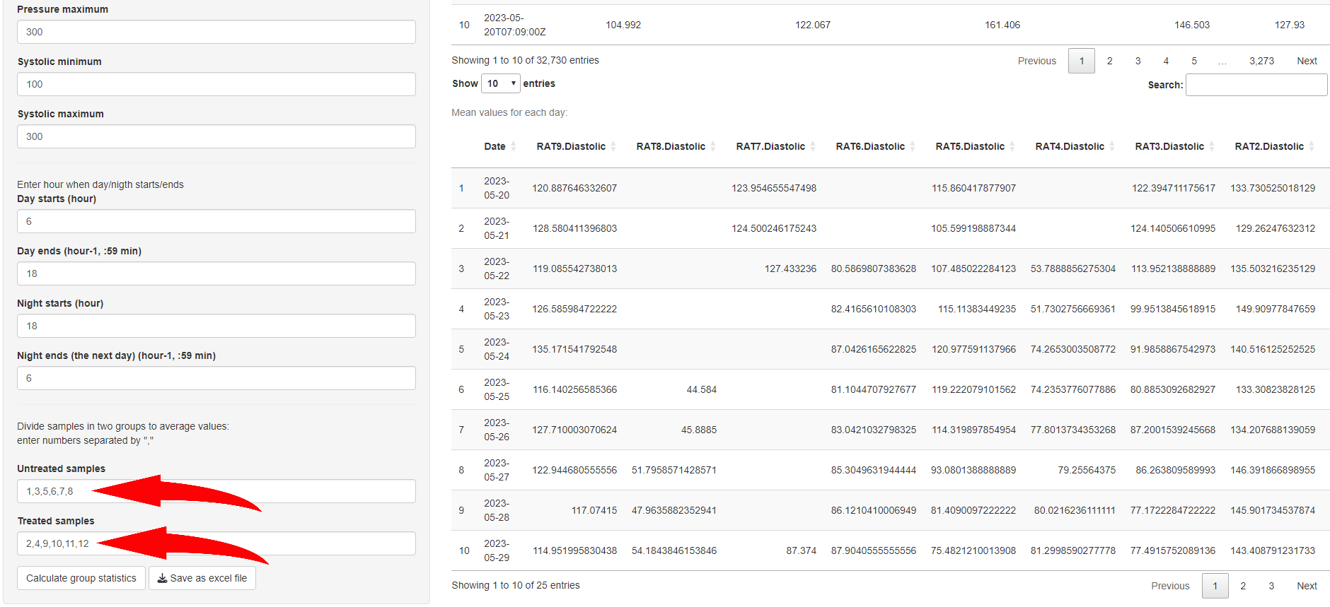

Program will accept any values but understand only those, which are completely match the actual values in column names. For example, RAT12.Diastolic is match number 12 only, separated by comma from other values: 1, 2, **12**, 21

If there is only one sample per group no comma is needed:

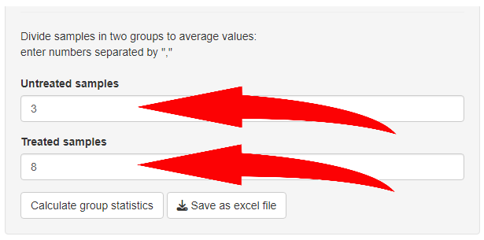

If instead of “3” by accident was typed “-3”, for example: {1,5,7,-3,4} – program still will accept it as number “3”.

Spaces and order don’t count: {1,5,7,3,4} = {1, 5,7 ,3 , 4} = {1,3,4,5,7}

But {1 2, 11, 7} not equal to {12, 11, 7} it will be understood as {1, 2, 11, 7}. However, please, use commas instead to clarify the number you specifying.

**Default sample numbers should be changed manually every time the program is launched (if they differ from default sample numbers)!**

Eventually, after pressing “Calculate group statistics” button the file will be created. There is no preview of the results and no status bar indicating the current progress of calculation. **Please, after pressing “Calculate group statistics” button wait until the notification with the green check mark appears.**

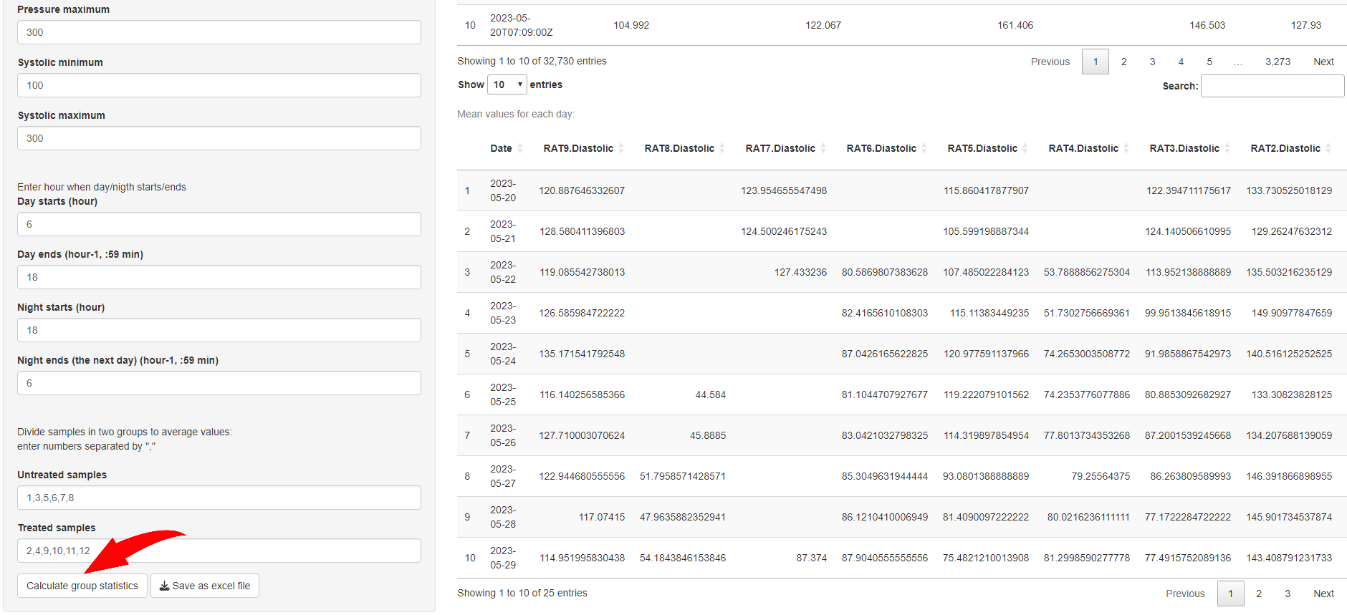

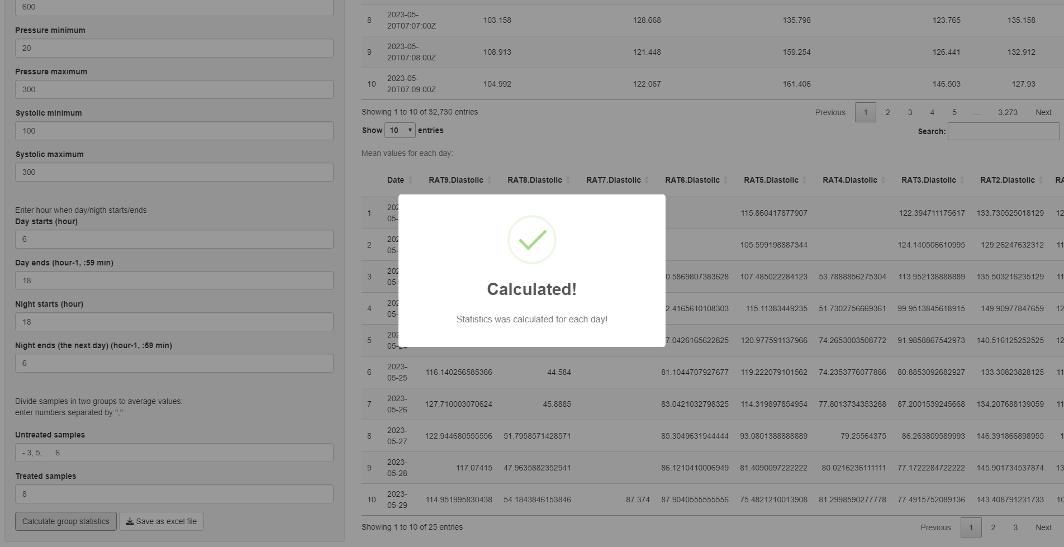

The results can be stored as mean_statistics.xlsx (or custom name) file by pressing “Save as excel file” button.

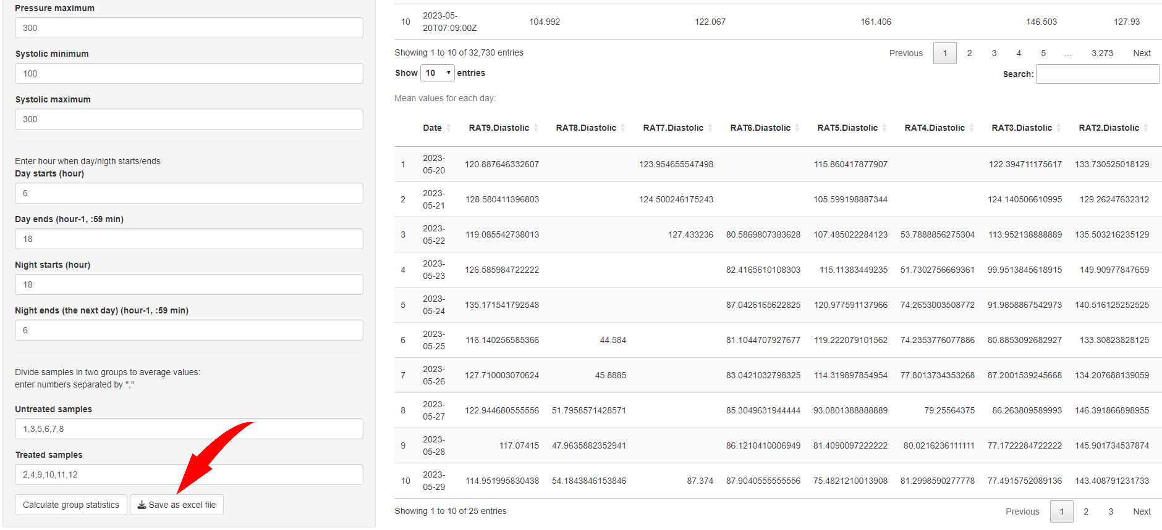

There are several sheets in mean_statistics.xlsx file with …_untreated_... and …_treated_... designations referred to chosen groups. Inside each sheet there are mean values for each sample (combined to match the specific group: treated/untreated) per day.

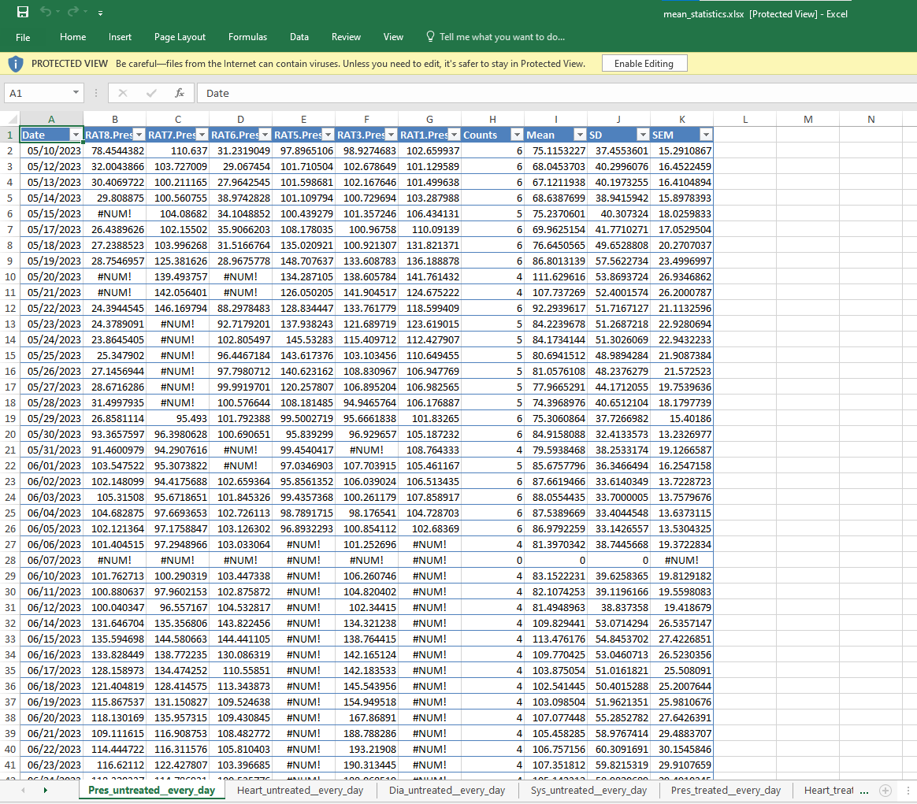

Then goes “Counts” column, where you can find information about the amount of valid mean values for a specific day, maximum = amount of samples in a group.

“Mean” column – mean of every mean value in a row for all samples in a group. If there are 6 samples per group for each day there are 6 mean values per day – mean of this 6 means is the value in the “Mean” column.

The same logic for “SD” and “SEM”, they are calculated considering the fact that there are N samples (in our example N=6 maximum) per day that have N values per day for which “SD” and “SEM” should be calculated.

In case of means: the mean (group mean) of means equal the mean for all values for all the day’s period time stamps for all samples in a group. But for SDs and SEMs – group SD or SEM **NOT** equal to SD or SEM for all values for all the day’s period time stamps for all samples in a group. To find a close estimate for SD and SEM in a previous file telemetry_statistics.xlsx in SD_..., SEM_... sheets samples should be manually sorted and divided into two groups and it is possible manually find **mean value** for SD and SEM in each group which will be close to SD and SEM calculated for all the day’s period time stamps for all samples in a group.