Field Dynamics and Environment Modeling
Standalone Report for MSc Thesis:
“Modern Control Methods for Agricultural Irrigation”
Tara Torbati
ITMO University, Saint Petersburg, Russia
April 2026

Study Site Description
The study site is a 6-hectare agricultural field located in Gilan Province, Iran (38.298$​^{∘}$N, 48.847$​^{∘}$E), in the humid subtropical coastal zone south of the Caspian Sea. Gilan is Iran’s primary rice-producing province, accounting for over 238,000 hectares of paddy fields [1]. The field exhibits a bowl-shaped topography with elevations ranging from 74 m to 181 m above sea level. A digital elevation model (DEM) was obtained from USGS Earth Explorer and processed in QGIS to extract a $10×13$ grid of 130 computational agents, each representing approximately 462 m$​^{2}$.

Topological Graph Construction
The DEM was used to construct a directed graph encoding water flow topology. For each agent $n$, the normalized elevation was computed as $γ_{n}=\left(z_{n}−z_{min}\right)/\left(z_{max}−z_{min}\right)$. Each agent sends lateral water flow to all eight-connected neighbors with strictly lower normalized elevation. The number of lower neighbors $N_{r}\left(n\right)$ determines the agent’s drainage capacity. Agents with $N_{r}=0$ are classified as sink agents—local minima where water accumulates. On this bowl-shaped field, sink agents are concentrated near the center and represent areas at risk of waterlogging.

Climate Data

Data Source and Period
Daily meteorological data were obtained from the NASA POWER database for 2000–2025 at coordinates (38.30$​^{∘}$N, 48.85$​^{∘}$E), providing satellite-derived and reanalysis-based parameters at $∼$50$×$60 km resolution. Thirteen variables were extracted: T2M, T2M_MAX, T2M_MIN, PRECTOTCORR, RH2M, WS2M, PS, T2MDEW, ALLSKY_SFC_SW_DWN, GWETROOT, and GWETTOP.

Preprocessing
The dataset was filtered to April–October for each year, yielding 5,564 daily records. No missing values were found. One rainfall anomaly was identified (April 7, 2022: 375 mm) and replaced with the calendar-day average (1.2 mm). Two reference evapotranspiration values were computed for each day (Section 2.3).

Reference Evapotranspiration
Two methods were compared:
Hargreaves equation [2]: ${\text{ET}}_{0}^{H}=0.0023⋅\left(T_{\text{mean}}+17.8\right)⋅{\left(T_{\text{max}}−T_{\text{min}}\right)}^{0.5}⋅R_{s}$
FAO Penman-Monteith [2]:
$${\text{ET}}_{0}^{PM}=\frac{0.408 Δ \left(R_{n}−G\right)+γ \frac{900}{T+273} u_{2} \left(e_{s}−e_{a}\right)}{Δ+γ \left(1+0.34 u_{2}\right)}$$
Over the 25-year rice season, Hargreaves overestimated ET$​_{0}$ by 34% (6.78 vs 5.02 mm/day, $r=0.965$). This is due to Gilan’s high humidity ($∼$64%) and low wind ($∼$1.40 m/s), which suppress evapotranspiration but are not captured by Hargreaves. Penman-Monteith was selected as the standard [2].
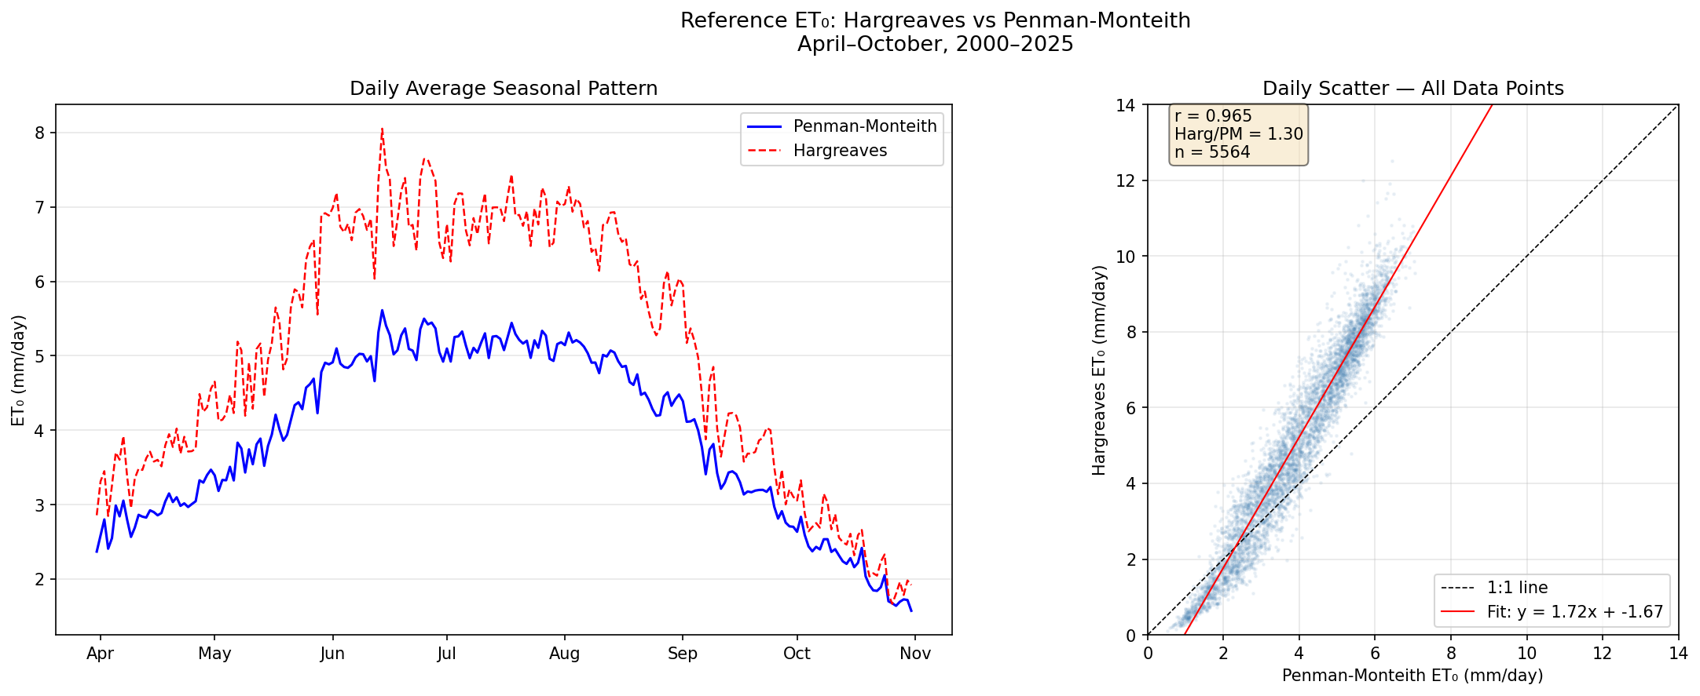
Comparison of Hargreaves and Penman-Monteith ET$​_{0}$. Left: seasonal pattern. Right: scatter plot with regression.

25-Year Climatology
Mean temperature ranges from 12$​^{∘}$C in early April to 26$​^{∘}$C in mid-July. Precipitation shows a dry mid-season (June–August, 0.5–1.5 mm/day) flanked by wetter months. Solar radiation peaks at 26 MJ/m$​^{2}$/day in June. Relative humidity remains 60–75% throughout—a defining feature of Gilan’s Caspian climate. Additional climate figures are provided in Appendix A.
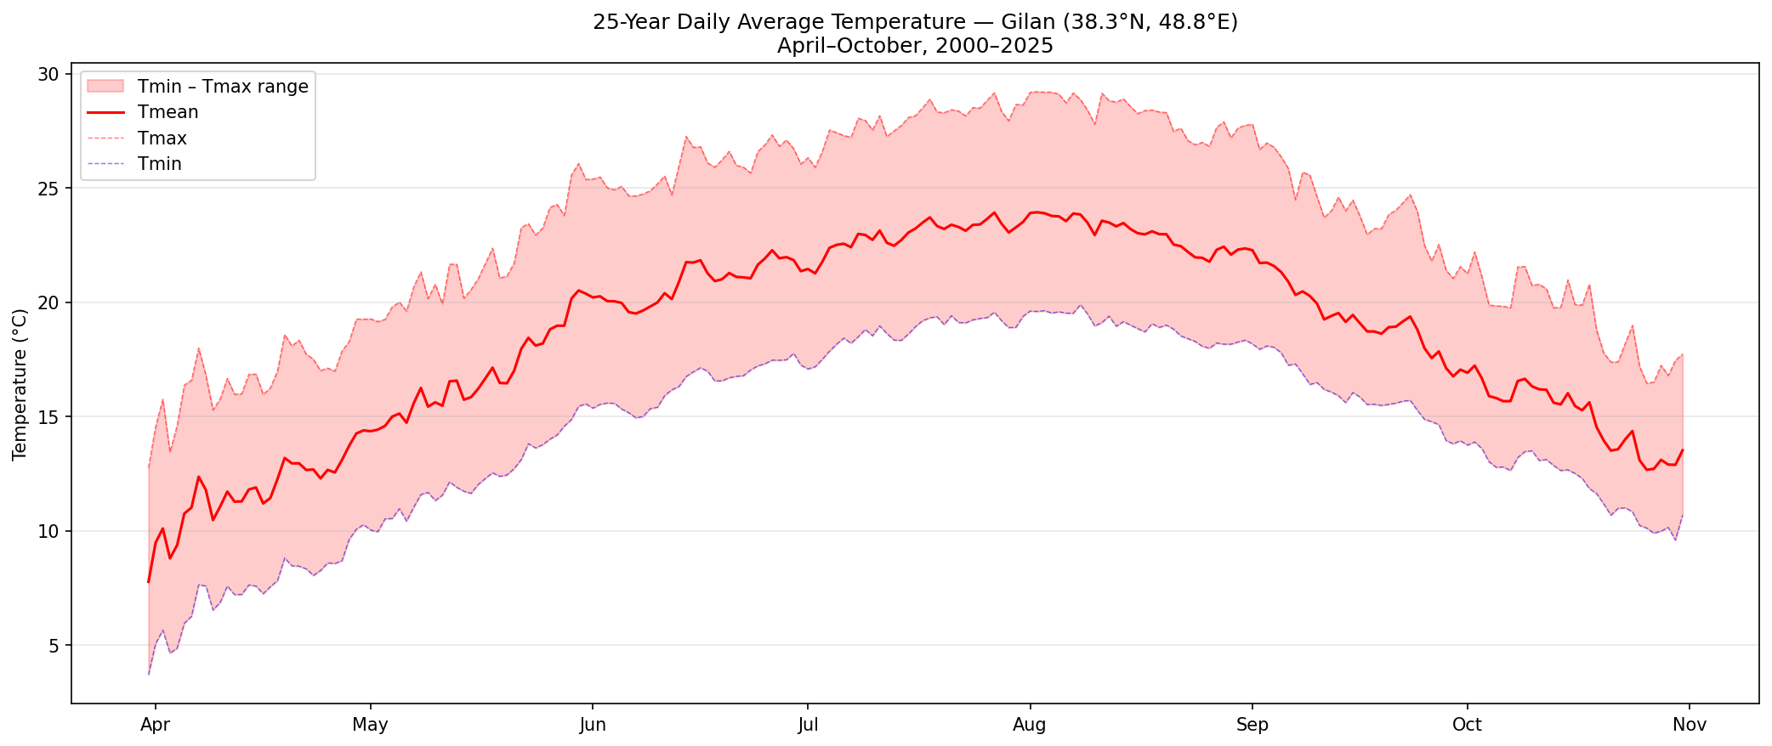
25-year daily average temperature (April–October, 2000–2025).
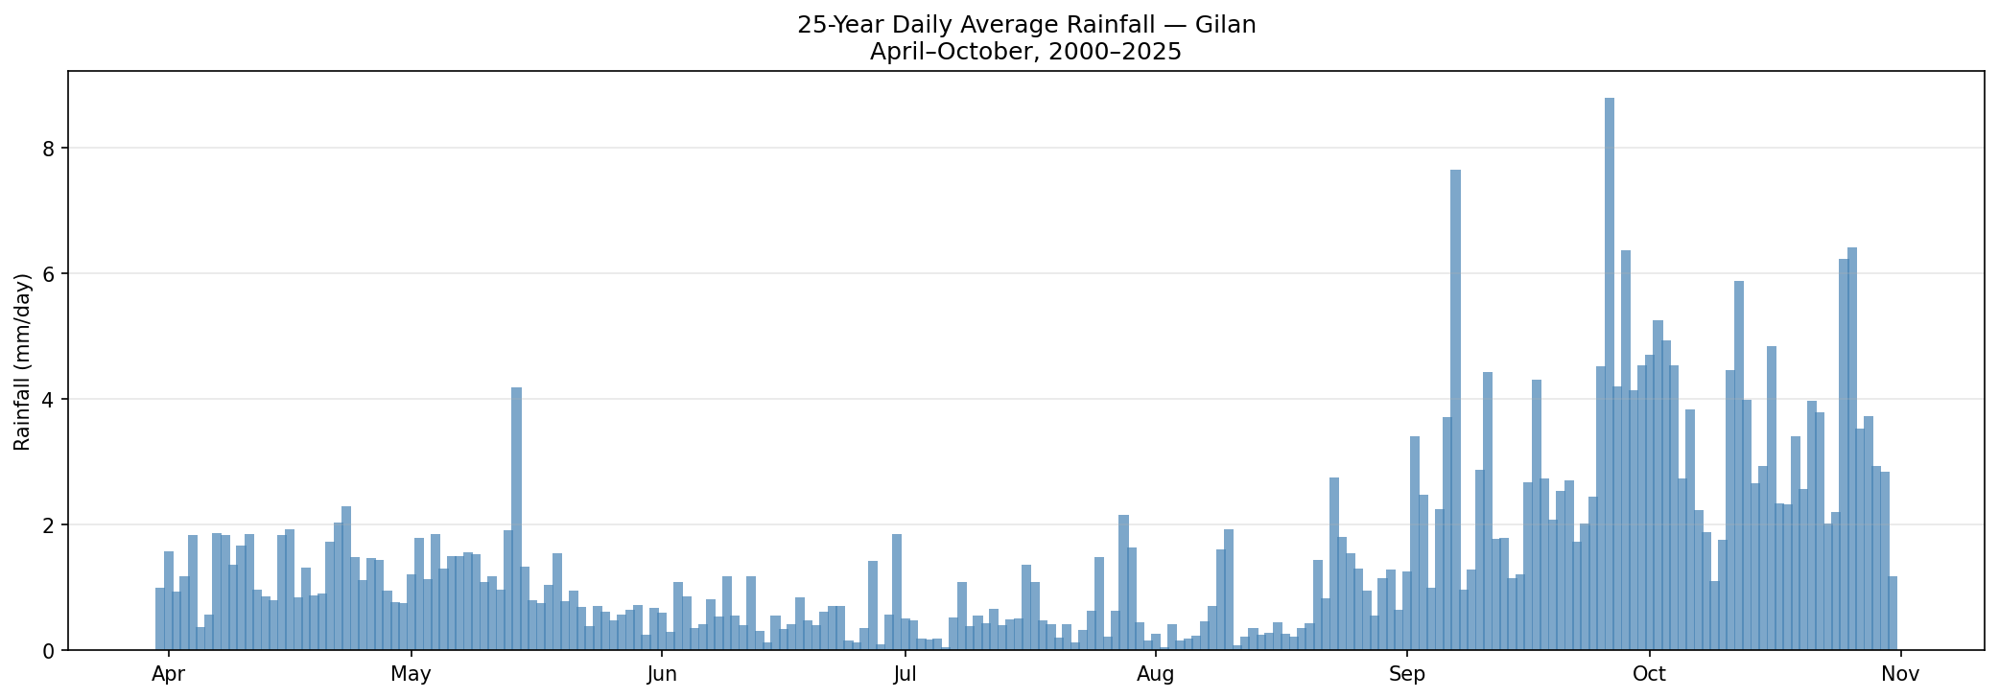
25-year daily average rainfall (April–October, 2000–2025).

Crop Parameterization
Two crops were selected: rice (Hashemi cultivar) and tobacco (Nicotiana tabacum). Both are commercially significant in Gilan [1, 3]. Their contrasting characteristics—high $K_{c}$/shallow roots/drought-sensitive rice versus moderate $K_{c}$/deep roots/drought-tolerant tobacco—enable evaluation of control algorithms under different agronomic conditions.

Rice (Hashemi Cultivar)

Base Temperature and Thermal Time
The base temperature $T_{\text{base}}={10}^{∘}$C follows the standard GDD convention [4, 5] and the baseline model [6]. The AquaCrop convention of 8$​^{∘}$C [20] produces proportionally higher GDD values without changing maturity dates.
The maturity threshold $θ_{18}=1250$ $​^{∘}$C$⋅$day was calibrated from the 25-year dataset and validated against Sadidi Shal et al. (2021), who measured 1216–1352 GDD for Hashemi rice in Gilan [7]. With a 20-day nursery contributing $∼$210 GDD (+5$​^{∘}$C greenhouse boost), 20/26 years reach maturity by August 20.

Season Window
Transplanting: May 20 (DOY 141), when 7-day rolling $T_{\text{mean}}≥{18}^{∘}$C and $T_{min}≥{12}^{∘}$C [8, 9].
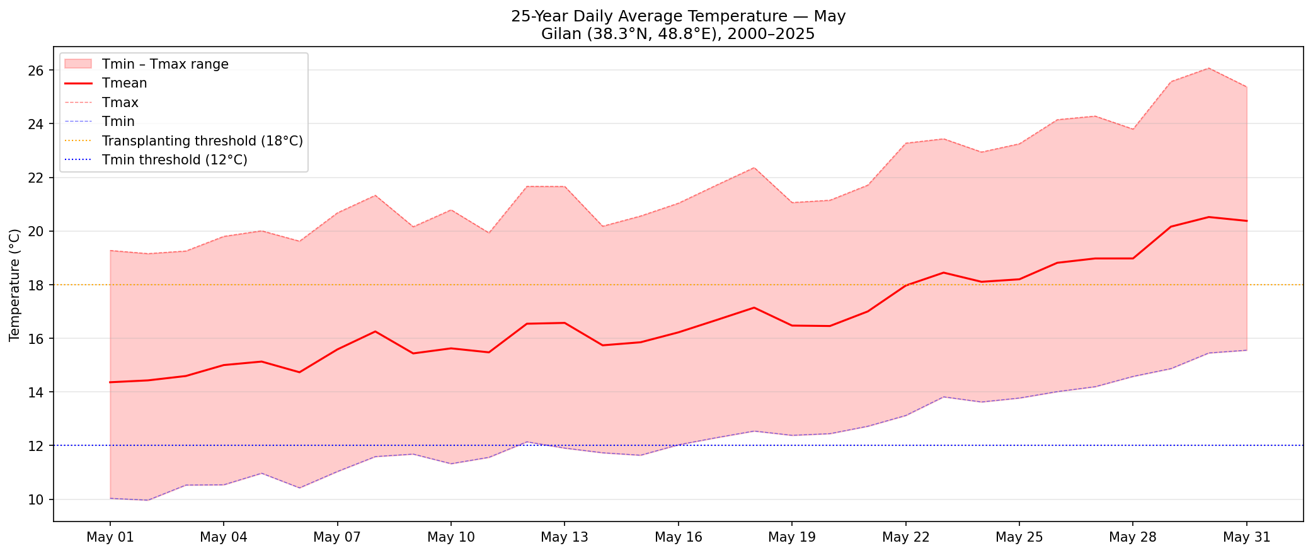
25-year average May temperature with transplanting thresholds.
Harvest: August 20 (DOY 233). WMO R20mm events ($≥$20 mm/day) [10] increase sharply after this date, causing lodging [10] and harvest disruption [11].
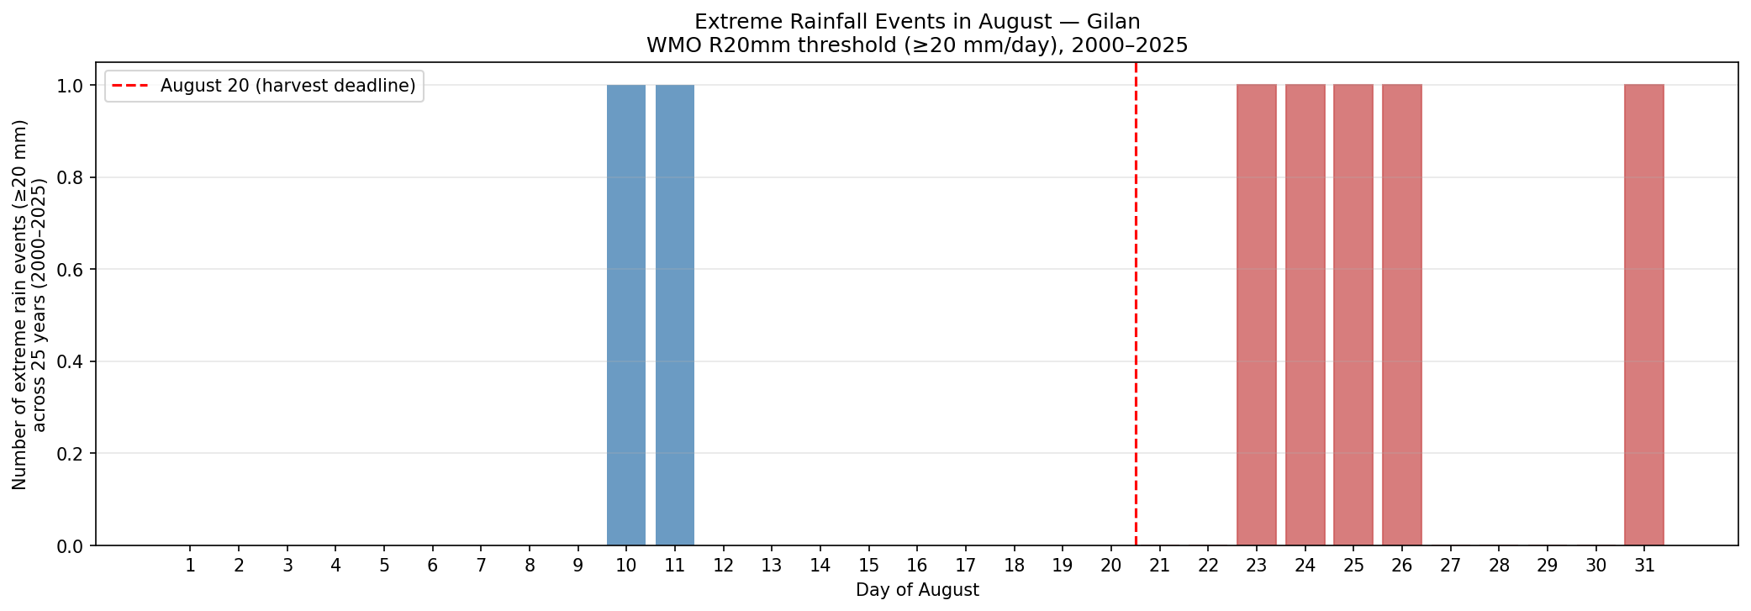
Extreme rainfall events ($≥$20 mm/day) per day of August, 2000–2025.
Field season: 93 days. Nursery provides $x_{2,\text{init}}=210$ GDD. Other parameters: $K_{c}=1.15$, $p=0.20$ [2], $θ_{5}=400$ mm, $θ_{13}=0.65$ g/MJ [12, 13], HI = 0.42 [14]. Expected yield: 3500–4000 kg/ha (optimized) or $∼$2000 kg/ha (traditional flooding, consistent with local farmer reports).

Tobacco (Nicotiana tabacum)

Base Temperature and Thermal Time
$T_{\text{base}}={10}^{∘}$C, within the 10–13$​^{∘}$C restriction range [15]. $θ_{18}=1200$ GDD (field only), calibrated to match the 104-day season. Duration consistent with FAO (90–120 days) [16] and Britannica (100–130 days) [17]. $x_{2,\text{init}}=0$ (nursery conditions unknown—seedlings delivered by company).

Season Window
Transplanting: May 25 (DOY 146). Harvest: September 5 (DOY 249). 104 field days.

Other Parameters
$θ_{5}=700$ mm (FAO: 500–1000 mm) [16]. $K_{c}=0.90$, $p=0.50$ [16]. $θ_{9}={30}^{∘}$C (FAO optimal ceiling) [15, 16]. $θ_{13}=0.30$ g/MJ [18], HI = 0.55. Expected yield: 2000–2500 kg/ha [16].

Parameter Summary
Complete crop and soil parameters.
Parameter | Symbol | Rice | Tobacco | Source
Shared soil parameters (silty loam)
Water uptake coeff. | $θ_{1}$ | 0.096 | 0.096 | [6]
Wilting point (vol.) | $θ_{2}$ | 0.15 | 0.15 | [2]
SCS threshold | $θ_{3}$ | 10 mm | 10 mm | [6]
Drainage coeff. | $θ_{4}$ | 0.05 | 0.05 | [6]
Field capacity (vol.) | $θ_{6}$ | 0.35 | 0.35 | [2]
Crop-specific parameters
Root depth | $θ_{5}$ | 400 mm | 700 mm | [2], [16]
Base temperature | $θ_{7}$ | 10$​^{∘}$C | 10$​^{∘}$C | [5], [15]
Heat stress onset | $θ_{9}$ | 35$​^{∘}$C | 30$​^{∘}$C | [16]
Extreme heat | $θ_{10}$ | 42$​^{∘}$C | 38$​^{∘}$C | –
RUE | $θ_{13}$ | 0.65 | 0.30 | [12], [18]
Drought sensitivity | $θ_{14}$ | 0.80 | 0.60 | [6]
Maturity GDD | $θ_{18}$ | 1250 | 1200 | [7], calib.
Max interception | $θ_{19}$ | 0.95 | 0.90 | [6]
50% intercept. GDD | $θ_{20}$ | 417 | 450 | [19]
Crop coefficient | $K_{c}$ | 1.15 | 0.90 | [2], [16]
Depletion fraction | $p$ | 0.20 | 0.50 | [2], [16]
Harvest index | HI | 0.42 | 0.55 | [14], [16]
Nursery GDD | $x_{2,\text{init}}$ | 210 | 0 | Calib.
Initial biomass | $x_{4,\text{init}}$ | 60 g/m$​^{2}$ | 8 g/m$​^{2}$ | Est.
Season | – | DOY 141–233 | DOY 146–249 | This study
Field days | – | 93 | 104 | –
FC | – | 140 mm | 245 mm | $θ_{6}×θ_{5}$
WP | – | 60 mm | 105 mm | $θ_{2}×θ_{5}$
TAW | – | 80 mm | 140 mm | FC $−$ WP
RAW | – | 16 mm | 70 mm | $p×$ TAW

Water Budget and Scenario Selection

Water Budget Formulation
Crop water demand: ${\text{ET}}_{c}=\overline{{\text{ET}}_{0}^{PM}}⋅K_{c}⋅N_{\text{days}}$. Full irrigation need: $I_{\text{full}}=max\left({\text{ET}}_{c}−\overline{P},0\right)$, using 25-year average rainfall (Method B).
Water budget summary.
 | Rice | Tobacco
Season duration | 93 days | 104 days
Avg ET$​_{0}$ (PM) | 5.02 mm/day | 4.95 mm/day
Crop demand | 537.0 mm | 463.4 mm
Avg season rainfall | 53.3 mm | 74.5 mm
Full irrigation need | 483.7 mm | 389.0 mm
Budget at 70% | 338.6 mm | 272.3 mm
Budget at 50% | 241.8 mm | 194.5 mm
Rice demand (537 mm) is consistent with Hashemi field measurements: 534 mm (SRI) to 632 mm (traditional flooding) [14]. Tobacco demand (463 mm) falls within the FAO range of 400–600 mm [16]. Despite a longer season, tobacco needs less irrigation due to lower $K_{c}$ and higher rainfall.

Scenario Selection
Selected climate scenarios.
Scenario | Year | Rice (mm) | Tobacco (mm)
Dry | 2022 | 39.7 | 54.0
Moderate | 2020 | 42.1 | 73.3
Wet | 2024 | 176.8 | 163.2

Agent-Based Model
The ABM follows López-Jiménez et al. [6]. Each of $N=130$ agents maintains: $x_{1}$ (soil water, mm), $x_{2}$ (thermal time, $​^{∘}$C$⋅$day), $x_{3}$ (maturity stress), $x_{4}$ (biomass, g/m$​^{2}$).

State Equations
Water balance:
$$x_{1}^{n}\left(k​+​1\right)=x_{1}^{n}\left(k\right)−φ_{1}^{n}−φ_{2}^{n}−φ_{3}^{n}−φ_{4,\text{out}}^{n}+φ_{4,\text{in}}^{n}+φ_{2,\text{in}}^{n}+P\left(k\right)+u^{n}\left(k\right)$$
Thermal time: $x_{2}^{n}\left(k+1\right)=x_{2}^{n}\left(k\right)+max\left(T_{\text{mean}}−θ_{7},0\right)$
Maturity stress: $x_{3}^{n}\left(k+1\right)=x_{3}^{n}\left(k\right)+θ_{11}\left(1−h_{2}\right)+θ_{12}\left(1−h_{3}^{n}\right)$
Biomass:
$$x_{4}^{n}\left(k​+​1\right)=x_{4}^{n}\left(k\right)+θ_{13}⋅h_{3}^{n}⋅h_{6}^{n}⋅h_{7}⋅g\left(x_{2}^{n}\right)⋅R_{s}\left(k\right)$$

Water Fluxes
$φ_{1}^{n}=min\left(max\left(θ_{1}\left(x_{1}^{n}−θ_{2}θ_{5}\right),0\right),{\text{ET}}_{0}\right)$ (transpiration)
$φ_{2}={\left(P−θ_{3}\right)}^{2}/\left(P+4θ_{3}\right)$ if $P>θ_{3}$, else 0 (SCS runoff)
$φ_{3}^{n}=θ_{4}⋅max\left(x_{1}^{n}+P−φ_{2}−θ_{6}θ_{5},0\right)$ (deep drainage)
$φ_{4,\text{out}}^{n}=max\left(x_{1}^{n}−θ_{6}θ_{5},0\right)$; φ4,inm=n∈Um​φ4,outn/Nrn (lateral flow)

Stress and Growth Functions
$h_{1}=max\left(T_{\text{mean}}−θ_{7},0\right)$; $h_{2}$: linear between $θ_{9}$ (no stress) and $θ_{10}$ (full stress); $h_{3}^{n}=1−θ_{14}⋅max\left(1−φ_{1}^{n}/{\text{ET}}_{0},0\right)$ (drought); $h_{6}^{n}=\text{clip}\left(1−\left(x_{1}^{n}−θ_{6}θ_{5}\right)/\left(θ_{6}θ_{5}\right),0,1\right)$ (waterlogging); $h_{7}=1$ if $T_{\text{mean}}>θ_{7}$, else 0.
Growth function:
$$g\left(x_{2}^{n}\right)=\left\{\begin{matrix}θ_{19}/\left(1+e^{−0.01\left(x_{2}^{n}−θ_{20}\right)}\right) & x_{2}^{n}≤θ_{18}/2 \\ θ_{19}/\left(1+e^{0.01\left(x_{2}^{n}+x_{3}^{n}−θ_{18}\right)}\right) & x_{2}^{n}>θ_{18}/2\end{matrix}\right.$$

Model Corrections and Extensions
Three corrections to the baseline [6] were implemented.

Mass Conservation
The original water balance includes $φ_{4,\text{in}}$ but omits $φ_{4,\text{out}}$, violating mass conservation. The corrected Eq. [eq:water] includes $−φ_{4,\text{out}}^{n}$.

Drought Stress on Biomass
The original biomass equation lacks $h_{3}$, so drought does not reduce biomass. The corrected Eq. [eq:biomass] includes $h_{3}^{n}$, reducing biomass by up to $θ_{14}×100\%$ under maximum drought (80% for rice, 60% for tobacco). This is essential for irrigation optimization: without it, the controller has no incentive to irrigate.

Surface Runoff Redistribution
Originally, $φ_{2}$ leaves the system. A simple redistribution was implemented: each agent’s runoff flows to lower neighbors with immediate infiltration ($φ_{2,\text{in}}^{n}$). A cascading alternative (top-to-bottom SCS re-application) was also tested.
Runoff redistribution comparison, no irrigation, wet scenario (2024).
Mode | Yield (kg/ha) | $x_{1}$ sinks (mm) | $x_{1}$ hills (mm)
None (original) | 2135 | 71.2 | 71.2
Simple (A) | 2273 | 74.8 | 72.0
Cascade (B) | 2278 | 79.5 | 72.0
Simple redistribution captures the first-order effect (6.5% yield improvement) with negligible difference from cascade (0.2%). Simple was adopted.
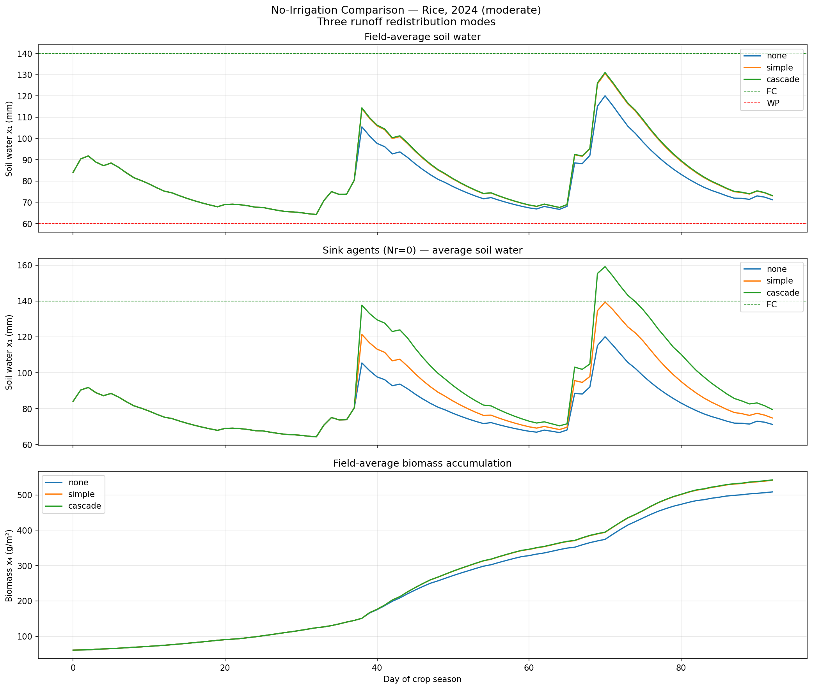
No-irrigation runoff mode comparison, wet scenario (2024).

Biomass Calibration
$θ_{13}$ was calibrated so $x_{4}$ represents g/m$​^{2}$ dry matter. Yield: $Y=x_{4}×\text{HI}×10$ (kg/ha). Rice: validated against $∼$2000 kg/ha (farmer reports) and 3500–4000 kg/ha (optimized) [14]. Initial conditions: rice $x_{2,\text{init}}=210$, $x_{4,\text{init}}=60$; tobacco $x_{2,\text{init}}=0$, $x_{4,\text{init}}=8$.

Model Validation

GWETROOT Cross-Validation
ABM soil water was compared to NASA MERRA-2 GWETROOT. Both normalized: ABM as $\left(x_{1}−\text{WP}\right)/\left(\text{FC}−\text{WP}\right)$; GWETROOT as native 0–1 fraction. Pearson correlation assessed temporal pattern agreement.
Cross-validation: ABM vs NASA GWETROOT.
Scenario | Year | Pearson $r$ | $p$-value
Dry | 2022 | 0.738 | $3.1×{10}^{−17}$
Moderate | 2020 | 0.534 | $3.4×{10}^{−8}$
Wet | 2024 | 0.337 | $9.6×{10}^{−4}$
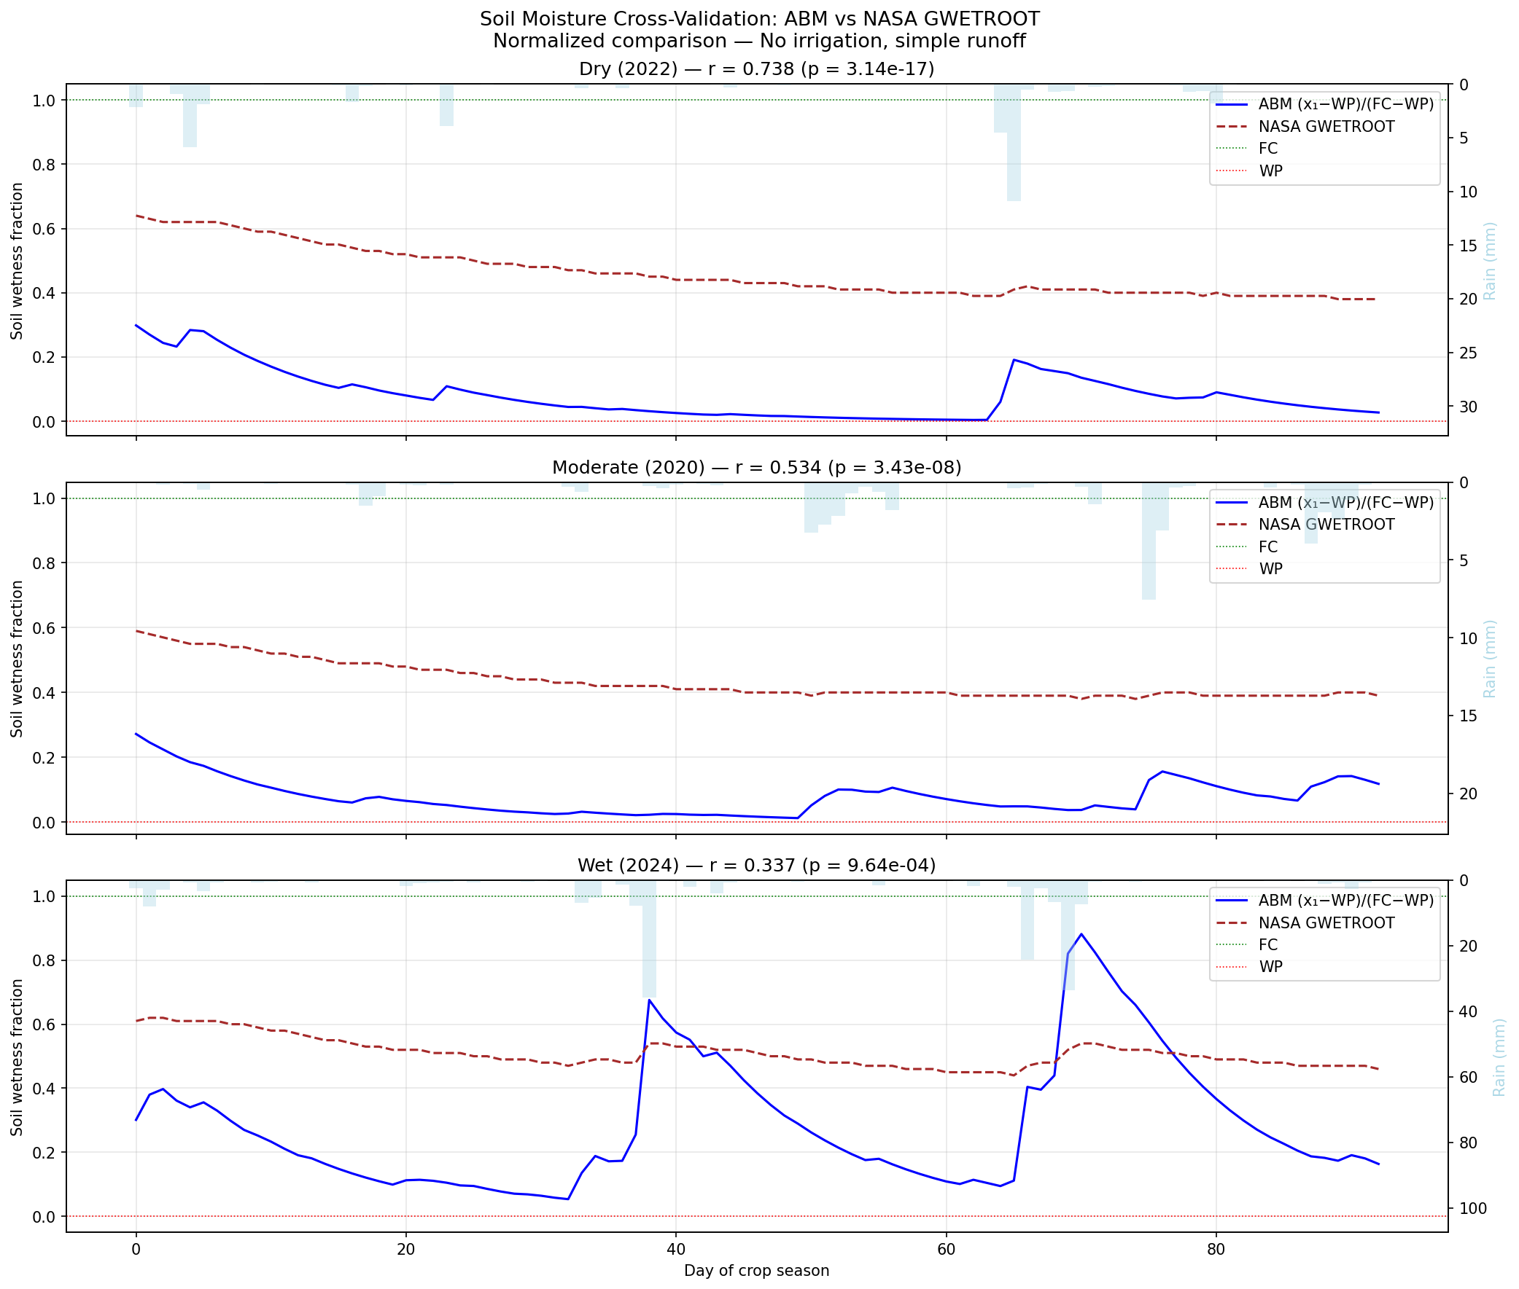
Normalized soil moisture: ABM (blue) vs NASA GWETROOT (brown).
The dry-year $r=0.74$ ($p<0.001$) confirms the ABM captures wetting/drying dynamics. Decreasing correlation with increasing rainfall is expected (reduced signal contrast in wet conditions). The absolute level difference (ABM $∼$0.08 vs GWETROOT $∼$0.46) reflects: (1) NASA’s deeper root zone ($∼$1000 mm vs 400 mm); (2) GWETROOT observes irrigated fields while the ABM simulates rain-fed conditions; (3) different soil parameterizations.

References
SurfIran, “Gilan’s rice fields,” 2025. Available: https://surfiran.com/mag/rice-transplantation-in-gilan-province/
R. G. Allen et al., “Crop evapotranspiration,” FAO Irrig. Drain. Paper 56, 1998.
“Tobacco,” Encyclopaedia Iranica. Available: https://www.iranicaonline.org/articles/tobacco/
G. S. McMaster and W. W. Wilhelm, “Growing degree-days,” Agric. For. Meteorol., vol. 87, pp. 291–300, 1997.
S. Laohasiriwong et al., “High temperature alters phenology in rice,” Plants, vol. 12, no. 3, p. 666, 2023.
A. López-Jiménez et al., “Agent-based MPC of soil-crop irrigation,” Control Eng. Pract., vol. 150, 2024.
S. M. T. Sadidi Shal et al., “GDD of Hashemi rice in Guilan,” J. Climate Res., vol. 1400(45), pp. 143–152, 2021.
P. Paredes et al., “Base and upper temperature thresholds for GDD,” Agric. Water Manag., vol. 319, 2025.
R. Faghani et al., “Planting date and seedling age effects on rice yield,” Afr. J. Biotechnol., 2011.
A. A. Sarma et al., “Adaptation of wetland rice to extreme weather,” 2018.
S. Nayak et al., “Extreme rainfall indices and rice productivity,” 2011.
S. R. Patel et al., “RUE in irrigated rice,” Paddy Water Environ., vol. 11, pp. 477–486, 2013.
V. O. Sadras and R. Trenchero, “Radiation use efficiency,” in Crop Physiology, Elsevier, 2021.
N. Jalali et al., “Water requirement of Hashemi rice,” Water Res. Agric., 2021.
Y. Y. Li et al., “Cold stress effects on tobacco,” BMC Plant Biol., vol. 21, p. 131, 2021.
FAO, “Crop information: Tobacco.” Available: https://www.fao.org/land-water/databases-and-software/crop-information/tobacco/en/
“Tobacco,” Encyclopaedia Britannica, 1999.
R. Ferrara, “RUE in flue-cured tobacco,” Field Crops Res., 2002.
Y. Zhang et al., “LAI simulation of tobacco,” Chin. J. Eco-Agric., 2017.
R. S. Raoufi et al., “Climate changes and rice cultivation,” Int. J. Plant Prod., 2025.
TasteIran, “Iran rice harvesting.” Available: https://www.tasteiran.net/stories/10/iran-rice-harvesting

Supplementary Climate Figures
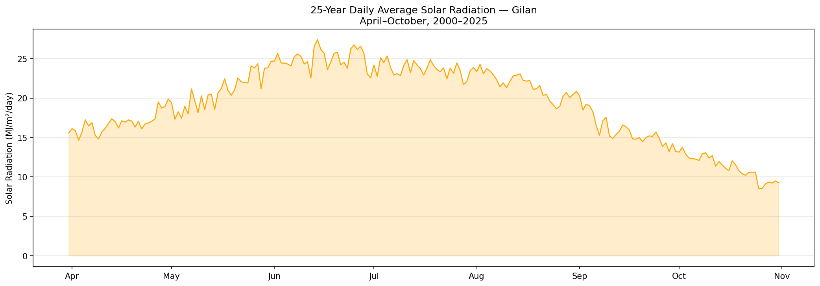
25-year daily average solar radiation, April–October.
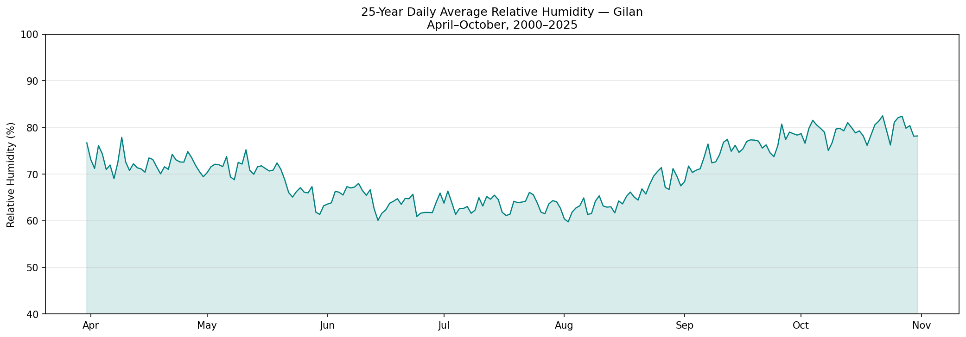
25-year daily average relative humidity, April–October.
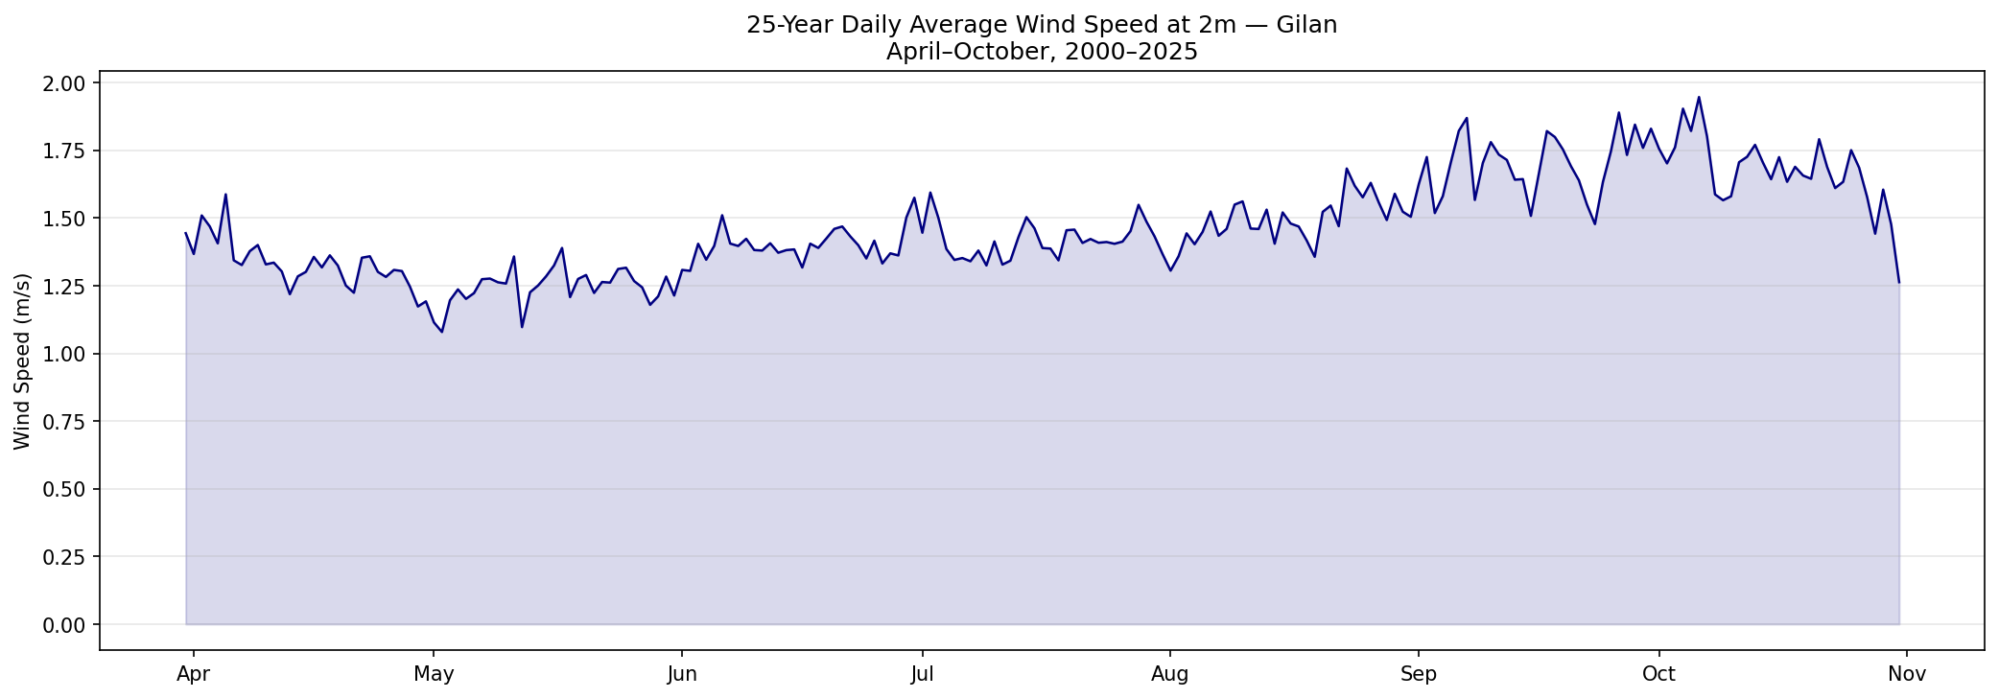
25-year daily average wind speed, April–October.
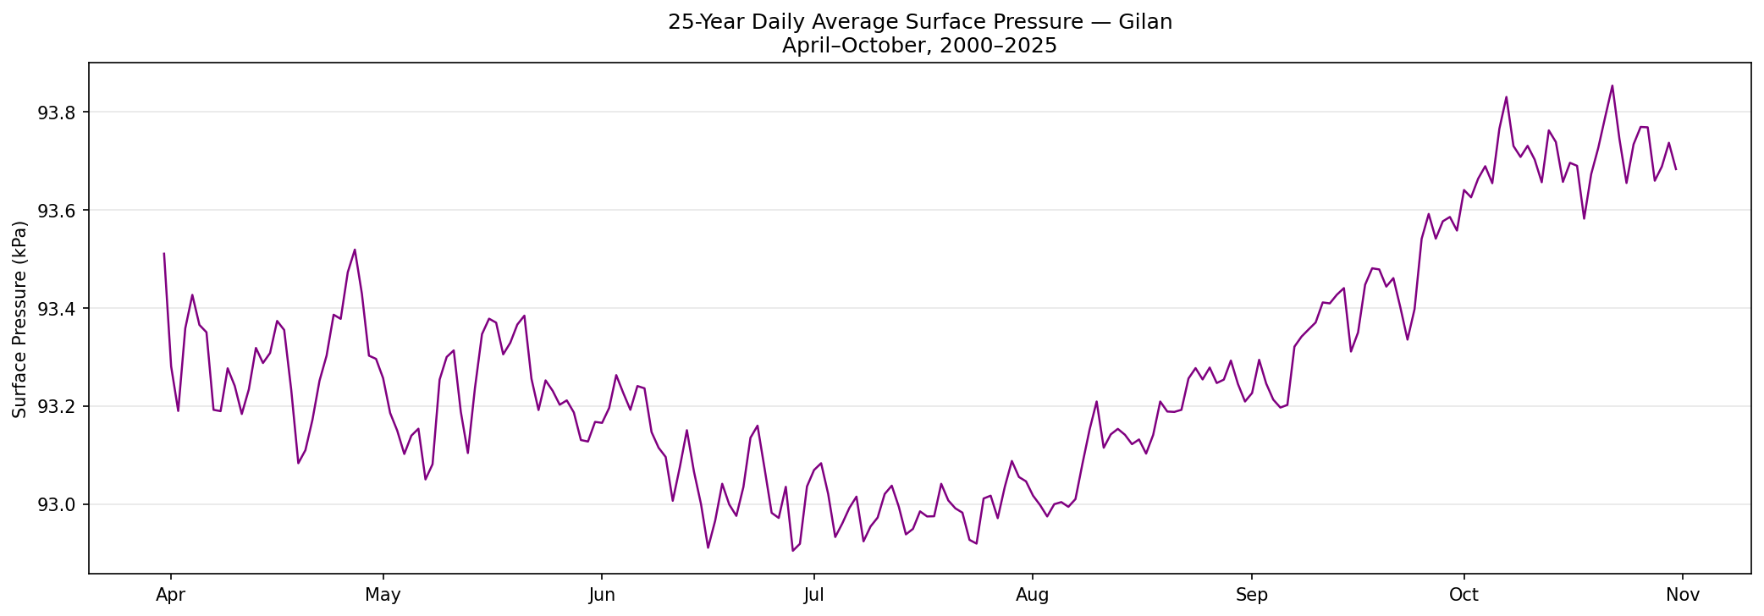
25-year daily average surface pressure, April–October.
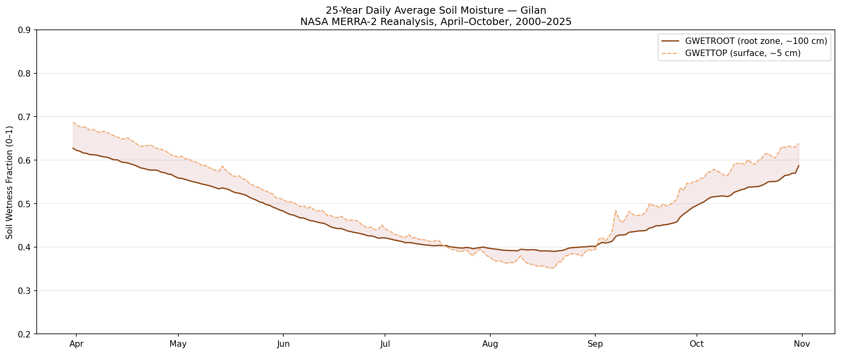
25-year daily average NASA MERRA-2 soil wetness, April–October.
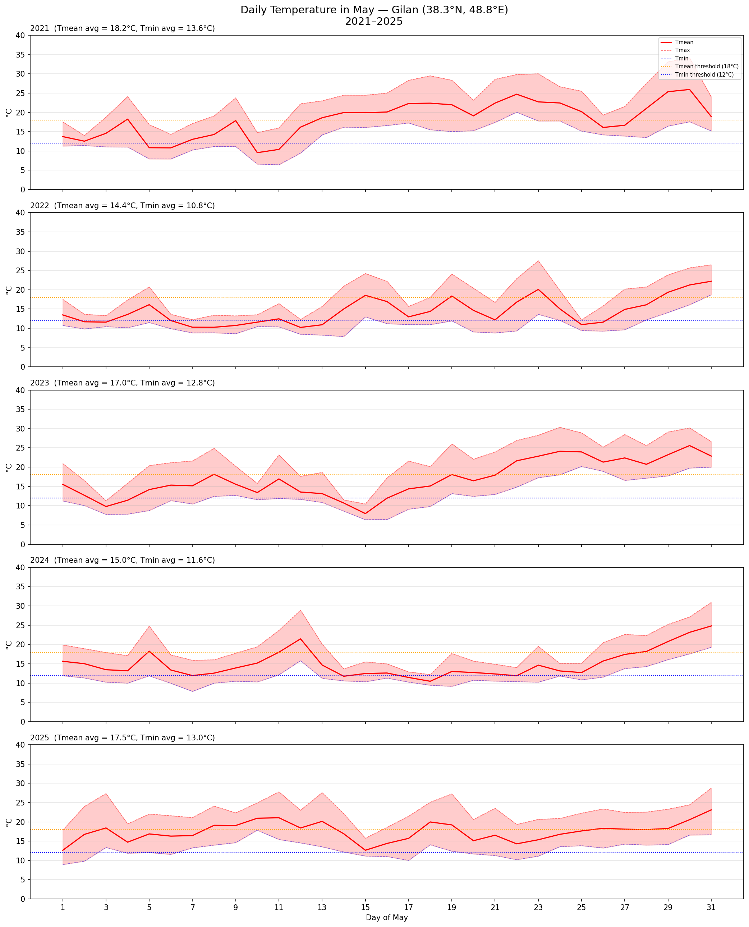
Daily temperature in May for 2021–2025.
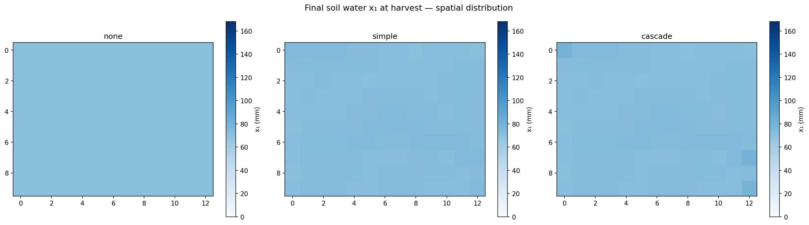
Spatial distribution of $x_{1}$ at harvest, three runoff modes, wet scenario (2024).
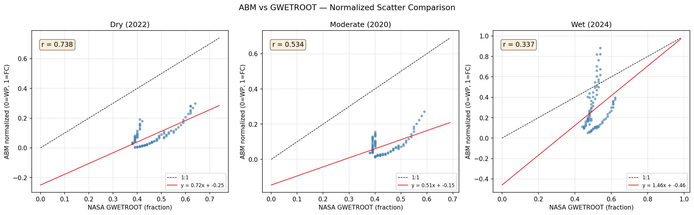
Scatter plots: ABM vs NASA GWETROOT for three scenarios.

