Tereza Prochazkova
t_p111@student.usc.edu.au
Student ID: 1173943
Campus: Sippy Downs
Tutor’s name: Andrew Lang
Due date: 20/09/2026
Submission date: 21/09/2026
Word Count: 1,120
Task 2 – Redis Database for TrailHire
ICT 320: Database Programming

Table of Contents
1 Introduction 1
2 System Design 1
2.1 Flask Endpoints 1
2.2 Front-End Web Design 1
2.3 Roles 1
Customer 2
Admin 2
System (Logs) 2
2.4 Design Decisions and Justification 2
2.5 Database Schema 4
Authentication 4
Equipment 4
User Rentals 4
Logs 4
Indexing 4
3 Testing 4
4 Future 5
5 Conclusion 5
AI Statement 6
Appendices 7
Appendix A – Redis Database Schema 7

Introduction
While traditional databases can handle thousands of queries per second, Redis can deliver sub-millisecond response times, making it ideal for rapidly growing markets where response times and scalability are key. TrailHire is a web-based outdoor equipment rental management system that allows customers to create an account and browse, select, and manage rental inventory. Building this system with time optimisation in mind, utilising Redis’ efficiency will provide immense benefits if implemented correctly.

System Design
In addition to Redis at the database layer, this system uses Python for the application layer and Flask + HTML/CSS for the presentation layer.

Flask Endpoints
Flask creates a connection between the frontend and back-end by establishing API endpoints; these are:
- / – default route for any undefined endpoints or when the user is not logged in
- /auth/signup – sign-up form
- /auth/login – login form
- /auth/reset – reset password form
- /logout – logs out the user
- /catalogue – displays equipment
- /user/rentals – displays rental list for the logged-in user
- /rentals/add – adds equipment to the rental list
- /rentals/remove – removes the equipment
- /admin/equipment (WIP) – views equipment controls
- /admin/users (WIP) – views user controls

Front-End Web Design
The web design uses basic HTML elements and utilises Flask’s features to generate and render dynamic items, such as equipment in the catalogue. I reused the components and CSS stylesheet from my pre-established design system (https://ds.tarcies.dev). Although the CSS is large, the website loads it only once, so it has no significant impact on performance.

Roles
The system currently supports the user and system roles, with the admin role functions created but not implemented.

Customer
Regular customers who sign up using the sign-up form and, after successfully logging in, can view the catalogue and rent in-stock equipment for a period of time. They can then view their rental list and see a quick, easy overview of their rented items, including the quantity and rental days. From this, the system calculates and displays the total rental price and provides a button to return the rental. Each rental item also displays the return date and remaining days, highlighted in red as a visual reminder of the upcoming return date.

Admin
In the future, the system will also offer administrative operations. These are already implemented on the application and database layers but are yet to be integrated into the presentation layer. This role will allow the owners of TrailHire (or any of their administrative staff) to view and control other user accounts, including viewing their rentals and granting administrative privileges, as well as control and modify equipment (adding new equipment, modifying their properties, such as stock or price, or removing them).

System (Logs)
This role handles logging functions by collecting information on user and admin events when appropriate. These include:
- Signup
- Login
- Password reset
- Rent equipment
- Return equipment
- Admin actions
  - Add/modify/remove equipment
  - Add/remove administrative privileges
  - Access/control/delete user accounts
- And any errors during any process
These logs include the actor’s email, resulting state (success/fail), details, the actor's IP address, and any system errors.

Design Decisions and Justification
While designing the system, I have made several key design decisions to optimise performance and maintainability.
For the database schema, I chose hashes over strings; in Redis, fetching either has O(1) time complexity, and with hashes we can fetch one or N specified fields, so the difference is negligible.
The main source of inefficiency in Redis is the number of callbacks (fetches), which can create significant delays, such as when fetching an entire equipment catalogue. To address this, we use pipelines to batch our queries and execute them at once, with the added benefit of atomic operations that prevent partial updates if crashes occur during the process.
We use pipelines with temporary variables to locally store the current user and their details, as well as the catalogue and the user’s rentals. This lets us send data to Redis while fetching it only when necessary. For example, we load the catalogue once and store it in a local dictionary; when a user rents equipment, we send a stock update to Redis and our local dictionary, then fetch the rental data from that dictionary.
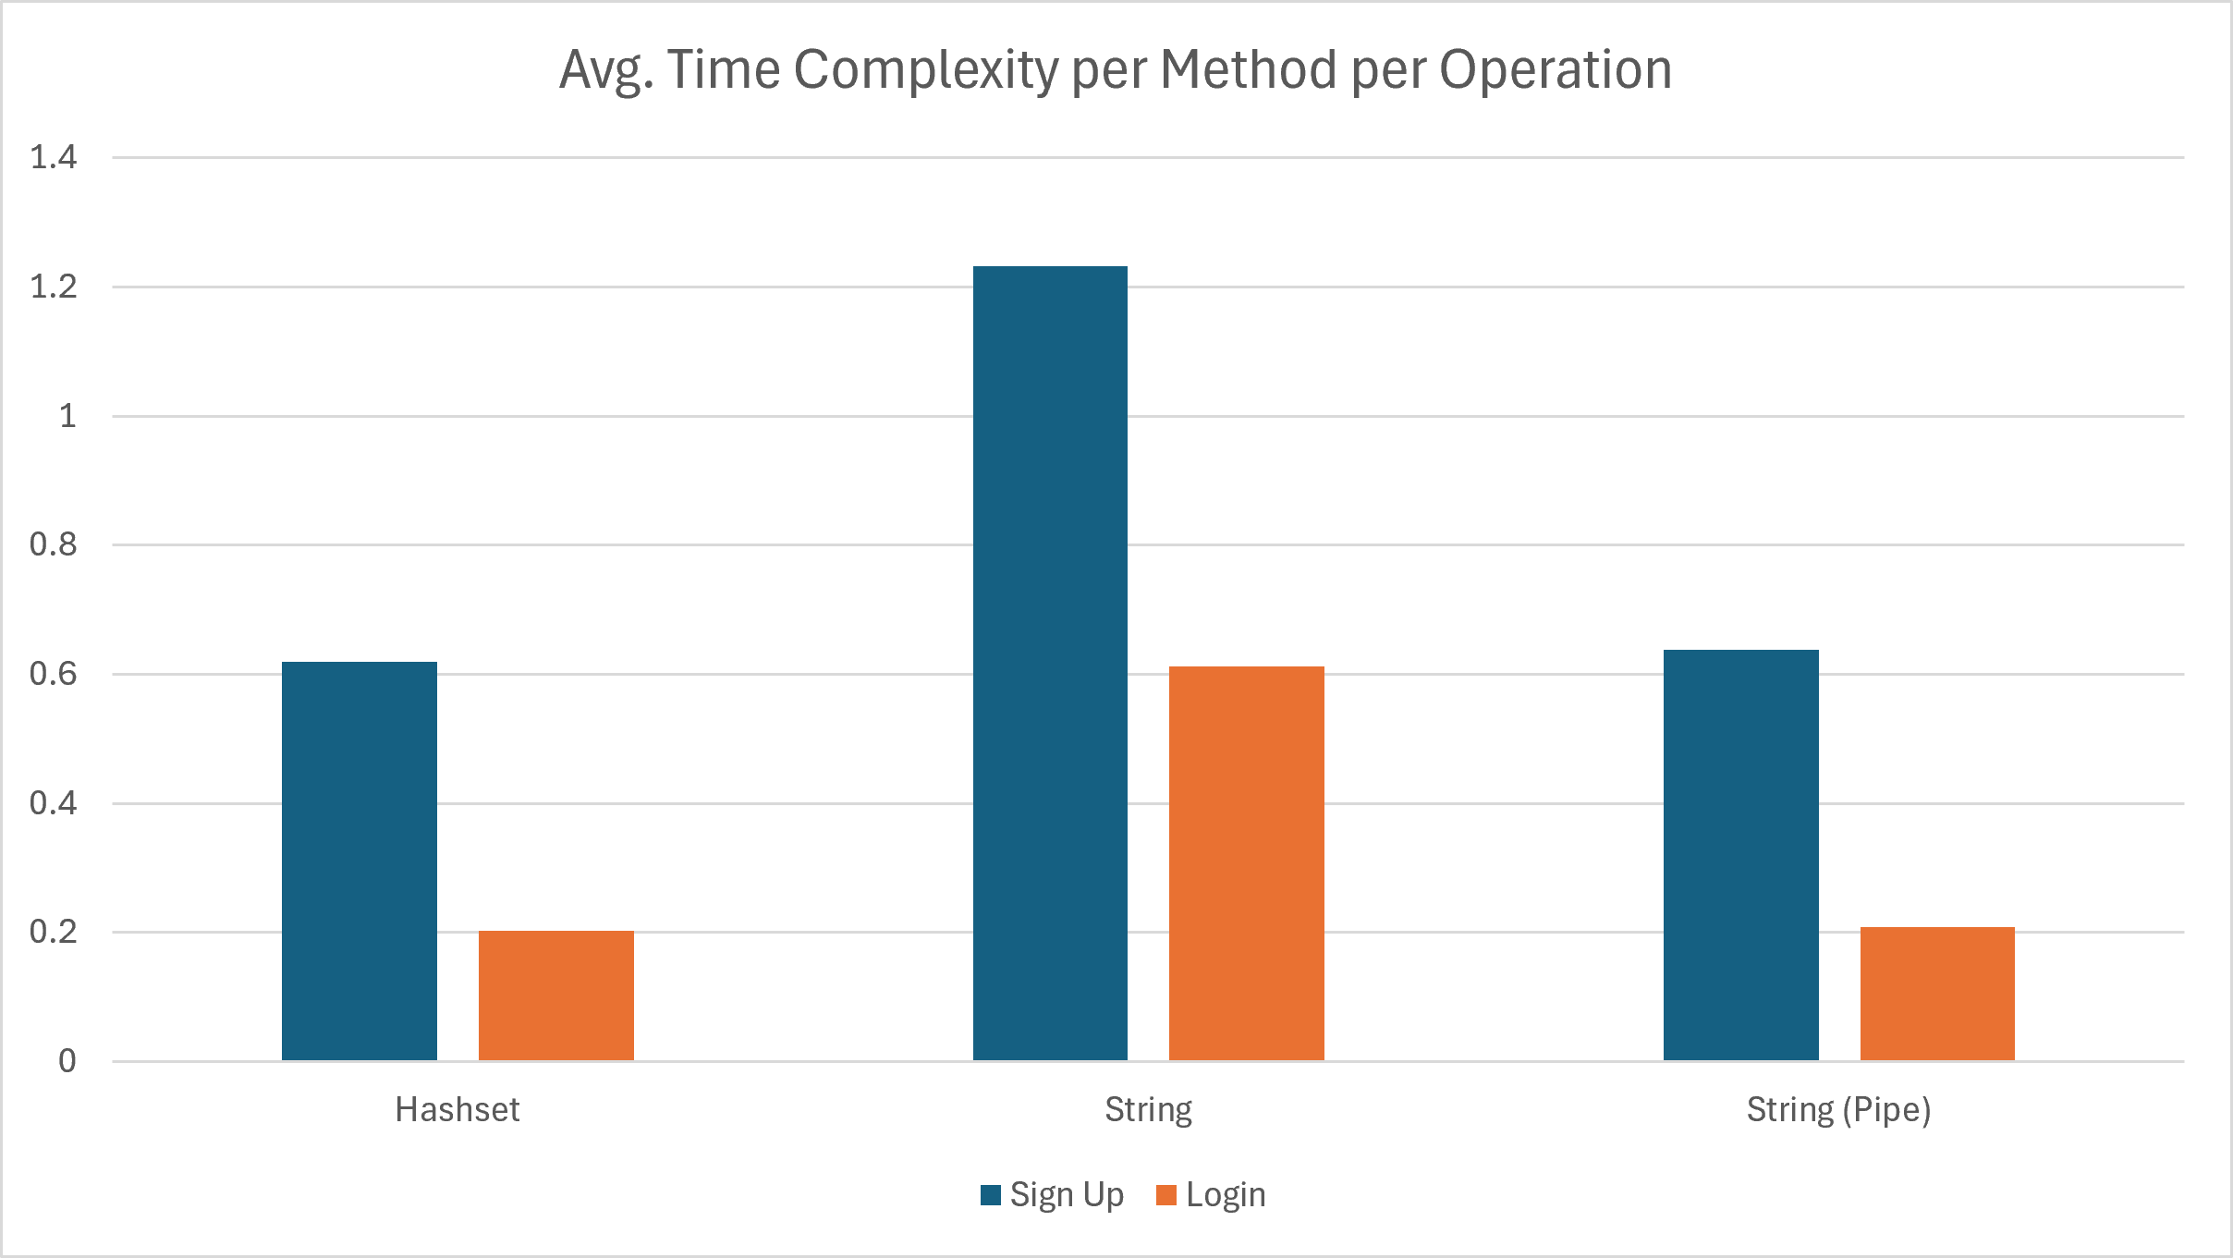
We also use indices for objects such as users, equipment, and admins to provide a concise set of identifier values (IDs/emails), allowing us to fetch all identifiers or quickly check whether someone is a member of a group. This also includes a sorted set of rentals that stores only the user, rental ID, and expiry date, which can later support a quick overview of rental status, expiry alerts, and a notification system.
To enhance security, passwords and security answers are stored as salted bcrypt hashes, ensuring that exfiltrated data cannot be exploited. Additionally, error responses do not include error stacks to avoid revealing the system’s business logic, and responses are generic to prevent enumeration attacks (e.g., ‘invalid credentials’ instead of ‘incorrect email’ or ‘incorrect password’).

Database Schema
Also see Appendix A.

Authentication
- Key: auth:{email} – (HASH)
- Fields: name, pass, secQ, secA, creAt

Equipment
- Key: equipment:{id} – (HASH)
- Fields: name, desc, price, stock, creAt

User Rentals
- Key: user:{email}:rentals – (HASH)
- Fields: {rentalId}: “equipmentId|qty|rentedAt|expiresAt”

Logs
- Key: logs:{email} – (LIST)
- Fields: {index}: “timestamp|action|value|details,ip”

Indexing
- users:all (SET): All registered user emails
- equipment:all (SET): All equipment IDs
- admins (SET): Admin user emails
- security:questions (SET): Pool of security questions

Testing
The program also includes a set of unit and integration tests to verify all the important features, which include:
- CSV loading
- Login (correct & wrong password)
- Catalogue fetching
- Add rental
- View rentals
- Stock management
- Multiple rentals (same equipment, different dates)
- Remove rental
- Stock restoration
- Admin promotion
- Signup
- Duplicate signup rejection
Additionally, anyone can manually test the system via the web interface.
Note: I built this test function with AI at the end of development because I didn't have enough time to write it myself.

Future
Before deployment, TrailHire must establish and integrate a payment gateway, such as Stripe, to handle rental payments and deposits.
Additional features may include an automated notification system for near-expiry rentals, equipment damage reporting to track damage and insurance claims, and advanced filters for category, price range, or ratings (which could be another feature).
The application can also be enhanced by implementing administrative accounts, stronger security practices and edge-case protection (including penetration testing), monitoring to track and detect bottlenecks or optimisation opportunities, and geographical replicas for redundancy and high availability.
Lastly, the system currently updates the fetched catalogue only once for optimisation; this would need to change for production, as it could cause race conditions or outdated data.

Conclusion
In conclusion, this project delivers a web application MVP that lets customers browse the catalogue, rent equipment, and manage and track their rentals. The outcome demonstrates Redis's time-efficiency advantages over traditional relational databases and its easy integration with Python code, encapsulated in a Flask-based web application. Overall, this has been a great learning experience.

AI Statement
I used Claude in this project to help me learn Flask, generate sample data, create a test function, and generate function docstrings.
  - Flask Technical Spike
Prompt: “What can you tell me about Flask? How does it work? How does it integrate with Python? What libraries do I need? What are templates and blocks? Include some generic code examples”
Output: “Flask is a lightweight, flexible web framework for building web applications in Python. It's known for being "micro" — meaning it provides just the essentials (routing, request handling, templates) without forcing you into a specific structure or bundling unnecessary features.” + comprehensive guide, generic implementation and code snippets
  - Sample Data
Prompt: “Can you help me create sample data based on the included headers? Add at least 4 users, 1 admin, 12 equipment, 6 questions + some rentals” + xlsx file with header fields
Output: “Let me create comprehensive sample data based on the provided schema.” + 4 CSV files with sample data
  - Test Function
Prompt: “Based on this Python file, can you give me a test function?” + app.py
Output: “Here's a comprehensive test function based on your app:” + def testSystem()
  - Docstrings
Prompt: “Can you add docstrings for the functions where appropriate? Don't modify the actual code” + app.py
Output: “Here’s the updated file with newly added docstrings:” + app.py with docstrings

Appendices

Appendix A – Redis Database Schema
