naiveBayes_cross_v_3_R_3_EFD_seeds

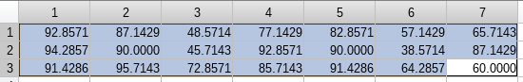
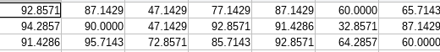

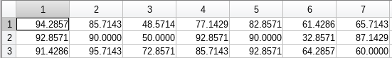

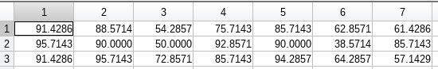
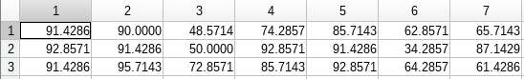

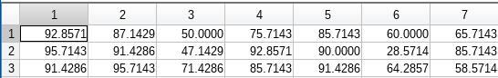
esse ultimo corresponde ao resultado abaixo

======= Atributos Relevantes ==========
Grupo 1: area
Grupo 2: area Lkernel
Grupo 3: perimetro
======= ================== ===========

===== Faixas dos Atributos por GRUPO =====

GRUPO 1
area = [10.590000 ~ 12.780000] ]12.780000 ~ 16.140000] ]16.140000 ~ 21.180000]
perimetro = [12.410000 ~ 13.730000] ]13.730000 ~ 15.180000] ]15.180000 ~ 17.250000]
compacteness = [0.808100 ~ 0.860900] ]0.860900 ~ 0.882900] ]0.882900 ~ 0.918300]
Lkernel = [4.899000 ~ 5.357000] ]5.357000 ~ 5.826000] ]5.826000 ~ 6.675000]
wkernel = [2.630000 ~ 3.049000] ]3.049000 ~ 3.465000] ]3.465000 ~ 4.033000]
asymetry = [0.765100 ~ 2.936000] ]2.936000 ~ 4.334000] ]4.334000 ~ 8.456000]
lkgroove = [4.519000 ~ 5.150000] ]5.150000 ~ 5.791000] ]5.791000 ~ 6.550000]

GRUPO 2
area = [10.590000 ~ 12.780000] ]12.780000 ~ 16.140000] ]16.140000 ~ 21.180000]
perimetro = [12.410000 ~ 13.730000] ]13.730000 ~ 15.180000] ]15.180000 ~ 17.250000]
compacteness = [0.808100 ~ 0.860900] ]0.860900 ~ 0.882900] ]0.882900 ~ 0.918300]
Lkernel = [4.899000 ~ 5.357000] ]5.357000 ~ 5.826000] ]5.826000 ~ 6.675000]
wkernel = [2.630000 ~ 3.049000] ]3.049000 ~ 3.465000] ]3.465000 ~ 4.033000]
asymetry = [0.765100 ~ 2.936000] ]2.936000 ~ 4.334000] ]4.334000 ~ 8.456000]
lkgroove = [4.519000 ~ 5.150000] ]5.150000 ~ 5.791000] ]5.791000 ~ 6.550000]

GRUPO 3
area = [10.590000 ~ 12.780000] ]12.780000 ~ 16.140000] ]16.140000 ~ 21.180000]
perimetro = [12.410000 ~ 13.730000] ]13.730000 ~ 15.180000] ]15.180000 ~ 17.250000]
compacteness = [0.808100 ~ 0.860900] ]0.860900 ~ 0.882900] ]0.882900 ~ 0.918300]
Lkernel = [4.899000 ~ 5.357000] ]5.357000 ~ 5.826000] ]5.826000 ~ 6.675000]
wkernel = [2.630000 ~ 3.049000] ]3.049000 ~ 3.465000] ]3.465000 ~ 4.033000]
asymetry = [0.765100 ~ 2.936000] ]2.936000 ~ 4.334000] ]4.334000 ~ 8.456000]
lkgroove = [4.519000 ~ 5.150000] ]5.150000 ~ 5.791000] ]5.791000 ~ 6.550000]

===== Faixas dos Atributos que mais se repetem por GRUPO =====

Grupo : 1
Atributo Faixa Qtd_Rep
area 2 56
perimetro 2 56
compacteness 2 33
Lkernel 2 49
wkernel 2 52
asymetry 1 45
lkgroove 1 42

Grupo : 2
Atributo Faixa Qtd_Rep
area 3 64
perimetro 3 63
compacteness 3 34
Lkernel 3 64
wkernel 3 60
asymetry 2 29
lkgroove 3 61

Grupo : 3
Atributo Faixa Qtd_Rep
area 1 62
perimetro 1 65
compacteness 1 51
Lkernel 1 56
wkernel 1 61
asymetry 3 45
lkgroove 1 41

===== RESULTADO =====

Grupo #Elem Atributo Faixa_Min~Faixa_Max Acerto Erros #Tx_Erros
1 70 area [12.780000 ~ 16.140000] 56 14 20.000000
2 70 area [16.140000 ~ 21.180000] 64 6 8.571429
2 70 Lkernel [5.826000 ~ 6.675000] 64 6 8.571429
3 70 perimetro [12.410000 ~ 13.730000] 65 5 7.142857>>

