**PRACTICE 5**

**(PART B)**

**DISCRETE-TIME FOURIER TRANSFORM (DTFT)**

**OBJECTIVE:**

Calculate the DT Fourier Transform of nonperiodic sequences x[n].

|  |  |
| --- | --- |
| **Name 1:** | Alejandro Serrano López |
| **Name 2:** | Mihnea-Iulian Popescu |

1. **Discrete-time Fourier Transform of non-periodic sequences x[n]**

Given a summable sequence x[n], the DT Fourier Transform of x[n] is defined as:

$$F\left(x[n]\right)=X(ω)=\sum_{n=-∞}^{∞}{x[n]e^{-iωn}}$$

and the inverse DT Fourier Transform of $X(ω)$ is:

$$F^{-1}\left(X\left(ω\right)\right)=x[n]=\frac{1}{2π}\int_{-π}^{π}{X(ω)e^{iωn}dω}$$

This following MATLAB script let you calculate the DT Fourier Transform of a rectangular pulse:

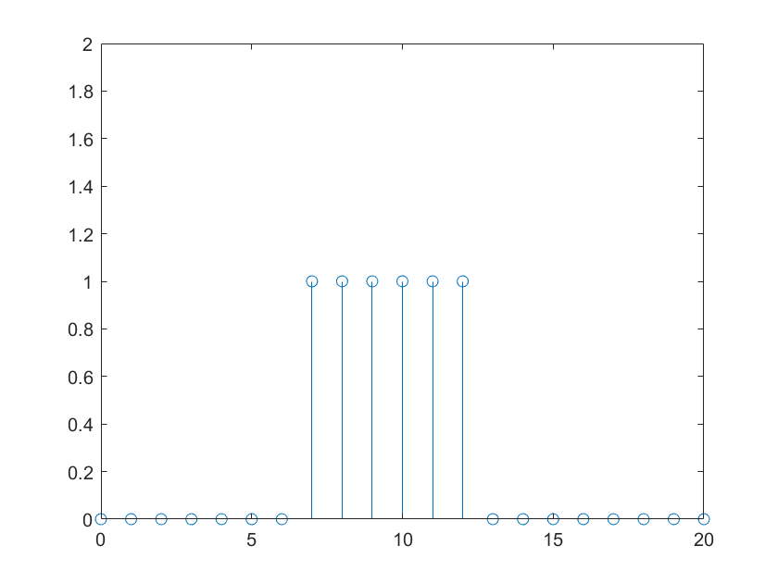

% DT Fourier Transform of a rectangular pulse

[x,n] = rectan(7,12,0,20);

axis([0,20,0,2])

syms w

F(w)= sum(x.*exp(-1i*w*n));

disp('DT Fourier Transform: ')

F(w)

subplot(2,1,1)

fplot(abs(F),[-3*pi,3*pi])

subplot(2,1,2)

fplot(angle(F),[-3*pi,3*pi])

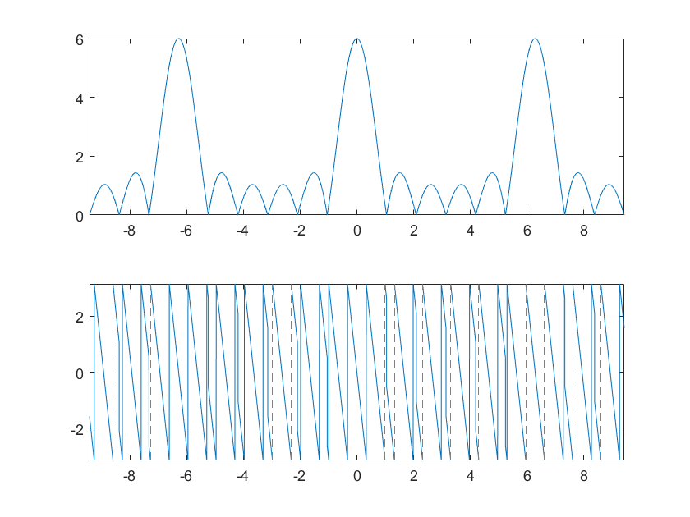

1. Define a MATLAB function that obtains the symbolic **DT Fourier Transform** of a sequence x[n] and plot the $F\left(x[n]\right)=F(ω)$ in the interval [$-π,π$] (both module and phase).

function [F] = MyDTFT(x,n)

|  |
| --- |
| **MyDTFT.m** |
| **function [F] = MyDTFT(x,n)**    syms w  ni = n(1);  nf = n(end);  %axis([ni,nf,0,2])  F(w)= sum(x.*exp(-1i*w*n));  %F(w)=simplify(F(w));  disp('DT Fourier Transform: ')  F(w)  subplot(2,1,1); fplot((real(F).^2 + imag(F).^2).^(1/2),[-pi,pi]) % no reconoce las abs(F) para este caso, de forma extraña, probamos la definición  subplot(2,1,2); fplot(phase(F),[-pi,pi]) %angle(F)  **end** |

1. Use the previous MATLAB function to calculate **the DT Fourier Transforms** of the following sequences:

**SAMPLED TRIANGULAR PULSE in the interval [-5,5] with sample period T=0.2**

A=3; a=3; syms t

x1(t)=(A+(A/a)*t)*(heaviside(t+a)-heaviside(t))+(A-+(A/a)*t)*(heaviside(t)-heaviside(t-a));

fplot(x1,[-5,5])

|  |  |
| --- | --- |
| **PLOT x(t) in [-5,5]**  **CONTINUOUS SIGNAL** | **PLOT X($Ω$) in [-10,10]**  **USING MYFOURIER** |
|  | **cf1 = MyFourier(x1,-10,10)** |
| **PLOT sampled x(t) in [-5,5]** | **PLOT X(w) in [-pi,pi]** |
| t = -5:0.2:5;  stem(t,x1(t))  THIS IS NOT REALLY A SEQUENCE, IT IS ONLY SAMPLED    stp=x1(t);  n=-25:25; % -5/0.2 = 25 because n needs to be an integer  stem(n,stp) | F = MyDTFT(stp,n); |

**SAMPLED EXPONENTIAL FUNCTION in the interval [-5,5] with sample period T=0.3**

syms t; A=3; b=1;

x(t) = A*exp(-b*abs(t));

fplot(x,[-5,5])

|  |  |
| --- | --- |
| **PLOT x(t) in [-5,5]** | **PLOT X($Ω$) in [-10,10]** |
|  | **cf2 = MyFourier(x,-10,10)**   |
| **PLOT sampled x(t) in [-5,5] and x[n]** | **PLOT X(w) in [-pi,pi]** |
| t = -5:0.3:5;  stem(t,x(t))**   | F = MyDTFT(stp,n);  ans =    3*exp(-1/5) + 3*exp(w*1i)*exp(-1/2) + 3*exp(-w*4i)*exp(-1) + 3*exp(w*6i)*exp(-2) + 3*exp(-w*2i)*exp(-2/5) + 3*exp(w*2i)*exp(-4/5) + 3*exp(-w*1i)*exp(-1/10) + 3*exp(w*4i)*exp(-7/5) + 3*exp(-w*9i)*exp(-5/2) + 3*exp(-w*14i)*exp(-4) + 3*exp(-w*6i)*exp(-8/5) + 3*exp(-w*3i)*exp(-7/10) + 3*exp(w*11i)*exp(-7/2) + 3*exp(w*16i)*exp(-5) + 3*exp(w*3i)*exp(-11/10) + 3*exp(-w*8i)*exp(-11/5) + 3*exp(w*8i)*exp(-13/5) + 3*exp(-w*5i)*exp(-13/10) + 3*exp(-w*10i)*exp(-14/5) + 3*exp(w*10i)*exp(-16/5) + 3*exp(w*5i)*exp(-17/10) + 3*exp(-w*12i)*exp(-17/5) + 3*exp(-w*7i)*exp(-19/10) + 3*exp(w*12i)*exp(-19/5) + 3*exp(w*7i)*exp(-23/10) + 3*exp(w*14i)*exp(-22/5) + 3*exp(-w*16i)*exp(-23/5) + 3*exp(w*9i)*exp(-29/10) + 3*exp(-w*11i)*exp(-31/10) + 3*exp(-w*13i)*exp(-37/10) + 3*exp(w*13i)*exp(-41/10) + 3*exp(-w*15i)*exp(-43/10) + 3*exp(w*15i)*exp(-47/10) + 3*exp(-w*17i)*exp(-49/10)  Gráfico, Gráfico de líneas  Descripción generada automáticamente |

**SAMPLED FORCED OSCILLATION in the interval [0,5] with sample period T=0.1**

syms t; b=1; w0=6;

x(t) = exp(-b*t).*cos(w0*t).* heaviside(t);

fplot(x,[0,5])

|  |  |
| --- | --- |
| **PLOT x(t) in [0,5]** | **PLOT X($Ω$) in [-10,10]** |
|  | **cf3 = MyFourier(x,-10,10)**   |
| **PLOT sampled x(t) in [0,5] and x[n]** | **PLOT X(w) in [-pi,pi]** |
| t = 0:0.1:5;  stem(t,x(t))**   | F = MyDTFT(stp,n);   |

**SAMPLED COSINE FUNCTION in the interval [-5,5] with sample period T=0.2**

syms t

w0=6;

x(t) = cos(w0*t);

fplot(x,[-5,5])

|  |  |
| --- | --- |
| **PLOT x(t) in [-5,5]** | **PLOT X($Ω$) in [-10,10]** |
|  | **Cf4 = MyFourier(x,-10,10)**  **F(w) =**    **pi*(dirac(w - 6) + dirac(w + 6))**      **cf4(w) =**    **pi*(dirac(w - 6) + dirac(w + 6))**  **%(the arrows have been manually drawn)** |
| **PLOT sampled x(t) in [-5,5] and x[n]** | **PLOT X(w) in [-pi,pi]** |
| t = -5:0.2:5;  stem(t,x(t))**   | F = MyDTFT(stp,n);   |

1. Define a MATLAB function that obtains **the inverse** **DT Fourier Transform $x\left[n\right]=F^{-1}\left(F\left(ω\right)\right)$** from -N to N.

function [x,n] = MyiDTFT(F,N)

|  |
| --- |
| **MyiDTFT.m** |
| **function [x,n] = MyiDTFT(F,N)**  if N < 0  N = -N;  end  n = -N:N;  x = int(F *exp(1i*n*symvar(F)),-pi,pi)/(2*pi);  disp('DT Fourier Inverse Transform: ')  x  stem(n, x);  **end** |

1. Use the previous MATLAB function to calculate **the inverse DT Fourier Transforms** in the case of the SAMPLED EXPONENTIAL FUNCTION.

>> [invX, n] = MyiDTFT(F,17)

x =

[0, 3*exp(-5), 3*exp(-47/10), 3*exp(-22/5), 3*exp(-41/10), 3*exp(-19/5), 3*exp(-7/2), 3*exp(-16/5), 3*exp(-29/10), 3*exp(-13/5), 3*exp(-23/10), 3*exp(-2), 3*exp(-17/10), 3*exp(-7/5), 3*exp(-11/10), 3*exp(-4/5), 3*exp(-1/2), 3*exp(-1/5), 3*exp(-1/10), 3*exp(-2/5), 3*exp(-7/10), 3*exp(-1), 3*exp(-13/10), 3*exp(-8/5), 3*exp(-19/10), 3*exp(-11/5), 3*exp(-5/2), 3*exp(-14/5), 3*exp(-31/10), 3*exp(-17/5), 3*exp(-37/10), 3*exp(-4), 3*exp(-43/10), 3*exp(-23/5), 3*exp(-49/10)]

