**PRACTICAL CASE**

**FREQUENCY-SELECTIVE FIR AND IIR FILTERS**

**OBJECTIVES:**

1. Design FIR and IIR filters: band-pass filters.
2. Practical case: recovering a message.
3. **Design selective-frequency FIR and IIR filters**

**EXAMPLE: THE BLACKMAN WINDOW BAND-PASS FILTER (CAUSAL LTI SYSTEM)**

$$y\left[n\right]=\sum_{k=0}^{L-1}{b_{k}x[n-k]}$$

where:

$$b_{k}=2\cos\left(ω_{0}k\right)W_{k}^{Bm}\frac{sin⁡[ω_{c}\left(k-\frac{L-1}{2}\right)]}{π\left(k-\frac{L-1}{2}\right)} k=0,…, L-1$$

$$W_{k}^{Bm}=0.42 - 0.5cos\left(\frac{2πk}{L - 1}\right)+ 0.08cos\left(\frac{4πk}{L - 1}\right) k=0,…, L-1$$

function [y,n] = bpf_bm(x,n,L,wi,wf) % x is the input sequence, L is the number of the weighted averaged samples and wi and wf are the band-pass frequencies. ac is a vector with the L-1 auxiliary conditions ac=[x[ni-1] … x[ni-(L-1)]]. Suppose ac=[0 … 0].

|  |
| --- |
| **bpf_bm.m** |
| function [y,n] = bpf_bm(x,n,L,wi,wf)  % L is an odd number  ac = zeros(1,L-1);  x_aux = [ac x];  y = zeros(1,length(x));  wc = (wf-wi)/2;  w0 = (wf+wi)/2;    i = 0:L-1;  w_b = 0.42-0.5*cos(2*pi*i/(L-1))+0.08*cos(4*pi*i/(L-1));  m = 0:((L-1)/2)-1;  hi1 = sin(wc*(m-(L-1)/2))./(pi*(m-(L-1)/2));  himax = wc/pi;  m=((L-1)/2)+1:L-1;  hi2 = sin(wc*(m-(L-1)/2))./(pi*(m-(L-1)/2));  hi=[hi1 himax hi2];    h = 2*cos(w0*i).*w_b.*hi;  for i = 1:length(x)  y(i) = sum(h.*x_aux(i:i+L-1));  end  stem(n,y)  end |

Compare graphically the log magnitude of the system frequency responses $H(e^{jω})$ for a **FIR-Blackman** and **IIR-elliptic** band-pass filters:

$$Gain=log magnitude of H\left(e^{jω}\right)=20\log_{10}\left|H(e^{jω})\right|$$

For L=61 we have:

|  |  |
| --- | --- |
| **PLOT h_fir[n]** | **PLOT H_fir(w) in [-pi,pi]** |
| N = 101;  [d,n] = Delta(0,0,N-1);  [h_fir,n] = bpf_bm(d,n,61,1.5,2.5); | H_fir = MyDTFT(h_fir,n); |

For order=7 we have:

|  |  |
| --- | --- |
| **PLOT h_iir[n]** | **PLOT H_iir(w) in [-pi,pi]** |
| [d,n] = Delta(0,0, N-1);  [b,a]=ellip(7,0.25,50,[1.5/pi 2.5/pi],'bandpass');  h_iir = filter(b,a,d);  stem(n, h_iir, '. ') | H_iir = MyDTFT(h_iir,n); |

[b,a] = ellip(n,Rp,Rs, [w1 w2],'bandpass')

Returns the transfer function coefficients of an nth-order bandpass digital elliptic filter with normalized lower edge frequency w1 and higher edge frequency w2. The resulting filter has Rp decibels of peak-to-peak passband ripple and Rs decibels of stopband attenuation down from the peak passband value.

|  |
| --- |
| **PLOT TOGETHER THE GAIN OF H_fir(w) AND H_iir(w) in [-pi,pi]** |
| G_H_fir = 20*log10(abs(H_fir));  G_H_iir = 20*log10(abs(H_iir));  fplot(G_H_fir,[-pi,pi])  hold on  fplot(G_H_iir,[-pi,pi])  legend('FIR Blackman','IIR Elliptic') |

1. **Practical case: recovering a message.**

load('Message.mat')

load('Signal.mat')

load('H_message.mat')

Ts = 0.2; % sampled period of 0.2

t = 0:Ts:40;

N = 201; % number of sampled values

n = 0:N-1;

m0 = n*2*pi/N;

m = m0(1:((N-1)/2)+1);

1. **The signal and the message:**

subplot(2,1,1)

x_ip = interp(xs,1/Ts);

t_ip = linspace(0,40,length(x_ip)-4);

plot(t_ip,x_ip(1:end-4))

title('The Signal')

subplot(2,1,2)

stem(t,xs,'.')

title('The sampled Signal')

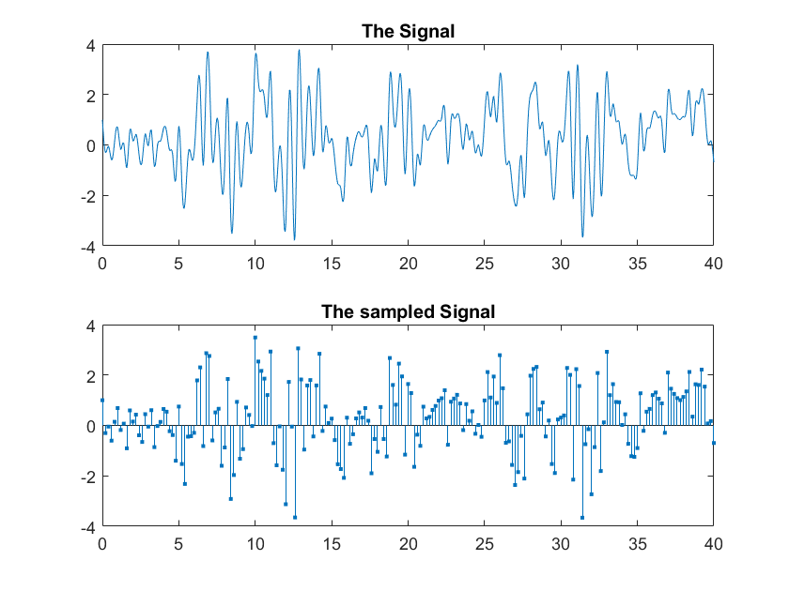

subplot(2,1,1)

x_ip = interp(msg,1/Ts);

t_ip = linspace(0,40,length(x_ip)-4);

plot(t_ip,x_ip(1:end-4))

title('The Message')

subplot(2,1,2)

x_ip = interp(xs,1/Ts);

t_ip = linspace(0,40,length(x_ip)-4);

plot(t_ip,x_ip(1:end-4))

title('The Signal')

% ON THIS SIGNAL THERE’S A HIDDEN MESSAGE IN A BAND WE CANNOT HEAR: THE 0-5 BAND WHICH IS ULTRASONIC TO OUR EARS

% THE OBJECTIVE IS TO FIRST OBTAIN THE MESSAGE AND THEN OBTAIN THE HIDDEN MESSAGE.

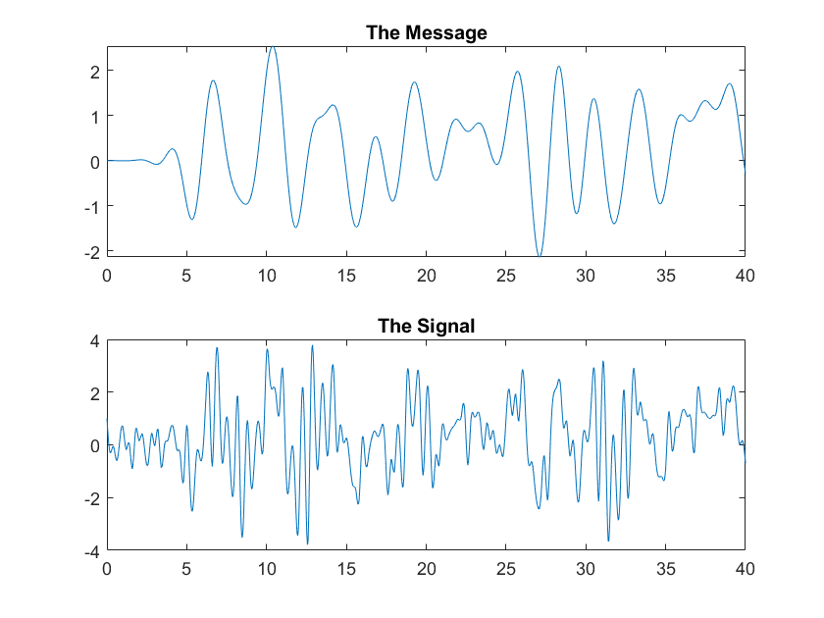

1. **The frequency response of the signal:**

Xs = fft(xs);

Xs_1= Xs(1:((N-1)/2)+1);

stem(m,abs(Xs_1),'.')

title('FFT of the Signal')

% The range from 1.3 and beyond and both pulses (carriers) are not noise because they may be indicators, real noise is not so steep. They are beacons, in-between there’s hidden information. First we’ll get the info from 0 to the first beacon (the visible message)

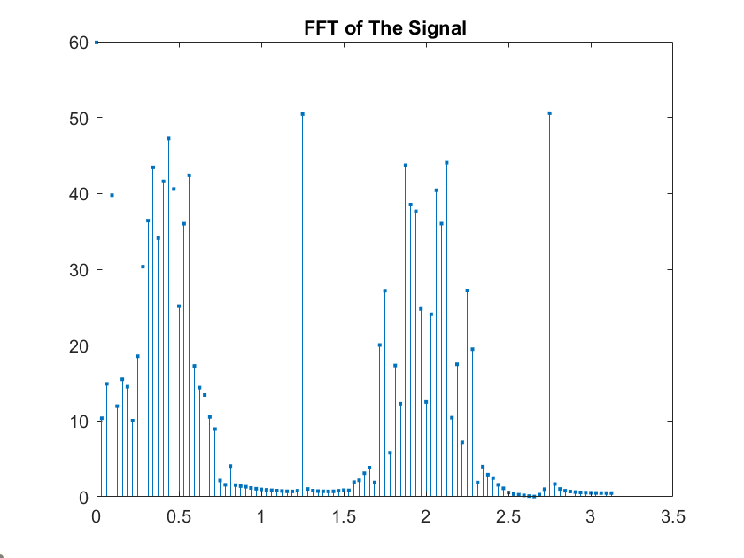

1. **Recovering the message:**

[ys,n] = lpf_bm(xs,n,55,0.3*pi); % wc = 0.9425

Ys = fft(ys);

Ys_1= Ys(1:((N-1)/2)+1);

stem(m,abs(Ys_1),'.')

title('FFT of the sampled message')

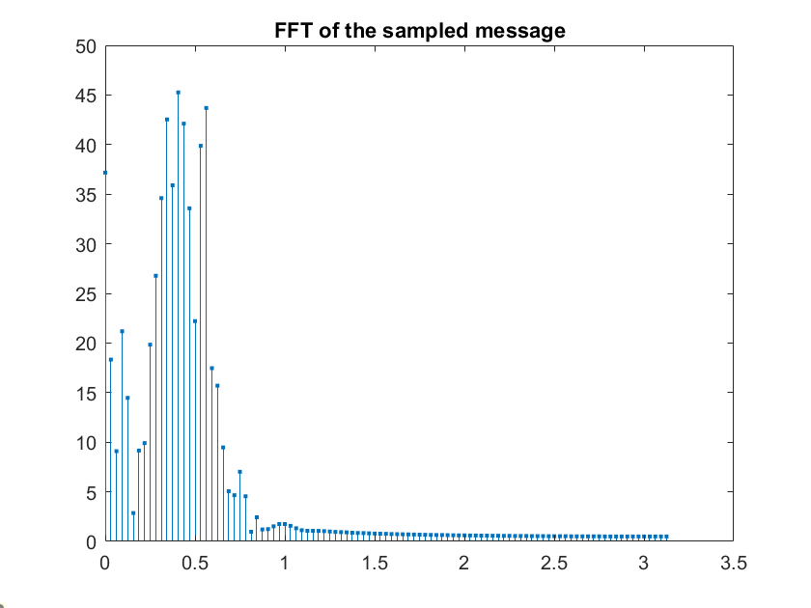

subplot(2,1,1)

stem(n,msg,'.')

title('The sampled message')

subplot(2,1,2)

stem(n,ys,'.')

title('The recovered sampled message')

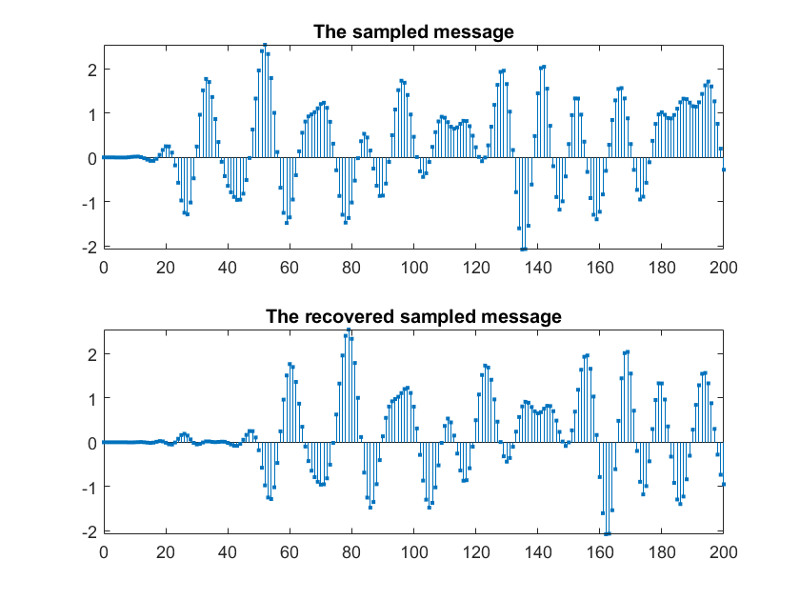

There’s a delay because the FIR has a linear phase, which gives a grouped delay, the derivative of the phase.

1. **Recovering the hidden message:**

% we use bandpass filter to remove the extra info outside the area, including the beacons. “b” and “a” are the coefficients of the transfer function.

[b,a] = ellip(7,0.25,50,[1.5/pi 2.5/pi],'bandpass');

% filter is calculating the output of this impulse response; we could design our personal function.

yhs = filter(b,a,xs);

Yhs = fft(yhs);

Yhs_1= Yhs(1:((N-1)/2)+1);

stem(m,abs(Yhs_1),'.')

title('FFT of the modulated hidden message')

% these sounds are still ultrasonic, we need to move it to a low frequency band, by shifting in frequency, but multiplied by cos(ωon), and not 2*cos(ωon) because that would give us twice the energy due to a replicated value).

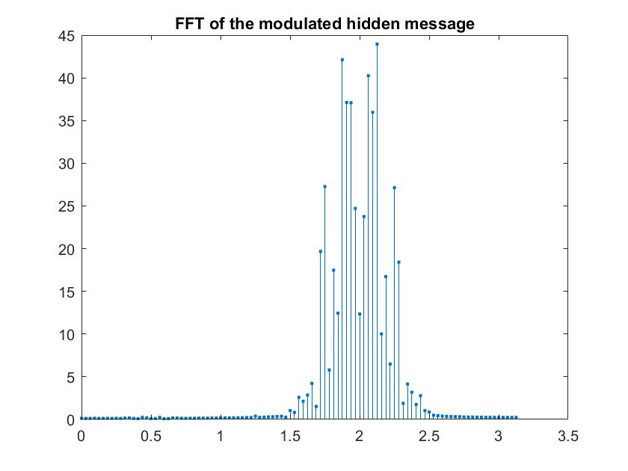

syms t

ph(t) = cos(10*t);

Ts = 0.2;

t = 0:Ts:40;

Ph = double(ph(t));

yhi = yhs.*Ph;

Yhi = fft(yhi);

Yhi_1= Yhi(1:((N-1)/2)+1);

stem(m,abs(Yhi_1),'.')

title('FFT of the pre-demodulated hidden message')

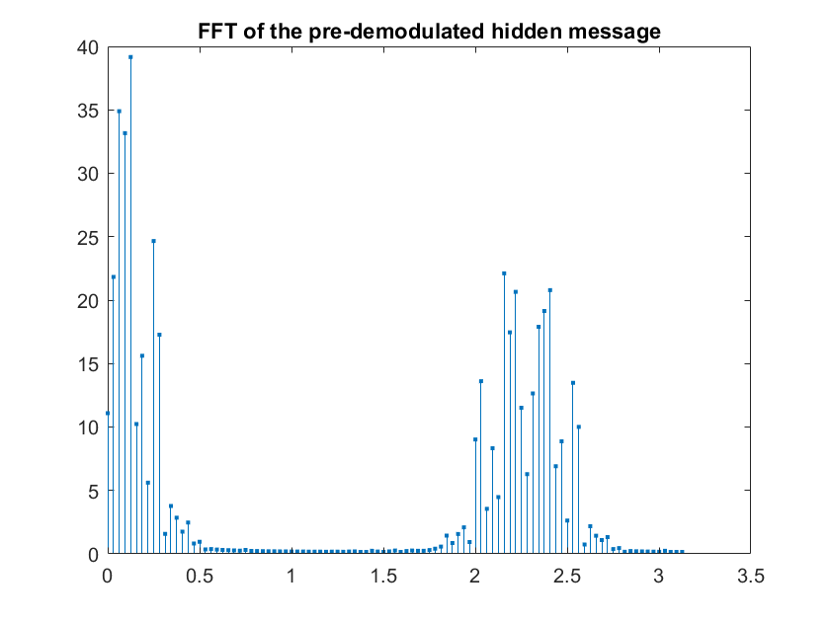

[y,n] = lpf_bm(yhi,n,55,0.7);

Y = fft(y);

Y_1= Y(1:((N-1)/2)+1);

stem(m,abs(Y_1),'.')

title('FFT of the demodulated hidden message')

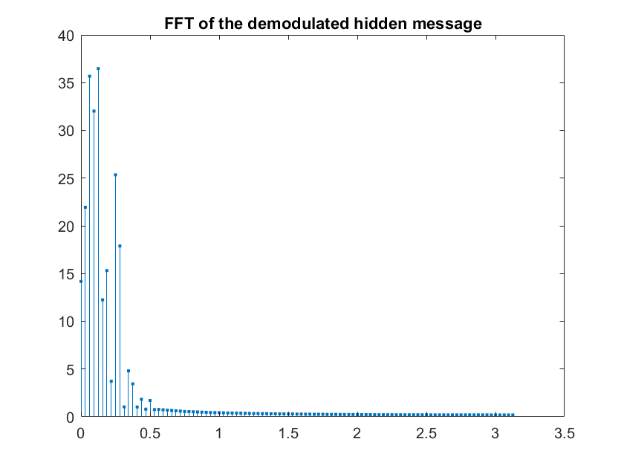

subplot(2,1,1)

stem(n,msgh,'.')

title('The sampled hidden message')

subplot(2,1,2)

stem(n,y,'.')

title('The recovered sampled hidden message')

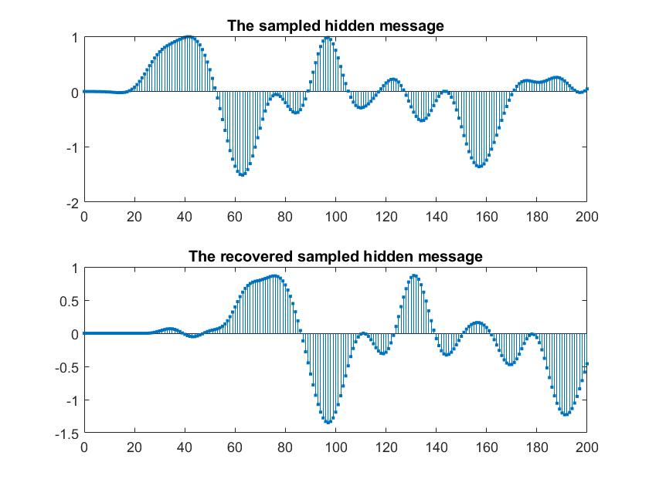

% the recovered signal has some loss due to the filter, I could improve the result with some gain amplifier