Chapter 4 — Empirical Results
Innovation-Driven Mergers and Acquisitions and Value Creation in the European
Pharmaceutical Industry
**Estimand.** Every coefficient below measures the **differential** post-versus-pre
change associated with an **innovation-driven** pharmaceutical transaction **relative to
an alternative-rationale transaction**. Both groups complete an M&A transaction. No
coefficient should be read as the effect of acquiring versus not acquiring.
**Status of this chapter.** The results are reported as **adjusted associations from a
small, provisional analytical sample**. They satisfy the design's data-cleaning and
identification checks (deduplicated events, frozen evidence-based classification,
reconstructed panels, examinable pre-trends, both groups represented), but the number of
acquirer clusters (12–13) is small and outcome coverage is partial. Estimates are
therefore precise enough to *describe direction and rule ranges in/out only weakly*, not
to support causal claims.

4.1 Final sample construction
The two source workbooks contained 351 candidate transactions (45 in the innovation
extract, 306 in the alternative extract). Consolidating on a canonical economic-event key
(normalised acquirer + normalised target + exact completion date) collapsed 42 cross-file
duplicate events — deals GlobalData had placed in both screens — and 3 within-file
duplicate pairs, yielding 306 unique economic events. The treatment workbook's
Panel_DiD sheet was found to contain 315 #REF! formula errors in the interaction
column and was discarded; all panels were rebuilt from source layers (Table 1).
Classification was performed on pre-completion evidence and by evidence rather than by
source workbook. This is consequential: the innovation screen contained clear commercial
false positives (e.g. Nicox/Doliage — an ophthalmic product portfolio; Esteve/Riemser
— a specialty product and manufacturing deal), while the alternative screen contained
clear R&D false negatives (e.g. Roche/Trophos — a Phase I neurodegeneration pipeline;
Ipsen/Syntaxin — a toxin technology platform and IP; UCB/Handl — gene-therapy discovery
capability). Among data-carrying deals, adjudication produced 13 high-confidence
innovation-driven and 12 alternative-rationale events (Table 3); two ineligible deals
(a childcare business and an 8.31% minority stake) and two mixed/borderline deals
(Vectura/Skyepharma; a reverse merger) were excluded from the primary analysis.
Because several acquirers recur (Roche 3×, GSK 2×, Recordati 2×) and same-firm financial
series are identical, the primary sample retains one non-overlapping event per acquirer
group, and all standard errors are clustered by acquirer. Serial-acquirer and balanced
samples are estimated as sensitivities (Table 2, Figure 1).

4.2 Outcome-specific coverage
Separate samples were constructed for each hypothesis (they need not contain the same
firms). Applying the preferred rule (≥ 2 non-missing pre and ≥ 2 non-missing post
observations, t0 omitted) and the one-event-per-acquirer restriction gives:
Sample | Events | Acquirer clusters | Innovation | Alternative | Obs
**H2 — ROA (primary)** | 12 | 12 | 8 | 4 | 72
**H1 — patent families (primary)** | 13 | 13 | 7 | 6 | 72
Coverage by relative year is shown in Figure 2. The samples are small and the innovation
side is dominated by small biotech/speciality acquirers.

4.3 Descriptive statistics (Tables 4–5)
Return on Assets (pp). The innovation group enters with a lower and far more volatile
pre-period ROA (mean −6.1, s.d. 35.9; driven by loss-making biotechs, minimum ≈ −110) than
the alternative group (mean +3.9, s.d. 13.0). Raw pre→post ROA change is +9.0 pp for
innovation versus +0.3 pp for alternative — directionally consistent with H2.
Patent families. The innovation group is more patent-intensive pre-deal (mean 11.7
families/yr vs 2.5) and its output declines post-completion (raw −3.9) while the
alternative group is roughly flat (raw −0.3) — directionally consistent with H1.

4.4 Pre-treatment comparability and common support (Table 6, Figures 7–8)
Standardised mean differences are large: for H2, pre-period ROA SMD ≈ −0.36 with a
variance ratio > 7, and pre-deal log-assets (0.90) and revenue (1.19) show the innovation
acquirers are markedly smaller; for H1, the pre-outcome SMD ≈ 1.12. Common-support overlap
exists but is thin, especially in the lower ROA tail (innovation only) and the upper
patent tail (innovation only). Deal fixed effects absorb these level differences, but
the imbalance means pre-trends carry the identification burden, and a matched/weighted
specification is not credibly supported at this sample size (matching on 12 events would
discard most of the data for cosmetic balance). Unweighted results are therefore the
benchmark, as the protocol requires.

4.5 H1 — differential patent output (Tables 7, 9; Figures 4, 6)
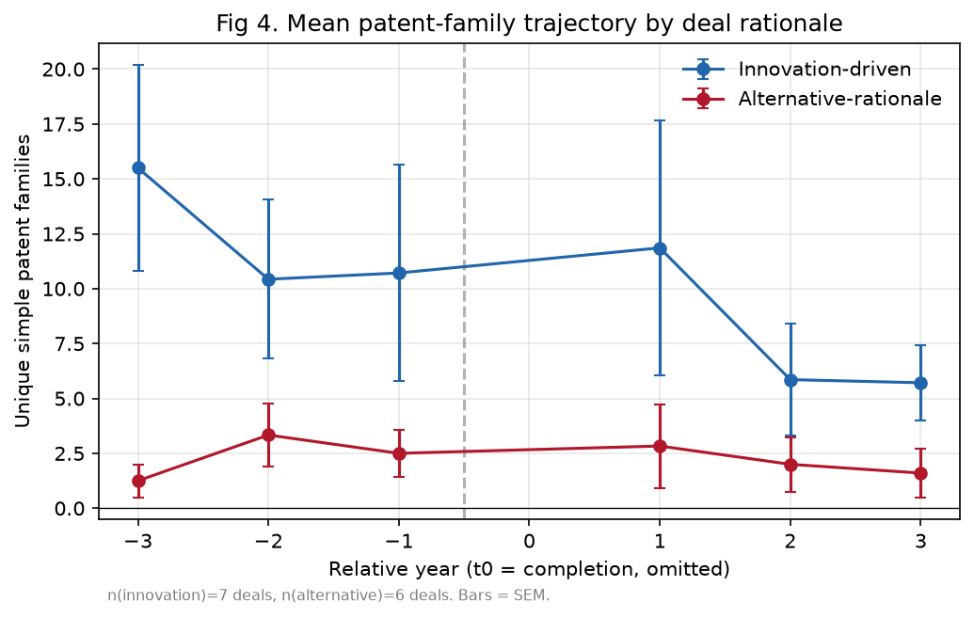
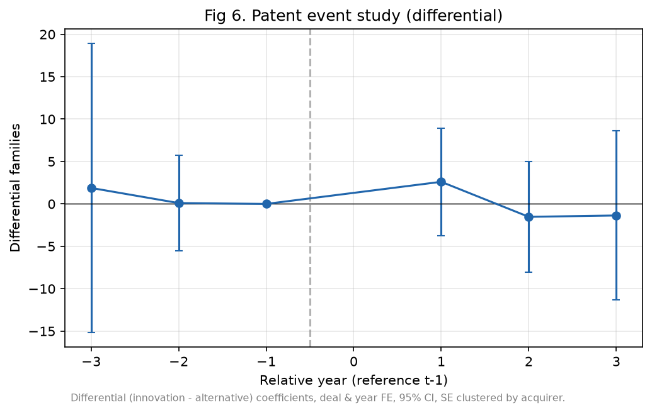
The two-way fixed-effects model gives a differential effect of
**β(Innovation × Post) = −0.46 patent families** (cluster-robust SE 2.07;
95% CI [−4.52, 3.61]; p = 0.83; **wild-bootstrap p = 0.82**), 13 events, 13 clusters.
Decomposition: the alternative group's modelled post change is δ = +5.20 families and the
innovation group's is δ + β = +4.74; the differential is essentially zero. The IHS
specification (β = 0.11, p = 0.85) and Poisson PPML (β = 0.05, p = 0.93) agree. The
event study (Figure 6) shows differential coefficients hovering around zero in every
post-year (+2.6, −1.5, −1.4 for t+1…t+3) with wide intervals, and the joint pre-trend
test does not reject parallel pre-trends (p = 0.96).
Reading. The data do not support H1 at conventional levels: there is no detectable
differential in patent-family output between the two rationales over the three post years.
Given the wide confidence interval, this is an imprecise null, not evidence of exact
equivalence.

4.6 H2 — differential ROA (Tables 8, 9; Figures 3, 5)
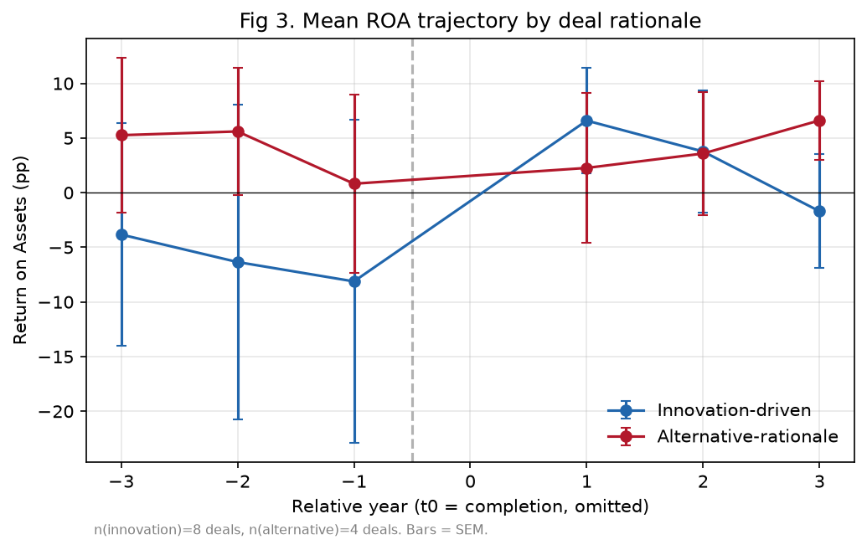
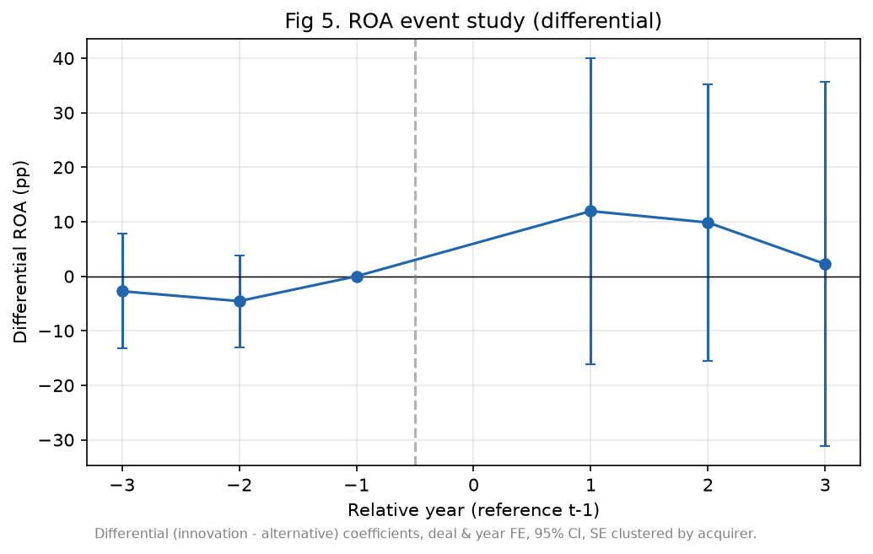
**β(Innovation × Post) = +10.78 pp** (cluster-robust SE 12.48; 95% CI [−13.69, 35.24];
p = 0.39; **wild-bootstrap p = 0.40**), 12 events, 12 clusters.
Decomposition: alternative post change δ = +2.76 pp; innovation post change δ + β = +13.53
pp. The point estimate is in the hypothesised direction (innovation deals show a more
favourable post-ROA change), but it is not statistically distinguishable from zero and
the interval is very wide. The event study (Figure 5) shows positive but insignificant
post coefficients (+12.0, +9.9, +2.2) and a non-rejected pre-trend test (p = 0.57),
though the pre-period differentials (−2.7, −4.6 pp) are not negligible in magnitude and
counsel caution.

4.7 Robustness and sensitivity analyses (Table 10)
Perturbation | H2 β (ROA) | H1 β (families)
Primary (unique acquirer, ≥2/≥2) | +10.78 | −0.46
Serial acquirers included | +6.43 | −0.81
Balanced 3-pre/3-post | +10.78 | −1.22
Winsorised 1/99 (pre-declared) | +10.10 | —
Include t0 as post | +11.29 | —
IHS / PPML (patents) | — | +0.11 / +0.05
Placebo (fake completion t−2, pre-only) | −3.18 (p 0.77) | +0.20 (p 0.98)
All signs are stable; no specification makes either estimate significant. Placebo tests
are correctly near zero. The winsorised and balanced results confirm the H2 point estimate
is not an artefact of a single extreme year, but…

4.8 Identification diagnostics and influence (Table 11, Figure 10)
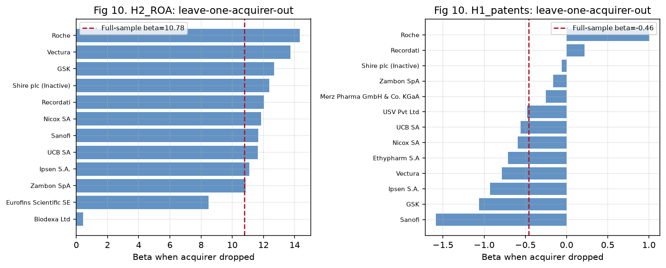
Leave-one-acquirer-out analysis reveals that H2 is fragile: dropping Biodexa (a
micro-cap with extreme ROA swings) collapses β from +10.78 to +0.43, while dropping
Roche pushes it to +14.33. The positive H2 signal is therefore driven by a small number
of tiny, volatile acquirers, not a broad-based pattern. H1 is stable across leave-one-out
(β ∈ [−1.59, +1.00]), consistent with its precise-null character. Neither outcome shows a
pre-trend violation, but low power means the pre-trend tests are weak evidence.

4.9 Joint interpretation
Taken together, the pattern is H1 ≈ 0 (imprecise null) and H2 > 0 in point estimate but
insignificant and outlier-driven. This is closest to the master framework's "H1 negative
/ null, H2 positive" cell — nominally consistent with an innovation–finance story in which
innovation-driven acquirers realise no additional near-term patent output relative to
other acquirers, while showing a more favourable short-run ROA change — but the evidence
here is far too weak to assert that mechanism. The confidence intervals include zero for
both hypotheses, and the H2 direction hangs on one or two firms.

4.10 Summary of findings and readiness status
- H1 (patents): Not supported at conventional levels; differential ≈ 0; robust to
PPML/IHS/serial/balanced; pre-trends not rejected. Status: associational, precise-null.
- H2 (ROA): Directionally consistent (positive) with the hypothesis but not
statistically significant, wide interval, and driven by influential small acquirers.
Status: associational, not confirmed.
Every number in this chapter is traceable to an exported file in outputs/tables/,
outputs/models/, or outputs/figures/. The models are provisional/associational, not
final causal estimates: the samples are small, coverage is partial, and classification —
though evidence-based — relies on GlobalData-embedded announcement text rather than archived
primary filings (no network access). These constraints, and the classification-error
discussion, are detailed in EMPIRICAL_LIMITATIONS.md.

Figure appendix
fig1_sample_flowchart.png
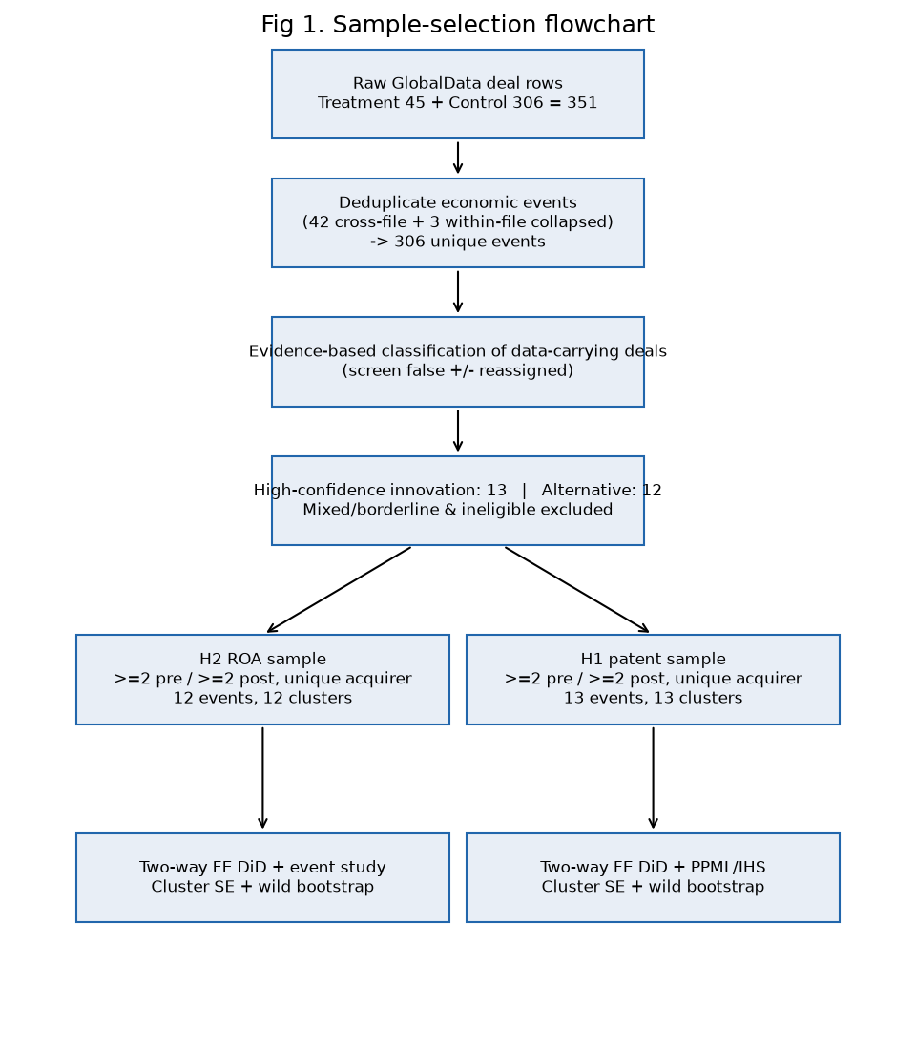
fig2_coverage_heatmap.png
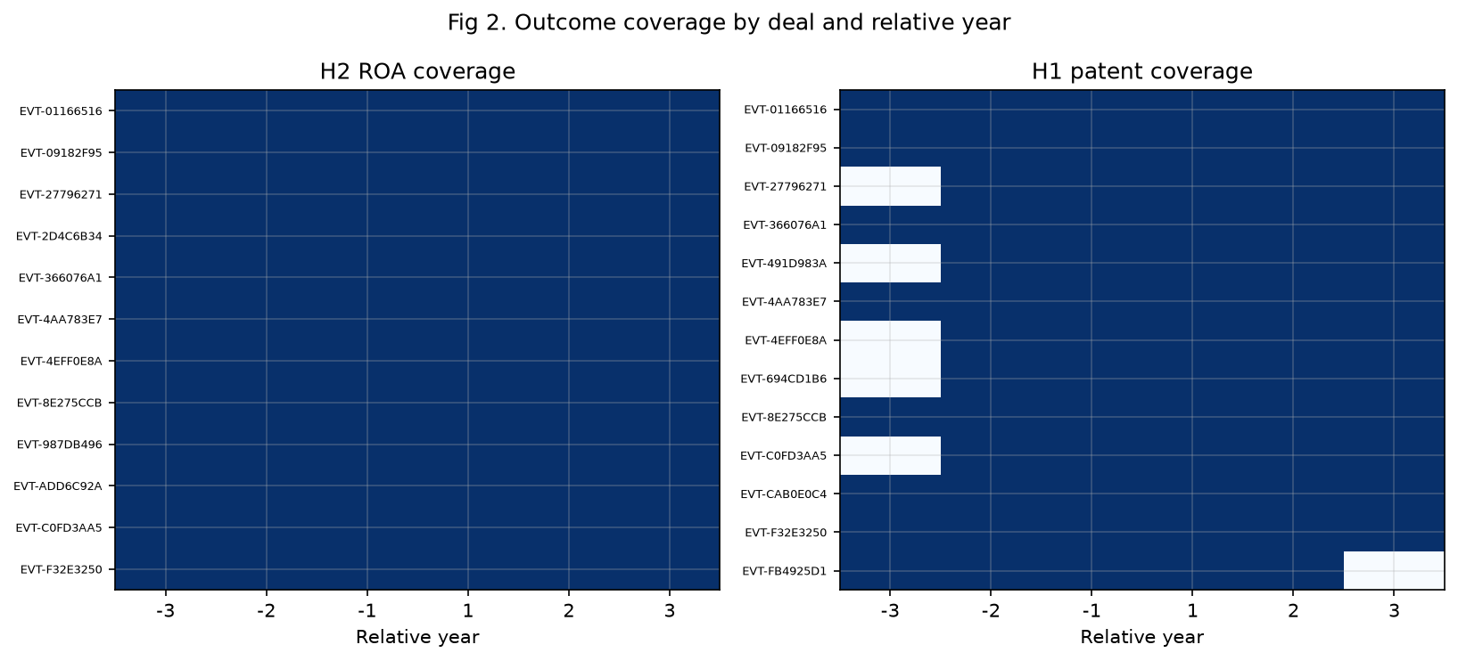
fig7_love_plot.png
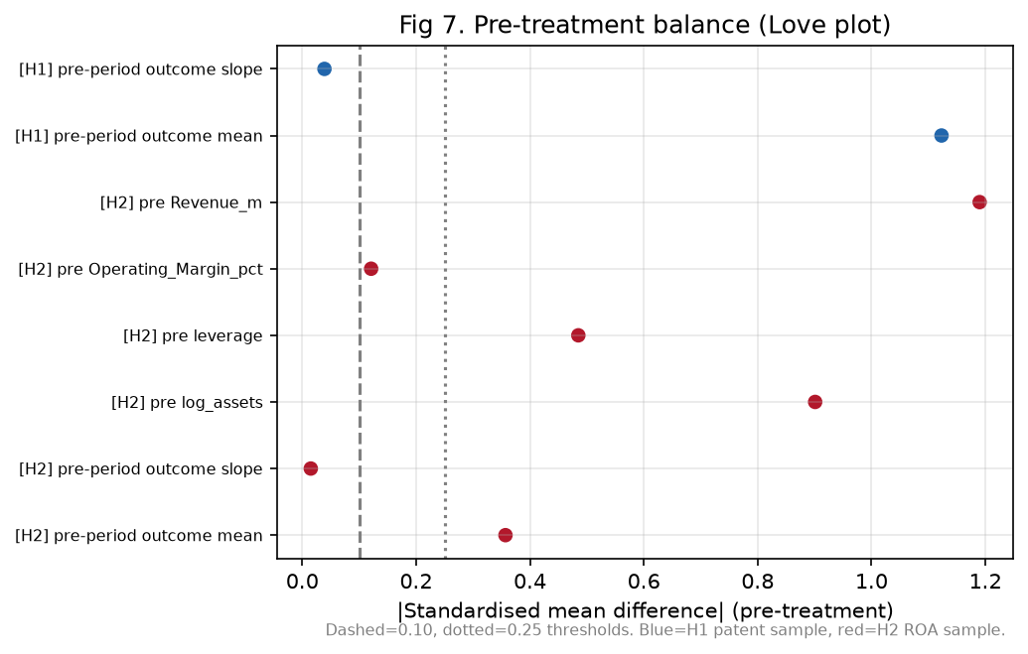
fig8_common_support.png
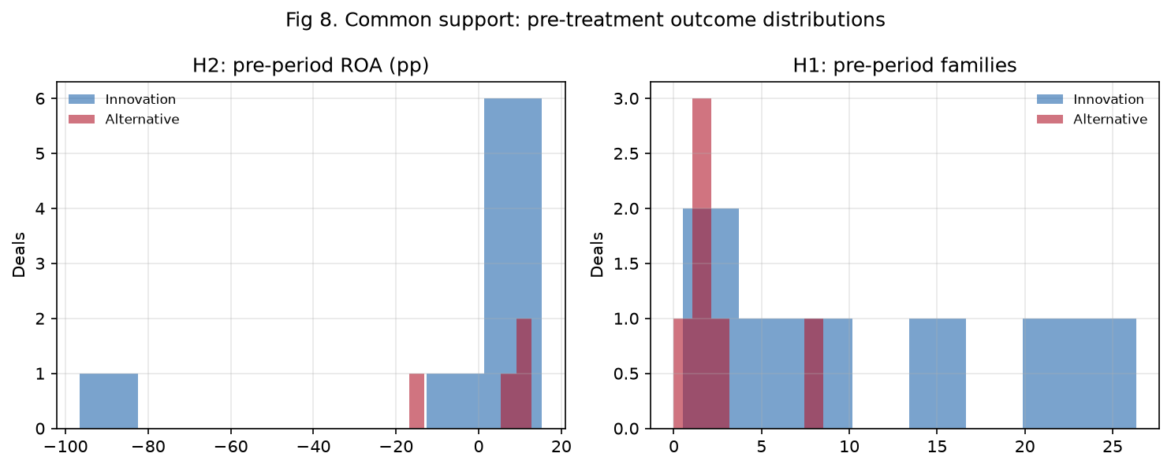
fig9_main_coefficients.png
