
KEDGE BUSINESS SCHOOL
__________

Master Thesis
presented in order to obtain
Master in Management Degree
SPECIALIZATION: Corporate & Market Finance
________________________________________________________________________
“Innovation-Driven Mergers and Acquisitions and Value Creation in the European Pharmaceutical Industry”
Nawar TARDOUST
________________________________________________________________________

Under the direction of: Professor Finance: Dr. Fazal MUHAMMAD
30th July 2026

Table of contents
1
Research question and hypotheses tested in this thesis 5
General research question 5
Introduction 6
1. Theoretical foundations and mechanisms 8
1.1 Resource-based view 8
1.2 Knowledge-based view 8
1.3 Absorptive capacity 9
1.4 Complementary assets 9
1.5 Agency, integration, and disruption costs 9
1.6 Replacement and pre-emption mechanisms 10
2. Defining innovation-driven and alternative-rationale acquisitions 13
2.1 Definition of innovation-driven acquisitions 13
2.2 Definition of alternative-rationale acquisitions 13
2.3 Why acquisition rationale matters 14
2.4 Classification and measurement error 15
3. Post-acquisition innovation performance 16
3.1 Evidence of negative innovation consequences 16
3.2 Evidence of positive, conditional, or insignificant effects 16
3.3 Innovation quantity and quality 17
3.4 Development lags 17
3.5 Development of H1 18
4. Post-acquisition financial performance 19
4.1 Financial synergies 19
4.2 Financial risks 19
4.3 Financial measurement 19
4.4 Innovation–finance divergence 20
4.5 Development of H2 20
6. Theoretical extensions and directions for future empirical research 22
6.1 Technological relatedness 22
6.2 Relative knowledge-base size 22
6.3 Cross-border innovation relocation 22
6.4 Therapeutic overlap and pipeline continuation 23
7. Research gap and contribution 24
Conclusion 25
3.1 Research design and empirical question 27
3.2 Empirical setting and transaction universe 29
3.3 Transaction eligibility and control transfer 30
3.3.1 Strict specification 30
3.3.2 Principal (verified control-transfer) sample 30
3.3.3 Exclusions 30
3.4 Data sources 31
3.4.1 GlobalData 31
3.4.2 Bloomberg 31
3.4.3 Lens.org 32
3.4.4 Classification-validation sources 33
3.5 Construction of the acquisition groups 34
3.5.1 Stage 1 — rationale screening 34
3.5.2 Stage 2 — deal-level substantive adjudication 34
3.6 Classification error and interpretation 36
3.7 Sample construction 37
3.8 Entity resolution 38
3.10 Event timing 40
3.11 Repeated acquirers and overlapping transactions 41
3.12 Hypotheses and variable operationalisation 42
3.12.1 Confirmatory hypotheses 42
3.12.2 Exploratory extensions 42
3.13 Descriptive statistics and comparability 44
3.14 Baseline Difference-in-Differences specification 45
3.15 Event-study specification 46
3.16 Patent-count specifications 47
3.17 Financial specifications 48
3.18 Inference 49
3.19 Identification assumptions 50
3.19.1 Parallel trends 50
3.19.2 No anticipation 50
3.19.3 Stable classification 50
3.19.4 No comparison-group contamination 50
3.19.5 No overlapping treatment 50
3.19.6 Limited interference 50
3.19.7 Stable sample composition 51
3.20 Robustness and sensitivity analyses 52
3.21 Methodological limitations 53
3.23 Reproducibility and research integrity 54
References 55

Research question and hypotheses tested in this thesis
This review provides the conceptual basis for an empirical study whose design is specified in the thesis methodology. At the outset, it is important to state the research question and the two confirmatory hypotheses, since these define the scope of the review, establish its terminology, and guide the argument developed in the sections that follow.

General research question
Do innovation-driven acquisitions create value for acquiring firms in the European pharmaceutical industry?

Introduction

The pharmaceutical industry is among the most research-intensive sectors of the global economy. Firms operate under high research and development (R&D) costs, protracted development cycles, and considerable technological and regulatory uncertainty. As the estimated cost of bringing a new drug to market has continued to rise, the pressure to find alternative means of sustaining innovation and international competitiveness has intensified (DiMasi et al., 2016). It is against this background that mergers and acquisitions (M&A) have become a principal strategic mechanism through which firms obtain external innovation assets—R&D pipelines, technology platforms, patents, and clinical-stage products—rather than developing every capability in house.
Although the literature on M&A is extensive, earlier work concentrated largely on financial performance and market concentration. More recent studies have instead treated acquisition as a process capable of shaping innovation performance and long-term value creation, particularly in knowledge-intensive industries such as pharmaceuticals (Hitt et al., 1991; Cloodt et al., 2006). Consistent with the open-innovation paradigm, a growing body of evidence indicates that pharmaceutical firms use innovation-driven acquisitions to complement, or to substitute for, internal research by securing access to external sources of innovation (Higgins & Rodriguez, 2006).
These questions are especially pertinent to the European pharmaceutical industry. Most empirical studies have been conducted in the United States, yet the European institutional framework—its regulation, pricing, and market size—differs in ways that are likely to affect both the incentives to undertake innovation-driven transactions and the manner in which such transactions create value.
Firm-level evidence on these associations in Europe nevertheless remains comparatively scarce. A clearer understanding of how innovation-driven M&A affects acquiring firms would inform the investment decisions of equity investors, the assessment and management of transaction performance, and the concerns of policymakers about the consequences of consolidation for innovation and public welfare.
The present study departs from much of this earlier work by comparing two types of completed transaction rather than contrasting acquiring with non-acquiring firms. It asks, more specifically, whether an innovation rationale is associated with distinctive post-acquisition trajectories, and whether innovation and financial value tend to move together or to diverge.
The remainder of this review is organised as follows. Section 1 sets out the theoretical foundations and examines the competing mechanisms through which acquisitions may create or destroy value. Section 2 defines the two acquisition categories and considers classification and measurement error. Section 3 reviews post-acquisition innovation performance and develops H1, and Section 4 turns to financial performance and develops H2. Section 5 discusses the identification implications of comparing two self-selected acquisition types, and Section 6 treats the mechanisms that are not tested here as a future-research agenda. Section 7 identifies the research gap and contribution, after which the conclusion establishes the link with the methodology presented in Chapter 3.

1. Theoretical foundations and mechanisms
The theoretical literature yields no single prediction about the consequences of acquisition. Several perspectives explain how access to external knowledge may create value; others show how that value may be dissipated. Considering these mechanisms together clarifies why innovation and financial outcomes are estimated separately in this thesis, and why the relevant comparison is between two acquisition rationales rather than between acquisition and its absence.

1.1 Resource-based view
The resource-based view offers a useful framework for explaining why a pharmaceutical firm might acquire an innovative target rather than develop comparable assets internally. Barney (1991) argues that sustained competitive advantage derives from resources that are valuable, rare, difficult to imitate, and not readily substitutable. In the pharmaceutical setting, such resources may include patented molecules, preclinical and clinical-stage pipeline assets, proprietary research platforms, clinical data, and highly specialised scientific expertise. Part of their value lies in their legal protection and in the difficulty a competitor would face in replicating the underlying tacit knowledge. By acquiring them, a firm can combine the target’s inventive know-how with its own manufacturing, regulatory, financial, and commercial capabilities, and so realise value that the target alone might not have achieved.

1.2 Knowledge-based view
The knowledge-based view builds on this perspective by treating the firm as an organisation that integrates and coordinates specialised knowledge (Grant, 1996). In pharmaceuticals, that knowledge is distributed across scientific teams, laboratories, therapeutic areas, and stages of development, so acquiring a firm that already possesses complementary knowledge may be faster and less costly than reproducing it internally. Ownership, however, does not guarantee successful transfer. Nelson and Winter’s (1982) evolutionary account holds that knowledge is embedded in the organisational routines and accumulated experience through which it developed, and such routines do not move automatically when control changes hands. Legal control of a target therefore offers no assurance that the acquirer will preserve or reproduce the processes on which the target’s innovative capability depends.

1.3 Absorptive capacity
Absorptive capacity refers here to a firm’s ability to recognise, assimilate, and exploit externally acquired knowledge. Cohen and Levinthal (1990) argue that this ability rests on related prior knowledge. In the acquisition context, too little technological overlap may impede communication and weaken the acquirer’s ability to assess the target’s R&D, whereas complete overlap may leave little scope for productive recombination. The evidence on subsequent innovation is broadly consistent with this view: Ahuja and Katila (2001) find that follow-on innovation depends on the attributes of the acquired knowledge base, a result echoed, within particular technology sectors, by Cloodt et al. (2006).
This evidence implies that the effects of the acquirer’s and the target’s knowledge bases are conditional on one another. Section 6 returns to this theme as a testable extension.

1.4 Complementary assets
Teece’s (1986) appropriability framework emphasises that owning a technology is rarely sufficient to profit from it. Commercialisation typically requires complementary assets—manufacturing expertise, regulatory knowledge, clinical-development capability, capital, and distribution and sales networks. A large pharmaceutical acquirer may accordingly create value by combining a target’s research with downstream capabilities the target lacks. The form of the transaction may matter as well. Drawing on the Indian pharmaceutical industry, Basant and Jaiswal (2022) find that innovation outcomes differ across mergers, share acquisitions, and asset purchases. Although their institutional setting is not European, the finding that business combinations should not be treated as equivalent lends further support to distinguishing acquisitions by their rationale.

1.5 Agency, integration, and disruption costs
These value-creating explanations must be weighed against a less favourable set of mechanisms. Agency theory holds that managers may pursue acquisitions to enlarge organisational size, visibility, or control even when the expected returns to shareholders are limited (Jensen, 1986), so that potential operating gains may be offset by overpayment, restructuring and integration costs, or managerial distraction. Integration may itself destroy value where resources are redundant, organisational routines are incompatible, or key scientific personnel depart. As the knowledge-based and evolutionary perspectives suggest, such disruption may be especially damaging when the target’s inventive capability is embedded in routines that do not survive the transfer of ownership. Whether an acquisition ultimately improves performance is therefore an empirical question, and cannot be inferred from the strategic fit asserted at announcement.

1.6 Replacement and pre-emption mechanisms
A further explanation for lower post-acquisition innovation is deliberate commercial choice rather than failed integration. Arrow’s (1962) replacement effect implies that an incumbent has weaker incentives than an entrant to introduce an innovation that would cannibalise the profits of existing products, and Gilbert and Newbery (1982) develop a related pre-emption argument in which the incumbent invests to protect its market position. In the pharmaceutical setting, an acquirer may value an acquired project less highly when the product it targets is closely related to one the acquirer already sells or is developing. Cunningham et al. (2021) provide project-level evidence consistent with this reasoning: an acquired drug project is more likely to be discontinued when it overlaps with the acquirer’s existing pipeline, particularly in less competitive segments or where the relevant patents have long to run before expiry. The same authors nonetheless estimate that such ‘killer’ acquisitions account for only a minority of transactions.
For the purposes of this review, two concepts that are easily conflated should be kept distinct. Therapeutic overlap denotes product-market substitution—whether an acquired project competes with therapies the acquirer already holds—and is generally expected to weaken development incentives. Technological relatedness, by contrast, concerns how effectively two knowledge bases can be combined, and may bear a non-linear, potentially beneficial, relationship to innovation. The two require different data and support different interpretations. Neither is tested as a confirmatory hypothesis here; both are examined further in Section 6.
Taken together, the perspectives reviewed above do not point to a single prediction. The resource-based view, the knowledge-based view, the absorptive-capacity perspective, and complementary-assets theory explain how access to external knowledge may create value, whereas agency costs, disruption to organisational routines, weaker competitive pressure, and replacement incentives explain how value may be lost. Because these mechanisms may operate at once and in opposite directions across innovation and financial performance, the two families of outcomes must be estimated separately before any divergence between them can be examined.

2. Defining innovation-driven and alternative-rationale acquisitions
The comparative design adopted in this thesis rests on a clear and observable distinction between the two acquisition categories. This section defines each category, explains why the distinction is analytically important, and then considers the classification and measurement error inherent in any rationale-based screening procedure.

2.1 Definition of innovation-driven acquisitions
An innovation-driven acquisition is defined here as a completed transaction in which the target contributes a material and identifiable innovation asset to the combined firm, and in which access to that asset constitutes a central, observable purpose of the deal. Such assets may include proprietary molecules; pre-clinical and clinical-stage pipeline assets; patents and patent families; scientific or technological platforms; specialised R&D staff; research data; discovery or clinical-development capabilities; and diagnostic tools or other R&D-enabled technologies. Each is defined by tangible characteristics observable before completion rather than by managers’ stated intentions. A transaction is not classified as innovation-driven merely because the announcement adopts the language of innovation. In the empirical design, candidate rationales such as expand offering / add products, access to resources, and forward or backward integration qualify only where the acquired assets are of the innovative types identified above.
Two qualifications clarify the boundary of this definition. First, mature commercial products, established brands, generic products, production capacity, manufacturing plants, distribution networks, sales teams, supply chains, raw materials, and ordinary downstream commercial integration are not treated as innovation assets by default, even where the stated rationale appears innovation-oriented. Second, satisfying a single criterion is not sufficient: a transaction is classified as innovation-driven only where the target held a material innovation asset before completion and access to that asset was a central purpose of the deal.

2.2 Definition of alternative-rationale acquisitions
An alternative-rationale acquisition is defined here as a completed transaction whose primary purpose is not the acquisition of innovation assets. The main candidate rationales are increase scale / business expansion, geographic expansion, business diversification, operational synergy, and access to a new customer segment. Broadly, these concern organisational scale, commercial or geographic expansion, customer access, distribution, mature product portfolios, production capacity, operating efficiency, cost consolidation, and structural or organisational integration. Crucially, firms in this comparison group also complete an acquisition or merger. They do not form an untreated, non-acquiring control group; the estimand concerns the difference between two acquisition types, not the difference between acquiring and not acquiring.
Two of these candidate rationales cannot be assigned mechanically. Business diversification may be innovation-driven when it proceeds through, say, the acquisition of a gene-therapy platform, yet alternative-rationale when it involves a mature consumer-health portfolio. Operational synergy, likewise, may be innovation-driven when it integrates R&D capability and alternative-rationale when it concerns manufacturing or distribution. Transactions are therefore classified according to the underlying assets and the available evidence, rather than the rationale label alone.

2.3 Why acquisition rationale matters
A rationale-based distinction is necessary because an aggregate measure of M&A pools transactions that operate through substantially different mechanisms. Ahuja and Katila (2001) find no significant post-acquisition innovation effect for non-technological transactions, while the effects of technological acquisitions vary with relatedness and the characteristics of the acquired knowledge base; Cloodt et al. (2006) report a similarly conditional pattern across high-technology sectors. Pooling the two forms of transaction would thus average over distinct mechanisms and obscure the comparison this thesis seeks to identify. The present design therefore does not ask whether acquisition in general affects outcomes, but whether an innovation rationale is associated with a different trajectory once the fact of acquiring is held constant.
A further issue is selection into acquisition type. Bena and Li (2014) show that innovation characteristics help predict which firms become acquirers and which firms combine, with transactions occurring more often where technological portfolios are linked or complementary. Phillips and Zhdanov (2013) add that the prospect of acquisition may stimulate R&D among smaller firms, while larger firms may prefer to buy innovation rather than develop it internally. Acquisition rationale is, on this evidence, far from randomly assigned, which is why a credible comparison group and an examination of pre-acquisition trends are essential—matters taken up in Section 5.

2.4 Classification and measurement error
Because true managerial motive cannot be observed directly, a classification derived from disclosed transaction information is best regarded as a systematic first-stage screen rather than a perfect measure. Such a screen admits both false positives and false negatives. A false positive arises when a transaction motivated by financial or commercial considerations is assigned an innovation rationale—for example, where a mature asset base or a manufacturing or services facility is acquired without any meaningful pre-deal innovation asset. A false negative arises when a genuine pipeline, platform, or R&D capability is recorded under a rationale of scale, diversification, integration, or a purely transactional objective. Both forms of error were material in the transaction set used in this thesis and were reassigned using evidence available before completion.
Three further complications bear on the interpretation of the classification. First, mixed-motive transactions combine material innovation and commercial objectives; rather than force these into either category, the strict comparative design labels them mixed, borderline, or insufficient evidence, and either excludes them from the main comparison or retains them for sensitivity analysis. Second, the error is unlikely to be randomly distributed, since the evidence available for classification may vary across firms and over time and may be correlated with firm characteristics. Third, the direction of any resulting bias cannot be assumed in advance: false negatives in the comparison group may pull differential estimates towards zero, while false positives may add heterogeneity to the innovation-driven group. Classification error must therefore be treated as a material feature of what the estimates can be taken to show, a point revisited in the development of H1 and in the identification discussion.

3. Post-acquisition innovation performance
This section reviews the evidence on the effect of acquisition on the innovation performance of acquiring firms. It first considers evidence of negative and conditional outcomes, then distinguishes innovation quantity from innovation quality and discusses the long development lags characteristic of pharmaceuticals, before deriving the first confirmatory hypothesis.

3.1 Evidence of negative innovation consequences
A growing body of evidence suggests that post-completion innovation outcomes are often less favourable than the strategic arguments advanced at announcement would imply. In a broad manufacturing sample, Hitt et al. (1991) report negative associations between acquisition activity and both R&D intensity and patent intensity. In pharmaceuticals specifically, Ornaghi (2009) finds that merged firms underperform comparable non-merging firms across several measures of R&D and innovation. Using European pharmaceutical mergers, Haucap, Rasch, and Stiebale (2019) identify substantial reductions in patenting and R&D among merged firms and, in some specifications, among their non-merging rivals; the effects are largest in research-intensive markets and where the merging firms already overlap, which suggests that both competition and the organisation of research shape the outcome. These declines have commonly been attributed to the elimination of duplicated research programmes, reduced research diversity, and the discontinuation of overlapping projects discussed in Section 1.6.

3.2 Evidence of positive, conditional, or insignificant effects
These findings should not, however, be read as evidence that every acquisition reduces innovation. The studies differ in their samples, treatment definitions, outcome measures, and identification strategies. Systematic reviews by Laermann-Nguyen and Backfisch (2021) and Suo et al. (2023) report positive, negative, and statistically insignificant effects, with outcomes depending on knowledge complementarity, absorptive capacity, technological fit, and the characteristics of the acquirer and target (e.g., Aghion et al., 2009; Azoulay and Crémieux, 2006; Blanes-Vidal and Ciocco, 2012 [SOURCE OR AUTHOR VERIFICATION REQUIRED: these three works are cited in the text but do not appear in the thesis reference list; they should be added to the reference list or removed]).

An important cross-border qualification emerges from Stiebale (2016), who estimates increases in innovative activity but finds the gains concentrated in the acquiring country while activity in the target country declines. The literature thus reaches a qualified conclusion: unambiguously positive effects are the exception rather than the rule for horizontal pharmaceutical mergers, yet acquirer and target characteristics, technological overlap, and the cross-country division of research labour can still permit them. This heterogeneity provides a strong rationale for a comparison based on acquisition rationale rather than an aggregate acquisition effect.

3.3 Innovation quantity and quality
A central difficulty in evaluating pharmaceutical innovation is that no single indicator offers a complete measure, so the assessment of an acquisition can vary with the outcome chosen. R&D expenditure is an input measure and does not reveal what that expenditure produces; a decline may reflect either weaker research effort or greater efficiency. Patent counts capture codified output but treat inventions of very different importance alike. Forward citations can signal technological impact, but Hall, Jaffe, and Trajtenberg (2001) note that gross citation counts are affected by the age and technology field of the cited patent and are subject to truncation; they must therefore be normalised and interpreted as a quality-adjusted indicator rather than as a direct measure of commercial value. Valentini (2012) likewise highlights the potential divergence between quantity and quality: an acquisition may raise the number of patents while lowering their impact, novelty, and generality, so that a simple count could suggest greater innovation even as the underlying inventions become less inventive.
Büssgen and Stargardt (2024) examine outcomes beyond patents and find no evidence of improved innovation following mergers. For the purposes of this thesis, the annual count of unique simple patent families ordered by earliest priority date is adopted as the primary innovation outcome, since it provides a clear measure of quantity that can be obtained readily and consistently for all European acquirers. Citation-weighted output is retained only as a secondary quality measure, and only where cohort normalisation and adjustment for truncation can be implemented credibly. Pipeline-stage indicators, although conceptually attractive, cannot be assembled consistently across the sample and are therefore reserved for future research.

3.4 Development lags
A further consideration is the unusually long development cycle of pharmaceutical innovation. A three-year post-acquisition window may fail to capture value embodied in late-stage pipeline products that remain in clinical development or await regulatory approval beyond that horizon. Moreover, patent-family counts dated by earliest priority year reflect the timing of invention and are not a direct indication of the commercial or clinical value later realised from an acquired programme. A zero or negative difference in patent volume within the first three years could therefore coexist with substantial acquired value that has yet to register in the chosen metric—a limitation that should be borne in mind when interpreting H1.

3.5 Development of H1
The development of H1 draws on three strands of the literature. First, the average-effect evidence indicates frequent declines in post-acquisition patenting, particularly where overlapping research programmes are consolidated. Second, the measurement literature supports patent-family quantity as the primary tractable outcome while cautioning that quantity and quality may diverge. Third, the development-lag argument implies that a short window is likely to understate the value of acquired assets. Taken together, and framed as a comparison against alternative-rationale acquisitions rather than against non-acquiring firms, these strands suggest that innovation-driven acquirers will experience a less favourable near-term change in patent-family output: such transactions are more likely to involve the consolidation of overlapping research, whereas alternative-rationale acquisitions are more often driven by scale, geography, or efficiency.
H1: Differential innovation performance. Compared to acquiring firms undertaking transactions for alternative rationale (acquiring pharmaceutical innovation-driven transactions), an acquiring firm undertaking an innovation-driven transaction will experience relatively lower total annual change in patent family output in the three years after closing.

The phrase “less favourable” is intended to encompass a range of patterns: a sharper decline, a slower rise, or a flat trajectory for the innovation-driven group while the alternative-rationale group holds steady or improves. The hypothesis is comparative and associational; it does not estimate the effect of acquisition relative to non-acquisition. Given the possibility of development lags and residual classification error, the expected relationship should be read as an average tendency rather than as a pattern that must hold for every transaction.

4. Post-acquisition financial performance
This section turns to the financial dimension of value creation. It reviews the synergies and risks associated with pharmaceutical acquisitions, considers the implications of alternative financial measures, and examines the possibility that financial and innovation outcomes may diverge, before developing the second confirmatory hypothesis.

4.1 Financial synergies
An acquisition may yield economic benefits even where innovation is unchanged or lower under the acquirer’s management. Such benefits include spreading fixed operating, marketing, and R&D costs over a larger base, eliminating duplication, using resources more efficiently, and commercialising existing assets across a wider market; financing and tax savings may also arise, and the acquirer may secure control of a research option rather than having to reproduce a costly capability from scratch. These arguments are consistent with the external-R&D interpretation advanced by Higgins and Rodriguez (2006) and with the transaction evidence of Danzon et al. (2007), who show that outcomes depend on firm characteristics and industry conditions. One implication is that cost and scale benefits may raise profitability without generating additional innovation, opening the possibility of the divergence discussed below.

4.2 Financial risks
Several countervailing factors may nonetheless suppress or postpone financial gains. Overpayment transfers value to target shareholders; restructuring and integration costs reduce near-term earnings; and the expansion of the asset base, together with acquisition accounting, may depress return-based measures even where underlying operations remain sound. Agency-driven empire-building (Jensen, 1986) may amplify these effects when transactions are undertaken for organisational size rather than expected return. Short-run profitability may consequently become volatile after completion. The sign of the financial effect is thus an empirical question and cannot be inferred from the strategic fit asserted by management.

4.3 Financial measurement
The choice of metric and horizon shapes any conclusion about financial performance. Announcement returns capture the market’s current estimate of short-run outcomes, whereas accounting measures reflect longer-run operational performance, though the latter may be distorted by purchase-price accounting, restructuring costs, or changes in the asset base. Revenue may rise simply because the combined firm is larger, and return on assets may fall immediately as goodwill inflates total assets. The primary measure of financial performance in this thesis is Bloomberg’s standardised return on assets (ROA), a realised accounting measure of operating profit relative to the firm’s assets that can be used directly within a firm-year, event-time framework. Operating margin serves as a secondary measure, since it can become severely negative for biotechnology firms with little revenue. Long-horizon market returns are not used, as they are more difficult to align with the firm-year difference-in-differences framework.

4.4 Innovation–finance divergence
Financial and innovation outcomes may move in opposite directions without any theoretical inconsistency. A merged firm may, for instance, close laboratories, cut duplicate projects, and reduce staffing—improving margins while narrowing the scope of research undertaken. Conversely, sustained investment in a broad pipeline may lower profitability in the short run while generating future options. Büssgen and Stargardt (2024) report that several financial measures improve after mergers, but not uniformly and not in step with innovation performance. Both lines of argument imply that the two sets of outcomes are governed by different processes and time horizons. An improvement in accounting performance is therefore no proof that the innovation rationale succeeded, just as a reduction in patenting is no proof that value has been lost. The two dimensions must be estimated independently before their direction and timing are compared.

4.5 Development of H2
The development of H2 rests on the evidence concerning synergies and the possibility of innovation–finance divergence. Scale economies, cost consolidation, and complementary assets may improve accounting performance within a relatively short period, even where innovation does not increase. The relevant comparative question is whether an innovation rationale is associated with a distinctive financial trajectory relative to alternative-rationale acquisitions. Two considerations suggest a more favourable change in ROA for innovation-driven acquirers. First, such deals tend to deliver complementary assets and option value that acquirers are well placed to commercialise, given the downstream competencies they already possess. Second, alternative-rationale acquisitions are more often scale-increasing, and so may impose greater integration and asset-base strain on returns in the near term. This expected difference, however, remains a conjecture to be tested rather than a settled conclusion.
H2 — Differential financial performance. Relative to acquirers undertaking alternative-rationale pharmaceutical transactions, acquirers undertaking innovation-driven transactions are expected to experience a more favourable post-acquisition change in return on assets during the three years following completion.
The phrase “more favourable” encompasses a larger improvement, a smaller decline, or stability in the innovation-driven group while the comparison group deteriorates. As with H1, the hypothesis is comparative and associational rather than an estimate of acquisition relative to non-acquisition, and its interpretation depends on the measure and horizon chosen. Estimating H1 and H2 under a common classification and event-time framework offers a direct means of examining whether financial and innovation value move together or become decoupled across the two acquisition types.

6. Theoretical extensions and directions for future empirical research
Several mechanisms once formulated as confirmatory hypotheses remain theoretically important but cannot be tested credibly with the data available for this thesis. They are therefore retained as theoretical extensions, and for each the additional data required for credible testing are specified. This approach preserves their contribution to the conceptual argument while confining the confirmatory empirical design to H1 and H2.

6.1 Technological relatedness
The literature suggests that the relationship between technological relatedness and post-acquisition innovation may follow an inverted-U pattern: low relatedness may impede communication and assimilation, high relatedness may render the two knowledge bases redundant, and a moderate degree may afford the greatest scope for recombination (Ahuja & Katila, 2001; Cloodt et al., 2006; Valentini, 2012). A valid test would require the pre-announcement patent portfolios of both firms, classified by IPC or CPC patent-family categories, from which an overlap or cosine-similarity score and its square could be constructed. Given the incompleteness of target-level data, relatedness is retained as a possible explanation—entered, where feasible, as an additional regression term—rather than as a further hypothesis for confirmatory testing.

6.2 Relative knowledge-base size
A related proposition is that a target knowledge base that is large relative to the acquirer’s may impose an integration burden and reduce subsequent innovation (Ahuja & Katila, 2001; Cloodt et al., 2006; Valentini, 2012). Testing it would require comparable pre-acquisition patent stocks for both firms, so that the ratio of target to acquirer patent stock could be interacted with the post-acquisition term. Because target-level patent coverage is incomplete, the mechanism is treated as an exploratory, future-research proposition rather than a tested hypothesis.

6.3 Cross-border innovation relocation
There is evidence that cross-border acquisitions may shift the geographical location of innovative activity. Stiebale (2016) finds that innovation may rise in the combined entity even as it falls in the target’s home country. A credible test would require inventor-country histories, which indicate where inventive activity actually takes place, rather than owner country or patent jurisdiction, which mainly reflect legal ownership. Since the available patent records do not provide consistent inventor-location histories that can be traced before and after completion, this proposition is not tested here.

6.4 Therapeutic overlap and pipeline continuation
Therapeutic overlap refers here to product-market substitution between an acquired project and the acquirer’s existing portfolio. It may help to distinguish unsuccessful integration from a deliberate decision to discontinue a competing project, consistent with the replacement and pre-emption incentives discussed in Section 1.6 and with the project-level evidence of Cunningham et al. (2021). A formal test would require consistent project-level information on therapeutic areas, mechanisms of action, clinical stages, project continuation or termination, and product-market overlap. As these data cannot be assembled consistently across the sample, therapeutic overlap and pipeline continuation are retained as theoretical mechanisms and directions for future research rather than confirmatory hypotheses. Therapeutic overlap should be kept distinct from the technological relatedness of Section 6.1: the former concerns product-market competition, the latter the compatibility of knowledge bases.

7. Research gap and contribution
Although the literature on pharmaceutical acquisitions is substantial, important gaps remain. First, the project-level evidence on therapeutic overlap has relied predominantly on US data, whereas European firm-level work has concentrated on patents and R&D. Second, studies of innovation and of financial returns are often separated by differences in samples and research designs. Third, the pronounced heterogeneity reported across studies suggests that aggregating all acquisitions may conceal effects that depend on the underlying transaction mechanism.
Against this background, the thesis makes several contributions. The first is to distinguish innovation-driven from alternative-rationale acquisitions using observable pre-completion assets and evidence. The second is to compare two categories of completed acquisition rather than aggregating all transactions or contrasting acquirers with non-acquirers. The third is to examine financial and innovation outcomes separately within a single taxonomy and event-time framework. The study also focuses on European pharmaceutical transactions, which, to the author’s knowledge, have not previously been examined in this way, and it treats classification error and the presence of completed acquisitions in the comparison group as material features of the design, testing whether financial and innovation outcomes depend on the type of deal.
The limits of this contribution should be stated plainly. The thesis does not estimate the effect of M&A relative to non-acquisition; it does not test technological relatedness, relative knowledge-base size, cross-border innovation relocation, or therapeutic overlap as confirmatory hypotheses; and it does not claim causal identification beyond that supported by the comparative difference-in-differences design and its stated assumptions. The design cannot remove every potential source of endogeneity. Its assumptions are, however, made explicit, the comparison group is defined appropriately, and the two dimensions of value creation are examined within a coherent empirical framework.

Conclusion
Taken together, the literature does not support the general claim that innovation-driven acquisitions invariably create or destroy value. On the one hand, such transactions may give pharmaceutical firms access to scarce technologies and to the complementary capabilities required for commercialisation. On the other, they may disrupt existing routines, narrow the scope for independent research, and weaken incentives to develop projects that compete with the acquirer’s portfolio. European evidence on horizontal mergers typically reports a decline in patenting and R&D, while cross-border evidence shows that an overall increase in activity may mask a decline in the target’s home country. The combined evidence thus points to offsetting mechanisms—resource and knowledge complementarities and absorptive capacity on one side, and agency costs, integration disruption, and replacement incentives on the other—that may act simultaneously and in opposite directions on both innovation and financial performance.
One consequence of these offsetting mechanisms is a potential divergence between financial and innovation value. Cost savings from scale economies, consolidation, and shared assets may raise book profits even where innovation does not grow, and the reverse may hold over longer horizons. This anticipated divergence forms part of the motivation for the thesis and the reason for analysing the two dimensions within a single framework.
On the basis of this review, the thesis carries forward two confirmatory hypotheses: relative to alternative-rationale acquirers, innovation-driven acquirers are expected to experience a less favourable near-term change in patent-family output (H1) and a more favourable near-term change in return on assets (H2). Technological relatedness, relative knowledge-base size, cross-border innovation relocation, therapeutic overlap, and pipeline continuation are identified as propositions for future research rather than tested hypotheses, since the data required for credible testing are not available.
The empirical strategy applies a difference-in-differences and event-study framework to compare the post-completion performance of two types of completed European pharmaceutical acquisition, alternative-rationale and innovation-driven. The outcomes examined are the stock of patent families and return on assets, organised under a common classification and event window. The aim is neither to assume that all mergers have identical effects nor to test mergers against non-mergers; it is to estimate the differential relationship associated with an innovation rationale and to assess when the two outcomes diverge or move together. The next chapter sets out the methodology through which this comparative design is implemented.

3.1 Research design and empirical question
The present study adopts a quantitative, explanatory, longitudinal, and comparative panel-data research design. Its purpose is to examine how the post-acquisition change in acquirers’ innovation and financial performance differs according to the strategic content of completed acquisitions in the European pharmaceutical sector. In essence, the study asks whether innovation-driven acquisitions create value for acquirers and, more specifically, how the post-acquisition change in innovation and financial performance compares between firms that completed an “innovation-driven” acquisition and those whose acquisitions were motivated by scale, geographic expansion, diversification, customer access, mature products, or operational efficiency.
A key feature of the design concerns the distinction between the two treatment groups. Every observed firm completes an acquisition, so the comparison group cannot be treated as a control group in the sense of an undisturbed group or a counterfactual with zero acquisition. The estimand is a differential treatment effect defined by acquisition-type classification—the post-versus-pre change for innovation-driven acquisitions relative to the corresponding change for alternative-rationale acquisitions—and it should not be interpreted as the effect of acquiring rather than not acquiring.
Two interpretive conventions should be borne in mind. First, a positive coefficient for a financial outcome indicates a more favourable relative financial change for innovation-driven transactions, but does not necessarily imply an absolute improvement. Second, a negative coefficient for an innovation outcome indicates a less favourable relative innovation trajectory. This may take the form of a larger decline, a smaller increase, or stability while the comparison group improves. In neither case does the sign alone establish an absolute increase or decrease in the level of the outcome.
For the purposes of this study, the unit of observation is defined as the deal-event × relative year, whereas the outcomes are measured at the acquirer level. Each eligible transaction is assigned a unique deal-event identifier, and the acquirer’s annual outcomes are organised around the completion year of that transaction. A deal-event indicator saves the individual event, whereas an acquirer-group indicator is used for both standard error clustering and handling repeated acquirers. Deal-event fixed effects are added to control for time-invariant acquirer- and transaction-specific characteristics.
The design is quasi-experimental and should not be read as causal on its face. Because acquisition type is self-selected, a causal interpretation is warranted only where several supporting conditions are satisfied: a credible treatment classification, sufficient common support between the groups, plausible parallel pre-treatment trends, limited influence of individual firms, an adequate number of acquirer clusters, and no overlapping treatment events within the estimation window. Where these conditions are not met, the estimates are interpreted with caution as conditional associations. It is also important to distinguish the completion of data cleaning and panel construction, which the design achieves, from the credibility of causal identification, which is assessed through the diagnostics in Sections 3.13 and 3.19 and remains constrained by the small realised samples.

3.2 Empirical setting and transaction universe
The empirical setting for this study is the European pharmaceutical and biotechnology industry. Candidate transactions were identified in GlobalData for completion dates between 1 January 2012 and 31 December 2020. It should be noted that the acquisition-completion period differs from the outcome-observation period. Since the event window extends from t−3 to t+3, a transaction completed in 2012 requires outcome observations from years preceding 2012, whereas a transaction completed in 2020 requires observations extending beyond 2020, subject to the historical coverage available for the acquiring firm.
The initial GlobalData extracts contained 45 innovation-oriented candidate rows and 306 alternative-rationale candidate rows, giving a total of 351 candidate rows before consolidation. These quantities refer to the screening extracts rather than to the regression samples. The analytical samples are substantially smaller and are determined by the eligibility, classification, and data-coverage rules set out below. All records in both extracts were classified by GlobalData as mergers and acquisitions. Licensing agreements, research partnerships, strategic alliances, and joint ventures were not included in the initial transaction universe.

3.3 Transaction eligibility and control transfer
Six thresholds were required for a transaction to be eligible: completion; a completion date that can be reliably determined; relevance to the European pharmaceutical or biotechnology industry; an identifiable acquirer and target; a material transfer of control; and outcome coverage adequate for the model concerned. Eligible transactions are then organised into a hierarchy of samples, so that the strength of the control-transfer requirement can itself be examined.

3.3.1 Strict specification
Under the strict specification, the sample is limited to completed 100% acquisitions with an identifiable surviving acquirer and continuous acquirer data before and after the transaction. This represents the most conservative definition of control transfer and is used as a robustness specification.

3.3.2 Principal (verified control-transfer) sample
The principal analytical sample is defined as a verified control-transfer sample. In addition to completed 100% acquisitions, it includes majority acquisitions and statutory mergers for which the direction of control, the surviving reporting entity, and the completion date are clearly established. The primary samples therefore contain both 100% acquisitions and verified majority control-transfer transactions. This definition was adopted because it reflects the transactions actually included in the analysis. Restricting the analysis to 100% acquisitions would further reduce samples that are already small. The 100%-only specification described in Section 3.3.1 is therefore treated as a robustness restriction rather than as the principal sample, and no claim is made that the primary analysis is based exclusively on 100% acquisitions.

3.3.3 Exclusions
Transactions were excluded if they involved minority shareholdings without control, ordinary portfolio investments, licences, alliances, joint ventures, cancelled or pending deals, reverse acquisitions without clear entity continuity, mergers of equals without an identifiable surviving acquirer, or activities outside the sector. The single reverse-acquisition observation in the comparison extract was reviewed separately because continuity of the entity before and after the transaction may be ambiguous.

3.4 Data sources

3.4.1 GlobalData
Data on the transactions were obtained from GlobalData. The database provides the names of the acquirer and target, deal status, announcement and completion dates, transaction form, transaction geography, disclosed deal value, narrative transaction description, and reported deal rationale. These fields were used to define the initial deal universe, establish the event date, and construct the first-stage rationale screens. The rationale categories are treated as observable descriptors rather than as error-free measures of managerial motive, since a single transaction may be associated with several rationales and the screening procedure was designed to favour breadth over precision.
Because the innovation and alternative-rationale screens are non-exclusive, the same transaction may appear in both initial extracts. Every overlap was therefore collapsed into a single definitive deal record. An initial comparison of the workbooks, based on an acquirer–target–year key, identified 39 overlaps. Programmatic consolidation—using normalised acquirer and target names, exact completion dates, and enriched company mappings—resolved 42 cross-file duplicates and removed 3 within-file duplicate pairs, so that the 351 candidate rows reduced to 306 distinct economic events. The figure of 42 cross-file duplicates is used consistently in this chapter and in Chapter 4, while the preliminary count of 39 is retained only to explain the reconciliation. Final classification was determined by the available evidence rather than by the extract in which a transaction originally appeared.

3.4.2 Bloomberg
Bloomberg was used to obtain annual financial information for acquiring firms that could be reliably identified in the database. Financial-data collection was availability-based: the 306 consolidated transactions form the starting universe rather than the estimation sample for H2, and only acquirers with sufficient historical Bloomberg observations could enter the financial regressions. This criterion does not invalidate Bloomberg as a source, but it limits the generalisability of the findings to acquirers followed by Bloomberg, which are likely to be larger, publicly listed, and more fully disclosed than the underlying population.

Only realised, historical financial observations were retained; any fields labelled Current, estimate, forecast, LTM, or NTM, along with all forward projections, were removed. Blank cells were treated as missing, and cells containing a dash were treated as missing until confirmed as an economic zero, so that no unknown financial observation was recorded as zero. The company identifier was determined from the contents of each Bloomberg workbook—company information, ticker, fiscal year-end, and currency—rather than from the external file name.
The Bloomberg standardised Return on Assets (ROA) was selected as the primary financial outcome, while operating margin was retained as the secondary outcome. Total assets, revenue, operating income, net income, leverage, total debt, and R&D expenditure were also retained for balance diagnostics and descriptive analysis where coverage was sufficiently consistent. These additional variables do not give rise to further confirmatory hypotheses.

3.4.3 Lens.org
Patent data were obtained from Lens.org to construct annual innovation indicators. For the purposes of this study, the unit of invention is defined as the simple patent family rather than the individual publication. This definition was adopted because a single invention may generate several filings across jurisdictions (OECD, 2009; Martinez, 2010). Each family was allocated to its earliest priority year, which is generally closer to the timing of the underlying inventive activity than either the publication date or the grant date.
Overlap between searches was handled by constructing an entity dictionary that linked each company to its owners, subsidiaries, and prior legal names, as well as its previous and alternative applicant names. Potential duplicates at the patent-family level were then merged across multiple application publications, applicant countries, subsidiaries, and overlapping applications, on the basis of family membership, Lens IDs, and application numbers. A company-year was assigned a value of zero only where the relevant set of owners and applicants had been searched across the full year, the subsidiary mappings had been implemented, and no eligible families were found; in all other cases the observation was retained as missing.
The annual number of simple patent families is used as the primary innovation outcome. Citation-weighted output is treated only as a secondary indicator of quality and is admissible where citation opportunity is comparable, priority-year cohorts can be normalised, and truncation can be addressed credibly. This caution is necessary because newer cohorts have had less time to accumulate citations (Hall et al., 2001). The current exports do not provide consistent inventor-location histories; consequently, the geographical relocation of inventive activity is not examined.

3.4.4 Classification-validation sources
Transactions were classified into the two acquisition groups primarily on the basis of the contemporaneous announcement text embedded in the GlobalData deal descriptions and the reported rationale fields. Supplementary verification through official acquisition announcements, annual reports, investor presentations, target websites, and regulatory filings was intended, but these sources were not systematically retrieved and archived for every analysed transaction at the time of estimation. The resulting classification is therefore evidence-based but subject to residual measurement error, and it should not be presented as the product of a comprehensive multi-source documentary protocol.
Given this constraint, not every classification is labelled “high confidence”. Each adjudicated transaction was placed in one of six categories: provisionally verified innovation-driven, alternative-rationale, mixed or borderline, ineligible, not substantively adjudicated, or insufficient evidence. An accompanying confidence level—strongly supported, medium, or mixed—indicates the strength of the available evidence rather than documentary completeness. Every decision is recorded in the frozen classification file, together with an evidence summary and a confidence level.

3.5 Construction of the acquisition groups
For the purposes of this study, construction of the acquisition groups was carried out in two stages. The first stage used the GlobalData rationale categories to generate candidate groups, while the second stage assessed the substantive meaning of those rationales using the transaction description and contemporaneous pre-completion evidence. This procedure retains the advantages of a systematic database screen while reducing the risk that commercial, manufacturing, or mature-product transactions are incorrectly classified as innovation-driven.

3.5.1 Stage 1 — rationale screening
At the first stage, the candidate innovation-driven group was identified through the rationales Expand Offering / Add Products, Access to Resources, and Integration—Forward or Backward. These categories were treated as innovation signals only where the substantive content concerned pipelines, clinical-stage candidates, proprietary molecules, patents, scientific platforms, R&D capabilities, discovery, clinical development, diagnostics, specialist scientific personnel, or research facilities. By contrast, they were not treated as innovation signals where they referred to mature products, brands, generics, factories, production capacity, distribution, sales networks, supply-chain access, or raw materials.
The candidate alternative-rationale group was identified through Increase Scale / Business Expansion, Geographic Expansion, Business Diversification, Operational Synergy, and Access to New Customer Segment. In general, these rationales describe commercial expansion, scale, geography, customers, distribution, mature product portfolios, production, organisational integration, or operating efficiency. Business Diversification and Operational Synergy nevertheless required additional examination, since diversification may occur through an innovative platform and operational synergies may include technological or R&D integration. Such transactions remained in the comparison group only where commercial diversification, cost efficiency, manufacturing, or organisational integration was the dominant rationale.

3.5.2 Stage 2 — deal-level substantive adjudication
At the second stage, each transaction underwent deal-level substantive adjudication. A transaction was categorised as innovation-driven where the target held a material innovation asset before completion and access to that asset was a central observable rationale for the deal. It was categorised as alternative-rationale where an efficiency-related motive—scale, geography, customer access, mature products, production, services, or operations—was the dominant observable rationale and no pipeline, platform, patent portfolio, or R&D capability formed a central part of the transaction. Only information available before completion was used, and post-acquisition outcome trajectories were not examined during classification.
The final classification comprises six categories: provisionally validated innovation-driven; alternative-rationale; mixed or borderline; ineligible; not substantively adjudicated; and insufficient evidence. The label insufficient evidence was applied only where the pre-completion evidence did not permit a defensible classification, and never merely because Bloomberg or Lens.org outcome data were unavailable. This distinction between substantive classification and outcome-data availability is central to the research design and is maintained in the sample-construction procedure described in Section 3.7.
Table 3.1. Operational protocol for classifying transactions
Final category | Required evidence | Role in analysis
Provisionally validated innovation-driven | Material pipeline, patent, proprietary molecule, platform, or R&D capability, plus explicit transaction evidence that access to it was central | Primary innovation-driven group
Alternative-rationale | Scale, geography, customers, mature products, production, or operating efficiency dominate; no central innovation asset | Primary comparison group
Mixed / borderline | Innovation and commercial-operational motives are both material, with no clear dominant classification | Excluded from primary; sensitivity only
Ineligible | Fails a sector, control-transfer, or completion requirement (Section 3.3) | Excluded
Not substantively adjudicated | Not data-carrying; no usable financial or patent outcome to enter a panel | Outside the analytical samples
Insufficient evidence | Pre-completion evidence does not permit a defensible classification | Excluded
Note. The original GlobalData rationale categories are retained in the audit file. Final classifications are frozen before the regression results are examined. Each adjudicated record is accompanied by a confidence level classified as strongly supported, medium, or mixed.

3.6 Classification error and interpretation
It is important to acknowledge that acquisition rationale cannot be observed directly and must therefore be inferred from the available transaction information. This creates a potential source of measurement error in the classification of the two acquisition groups. A false positive may arise when a transaction motivated primarily by commercial expansion, manufacturing capacity, or market access is classified as innovation-driven. Such cases increase heterogeneity within the innovation-driven group and reduce the clarity of the intended comparison. Conversely, a false negative occurs when an acquisition involving a significant pipeline, technological platform, or R&D capability is retained in the alternative-rationale group. This may contaminate the comparison group and reduce the estimated difference between the two categories, potentially biasing the coefficient towards zero. A further concern is that classification accuracy may vary systematically according to firm size, listing status, disclosure quality, patent visibility, country, language, and database coverage. Consequently, the direction of the resulting bias cannot be determined with certainty. The estimated coefficient should therefore be interpreted as the differential outcome associated with transactions classified as innovation-driven under the observable classification protocol, rather than as the causal effect of the acquirer’s unobservable underlying motive.

3.7 Sample construction
Sample construction proceeded sequentially and deliberately distinguished between the transaction universe, the adjudicated sample, the financial-data sample, the patent-data sample, and the final analytical samples. The following procedure was applied:
1. The two GlobalData extracts were merged while all original rationale fields were retained.
2. Company identities were normalised.
3. Cross-file and within-file records were deduplicated using deal identifiers and a normalised acquirer–target–completion-date key.
4. The date, geography, sector, completion-status, and control-transfer criteria were applied.
5. Transactions capable of carrying data were identified separately for H1 and H2.
6. Every transaction capable of entering either analytical panel was substantively adjudicated using pre-completion evidence.
7. Ineligible and mixed or borderline transactions were excluded from the strict comparison.
8. Acquirers were mapped to Bloomberg using validated company and subsidiary identifiers.
9. Acquirers and their relevant subsidiaries were mapped to Lens.org.
10. The preferred unbalanced sample required at least two usable observations before completion and two usable observations after completion.
11. Repeated acquirers and overlapping event windows were identified.
12. Separate final panels were constructed for H1 and H2.
Because Bloomberg and Lens.org differ in coverage, the financial and patent samples are availability-based subsets of the transaction universe and are presented separately in the attrition tables. Only data-carrying transactions—those that yielded a financial or patent outcome capable of entering a panel—were substantively resolved; the remaining transactions are recorded as not substantively adjudicated rather than as fully classified. For this reason, no table is described as a “final classification of all 306 events”. Instead, the relevant table reports the adjudication and data-availability status of the consolidated transaction universe, thereby distinguishing substantive classification from outcome-data availability.

3.8 Entity resolution
To resolve entities across the three data sources, a versioned entity dictionary was constructed. Each mapping links a GlobalData acquirer or target name to a company name or Bloomberg ticker, to a Lens.org applicant or owner, to a prior legal name, or to a known subsidiary or relevant acquirer group. Company names cannot serve as a single automatic merge key, because abbreviations differ, corporate restructurings occur, and parent–subsidiary structures and listings may not coincide.
Wherever an exact identifier was available, it was used. Where none existed, normalised names, transaction dates, and documented parent–subsidiary relationships were used instead, and any remaining ambiguity was resolved by manual review. Fuzzy matches were only ever proposed as candidates; they were never used to assign a company identifier automatically. A proposed identifier was accepted only when supported by an exact identifier, a matching date, or documentary evidence of a parent–subsidiary relationship.
The entire dictionary was version controlled so every decision would be archived and be revisable.
3.9 Analytical panel construction
Two outcome-specific panels were constructed using common classification and event-time rules. Each panel contains one observation for each deal-event and relative year. The deal-event identifier preserves the individual transaction, whereas the acquirer-group identifier is used for clustering and for checks involving repeated events.
The H1 patent panel records the annual simple patent-family count of the acquirer group for each deal-event and relative year, with patent families assigned to their earliest priority calendar year. The H2 financial panel records the Bloomberg standardised ROA for each deal-event and relative year, with the calendar year of the fiscal year-end aligned to the completion year.
It is essential to recognise that the firms in the Bloomberg and Lens.org samples need not coincide. The estimation samples for H1 and H2 are not assumed to overlap. The two panels share the same classification criteria, event-time framework, and comparative estimand, but they draw on analytical samples constructed independently of one another.

Raw source data are retained and all manipulations are documented in the analysis code.

3.10 Event timing
Relative event time was defined as the year of observation minus the year of completion, and the year of completion was used as the central event date. In the estimation, we define the event window as t−3, t−2, t−1, t0, t+1, t+2, t+3. Based on the primary definition, we designate periods t−3 to t−1 as the pre-completion period and periods t+1 to t+3 as the post-completion period. We exclude the completion year t0 as it may include both pre- and post-completion months and other mechanical effects such as pure consolidation, accounting for restructuring or purchase accounting.

In the event-study specification we use t−1 as the reference period for the pre-completion effects. We also perform sensitivity tests by considering other event-time conventions: treating t0 as post, focusing only on a three-pre/three-post balanced window, using the first full fiscal year subsequent to completion, and adopting announcement timing if announcement date relative to completion date is well-established and informative. We apply the same event timing rule for the two groups of acquisitions. Event-study figures report the number of deals, acquirer clusters, and observations supporting each relative-year coefficient so that changes in composition can be identified.

3.11 Repeated acquirers and overlapping transactions
Repeated acquirers required explicit treatment because acquirer-level financial and patent outcomes may be associated with several deal-events. A manually validated parent-company, or acquirer-group, key was therefore used to identify repeated acquirers and to consolidate name variants.
In our primary analysis we keep the earliest qualifying event per acquirer group and remove/censor any overlapping events as described in Chapter 4. For robustness, we test alternatives that include all qualifying events forserial acquirers and implement balanced three-pre/three-post specifications. Standard errors are clustered by acquirer group in all specifications.
Despite the many acquirers performing a single qualifying transaction, our analysis is still longitudinal rather than cross-sectional, since our identification strategy is based on the within-deal-event evolution of outcomes. The design is limited, however, in its ability to test acquisition-learning effects, cumulative acquisition strategies, transaction sequencing, or serial-acquirer behaviour. No claims concerning these mechanisms are therefore made.

3.12 Hypotheses and variable operationalisation
The confirmatory analysis was restricted to two hypotheses. Innovation and financial outcomes were estimated separately rather than combined into an arbitrary composite measure of value creation.

3.12.1 Confirmatory hypotheses
H1: Differential innovation performance. Compared with acquirers undertaking alternative-rationale pharmaceutical transactions, acquirers undertaking innovation-driven transactions are expected to experience a different post-versus-pre change in innovation output.
For H1, the annual simple patent-family count is used as the primary outcome. Cohort-normalised citation-weighted patent-family output is treated as a secondary outcome and is included only where its use can be justified credibly.
H2: Differential financial performance. Compared with acquirers undertaking alternative-rationale pharmaceutical transactions, acquirers undertaking innovation-driven transactions are expected to experience a different post-versus-pre change in financial performance.
For H2, the Bloomberg standardised ROA is used as the primary outcome. Operating margin is retained as a secondary measure and is not assigned the same confirmatory status as ROA.

3.12.2 Exploratory extensions
Several exploratory extensions were considered but were not tested because the required data were incomplete. Technological relatedness would require complete acquirer and target patent-class portfolios; relative knowledge-base size would require comparable patent stocks for the target and acquirer; cross-border innovation relocation would require inventor-location histories; and therapeutic overlap would require project-level pipeline and therapeutic-area information. These issues are therefore retained as directions for future research rather than as confirmatory hypotheses.
Table 3.2. Operational definitions of the principal variables
Variable | Definition | Source | Role
InnovationDeal | 1 = provisionally validated innovation-driven; 0 = validated alternative-rationale | GlobalData + pre-deal adjudication | Treatment type
Post | 1 for t+1 to t+3; 0 for t−3 to t−1; t0 omitted | Completion date | Post-acquisition indicator
PatentFamilies | Unique simple patent families by earliest priority year | Lens.org | Primary H1 outcome
NormalisedCitations | Cohort-normalised cited-by score by priority year | Lens.org | Secondary H1 outcome
ROA | Bloomberg standardised Return on Assets (percentage points) | Bloomberg | Primary H2 outcome
OperatingMargin | Bloomberg standardised operating margin (percentage points) | Bloomberg | Secondary H2 outcome
LogAssets | Natural log of pre-acquisition total assets | Bloomberg | Balance / matching
PreOutcomeTrend | Slope of the outcome over t−3 to t−1 | Bloomberg / Lens.org | Balance / parallel-trend diagnostic
acquirer_group | Manually resolved parent/group key unifying name variants | Entity dictionary | Clustering unit

3.13 Descriptive statistics and comparability
Descriptive analysis was undertaken before regression and was reported separately for H1 and H2. For each hypothesis, the analysis reports the number of transactions and acquirer clusters, group composition, event years, transaction forms, outcome availability, pre- and post-period means, missingness, and outliers.
Standardised mean differences, variance ratios, distribution plots and common-support graphs were calculated and evaluated to check pre-treatment comparability across pre-treatment outcome and slope measures as well as total assets, revenue, leverage, operating margin, the R&D intensity of the subject company where relevant, patent-family stocks, transaction year, subsector and deal category. Only after the finalized coverage and classification standards were finalized were comparability issues inspected and for each outcome-panel in isolation.
Although deal-event fixed effects absorb time-invariant differences in levels between the two groups, they cannot create common support or correct differential pre-treatment dynamics. A small standardised mean difference in pre-treatment slopes should therefore not be regarded as conclusive evidence of parallel trends when variance ratios and sample limitations remain substantial. Barber and Lyon (1996) show that tests of operating performance are sensitive to unusual pre-event performance; consequently, matching on firm size alone would be insufficient. Where acceptable balance and parallel pre-treatment trajectories cannot be established, the estimates are interpreted as conditional associations rather than as causal effects.

3.14 Baseline Difference-in-Differences specification
The baseline Difference-in-Differences model includes a general post-acquisition indicator and an interaction between that indicator and acquisition type:
Y_{it} = α_{i} + λ_{t} + δ Post_{it} + β (Innovation_{i} × Post_{it}) + ε_{it} (3.1)
In Equation (3.1), i indexes deal-events and t indexes calendar years or relative event years. αi denotes deal-event fixed effects, λt denotes calendar-year fixed effects, Postit equals one for t+1 to t+3, and Innovationi equals one for innovation-driven transactions. The coefficient δ represents the post-versus-pre change for the alternative-rationale group, while δ + β represents the corresponding change for the innovation-driven group. The principal estimand is β, namely the difference between these two changes.
The general Post term is required because both groups complete an acquisition; the model does not estimate the effect of M&A relative to no transaction. A separate main effect for the treatment group is not included because acquisition type is time-invariant within each deal-event and is absorbed by the deal-event fixed effects. Each outcome is estimated separately, and the group-specific pre/post changes are reported together with β.

3.15 Event-study specification
To examine pre-treatment trajectories and the timing of post-acquisition differences, the following dynamic event-study model is estimated:
Y_{it} = α_{i} + λ_{t} + Σ_{k≠−1} δ_{k} D_{it}(k) + Σ_{k≠−1} β_{k} (Innovation_{i} × D_{it}(k)) + ε_{it} (3.2)
In Equation (3.2), Dit(k) is an indicator for relative year k, and k = −1 is omitted as the reference period. The coefficients δk trace the trajectory of the alternative-rationale group relative to t−1, while δk + βk trace the corresponding trajectory of the innovation-driven group. The coefficient βk therefore represents the differential trajectory. For each pre- and post-treatment coefficient, the analysis reports the 95% confidence interval, the number of observations and clusters supporting the estimate, and a joint test of the pre-treatment interaction coefficients.
It is important to note that failure to reject the pre-treatment coefficients does not prove that parallel trends hold, particularly when the number of clusters is small and the tests have limited power (Roth, 2022). Completion dates are staggered across 2012–2020, and conventional two-way fixed-effects event studies may be difficult to interpret when effects differ across cohorts (Callaway & Sant’Anna, 2021; Sun & Abraham, 2021). Since every observation experiences an acquisition, estimators that rely on never-treated units do not correspond to the research question. The model is therefore described as a comparative event study, with stacked or cohort-stratified comparisons used as robustness checks where the sample size permits.

3.16 Patent-count specifications
The patent outcome was estimated using three specifications: a linear fixed-effects DiD model as the transparent baseline, a fixed-effects Poisson pseudo-maximum-likelihood (PPML) model, and an inverse-hyperbolic-sine (IHS) transformation. These alternatives were selected because patent-family counts are non-negative, skewed, may contain many zeros, and can be strongly influenced by the largest firms.
Although PPML and IHS address important distributional features of count data, they do not resolve classification error or weak common support. These threats are examined through the diagnostics described in Sections 3.6 and 3.13 rather than through the choice of count model. Zero patent-years are included only where the completeness of the search coverage has been verified.

3.17 Financial specifications
ROA is the principal financial outcome and is estimated in percentage points using a linear fixed-effects DiD model. The main analysis retains the untransformed ratios. As a sensitivity check, ROA is winsorised at the 1st and 99th percentiles on a pooled basis, with the thresholds fixed before the robustness estimates were examined; winsorisation is never carried out within acquisition groups separately. Operating margin is retained only as a secondary specification, because it can be mechanically extreme for firms with very low revenues, such as pre-commercial biotechnology firms or firms with very high R&D spending; where it is used, the sample is restricted to firms with revenue of at least €50 million and the measure is winsorised.
Operating income divided by average assets is reported where sufficient statement fields are available. Consistent with the full-effect interpretation of the baseline model, no post-treatment variable is included as a control for the year-on-year outcome, since doing so would absorb part of the total post-acquisition association.

3.18 Inference
Standard errors are clustered at the acquirer-group level, reflecting the concern that serial correlation and repeated events might otherwise understate sampling variability (Bertrand et al., 2004). The realised samples contain approximately twelve to thirteen acquirer clusters. Because this number is too small for exclusive reliance on asymptotic cluster-robust inference, the analysis supplements cluster-robust standard errors with a restricted wild-cluster bootstrap using Rademacher weights and 1,999 replications. Statistical interpretation therefore relies on confidence intervals, the size of the economic effect, the pre-treatment mean, and sensitivity to individual firms, rather than on p-values alone. A limitation of the estimation environment should also be noted: the intended R toolchain—fixest, fwildclusterboot, wildboottestjlr, and clubSandwich—was unavailable at the time of estimation. The point estimates and the restricted wild-cluster bootstrap were consequently produced in Python using a hand-coded routine. Results were cross-checked across the linear fixed-effects, PPML, and IHS specifications, but independent replication in R has not yet been completed. Replication using the intended packages and unit-testing of the bootstrap routine are recorded as outstanding validation steps, so the custom bootstrap should not be described as fully validated.

3.19 Identification assumptions

3.19.1 Parallel trends
The central identification assumption is that, in the absence of an innovation-driven rather than an alternative-rationale transaction, the outcome trajectories of the two acquisition categories would have evolved comparably. Equal pre-treatment slopes are not necessary but unmaterially different pre-treatment slopes would undermine the design. The plausibility of the assumption is examined by event-time graphs, pre-treatment interaction coefficients, joint tests, slope checks, placebo timing, and common-support diagnostics.

3.19.2 No anticipation
A second problem of possible concern is anticipation. Companies may react to a transaction by implementing changes after an announcement but before the closing. The exclusion of t0 mitigates this problem but it may still exist and anticipatory actions could occur in t−1. Announcement to completion periods are then presented and other time specifications assessed where the period is long or post closing or pre closing integration work has already been carried out.

3.19.3 Stable classification
To maintain a stable classification, only pre-completion evidence was used, and the classification file was frozen before any post-acquisition results were examined. This procedure prevents outcome information from influencing assignment to the treatment category.

3.19.4 No comparison-group contamination
The alternative-rationale group should not contain material innovation-driven false negatives. Transactions initially described as geographic, operational, or scale-related are reclassified, assigned to the mixed category, or excluded from the strict sample where they transfer a material pipeline, patent portfolio, or research platform.

3.19.5 No overlapping treatment
Additional acquisitions, mergers, divestitures, or major restructurings within the event window may confound the observed outcome trajectory. A deal calendar is therefore constructed for each acquirer. The strict analysis either excludes overlapping events or censors the first event at the next major transaction.

3.19.6 Limited interference
Pharmaceutical transactions may also affect other firms through competition, research races, patent strategy, employee mobility, licensing, and interactions within therapeutic markets. The firm-level analysis assumes that such spillovers do not dominate the observed contrast between the groups. This assumption is acknowledged as a limitation rather than asserted to hold perfectly.

3.19.7 Stable sample composition
Sample composition may change over event time as a result of delisting, bankruptcy, acquisition of the acquirer, reporting changes, incomplete patent mapping, or selective Bloomberg coverage. These changes are documented through outcome-specific attrition tables and event-time support tables.
Table 3.3. Principal identification assumptions, threats, and diagnostic responses
Assumption | Main threat | Diagnostic / response
Parallel trends | Different pre-deal outcome trajectories | Event-study leads, plots, trend balance, placebo dates; weaken causal language if violated
No anticipation | Actions between announcement and completion | Exclude t0; inspect announcement interval; alternative timing
Stable classification | Outcome-driven or ambiguous coding | Pre-deal evidence only; frozen classification file; confidence categories
No contamination | Pipeline/platform deal retained as alternative-rationale | Equal-depth review; reclassify, exclude, or mixed sensitivity
No overlapping events | Second acquisition or restructuring in window | Acquirer event calendar; exclusion or censoring
Stable composition | Missing, delisted, or unmapped firms | Outcome-specific attrition and event-time support tables

3.20 Robustness and sensitivity analyses
The robustness programme tests sensitivity to classification, transaction scope, event timing, comparability, and outcome construction. The principal tests are as follows:
- restricting the innovation-driven group to provisionally validated, stronger-evidence transactions and comparing the results with a broader sample that also includes medium-confidence cases;
- excluding mixed, borderline, and unresolved cross-file-overlap transactions;
- comparing the strict 100%-acquisition specification with the principal verified control-transfer sample;
- excluding t0, treating t0 as post, and applying announcement-based timing where defensible;
- including serial acquirers, censoring observations at the next major event, and retaining only the first event;
- comparing a balanced three-pre/three-post panel with the minimum two-pre/two-post sample;
- comparing raw ROA with ROA winsorised at the 1st and 99th percentiles, and restricting operating-margin analysis to firms with revenue of at least €50 million;
- estimating linear fixed-effects, PPML, and IHS patent models;
- using a placebo treatment date; and
- conducting leave-one-acquirer-out estimation.
Other tests, such as matching or weighting, matched event studies, country and subsector studies, and cohort-specific or stacked event studies, are employed only when supported by sufficiently large samples and ample common support. Matching or weighting are not imposed when the sample is too small, and common support is poor, as it only results in eliminating most data to create the appearance of balanced samples. The unweighted fixed-effects model therefore remains the transparent benchmark.

3.21 Methodological limitations
The present research design has several limitations that are anticipated here and revisited in Chapter 4. Some of these limitations are structural rather than matters that can be resolved through additional robustness checks, and they therefore place clear bounds on the interpretation of the findings.
Perhaps the most important limitation is the small size of the analytical samples and the limited number of acquirer clusters, which reduce statistical power and widen confidence intervals. The financial sample is based on availability and limited to acquirers covered by Bloomberg; and although comprehensive, the Lens. Org coverage is again incomplete. As such neither sample is a random draw in respect to firm size or listing status. Classification is evidence based, but relies predominantly on the announcement text captured within GlobalData, and complete primary source checks were not undertaken, leaving the possibility of residual classification error, including the contamination of the comparison group through false negative reporting.
Common support is scarce, influence of single firm is high, post announcement purchase time varies, the technology-relatedness moderation cannot be estimated. Finally, although patent-family counts, rather than value of innovation have been used, evidence on the importance of actual and predicted usage of individual claims of a patent-family not always accessible, anticipation might still exist, while missing data might not be random. As a result any estimate needs to be treated with a great degree of skepticism and are likely only generalisable to full or nearly full control transfer acquisitions of a European pharmaceutical target between 2012 and 2020 meeting control transfer, selection and control selection criteria.

3.23 Reproducibility and research integrity
To enhance reproducibility and research integrity, the empirical workflow is organised around a deal master, a versioned entity dictionary, preserved raw-source tables, and outcome-specific analytical panels. The deal master records all original rationales, eligibility decisions, evidence sources, final classifications, and confidence levels. The entity dictionary records GlobalData, Bloomberg, and Lens.org name variants together with the acquirer-group key. Raw files are preserved without alteration, all exclusions are logged, entity mappings are versioned, and classification decisions are documented.
The final classification file is frozen prior to estimation and a recorded checksum ensures its integrity. Seeds are set and the software environment as well as package versions are recorded. All reported results are referable back to an exported table or model object and no assertions are made regarding software validation for which verification has not been performed. As stated in Section 3.18, the point estimates and bootstrap were produced in Python, while independent replication in R remains an outstanding validation step. Final analytical sample counts are reported in Chapter 4 only after the classification and coverage restrictions have been applied. This sequencing ensures that the methodological rules are specified before the empirical results are selected and interpreted.

Chapter 4 — Empirical Results

4.1 Introduction, estimand and status of the evidence
The aim of this chapter is to report the findings of the empirical stage of the thesis. The study set out to compare two categories of completed European pharmaceutical mergers and acquisitions over 2012–2020: innovation-driven transactions, in which the acquirer purchases a target possessing a material pre-deal innovation asset, such as a clinical pipeline, technology platform, patent portfolio, or R&D capability; and alternative-rationale transactions, motivated by scale, geographic expansion, mature products, services, or efficiency. Within a difference-in-differences (DiD) framework, the analysis examines two hypotheses: H1, which proposes that innovation-driven acquisitions are associated with a differential change in the acquirer's patent-family output relative to alternative-rationale acquisitions; and H2, which proposes a differential change in the acquirer's return on assets (ROA).
It is important to clarify the estimand at the outset. Each coefficient reported in this chapter represents the differential post-versus-pre change associated with an innovation-driven transaction, relative to the corresponding change following an alternative-rationale transaction. Since both groups complete an acquisition, the comparison group cannot be regarded as untreated. The estimates should not, therefore, be interpreted as the effect of acquiring rather than not acquiring.
A further point to be noted concerns the status of the evidence. The results reported here are adjusted associations derived from a small and provisional analytical sample. Although the principal data-cleaning and identification requirements have been met—the transaction set has been deduplicated, the evidence-based treatment classification has been frozen, the outcome panels have been reconstructed from audited source layers, pre-trends can be examined, and both groups are represented—the analysis is limited by the small number of acquirer clusters (12–13) and partial outcome coverage. These estimates provide an indication of the direction of the associations and permit only weak exclusion of particular ranges. They are not sufficiently precise to support causal claims. These results therefore need to be interpreted with caution, as discussed further in Section 4.11.
The remainder of the chapter is organised as follows. Turning first to the construction of the evidence base, Section 4.2 documents the source-data audit and final-sample construction, while Section 4.3 describes the outcome-specific analytical samples. Section 4.4 presents the descriptive statistics, and Section 4.5 examines pre-treatment comparability and common support. Sections 4.6 and 4.7 then report the DiD estimates and corresponding event studies for H1 and H2. The robustness and sensitivity analyses are presented in Section 4.8, followed by the influence diagnostics in Section 4.9. Section 4.10 summarises the hypothesis decisions, and the principal limitations of the empirical analysis are considered in Section 4.11.

4.2 Data audit and final sample construction

4.2.1 Audit of the source workbooks
The research is based on two GlobalData transaction extracts assembled into a treatment workbook (innovation screen) and a control workbook (alternative screen), both of which were enriched with Bloomberg financial imports and Lens patent-family exports. Prior to estimation, a sheet-by-sheet audit of the two workbooks was undertaken (Table 4.1). The audit revealed a material integrity problem: the pre-built Panel_DiD sheet in the treatment workbook contained 315 #REF! formula errors concentrated in the treatment-interaction column, whereas the control workbook's panel sheet did not contain a final treatment indicator. Consequently, neither pre-built panel was used. Instead, every estimation panel was reconstructed directly from the audited source layers—the deal master sheets, raw Bloomberg financial imports, and Lens patent-year summaries—so that all subsequent results could be traced to an unmodified source cell. At no stage were the raw workbooks altered.
Table 4.1. Audit of the source workbooks (structure and formula integrity)
Workbook | Sheet | Rows | Formulas | Formula errors
Treatment | Deal_Master_Wide | 47 | 979 | 0
Treatment | Panel_DiD | 316 | 4,095 | 315
Treatment | Financial_Long_Raw | 209 | 0 | 0
Treatment | Patent_Year_Summary | 77 | 0 | 0
Treatment | Patent_Family_Long | 1,178 | 0 | 0
Control | Deal_Master_Wide | 308 | 7,038 | 0
Control | Panel_DiD | 2,143 | 23,562 | 0
Control | Financial_Long_Raw | 309 | 0 | 0
Control | Patent_Year_Summary | 230 | 0 | 0
Control | Patent_Family_Long | 745 | 0 | 0
Note. Ancillary sheets (variable dictionaries, import logs, lists) are omitted for readability; the full audit covers 17 sheets. The treatment Panel_DiD sheet (315 #REF! errors in the interaction block) and the control Panel_DiD sheet (no final treatment indicator) were discarded; all panels were rebuilt from the source layers. Source: author's audit of the GlobalData/Bloomberg/Lens workbooks.

4.2.2 Deduplication and the canonical transaction set
Taken together, the two extracts contained 351 candidate transaction rows, comprising 45 observations in the innovation extract and 306 in the alternative extract. Since the GlobalData screens overlap, a single economic event may be recorded in both extracts. The transactions were therefore consolidated using a canonical economic-event key based on the normalised acquirer name, normalised target name, and exact completion date; legal suffixes were removed solely for matching purposes, while the original names were retained. This procedure collapsed 42 cross-file duplicate events—transactions assigned by GlobalData to both screens—and three within-file duplicate pairs (Vectura/Activaero, MediGene, and SBI/Photonamic), leaving 306 unique economic events. These cross-file twins represent the cases in which the first-stage screens disagree and were therefore resolved on the basis of evidence rather than source-workbook membership, as explained below.

4.2.3 Evidence-based treatment classification
It is important to note that the GlobalData innovation and alternative extracts constitute first-stage screens rather than definitive classifications. Each data-carrying transaction—that is, each transaction with usable financial or patent outcome data and therefore capable of entering H1 or H2—was individually assessed using pre-completion evidence. This assessment drew on the contemporaneous announcement text embedded in the GlobalData deal descriptions and was supplemented by the stated GlobalData deal rationale. A transaction was classified as high-confidence innovation-driven only where two conditions were met: first, the target demonstrably possessed a material pre-deal innovation asset, including a pipeline, platform, patents, or R&D capability; and second, the contemporaneous evidence indicated that access to this asset was central to the transaction. Once completed, the classification was frozen before estimation and its integrity was protected by a SHA-256 checksum.
The results of this adjudication revealed that screening error was both substantive and bidirectional. The innovation screen included clear commercial false positives that were reassigned to the alternative group. Notable examples include Nicox/Doliage, which concerned an ophthalmic product portfolio; Eurofins/AROS, a services acquisition; Esteve/Riemser, a specialty-product and manufacturing transaction; and Cardiome/Correvio, a commercial restructuring. Conversely, the alternative screen contained clear R&D false negatives that were reassigned to the innovation group, including Roche/Trophos (a Phase I neurodegeneration pipeline), Roche/Tusk, Roche/Signature, GSK/GlycoVaxyn (a bioconjugation vaccine platform), Ipsen/Syntaxin (a toxin technology platform and its IP), UCB/Handl (gene-therapy discovery capability), and Vectura/Activaero (inhalation technology). Two transactions were found to be ineligible on the available evidence: Busy Bees/Teddy Bear, a childcare business outside the sector, and Swedbank Robur/Camurus, an 8.31% minority stake involving no transfer of control. A further two cases were classified as mixed or borderline and excluded from the primary contrast.
Table 4.2. Sample selection flow
Step | n
Raw transaction rows (innovation extract 45 + alternative extract 306) | 351
Unique economic events after cross-file and within-file deduplication | 306
Data-carrying events individually adjudicated on pre-completion evidence | 29
High-confidence innovation-driven events | 13
Alternative-rationale events | 12
H2 (ROA) primary analytical events | 12
H1 (patent families) primary analytical events | 13
Source: author's calculations based on the consolidated GlobalData transaction set.
Table 4.3. Final classification of the 306 unique economic events
Final classification | Events
Insufficient evidence (not data-carrying) | 277
High-confidence innovation-driven | 13
Alternative-rationale | 12
Ineligible transaction | 2
Mixed / borderline | 2
Note. Consistent with the analysis protocol, only data-carrying transactions were individually adjudicated; the remaining eligible transactions lack imported outcome data and cannot enter H1/H2. Source: author's evidence-based classification (frozen; SHA-256 recorded).
As shown in Table 4.4, the two comparison groups comprise twenty-five adjudicated transactions. With respect to the innovation-driven group, the sample is dominated by pipeline and platform acquisitions undertaken by both large pharmaceutical groups (Roche, GSK, Sanofi, UCB, Ipsen, and Shire) and smaller biotechnology or specialty acquirers (Biodexa, TiGenix, Vectura, and Chinook/Aduro). By contrast, the alternative-rationale group consists primarily of commercial, geographic, and structural transactions completed by mid-sized specialty firms, including Recordati, Zentiva, Merz, Zambon, Ethypharm, USV, Esteve, Eurofins, Nicox, and Correvio.
Table 4.4. Adjudicated transactions by classification
Acquirer | Target | Year | Classification | Confidence
GSK plc | ReiThera Srl | 2013 | Innovation-driven | High
Ipsen S.A. | Syntaxin Ltd | 2013 | Innovation-driven | High
Shire plc | Premacure AB | 2013 | Innovation-driven | High
Biodexa Ltd | Q Chip Ltd | 2014 | Innovation-driven | High
Vectura Group Ltd | Vectura GmbH (Activaero) | 2014 | Innovation-driven | High
Chinook (Aduro) | BioNovion Holding B.V. | 2015 | Innovation-driven | High
F. Hoffmann-La Roche | Trophos SA | 2015 | Innovation-driven | High
GSK plc | GlycoVaxyn AG | 2015 | Innovation-driven | High
Roche Holding AG | Signature Diagnostics GmbH | 2015 | Innovation-driven | High
TiGenix NV | Coretherapix SLU | 2015 | Innovation-driven | High
F. Hoffmann-La Roche | Tusk Therapeutics Ltd | 2018 | Innovation-driven | High
Sanofi | Ablynx NV | 2018 | Innovation-driven | High
UCB SA | Handl Therapeutics | 2020 | Innovation-driven | High
Recordati S.p.A. | FarmaProjekt Sp. z o.o. | 2012 | Alternative-rationale | High
Correvio Pharma Corp. | Correvio International Sarl | 2013 | Alternative-rationale | High
Eurofins Scientific SE | AROS Applied Biotechnology | 2013 | Alternative-rationale | Medium
Merz Pharma GmbH & Co. | Neocutis S.A. | 2013 | Alternative-rationale | High
Nicox SA | Doliage | 2014 | Alternative-rationale | High
Ethypharm S.A. | Ethypharm UK Ltd | 2015 | Alternative-rationale | High
Zambon SpA | Nigaard Pharma AS | 2015 | Alternative-rationale | Medium
Recordati SpA | Laboratoires Tonipharm | 2018 | Alternative-rationale | High
USV Pvt Ltd | Juta Pharma GmbH | 2018 | Alternative-rationale | High
Zentiva Group AS | Creo Pharma Ltd | 2019 | Alternative-rationale | Medium
Esteve Pharmaceuticals SA | ESTEVE Pharmaceuticals GmbH | 2020 | Alternative-rationale | High
Zentiva Group AS | LaborMed Pharma SA | 2020 | Alternative-rationale | High
Note. Classification is on pre-completion evidence (announcement text embedded in the GlobalData deal descriptions plus the GlobalData rationale) and by evidence, not by source extract. Source: author's frozen classification file.

4.2.4 Repeated acquirers and the primary sample rule
Several acquirers were represented by more than one adjudicated transaction during the observation window. Roche appeared three times (Trophos and Signature in 2015, and Tusk in 2018), while GSK appeared twice (2013 and 2015) and Recordati twice (2012 and 2018). Since the financial outcome is measured at the acquirer level, the ROA series for transactions undertaken by the same firm are identical, and retaining every event would mechanically duplicate acquirer-years. The primary sample therefore includes one non-overlapping event per acquirer group, defined as the earliest completion. The acquirer-group variable is a manually resolved parent key that consolidates name variants—for example, “F. Hoffmann-La Roche Ltd” and “Roche Holding AG” are both assigned to Roche. Standard errors are clustered at this acquirer-group level. Specifications that retain all serial-acquirer events, together with balanced samples, are examined as sensitivity analyses in Section 4.8. Figure 4.1 provides an overview of the complete analytical-sample construction process.
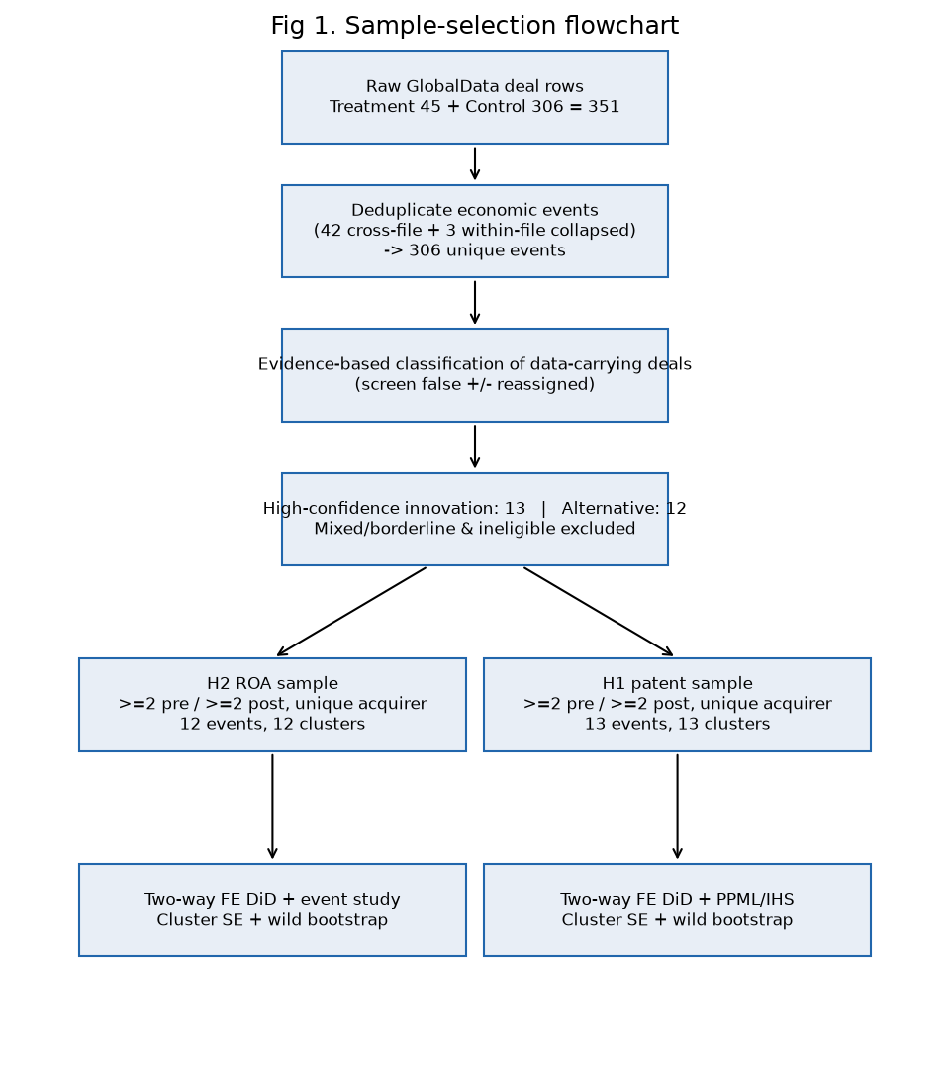
Figure 4.1. Sample construction flowchart, from raw extracts to the analytical samples
Source: author's elaboration based on the consolidated GlobalData transaction set.

4.3 Outcome-specific analytical samples and coverage
Separate analytical samples were constructed for the two hypotheses because a transaction may contain usable patent data but no financial data, or financial data but no patent data; consequently, the samples are not required to include the same firms. The preferred inclusion criterion required at least two non-missing pre-completion observations and at least two non-missing post-completion observations for the relevant outcome within the event window t−3 to t+3, together with the one-event-per-acquirer restriction. The completion year, t0, was excluded from the primary specification because it combines pre- and post-transaction months. In the case of the financial outcomes, only Bloomberg standardised realised actuals were used: blank cells were treated as missing rather than zero, and the sample was capped at calendar year 2023 to exclude Bloomberg estimate years. Patent outcomes were measured as unique simple patent-family counts by earliest priority year from Lens and were validated against the family-level export.
Table 4.5. Primary analytical samples
Sample | Events | Acquirer clusters | Innovation | Alternative | Observations
H2 — ROA (pp) | 12 | 12 | 8 | 4 | 72
H1 — patent families | 13 | 13 | 7 | 6 | 72
Note. Inclusion rule: ≥2 non-missing pre and ≥2 non-missing post observations, t0 omitted, one non-overlapping event per acquirer group. Source: author's calculations.
As can be seen from Figure 4.2, outcome coverage is strongest within the central event window from t−3 to t+3 and becomes thinner towards the edges. Another important feature of the H2 sample is that its innovation group is dominated by small biotechnology and specialty acquirers. This imbalance is assessed formally in Section 4.5 and must be borne in mind when interpreting the H2 findings.
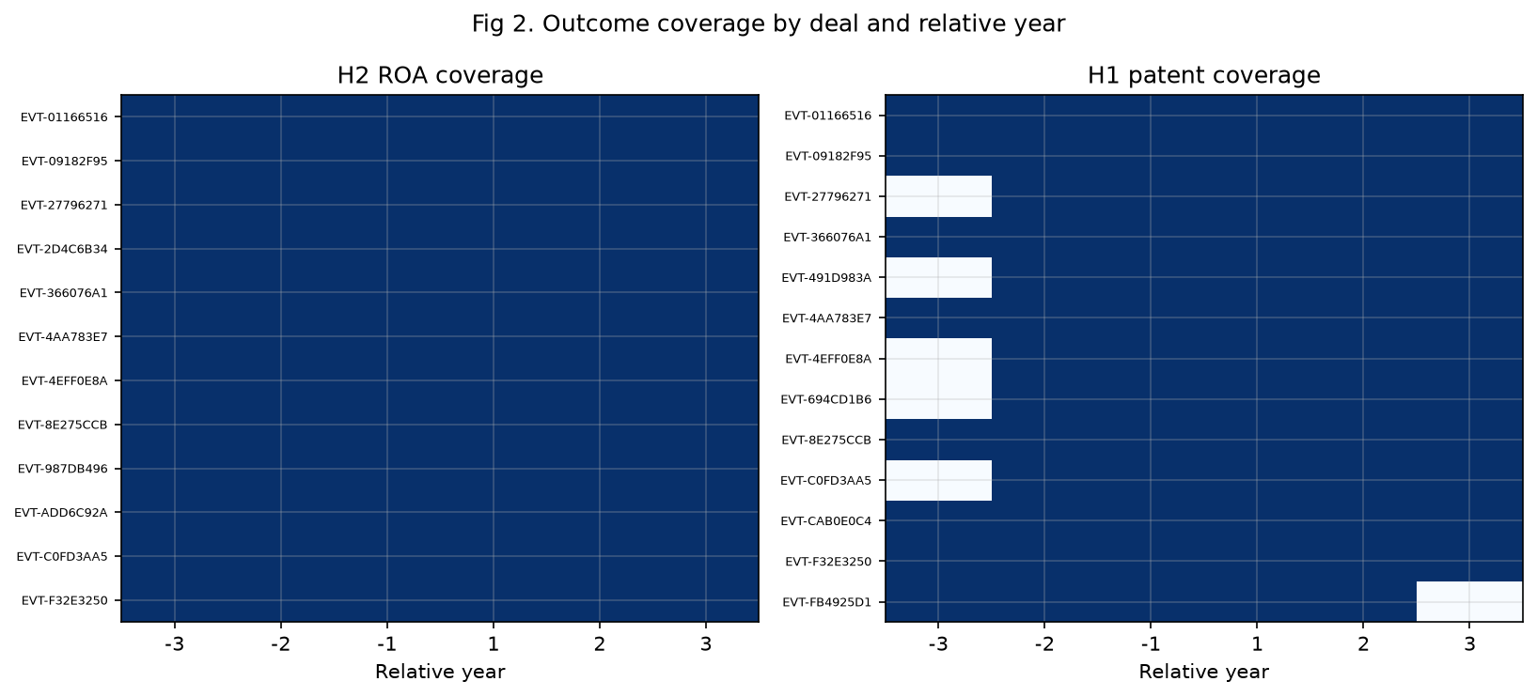
Figure 4.2. Outcome coverage by relative event year (H1 and H2 samples)
Source: author's calculations based on Bloomberg and Lens imports.

4.4 Descriptive statistics
Table 4.6 presents the pre- and post-period descriptive statistics for each group. Three main patterns emerge from the data. First, in terms of financial performance, the innovation group entered the transaction period with both a lower and substantially more volatile ROA: its pre-period mean was −6.1 pp, with a standard deviation of 35.9 and a minimum of approximately −110 pp, largely reflecting loss-making biotechnology firms. The corresponding alternative-group mean was +3.9 pp, with a standard deviation of 13.0. Second, the unadjusted pre-to-post change in ROA was +9.0 pp for the innovation group, compared with +0.3 pp for the alternative group. This initial result is directionally consistent with H2, although it precedes any adjustment. Third, with respect to patent activity, the innovation group was markedly more patent-intensive before completion, producing 11.7 families per year compared with 2.5 in the alternative group. Its output subsequently declined by −3.9 families, whereas the alternative group remained broadly stable, with a change of −0.3. This pattern is directionally consistent with H1's expectation of a less favourable differential in measured patent output.
Table 4.6. Descriptive statistics by hypothesis sample and group
Sample | Group | Events | Obs | Pre mean | Pre s.d. | Post mean | Post s.d. | Raw Δ (post−pre) | Min | Max
H2 ROA (pp) | Alternative | 4 | 24 | 3.89 | 12.99 | 4.15 | 10.19 | +0.26 | −23.2 | 14.0
H2 ROA (pp) | Innovation | 8 | 48 | −6.10 | 35.93 | 2.88 | 14.54 | +8.99 | −110.5 | 31.0
H1 families | Alternative | 6 | 33 | 2.50 | 2.73 | 2.18 | 3.40 | −0.32 | 0 | 12
H1 families | Innovation | 7 | 39 | 11.67 | 10.60 | 7.81 | 9.95 | −3.86 | 0 | 42
Note. ROA is the Bloomberg standardised return on assets in percentage points (realised actuals only); patent families are unique simple families by earliest priority year (Lens). Source: author's calculations.
Figures 4.3 and 4.4 illustrate the group-mean trajectories of ROA and patent-family output in event time. With regard to ROA, Figure 4.3 shows that the deep and volatile pre-period losses of the innovation group moved towards the level observed for the alternative group after completion. In contrast, Figure 4.4 shows a higher initial level of patent activity in the innovation group followed by a post-completion decline, while the alternative group remained approximately flat. These descriptive patterns provide useful motivation for the analysis, but they do not substitute for the fixed-effects estimates reported in Sections 4.6 and 4.7.
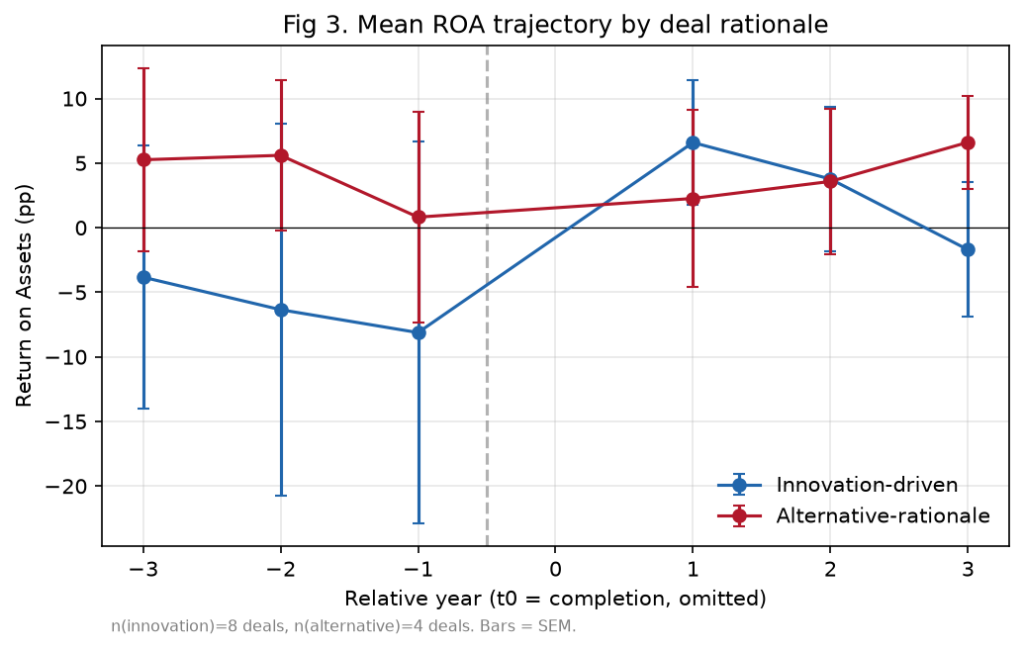
Figure 4.3. Mean ROA by group in event time (H2 sample)
Source: author's calculations based on Bloomberg data.
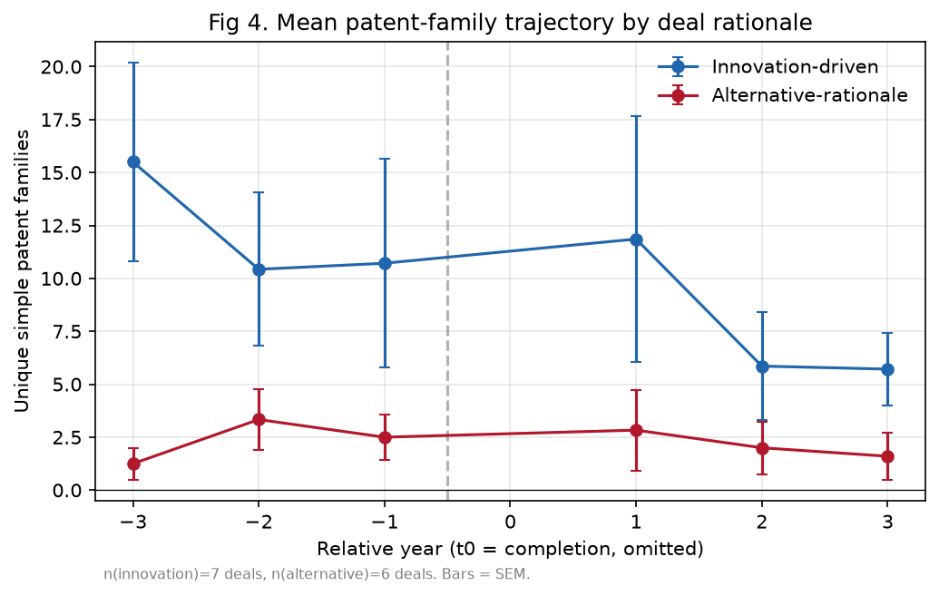
Figure 4.4. Mean patent-family output by group in event time (H1 sample)
Source: author's calculations based on Lens data.

4.5 Pre-treatment comparability and common support
Table 4.7 reports the standardised mean differences (SMDs) and variance ratios for the pre-treatment characteristics, while Figure 4.5 provides the corresponding love plot. The results show substantial imbalance between the groups. For H2, the pre-period ROA level differs moderately (SMD ≈ −0.36), but the variance ratio exceeds 7. The firm-size covariates also indicate that innovation acquirers are considerably smaller, with an SMD of 0.90 for pre-deal log-assets and 1.19 for revenue. For H1, the pre-period outcome level is itself strongly imbalanced (SMD ≈ 1.12). A more reassuring finding is that the pre-period outcome slopes are almost identical across the two groups for both outcomes (SMD = 0.02 and 0.04), which is the dimension most directly relevant to the parallel-trends assumption.
Table 4.7. Pre-treatment balance: standardised mean differences and variance ratios
Sample | Variable | SMD | Variance ratio
H2 | Pre-period outcome mean (ROA) | −0.36 | 7.07
H2 | Pre-period outcome slope | 0.02 | 17.65
H2 | Pre-deal log total assets | 0.90 | 9.72
H2 | Pre-deal leverage | 0.49 | 10.03
H2 | Pre-deal operating margin | 0.12 | 0.72
H2 | Pre-deal revenue (€m) | 1.19 | 2,240.1
H1 | Pre-period outcome mean (families) | 1.12 | 10.65
H1 | Pre-period outcome slope | 0.04 | 12.44
Note. SMD = (mean innovation − mean alternative) / pooled standard deviation; conventional balance thresholds are |SMD| < 0.10–0.25. Source: author's calculations.
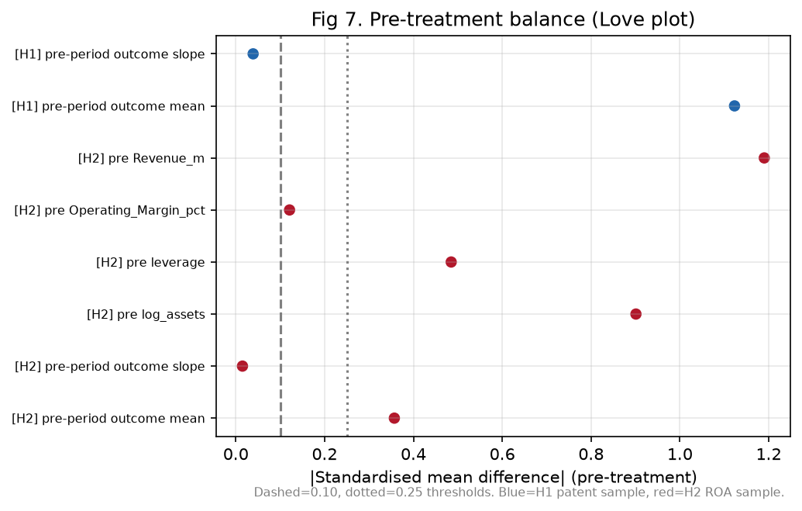
Figure 4.5. Love plot of standardised mean differences (pre-treatment characteristics)
Source: author's calculations.
Figure 4.6 examines common support in the distributions of the pre-period outcome means, with additional distributional information reported in Table 4.8. The evidence shows that some overlap exists, but that it is limited: the deepest-loss ROA observations are found exclusively among innovation acquirers, and the same is true of the upper tail of patent output. Although deal fixed effects absorb these level differences, the thin overlap means that identification depends heavily on the parallel pre-trends assessed in Sections 4.6 and 4.7. A matched or weighted specification was deliberately not adopted as the benchmark because, with only 12–13 events, matching would remove a large share of the observations while producing largely cosmetic balance. The sample is therefore not sufficiently large to support such an approach credibly. In accordance with the analysis protocol, the benchmark consists of unweighted fixed-effects estimates, with the limitations arising from imbalance stated explicitly.
Table 4.8. Common support: distribution of pre-period outcome means by group
Sample | Group | n | Min | P25 | Median | P75 | Max
H2 ROA (pp) | Innovation | 8 | −96.5 | 0.1 | 6.6 | 10.0 | 15.4
H2 ROA (pp) | Alternative | 4 | −16.9 | 2.4 | 9.8 | 11.3 | 12.8
H1 families | Innovation | 7 | 0.5 | 3.8 | 7.3 | 17.0 | 26.3
H1 families | Alternative | 6 | 0.0 | 1.7 | 1.8 | 2.8 | 8.5
Source: author's calculations.
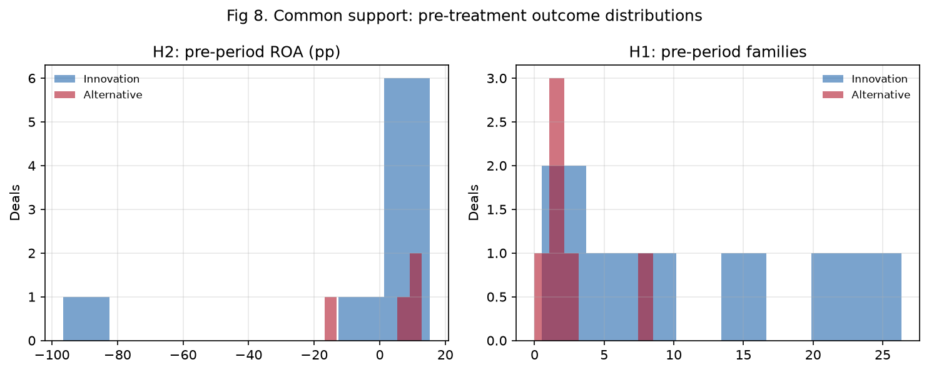
Figure 4.6. Common support of pre-period outcome means (H2 and H1 samples)
Source: author's calculations.

4.6 H1 — Differential patent output
The baseline analysis was conducted using a two-way fixed-effects DiD model estimated on the event panel: Yit = αi + λt + δ·Postit + β·(Innovationi × Postit) + εit. In this specification, α represents deal fixed effects, which absorb the treatment main effect; λ denotes calendar-year fixed effects; δ captures the post-period change in the alternative group; and β is the differential of interest. Since the number of clusters (12–13) is well below the level at which asymptotic cluster-robust inference is generally reliable, the analysis reports p-values obtained from a restricted wild-cluster bootstrap using Rademacher weights and B = 1,999, alongside cluster-robust standard errors.
The results obtained for H1 are reported in Table 4.9. The estimated differential was β = −0.46 patent families, with a cluster-robust SE of 2.07, a 95% CI of [−4.52, 3.61], a cluster-robust p-value of 0.83, and a wild-bootstrap p-value of 0.82, based on 13 events and 13 acquirer clusters. The decomposition indicates a modelled post-period change of δ = +5.20 families for the alternative group and δ + β = +4.74 for the innovation group. Thus, the differential is close to zero. This finding was also obtained under the inverse-hyperbolic-sine transformation (β = 0.11, p = 0.85) and the Poisson pseudo-maximum-likelihood specification, which is appropriate for a count outcome (β = 0.05 on the log-count scale, p = 0.93).
Table 4.9. H1 — DiD estimates for patent-family output
Specification | δ (Alt., Post) | β (Innov. × Post) | SE | 95% CI | p | Wild p | Events | Clusters
Primary (linear FE) | 5.20 | −0.46 | 2.07 | [−4.52, 3.61] | 0.83 | 0.82 | 13 | 13
IHS transform | 0.14 | 0.11 | 0.56 | [−0.99, 1.21] | 0.85 | 0.83 | 13 | 13
Poisson PPML | 0.87 | 0.05 | 0.52 | [−0.97, 1.06] | 0.93 | — | 13 | 13
Serial acquirers included | 5.50 | −0.81 | 1.81 | [−4.35, 2.73] | 0.65 | 0.67 | 16 | 13
Balanced 3-pre/3-post | 22.57 | −1.22 | 3.15 | [−7.40, 4.95] | 0.70 | 0.79 | 8 | 8
Note. Deal and calendar-year fixed effects; SEs clustered by acquirer group; wild-cluster bootstrap (Rademacher, B = 1,999). PPML coefficients are log-count differentials. Source: author's estimations.
Figure 4.7 presents the event-study decomposition of the differential by relative year. The post-completion coefficients remain close to zero, taking values of +2.61 at t+1, −1.52 at t+2, and −1.36 at t+3, and are accompanied by wide confidence intervals. The pre-period coefficients are also small and statistically indistinguishable from zero. Consistent with this pattern, the joint pre-trend test does not reject the parallel-trends assumption (p = 0.96).
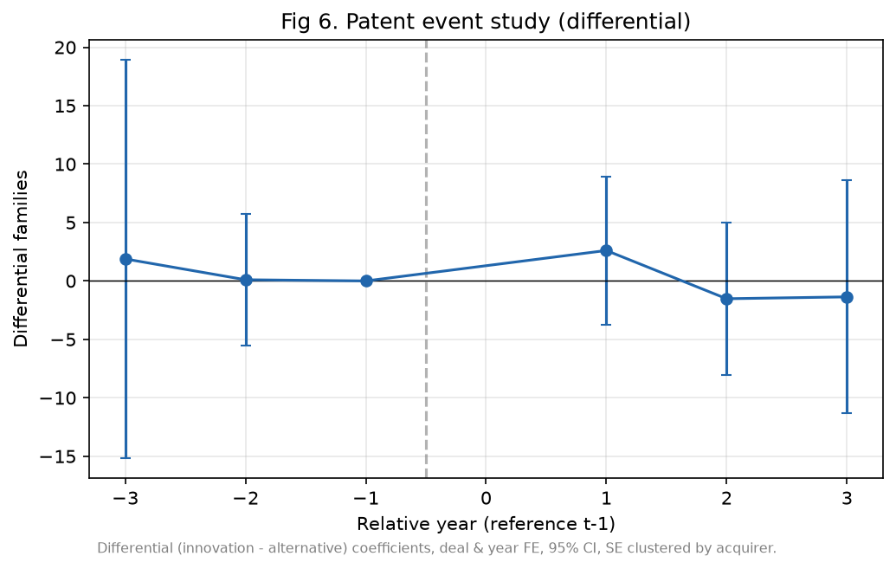
Figure 4.7. Event study — differential patent-family output (H1)
Note. Reference period t−1; whiskers are 95% confidence intervals (cluster-robust). Source: author's estimations.
Taken together, these results do not support H1 at conventional levels of statistical significance. Over the three post-completion years, no detectable differential in patent-family output is observed between innovation-driven and alternative-rationale acquirers. However, these data must be interpreted with caution because the confidence interval remains wide. The result is therefore an imprecise null: moderate effects in either direction cannot be ruled out, and exact equivalence has not been demonstrated. There are at least two possible explanations for this pattern, which are developed further in Chapter 5. First, patent quantity measured over a three-year horizon may not capture the value of an acquired late-stage pipeline. Second, residual false negatives in the comparison group could attenuate a genuine contrast towards zero.

4.7 H2 — Differential financial performance (ROA)
As shown in Table 4.10, the estimated H2 differential was β = +10.78 percentage points of ROA, with a cluster-robust SE of 12.48, a 95% CI of [−13.69, 35.24], a cluster-robust p-value of 0.39, and a wild-bootstrap p-value of 0.40, based on 12 events and 12 acquirer clusters. The decomposition attributes a post-period change of δ = +2.76 pp to the alternative group and δ + β = +13.53 pp to the innovation group. The point estimate is therefore in the direction predicted by H2, suggesting a more favourable post-completion change in ROA for innovation-driven transactions. Nevertheless, the estimate is not statistically distinguishable from zero, and its confidence interval is very wide.
Table 4.10. H2 — DiD estimates for financial performance
Specification | δ (Alt., Post) | β (Innov. × Post) | SE | 95% CI | p | Wild p | Events | Clusters
Primary (ROA, linear FE) | 2.76 | +10.78 | 12.48 | [−13.69, 35.24] | 0.39 | 0.40 | 12 | 12
Winsorised 1/99 (pre-declared) | 1.64 | +10.10 | 12.37 | [−14.14, 34.35] | 0.41 | 0.44 | 12 | 12
Serial acquirers included | 3.05 | +6.43 | 7.85 | [−8.96, 21.83] | 0.41 | 0.38 | 16 | 12
Balanced 3-pre/3-post | 2.76 | +10.78 | 12.48 | [−13.69, 35.24] | 0.39 | 0.40 | 12 | 12
t0 coded as post | 0.98 | +11.29 | 11.51 | [−11.28, 33.86] | 0.33 | — | 12 | 12
Op. margin (winsorised, rev ≥ €50m) | −6.77 | +21.72 | 25.14 | [−27.55, 70.99] | 0.39 | 0.54 | 10 | 10
Note. Deal and calendar-year fixed effects; SEs clustered by acquirer group; wild-cluster bootstrap (Rademacher, B = 1,999). The operating-margin specification is restricted to revenue ≥ €50m and winsorised because the margin is mechanically extreme for near-zero-revenue biotechs. Source: author's estimations.
Figure 4.8 shows positive but individually insignificant post-completion coefficients of +11.96 at t+1, +9.86 at t+2, and +2.24 at t+3, with the magnitude diminishing by the third year. The joint pre-trend test does not reject parallel pre-trends (p = 0.57). However, the pre-period differentials of −2.74 at t−3 and −4.56 pp at t−2 are not negligible in magnitude. Given the limited statistical power of the sample, this non-rejection constitutes only weak evidence. These results therefore need to be interpreted with additional caution when assessing the positive post-period pattern.
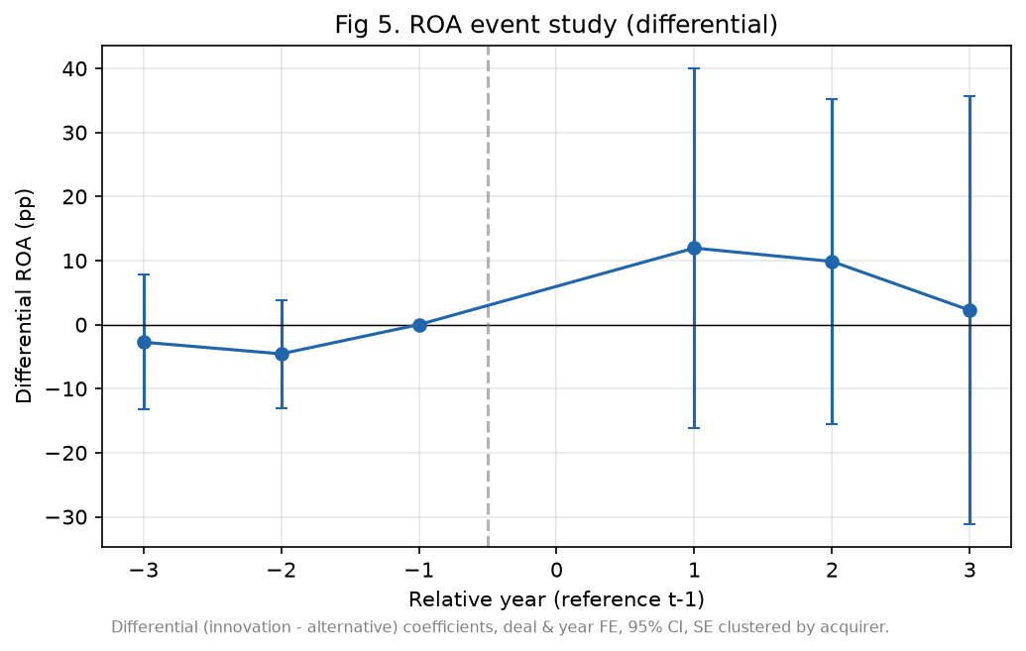
Figure 4.8. Event study — differential ROA (H2)
Note. Reference period t−1; whiskers are 95% confidence intervals (cluster-robust). Source: author's estimations.
Taken together, the H2 findings provide directional rather than statistical support. The differential change in ROA is positive across all specifications, but it does not approach conventional levels of significance. Moreover, as shown in Section 4.9, the point estimate is concentrated in a small number of small and volatile acquirers. The evidence therefore suggests an association that is compatible with the hypothesised innovation–finance pattern, but it does not confirm an effect.

4.8 Robustness, sensitivity and placebo analyses
The principal robustness dimensions are already reported in Tables 4.9 and 4.10. These include the retention of serial acquirers, which mechanically re-weights repeat acquirers and reduces the H2 estimate to +6.43 pp while leaving the substance of H1 unchanged; the balanced 3-pre/3-post panel; the pre-declared 1/99 winsorisation; alternative coding of t0; and the transformation and count-model checks for the patent outcome. Across these perturbations, the signs of the estimates remain stable, and no specification produces a statistically significant result for either hypothesis. Table 4.11 summarises the full perturbation grid. Table 4.12 then reports a placebo analysis in which a false completion date is assigned at t−2 and the model is re-estimated using only pre-period data. As expected, both placebo differentials are close to zero and statistically insignificant (H2: −3.18, p = 0.77; H1: +0.20, p = 0.98). This finding suggests that the estimation procedure does not generate an apparent effect in a period in which none should be present.
Table 4.11. Summary of robustness perturbations
Perturbation | H2 β (ROA, pp) | H1 β (families)
Primary (unique acquirer, ≥2 pre / ≥2 post) | +10.78 | −0.46
Serial acquirers included | +6.43 | −0.81
Balanced 3-pre/3-post | +10.78 | −1.22
Winsorised 1/99 (pre-declared) | +10.10 | —
t0 coded as post | +11.29 | —
IHS / PPML (count outcome) | — | +0.11 / +0.05
Placebo (fake completion at t−2) | −3.18 (p = 0.77) | +0.20 (p = 0.98)
Source: author's estimations.
Table 4.12. Placebo test — fake completion at t−2, pre-period data only
Sample | Placebo β | SE | p | Obs
H2 — ROA | −3.18 | 10.74 | 0.77 | 36
H1 — patent families | +0.20 | 9.77 | 0.98 | 34
Note. The placebo interaction should be, and is, statistically indistinguishable from zero. Source: author's estimations.

4.9 Influence diagnostics: leave-one-acquirer-out
To assess the influence of individual observations in these small samples, each estimate was recalculated after excluding one acquirer group at a time (Table 4.13 and Figure 4.9). The analysis revealed a marked difference between the two hypotheses. With respect to H1, the differential remained within [−1.59, +1.00] regardless of the acquirer omitted, indicating a comparatively stable near-zero result. By contrast, the H2 estimate was highly sensitive to particular firms. Excluding Biodexa, a micro-cap acquirer with extreme ROA fluctuations, reduced the differential from +10.78 to +0.43, whereas excluding Roche increased it to +14.33. These findings suggest that the positive H2 pattern is driven by a small number of very small and volatile acquirers rather than by a broadly distributed effect. It should not, therefore, be generalised beyond the observed region of support.
Table 4.13. Leave-one-acquirer-out estimates (selected)
Sample | Acquirer dropped | β | Δ vs baseline
H2 — ROA | Biodexa Ltd | +0.43 | −10.34
H2 — ROA | Eurofins Scientific SE | +8.49 | −2.29
H2 — ROA | Zambon SpA | +10.86 | +0.09
H2 — ROA | Sanofi | +11.68 | +0.90
H2 — ROA | GSK | +12.67 | +1.90
H2 — ROA | Vectura | +13.73 | +2.96
H2 — ROA | Roche | +14.33 | +3.55
H1 — families | Sanofi | −1.59 | −1.13
H1 — families | GSK | −1.06 | −0.61
H1 — families | Zambon SpA | −0.16 | +0.29
H1 — families | Recordati | +0.22 | +0.67
H1 — families | Roche | +1.00 | +1.46
Note. Baselines: H2 = +10.78; H1 = −0.46. The full grid (12 + 13 exclusions) is reported in the analysis repository (T11). Source: author's estimations.
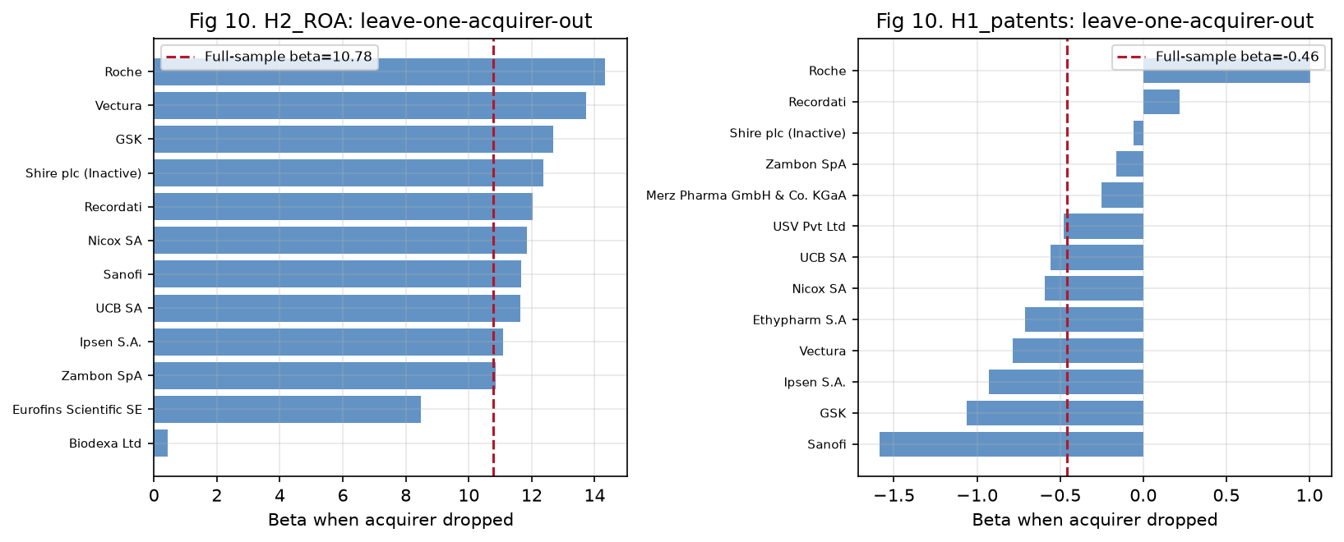
Figure 4.9. Leave-one-acquirer-out sensitivity of the DiD differentials
Source: author's estimations.

4.10 Hypothesis decisions and joint interpretation
Figure 4.10 presents the two headline differentials together with their 95% confidence intervals, while Table 4.14 summarises the formal decisions for the two hypotheses.
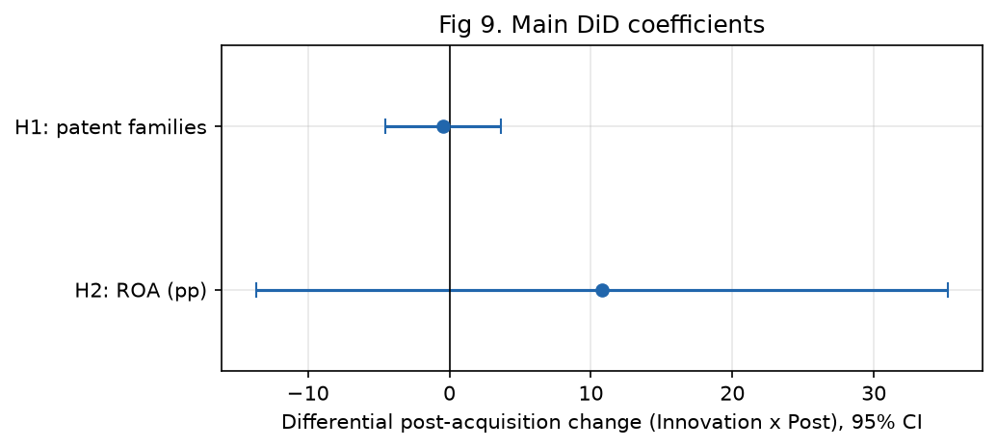
Figure 4.10. Headline DiD differentials with 95% confidence intervals
Source: author's estimations.
Table 4.14. Hypothesis decision matrix
Hypothesis | Expected direction | β | 95% CI | Wild p | Pre-trend p | Events / clusters | Decision
H1 — differential patent output | Innovation < Alternative | −0.46 | [−4.52, 3.61] | 0.82 | 0.96 | 13 / 13 | Not supported (imprecise null)
H2 — differential ROA | Innovation > Alternative | +10.78 | [−13.69, 35.24] | 0.40 | 0.57 | 12 / 12 | Directionally consistent, not significant
Source: author's estimations.
Taken together, the results suggest H1 ≈ 0 and H2 > 0 in point estimate, although the latter is statistically insignificant and outlier-sensitive. Within the framework developed in Chapters 2 and 3, this pattern corresponds most closely to the “H1 null / H2 positive” configuration. In nominal terms, it is consistent with an innovation–finance account in which innovation-driven acquirers do not generate additional near-term patent output relative to other acquirers, while experiencing a more favourable short-run change in ROA. However, the evidence from this study is not sufficiently strong to establish that mechanism. Both confidence intervals include zero, the direction of the H2 estimate depends heavily on one or two firms, and the evidence-based classification—although frozen before estimation—could not draw on archived primary filings. The possible mechanisms underlying this pattern, together with the evidence required to distinguish between them, are considered in Chapter 5.

Summary of findings
With respect to H1, the hypothesis is not supported at conventional levels. The estimated differential is close to zero (β = −0.46 families; wild p = 0.82) and remains substantively unchanged under the IHS, PPML, serial-acquirer, and balanced specifications. The joint test does not reject parallel pre-trends (p = 0.96), and the placebo estimate is also near zero. The result is associational and should be characterised as an imprecise null rather than evidence of equivalence.
Regarding H2, the estimate is directionally consistent with the hypothesis (β = +10.78 pp) but is not statistically significant (wild p = 0.40). The confidence interval is wide, and the positive result is driven by influential small acquirers; when Biodexa is excluded, the estimate falls to +0.43. The evidence is therefore associational and does not confirm H2.
It is important to note that every numerical result reported in this chapter can be traced to an exported table, model file, or figure generated by the reproducible analysis pipeline using seed 20260730. The raw source workbooks were not modified.

4.11 Limitations of the empirical analysis
The interpretation of these findings is subject to the limitations set out below. These constraints also provide the basis for the research extensions proposed in Chapter 5.
- Small analytical samples and few clusters. The research is limited by the relatively small primary samples, which contain 12 events for H2 and 13 events for H1, with an equally small number of acquirer clusters. Although wild-cluster bootstrap inference was used, statistical power remains low and the confidence intervals are wide. Consequently, statistically insignificant estimates should not be treated as evidence of no difference, and still less as evidence of equivalence.
- Partial outcome coverage. A further limitation is that Bloomberg financial data and Lens patent exports are available for only a subset of the eligible transaction universe. In accordance with the protocol, the analysis prioritised data-carrying transactions. However, the large number of otherwise eligible transactions without imported outcomes cannot enter H1 or H2, and their exclusion is unlikely to be random with respect to firm size and listing status.
- Classification relies on GlobalData-embedded evidence rather than archived filings. The study is limited in that pre-completion company announcements and target filings could not be retrieved and archived because network access was unavailable during estimation. Classification therefore relied on the announcement text embedded in the workbook deal descriptions, together with the GlobalData rationale. Residual classification error cannot be ruled out. False positives would increase heterogeneity within the treatment group, whereas false negatives remaining in the comparison group would tend to attenuate the estimated contrast towards zero. Although several such cases were identified and reassigned, others may remain among the non-data-carrying transactions, and the direction of the resulting net bias is uncertain.
- Poor pre-treatment balance. The data show that innovation acquirers are systematically smaller and more volatile than alternative acquirers. Although fixed effects remove differences in levels, they do not eliminate differential dynamics. At this sample size, a credible matched or weighted counterfactual cannot be constructed. Fixed effects alone cannot create an adequate counterfactual where common support is limited.
- Influence of individual firms. The H2 point estimate is strongly affected by one or two small and volatile acquirers, most notably Biodexa, and excluding these observations largely removes the apparent effect. These findings cannot be extrapolated beyond the support region represented in the sample.
- Outcome-metric limits. Another limitation concerns the measures used. Patent-family counts based on earliest priority year capture the quantity of innovation rather than its value or quality. A credible citation-weighted secondary outcome could not be constructed with cells of this size and was therefore not reported. In addition, operating margin is mechanically extreme for biotechnology firms with near-zero revenue and is consequently reported only after restricting the sample by revenue and applying winsorisation.
- Patent search-scope heterogeneity. The research is limited by differences in the Lens applicant-search scope across companies, including explicit versus inferred ranges and occasional EP-only or limited-subsidiary coverage, as in the Sanofi/Ablynx case. Enforcing a strictly scope-consistent sample would reduce an already small sample still further. The scope-consistent year-summary series was therefore retained, and the discrepancy was documented.
- Staggered completion timing. A further methodological limitation concerns the distribution of completion dates across 2012–2020. Two-way fixed-effects DiD estimators may be biased under heterogeneous treatment timing when effects vary across cohorts. Cohort-stratified or stacked event-study designs could not be implemented with cells of the present size and remain an important area for future research.
- Estimation environment. The analysis was also limited by the unavailability of the pre-registered R environment based on fixest. Python equivalents implemented through statsmodels and linearmodels were therefore used, together with a manually coded restricted wild-cluster bootstrap. Although the findings were cross-checked across linear fixed-effects, PPML, and IHS specifications, they were not independently replicated in R.
- Protocol documents. A final limitation is that the binding methodology and literature-review documents were not available during the estimation run. The analysis was consequently governed by the restated protocol contained in the master analysis prompt, and any methodological requirement not reproduced there could not be implemented. All resulting deviations are recorded in the analysis decision and conflict logs.

Chapter 5 — Discussion
5.1 Summary of the principal findings
This chapter interprets the empirical evidence reported in Chapter 4 in the light of the theoretical framework and the prior literature reviewed in Chapters 1 and 2. The general research question asked whether innovation-driven acquisitions create value for acquiring firms in the European pharmaceutical industry. The empirical design does not answer this question by contrasting acquiring with non-acquiring firms; instead, it compares two categories of completed transaction, namely innovation-driven acquisitions, in which the target contributes a material pre-completion pipeline, technology platform, or research capability, and alternative-rationale acquisitions, which are motivated primarily by scale, geographic reach, mature products, services, or organisational efficiency. Two primary outcomes were examined over the three years following completion: patent-family output, addressed by H1, and return on assets, addressed by H2. Each coefficient measures the differential post-versus-pre change associated with an innovation-driven transaction relative to an alternative-rationale transaction, and none should be read as the effect of acquiring rather than not acquiring.
The evidence does not support H1. The analysis does not identify a statistically detectable difference in the three-year patent-family trajectories of the two acquisition categories: the estimated differential is close to zero (β = −0.46 families; wild-bootstrap p = 0.82), and this result is substantively unchanged under the inverse-hyperbolic-sine and Poisson pseudo-maximum-likelihood specifications. Because the confidence interval remains wide, at approximately [−4.52, 3.61], the finding is best characterised as an imprecise null rather than as evidence that the two categories are equivalent.
H2 is not supported at conventional significance levels, although the baseline point estimate is directionally consistent with the predicted relationship. The estimated differential in return on assets is positive (β = +10.78 percentage points) but statistically insignificant (wild-bootstrap p = 0.40), with a wide confidence interval of approximately [−13.69, 35.24]. The influence diagnostics further show that this positive point estimate is fragile: excluding a single micro-cap acquirer reduces it to approximately +0.43 percentage points. Neither result, therefore, demonstrates equivalence between the two categories, and neither supports a strong causal conclusion. Rather than confirming a universal pattern, the findings direct attention to heterogeneity and to the conditions under which acquired innovation assets are, or are not, converted into measurable performance.
5.2 Interpretation of H1 — Patent-family output
The first hypothesis anticipated that innovation-driven acquirers would experience a relatively less favourable change in annual patent-family output than alternative-rationale acquirers in the three years following completion. The estimated differential is essentially zero and imprecisely estimated, so the anticipated negative differential is not observed. It is important to be clear about what this result does and does not say. It indicates that, on average and within this sample, the two categories of acquirer do not display measurably different three-year patent-family trajectories; it does not establish that acquisition rationale is irrelevant to innovation, nor that the two groups are equivalent.
Several interpretations are consistent with a near-zero average differential. The first concerns the well-documented development lags of pharmaceutical research. As emphasised in the literature on innovation measurement and drug development (DiMasi et al., 2016), the interval between priority filing, clinical progression, and regulatory approval is long, and a three-year post-completion window may be too short for the innovative contribution of an acquired pipeline to register as new patent families attributable to the acquirer. A related consideration is that the assets motivating an innovation-driven transaction were frequently patented by the target before completion; their scientific value may subsequently be realised through clinical progression or regulatory approval rather than through additional filings, forms of value that a family count does not capture. This distinction between patent quantity and patent quality or value is central to the measurement literature (Valentini, 2012; Hall, Jaffe and Trajtenberg, 2001), which cautions that counts and quality-adjusted measures may diverge.
A second interpretation concerns treatment heterogeneity. The innovation-driven group is not uniform: it combines pipeline, platform, diagnostic, gene-therapy, inhalation-technology, and specialist-technology transactions undertaken by acquirers ranging from large pharmaceutical groups to small biotechnology and specialty firms. The theoretical literature on absorptive capacity (Cohen and Levinthal, 1990) and on technological relatedness (Ahuja and Katila, 2001; Cloodt et al., 2006) suggests that the innovative consequences of an acquisition depend on the compatibility between the acquired knowledge base and the acquirer's existing competences. Where relatedness and absorptive capacity are high, integration may sustain or increase inventive output; where they are low, disruption may suppress it. Averaging across such heterogeneous transactions can produce a coefficient near zero even when transaction-level effects are substantial and offsetting.
A third interpretation concerns classification. As documented in Chapter 4, the first-stage rationale screens were subject to bidirectional error, and although the adjudication reassigned several clear cases, residual false negatives may remain among the transactions that could not be individually examined. Because false negatives place genuine innovation-driven transactions into the comparison group, they contaminate that group and attenuate any true contrast towards zero. Low statistical power compounds this: with a small number of acquirer clusters, the estimator is unlikely to detect a moderate differential even if one exists, which is precisely why the confidence interval is wide.
It is also worth noting what the event-study evidence adds to this reading. The joint test does not reject parallel pre-trends, which lends some credibility to the comparison, but the associated confidence intervals are wide in every relative year, so the absence of a detectable pre-trend reflects limited power as much as genuine parallelism. A near-zero differential estimated with such imprecision is therefore fragile evidence on which to build any strong claim, whether of an effect or of its absence.
Taken together, H1 is not supported, but the appropriate conclusion is cautious. The analysis does not establish equivalence between the two acquisition categories, and a near-zero average coefficient may conceal heterogeneous, transaction-specific effects that partially offset one another. The result is therefore most accurately described as an imprecise null that is compatible with development lags, measurement limitations, and residual classification error, rather than as evidence that acquisition rationale has no bearing on innovation.
5.3 Interpretation of H2 — Return on assets
The second hypothesis anticipated a more favourable post-completion change in return on assets for innovation-driven acquirers than for alternative-rationale acquirers. The estimated differential is positive, at +10.78 percentage points, and the decomposition attributes a post-period change of +2.76 percentage points to the alternative group and +13.53 percentage points to the innovation group. The direction of this estimate is consistent with the hypothesis. Nevertheless, the estimate is not statistically distinguishable from zero, its confidence interval is very wide, and, as discussed below, it is highly sensitive to influential observations.
A positive differential of this kind is compatible with several mechanisms, although the design cannot demonstrate that any of them operated. The financial-synergy literature indicates that cost consolidation, the removal of duplicated functions, the reallocation of resources, and the exploitation of complementary manufacturing, regulatory, and commercial capabilities may improve accounting performance within a relatively short period, even where innovation output does not increase (Teece, 1986). The commercialisation of acquired assets and post-completion restructuring may also raise measured returns. A positive point estimate is therefore theoretically plausible; but plausibility is not confirmation, and the statistical insignificance of the estimate means that these mechanisms remain conjectural in the present sample.
An alternative and more sceptical reading is equally consistent with the evidence. The innovation-driven group enters the observation window with a lower and considerably more volatile pre-period return on assets, a feature associated with the presence of small, loss-making biotechnology acquirers. When an initially weak or volatile series is observed over a subsequent period, a portion of any apparent improvement may reflect convergence from an unusually low base, or regression towards the mean, rather than an economic consequence of the transaction. Acquisition accounting introduces a further complication: changes in the asset base, restructuring expenses, integration costs, and impairments can all move return on assets in the years immediately after completion for reasons unrelated to the underlying performance of the acquired innovation. In addition, synergies typically require time to materialise, so a three-year window may capture integration costs more fully than realised benefits.
The influence diagnostics are decisive for the interpretation of H2. The leave-one-acquirer-out analysis shows that the positive differential is concentrated in a small number of small and volatile acquirers rather than being broadly distributed. Excluding Biodexa, a micro-cap acquirer with extreme fluctuations in return on assets, reduces the differential from +10.78 to approximately +0.43 percentage points, whereas excluding Roche raises it to +14.33. A result that moves so sharply with the removal of one firm cannot be regarded as a stable, systematic pattern. The retention of serial acquirers likewise reduces the estimate, to +6.43 percentage points, underlining its dependence on sample composition.
The event-study evidence reinforces this cautious reading. The post-completion coefficients are positive in the first two years but diminish by the third, and the joint pre-trend test does not reject parallel pre-trends; yet the pre-period differentials are not negligible in magnitude, so the parallel-trends assumption is supported weakly rather than firmly. A differential that is positive but declining, imprecisely estimated, and concentrated in a few firms is precisely the configuration in which an apparently favourable average can coexist with the absence of any systematic economic effect.
The appropriate conclusion is therefore measured. The positive estimate is compatible with cost consolidation, resource reallocation, complementary-asset exploitation, and the commercialisation of acquired capabilities, but the analysis cannot demonstrate that financial synergies occurred. Because the estimate appears to be driven by a small number of volatile acquirers rather than by a broad and systematic tendency, H2 should be described as directionally consistent but statistically unsupported and fragile, and it should not be characterised as confirmed.
5.4 Comparison with previous literature
The findings can be located within the existing literature by considering, in turn, the points of agreement, the points of difference, and the methodological reasons why the present results need not contradict earlier work. The intention here is not to restate the review presented in Chapters 1 and 2 but to interpret the two headline results against the studies already discussed there.
With respect to agreement, the H1 result is broadly compatible with the strand of research that reports conditional or heterogeneous, rather than uniformly negative, innovation consequences of acquisitions. Ahuja and Katila (2001) and Cloodt et al. (2006) emphasise that post-acquisition inventive performance depends on the relatedness and absolute size of the acquired knowledge base, so that outcomes vary across transactions rather than following a single sign. Cohen and Levinthal (1990) provide the absorptive-capacity foundation for this conditionality. A near-zero average differential is consistent with a setting in which such heterogeneous, offsetting effects are aggregated, and in which a short window and a quantity-based outcome further limit what can be detected.
With respect to difference, part of the literature reports declines in patenting following consolidation, particularly where overlapping research programmes are rationalised, as discussed by Ornaghi (2009) and in the wider evidence on how mergers affect innovation (Haucap, Rasch and Stiebale, 2019). The present study does not reproduce the negative result identified in some of this research; however, the wide confidence interval does not rule out a moderate negative differential, so the evidence is better read as insufficiently precise to adjudicate than as a contradiction. Much of the earlier work also differs from the present study in ways that bear directly on comparability. Earlier studies frequently contrast acquiring with non-acquiring firms, whereas the present design compares two types of completed acquisition; they often draw on larger samples and different national settings, whereas the present analysis is confined to a small European sample; and they sometimes employ different innovation measures, whereas this study relies on simple patent-family counts over a three-year horizon. Differences in transaction definitions, in comparison groups, in classification accuracy, and in the completeness of target-level data can each generate divergent estimates without implying that any one study is incorrect.
The financial results invite a similarly careful comparison. The literature on outsourced research through acquisition (Higgins and Rodriguez, 2006) and on financial synergies indicates that accounting performance may improve after acquisitions for reasons distinct from innovation. The possibility that innovation and financial value diverge is central to Büssgen and Stargardt (2024), who examine the differing effects of pharmaceutical mergers on innovation and financial outcomes. The pattern observed here, of a null innovation differential alongside a positive but insignificant financial differential, is directionally compatible with such an innovation–finance divergence. It is essential, however, to avoid overstating this correspondence: the present study does not empirically establish divergence, because the financial estimate is statistically insignificant and fragile, and the innovation estimate is imprecise. The literature on killer acquisitions (Cunningham et al., 2021), in which incumbents acquire and discontinue innovative targets, offers a further interpretive lens for a null or negative innovation differential, but the data used here cannot identify project-level discontinuation and so cannot test that mechanism.
Considered as a whole, the comparison suggests that the evidence is more consistent with a heterogeneous and conditional account of pharmaceutical-acquisition performance than with a universal positive or negative effect. The results neither confirm nor conclusively contradict the prior literature; rather, they indicate that, in a small and imperfectly measured European sample, the average differences between the two acquisition categories are too weakly estimated to distinguish among the competing accounts.
5.5 Theoretical implications
The theoretical framework developed in the review provides a coherent structure for interpreting these findings, provided that theoretical consistency is not mistaken for empirical confirmation. The resource-based and knowledge-based views (Barney, 1991; Grant, 1996) hold that access to valuable, difficult-to-imitate resources and knowledge can underpin competitive advantage. The evidence here is a useful reminder that acquiring a valuable resource is not the same as converting it into measurable post-acquisition performance. Legal ownership of a pipeline, platform, or patent portfolio does not guarantee the transfer of the tacit knowledge, organisational routines, scientific judgement, and team-specific capabilities on which the value of that resource depends (Nelson and Winter, 1982). The near-zero innovation differential is consistent with the possibility that ownership was transferred while the underlying capability was not fully absorbed, although this interpretation cannot be established directly with the available data.
The absorptive-capacity perspective (Cohen and Levinthal, 1990) and the literature on technological relatedness (Ahuja and Katila, 2001) further suggest that average effects may conceal differences in technological compatibility between acquirer and target. Where the acquired knowledge base is closely related to the acquirer's prior competences, integration is more likely to sustain inventive output; where it is distant, the same transaction may depress it. An average differential near zero is consistent with the coexistence of both patterns within the sample, which provides a plausible interpretation of the imprecise H1 result without demonstrating the underlying mechanism.
The theory of complementary assets (Teece, 1986) offers a bridge between the innovation and financial findings. It implies that an acquirer may generate financial value from complementary manufacturing, regulatory, and commercial capabilities even without producing additional patents, since these assets support the commercialisation of existing innovation. The pattern of a null innovation differential alongside a positive, if fragile, financial differential is consistent with such a mechanism. At the same time, agency theory (Jensen, 1986) cautions that overpayment, empire-building, and the free-cash-flow problem may erode value, while integration and disruption costs may offset potential gains, particularly in the short run. The replacement and pre-emption mechanisms discussed in the review (Arrow, 1962; Gilbert and Newbery, 1982) indicate that incumbents' incentives to develop or to shelve acquired innovation may differ from those of independent firms, which may reduce observed inventive output for strategic rather than integrative reasons.
It follows that the two hypotheses are best understood as addressing conceptually distinct questions rather than two sides of a single effect. Whether an acquired capability raises the acquirer's inventive output and whether it improves the acquirer's accounting performance depend on different mechanisms, and a firm may achieve one without the other. This is why estimating H1 and H2 under a common classification and event-time framework is analytically valuable even when neither estimate is precise: it makes visible the possibility that the innovation and financial consequences of the same transactions diverge, which a single-outcome design would obscure.
The broader theoretical implication is that innovation and financial value operate through different mechanisms and over different time horizons, so that they need not move together within a three-year window. This is precisely the innovation–finance divergence articulated by Büssgen and Stargardt (2024). The present evidence is consistent with such divergence and may reflect it, but, given the imprecision of both estimates, the divergence cannot be established directly with the available data. The contribution of the theory here is interpretive: it renders the observed pattern intelligible and identifies the mechanisms that richer data would be required to test, rather than confirming any single mechanism as an empirical finding.
5.6 Managerial implications
Because the empirical findings are statistically inconclusive, the managerial implications are best framed as prudent responses to uncertainty rather than as prescriptions demonstrated by the regressions. The most general implication is that the value of an innovation-driven acquisition cannot be inferred from the presence of an attractive pipeline or platform alone; it depends on whether the acquirer can absorb and develop the acquired capability. This directs attention to pre-acquisition due diligence that looks beyond the headline asset to assess technological fit, pipeline quality, the strength and breadth of the underlying patents, and the degree to which value depends on a small number of key scientists whose departure would erode it.
The evidence on heterogeneity and on the fragility of the financial result also suggests that integration capacity deserves explicit attention. Where an acquisition adds capability that overlaps with existing programmes, managers should consider the risk of therapeutic or technological duplication and the possibility that consolidation, while improving short-run accounting measures, may reduce inventive output. Protecting scientific teams and tacit knowledge, preserving an appropriate degree of research autonomy, and maintaining continuity in critical projects are plausible means of retaining the capability for which the premium was paid, even though the present study cannot quantify their effect.
A further implication concerns how post-completion performance is monitored. The analysis indicates that no single indicator is adequate. Managers and investors should not evaluate an innovation-driven transaction using patent counts alone, since these may lag or fail to capture value; nor using one-year profitability, which is sensitive to acquisition accounting and to influential observations; nor using announced synergies, which may not be realised. A more informative approach is multidimensional, combining, where conceptually relevant, clinical progression, pipeline milestones, project continuation, scientist retention, regulatory events, patent quality, and realised financial outcomes over a horizon long enough for integration to take effect. Framed in this way, the practical lesson is one of measured caution: innovation-driven acquisitions may be strategically valuable, but their realised value is contingent and should be assessed with a broad and patient set of indicators rather than a single short-run metric.
5.7 Alternative explanations
Before drawing conclusions, it is necessary to consider whether the empirical pattern might arise from factors other than acquisition rationale. Several such explanations can be identified, and for each it is useful to state the mechanism, the result most affected, and the likely direction of any resulting bias.
The first is that innovation-driven acquirers are systematically smaller and more financially volatile than alternative-rationale acquirers. This composition could generate an apparent financial differential through convergence from a low base rather than through any consequence of the transaction; the mechanism operates mainly on H2, and the direction of the bias is most plausibly upward, inflating the positive estimate. Regression towards the mean works in the same direction and affects the same outcome. A related concern is that extreme biotechnology-accounting ratios, arising when returns are computed for firms with very small asset or revenue bases, may produce influential outliers; the leave-one-acquirer-out evidence indicates that this mechanism materially affects H2, again in an upward direction, since the removal of one volatile acquirer collapses the estimate.
A second group of explanations concerns data generation. Selection in Bloomberg coverage, whereby financial data are more complete for larger or listed acquirers, and uneven Lens search scopes across companies, could shape both samples in ways unrelated to rationale; the resulting bias is of uncertain direction because it depends on which firms are over- or under-represented. Residual classification error and comparison-group contamination, discussed above, principally affect H1 and are expected to bias the differential towards zero. Acquisition timing and fiscal-year alignment, whereby the completion year combines pre- and post-transaction months, could distort the event-time mapping; the primary specification omits t0 precisely to limit this, but any residual effect is of unpredictable sign.
A third group concerns unobserved events. The assets motivating an innovation-driven transaction were often patented before completion, so that measured post-completion filings understate the acquired contribution; this depresses the apparent innovation differential. Subsequent acquisitions or other strategic events during the window, and missing data that may not be random, could each move either outcome in a direction that cannot be signed a priori. None of these explanations can be excluded with the available data, and their coexistence reinforces the central message that the two headline estimates are too weakly identified to attribute confidently to acquisition rationale alone.
5.8 Limitations and future research
The limitations of the analysis are not merely formal; they shape what the evidence can and cannot support, and each points to a corresponding improvement in future work. The most consequential limitation is the small size of the two analytical samples and the correspondingly small number of acquirer clusters. This directly produces low statistical power and wide confidence intervals, which is why both hypotheses yield imprecise estimates and why moderate effects cannot be ruled out. The natural improvement is to assemble substantially larger samples of completed European pharmaceutical transactions, which would narrow the intervals and permit the detection of moderate differentials that the present design cannot resolve.
A second limitation concerns coverage. Bloomberg financial data and Lens patent data are available for only a subset of eligible transactions, and this coverage is neither complete nor evenly distributed across firms, which raises the possibility of selection and limits comparability. More complete and consistently scoped data collection, including uniform subsidiary mapping so that patent portfolios are attributed consistently across acquirers, would reduce this concern. A third limitation is the short three-year observation window, which may be too brief to capture the delayed innovative and financial consequences of pharmaceutical acquisitions; extending the post-completion horizon would allow late-emerging effects to be observed.
A fourth set of limitations concerns measurement. Patent-family counts capture innovation quantity rather than value or quality, and the study was unable to construct credible citation-based or quality-adjusted measures at these cell sizes. Future work with richer data could employ cohort-normalised citation measures and quality indicators, and could supplement patent counts with clinical milestones, project progression, regulatory approval, and evidence of project continuation or termination, thereby measuring innovation value rather than volume alone. The absence of complete target patent portfolios also prevented a credible test of technological relatedness and of relative knowledge-base size, and the absence of inventor-location histories precluded any test of cross-border innovation relocation; assembling acquirer and target portfolios and inventor-country histories would allow these theoretically important dimensions to be examined.
A fifth set of limitations concerns identification and design. The absence of project-level pipeline data means that integration failure cannot be distinguished from deliberate project termination, so that a null or negative innovation differential cannot be attributed to a specific mechanism. Poor pre-treatment balance and thin common support constrain the credibility of the comparison and make matched or weighted specifications difficult to sustain at the present sample size; larger samples with better overlap would permit stronger matching or weighting where common support allows. Finally, the staggered timing of completions and the small size of the resulting cohort cells prevented the estimation of a stronger cohort-specific or stacked event study; with more transactions per cohort, such designs could be implemented to guard against the biases associated with two-way fixed-effects estimation under heterogeneous timing. Taken together, these limitations explain why the study yields associational rather than confirmatory evidence, and they define a coherent agenda for the research that would be required to reach firmer conclusions. These considerations lead directly to the concluding chapter, which returns to the research question and states what can, and cannot, be concluded from the evidence assembled here.
Chapter 6 — Conclusion
6.1 Direct answer to the research question
This thesis asked whether innovation-driven acquisitions create value for acquiring firms in the European pharmaceutical industry. The design answers a specific and carefully bounded version of that question. It compares innovation-driven acquisitions with alternative-rationale acquisitions, both of which are completed transactions, and it therefore estimates the differential post-completion change associated with an innovation rationale, not the effect of acquiring rather than not acquiring. Within this frame, the answer is that the available evidence is insufficient to establish that innovation-driven acquisitions create either more or less value than alternative-rationale acquisitions along the two dimensions examined.
With respect to innovation, H1 is not supported: no statistically detectable difference in three-year patent-family output is found between the two categories, and the estimate, while close to zero, is imprecise. With respect to financial performance, H2 is not statistically supported; the differential in return on assets is directionally positive, and thus consistent with the predicted relationship, but it is imprecisely estimated and highly sensitive to a small number of influential firms, falling to approximately +0.43 percentage points when a single volatile acquirer is excluded. Neither result should be read as proof that the two categories are equivalent, since imprecise estimates and wide confidence intervals leave open the possibility of moderate differences in either direction. The most accurate answer to the research question is therefore a qualified one: innovation-driven pharmaceutical acquisitions may be strategically valuable, but the evidence assembled here is not sufficient to support a precise or causal conclusion about whether they create differential value for acquirers, and it points instead to a heterogeneous and conditional pattern.
6.2 Main contributions
The contribution of the thesis is conceptual, methodological, and empirical, and in each respect it lies in how the question is framed and examined rather than in a confirmed treatment effect. The conceptual contribution is to distinguish innovation-driven from alternative-rationale acquisitions and to treat this distinction as central rather than incidental. By declining to treat all mergers and acquisitions as strategically equivalent, and by separating innovation value from financial value, the thesis clarifies what it means to ask whether innovation-motivated transactions create value and why the two outcomes need not move together.
The methodological contribution is an observable, transaction-level classification protocol in which first-stage rationale screens are adjudicated on pre-completion evidence, classification error is made explicit and treated as bidirectional, and the resulting groups are analysed within a common event-time framework. Outcome-specific patent and financial panels are constructed so that transactions may enter one analysis without the other, and a comparative acquisition-type difference-in-differences design is applied with clustering at the acquirer-group level and inference appropriate to small samples. This protocol offers a transparent template for comparing acquisition types rather than comparing acquirers with non-acquirers.
The empirical contribution is to bring this design to bear on completed European pharmaceutical transactions and to examine patent-family output and return on assets separately over a common horizon. In doing so, the study documents, concretely, the limitations of an acquisition-type difference-in-differences design when data are sparse, and it illustrates a pattern that is directionally compatible with innovation–finance divergence without claiming that such divergence has been confirmed. The contribution is thus an analytical framework and a body of carefully qualified evidence, not a demonstrated positive or negative effect of innovation-driven acquisition.
6.3 Managerial implications
For managers and investors, the principal lesson is that the value of an innovation-driven acquisition is contingent rather than automatic and cannot be judged from the acquired asset alone. Due diligence should therefore assess technological fit, pipeline quality, patent strength, and dependence on key scientists, and should weigh the acquirer's capacity to integrate and develop the target's capability without dissipating it. Because no single indicator proved sufficient in this analysis, post-completion performance is better monitored through a multidimensional set of measures, combining clinical progression, pipeline milestones, project continuation, scientist retention, regulatory events, patent quality, and realised financial outcomes over a sufficiently long horizon. Given the inconclusive statistical evidence, these implications are offered as prudent guidance under uncertainty rather than as prescriptions established by the results.
6.4 Limitations
The final answer is constrained by a small number of limitations that bear most directly on what can be concluded. The analytical samples are small and the acquirer clusters few, which limits statistical power and widens the confidence intervals; common support between the two groups is thin; and Bloomberg and Lens coverage is selective and unevenly scoped. Classification, although frozen before estimation, relied on evidence embedded in the transaction data rather than on archived primary filings, so that residual misclassification cannot be excluded. The observation window is short relative to pharmaceutical development, and the primary innovation measure captures patent-family quantity rather than quality or clinical value. Finally, the H2 estimate is sensitive to individual firms. These constraints are the reason the evidence is associational rather than confirmatory, and they should be borne in mind when interpreting the conclusions.
6.5 Future research
The agenda that follows from this study can be organised around better coverage, better innovation measures, and better empirical designs. Better coverage would begin with substantially larger samples of completed European transactions and longer post-completion periods, supported by consistent subsidiary mapping and by classification anchored in archived primary sources rather than in embedded descriptions. These improvements would narrow the confidence intervals and reduce the classification uncertainty that limits the present study.
Better innovation measures would move beyond patent-family counts to cohort-normalised citations and other indicators of patent quality, and would incorporate clinical milestones, project progression, regulatory approval, and evidence of project continuation or termination, so that innovation value, rather than volume alone, could be assessed. The assembly of acquirer and target patent portfolios, together with inventor-country histories, would additionally permit tests of technological relatedness, relative knowledge-base size, therapeutic overlap, and cross-border innovation relocation, all of which the present data could not support.
Better empirical designs would exploit larger samples to implement cohort-specific or stacked event studies that are robust to staggered completion timing, and to apply stronger matching or weighting where common support permits. Together, these directions describe the conditions under which the questions raised here could be answered with greater precision and with a firmer basis for causal interpretation.
In conclusion, innovation-driven pharmaceutical acquisitions cannot be described, on the basis of this evidence, as uniformly creating or destroying value. Access to pipelines, technology platforms, and specialised scientific knowledge may be strategically valuable, but whether that value is realised appears to depend on integration, technological fit, timing, and the availability of complementary assets, and innovation and financial outcomes may move differently and over different horizons. The thesis contributes less through a single definitive estimate than through its classification protocol and its joint analytical framework for comparing two types of completed acquisition, and through the disciplined, cautious interpretation of what such a design can support. Firmer conclusions about whether innovation-driven acquisitions create value for European pharmaceutical acquirers will require richer data, better measures of innovation value, and larger samples than were available here; on the present evidence, the most responsible conclusion is a carefully qualified one.

References
Barber, B. M., & Lyon, J. D. (1996). Detecting abnormal operating performance: The empirical power and specification of test statistics. Journal of Financial Economics, 41(3), 359–399. https://doi.org/10.1016/0304-405X(96)84701-5
Bertrand, M., Duflo, E., & Mullainathan, S. (2004). How much should we trust differences-in-differences estimates? The Quarterly Journal of Economics, 119(1), 249–275. https://doi.org/10.1162/003355304772839588
Callaway, B., & Sant’Anna, P. H. C. (2021). Difference-in-differences with multiple time periods. Journal of Econometrics, 225(2), 200–230. https://doi.org/10.1016/j.jeconom.2020.12.001
Hall, B. H., Jaffe, A. B., & Trajtenberg, M. (2001). The NBER patent citation data file: Lessons, insights and methodological tools (NBER Working Paper No. 8498). National Bureau of Economic Research. https://doi.org/10.3386/w8498
Martinez, C. (2010). Insight into different types of patent families (OECD Science, Technology and Industry Working Papers No. 2010/02). OECD Publishing. https://doi.org/10.1787/5kml97dr6ptl-en
OECD. (2009). OECD patent statistics manual. OECD Publishing. https://doi.org/10.1787/9789264056442-en
Roth, J. (2022). Pretest with caution: Event-study estimates after testing for parallel trends. American Economic Review: Insights, 4(3), 305–322. https://doi.org/10.1257/aeri.20210236
Sun, L., & Abraham, S. (2021). Estimating dynamic treatment effects in event studies with heterogeneous treatment effects. Journal of Econometrics, 225(2), 175–199. https://doi.org/10.1016/j.jeconom.2020.09.006
Ahuja, G., & Katila, R. (2001). Technological acquisitions and the innovation performance of acquiring firms: A longitudinal study. Strategic Management Journal, 22(3), 197–220. https://doi.org/10.1002/smj.157
Arrow, K. J. (1962). Economic welfare and the allocation of resources for invention. In Universities–National Bureau Committee for Economic Research & Committee on Economic Growth of the Social Science Research Council (Eds.), The rate and direction of inventive activity: Economic and social factors (pp. 609–626). Princeton University Press.
Barney, J. (1991). Firm resources and sustained competitive advantage. Journal of Management, 17(1), 99–120. https://doi.org/10.1177/014920639101700108
Basant, R., & Jaiswal, R. (2022). Impact of mergers and acquisitions on innovation: Evidence from a panel of Indian pharmaceutical firms (IIMA Working Paper No. WP 2022-01-01). Indian Institute of Management Ahmedabad.
Bena, J., & Li, K. (2014). Corporate innovations and mergers and acquisitions. The Journal of Finance, 69(5), 1923–1960. https://doi.org/10.1111/jofi.12059
Büssgen, M., & Stargardt, T. (2024). To merge or not to merge? The impact of mergers and acquisitions on corporate success in the pharmaceutical industry. Managerial and Decision Economics, 45(4), 2196–2209. https://doi.org/10.1002/mde.4129
Cloodt, M., Hagedoorn, J., & Van Kranenburg, H. (2006). Mergers and acquisitions: Their effect on the innovative performance of companies in high-tech industries. Research Policy, 35(5), 642–654. https://doi.org/10.1016/j.respol.2006.02.007
Cohen, W. M., & Levinthal, D. A. (1990). Absorptive capacity: A new perspective on learning and innovation. Administrative Science Quarterly, 35(1), 128–152. https://doi.org/10.2307/2393553
Cunningham, C., Ederer, F., & Ma, S. (2021). Killer acquisitions. Journal of Political Economy, 129(3), 649–702. https://doi.org/10.1086/712506
Danzon, P. M., Epstein, A., & Nicholson, S. (2007). Mergers and acquisitions in the pharmaceutical and biotech industries. Managerial and Decision Economics, 28(4–5), 307–328. https://doi.org/10.1002/mde.1343
DiMasi, J. A., Grabowski, H. G., & Hansen, R. W. (2016). Innovation in the pharmaceutical industry: New estimates of R&D costs. Journal of Health Economics, 47, 20–33. https://doi.org/10.1016/j.jhealeco.2016.01.012
Gilbert, R. J., & Newbery, D. M. G. (1982). Preemptive patenting and the persistence of monopoly. American Economic Review, 72(3), 514–526.
Grant, R. M. (1996). Toward a knowledge-based theory of the firm. Strategic Management Journal, 17(S2), 109–122. https://doi.org/10.1002/smj.4250171110
Hall, B. H., Jaffe, A. B., & Trajtenberg, M. (2001). The NBER patent citation data file: Lessons, insights and methodological tools (NBER Working Paper No. 8498). National Bureau of Economic Research. https://doi.org/10.3386/w8498
Haucap, J., Rasch, A., & Stiebale, J. (2019). How mergers affect innovation: Theory and evidence. International Journal of Industrial Organization, 63, 283–325. https://doi.org/10.1016/j.ijindorg.2018.10.003
Higgins, M. J., & Rodriguez, D. (2006). The outsourcing of R&D through acquisitions in the pharmaceutical industry. Journal of Financial Economics, 80(2), 351–383. https://doi.org/10.1016/j.jfineco.2005.04.004
Hitt, M. A., Hoskisson, R. E., Ireland, R. D., & Harrison, J. S. (1991). Effects of acquisitions on R&D inputs and outputs. Academy of Management Journal, 34(3), 693–706. https://doi.org/10.5465/256412
Jensen, M. C. (1986). Agency costs of free cash flow, corporate finance, and takeovers. American Economic Review, 76(2), 323–329.
Laermann-Nguyen, U., & Backfisch, M. (2021). Innovation effects of mergers and acquisitions: A systematic review. Management Review Quarterly. Advance online publication. https://doi.org/10.1007/s11301-021-00243-6
Nelson, R. R., & Winter, S. G. (1982). An evolutionary theory of economic change. Belknap Press of Harvard University Press.
Ornaghi, C. (2009). Mergers and innovation in big pharma. International Journal of Industrial Organization, 27(1), 70–79. https://doi.org/10.1016/j.ijindorg.2008.04.003
Phillips, G. M., & Zhdanov, A. (2013). R&D and the incentives from merger and acquisition activity. The Review of Financial Studies, 26(1), 34–78. https://doi.org/10.1093/rfs/hhs109
Stiebale, J. (2016). Cross-border M&As and innovative activity of acquiring and target firms. Journal of International Economics, 99, 1–15. https://doi.org/10.1016/j.jinteco.2015.12.005
Suo, L., Yang, S., & Ji, H. (2023). The impact of technology mergers and acquisitions on enterprise innovation: A review. Sustainability, 15(17), 12883. https://doi.org/10.3390/su151712883
Teece, D. J. (1986). Profiting from technological innovation: Implications for integration, collaboration, licensing and public policy. Research Policy, 15(6), 285–305. https://doi.org/10.1016/0048-7333(86)90027-2
Valentini, G. (2012). Measuring the effect of M&A on patenting quantity and quality. Strategic Management Journal, 33(3), 336–346. https://doi.org/10.1002/smj.946

