
KEDGE BUSINESS SCHOOL
__________

Master Thesis
presented in order to obtain
Master in Management Degree
SPECIALIZATION: Corporate & Market Finance
________________________________________________________________________
“Innovation-Driven Mergers and Acquisitions and Value Creation in the European Pharmaceutical Industry”
Nawar TARDOUST
________________________________________________________________________

Under the direction of: Professor Finance: Dr. Fazal MUHAMMAD
30th July 2026

Table of contents
1
Research question and hypotheses tested in this thesis 5
General research question 5
Introduction 6
1. Theoretical foundations and mechanisms 8
1.1 Resource-based view 8
1.2 Knowledge-based view 8
1.3 Absorptive capacity 9
1.4 Complementary assets 9
1.5 Agency, integration, and disruption costs 9
1.6 Replacement and pre-emption mechanisms 10
2. Defining innovation-driven and alternative-rationale acquisitions 13
2.1 Definition of innovation-driven acquisitions 13
2.2 Definition of alternative-rationale acquisitions 13
2.3 Why acquisition rationale matters 14
2.4 Classification and measurement error 15
3. Post-acquisition innovation performance 16
3.1 Evidence of negative innovation consequences 16
3.2 Evidence of positive, conditional, or insignificant effects 16
3.3 Innovation quantity and quality 17
3.4 Development lags 17
3.5 Development of H1 18
4. Post-acquisition financial performance 19
4.1 Financial synergies 19
4.2 Financial risks 19
4.3 Financial measurement 19
4.4 Innovation–finance divergence 20
4.5 Development of H2 20
6. Theoretical extensions and directions for future empirical research 22
6.1 Technological relatedness 22
6.2 Relative knowledge-base size 22
6.3 Cross-border innovation relocation 22
6.4 Therapeutic overlap and pipeline continuation 23
7. Research gap and contribution 24
Conclusion 25
3.1 Research design and empirical question 27
3.2 Empirical setting and transaction universe 29
3.3 Transaction eligibility and control transfer 30
3.3.1 Strict specification 30
3.3.2 Principal (verified control-transfer) sample 30
3.3.3 Exclusions 30
3.4 Data sources 31
3.4.1 GlobalData 31
3.4.2 Bloomberg 31
3.4.3 Lens.org 32
3.4.4 Classification-validation sources 33
3.5 Construction of the acquisition groups 34
3.5.1 Stage 1 — rationale screening 34
3.5.2 Stage 2 — deal-level substantive adjudication 34
3.6 Classification error and interpretation 36
3.7 Sample construction 37
3.8 Entity resolution 38
3.10 Event timing 40
3.11 Repeated acquirers and overlapping transactions 41
3.12 Hypotheses and variable operationalisation 42
3.12.1 Confirmatory hypotheses 42
3.12.2 Exploratory extensions 42
3.13 Descriptive statistics and comparability 44
3.14 Baseline Difference-in-Differences specification 45
3.15 Event-study specification 46
3.16 Patent-count specifications 47
3.17 Financial specifications 48
3.18 Inference 49
3.19 Identification assumptions 50
3.19.1 Parallel trends 50
3.19.2 No anticipation 50
3.19.3 Stable classification 50
3.19.4 No comparison-group contamination 50
3.19.5 No overlapping treatment 50
3.19.6 Limited interference 50
3.19.7 Stable sample composition 51
3.20 Robustness and sensitivity analyses 52
3.21 Methodological limitations 53
3.23 Reproducibility and research integrity 54
References 55

Research question and hypotheses tested in this thesis
This review provides the conceptual basis for an empirical study whose design is specified in the thesis methodology. At the outset, it is important to state the research question and the two confirmatory hypotheses, since these define the scope of the review, establish its terminology, and guide the argument developed in the sections that follow.

General research question
Do innovation-driven acquisitions create value for acquiring firms in the European pharmaceutical industry?

Introduction

The pharmaceutical industry is widely regarded as one of the most research-intensive sectors of the global economy. Firms are confronted with high research and development (R&D) costs, lengthy development cycles, and considerable technological and regulatory uncertainty. Estimates of the cost of bringing a new drug to market have continued to increase, thereby intensifying the pressure on companies to identify alternative means of sustaining innovation and international competitiveness (DiMasi et al., 2016). Against this background, mergers and acquisitions (M&A) have become a major strategic mechanism through which firms obtain external innovation assets—including R&D pipelines, technology platforms, patents, and clinical-stage products—instead of developing every capability internally.
A considerable amount of literature has been published on M&A, although earlier research tended to focus primarily on financial performance and market concentration. More recent studies, however, have examined acquisition as a process that may shape innovation performance and long-term value creation, particularly in knowledge-intensive industries such as pharmaceuticals (Hitt et al., 1991; Cloodt et al., 2006). Consistent with the open-innovation paradigm, there is growing evidence that pharmaceutical firms use innovation-driven acquisitions to complement or substitute internal research by obtaining access to external sources of innovation (Higgins & Rodriguez, 2006).
This issue is most relevant to the European pharmaceutical industry. While most empirical studies have taken place in the U. , the institutional framework, including regulation, pricing and market size, is different in Europe. As a result, these differences in institutions are likely to affect both incentives to participate in innovation driven transactions and how such transactions create value.
However, there have been fewer firm-level studies to investigate these associations in Europe. A clear understanding of the impact of innovation driven M&A on firms is required to make investment decisions, assess and manage transaction performance (for equity investors) and, policymakers concerned with the implications for innovation and public welfare from consolidation.
The present study differs from much previous research in that it compares two types of completed transaction rather than acquiring and non-acquiring firms. More specifically, it examines whether an innovation rationale is associated with distinctive post-acquisition trajectories and whether innovation and financial value tend to move together or to diverge.
The remainder of this review is organised as follows. Section 1 presents the theoretical foundations and examines the competing mechanisms through which acquisitions may create or destroy value. Section 2 defines the two acquisition categories and discusses classification and measurement error. Section 3 reviews post-acquisition innovation performance and develops H1, while Section 4 considers financial performance and develops H2. Section 5 discusses the identification implications of comparing two self-selected acquisition types. Section 6 considers the non-tested mechanisms as part of a future-research agenda. Section 7 identifies the research gap and contribution, after which the conclusion establishes the link with the methodology presented in Chapter 3.

1. Theoretical foundations and mechanisms
The theoretical literature offers no single prediction concerning the consequences of acquisition. Several perspectives explain how access to external knowledge may create value, whereas others indicate how that value may be dissipated. By considering these mechanisms together, it becomes possible to clarify why innovation and financial outcomes are estimated separately and why the relevant comparison is between two acquisition rationales rather than between acquisition and its absence.

1.1 Resource-based view
The resource-based view provides a useful framework for explaining why a pharmaceutical firm may acquire an innovative target instead of developing comparable assets internally. According to Barney (1991), sustained competitive advantage derives from resources that are valuable, rare, difficult to imitate, and not readily substitutable. In the pharmaceutical context, such resources may include patented molecules, preclinical and clinical-stage pipeline assets, proprietary research platforms, clinical data, and highly specialised scientific expertise. These assets may have value in themselves by reason of their legal protection and the difficulty with which a competing company might replicate them through tacit knowledge: by acquiring them the existing company can leverage the target's inventive know-how along with its own manufacturing, regulatory, financial, and commercial capabilities, realizing value that the target may not have been able to achieve.

1.2 Knowledge-based view
Building on the previous research, the knowledge-based view regards the company as an organisation which combines and coordinates specialised knowledge (Grant 1996). In pharmaceuticals, expertise is distributed across scientific teams, laboratories, therapeutic areas, and stages of development. Acquiring a firm that already possesses complementary knowledge may therefore be faster and less costly than reproducing that knowledge internally. However, it is important to note that ownership does not necessarily ensure successful knowledge transfer. Nelson and Winter’s (1982) evolutionary account suggests that knowledge is embedded in the organisational routines and experience through which it was developed, and such routines do not automatically transfer when control changes. Consequently, legal control of a target does not in itself guarantee that the acquirer will preserve or reproduce the processes supporting the target’s innovative capability.

1.3 Absorptive capacity
The concept of absorptive capacity is used here to refer to the ability of a firm to recognise, assimilate, and exploit externally acquired knowledge. Cohen and Levinthal (1990) argue that this ability depends on the existence of related prior knowledge. In the acquisition case, little technological overlap may disrupt communication and compromise the acquirer’s assessment of the target firm’s R\&D, while maximal overlap may preclude fruitful recombination. The empirical evidence on subsequent innovation activity appears broadly supportive. Ahuja and Katila (2001) find that follow-on innovation depends upon prior knowledge base attributes, and their results are repeated by Cloodt et al. (2006), though restricted to specific technology sectors.
The evidence implies that the consequences of prior and target knowledge overlaps are conditional on one another. Section 6 revisits this theme as a testable extension.

1.4 Complementary assets
Teece’s (1986) appropriability framework highlights that even having ownership over a particular technology is seldom enough to make profit. Marketing requires additional complementary assets such as manufacturing expertise, regulatory knowledge, the ability to conduct clinical development, investment, distribution and sales. A large pharmaceutical acquirer may therefore create value by combining the target’s research with downstream capabilities that the target does not possess. The form of the transaction may also be important. Using data from the Indian pharmaceutical industry, Basant and Jaiswal (2022) find that innovation outcomes differ across mergers, share acquisitions, and asset purchases. Although their institutional setting is not European, the findings suggest that business combinations should not be treated as equivalent and provide further support for distinguishing acquisitions according to their rationale.

1.5 Agency, integration, and disruption costs
However, these value-creating explanations need to be considered alongside a less favourable set of mechanisms. Agency theory suggests that managers may pursue acquisitions to increase organisational size, visibility, or control even when the expected returns to shareholders are limited (Jensen, 1986). As a result, potential operating gains may be offset by overpayment, restructuring and integration costs, or managerial distraction. Integration may also destroy value where resources are redundant, organisational routines are incompatible, or key scientific personnel leave the combined firm. The knowledge-based and evolutionary perspectives discussed above imply that this disruption may be particularly damaging when the target’s inventive capability is embedded in routines that do not survive the transfer of ownership. Whether an acquisition ultimately improves performance is therefore an empirical question and cannot be inferred solely from the strategic fit claimed at announcement.

1.6 Replacement and pre-emption mechanisms
A further possible explanation for lower post-acquisition innovation is deliberate commercial choice rather than unsuccessful integration. Arrow’s (1962) replacement effect suggests that an incumbent has weaker incentives than an entrant to introduce an innovation that would cannibalise profits from existing products. Gilbert and Newbery (1982) develop a related pre-emption argument in which the incumbent invests in order to protect its market position. In pharmaceutical context the acquiring firm may perceive an acquired project as being worth less if the product it is targeting is closely related to a product the acquiring firm is currently selling or developing. It can be empirically illustrated at project level (Cunningham et al. 2021), that an acquired drug project is more likely to be discarded if it is related to other drug projects in the acquiring firm's R&D pipeline, particularly in low competitive segments, or when related patents have a long remaining time before expiation. Nevertheless, the authors estimate that these ‘killer’ acquisitions represent only a minority of transactions.
For the purposes of this review, it is important to distinguish between two concepts that may otherwise be conflated. The term therapeutic overlap is used to refer to product-market substitution—that is, whether an acquired project competes with therapies already held by the acquirer—and this form of overlap is generally expected to weaken development incentives. By contrast, technological relatedness concerns the extent to which two knowledge bases can be combined effectively and may have a non-linear, potentially beneficial relationship with innovation. These concepts require different data and different interpretations. Neither is tested as a confirmatory hypothesis in this thesis; both are considered further in Section 6.
Taken together, the theoretical perspectives reviewed above do not support a single prediction. The resource-based view, knowledge-based view, absorptive-capacity perspective, and complementary-assets theory explain how access to external knowledge may create value. In contrast, agency costs, disruption to organisational routines, weaker competitive pressure, and replacement incentives explain how value may be lost. Since these mechanisms may operate simultaneously and in opposite directions across innovation and financial performance, the two families of outcomes must first be estimated separately before their potential divergence can be examined.

2. Defining innovation-driven and alternative-rationale acquisitions
The comparative design adopted in this thesis depends on a clear and observable distinction between the two acquisition categories. This section first defines each category, then explains why the distinction is analytically important, and finally considers the classification and measurement error associated with any rationale-based screening procedure.

2.1 Definition of innovation-driven acquisitions
The term innovation-driven acquisition is used in this thesis to refer to a completed transaction in which the target contributes a material and identifiable innovation asset to the combined firm and access to that asset constitutes a central observable purpose of the deal. These may be owned molecules; pipeline assets in pre-clinical and clinical development; patented entities/patent families; science/technology platforms; expert R&D staff; research data; discovery capabilities or clinical development expertise; diagnostic tools or other R&D-enabled technologies; research capabilities or scientific expertise, all defined based on tangible characteristics prior to completion rather than manager representations of intent. Thus, a transaction is not classified as innovation-driven merely because the announcement uses the language of innovation. In the empirical design, candidate rationales such as expand offering / add products, access to resources, and forward or backward integration qualify only where the assets acquired are of the innovative types identified above.
Two points should be noted in order to clarify the boundary of this definition. First, mature commercial products, established brands, generic products, production capacity, manufacturing plants, distribution networks, sales teams, supply chains, raw materials, and ordinary downstream commercial integration are not automatically treated as innovation assets, even when the stated rationale appears innovation-oriented. Second, it is not sufficient for only one criterion to be satisfied. An acquisition is classified as innovation-driven only where the target possessed a material innovation asset before completion and access to that asset was a central purpose of the transaction.

2.2 Definition of alternative-rationale acquisitions
The term alternative-rationale acquisition is used here to refer to a completed transaction whose primary purpose is not the acquisition of innovation assets. The main candidate rationales include increase scale / business expansion, geographic expansion, business diversification, operational synergy, and access to a new customer segment. In general terms, these rationales concern organisational scale, commercial or geographic expansion, customer access, distribution, mature product portfolios, production capacity, operating efficiency, cost consolidation, and structural or organisational integration. It is important to emphasise that firms in this comparison group also complete an acquisition or merger. They do not constitute an untreated, non-acquiring, or no-acquisition control group; the estimand concerns the difference between two acquisition types rather than between acquisition and its absence.
It is important to recognise that two candidate rationales cannot be assigned mechanically. Business diversification may be innovation-driven when it is achieved through, for example, the acquisition of a gene-therapy platform, but it may be alternative-rationale when it involves a mature consumer-health portfolio. Similarly, operational synergy may be innovation-driven when it integrates R&D capability and alternative-rationale when it concerns manufacturing or distribution. Such transactions are therefore classified according to the underlying assets and available evidence rather than according to the rationale label alone.

2.3 Why acquisition rationale matters
A rationale-based distinction is necessary because an aggregate measure of M&A combines transactions that operate through substantially different mechanisms. Ahuja and Katila (2001) find no significant post-acquisition innovation effect for non-technological transactions, whereas the effects of technological acquisitions vary according to relatedness and the characteristics of the acquired knowledge base. Similarly, Cloodt et al. (2006) report a conditional pattern across high-technology sectors. These findings suggest that pooling the two forms of transaction would average over distinct mechanisms and obscure the comparison that this thesis seeks to identify. Accordingly, the present design does not ask whether acquisition in general affects outcomes; it asks whether an innovation rationale is associated with a different trajectory when the fact of acquiring is held constant.
A further issue concerns selection into acquisition type. Bena and Li (2014) show that innovation characteristics help to predict which firms become acquirers and which combinations of firms merge, with transactions occurring more frequently where technological portfolios are linked or complementary. Phillips and Zhdanov (2013) further argue that the prospect of acquisition may stimulate R&D among smaller firms, while larger firms may prefer to purchase innovation rather than develop it internally. These studies suggest that acquisition rationale is not randomly assigned. A credible comparison group and an examination of pre-acquisition trends are therefore essential, as discussed in Section 5.

2.4 Classification and measurement error
Because true managerial motive cannot be observed directly, the classification derived from disclosed transaction information should be regarded as a systematic first-stage screen rather than a perfect measure. This methodology is not without its flaws-there’s no room for both false positives and false negatives. In the former instance, an transaction motivated by financial criteria receives an innovative raison d’étre (perhaps if a mature set of assets or manufacturing & services facilities without a meaningful pre-deal innovation asset is targeted). The latter occurs if a legitimate pipeline, platform, or R&D capability is justified on the basis of its scale, the added diversification/integration possibilities it brings or a purely transaction-focused goal.Both forms of error were material in the transaction set used in this thesis and were reassigned using evidence available before completion.
Three additional complications should be considered when interpreting the classification. First, mixed-motive transactions combine material innovation and commercial objectives. In the strict comparative design, such transactions are not forced into either category but are classified as mixed, borderline, or insufficient evidence and are either excluded from the main comparison or retained for sensitivity analysis. Second, error is not randomly distributed across the data, in that the data used to form classifications may differ across companies and time and be correlated with company characteristics. Third, the directional bias of any observed estimates cannot be simply presupposed: false negatives in the comparison group might push any differential estimates toward zero, whilst false positives might generate greater heterogeneity in the innovative group. Ultimately, the classification error has to be seen as a significant attribute of whatever value any estimates tell us about. This issue is revisited in the development of H1 and in the identification discussion.

3. Post-acquisition innovation performance
This section reviews the evidence concerning the effect of acquisition on the innovation performance of acquiring firms. It first considers evidence of negative and conditional outcomes, then distinguishes innovation quantity from innovation quality and discusses pharmaceutical development lags, before deriving the first confirmatory hypothesis.

3.1 Evidence of negative innovation consequences
A growing body of evidence suggests that post-completion innovation outcomes may be less favourable than the strategic arguments advanced by acquirers. In a broad manufacturing sample, Hitt et al. (1991) report negative associations between acquisition activity and both R&D intensity and patent intensity. Similarly, Ornaghi (2009) finds that merged pharmaceutical firms underperform comparable non-merging firms across several measures of R&D and innovation. Using European pharmaceutical mergers, Haucap, Rasch, and Stiebale (2019) identify substantial reductions in patenting and R&D among merged firms and, in some specifications, among non-merging rivals. The effects are largest in research-intensive markets and in fields where the merging firms already overlap, suggesting that both competition and the organisation of research influence the outcome. These declines have commonly been attributed to the elimination of duplicated research programmes, lower research diversity, and the discontinuation of overlapping projects discussed in Section 1.6.

3.2 Evidence of positive, conditional, or insignificant effects
However, these findings should not be interpreted as evidence that every acquisition reduces innovation. The studies differ in their samples, treatment definitions, outcome measures, and identification strategies. Systematic reviews by Laermann-Nguyen and Backfisch (2021) and Suo et al. (2023) report positive, negative, and statistically insignificant effects, with results depending on knowledge complementarity, absorptive capacity, technological fit, and the characteristics of the acquirer and target. Absorptive capacity, technical fit and attributes of acquirers and targets (e. G. Aghion et al. 2009; Azoulay and Cremieux 2006; Blanes-Vidal and Ciocco 2012).

A critical European cross-border caveat emerges from Stiebale (2016). This study estimates increases in innovativeness, but found the gains were concentrated in the acquiring country whilst activity in the target country decreased. Hence, overall, these studies seem to reach a qualified conclusion: that positive effects are the exception not the rule for horizontal drug mergers, but other factors such as acquirer/target, technical overlap and domestic division of labor over research can still allow this. This heterogeneity provides a strong justification for a rationale-based comparison rather than an aggregate acquisition effect.

3.3 Innovation quantity and quality
A major difficulty in evaluating pharmaceutical innovation is that no single indicator provides a complete measure, and the interpretation of an acquisition may vary with the outcome selected. R&D expenditure is an input measure and does not indicate what the expenditure produces; a decline may reflect either weaker research effort or increased efficiency. Patent counts are a measure of coded output and treat inventions of vastly different importance the same. Forward citations can signal technological impact. Hall, Jaffe and Trajtenberg (2001) note that gross citation counts will be affected by time and the technology of the cited patent, and are truncated; such estimates will then need to be normalized and interpreted as a quality-adjusted indicator and not as a direct indicator of commercial value. Valentini (2012) highlights the potential for a difference between quantity and quality; an acquisition might lead to an increase in patents, but a fall in their impact, novelty and generality such that a simple count measure could imply increased innovation activity as the new inventions become less inventive.
Büssgen and Stargardt (2024) investigate other outcomes besides patents, and do not find evidence for improved innovation after Mergers. For the aims of this dissertation, the annually reported simple patent-family count ordered by earliest priority date is adopted as the main innovation outcome variable. This provides a clear measure of quantity that can be obtained readily and consistently for all European acquirers.Citation-weighted output is retained only as a secondary quality measure and only where cohort normalisation and adjustment for truncation can be implemented credibly. Although pipeline-stage indicators may offer conceptual advantages, they cannot be assembled consistently across the sample and are therefore reserved for future research.

3.4 Development lags
A further consideration is the unusually long development cycle of pharmaceutical innovation. A 3-year window post-acquisition may also fail to capture the value derived from the latestage pipeline products under ongoing clinical development or awaiting regulatory approvals beyond a 3 year timespan. Moreover, the patent-family numbers based on earliest priority year reflect a timeframe of invention and are not directly indicative of the commercial/clinical value achieved post-transaction for the acquired programme. Accordingly, a zero or negative difference in the volume of patents within the first three years of acquisition could coexist with a significant acquired value, yet to manifest under the given metric. This limitation should be borne in mind when interpreting H1.

3.5 Development of H1
The development of H1 draws on three strands of the literature. First, the average-effect evidence indicates frequent declines in post-acquisition patenting, particularly where overlapping research programmes are consolidated. Second, the measurement literature supports the use of patent-family quantity as the primary tractable outcome while demonstrating that innovation quantity and quality may diverge. Third, the development lag argument is likely to underestimate assets being “ acquired ”. As is the case with arguments comparing against rival-rationale acquisitions instead of nonacquiring firms, the development-lag argument suggests that innovation driven acquirers will experience a less propitious change in patent family output in the near-term. Innovation driven acquisitions are more likely to be characterized by consolidation and combination of overlap, whereas rival-rationale acquisitions are more apt to be driven by scale, geography or efficiency considerations.
H1: Differential innovation performance. Compared to acquiring firms undertaking transactions for alternative rationale (acquiring pharmaceutical innovation-driven transactions), an acquiring firm undertaking an innovation-driven transaction will experience relatively lower total annual change in patent family output in the three years after closing.

“Less favorable” here is intended to cover a range of possible patterns: a faster fall, a slow rise, or flat trends for the “alternative-rationale” group while the innovation-driven ones deteriorate. The hypothesis is comparative and associational; it does not estimate the effect of acquisition relative to non-acquisition. Given the possibility of development lags and residual classification error, the expected relationship should be interpreted as an average tendency rather than as a result that must apply to every transaction.

4. Post-acquisition financial performance
This section considers the financial dimension of value creation. It reviews the potential synergies and risks associated with pharmaceutical acquisitions, discusses the implications of alternative financial measures, and examines the possibility that financial and innovation outcomes may diverge, before developing the second confirmatory hypothesis.

4.1 Financial synergies
Acquire A Different Business There are numerous ways that an acquisition can result in an economic benefit, despite there being no actual or even negative innovation under current management. These benefits might include sharing over an increased base fixed operating, marketing, and R&D costs, eliminating duplications, more optimal resource utilization, and commercializing existing assets over a larger market. Financing and/or tax savings may be realized. Also the acquiring ﬁrm may be in control of a research option, instead of having to replicate an extremely expensive capability. These arguments are consistent with the external-R&D interpretation advanced by Higgins and Rodriguez (2006) and with the transaction evidence reported by Danzon et al. (2007), who show that outcomes depend on firm characteristics and industry conditions. One important implication is that cost and scale benefits may improve profitability without producing additional innovation, thereby creating the possibility of divergence discussed below.

4.2 Financial risks
Nevertheless, several countervailing factors may suppress or postpone financial gains. Overpayment transfers value to target shareholders, restructuring and integration costs reduce near-term earnings, and the expansion of the asset base—together with acquisition accounting—may depress return-based measures even where underlying operations remain sound. Agency-driven empire building (Jensen, 1986) may intensify these effects when transactions are undertaken for organisational size rather than expected return. Thus, the short term profitability can become volatile after its completion. Hence, the sign of the financial effect is an empirical question, and cannot be assumed by stating the strategic fit by its manager.

4.3 Financial measurement
The choice of metric and investment horizon will thus affect our conclusions about whether such actions affect financial performance, as announcement returns measure current estimates of short-run outcomes whereas accounting measures reflect longer-run operational performance, though may also be distorted by purchase-price accounting, restructuring costs or changes in the level of assets. Revenue might increase simply because the combined firm is bigger and return on assets might even fall immediately due to accounting for goodwill which increases total assets. 7 In this thesis the main measure of financial performance is Bloomberg's standardised return on assets (ROA), which, is a realised accounting measure of operational profit in relation to the firm's assets. This measures a real operating performance that can be readily used with a firm-year event-time framework. Operating Margin is used as a secondary performance measure because it can become severely negative for biotechnology companies that do not have substantial revenues. Long-horizon market returns are not used, since they are more difficult to align with the firm-year difference-in-differences framework.

4.4 Innovation–finance divergence
It is important to note that financial and innovation outcomes can move in opposite directions without creating a theoretical inconsistency. For example, a merged firm may close laboratories, eliminate duplicate projects, and reduce staffing, thereby improving margins while narrowing the range of research undertaken. Instead, investing in a broad pipeline could lower profitability in the short term but generate future options. As Büssgen and Stargardt (2024) present findings, several financial performance measures have improved but not all of them uniformly with overall innovation performance. Both strands of argument imply that the two sets of outcomes are indeed associated with different processes and time horizons. Hence an improvement in accounting performance is no proof that the innovation rationale worked; and a reduction in patenting is no proof that value has been lost. The two dimensions must therefore be estimated independently before their direction and timing are compared.

4.5 Development of H2
The development of H2 rests on the evidence concerning synergies and the possibility of innovation–finance divergence. Scale economies, cost consolidation, and complementary assets may improve accounting performance within a relatively short period, even where innovation does not increase. The relevant comparative question is whether an innovation rationale is associated with a distinctive financial trajectory relative to alternative-rationale acquisitions. Two potential reasons would imply that the change in ROA is more favorable to innovation-acquiring firms. One is that these deals produce complementarity assets and option value, for which acquiring firms likely already have established competencies that facilitate the commercialization process. Second, alternative-rationale acquisitions might tend to be scale-increasing, and thus result in larger integration and asset-base strain on returns in the nearer term. However, this expected difference is a conjecture that remains to be proven rather than already concluded.
H2 — Differential financial performance. Relative to acquirers undertaking alternative-rationale pharmaceutical transactions, acquirers undertaking innovation-driven transactions are expected to experience a more favourable post-acquisition change in return on assets during the three years following completion.
The phrase “more favourable” is used to include a larger improvement, a smaller decline, or stability in the innovation-driven group while the comparison group deteriorates. As with H1, the hypothesis is comparative and associational rather than an estimate of acquisition relative to non-acquisition, and its interpretation depends on the measure and horizon selected. Estimating H1 and H2 under a common classification and event-time framework provides a direct means of examining whether financial and innovation value move together or become decoupled across the two acquisition types.

6. Theoretical extensions and directions for future empirical research
Several mechanisms previously formulated as confirmatory hypotheses remain theoretically important, although they cannot be tested credibly with the data available for this thesis. They are therefore retained as theoretical extensions, and the additional data required for credible testing are specified for each mechanism. This approach preserves their contribution to the conceptual argument while restricting the confirmatory empirical design to H1 and H2.

6.1 Technological relatedness
The literature suggests that the relationship between technological relatedness and post-acquisition innovation may follow an inverted-U pattern. Low relatedness may impede communication and assimilation, whereas high relatedness may make the two knowledge bases redundant; a moderate degree of relatedness may provide the greatest opportunity for recombination (Ahuja & Katila, 2001; Cloodt et al., 2006; Valentini, 2012). A valid test would necessitate the existence of pre-announcement, by acquisition, patent portfolios of both firms, say, by classification, as for patent families distributed across classes of IPC or CPC. Such data would be sufficient to build an overlap/cosine-similarity score and its square, yet given data limitations at target level, the similarity is kept as a possible explanation by adding as additional regression terms, instead of an additional empirical hypothesis validation.

6.2 Relative knowledge-base size
A related proposition is that a target knowledge base that is large relative to that of the acquirer may create an integration burden and reduce subsequent innovation (Ahuja & Katila, 2001; Cloodt et al., 2006; Valentini, 2012). Testing this proposition would require comparable pre-acquisition patent stocks for both firms, enabling the ratio of target to acquirer patent stock to be interacted with the post-acquisition term. Since target-level patent coverage is incomplete, the mechanism is treated as an exploratory or future-research proposition rather than as a tested hypothesis.

6.3 Cross-border innovation relocation
There is evidence to suggest that cross-border acquisitions may alter the geographical location of innovative activity. Stiebale (2016) finds that innovation may increase in the combined entity even while it declines in the target’s home country. A credible test would require histories of inventor country, which identify where inventive activity takes place, rather than owner country or patent jurisdiction, which primarily reflect legal ownership. As the available patent files do not provide consistent inventor-location histories that can be followed before and after completion, this proposition is not tested in the present study.

6.4 Therapeutic overlap and pipeline continuation
The term therapeutic overlap is used here to refer to product-market substitution between an acquired project and the acquirer’s existing portfolio. This mechanism may help to distinguish unsuccessful integration from a deliberate decision to discontinue a competing project and is consistent with the replacement and pre-emption incentives discussed in Section 1.6 and with the project-level evidence reported by Cunningham et al. (2021). A formal test would require consistent project-level information on therapeutic areas, mechanisms of action, clinical stages, project continuation or termination, and product-market overlap. Since these data cannot be assembled consistently across the sample, therapeutic overlap and pipeline continuation are retained as theoretical mechanisms and directions for future research rather than as confirmatory hypotheses. It is important to reiterate that therapeutic overlap differs conceptually from the technological relatedness discussed in Section 6.1: the former concerns product-market competition, whereas the latter concerns the compatibility of knowledge bases.

7. Research gap and contribution
While academic literature examining acquisitions in the pharmaceutical sector is rife, some research is lacking. Firstly the evidence relating to therapeutic overlap from the project-level studies has predominantly relied upon US data, whereas the focus in relation to European firm-level data has been more upon patents and R&D. Secondly, there is often a disconnect between the studies of innovation and financial returns based on samples and research designs. Finally, the substantial heterogeneity reported across studies suggests that the aggregation of all acquisitions may conceal effects that depend on the underlying transaction mechanism.
Against this background, the present thesis makes several contributions. The first contribution is to distinguish innovation-driven acquisitions from alternative-rationale acquisitions using observable pre-completion assets and evidence. A second contribution is to compare two categories of completed acquisition rather than aggregating all transactions or contrasting acquirers with non-acquirers. Furthermore, the paper treats financial and innovation outcomes separately using the same taxonomy and event-time framework. Moreover it only considers EU pharmaceutical deals, which, to the best of our knowledge, have not yet been examined. Importantly it considers the classification errors and the contaminating presence of non-acquisition deals in the comparison group as significant and tests if outcomes in financial or innovation depend on the type of deal.
It is important to state the limits of this contribution. The thesis does not estimate the effect of M&A relative to non-acquisition, does not test technological relatedness, relative knowledge-base size, cross-border innovation relocation, or therapeutic overlap as confirmatory hypotheses, and does not claim causal identification beyond that supported by the comparative difference-in-differences design and its stated assumptions. The design cannot eliminate every potential source of endogeneity. Nevertheless, its assumptions are made explicit, the comparison group is defined correctly, and the two dimensions of value creation are examined within a coherent empirical framework.

Conclusion
Taken together, the literature does not support the general conclusion that innovation-driven acquisitions invariably create or destroy value. On the one hand, such transactions may provide pharmaceutical firms with access to scarce technologies and the complementary capabilities required for commercialisation. They may, however, destroy existing routines, create fewer opportunities for independent research and diminish incentives for developing projects which compete with the acquirer’s portfolio. European horizontal merger evidence usually reports a decrease in patenting and R&D post-merger while cross-border evidence shows that an increase in overall activity might hide a decrease in the target’s country. Combined evidence thus suggests that offsetting mechanisms of resource and knowledge complementarities and absorptive capacity on the one hand, and agency cost, disruption of integration, and replacement incentive on the other hand, may act simultaneously in opposite directions on both innovation and financial performance.
‎A possible consequence of these offsetting mechanisms is a divergence between financial and innovation value. Cost savings through scale economies, consolidation and common assets may increase book profits even if innovation does not grow, or vice versa over longer periods. This expected divergence will form part of the motivation behind the paper and the reason for analyzing these two dimensions within the same framework.
On the basis of this review, the thesis carries forward two confirmatory hypotheses: relative to alternative-rationale acquirers, innovation-driven acquirers are expected to experience a less favourable near-term change in patent-family output (H1) and a more favourable near-term change in return on assets (H2). In addition, technological relatedness, relative knowledge-base size, cross-border innovation relocation, therapeutic overlap, and pipeline continuation are identified as propositions for future research rather than as tested hypotheses, since the data required for credible testing are not available.
‎In addition, we exploit a difference-in-differences and an event-study framework, comparing the post-completion performance and cashflows of 2 types of finished European acquisitions of pharmaceutical firms (alternative-rationale and innovation-driven). We look for outcomes, such as the stock of patent families, return on assets that can be classified according to 2 different taxonomies and event windows. We don't intend to test that all mergers yield identical effects, nor we test for mergers against non-mergers. Rather we will estimate the differential relationship tied to the innovation rationale and assess when these two outcomes diverge or move together. The next chapter sets out the research methodology through which this comparative design is implemented.

3.1 Research design and empirical question
The present study adopts a quantitative, explanatory, longitudinal, and comparative panel-data research design. This study is designed to investigate how acquirer change in innovation and financial performance after acquisition differs, depending on the strategic content of finished acquisitions in the European pharmaceutical sector. Very simply, the study asks whether value is created to acquirers from innovation driven acquisitions. More specifically, we ask how the innovation performance and financial outcome that can be attributed to the post acquisition period compares between companies that concluded “innovation-driven” acquisition and those who acquired to exploit, “scale-related”, “geographic expansion”, “diversification”, “customer acquisition, “mature product”, or “operational efficiency”..
A significant remark to be made concerns the distinction between the two treatment groups; all observed firms undergo the acquisition deal and therefore the comparison group cannot be treated as a control group or in other terms an “undisburbed group” or a counterfactual with zero acquisition. The estimand is, first and foremost, a differential treatment effect where the difference is accounted by acquisition-type classification, specifically post-versus pre-treatment change in innovation-driven acquisitions over that for other alternative rationale acquisitions. It should not be interpreted as the effect of acquiring rather than not acquiring.
Two interpretive conventions should be borne in mind. First, a positive coefficient for a financial outcome indicates a more favourable relative financial change for innovation-driven transactions, but does not necessarily imply an absolute improvement. Second, a negative coefficient for an innovation outcome indicates a less favourable relative innovation trajectory. This may take the form of a larger decline, a smaller increase, or stability while the comparison group improves. In neither case does the sign alone establish an absolute increase or decrease in the level of the outcome.
For the purposes of this study, the unit of observation is defined as the deal-event × relative year, whereas the outcomes are measured at the acquirer level. Each eligible transaction is assigned a unique deal-event identifier, and the acquirer’s annual outcomes are organised around the completion year of that transaction. A deal-event indicator saves the individual event, whereas an acquirer-group indicator is used for both standard error clustering and handling repeated acquirers. Deal-event fixed effects are added to control for time-invariant acquirer- and transaction-specific characteristics.
Design The design is quasi-experimental, but should not be considered as causal on face-value. Because acquisition type is self-selected, a causal interpretation is justified only if at least several of the following conditions hold: a valid treatment classification, a significant common support between the groups, parallel pre-trend lines, a negligible firm-level impact, a reasonably large number of acquirer clusters, and an absence of overlapping treatment events during the estimation window. regarded as causal. Since acquisition type is self-selected, a causal interpretation is warranted only where several supporting conditions are satisfied: credible treatment classification, sufficient common support between the groups, plausible parallel pre-treatment trends, limited influence of individual firms, an adequate number of acquirer clusters, and no overlapping treatment events within the estimation window. Where these conditions are not met, the estimates are interpreted with caution as conditional associations. It is also important to distinguish the completion of data cleaning and panel construction, which the design achieves, from the credibility of causal identification, which is assessed through the diagnostics in Sections 3.13 and 3.19 and remains constrained by the small realised samples.

3.2 Empirical setting and transaction universe
The empirical setting for this study is the European pharmaceutical and biotechnology industry. Candidate transactions were identified in GlobalData for completion dates between 1 January 2012 and 31 December 2020. It should be noted that the acquisition-completion period differs from the outcome-observation period. Since the event window extends from t−3 to t+3, a transaction completed in 2012 requires outcome observations from years preceding 2012, whereas a transaction completed in 2020 requires observations extending beyond 2020, subject to the historical coverage available for the acquiring firm.
The initial GlobalData extracts contained 45 innovation-oriented candidate rows and 306 alternative-rationale candidate rows, giving a total of 351 candidate rows before consolidation. These quantities refer to the screening extracts rather than to the regression samples. The analytical samples are substantially smaller and are determined by the eligibility, classification, and data-coverage rules set out below. All records in both extracts were classified by GlobalData as mergers and acquisitions. Licensing agreements, research partnerships, strategic alliances, and joint ventures were not included in the initial transaction universe.

3.3 Transaction eligibility and control transfer
We require the following six thresholds for a transaction to be considered: completion; date of completionor a date of completion that can be reliably determined; relevance to the European pharmaceutical or biotech0industry; identifiable acquirerandtarget; significant transfer of control; suitable coverage of outcome for the model in question. The eligible transactions are classified into a hierarchy of samples so that the strength of the control-transfer requirement can itself be examined.

3.3.1 Strict specification
Under the strict specification, the sample is limited to completed 100% acquisitions with an identifiable surviving acquirer and continuous acquirer data before and after the transaction. This represents the most conservative definition of control transfer and is used as a robustness specification.

3.3.2 Principal (verified control-transfer) sample
The principal analytical sample is defined as a verified control-transfer sample. In addition to completed 100% acquisitions, it includes majority acquisitions and statutory mergers for which the direction of control, the surviving reporting entity, and the completion date are clearly established. The primary samples therefore contain both 100% acquisitions and verified majority control-transfer transactions. This definition was adopted because it reflects the transactions actually included in the analysis. Restricting the analysis to 100% acquisitions would further reduce samples that are already small. The 100%-only specification described in Section 3.3.1 is therefore treated as a robustness restriction rather than as the principal sample, and no claim is made that the primary analysis is based exclusively on 100% acquisitions.

3.3.3 Exclusions
Transactions were excluded if they involved minority shareholdings without control, ordinary portfolio investments, licences, alliances, joint ventures, cancelled or pending deals, reverse acquisitions without clear entity continuity, mergers of equals without an identifiable surviving acquirer, or activities outside the sector. The single reverse-acquisition observation in the comparison extract was reviewed separately because continuity of the entity before and after the transaction may be ambiguous.

3.4 Data sources

3.4.1 GlobalData
Data on the transactions were obtained from GlobalData. The database provides the names of the acquirer and target, deal status, announcement and completion dates, transaction form, transaction geography, disclosed deal value, narrative transaction description, and reported deal rationale. These fields were used to define the initial deal universe, establish the event date, and construct the first-stage rationale screens. The rationale categories are treated as observable descriptors rather than as error-free measures of managerial motive, since a single transaction may be associated with several rationales and the screening procedure was designed to favour breadth over precision.
As the innovation and alternative-rationale screens are non-exclusive, the same transaction may appear in both initial extracts. Every overlap was thus collapsed into one definitive deal record. The initial workbook comparisons yielded an overall 39 identified overlaps, based on an acquirer, target and year key. Programmatic consolidation – based on normalized acquirer and target values, precise transaction dates and enriched company mappings – resolved 42 cross-file duplicates and eliminated 3 within-file duplicate pair transactions. From 351 candidates, we thus resulted in 306 distinct economic events. The count of 42 cross-file duplicates is used consistently in this chapter and in Chapter 4, whereas the preliminary count of 39 is retained only to explain the reconciliation. Final classification was determined by the available evidence and not by the extract in which the transaction originally appeared.

3.4.2 Bloomberg
Bloomberg was used to obtain annual financial information for acquiring firms that could be reliably identified in the database. Financial data collection was availability based. The 306 alternative rationale deal transactions is the starting sample and not the sample in the financial regression; only acquirers for which sufficient past Bloomberg observations were available could be used in testing H2. This selection criteria, while not invalidating Bloomberg as a source, limits the generalizability of findings to acquirers followed by Bloomberg which are likely to be larger, public, and more easily disclosed entities than the population.

Only realised and historical financial observations were kept; any columns starting with the Current, estimate, forecast, LTM and or NTM, along with any future projections, were removed. Columns with blank values were treated as unknown and any columns with a dash were treated as unknown until confirmation as being an economic zero, no unknown financial observations were recorded as zero. Company identifier was determined from each of the Bloomberg workbooks, rather than the external file name; these were derived from the company information, ticker, fiscal year ending and the currency..
The Bloomberg standardised Return on Assets (ROA) was selected as the primary financial outcome, while operating margin was retained as the secondary outcome. Total assets, revenue, operating income, net income, leverage, total debt, and R&D expenditure were also retained for balance diagnostics and descriptive analysis where coverage was sufficiently consistent. These additional variables do not give rise to further confirmatory hypotheses.

3.4.3 Lens.org
Patent data were obtained from Lens.org to construct annual innovation indicators. For the purposes of this study, the unit of invention is defined as the simple patent family rather than the individual publication. This definition was adopted because a single invention may generate several filings across jurisdictions (OECD, 2009; Martinez, 2010). Each family was allocated to its earliest priority year, which is generally closer to the timing of the underlying inventive activity than either the publication date or the grant date.
The overlap between searches was handled by the creation of a dictionary for entities such that each company including their owners, subsidiaries and previous legal names as well as previous and alternate applicant names. Any potential duplicates at the patent family level were then merged across multiple application publications, applicant countries, subsidiaries and overlapping applications, based upon family membership, Lens IDs and the application number. Company years were given a zero value only if the specific owners and applicants set concerned had been researched across the whole year and had the full subsidiary mappings implemented and no viable families had been located.In all other circumstances, the observation was retained as missing.
The annual number of simple patent families is used as the primary innovation outcome. Citation-weighted output is treated only as a secondary indicator of quality and is admissible where citation opportunity is comparable, priority-year cohorts can be normalised, and truncation can be addressed credibly. This caution is necessary because newer cohorts have had less time to accumulate citations (Hall et al., 2001). The current exports do not provide consistent inventor-location histories; consequently, the geographical relocation of inventive activity is not examined.

3.4.4 Classification-validation sources
The classification of transactions into the two acquisition groups was based primarily on the contemporaneous announcement text embedded in the GlobalData deal descriptions and on the reported rationale fields. Supplementary verification through official acquisition announcements, annual reports, investor presentations, target websites, and regulatory filings was intended, but these sources were not systematically retrieved and archived for every analysed transaction at the time of estimation. The derived classification is therefore evidence-based but will suffer from remaining measurement error and should not be presented as a product of a comprehensive multi-source documentary protocol.
Given this constraint not all classifications are explicitly labeled as “high confidence”. Every adjudicated transaction is placed into one of the six following classifications: provisionally verified innovation driven, alternative rationale, mixed or borderline, ineligible, not substantially adjudicated, or lacking evidence. An accompanying confidence level—strongly supported, medium, or mixed—indicates the strength of the available evidence rather than documentary completeness. Every decision is recorded in the frozen classification file together with an evidence summary and confidence level.

3.5 Construction of the acquisition groups
For the purposes of this study, construction of the acquisition groups was carried out in two stages. The first stage used the GlobalData rationale categories to generate candidate groups, while the second stage assessed the substantive meaning of those rationales using the transaction description and contemporaneous pre-completion evidence. This procedure retains the advantages of a systematic database screen while reducing the risk that commercial, manufacturing, or mature-product transactions are incorrectly classified as innovation-driven.

3.5.1 Stage 1 — rationale screening
At the first stage, the candidate innovation-driven group was identified through the rationales Expand Offering / Add Products, Access to Resources, and Integration—Forward or Backward. These categories were treated as innovation signals only where the substantive content concerned pipelines, clinical-stage candidates, proprietary molecules, patents, scientific platforms, R&D capabilities, discovery, clinical development, diagnostics, specialist scientific personnel, or research facilities. By contrast, they were not treated as innovation signals where they referred to mature products, brands, generics, factories, production capacity, distribution, sales networks, supply-chain access, or raw materials.
The candidate alternative-rationale group was identified through Increase Scale / Business Expansion, Geographic Expansion, Business Diversification, Operational Synergy, and Access to New Customer Segment. In general, these rationales describe commercial expansion, scale, geography, customers, distribution, mature product portfolios, production, organisational integration, or operating efficiency. Business Diversification and Operational Synergy nevertheless required additional examination, since diversification may occur through an innovative platform and operational synergies may include technological or R&D integration. Such transactions remained in the comparison group only where commercial diversification, cost efficiency, manufacturing, or organisational integration was the dominant rationale.

3.5.2 Stage 2 — deal-level substantive adjudication
At the second stage, each transaction was subjected to deal-level substantive adjudication. The transaction would be categorized as innovation driven if there was a material innovation asset in the target prior to the completion of the transaction and the ability to access that innovation asset was a primary observable rationale in the acquisition. A transaction would be categorized as alternative-rationale if efficiency related (scale, geography, customer access, mature products, production, services, or operating) were the dominant observable rationale and there was no pipeline, platform, patent portfolio or R&D capacity that was a primary part.. Only information available before completion was used, and post-acquisition outcome trajectories were not examined during classification.
The final classification comprises six categories: provisionally validated innovation-driven; alternative-rationale; mixed or borderline; ineligible; not substantively adjudicated; and insufficient evidence. The label insufficient evidence was applied only where the pre-completion evidence did not permit a defensible classification, and never merely because Bloomberg or Lens.org outcome data were unavailable. This distinction between substantive classification and outcome-data availability is central to the research design and is maintained in the sample-construction procedure described in Section 3.7.
Table 3.1. Operational protocol for classifying transactions
Final category | Required evidence | Role in analysis
Provisionally validated innovation-driven | Material pipeline, patent, proprietary molecule, platform, or R&D capability, plus explicit transaction evidence that access to it was central | Primary innovation-driven group
Alternative-rationale | Scale, geography, customers, mature products, production, or operating efficiency dominate; no central innovation asset | Primary comparison group
Mixed / borderline | Innovation and commercial-operational motives are both material, with no clear dominant classification | Excluded from primary; sensitivity only
Ineligible | Fails a sector, control-transfer, or completion requirement (Section 3.3) | Excluded
Not substantively adjudicated | Not data-carrying; no usable financial or patent outcome to enter a panel | Outside the analytical samples
Insufficient evidence | Pre-completion evidence does not permit a defensible classification | Excluded
Note. The original GlobalData rationale categories are retained in the audit file. Final classifications are frozen before the regression results are examined. Each adjudicated record is accompanied by a confidence level classified as strongly supported, medium, or mixed.

3.6 Classification error and interpretation
It is important to acknowledge that acquisition rationale cannot be observed directly and must therefore be inferred from the available transaction information. This creates a potential source of measurement error in the classification of the two acquisition groups. A false positive may arise when a transaction motivated primarily by commercial expansion, manufacturing capacity, or market access is classified as innovation-driven. Such cases increase heterogeneity within the innovation-driven group and reduce the clarity of the intended comparison. Conversely, a false negative occurs when an acquisition involving a significant pipeline, technological platform, or R&D capability is retained in the alternative-rationale group. This may contaminate the comparison group and reduce the estimated difference between the two categories, potentially biasing the coefficient towards zero. A further concern is that classification accuracy may vary systematically according to firm size, listing status, disclosure quality, patent visibility, country, language, and database coverage. Consequently, the direction of the resulting bias cannot be determined with certainty. The estimated coefficient should therefore be interpreted as the differential outcome associated with transactions classified as innovation-driven under the observable classification protocol, rather than as the causal effect of the acquirer’s unobservable underlying motive.

3.7 Sample construction
Sample construction proceeded sequentially and deliberately distinguished between the transaction universe, the adjudicated sample, the financial-data sample, the patent-data sample, and the final analytical samples. The following procedure was applied:
1. The two GlobalData extracts were merged while all original rationale fields were retained.
2. Company identities were normalised.
3. Cross-file and within-file records were deduplicated using deal identifiers and a normalised acquirer–target–completion-date key.
4. The date, geography, sector, completion-status, and control-transfer criteria were applied.
5. Transactions capable of carrying data were identified separately for H1 and H2.
6. Every transaction capable of entering either analytical panel was substantively adjudicated using pre-completion evidence.
7. Ineligible and mixed or borderline transactions were excluded from the strict comparison.
8. Acquirers were mapped to Bloomberg using validated company and subsidiary identifiers.
9. Acquirers and their relevant subsidiaries were mapped to Lens.org.
10. The preferred unbalanced sample required at least two usable observations before completion and two usable observations after completion.
11. Repeated acquirers and overlapping event windows were identified.
12. Separate final panels were constructed for H1 and H2.
Since Bloomberg and Lens.Org have different coverage, the financial and patent samples are availability-based subsets of the transaction universe and are presented separately in the attrition tables. Crucially, we have only substantively resolved data-carrying transactions (those that yielded a financial or patent outcome with potential for insertion into a panel). The remaining transactions are recorded as not substantively adjudicated rather than as fully classified. For this reason, no table is described as a “final classification of all 306 events”. Instead, the relevant table reports the adjudication and data-availability status of the consolidated transaction universe, thereby distinguishing substantive classification from outcome-data availability.

3.8 Entity resolution
To resolve entities across the three data sources, a versioned entity dictionary was constructed. Each mapping ties a GlobalData acquirer and target name to a company name or Bloomberg ticker, or an applicant/owner on Lens. Org or historically, another valid prior (legal) name, or known subsidiary or relevant acquirer-group. Companies names would not work as an automatic single merge key - acronyms are different, company restructure operations occur and parent-subsidiary structures and their listing may differ.
Whenever an exact identifier was possible it was used. Where no exact identifier exists the normalised names and dates of the transaction and any documented parent-subsidiary relationships were used; when anything was still ambiguous it was manually reviewed. Fuzzy matches would only be suggested and would never assign a company id in the itself. A suggestion of a company id was only accepted with an identifier, or date or supporting documentary evidence of a parent-subsidiary relationship.
The entire dictionary was version controlled so every decision would be archived and be revisable.
3.9 Analytical panel construction
Two outcome-specific panels were constructed using common classification and event-time rules. Each panel contains one observation for each deal-event and relative year. The deal-event identifier preserves the individual transaction, whereas the acquirer-group identifier is used for clustering and for checks involving repeated events.
The H1 patent panel records the annual simple patent-family count of the acquirer group for each deal-event and relative year, with patent families assigned to their earliest priority calendar year. The H2 financial panel records the Bloomberg standardised ROA for each deal-event and relative year, with the calendar year of the fiscal year-end aligned to the completion year.
The fact that the firms in the Bloomberg and Lens. Org samples need not be the same is critical. We do not propose that firm-specific samples in the estimation of H1 and H2 overlap with one another. The classification criteria, the event-time framework, and the comparison estimand of the two panels are the same, but they draw upon analytical samples constructed independently of each other.

Raw source data are retained and all manipulations are documented in the analysis code.

3.10 Event timing
Relative event time was defined as the year of observation minus the year of completion, and the year of completion was used as the central event date. In the estimation, we define the event window as t−3, t−2, t−1, t0, t+1, t+2, t+3. Based on the primary definition, we designate periods t−3 to t−1 as the pre-completion period and periods t+1 to t+3 as the post-completion period. We exclude the completion year t0 as it may include both pre- and post-completion months and other mechanical effects such as pure consolidation, accounting for restructuring or purchase accounting.

In the event-study specification we use t−1 as the reference period for the pre-completion effects. We also perform sensitivity tests by considering other event-time conventions: treating t0 as post, focusing only on a three-pre/three-post balanced window, using the first full fiscal year subsequent to completion, and adopting announcement timing if announcement date relative to completion date is well-established and informative. We apply the same event timing rule for the two groups of acquisitions. Event-study figures report the number of deals, acquirer clusters, and observations supporting each relative-year coefficient so that changes in composition can be identified.

3.11 Repeated acquirers and overlapping transactions
Repeated acquirers required explicit treatment because acquirer-level financial and patent outcomes may be associated with several deal-events. A manually validated parent-company, or acquirer-group, key was therefore used to identify repeated acquirers and to consolidate name variants.
In our primary analysis we keep the earliest qualifying event per acquirer group and remove/censor any overlapping events as described in Chapter 4. For robustness, we test alternatives that include all qualifying events forserial acquirers and implement balanced three-pre/three-post specifications. Standard errors are clustered by acquirer group in all specifications.
Despite the many acquirers performing a single qualifying transaction, our analysis is still longitudinal rather than cross-sectional, since our identification strategy is based on the within-deal-event evolution of outcomes. The design is limited, however, in its ability to test acquisition-learning effects, cumulative acquisition strategies, transaction sequencing, or serial-acquirer behaviour. No claims concerning these mechanisms are therefore made.

3.12 Hypotheses and variable operationalisation
The confirmatory analysis was restricted to two hypotheses. Innovation and financial outcomes were estimated separately rather than combined into an arbitrary composite measure of value creation.

3.12.1 Confirmatory hypotheses
H1: Differential innovation performance. Compared with acquirers undertaking alternative-rationale pharmaceutical transactions, acquirers undertaking innovation-driven transactions are expected to experience a different post-versus-pre change in innovation output.
For H1, the annual simple patent-family count is used as the primary outcome. Cohort-normalised citation-weighted patent-family output is treated as a secondary outcome and is included only where its use can be justified credibly.
H2: Differential financial performance. Compared with acquirers undertaking alternative-rationale pharmaceutical transactions, acquirers undertaking innovation-driven transactions are expected to experience a different post-versus-pre change in financial performance.
For H2, the Bloomberg standardised ROA is used as the primary outcome. Operating margin is retained as a secondary measure and is not assigned the same confirmatory status as ROA.

3.12.2 Exploratory extensions
Several exploratory extensions were considered but were not tested because the required data were incomplete. Technological relatedness would require complete acquirer and target patent-class portfolios; relative knowledge-base size would require comparable patent stocks for the target and acquirer; cross-border innovation relocation would require inventor-location histories; and therapeutic overlap would require project-level pipeline and therapeutic-area information. These issues are therefore retained as directions for future research rather than as confirmatory hypotheses.
Table 3.2. Operational definitions of the principal variables
Variable | Definition | Source | Role
InnovationDeal | 1 = provisionally validated innovation-driven; 0 = validated alternative-rationale | GlobalData + pre-deal adjudication | Treatment type
Post | 1 for t+1 to t+3; 0 for t−3 to t−1; t0 omitted | Completion date | Post-acquisition indicator
PatentFamilies | Unique simple patent families by earliest priority year | Lens.org | Primary H1 outcome
NormalisedCitations | Cohort-normalised cited-by score by priority year | Lens.org | Secondary H1 outcome
ROA | Bloomberg standardised Return on Assets (percentage points) | Bloomberg | Primary H2 outcome
OperatingMargin | Bloomberg standardised operating margin (percentage points) | Bloomberg | Secondary H2 outcome
LogAssets | Natural log of pre-acquisition total assets | Bloomberg | Balance / matching
PreOutcomeTrend | Slope of the outcome over t−3 to t−1 | Bloomberg / Lens.org | Balance / parallel-trend diagnostic
acquirer_group | Manually resolved parent/group key unifying name variants | Entity dictionary | Clustering unit

3.13 Descriptive statistics and comparability
Descriptive analysis was undertaken before regression and was reported separately for H1 and H2. For each hypothesis, the analysis reports the number of transactions and acquirer clusters, group composition, event years, transaction forms, outcome availability, pre- and post-period means, missingness, and outliers.
Standardised mean differences, variance ratios, distribution plots and common-support graphs were calculated and evaluated to check pre-treatment comparability across pre-treatment outcome and slope measures as well as total assets, revenue, leverage, operating margin, the R&D intensity of the subject company where relevant, patent-family stocks, transaction year, subsector and deal category. Only after the finalized coverage and classification standards were finalized were comparability issues inspected and for each outcome-panel in isolation.
Although deal-event fixed effects absorb time-invariant differences in levels between the two groups, they cannot create common support or correct differential pre-treatment dynamics. A small standardised mean difference in pre-treatment slopes should therefore not be regarded as conclusive evidence of parallel trends when variance ratios and sample limitations remain substantial. Barber and Lyon (1996) show that tests of operating performance are sensitive to unusual pre-event performance; consequently, matching on firm size alone would be insufficient. Where acceptable balance and parallel pre-treatment trajectories cannot be established, the estimates are interpreted as conditional associations rather than as causal effects.

3.14 Baseline Difference-in-Differences specification
The baseline Difference-in-Differences model includes a general post-acquisition indicator and an interaction between that indicator and acquisition type:
Y_{it} = α_{i} + λ_{t} + δ Post_{it} + β (Innovation_{i} × Post_{it}) + ε_{it} (3.1)
In Equation (3.1), i indexes deal-events and t indexes calendar years or relative event years. αi denotes deal-event fixed effects, λt denotes calendar-year fixed effects, Postit equals one for t+1 to t+3, and Innovationi equals one for innovation-driven transactions. The coefficient δ represents the post-versus-pre change for the alternative-rationale group, while δ + β represents the corresponding change for the innovation-driven group. The principal estimand is β, namely the difference between these two changes.
The general Post term is required because both groups complete an acquisition; the model does not estimate the effect of M&A relative to no transaction. A separate main effect for the treatment group is not included because acquisition type is time-invariant within each deal-event and is absorbed by the deal-event fixed effects. Each outcome is estimated separately, and the group-specific pre/post changes are reported together with β.

3.15 Event-study specification
To examine pre-treatment trajectories and the timing of post-acquisition differences, the following dynamic event-study model is estimated:
Y_{it} = α_{i} + λ_{t} + Σ_{k≠−1} δ_{k} D_{it}(k) + Σ_{k≠−1} β_{k} (Innovation_{i} × D_{it}(k)) + ε_{it} (3.2)
In Equation (3.2), Dit(k) is an indicator for relative year k, and k = −1 is omitted as the reference period. The coefficients δk trace the trajectory of the alternative-rationale group relative to t−1, while δk + βk trace the corresponding trajectory of the innovation-driven group. The coefficient βk therefore represents the differential trajectory. For each pre- and post-treatment coefficient, the analysis reports the 95% confidence interval, the number of observations and clusters supporting the estimate, and a joint test of the pre-treatment interaction coefficients.
It is important to note that failure to reject the pre-treatment coefficients does not prove that parallel trends hold, particularly when the number of clusters is small and the tests have limited power (Roth, 2022). Completion dates are staggered across 2012–2020, and conventional two-way fixed-effects event studies may be difficult to interpret when effects differ across cohorts (Callaway & Sant’Anna, 2021; Sun & Abraham, 2021). Since every observation experiences an acquisition, estimators that rely on never-treated units do not correspond to the research question. The model is therefore described as a comparative event study, with stacked or cohort-stratified comparisons used as robustness checks where the sample size permits.

3.16 Patent-count specifications
The patent outcome was estimated using three specifications: a linear fixed-effects DiD model as the transparent baseline, a fixed-effects Poisson pseudo-maximum-likelihood (PPML) model, and an inverse-hyperbolic-sine (IHS) transformation. These alternatives were selected because patent-family counts are non-negative, skewed, may contain many zeros, and can be strongly influenced by the largest firms.
Although PPML and IHS address important distributional features of count data, they do not resolve classification error or weak common support. These threats are examined through the diagnostics described in Sections 3.6 and 3.13 rather than through the choice of count model. Zero patent-years are included only where the completeness of the search coverage has been verified.

3.17 Financial specifications
ROA is used as the principal financial outcome and is estimated in percentage points through a linear fixed-effects DiD model. In the main analysis the untransformed ratios are kept. Pre-determined pooled winsorisation at the 1st and 99th percentile is used as a sensitivity to this as part of the robustness test, with levels decided on prior to looking at the robustness estimates. Winsorisation is never done by acquisition group in isolation. We only retain operating margin as a secondaryspecification in that it can be mechanically very extreme for companies with very low revenues, biotechnology firms with pre-commercial business models or very high levels of R&D spending, where we apply the measure we restrict the sample to companies with revenues at or above€ 50m and winsorise.
Operating income divided by average assets is reported where sufficient statement fields are present. In line with the full-effectinterpretation of our baseline model, no post – treatment variable is included as a control for year – on – year outcomes, as this will “ block” part of the total post – acquisition association.

3.18 Inference
Standard errors are clustered at the acquirer-group level, reflecting the concern that serial correlation and repeated events may otherwise lead to an understatement of sampling variability (Bertrand et al., 2004). The realised samples contain approximately twelve to thirteen acquirer clusters. Since this number is too small for exclusive reliance on asymptotic cluster-robust inference, the analysis supplements cluster-robust standard errors with a restricted wild-cluster bootstrap using Rademacher weights and 1,999 replications. The “Statistical Interpretation” section relies, therefore on confidence intervals, size of the economic effect, pre-treatment mean, sensitivity to Firms, instead of only on p-values. The violation of the estimation environment must also be mentioned. The R toolchain we set out in the registration process, relying on fixest, fwildclusterboot, wildboottestjlr and clubSandwich, were unfortunately not available when we estimated the treatment effects. So we have the point estimates and the wild-cluster bootstrap in python with a restructed bootstrap computed in a hand-coded. Results were cross-checked across the linear fixed-effects, PPML, and IHS specifications, but independent replication in R has not yet been completed. Replication using the intended packages and unit-testing of the bootstrap routine are recorded as outstanding validation steps; consequently, the custom bootstrap should not be described as fully validated.

3.19 Identification assumptions

3.19.1 Parallel trends
The central identification assumption is that, in the absence of an innovation-driven rather than an alternative-rationale transaction, the outcome trajectories of the two acquisition categories would have evolved comparably. Equal pre-treatment slopes are not necessary but unmaterially different pre-treatment slopes would undermine the design. The plausibility of the assumption is examined by event-time graphs, pre-treatment interaction coefficients, joint tests, slope checks, placebo timing, and common-support diagnostics.

3.19.2 No anticipation
A second problem of possible concern is anticipation. Companies may react to a transaction by implementing changes after an announcement but before the closing. The exclusion of t0 mitigates this problem but it may still exist and anticipatory actions could occur in t−1. Announcement to completion periods are then presented and other time specifications assessed where the period is long or post closing or pre closing integration work has already been carried out.

3.19.3 Stable classification
‎‎For maintaining a stable classification we only consider pre-completion, evidence only and freeze classification file until we see post-acquisition result, ‎this procedure prevents outcome information from influencing assignment to the treatment category.

3.19.4 No comparison-group contamination
The alternative-rationale group should not contain material innovation-driven false negatives. Transactions initially described as geographic, operational, or scale-related are reclassified, assigned to the mixed category, or excluded from the strict sample where they transfer a material pipeline, patent portfolio, or research platform.

3.19.5 No overlapping treatment
Additional acquisitions, mergers, divestitures, or major restructurings within the event window may confound the observed outcome trajectory. A deal calendar is therefore constructed for each acquirer. The strict analysis either excludes overlapping events or censors the first event at the next major transaction.

3.19.6 Limited interference
Pharmaceutical transactions may also affect other firms through competition, research races, patent strategy, employee mobility, licensing, and interactions within therapeutic markets. The firm-level analysis assumes that such spillovers do not dominate the observed contrast between the groups. This assumption is acknowledged as a limitation rather than asserted to hold perfectly.

3.19.7 Stable sample composition
Sample composition may change over event time as a result of delisting, bankruptcy, acquisition of the acquirer, reporting changes, incomplete patent mapping, or selective Bloomberg coverage. These changes are documented through outcome-specific attrition tables and event-time support tables.
Table 3.3. Principal identification assumptions, threats, and diagnostic responses
Assumption | Main threat | Diagnostic / response
Parallel trends | Different pre-deal outcome trajectories | Event-study leads, plots, trend balance, placebo dates; weaken causal language if violated
No anticipation | Actions between announcement and completion | Exclude t0; inspect announcement interval; alternative timing
Stable classification | Outcome-driven or ambiguous coding | Pre-deal evidence only; frozen classification file; confidence categories
No contamination | Pipeline/platform deal retained as alternative-rationale | Equal-depth review; reclassify, exclude, or mixed sensitivity
No overlapping events | Second acquisition or restructuring in window | Acquirer event calendar; exclusion or censoring
Stable composition | Missing, delisted, or unmapped firms | Outcome-specific attrition and event-time support tables

3.20 Robustness and sensitivity analyses
The robustness programme was used to test for sensitivity to classification, the scope of transactions, the timing of events, comparability and how the result is constructed, the main tests are:
- restricting the innovation-driven group to provisionally validated, stronger-evidence transactions and comparing the results with a broader sample that also includes medium-confidence cases;
- excluding mixed, borderline, and unresolved cross-file-overlap transactions;
- comparing the strict 100%-acquisition specification with the principal verified control-transfer sample;
- excluding t0, treating t0 as post, and applying announcement-based timing where defensible;
- including serial acquirers, censoring observations at the next major event, and retaining only the first event;
- comparing a balanced three-pre/three-post panel with the minimum two-pre/two-post sample;
- comparing raw ROA with ROA winsorised at the 1st and 99th percentiles, and restricting operating-margin analysis to firms with revenue of at least €50 million;
- estimating linear fixed-effects, PPML, and IHS patent models;
- using a placebo treatment date; and
- conducting leave-one-acquirer-out estimation.
Other tests, such as matching or weighting, matched event studies, country and subsector studies, and cohort-specific or stacked event studies, are employed only when supported by sufficiently large samples and ample common support. Matching or weighting are not imposed when the sample is too small, and common support is poor, as it only results in eliminating most data to create the appearance of balanced samples. The unweighted fixed-effects model therefore remains the transparent benchmark.

3.21 Methodological limitations
The present research design has several limitations that are anticipated here and revisited in Chapter 4. Some of these limitations are structural rather than matters that can be resolved through additional robustness checks, and they therefore place clear bounds on the interpretation of the findings.
Perhaps the most important limitation is the small size of the analytical samples and the limited number of acquirer clusters, which reduce statistical power and widen confidence intervals. The financial sample is based on availability and limited to acquirers covered by Bloomberg; and although comprehensive, the Lens. Org coverage is again incomplete. As such neither sample is a random draw in respect to firm size or listing status. Classification is evidence based, but relies predominantly on the announcement text captured within GlobalData, and complete primary source checks were not undertaken, leaving the possibility of residual classification error, including the contamination of the comparison group through false negative reporting.
Common support is scarce, influence of single firm is high, post announcement purchase time varies, the technology-relatedness moderation cannot be estimated. Finally, although patent-family counts, rather than value of innovation have been used, evidence on the importance of actual and predicted usage of individual claims of a patent-family not always accessible, anticipation might still exist, while missing data might not be random. As a result any estimate needs to be treated with a great degree of skepticism and are likely only generalisable to full or nearly full control transfer acquisitions of a European pharmaceutical target between 2012 and 2020 meeting control transfer, selection and control selection criteria.

3.23 Reproducibility and research integrity
To enhance reproducibility and research integrity, the empirical workflow is organised around a deal master, a versioned entity dictionary, preserved raw-source tables, and outcome-specific analytical panels. The deal master records all original rationales, eligibility decisions, evidence sources, final classifications, and confidence levels. The entity dictionary records GlobalData, Bloomberg, and Lens.org name variants together with the acquirer-group key. Raw files are preserved without alteration, all exclusions are logged, entity mappings are versioned, and classification decisions are documented.
The final classification file is frozen prior to estimation and a recorded checksum ensures its integrity. Seeds are set and the software environment as well as package versions are recorded. All reported results are referable back to an exported table or model object and no assertions are made regarding software validation for which verification has not been performed. As stated in Section 3.18, the point estimates and bootstrap were produced in Python, while independent replication in R remains an outstanding validation step. Final analytical sample counts are reported in Chapter 4 only after the classification and coverage restrictions have been applied. This sequencing ensures that the methodological rules are specified before the empirical results are selected and interpreted.

Chapter 4 — Empirical Results

4.1 Introduction, estimand and status of the evidence
The aim of this chapter is to report the findings of the empirical stage of the thesis. The study set out to compare two categories of completed European pharmaceutical mergers and acquisitions over 2012–2020: innovation-driven transactions, in which the acquirer purchases a target possessing a material pre-deal innovation asset, such as a clinical pipeline, technology platform, patent portfolio, or R&D capability; and alternative-rationale transactions, motivated by scale, geographic expansion, mature products, services, or efficiency. Within a difference-in-differences (DiD) framework, the analysis examines two hypotheses: H1, which proposes that innovation-driven acquisitions are associated with a differential change in the acquirer's patent-family output relative to alternative-rationale acquisitions; and H2, which proposes a differential change in the acquirer's return on assets (ROA).
It is important to clarify the estimand at the outset. Each coefficient reported in this chapter represents the differential post-versus-pre change associated with an innovation-driven transaction, relative to the corresponding change following an alternative-rationale transaction. Since both groups complete an acquisition, the comparison group cannot be regarded as untreated. The estimates should not, therefore, be interpreted as the effect of acquiring rather than not acquiring.
A further point to be noted concerns the status of the evidence. The results reported here are adjusted associations derived from a small and provisional analytical sample. Although the principal data-cleaning and identification requirements have been met—the transaction set has been deduplicated, the evidence-based treatment classification has been frozen, the outcome panels have been reconstructed from audited source layers, pre-trends can be examined, and both groups are represented—the analysis is limited by the small number of acquirer clusters (12–13) and partial outcome coverage. These estimates provide an indication of the direction of the associations and permit only weak exclusion of particular ranges. They are not sufficiently precise to support causal claims. These results therefore need to be interpreted with caution, as discussed further in Section 4.11.
The remainder of the chapter is organised as follows. Turning first to the construction of the evidence base, Section 4.2 documents the source-data audit and final-sample construction, while Section 4.3 describes the outcome-specific analytical samples. Section 4.4 presents the descriptive statistics, and Section 4.5 examines pre-treatment comparability and common support. Sections 4.6 and 4.7 then report the DiD estimates and corresponding event studies for H1 and H2. The robustness and sensitivity analyses are presented in Section 4.8, followed by the influence diagnostics in Section 4.9. Section 4.10 summarises the hypothesis decisions, and the principal limitations of the empirical analysis are considered in Section 4.11.

4.2 Data audit and final sample construction

4.2.1 Audit of the source workbooks
The research is based on two GlobalData transaction extracts assembled into a treatment workbook (innovation screen) and a control workbook (alternative screen), both of which were enriched with Bloomberg financial imports and Lens patent-family exports. Prior to estimation, a sheet-by-sheet audit of the two workbooks was undertaken (Table 4.1). The audit revealed a material integrity problem: the pre-built Panel_DiD sheet in the treatment workbook contained 315 #REF! formula errors concentrated in the treatment-interaction column, whereas the control workbook's panel sheet did not contain a final treatment indicator. Consequently, neither pre-built panel was used. Instead, every estimation panel was reconstructed directly from the audited source layers—the deal master sheets, raw Bloomberg financial imports, and Lens patent-year summaries—so that all subsequent results could be traced to an unmodified source cell. At no stage were the raw workbooks altered.
Table 4.1. Audit of the source workbooks (structure and formula integrity)
Workbook | Sheet | Rows | Formulas | Formula errors
Treatment | Deal_Master_Wide | 47 | 979 | 0
Treatment | Panel_DiD | 316 | 4,095 | 315
Treatment | Financial_Long_Raw | 209 | 0 | 0
Treatment | Patent_Year_Summary | 77 | 0 | 0
Treatment | Patent_Family_Long | 1,178 | 0 | 0
Control | Deal_Master_Wide | 308 | 7,038 | 0
Control | Panel_DiD | 2,143 | 23,562 | 0
Control | Financial_Long_Raw | 309 | 0 | 0
Control | Patent_Year_Summary | 230 | 0 | 0
Control | Patent_Family_Long | 745 | 0 | 0
Note. Ancillary sheets (variable dictionaries, import logs, lists) are omitted for readability; the full audit covers 17 sheets. The treatment Panel_DiD sheet (315 #REF! errors in the interaction block) and the control Panel_DiD sheet (no final treatment indicator) were discarded; all panels were rebuilt from the source layers. Source: author's audit of the GlobalData/Bloomberg/Lens workbooks.

4.2.2 Deduplication and the canonical transaction set
Taken together, the two extracts contained 351 candidate transaction rows, comprising 45 observations in the innovation extract and 306 in the alternative extract. Since the GlobalData screens overlap, a single economic event may be recorded in both extracts. The transactions were therefore consolidated using a canonical economic-event key based on the normalised acquirer name, normalised target name, and exact completion date; legal suffixes were removed solely for matching purposes, while the original names were retained. This procedure collapsed 42 cross-file duplicate events—transactions assigned by GlobalData to both screens—and three within-file duplicate pairs (Vectura/Activaero, MediGene, and SBI/Photonamic), leaving 306 unique economic events. These cross-file twins represent the cases in which the first-stage screens disagree and were therefore resolved on the basis of evidence rather than source-workbook membership, as explained below.

4.2.3 Evidence-based treatment classification
It is important to note that the GlobalData innovation and alternative extracts constitute first-stage screens rather than definitive classifications. Each data-carrying transaction—that is, each transaction with usable financial or patent outcome data and therefore capable of entering H1 or H2—was individually assessed using pre-completion evidence. This assessment drew on the contemporaneous announcement text embedded in the GlobalData deal descriptions and was supplemented by the stated GlobalData deal rationale. A transaction was classified as high-confidence innovation-driven only where two conditions were met: first, the target demonstrably possessed a material pre-deal innovation asset, including a pipeline, platform, patents, or R&D capability; and second, the contemporaneous evidence indicated that access to this asset was central to the transaction. Once completed, the classification was frozen before estimation and its integrity was protected by a SHA-256 checksum.
The results of this adjudication revealed that screening error was both substantive and bidirectional. The innovation screen included clear commercial false positives that were reassigned to the alternative group. Notable examples include Nicox/Doliage, which concerned an ophthalmic product portfolio; Eurofins/AROS, a services acquisition; Esteve/Riemser, a specialty-product and manufacturing transaction; and Cardiome/Correvio, a commercial restructuring. Conversely, the alternative screen contained clear R&D false negatives that were reassigned to the innovation group, including Roche/Trophos (a Phase I neurodegeneration pipeline), Roche/Tusk, Roche/Signature, GSK/GlycoVaxyn (a bioconjugation vaccine platform), Ipsen/Syntaxin (a toxin technology platform and its IP), UCB/Handl (gene-therapy discovery capability), and Vectura/Activaero (inhalation technology). Two transactions were found to be ineligible on the available evidence: Busy Bees/Teddy Bear, a childcare business outside the sector, and Swedbank Robur/Camurus, an 8.31% minority stake involving no transfer of control. A further two cases were classified as mixed or borderline and excluded from the primary contrast.
Table 4.2. Sample selection flow
Step | n
Raw transaction rows (innovation extract 45 + alternative extract 306) | 351
Unique economic events after cross-file and within-file deduplication | 306
Data-carrying events individually adjudicated on pre-completion evidence | 29
High-confidence innovation-driven events | 13
Alternative-rationale events | 12
H2 (ROA) primary analytical events | 12
H1 (patent families) primary analytical events | 13
Source: author's calculations based on the consolidated GlobalData transaction set.
Table 4.3. Final classification of the 306 unique economic events
Final classification | Events
Insufficient evidence (not data-carrying) | 277
High-confidence innovation-driven | 13
Alternative-rationale | 12
Ineligible transaction | 2
Mixed / borderline | 2
Note. Consistent with the analysis protocol, only data-carrying transactions were individually adjudicated; the remaining eligible transactions lack imported outcome data and cannot enter H1/H2. Source: author's evidence-based classification (frozen; SHA-256 recorded).
As shown in Table 4.4, the two comparison groups comprise twenty-five adjudicated transactions. With respect to the innovation-driven group, the sample is dominated by pipeline and platform acquisitions undertaken by both large pharmaceutical groups (Roche, GSK, Sanofi, UCB, Ipsen, and Shire) and smaller biotechnology or specialty acquirers (Biodexa, TiGenix, Vectura, and Chinook/Aduro). By contrast, the alternative-rationale group consists primarily of commercial, geographic, and structural transactions completed by mid-sized specialty firms, including Recordati, Zentiva, Merz, Zambon, Ethypharm, USV, Esteve, Eurofins, Nicox, and Correvio.
Table 4.4. Adjudicated transactions by classification
Acquirer | Target | Year | Classification | Confidence
GSK plc | ReiThera Srl | 2013 | Innovation-driven | High
Ipsen S.A. | Syntaxin Ltd | 2013 | Innovation-driven | High
Shire plc | Premacure AB | 2013 | Innovation-driven | High
Biodexa Ltd | Q Chip Ltd | 2014 | Innovation-driven | High
Vectura Group Ltd | Vectura GmbH (Activaero) | 2014 | Innovation-driven | High
Chinook (Aduro) | BioNovion Holding B.V. | 2015 | Innovation-driven | High
F. Hoffmann-La Roche | Trophos SA | 2015 | Innovation-driven | High
GSK plc | GlycoVaxyn AG | 2015 | Innovation-driven | High
Roche Holding AG | Signature Diagnostics GmbH | 2015 | Innovation-driven | High
TiGenix NV | Coretherapix SLU | 2015 | Innovation-driven | High
F. Hoffmann-La Roche | Tusk Therapeutics Ltd | 2018 | Innovation-driven | High
Sanofi | Ablynx NV | 2018 | Innovation-driven | High
UCB SA | Handl Therapeutics | 2020 | Innovation-driven | High
Recordati S.p.A. | FarmaProjekt Sp. z o.o. | 2012 | Alternative-rationale | High
Correvio Pharma Corp. | Correvio International Sarl | 2013 | Alternative-rationale | High
Eurofins Scientific SE | AROS Applied Biotechnology | 2013 | Alternative-rationale | Medium
Merz Pharma GmbH & Co. | Neocutis S.A. | 2013 | Alternative-rationale | High
Nicox SA | Doliage | 2014 | Alternative-rationale | High
Ethypharm S.A. | Ethypharm UK Ltd | 2015 | Alternative-rationale | High
Zambon SpA | Nigaard Pharma AS | 2015 | Alternative-rationale | Medium
Recordati SpA | Laboratoires Tonipharm | 2018 | Alternative-rationale | High
USV Pvt Ltd | Juta Pharma GmbH | 2018 | Alternative-rationale | High
Zentiva Group AS | Creo Pharma Ltd | 2019 | Alternative-rationale | Medium
Esteve Pharmaceuticals SA | ESTEVE Pharmaceuticals GmbH | 2020 | Alternative-rationale | High
Zentiva Group AS | LaborMed Pharma SA | 2020 | Alternative-rationale | High
Note. Classification is on pre-completion evidence (announcement text embedded in the GlobalData deal descriptions plus the GlobalData rationale) and by evidence, not by source extract. Source: author's frozen classification file.

4.2.4 Repeated acquirers and the primary sample rule
Several acquirers were represented by more than one adjudicated transaction during the observation window. Roche appeared three times (Trophos and Signature in 2015, and Tusk in 2018), while GSK appeared twice (2013 and 2015) and Recordati twice (2012 and 2018). Since the financial outcome is measured at the acquirer level, the ROA series for transactions undertaken by the same firm are identical, and retaining every event would mechanically duplicate acquirer-years. The primary sample therefore includes one non-overlapping event per acquirer group, defined as the earliest completion. The acquirer-group variable is a manually resolved parent key that consolidates name variants—for example, “F. Hoffmann-La Roche Ltd” and “Roche Holding AG” are both assigned to Roche. Standard errors are clustered at this acquirer-group level. Specifications that retain all serial-acquirer events, together with balanced samples, are examined as sensitivity analyses in Section 4.8. Figure 4.1 provides an overview of the complete analytical-sample construction process.
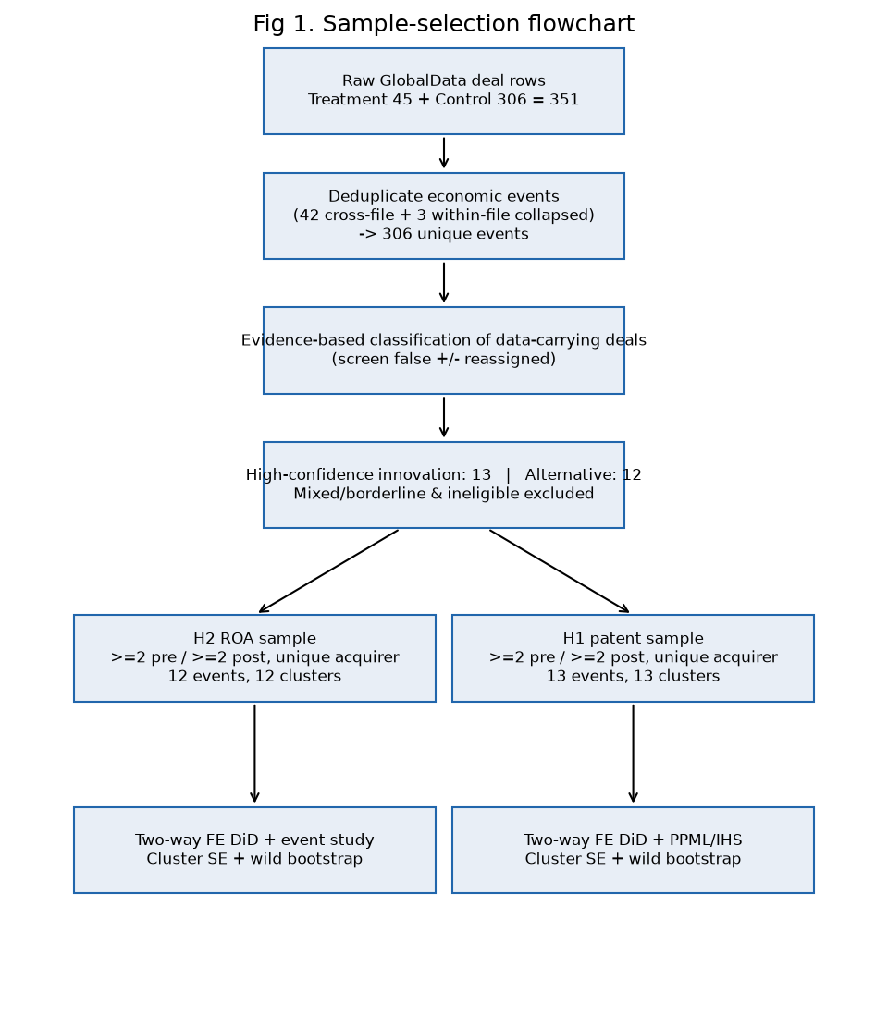
Figure 4.1. Sample construction flowchart, from raw extracts to the analytical samples
Source: author's elaboration based on the consolidated GlobalData transaction set.

4.3 Outcome-specific analytical samples and coverage
Separate analytical samples were constructed for the two hypotheses because a transaction may contain usable patent data but no financial data, or financial data but no patent data; consequently, the samples are not required to include the same firms. The preferred inclusion criterion required at least two non-missing pre-completion observations and at least two non-missing post-completion observations for the relevant outcome within the event window t−3 to t+3, together with the one-event-per-acquirer restriction. The completion year, t0, was excluded from the primary specification because it combines pre- and post-transaction months. In the case of the financial outcomes, only Bloomberg standardised realised actuals were used: blank cells were treated as missing rather than zero, and the sample was capped at calendar year 2023 to exclude Bloomberg estimate years. Patent outcomes were measured as unique simple patent-family counts by earliest priority year from Lens and were validated against the family-level export.
Table 4.5. Primary analytical samples
Sample | Events | Acquirer clusters | Innovation | Alternative | Observations
H2 — ROA (pp) | 12 | 12 | 8 | 4 | 72
H1 — patent families | 13 | 13 | 7 | 6 | 72
Note. Inclusion rule: ≥2 non-missing pre and ≥2 non-missing post observations, t0 omitted, one non-overlapping event per acquirer group. Source: author's calculations.
As can be seen from Figure 4.2, outcome coverage is strongest within the central event window from t−3 to t+3 and becomes thinner towards the edges. Another important feature of the H2 sample is that its innovation group is dominated by small biotechnology and specialty acquirers. This imbalance is assessed formally in Section 4.5 and must be borne in mind when interpreting the H2 findings.
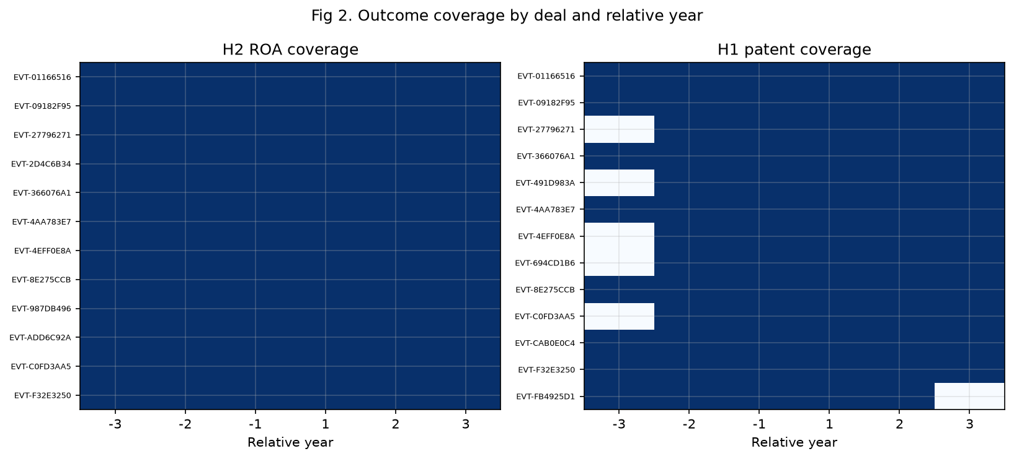
Figure 4.2. Outcome coverage by relative event year (H1 and H2 samples)
Source: author's calculations based on Bloomberg and Lens imports.

4.4 Descriptive statistics
Table 4.6 presents the pre- and post-period descriptive statistics for each group. Three main patterns emerge from the data. First, in terms of financial performance, the innovation group entered the transaction period with both a lower and substantially more volatile ROA: its pre-period mean was −6.1 pp, with a standard deviation of 35.9 and a minimum of approximately −110 pp, largely reflecting loss-making biotechnology firms. The corresponding alternative-group mean was +3.9 pp, with a standard deviation of 13.0. Second, the unadjusted pre-to-post change in ROA was +9.0 pp for the innovation group, compared with +0.3 pp for the alternative group. This initial result is directionally consistent with H2, although it precedes any adjustment. Third, with respect to patent activity, the innovation group was markedly more patent-intensive before completion, producing 11.7 families per year compared with 2.5 in the alternative group. Its output subsequently declined by −3.9 families, whereas the alternative group remained broadly stable, with a change of −0.3. This pattern is directionally consistent with H1's expectation of a less favourable differential in measured patent output.
Table 4.6. Descriptive statistics by hypothesis sample and group
Sample | Group | Events | Obs | Pre mean | Pre s.d. | Post mean | Post s.d. | Raw Δ (post−pre) | Min | Max
H2 ROA (pp) | Alternative | 4 | 24 | 3.89 | 12.99 | 4.15 | 10.19 | +0.26 | −23.2 | 14.0
H2 ROA (pp) | Innovation | 8 | 48 | −6.10 | 35.93 | 2.88 | 14.54 | +8.99 | −110.5 | 31.0
H1 families | Alternative | 6 | 33 | 2.50 | 2.73 | 2.18 | 3.40 | −0.32 | 0 | 12
H1 families | Innovation | 7 | 39 | 11.67 | 10.60 | 7.81 | 9.95 | −3.86 | 0 | 42
Note. ROA is the Bloomberg standardised return on assets in percentage points (realised actuals only); patent families are unique simple families by earliest priority year (Lens). Source: author's calculations.
Figures 4.3 and 4.4 illustrate the group-mean trajectories of ROA and patent-family output in event time. With regard to ROA, Figure 4.3 shows that the deep and volatile pre-period losses of the innovation group moved towards the level observed for the alternative group after completion. In contrast, Figure 4.4 shows a higher initial level of patent activity in the innovation group followed by a post-completion decline, while the alternative group remained approximately flat. These descriptive patterns provide useful motivation for the analysis, but they do not substitute for the fixed-effects estimates reported in Sections 4.6 and 4.7.
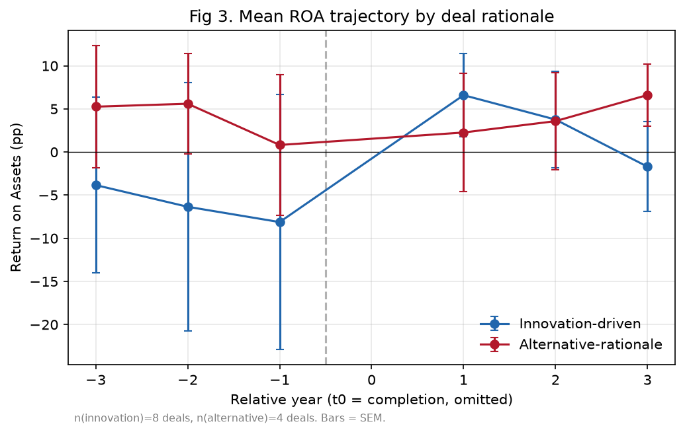
Figure 4.3. Mean ROA by group in event time (H2 sample)
Source: author's calculations based on Bloomberg data.
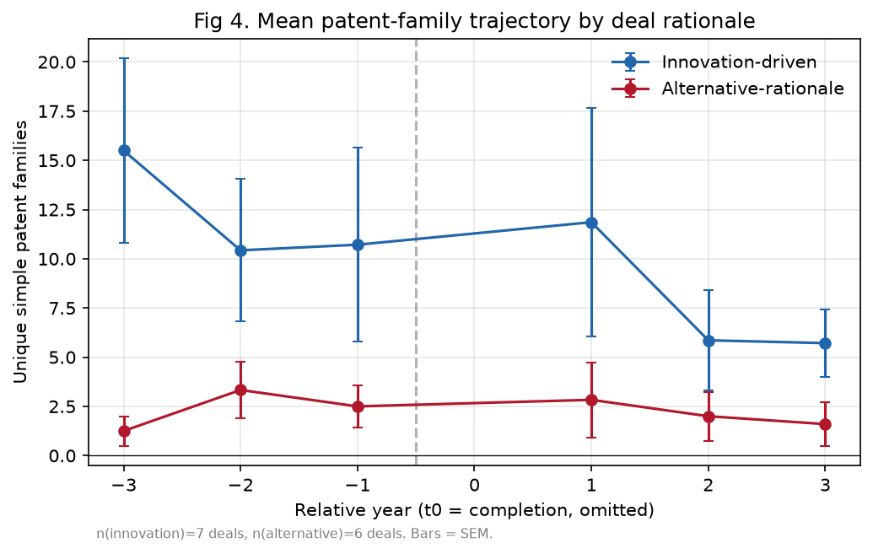
Figure 4.4. Mean patent-family output by group in event time (H1 sample)
Source: author's calculations based on Lens data.

4.5 Pre-treatment comparability and common support
Table 4.7 reports the standardised mean differences (SMDs) and variance ratios for the pre-treatment characteristics, while Figure 4.5 provides the corresponding love plot. The results show substantial imbalance between the groups. For H2, the pre-period ROA level differs moderately (SMD ≈ −0.36), but the variance ratio exceeds 7. The firm-size covariates also indicate that innovation acquirers are considerably smaller, with an SMD of 0.90 for pre-deal log-assets and 1.19 for revenue. For H1, the pre-period outcome level is itself strongly imbalanced (SMD ≈ 1.12). A more reassuring finding is that the pre-period outcome slopes are almost identical across the two groups for both outcomes (SMD = 0.02 and 0.04), which is the dimension most directly relevant to the parallel-trends assumption.
Table 4.7. Pre-treatment balance: standardised mean differences and variance ratios
Sample | Variable | SMD | Variance ratio
H2 | Pre-period outcome mean (ROA) | −0.36 | 7.07
H2 | Pre-period outcome slope | 0.02 | 17.65
H2 | Pre-deal log total assets | 0.90 | 9.72
H2 | Pre-deal leverage | 0.49 | 10.03
H2 | Pre-deal operating margin | 0.12 | 0.72
H2 | Pre-deal revenue (€m) | 1.19 | 2,240.1
H1 | Pre-period outcome mean (families) | 1.12 | 10.65
H1 | Pre-period outcome slope | 0.04 | 12.44
Note. SMD = (mean innovation − mean alternative) / pooled standard deviation; conventional balance thresholds are |SMD| < 0.10–0.25. Source: author's calculations.
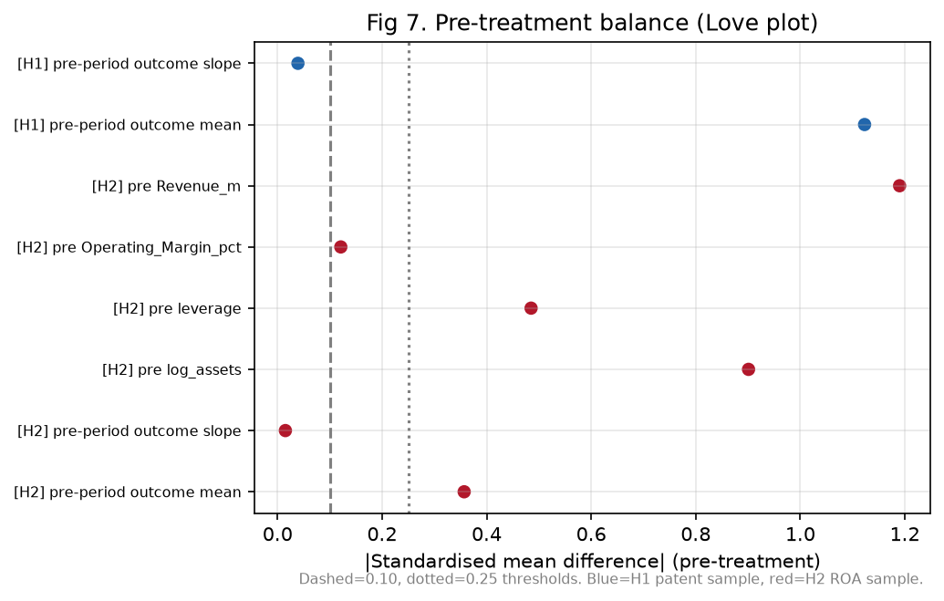
Figure 4.5. Love plot of standardised mean differences (pre-treatment characteristics)
Source: author's calculations.
Figure 4.6 examines common support in the distributions of the pre-period outcome means, with additional distributional information reported in Table 4.8. The evidence shows that some overlap exists, but that it is limited: the deepest-loss ROA observations are found exclusively among innovation acquirers, and the same is true of the upper tail of patent output. Although deal fixed effects absorb these level differences, the thin overlap means that identification depends heavily on the parallel pre-trends assessed in Sections 4.6 and 4.7. A matched or weighted specification was deliberately not adopted as the benchmark because, with only 12–13 events, matching would remove a large share of the observations while producing largely cosmetic balance. The sample is therefore not sufficiently large to support such an approach credibly. In accordance with the analysis protocol, the benchmark consists of unweighted fixed-effects estimates, with the limitations arising from imbalance stated explicitly.
Table 4.8. Common support: distribution of pre-period outcome means by group
Sample | Group | n | Min | P25 | Median | P75 | Max
H2 ROA (pp) | Innovation | 8 | −96.5 | 0.1 | 6.6 | 10.0 | 15.4
H2 ROA (pp) | Alternative | 4 | −16.9 | 2.4 | 9.8 | 11.3 | 12.8
H1 families | Innovation | 7 | 0.5 | 3.8 | 7.3 | 17.0 | 26.3
H1 families | Alternative | 6 | 0.0 | 1.7 | 1.8 | 2.8 | 8.5
Source: author's calculations.
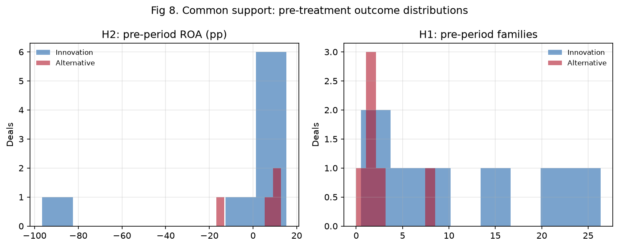
Figure 4.6. Common support of pre-period outcome means (H2 and H1 samples)
Source: author's calculations.

4.6 H1 — Differential patent output
The baseline analysis was conducted using a two-way fixed-effects DiD model estimated on the event panel: Yit = αi + λt + δ·Postit + β·(Innovationi × Postit) + εit. In this specification, α represents deal fixed effects, which absorb the treatment main effect; λ denotes calendar-year fixed effects; δ captures the post-period change in the alternative group; and β is the differential of interest. Since the number of clusters (12–13) is well below the level at which asymptotic cluster-robust inference is generally reliable, the analysis reports p-values obtained from a restricted wild-cluster bootstrap using Rademacher weights and B = 1,999, alongside cluster-robust standard errors.
The results obtained for H1 are reported in Table 4.9. The estimated differential was β = −0.46 patent families, with a cluster-robust SE of 2.07, a 95% CI of [−4.52, 3.61], a cluster-robust p-value of 0.83, and a wild-bootstrap p-value of 0.82, based on 13 events and 13 acquirer clusters. The decomposition indicates a modelled post-period change of δ = +5.20 families for the alternative group and δ + β = +4.74 for the innovation group. Thus, the differential is close to zero. This finding was also obtained under the inverse-hyperbolic-sine transformation (β = 0.11, p = 0.85) and the Poisson pseudo-maximum-likelihood specification, which is appropriate for a count outcome (β = 0.05 on the log-count scale, p = 0.93).
Table 4.9. H1 — DiD estimates for patent-family output
Specification | δ (Alt., Post) | β (Innov. × Post) | SE | 95% CI | p | Wild p | Events | Clusters
Primary (linear FE) | 5.20 | −0.46 | 2.07 | [−4.52, 3.61] | 0.83 | 0.82 | 13 | 13
IHS transform | 0.14 | 0.11 | 0.56 | [−0.99, 1.21] | 0.85 | 0.83 | 13 | 13
Poisson PPML | 0.87 | 0.05 | 0.52 | [−0.97, 1.06] | 0.93 | — | 13 | 13
Serial acquirers included | 5.50 | −0.81 | 1.81 | [−4.35, 2.73] | 0.65 | 0.67 | 16 | 13
Balanced 3-pre/3-post | 22.57 | −1.22 | 3.15 | [−7.40, 4.95] | 0.70 | 0.79 | 8 | 8
Note. Deal and calendar-year fixed effects; SEs clustered by acquirer group; wild-cluster bootstrap (Rademacher, B = 1,999). PPML coefficients are log-count differentials. Source: author's estimations.
Figure 4.7 presents the event-study decomposition of the differential by relative year. The post-completion coefficients remain close to zero, taking values of +2.61 at t+1, −1.52 at t+2, and −1.36 at t+3, and are accompanied by wide confidence intervals. The pre-period coefficients are also small and statistically indistinguishable from zero. Consistent with this pattern, the joint pre-trend test does not reject the parallel-trends assumption (p = 0.96).
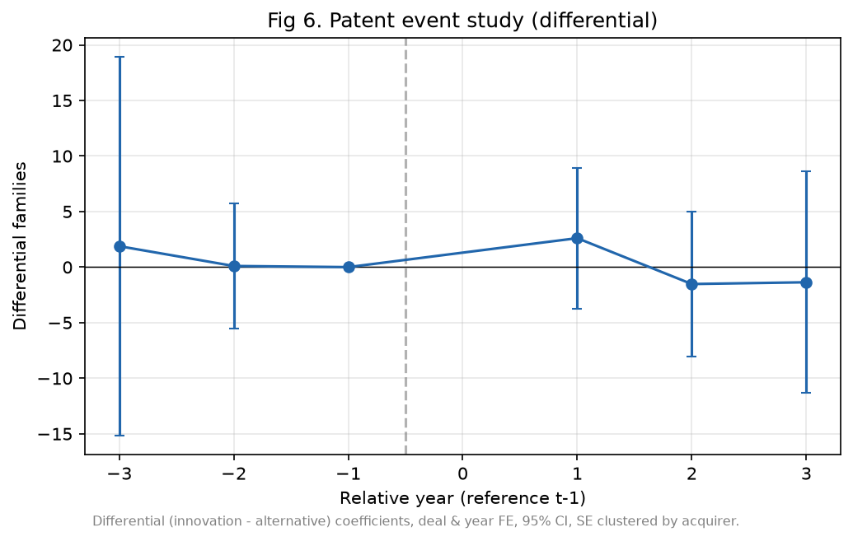
Figure 4.7. Event study — differential patent-family output (H1)
Note. Reference period t−1; whiskers are 95% confidence intervals (cluster-robust). Source: author's estimations.
Taken together, these results do not support H1 at conventional levels of statistical significance. Over the three post-completion years, no detectable differential in patent-family output is observed between innovation-driven and alternative-rationale acquirers. However, these data must be interpreted with caution because the confidence interval remains wide. The result is therefore an imprecise null: moderate effects in either direction cannot be ruled out, and exact equivalence has not been demonstrated. There are at least two possible explanations for this pattern, which are developed further in Chapter 5. First, patent quantity measured over a three-year horizon may not capture the value of an acquired late-stage pipeline. Second, residual false negatives in the comparison group could attenuate a genuine contrast towards zero.

4.7 H2 — Differential financial performance (ROA)
As shown in Table 4.10, the estimated H2 differential was β = +10.78 percentage points of ROA, with a cluster-robust SE of 12.48, a 95% CI of [−13.69, 35.24], a cluster-robust p-value of 0.39, and a wild-bootstrap p-value of 0.40, based on 12 events and 12 acquirer clusters. The decomposition attributes a post-period change of δ = +2.76 pp to the alternative group and δ + β = +13.53 pp to the innovation group. The point estimate is therefore in the direction predicted by H2, suggesting a more favourable post-completion change in ROA for innovation-driven transactions. Nevertheless, the estimate is not statistically distinguishable from zero, and its confidence interval is very wide.
Table 4.10. H2 — DiD estimates for financial performance
Specification | δ (Alt., Post) | β (Innov. × Post) | SE | 95% CI | p | Wild p | Events | Clusters
Primary (ROA, linear FE) | 2.76 | +10.78 | 12.48 | [−13.69, 35.24] | 0.39 | 0.40 | 12 | 12
Winsorised 1/99 (pre-declared) | 1.64 | +10.10 | 12.37 | [−14.14, 34.35] | 0.41 | 0.44 | 12 | 12
Serial acquirers included | 3.05 | +6.43 | 7.85 | [−8.96, 21.83] | 0.41 | 0.38 | 16 | 12
Balanced 3-pre/3-post | 2.76 | +10.78 | 12.48 | [−13.69, 35.24] | 0.39 | 0.40 | 12 | 12
t0 coded as post | 0.98 | +11.29 | 11.51 | [−11.28, 33.86] | 0.33 | — | 12 | 12
Op. margin (winsorised, rev ≥ €50m) | −6.77 | +21.72 | 25.14 | [−27.55, 70.99] | 0.39 | 0.54 | 10 | 10
Note. Deal and calendar-year fixed effects; SEs clustered by acquirer group; wild-cluster bootstrap (Rademacher, B = 1,999). The operating-margin specification is restricted to revenue ≥ €50m and winsorised because the margin is mechanically extreme for near-zero-revenue biotechs. Source: author's estimations.
Figure 4.8 shows positive but individually insignificant post-completion coefficients of +11.96 at t+1, +9.86 at t+2, and +2.24 at t+3, with the magnitude diminishing by the third year. The joint pre-trend test does not reject parallel pre-trends (p = 0.57). However, the pre-period differentials of −2.74 at t−3 and −4.56 pp at t−2 are not negligible in magnitude. Given the limited statistical power of the sample, this non-rejection constitutes only weak evidence. These results therefore need to be interpreted with additional caution when assessing the positive post-period pattern.
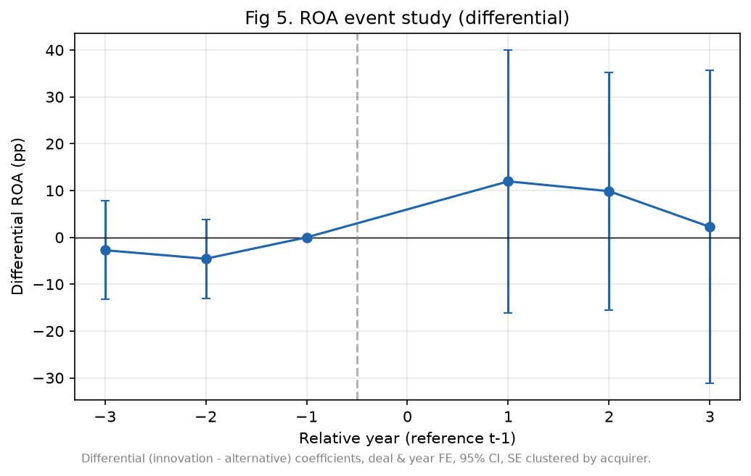
Figure 4.8. Event study — differential ROA (H2)
Note. Reference period t−1; whiskers are 95% confidence intervals (cluster-robust). Source: author's estimations.
Taken together, the H2 findings provide directional rather than statistical support. The differential change in ROA is positive across all specifications, but it does not approach conventional levels of significance. Moreover, as shown in Section 4.9, the point estimate is concentrated in a small number of small and volatile acquirers. The evidence therefore suggests an association that is compatible with the hypothesised innovation–finance pattern, but it does not confirm an effect.

4.8 Robustness, sensitivity and placebo analyses
The principal robustness dimensions are already reported in Tables 4.9 and 4.10. These include the retention of serial acquirers, which mechanically re-weights repeat acquirers and reduces the H2 estimate to +6.43 pp while leaving the substance of H1 unchanged; the balanced 3-pre/3-post panel; the pre-declared 1/99 winsorisation; alternative coding of t0; and the transformation and count-model checks for the patent outcome. Across these perturbations, the signs of the estimates remain stable, and no specification produces a statistically significant result for either hypothesis. Table 4.11 summarises the full perturbation grid. Table 4.12 then reports a placebo analysis in which a false completion date is assigned at t−2 and the model is re-estimated using only pre-period data. As expected, both placebo differentials are close to zero and statistically insignificant (H2: −3.18, p = 0.77; H1: +0.20, p = 0.98). This finding suggests that the estimation procedure does not generate an apparent effect in a period in which none should be present.
Table 4.11. Summary of robustness perturbations
Perturbation | H2 β (ROA, pp) | H1 β (families)
Primary (unique acquirer, ≥2 pre / ≥2 post) | +10.78 | −0.46
Serial acquirers included | +6.43 | −0.81
Balanced 3-pre/3-post | +10.78 | −1.22
Winsorised 1/99 (pre-declared) | +10.10 | —
t0 coded as post | +11.29 | —
IHS / PPML (count outcome) | — | +0.11 / +0.05
Placebo (fake completion at t−2) | −3.18 (p = 0.77) | +0.20 (p = 0.98)
Source: author's estimations.
Table 4.12. Placebo test — fake completion at t−2, pre-period data only
Sample | Placebo β | SE | p | Obs
H2 — ROA | −3.18 | 10.74 | 0.77 | 36
H1 — patent families | +0.20 | 9.77 | 0.98 | 34
Note. The placebo interaction should be, and is, statistically indistinguishable from zero. Source: author's estimations.

4.9 Influence diagnostics: leave-one-acquirer-out
To assess the influence of individual observations in these small samples, each estimate was recalculated after excluding one acquirer group at a time (Table 4.13 and Figure 4.9). The analysis revealed a marked difference between the two hypotheses. With respect to H1, the differential remained within [−1.59, +1.00] regardless of the acquirer omitted, indicating a comparatively stable near-zero result. By contrast, the H2 estimate was highly sensitive to particular firms. Excluding Biodexa, a micro-cap acquirer with extreme ROA fluctuations, reduced the differential from +10.78 to +0.43, whereas excluding Roche increased it to +14.33. These findings suggest that the positive H2 pattern is driven by a small number of very small and volatile acquirers rather than by a broadly distributed effect. It should not, therefore, be generalised beyond the observed region of support.
Table 4.13. Leave-one-acquirer-out estimates (selected)
Sample | Acquirer dropped | β | Δ vs baseline
H2 — ROA | Biodexa Ltd | +0.43 | −10.34
H2 — ROA | Eurofins Scientific SE | +8.49 | −2.29
H2 — ROA | Zambon SpA | +10.86 | +0.09
H2 — ROA | Sanofi | +11.68 | +0.90
H2 — ROA | GSK | +12.67 | +1.90
H2 — ROA | Vectura | +13.73 | +2.96
H2 — ROA | Roche | +14.33 | +3.55
H1 — families | Sanofi | −1.59 | −1.13
H1 — families | GSK | −1.06 | −0.61
H1 — families | Zambon SpA | −0.16 | +0.29
H1 — families | Recordati | +0.22 | +0.67
H1 — families | Roche | +1.00 | +1.46
Note. Baselines: H2 = +10.78; H1 = −0.46. The full grid (12 + 13 exclusions) is reported in the analysis repository (T11). Source: author's estimations.
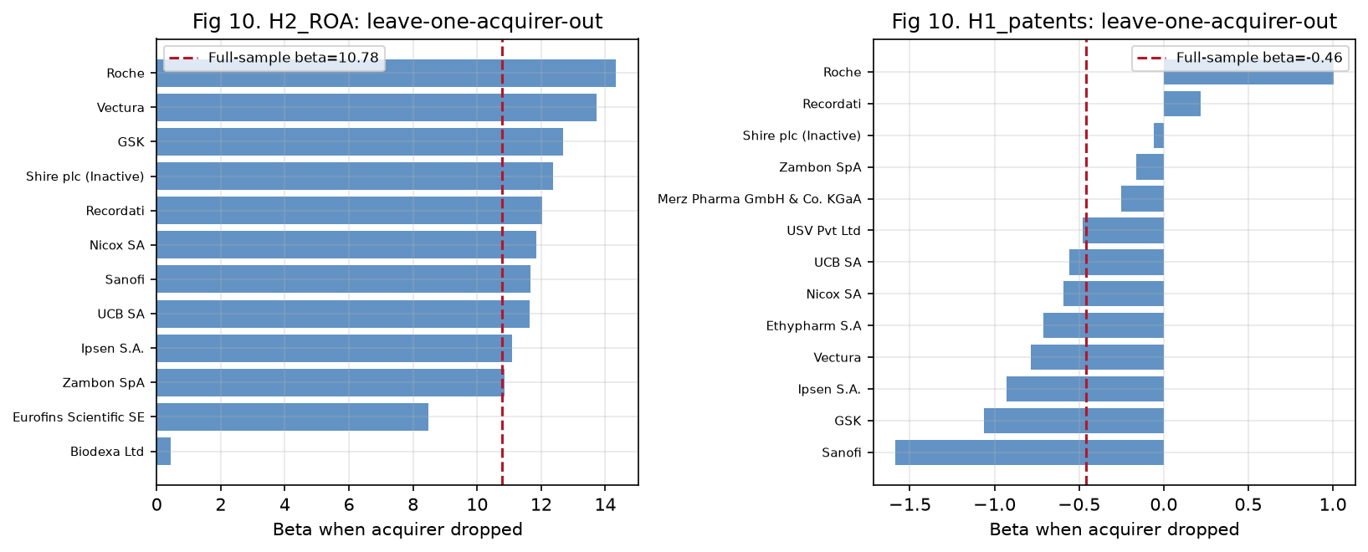
Figure 4.9. Leave-one-acquirer-out sensitivity of the DiD differentials
Source: author's estimations.

4.10 Hypothesis decisions and joint interpretation
Figure 4.10 presents the two headline differentials together with their 95% confidence intervals, while Table 4.14 summarises the formal decisions for the two hypotheses.
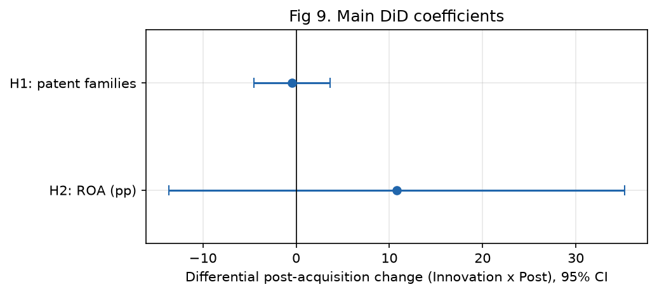
Figure 4.10. Headline DiD differentials with 95% confidence intervals
Source: author's estimations.
Table 4.14. Hypothesis decision matrix
Hypothesis | Expected direction | β | 95% CI | Wild p | Pre-trend p | Events / clusters | Decision
H1 — differential patent output | Innovation < Alternative | −0.46 | [−4.52, 3.61] | 0.82 | 0.96 | 13 / 13 | Not supported (imprecise null)
H2 — differential ROA | Innovation > Alternative | +10.78 | [−13.69, 35.24] | 0.40 | 0.57 | 12 / 12 | Directionally consistent, not significant
Source: author's estimations.
Taken together, the results suggest H1 ≈ 0 and H2 > 0 in point estimate, although the latter is statistically insignificant and outlier-sensitive. Within the framework developed in Chapters 2 and 3, this pattern corresponds most closely to the “H1 null / H2 positive” configuration. In nominal terms, it is consistent with an innovation–finance account in which innovation-driven acquirers do not generate additional near-term patent output relative to other acquirers, while experiencing a more favourable short-run change in ROA. However, the evidence from this study is not sufficiently strong to establish that mechanism. Both confidence intervals include zero, the direction of the H2 estimate depends heavily on one or two firms, and the evidence-based classification—although frozen before estimation—could not draw on archived primary filings. The possible mechanisms underlying this pattern, together with the evidence required to distinguish between them, are considered in Chapter 5.

Summary of findings
With respect to H1, the hypothesis is not supported at conventional levels. The estimated differential is close to zero (β = −0.46 families; wild p = 0.82) and remains substantively unchanged under the IHS, PPML, serial-acquirer, and balanced specifications. The joint test does not reject parallel pre-trends (p = 0.96), and the placebo estimate is also near zero. The result is associational and should be characterised as an imprecise null rather than evidence of equivalence.
Regarding H2, the estimate is directionally consistent with the hypothesis (β = +10.78 pp) but is not statistically significant (wild p = 0.40). The confidence interval is wide, and the positive result is driven by influential small acquirers; when Biodexa is excluded, the estimate falls to +0.43. The evidence is therefore associational and does not confirm H2.
It is important to note that every numerical result reported in this chapter can be traced to an exported table, model file, or figure generated by the reproducible analysis pipeline using seed 20260730. The raw source workbooks were not modified.

4.11 Limitations of the empirical analysis
The interpretation of these findings is subject to the limitations set out below. These constraints also provide the basis for the research extensions proposed in Chapter 5.
- Small analytical samples and few clusters. The research is limited by the relatively small primary samples, which contain 12 events for H2 and 13 events for H1, with an equally small number of acquirer clusters. Although wild-cluster bootstrap inference was used, statistical power remains low and the confidence intervals are wide. Consequently, statistically insignificant estimates should not be treated as evidence of no difference, and still less as evidence of equivalence.
- Partial outcome coverage. A further limitation is that Bloomberg financial data and Lens patent exports are available for only a subset of the eligible transaction universe. In accordance with the protocol, the analysis prioritised data-carrying transactions. However, the large number of otherwise eligible transactions without imported outcomes cannot enter H1 or H2, and their exclusion is unlikely to be random with respect to firm size and listing status.
- Classification relies on GlobalData-embedded evidence rather than archived filings. The study is limited in that pre-completion company announcements and target filings could not be retrieved and archived because network access was unavailable during estimation. Classification therefore relied on the announcement text embedded in the workbook deal descriptions, together with the GlobalData rationale. Residual classification error cannot be ruled out. False positives would increase heterogeneity within the treatment group, whereas false negatives remaining in the comparison group would tend to attenuate the estimated contrast towards zero. Although several such cases were identified and reassigned, others may remain among the non-data-carrying transactions, and the direction of the resulting net bias is uncertain.
- Poor pre-treatment balance. The data show that innovation acquirers are systematically smaller and more volatile than alternative acquirers. Although fixed effects remove differences in levels, they do not eliminate differential dynamics. At this sample size, a credible matched or weighted counterfactual cannot be constructed. Fixed effects alone cannot create an adequate counterfactual where common support is limited.
- Influence of individual firms. The H2 point estimate is strongly affected by one or two small and volatile acquirers, most notably Biodexa, and excluding these observations largely removes the apparent effect. These findings cannot be extrapolated beyond the support region represented in the sample.
- Outcome-metric limits. Another limitation concerns the measures used. Patent-family counts based on earliest priority year capture the quantity of innovation rather than its value or quality. A credible citation-weighted secondary outcome could not be constructed with cells of this size and was therefore not reported. In addition, operating margin is mechanically extreme for biotechnology firms with near-zero revenue and is consequently reported only after restricting the sample by revenue and applying winsorisation.
- Patent search-scope heterogeneity. The research is limited by differences in the Lens applicant-search scope across companies, including explicit versus inferred ranges and occasional EP-only or limited-subsidiary coverage, as in the Sanofi/Ablynx case. Enforcing a strictly scope-consistent sample would reduce an already small sample still further. The scope-consistent year-summary series was therefore retained, and the discrepancy was documented.
- Staggered completion timing. A further methodological limitation concerns the distribution of completion dates across 2012–2020. Two-way fixed-effects DiD estimators may be biased under heterogeneous treatment timing when effects vary across cohorts. Cohort-stratified or stacked event-study designs could not be implemented with cells of the present size and remain an important area for future research.
- Estimation environment. The analysis was also limited by the unavailability of the pre-registered R environment based on fixest. Python equivalents implemented through statsmodels and linearmodels were therefore used, together with a manually coded restricted wild-cluster bootstrap. Although the findings were cross-checked across linear fixed-effects, PPML, and IHS specifications, they were not independently replicated in R.
- Protocol documents. A final limitation is that the binding methodology and literature-review documents were not available during the estimation run. The analysis was consequently governed by the restated protocol contained in the master analysis prompt, and any methodological requirement not reproduced there could not be implemented. All resulting deviations are recorded in the analysis decision and conflict logs.

Chapter 5 — Discussion (opening bridge)

5.1 From estimates to interpretation
The empirical analysis compared innovation-driven European pharmaceutical M&A, in which the target contributes a material pre-deal pipeline, platform, or R&D capability, with alternative-rationale transactions motivated by scale, geography, mature products, services, or efficiency. The principal findings are twofold. First, the innovation-output differential is close to zero (−0.46 families; wild p = 0.82), a result reproduced by the PPML and IHS specifications. Thus, over the three post-completion years, innovation-driven acquirers show neither additional nor reduced patent-family output relative to other acquirers. Second, the ROA differential is +10.8 percentage points in point estimate, but it is statistically insignificant (wild p = 0.40) and concentrated in a small number of small, volatile acquirers.

5.2 Consistency with the mechanisms in the literature
These findings are consistent with several mechanisms discussed in the innovation-M&A literature, but they do not identify any one of them. One possible explanation is an innovation–finance divergence mechanism: near-term financial gains may arise through cost consolidation, the removal of duplicate R&D projects, or the faster realisation of financial synergies, without a contemporaneous measured innovation dividend. A second possible explanation is a development lag, since patent-family counts by earliest priority year may not capture the value of late-stage pipelines within three years and measure quantity rather than value. A further measurement explanation is that genuine innovation transactions remained in the comparison group as screening false negatives, potentially attenuating the H1 contrast towards zero. The regressions cannot distinguish between these mechanisms, and the estimates are too imprecise to adjudicate among them. No causal interpretation or claim about managerial motives is therefore advanced.

5.3 From associational to confirmatory evidence
Four extensions could move the design towards confirmatory evidence. First, archived announcements and filings would reduce classification error. Second, broader Bloomberg and Lens coverage of eligible 100% and majority-control transactions would expand the acquirer-cluster sample and support matching or weighting. Third, cohort-normalised citations and pipeline-stage milestones should complement raw patent-family counts. Fourth, cohort-stratified or stacked event studies should address bias from staggered treatment timing. Chapter 5 develops these extensions.

References
Barber, B. M., & Lyon, J. D. (1996). Detecting abnormal operating performance: The empirical power and specification of test statistics. Journal of Financial Economics, 41(3), 359–399. https://doi.org/10.1016/0304-405X(96)84701-5
Bertrand, M., Duflo, E., & Mullainathan, S. (2004). How much should we trust differences-in-differences estimates? The Quarterly Journal of Economics, 119(1), 249–275. https://doi.org/10.1162/003355304772839588
Callaway, B., & Sant’Anna, P. H. C. (2021). Difference-in-differences with multiple time periods. Journal of Econometrics, 225(2), 200–230. https://doi.org/10.1016/j.jeconom.2020.12.001
Hall, B. H., Jaffe, A. B., & Trajtenberg, M. (2001). The NBER patent citation data file: Lessons, insights and methodological tools (NBER Working Paper No. 8498). National Bureau of Economic Research. https://doi.org/10.3386/w8498
Martinez, C. (2010). Insight into different types of patent families (OECD Science, Technology and Industry Working Papers No. 2010/02). OECD Publishing. https://doi.org/10.1787/5kml97dr6ptl-en
OECD. (2009). OECD patent statistics manual. OECD Publishing. https://doi.org/10.1787/9789264056442-en
Roth, J. (2022). Pretest with caution: Event-study estimates after testing for parallel trends. American Economic Review: Insights, 4(3), 305–322. https://doi.org/10.1257/aeri.20210236
Sun, L., & Abraham, S. (2021). Estimating dynamic treatment effects in event studies with heterogeneous treatment effects. Journal of Econometrics, 225(2), 175–199. https://doi.org/10.1016/j.jeconom.2020.09.006
Ahuja, G., & Katila, R. (2001). Technological acquisitions and the innovation performance of acquiring firms: A longitudinal study. Strategic Management Journal, 22(3), 197–220. https://doi.org/10.1002/smj.157
Arrow, K. J. (1962). Economic welfare and the allocation of resources for invention. In Universities–National Bureau Committee for Economic Research & Committee on Economic Growth of the Social Science Research Council (Eds.), The rate and direction of inventive activity: Economic and social factors (pp. 609–626). Princeton University Press.
Barney, J. (1991). Firm resources and sustained competitive advantage. Journal of Management, 17(1), 99–120. https://doi.org/10.1177/014920639101700108
Basant, R., & Jaiswal, R. (2022). Impact of mergers and acquisitions on innovation: Evidence from a panel of Indian pharmaceutical firms (IIMA Working Paper No. WP 2022-01-01). Indian Institute of Management Ahmedabad.
Bena, J., & Li, K. (2014). Corporate innovations and mergers and acquisitions. The Journal of Finance, 69(5), 1923–1960. https://doi.org/10.1111/jofi.12059
Büssgen, M., & Stargardt, T. (2024). To merge or not to merge? The impact of mergers and acquisitions on corporate success in the pharmaceutical industry. Managerial and Decision Economics, 45(4), 2196–2209. https://doi.org/10.1002/mde.4129
Cloodt, M., Hagedoorn, J., & Van Kranenburg, H. (2006). Mergers and acquisitions: Their effect on the innovative performance of companies in high-tech industries. Research Policy, 35(5), 642–654. https://doi.org/10.1016/j.respol.2006.02.007
Cohen, W. M., & Levinthal, D. A. (1990). Absorptive capacity: A new perspective on learning and innovation. Administrative Science Quarterly, 35(1), 128–152. https://doi.org/10.2307/2393553
Cunningham, C., Ederer, F., & Ma, S. (2021). Killer acquisitions. Journal of Political Economy, 129(3), 649–702. https://doi.org/10.1086/712506
Danzon, P. M., Epstein, A., & Nicholson, S. (2007). Mergers and acquisitions in the pharmaceutical and biotech industries. Managerial and Decision Economics, 28(4–5), 307–328. https://doi.org/10.1002/mde.1343
DiMasi, J. A., Grabowski, H. G., & Hansen, R. W. (2016). Innovation in the pharmaceutical industry: New estimates of R&D costs. Journal of Health Economics, 47, 20–33. https://doi.org/10.1016/j.jhealeco.2016.01.012
Gilbert, R. J., & Newbery, D. M. G. (1982). Preemptive patenting and the persistence of monopoly. American Economic Review, 72(3), 514–526.
Grant, R. M. (1996). Toward a knowledge-based theory of the firm. Strategic Management Journal, 17(S2), 109–122. https://doi.org/10.1002/smj.4250171110
Hall, B. H., Jaffe, A. B., & Trajtenberg, M. (2001). The NBER patent citation data file: Lessons, insights and methodological tools (NBER Working Paper No. 8498). National Bureau of Economic Research. https://doi.org/10.3386/w8498
Haucap, J., Rasch, A., & Stiebale, J. (2019). How mergers affect innovation: Theory and evidence. International Journal of Industrial Organization, 63, 283–325. https://doi.org/10.1016/j.ijindorg.2018.10.003
Higgins, M. J., & Rodriguez, D. (2006). The outsourcing of R&D through acquisitions in the pharmaceutical industry. Journal of Financial Economics, 80(2), 351–383. https://doi.org/10.1016/j.jfineco.2005.04.004
Hitt, M. A., Hoskisson, R. E., Ireland, R. D., & Harrison, J. S. (1991). Effects of acquisitions on R&D inputs and outputs. Academy of Management Journal, 34(3), 693–706. https://doi.org/10.5465/256412
Jensen, M. C. (1986). Agency costs of free cash flow, corporate finance, and takeovers. American Economic Review, 76(2), 323–329.
Laermann-Nguyen, U., & Backfisch, M. (2021). Innovation effects of mergers and acquisitions: A systematic review. Management Review Quarterly. Advance online publication. https://doi.org/10.1007/s11301-021-00243-6
Nelson, R. R., & Winter, S. G. (1982). An evolutionary theory of economic change. Belknap Press of Harvard University Press.
Ornaghi, C. (2009). Mergers and innovation in big pharma. International Journal of Industrial Organization, 27(1), 70–79. https://doi.org/10.1016/j.ijindorg.2008.04.003
Phillips, G. M., & Zhdanov, A. (2013). R&D and the incentives from merger and acquisition activity. The Review of Financial Studies, 26(1), 34–78. https://doi.org/10.1093/rfs/hhs109
Stiebale, J. (2016). Cross-border M&As and innovative activity of acquiring and target firms. Journal of International Economics, 99, 1–15. https://doi.org/10.1016/j.jinteco.2015.12.005
Suo, L., Yang, S., & Ji, H. (2023). The impact of technology mergers and acquisitions on enterprise innovation: A review. Sustainability, 15(17), 12883. https://doi.org/10.3390/su151712883
Teece, D. J. (1986). Profiting from technological innovation: Implications for integration, collaboration, licensing and public policy. Research Policy, 15(6), 285–305. https://doi.org/10.1016/0048-7333(86)90027-2
Valentini, G. (2012). Measuring the effect of M&A on patenting quantity and quality. Strategic Management Journal, 33(3), 336–346. https://doi.org/10.1002/smj.946

