Documentation Template

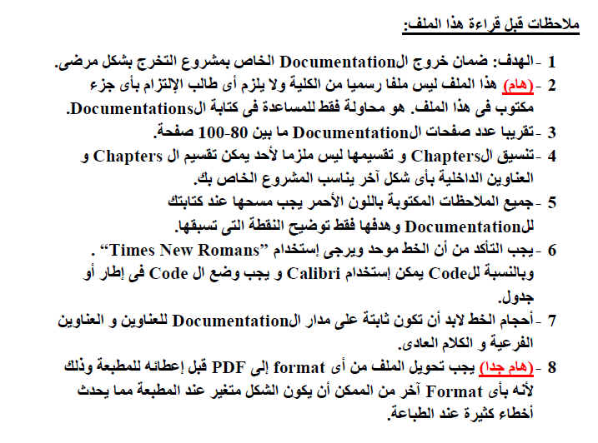


Ain Shams University
Faculty of Computer & Information Sciences

………………………. Department

Project Title

[On this cover page put a background image suitable for your project]

June 2020

[Sponsor logo if exist] [ITIDA logo if exist]

Ain Shams University
Faculty of Computer & Information Sciences

………………………. Department

Project Title

This documentation submitted as required for the degree of bachelors in Computer and Information Sciences.

By

Team Member 1 [Department]

Team Member 2 [Department]

Team Member 3 [Department]

Team Member 4 [Department]

Under Supervision of

[Supervisor 1]
[Supervisor Title],
………………. Department,

Faculty of Computer and Information Sciences,
Ain Shams University.

[Supervisor 2]
[Supervisor Title],
………………. Department,

Faculty of Computer and Information Sciences,
Ain Shams University.

[Supervisor 3]
[Supervisor Title],
………………. Department,

Faculty of Computer and Information Sciences,
Ain Shams University.

June 2020

[Sponsor logo if exist] [ITIDA logo if exist]

Acknowledgements | 1

Acknowledgements

[This is just an example write it as you like. thank what you want in any order]

All praise and thanks to ALLAH, who provided me the ability to complete this work. I hope to accept this work from me.

I am grateful of my parents and my family who are always providing help and support throughout the whole years of study. I hope I can give that back to them.

I also offer my sincerest gratitude to my supervisors, Prof. Dr. ………………, Dr.

……………… and T.A.………………. who have supported me throughout my thesis with their patience, knowledge and experience.

Finally, I would thank my friends and all people who gave me support and encouragement.

Abstract | 2

Abstract

[The most important page in documentation. In this page you should clarify what is your project about. Very briefly state problem definition, objectives, project steps and conclusion]

Table of Contents

[At the end of each line put page number]

Acknowledgements.…….……..……………………………………….1

Abstract………….………………...……………………………………2

List of Figures….………………………………...………………………

List of Tables…………...………………………..……….……………...

List of Abbreviations….……………………..…………….……………

Chapter 1: Introduction…………………………………………...……

1.1 Problem Definition………………………………………….........
  - History……………………………………………

  - Applications………………………………………

[Gives an introduction to your project.]

[State problem definition in points.]

1.2 Motivation……………………………………………………........
[State Motivation for your project]
1.3 Objectives……………………………………………………........

[State objectives in points.]

1.4 Time plan…………………………………………………….........

[State time plan in a chart like Gantt chart.]

1.5 Documentation Outline..............……………………………........

[This is one page stating the rest of documentation. Like chapter 2 talks about … and chapter 3 talks about… and so on]

Chapter 2: Background…………………….……………..…………….

[The objectives of this chapter are to give the reader the required literature review, survey, mathematical background, algorithms and techniques required.]

Chapter 3: System Architecture.......…………………………..

[Architecture design showing main components of the systems and the relations between these components]

Chapter 4: System Implementation…..........…………………………..

[Try to classify this chapter to main components describing your detailed implementation of system architecture.]
[ Don’t put any code, only flowcharts and pseudocode of your algorithms]
[ Add your results and discussion on each component]

Chapter 5: System Testing....………………………..

[How can I test and run your application. Clarify this with screen shots]

Chapter 6: Conclusion and Future Work………….…………………..

6.1 Conclusion…………………………………………………………

[Summarize your project and states the advantages and disadvantages of your project.]

6.2 Future Work………………………………………………………

[Open points in your project that can be continued in the next year.]

TOOLS……….……………………………………………………………….…….

[Tools used in the project. If you can classify it to hardware and software tools]

REFERENCES……………………………………………………………….…….

[Write books and papers firstly ordered by date then websites. You must refer to references in the documentation].

Examples of how to write references:

If book

[1] William Stalling, “Cryptography and Network Security Principles and Practices”, Fourth Edition, Prentice Hall, November 16, 2005.

If paper

[2] Eslam Gamal Ahmed, Eman Shabaan, Mohamed Hashem, “Lightweight Mutual Authentication Protocol for Low cost RFID Tags”, International Journal of Network

Security & Its Application (IJNSA), Academy & Industry Research Collaboration Center (AIRCC), April 2010, Vol.2, No.2, PP.27-37.

If website:

[3] http://www.buzzle.com/articles/rfid-vs-barcode.html, Last Retrieved on 27/06/2012.

This date is the last date you visited the website.

List of Figures

List of Figures

[State all figures in your documentation with page number]

Format

Chapter number.Figure number: Figure title……………………...………………….page number

For example

Figure 1.1: Time Plane ……..………………………………………………………11

Figure 1.2: System Architecture….………………………………………………20

List of Tables

List of Tables

[State all tables in your documentation with page number]

Format

Chapter number.Table number: Figure title……………………...………………….page number

For example

Table 1.1: Results of (….).……………...……………………………………21

Table 1.2: System Advantages and Disadvantages…….……………………………39

List of Abbreviations

List of Abbreviations

[State all abbreviations in your documentation]

Format

Abbreviation: What Abbreviation means

For example

SVM: Support Vector Machine

NN: Neural Network

Chapter One:

Introduction

1.1 Problem Definition………………………………………….........
- History……………………………………………
- Applications………………………………………

1.2Motivation……………………………………………………........
1.3 Objectives……………………………………………………........
1.4 Time plan……………………………………………………......
1.5 Documentation Outline..............……………………………........

[Repeat this page at the beginning of each chapter with the title and points of each chapter]

