FACULTY OF SCIENCE AND TECHNOLOGY
PROGRAMME: BBC

AIRLINE PASSENGER SATISFACTION ANALYSIS
Group 1 — Probability & Statistics (2101 ST)

Lecturer: Dr. Ronald Bbosa
Group members and student IDs: __________________________________________
Submission date: ____________________

Executive Summary
This study evaluates whether the average passenger rating for Inflight Service is below the company target of 4.0 on a 0–5 rating scale. The analysis uses the training dataset (train.csv) and a one-sample, left-tailed Student’s t-test. The dataset contains 103,904 observations for the selected variable. The observed mean was 3.64 (SD = 1.18), below the target by approximately 0.36 points. The test was statistically significant, t(103,903) = −98.6, p < .001, with Cohen’s d = −0.306. A Wilcoxon signed-rank sensitivity test also returned p < .001. The results support the conclusion that the mean Inflight Service rating is below 4.0.

1. Introduction and Problem Statement
Passenger satisfaction is important to airline service quality and customer retention. Inflight Service is one aspect of the passenger experience that can be measured using a numerical rating. The case study asks whether the average Inflight Service rating is significantly lower than the company’s target score of 4.0. The analysis tests the sample evidence against this target rather than assuming that the sample mean alone proves a difference.

2. Research Question and Hypotheses
Research question: Is the population mean Inflight Service rating below 4.0?
Null hypothesis (H₀): μ = 4.0 (equivalently, the mean is not below the target).
Alternative hypothesis (H₁): μ < 4.0.
A significance level of α = .05 is used. The test is one-tailed because the research question specifically asks whether the mean is lower than the target.

3. Data and Variables
The primary analysis uses train.csv. The selected variable is Inflight service, measured on a 0–5 rating scale. The one-sample test compares the sample mean with the fixed reference value 4.0. The separate test.csv file is not included in the primary hypothesis test.
Item | Description
Dataset | train.csv
Outcome variable | Inflight service rating
Measurement | Numeric rating on a 0–5 scale
Reference value | 4.0
Valid observations reported by jamovi | 103,904

4. Statistical Method
A one-sample Student’s t-test was performed in jamovi with the test value set to 4 and the alternative hypothesis set to “less than the test value.” Descriptive statistics and Cohen’s d were requested. A Wilcoxon signed-rank test was also run as a sensitivity analysis because ratings are discrete and may not follow a normal distribution.
The normality test output in the current jamovi screenshots displays NaN for the Shapiro–Wilk statistic. Therefore, no Shapiro–Wilk statistic or p-value is interpreted or reported as a valid result. The Q–Q plot shows the discrete nature of the ratings. With a very large sample, the t-test is generally robust to moderate departures from normality, but this does not eliminate the need to interpret the scale and data carefully.

5. Results

5.1 Descriptive Statistics
Statistic | Result
N | 103,904
Mean | 3.64
Median | 4.00
Standard deviation | 1.18
Standard error | 0.00365
Difference from target (mean − 4) | −0.360

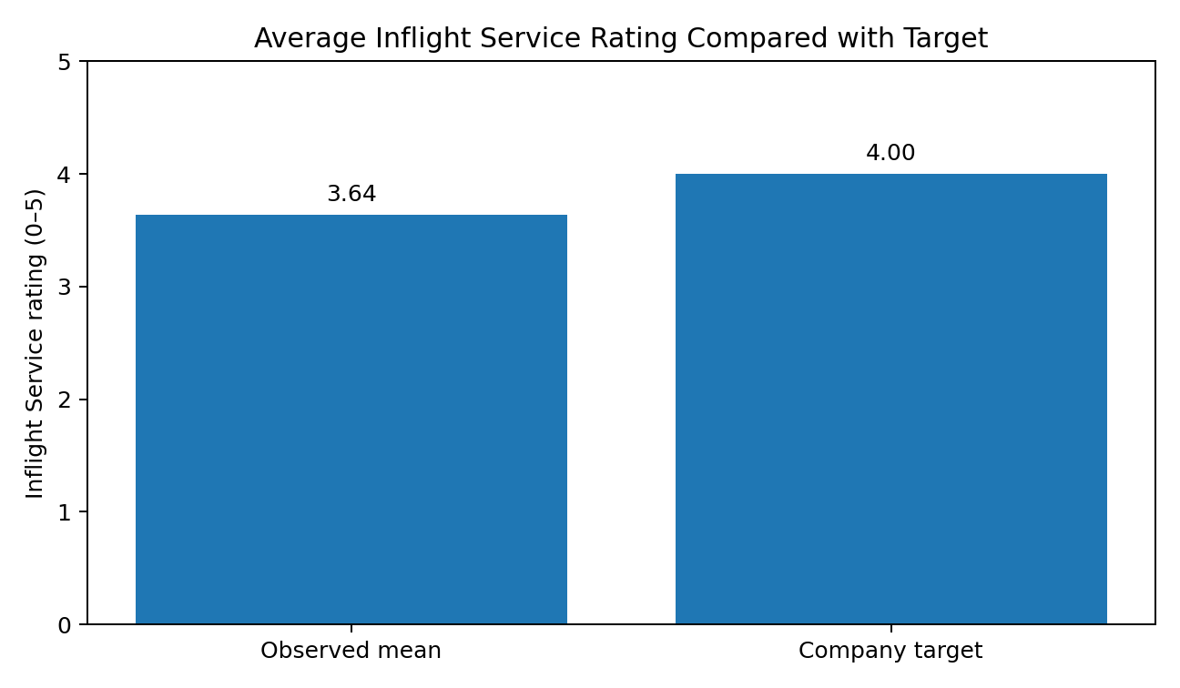
Figure 1. Observed mean Inflight Service rating compared with the company target.

5.2 One-Sample t-Test
Test | t | df | p-value | Mean difference | Cohen’s d
One-sample Student’s t-test | −98.6 | 103,903 | < .001 | −0.360 | −0.306

The test is statistically significant at α = .05. Since p < .001 and the sample mean (3.64) is below 4.0, the null hypothesis is rejected. The data provide strong evidence that the mean Inflight Service rating is below the target. Cohen’s d of approximately −0.306 indicates a small-to-moderate standardized difference, with the negative sign showing that the observed mean is below the reference value.

5.3 Wilcoxon Sensitivity Test
Output | Result visible in jamovi
Wilcoxon test | Wilcoxon rank test selected
p-value | < .001
Rank-biserial correlation | −0.409

The Wilcoxon output also reports p < .001, which supports the same directional conclusion as the t-test. This is a sensitivity check rather than a replacement for the primary test. The displayed Wilcoxon statistic in the screenshot is difficult to read precisely, so it is not transcribed here.

6. Discussion
The average Inflight Service rating is approximately 0.36 points below the target. The very small p-value indicates that the difference is unlikely to be explained by sampling variation alone under the null hypothesis. The effect size suggests that the gap is not enormous in standardized terms, but the shortfall may still matter operationally because the company has established 4.0 as its target.

7. Recommendations
- Review passenger feedback to identify the specific aspects of inflight service associated with lower ratings.
- Examine results by travel class, customer type, and type of travel where those variables are available and relevant.
- Prioritize practical improvements such as cabin-crew responsiveness, consistency of service, and communication with passengers, while using further data to identify the actual drivers of ratings.
- Monitor the mean Inflight Service rating over time and repeat the analysis after improvements to assess whether the target is being met.

8. Limitations and Responsible Interpretation
- The analysis establishes a statistical difference from the target but does not identify the causes of lower ratings.
- A large sample can produce a very small p-value even when the standardized effect size is modest; both statistical significance and practical importance should be considered.
- The Shapiro–Wilk output in jamovi showed NaN, so a valid normality-test result cannot be claimed from the current output.
- Ratings are discrete and bounded. The Q–Q plot reflects this structure, and the Wilcoxon test was included as a sensitivity check.
- The report should be checked against the final saved jamovi project and the course instructions before submission.

9. Conclusion
The one-sample t-test found that the mean Inflight Service rating (M = 3.64, SD = 1.18) was significantly below the target of 4.0, t(103,903) = −98.6, p < .001. The estimated mean shortfall was 0.36 rating points, and Cohen’s d was approximately −0.306. The Wilcoxon sensitivity test also returned p < .001. Therefore, the null hypothesis is rejected in favour of the conclusion that the mean Inflight Service rating is below 4.0.

10. Reproducibility in jamovi
- Open train.csv in jamovi.
- Choose Analyses → T-Tests → One Sample T-Test.
- Move Inflight service into Dependent Variables.
- Set Test value to 4 and select the alternative hypothesis “< Test value.”
- Enable Mean difference, Effect size, and Descriptives.
- Optionally select Wilcoxon rank as the sensitivity test.
- Save the analysis as Group1_Airline_Satisfaction.omv and retain clear screenshots of the output.

References
The analysis was performed using jamovi statistical software. The results reported here are based on the user’s jamovi output screenshots and the stated train.csv dataset. Add any dataset citation or course-provided reference required by the lecturer before submission.

Submission checklist
- Replace the blank group-member and student-ID line on the cover page.
- Confirm that the final .omv file opens and displays the correct results.
- Attach screenshots if required by the lecturer.
- Add the course’s required GitHub link or repository evidence only if your assignment specifically asks for it and the group has actually created one.

