

**Health-care System**

Supervisor By Dr / Aref eliwa

Students:

MERNA FAYEZ

MOHAMMED MAGDY

ABDELRAHMAN TYMOR

TAREK ADEL

RANEEM MOSAD

FATMA ALI

IBRAHIM ALAA

Heba Tallah Hatem

Karim Mahmud

Ahmed Awad

**Objective:**

**Pic of Robot:**

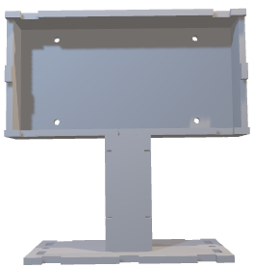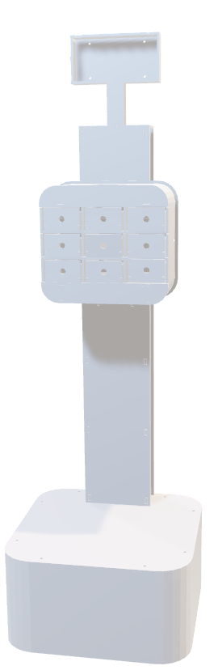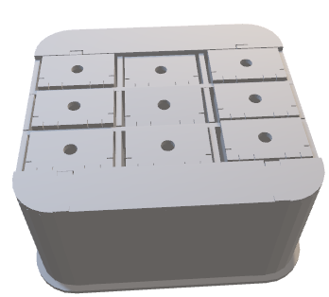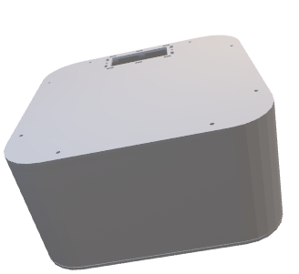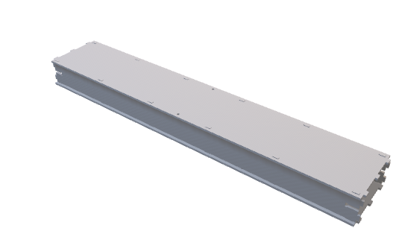

**Conclusion:**

The medical robot is designed to efficiently deliver medication to patients based on their prescribed schedule. It operates on a predetermined schedule, visiting each patient three times a day to administer the medication. The robot uses a line follower sensor to navigate its way to the patient's location within the facility.

To ensure accurate medication administration, the robot incorporates various sensors to monitor the patient's vital signs. These include temperature, SPO2 (blood oxygen saturation), and heart rate sensors. The sensors are connected to the Arduino Mega board, which processes the sensor data.

The robot communicates with a dedicated mobile app using Firebase as the backend service. The app allows healthcare professionals to remotely control and monitor the robot. It provides a user-friendly interface for sending commands to the robot and receiving real-time data from the sensors.

The mobile app communicates with the robot through the NodeMCU8266, which serves as the interface between the Arduino Mega and the Firebase service. The NodeMCU8266 module facilitates the transfer of data between the robot and the mobile app over a Wi-Fi connection.

In future iterations of the system, the architecture can be expanded to include additional features. Some possible enhancements include:

Integration of an ARM-based microcontroller, such as TivaC, for more advanced processing capabilities and improved performance.

Incorporation of a GSM module alongside Wi-Fi connectivity to ensure reliable communication in areas with limited or no Wi-Fi coverage.

Modification of the robot's architecture to serve multiple patients simultaneously, potentially utilizing advanced robotics techniques and algorithms to optimize the robot's movements and interactions with patients.

Overall, the medical robot system offers an efficient and automated approach to medication delivery while ensuring accurate monitoring of patients' vital signs.