
3/7/2026
Git Basics
Lab 2
Ainshams University
Tarek Mohamed Atef | 2300245
Agile

Exercise 1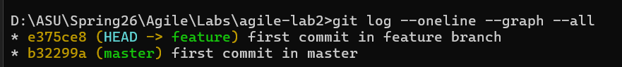

Exercise 2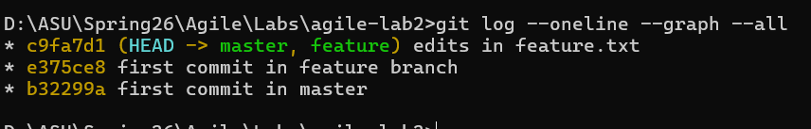 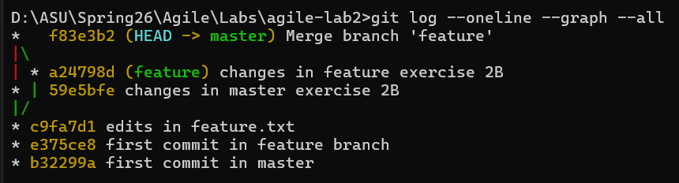
Exercise 3 