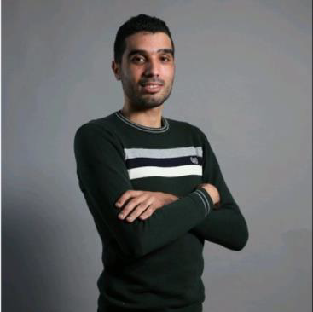

BENA ARFA TAREK
Link portfolio : https://tarek12345.github.io/tarek/

Dynamic and versatile, I am passionate about innovation and problem-solving. With a solid background in engineering, I have acquired expertise in developing effective and sustainable technological solutions. My professional experience has allowed me to develop skills in project management and teamwork, as well as an ability to adapt quickly to new environments. Always eager to learn and take on new challenges, I am looking for opportunities where I can put my skills to use and contribute to the success of stimulating projects.

PROFESSIONAL EXPERIENCE

Medisys (ACCON-RVS Accounting) | Full-Stack Developer
2024-Present

Development of a platform with a full suite of modules (travel, invoice, webflow). This is a management platform (invoice calculation and banks + relationship with travel agencies). Tech: Angular 14, Laravel 8. Project: URL of the project works only in Germany or via VPN.

Digit Prod (B-frobiz Franch) | Front-End Developer
January 2021 – December 2023

Development of a platform overhaul version allowing you to manage and supervise information elements of Google MyBusiness files. This project was developed with Node.js, React.js, Bootstrap, Redux, and MongoDB for task division. CRM Zoho Sprint (agile Scrum method) + Git Bitbucket, support on Gutenberg WordPress, creation of sites with Gutenberg WordPress.
Exemple project :
https://bboard.b-forbiz.com/login
Digit prod (B-frobiz franch) | Web Developer
January 2019 – Present
Development of a portal management platform for the client. This is an internal project of the technology company. Tech: AngularJS, Laravel, Bootstrap 4, MySQL for task division. CRM Zoho Sprint (agile Kanban method) + Git Bitbucket.
Digital communication (Cliqeo franch) Front-End Developer
January 2018 - December 2019
Development of websites for the client CLIQEO, custom or with responsive WordPress CMS templates using Elementor Pro. Exemples des sites : https://www.conceptstore-reims.fr/
https://www.b-forbiz.com https://www.flash-carte-grise.fr/

EDUCATION
Higher Institute of Technological Studies Charguia — 2013–2016

Applied Bachelor's Degree in Information System Development
Baccalaureate — 2012–2013
Baccalaureate with Mathematics specialization

Full-Stack Developer | Experience: 8 years

CONTACT
+216 50 269 194
15 Rue Elbekri beb khadra tarekbenarfa53@gmail.com

SKILLS
- Html 5
- CSS 3/SCSS
- Tailwind CSS
- JavaScript
- React js + node
- Angular js + laravel
- Next js
- Photoshop
- Illustrator
- figma
- Wordpress
- REST API

SOFTWARE
- Git Bash
- Git hub
- Bitbucket
- Adobpe
- Vs code
- CRM zoho
- Docker desktop

SOCIAL :
linkedin.com/in/benarfa-tarek-
104964112

LANGUES
Frensh : very good
English : Intermediate

