IGBT

What an IGBT is:

**IGBT is an abbreviation for insulated-gate bipolar transistors a three-terminal power semiconductor device primarily forming an electronic switch.**

**It consists of four alternating layers (P–N–P–N) that are controlled by a metal–oxide–semiconductor (MOS) gate structure.**

**It is a power transistor that combines an input MOS and an output bipolar transistor.**

**The IGBT is a transistor ideal for high-voltage, high-current applications. Available with a voltage rating ranging from 400 V to 2000 V and a current rating ranging from 5 A to 1000 A.**

**IGBTs are mainly used in power electronics applications, such as inverters, converters and power supplies, were the demands of the solid state switching device are not fully met by power bipolar and power MOSFETs. High-current and high-voltage bipolar are available, but their switching speeds are slow, while power MOSFETs may have higher switching speeds, but high-voltage and high-current devices are expensive and hard to achieve.**

**Comparison between different types of transistors**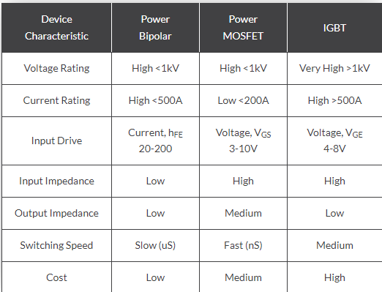

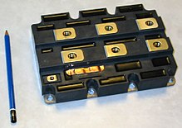

In reality

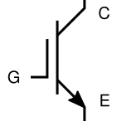

Schematic symbol

**The Key Parameters of IGBT**

The same as MOSFET

**Collector-Emitter Voltage (V_CE)**:

**Maximum (V_CE max)**: The maximum voltage that can be applied between the collector and emitter without damaging the device.

**Saturation Voltage (V_CE(sat))**: The voltage drop across the IGBT when it is fully on and conducting current.

**Collector Current (I_C)**:

**Maximum Collector Current (I_C max)**: The maximum continuous current the IGBT can handle without damage.

**Peak Collector Current (I_C peak)**: The maximum peak current that the IGBT can handle for a short duration.

**Gate Threshold Voltage (V_GE(th))**:

The minimum gate-emitter voltage required to turn the IGBT on. This is the voltage at which the device starts to conduct a small amount of current.

**Gate-Emitter Voltage (V_GE)**:

**Maximum (V_GE max)**: The maximum allowable gate-emitter voltage, beyond which the gate oxide may be damaged.

**Power Dissipation (P_D)**:

The maximum amount of power the IGBT can dissipate without exceeding its temperature limits.

**Switching Times**:

**Turn-On Time (t_on)**: The time it takes for the IGBT to switch from off to on.

**Turn-Off Time (t_off)**: The time it takes for the IGBT to switch from on to off.

**Total Switching Losses**: The energy lost during the switching transitions.

**Thermal Resistance (R_θJC and R_θJA)**:

**Junction-to-Case (R_θJC)**: Thermal resistance between the junction and the case of the IGBT.

**Junction-to-Ambient (R_θJA)**: Thermal resistance between the junction and the surrounding environment.

**Safe Operating Area (SOA)**:

The range of voltages and currents over which the IGBT can operate safely without risk of damage.

**The region of Operation of IGBT**

The output characteristics of IGBT have three stages, initially, when the Gate Voltage VGE is zero the device is in the off state, this is called the cutoff region. When VGE is increased and if it is less than the threshold voltage then there will be a small leakage current flowing through the device, but the device will still be in the cutoff region. When the VGE is increased beyond the threshold voltage the device goes into the active region and the current starts flowing through the device. The flow of current will increase with an increase in the voltage VGE as shown in the graph above.

