

PlantPulse – Google Play listing kit
Everything Play Console asks for, ready to copy and paste. Shaded text = copy it as is. All screenshots use the DEMO sample organisation (no company data).
كل ما يطلبه Play Console جاهز للنسخ. النص المظلل يُنسخ كما هو. الصور في آخر الملف: اضغط على الصورة بزر الفأرة الأيمن ← Save as Picture لحفظها ثم رفعها.

1. Main store listing (Grow → Store presence → Main store listing)
Field | Value
App name (≤30) | PlantPulse – Maintenance
Category | Business (alternative: Productivity)
Tags | Business, Productivity
Contact e-mail | A support address you are happy to show publicly
Website (optional) | https://84-8-106-22.sslip.io
Privacy policy URL | https://84-8-106-22.sslip.io/privacy

English (en-US) – default language
App name:
PlantPulse – Maintenance

Short description (≤80):
Work orders, PM, lubrication and condition monitoring for maintenance teams

Full description (≤4000):
PlantPulse is a maintenance management system (CMMS) for industrial plants. It brings work orders, preventive maintenance, lubrication, condition monitoring and spare parts into one app that works on the shop floor as well as in the office.

PlantPulse is for organisations that run it: sign in with the account your maintenance administrator gives you.

WORK ORDERS
• Raise a work request in seconds, with standard symptoms and a photo
• Plan, assign, start and complete jobs; record labour, parts and the failure cause
• "My work" shows each technician exactly what is due today

PREVENTIVE MAINTENANCE & LUBRICATION
• Time- and meter-based PM plans that generate work orders automatically
• Lubrication routes with points, lubricants and intervals
• Overdue and upcoming work at a glance

CONDITION MONITORING (PdM)
• Vibration, temperature, oil and other readings against warning and alarm limits
• Critical points first, trends per point, alerts when a limit is crossed
• Import historical readings from Excel

ASSETS & RELIABILITY
• Asset tree with search, QR code labels and a built-in scanner
• Failure-mode catalogue, Pareto by failure mode, MTBF / MTTR KPIs
• Department-based access: every team sees its own area

BUILT FOR REAL PLANTS
• English, Arabic and Bengali interfaces
• Roles for managers, planners, supervisors, engineers and technicians
• Excel import and export for assets, plans, users and readings
• Shift rosters and notifications by department

Your organisation's data stays on its own server and is sent only over encrypted connections.

Arabic (ar) – add as a translation
App name:
PlantPulse – الصيانة

Short description:
أوامر العمل والصيانة الوقائية والتزييت ومراقبة الحالة لفرق صيانة المصانع

Full description:
PlantPulse نظام لإدارة الصيانة (CMMS) للمنشآت الصناعية. يجمع أوامر العمل والصيانة الوقائية والتزييت ومراقبة الحالة وقطع الغيار في تطبيق واحد يعمل في الموقع وفي المكتب.

التطبيق مخصص للمنشآت التي تستخدمه: سجّل الدخول بالحساب الذي يعطيك إياه مسؤول الصيانة.

أوامر العمل
• طلب عمل خلال ثوانٍ مع أعراض قياسية وصورة
• تخطيط وتعيين وبدء وإنهاء الأعمال مع تسجيل العمالة وقطع الغيار وسبب العطل
• شاشة "عملي" تعرض لكل فني ما هو مطلوب اليوم

الصيانة الوقائية والتزييت
• خطط صيانة حسب الوقت أو العدّاد تُنشئ أوامر العمل تلقائياً
• مسارات تزييت بالنقاط والزيوت والفترات
• الأعمال المتأخرة والقادمة في لمحة

مراقبة الحالة (PdM)
• قراءات الاهتزاز والحرارة والزيت وغيرها مع حدود التحذير والإنذار
• النقاط الحرجة أولاً، واتجاه كل نقطة، وتنبيه عند تجاوز الحد
• استيراد القراءات السابقة من Excel

المعدات والاعتمادية
• شجرة معدات مع بحث وملصقات QR وماسح مدمج
• كتالوج أنماط الأعطال وتحليل باريتو ومؤشرات MTBF / MTTR
• صلاحيات حسب القسم: كل فريق يرى منطقته

مصمم للمصانع الحقيقية
• واجهة بالإنجليزية والعربية والبنغالية
• أدوار للمدير والمخطط والمشرف والمهندس والفني
• استيراد وتصدير Excel للمعدات والخطط والمستخدمين والقراءات
• جداول الورديات والإشعارات حسب القسم

بيانات منشأتك تبقى على خادمها الخاص ولا تُنقل إلا عبر اتصال مشفّر.

Graphics to upload
Field in Play Console | Image (at the end of this file) | Size
App icon | App icon | 512 × 512
Feature graphic | Feature graphic | 1024 × 500
Phone screenshots (2–8) | Screenshots 1 – 7 | 1080 × 1920

2. App content (Policy → App content)

Privacy policy
https://84-8-106-22.sslip.io/privacy

Ads
- No, my app does not contain ads.

App access
- Choose: All or some functionality is restricted → Add instructions
Field | Value
Name | Demo account
Username | manager@demo.example.com
Password | The demo password you chose on the server (type it only in Play Console)
Other information | Sign in with the account above. It belongs to a separate DEMO organisation with sample data only. No other steps are needed.

Create the demo organisation once on the server (separate from the real data; you type the password yourself):
cd /opt/cmms && sudo docker compose -f deploy/docker-compose.yml --env-file deploy/.env exec api python -m app.cli seed-demo

Content rating (IARC questionnaire)
Question | Answer
Category | All other app types
Violence, sexual content, profanity, drugs, gambling, horror | No (all)
Users interact or exchange content? | Yes – only users inside the same organisation (work orders, comments). No public chat.
Shares user location? | No
Purchases of digital goods? | No
Unrestricted internet browser? | No
Expected result | Everyone / PEGI 3

Target audience and content
Question | Answer
Target age | 18 and over only
Appeals to children? | No

Other declarations
Declaration | Answer
News app | No
COVID-19 contact tracing | No
Government app | No
Financial features | My app doesn't provide any financial features
Health apps | My app does not have any health features

Data safety
Question | Answer
Does your app collect or share any of the required user data types? | Yes
Is all of the user data encrypted in transit? | Yes
Which ways can users request that their data is deleted? | Users ask their organisation's administrator, who can deactivate the account and delete personal data. (add your support e-mail)
Data shared with third parties? | No
Data sold? | No

Data types collected (each one: Collected = Yes, Shared = No, Processed ephemerally = No, Required):
Section | Data type | Purpose | Why
Personal info | Name | App functionality, Account management | Name on work orders
Personal info | Email address | App functionality, Account management | Sign-in
Personal info | User IDs | App functionality, Account management | Account and employee number
Photos and videos | Photos | App functionality | Photos on requests / work orders
App activity | Other user-generated content | App functionality | Work orders, comments, readings
App activity | Other actions | App functionality, Fraud prevention, security and compliance | Audit log, sign-in times, IP address
Location | — | — | Not collected
Device or other IDs | — | — | Not collected

3. Closed testing (required for new personal accounts)
- Testing → Closed testing → Create track (or use "Alpha").
- Testers: create a Google Group (e.g. plantpulse-testers@googlegroups.com) or an e-mail list, with at least 12 people who have a Google account and an Android phone.
- Create release → upload the .aab from PWABuilder → release name 1.0.0 (1) → notes "First test release".
- Countries: Saudi Arabia (and any others) → Review and roll out.
- Send testers the opt-in link shown on the track. Each one opens it, taps Become a tester, then installs from Google Play.
- Testers keep the app installed for 14 days in a row and open it from time to time. Collect their feedback.
- After 14 days with 12+ testers: Dashboard → Apply for production, answer the short questionnaire (who tested, feedback, what changed).
- After approval: Production → Create release (same or newer .aab) → Roll out.
Before step 3: send assetlinks.json (from the PWABuilder package) so it is put on the server; otherwise the app shows a browser address bar.

4. Images (right-click → Save as Picture, then upload)

App icon – 512 × 512

Feature graphic – 1024 × 500
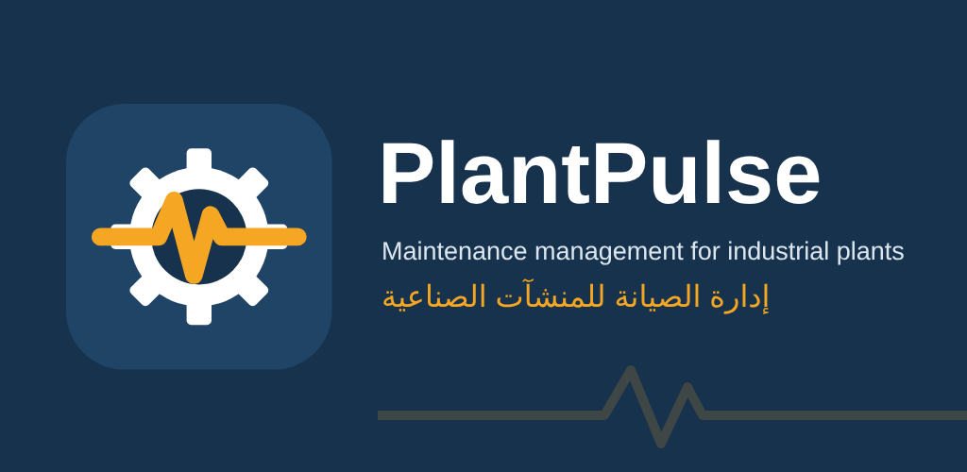

Phone screenshots – 1080 × 1920
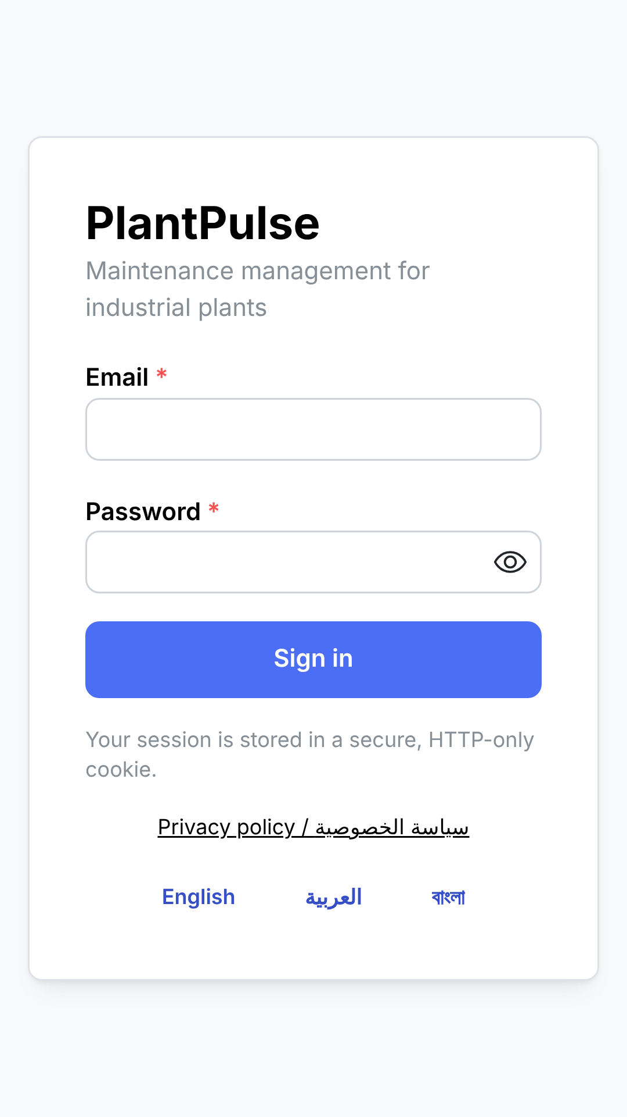 | 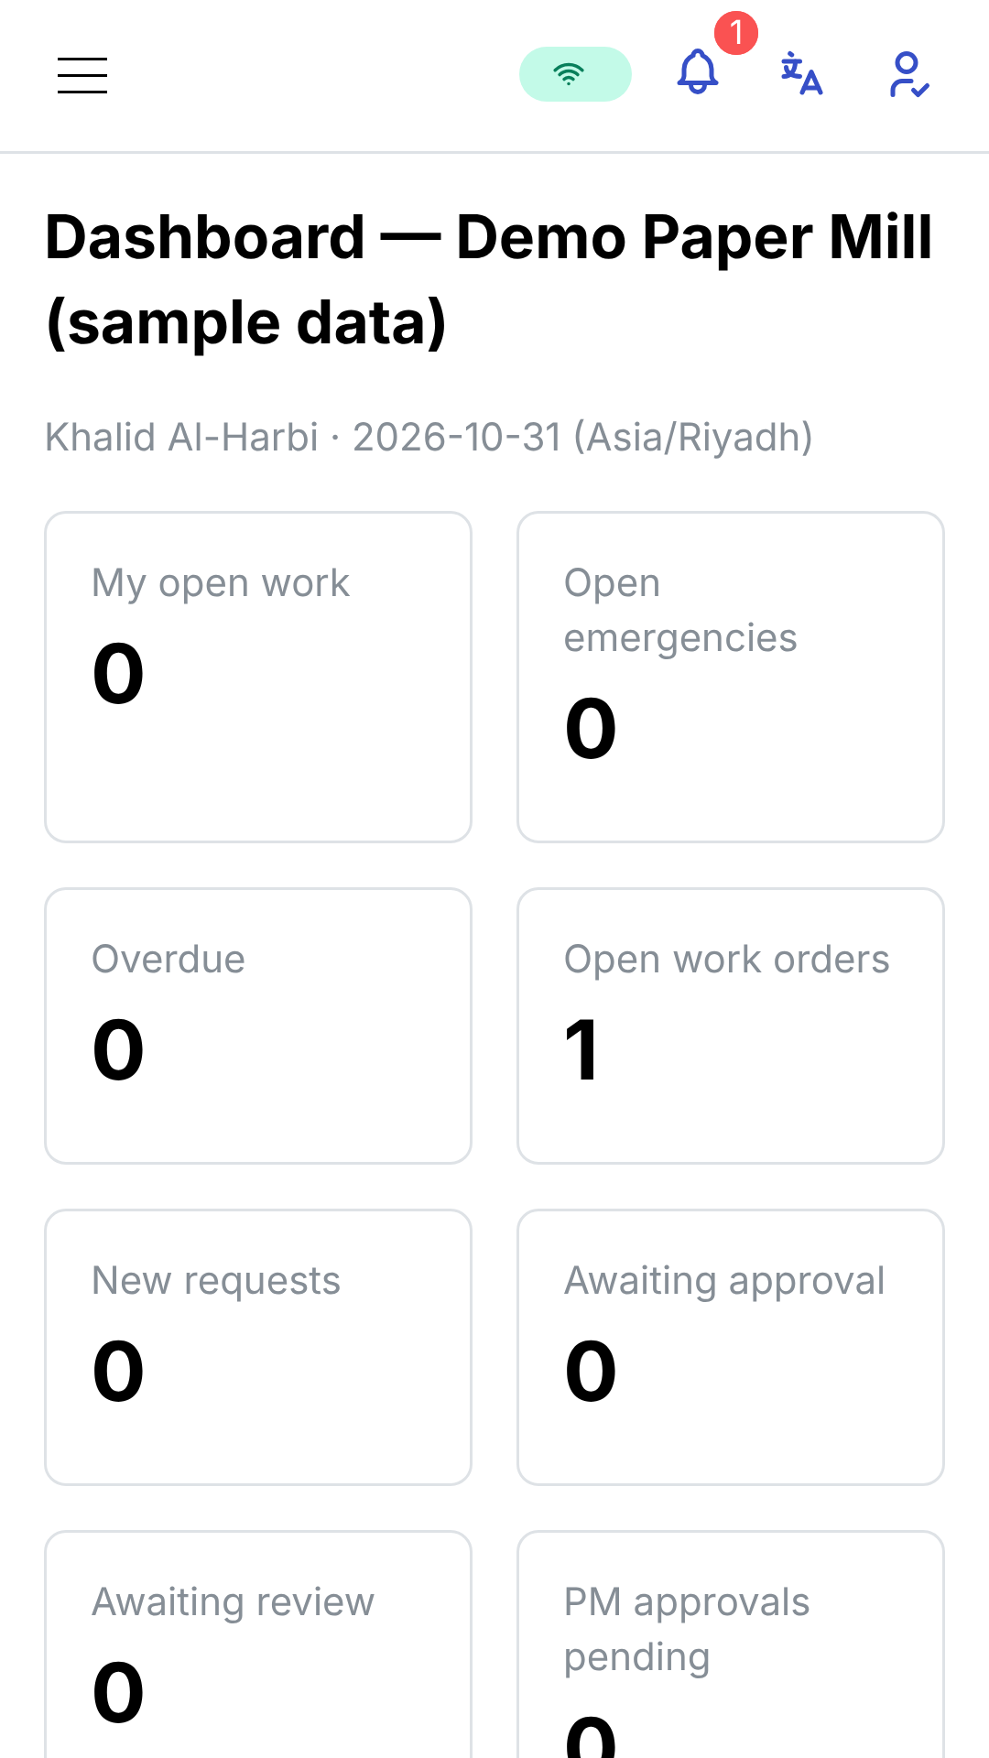
1. Sign in | 2. Dashboard

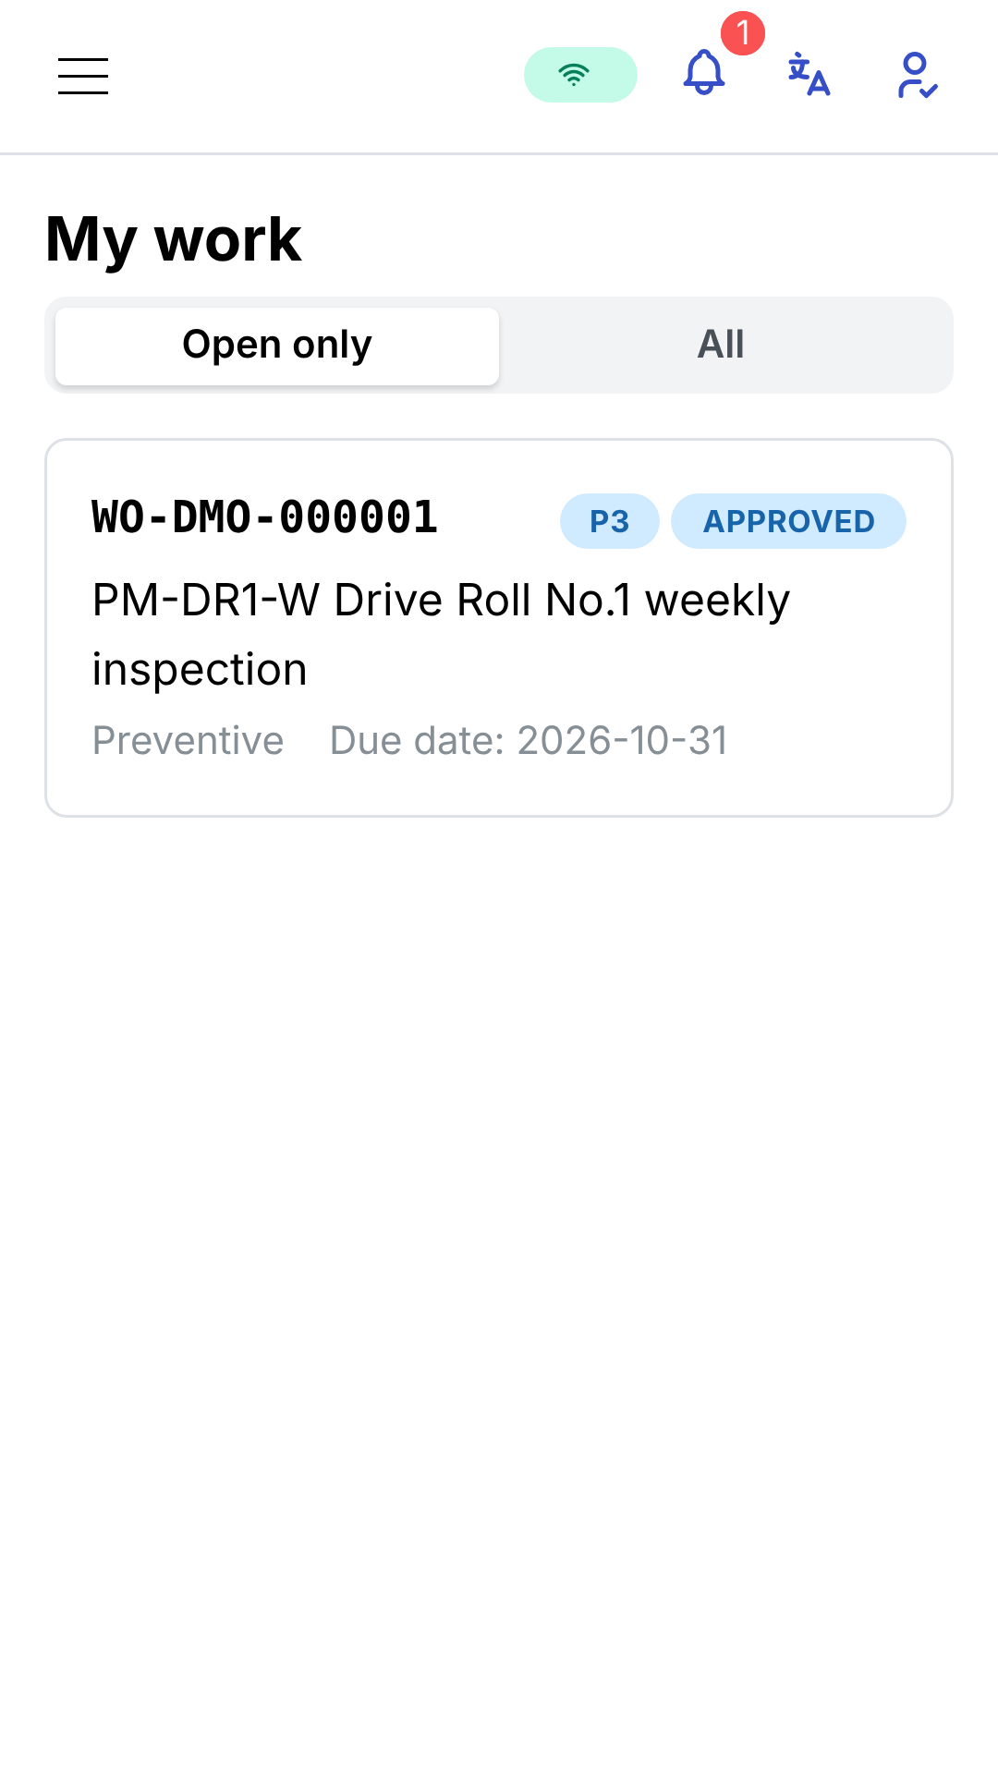 | 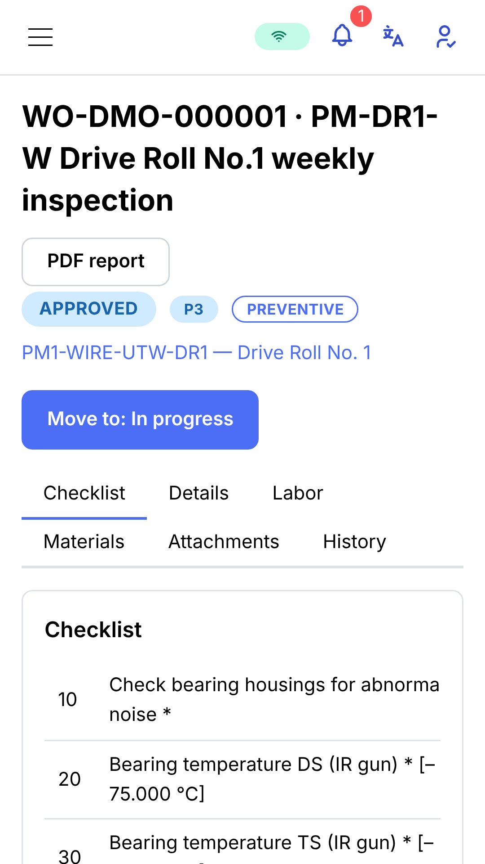
3. My work | 4. Work order

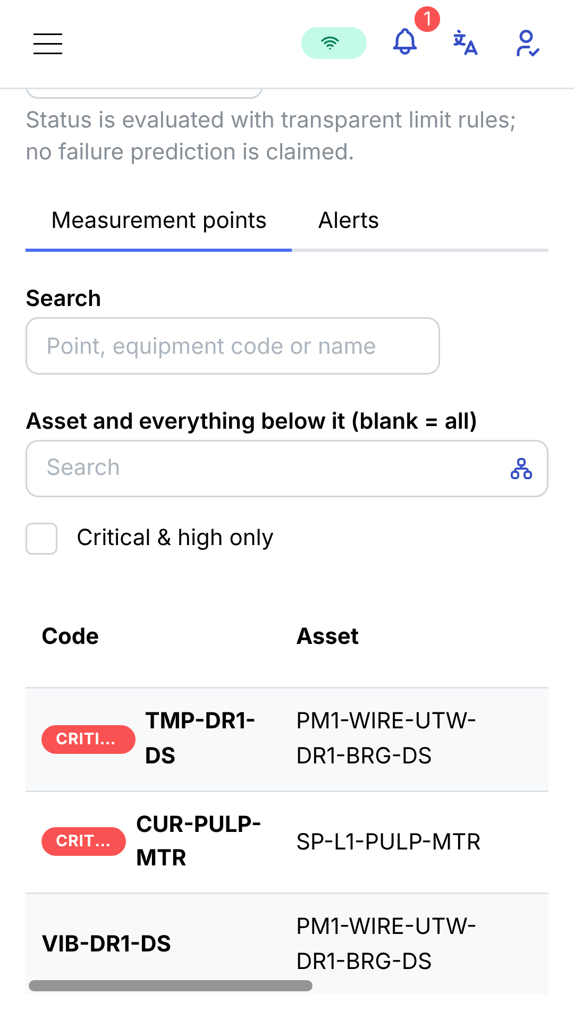 | 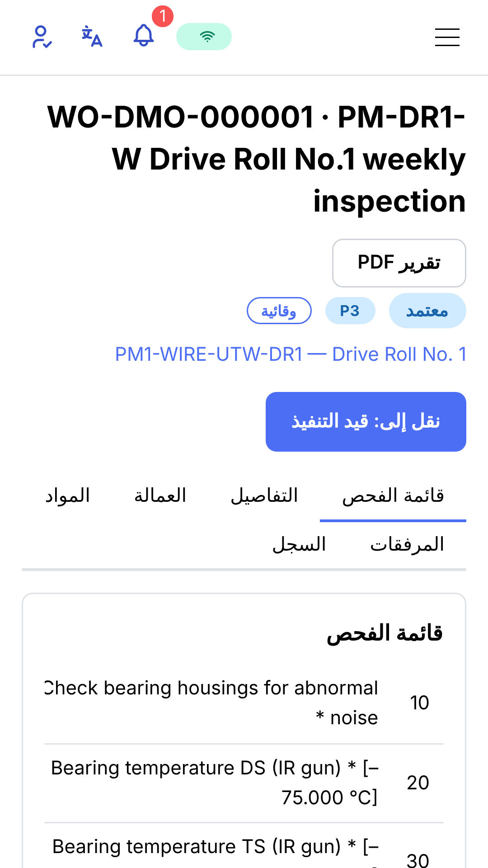
5. Condition monitoring | 6. Work order (Arabic)

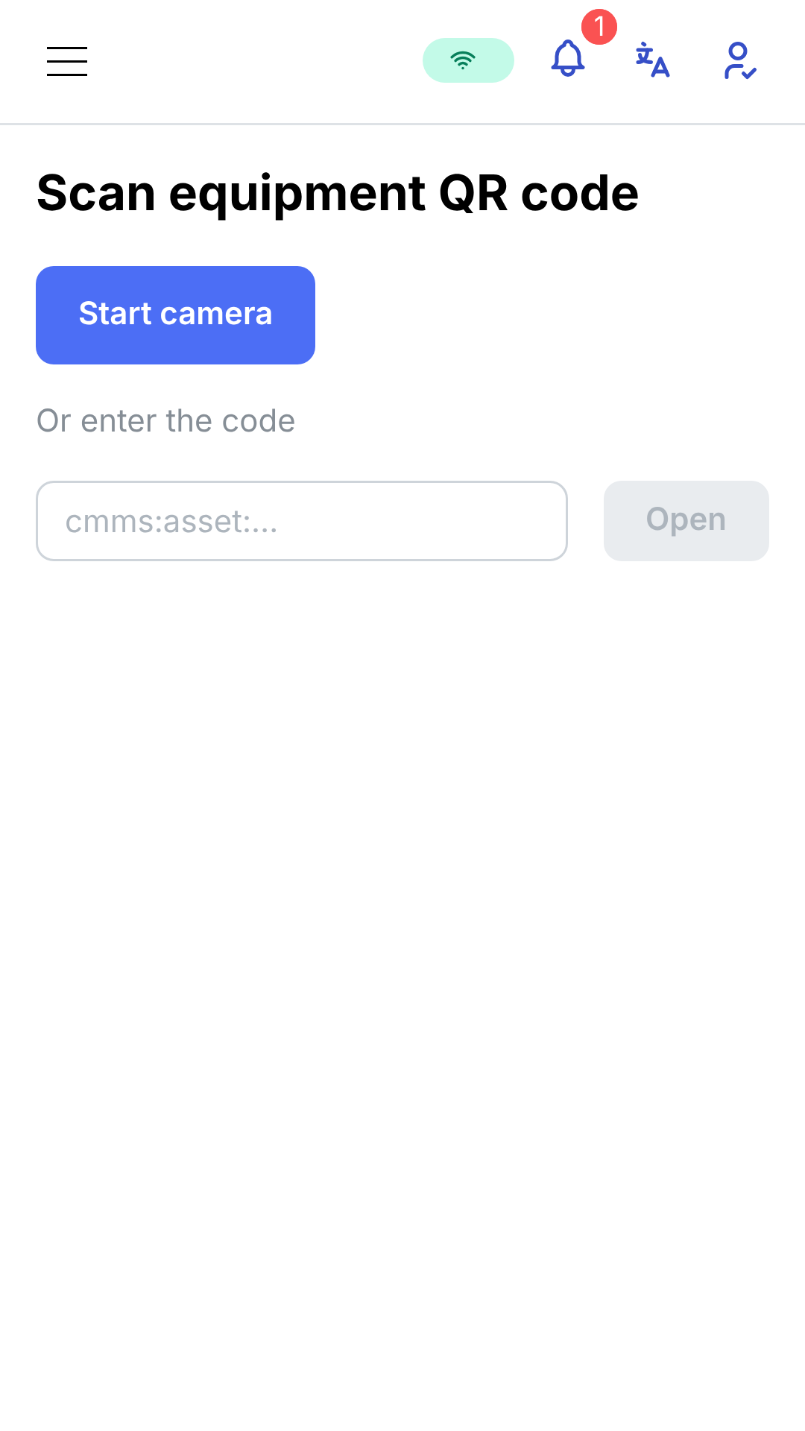
7. QR scan

