PlantPulse – Roles, access and approval process
What each user role can see and do, and who approves each step. Taken directly from the system's permission settings. Access is always checked by the server, not only hidden on screen.

1. What each role can see and do
Role | Typical person | Can see | Can do / approve
System Administrator | IT / CMMS owner | Everything, all departments, audit log | Everything; the only role that adds users, sets roles and departments, plant settings and workflow
Maintenance Manager | Maintenance / plant manager | Everything (incl. audit log), KPIs, costs | Every maintenance step: approve, plan, close, emergency closure, PM deferrals, KPIs & budgets. Not users or plant settings
Maintenance Planner | Planning engineer | All modules (view), KPIs, reports | Triage requests, create/plan/schedule/assign WOs, cancel, PM & lubrication plans, run PM scheduler, assets & imports, condition point priority, shutdowns, rosters, purchase, KPI data. Does NOT approve, execute or close WOs
Mechanical Supervisor / Electrical-Automation Supervisor | Area / trade supervisor | All modules (view), KPIs, reports | Triage, approve, plan, assign, execute, review, safety (LOTO/permit) sign-off, close (incl. emergency), cancel; approve PM deferrals; condition alerts; confirm handovers; rosters; shutdowns
Reliability Engineer | Reliability / CM engineer | All modules (view), KPIs, reports | Create WOs, review completed work, PM plans, condition monitoring points/limits/priority & alerts, lubrication plans and lubricant alternatives, assets, KPI data
Engineer | Mechanical / electrical engineer | All modules (view), KPIs, reports | Create & edit WOs, execute work, review completed work, record readings, set point priority, edit assets, handovers
Technician | Technician / fitter / electrician | Assets, work orders, PM, lubrication, condition monitoring, shifts, spare parts, shutdowns (no KPIs) | Submit work requests, do the work (start, hold, labour, checklist, photos, submit for review), lubrication tasks, readings, handovers
Storekeeper | Store / warehouse | Assets, work orders, spare parts, lubrication | Parts master, receive / issue / return / adjust stock, reservations, purchase references, export reports
Production User | Operator / shift leader | Assets, work orders, condition monitoring, KPIs | Submit work requests only
Management Viewer | Senior management | All modules and KPIs (read only, no audit log) | Export reports only

Departments: any role can be limited to one or more departments (e.g. PM + SP). Then the user sees and acts only on that equipment: work orders, requests, PM, lubrication, condition monitoring, assets, dashboard, KPIs and notifications. Leave departments empty for people who cover the whole plant.

2. Approval process – work requests and work orders
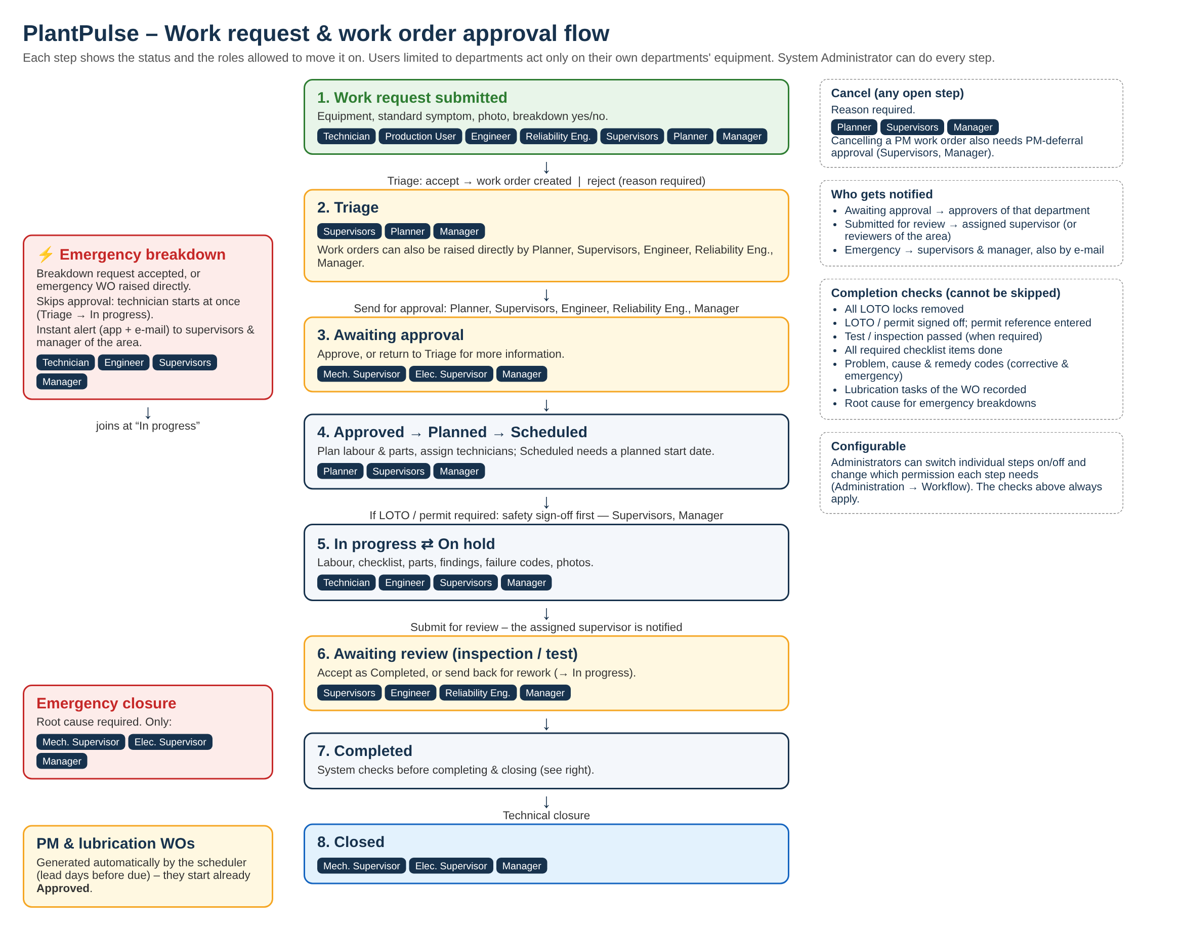

3. Other approvals
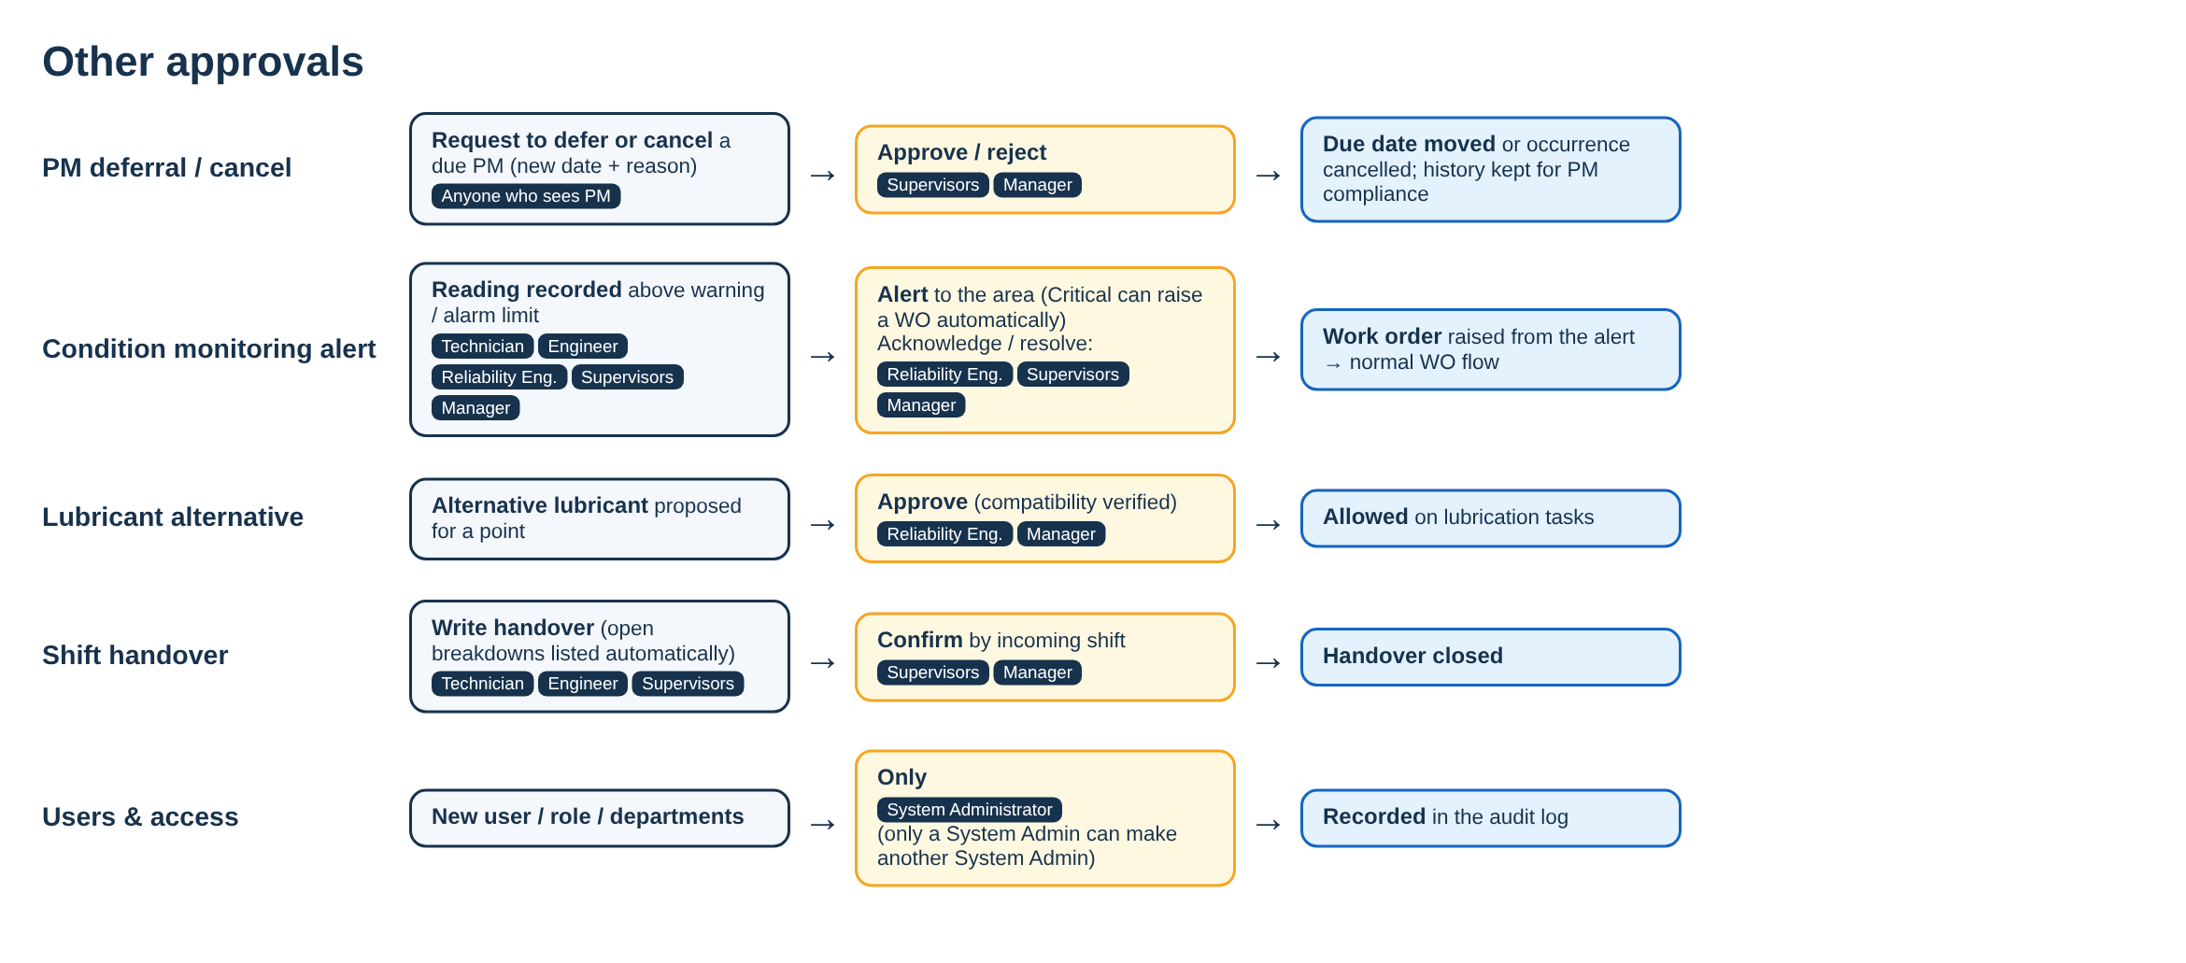

4. Work order steps – who can move each one
From | To | Permission | Roles (plus System Administrator)
Triage | Awaiting approval | wo.edit | Maintenance Manager, Maintenance Planner, Mech. Supervisor, Elec./Autom. Supervisor, Reliability Engineer, Engineer
Triage | Approved | wo.approve | Maintenance Manager, Mech. Supervisor, Elec./Autom. Supervisor
Triage | In progress (emergency only) | wo.execute | Maintenance Manager, Mech. Supervisor, Elec./Autom. Supervisor, Engineer, Technician
Triage | Cancelled | wo.cancel | Maintenance Manager, Maintenance Planner, Mech. Supervisor, Elec./Autom. Supervisor
Awaiting approval | Approved | wo.approve | Maintenance Manager, Mech. Supervisor, Elec./Autom. Supervisor
Awaiting approval | Triage | wo.approve | Maintenance Manager, Mech. Supervisor, Elec./Autom. Supervisor
Awaiting approval | Cancelled | wo.cancel | Maintenance Manager, Maintenance Planner, Mech. Supervisor, Elec./Autom. Supervisor
Approved | Planned | wo.plan | Maintenance Manager, Maintenance Planner, Mech. Supervisor, Elec./Autom. Supervisor
Approved | Scheduled | wo.plan | Maintenance Manager, Maintenance Planner, Mech. Supervisor, Elec./Autom. Supervisor
Approved | In progress | wo.execute | Maintenance Manager, Mech. Supervisor, Elec./Autom. Supervisor, Engineer, Technician
Approved | Cancelled | wo.cancel | Maintenance Manager, Maintenance Planner, Mech. Supervisor, Elec./Autom. Supervisor
Planned | Scheduled | wo.plan | Maintenance Manager, Maintenance Planner, Mech. Supervisor, Elec./Autom. Supervisor
Planned | Cancelled | wo.cancel | Maintenance Manager, Maintenance Planner, Mech. Supervisor, Elec./Autom. Supervisor
Scheduled | In progress | wo.execute | Maintenance Manager, Mech. Supervisor, Elec./Autom. Supervisor, Engineer, Technician
Scheduled | Planned | wo.plan | Maintenance Manager, Maintenance Planner, Mech. Supervisor, Elec./Autom. Supervisor
Scheduled | Cancelled | wo.cancel | Maintenance Manager, Maintenance Planner, Mech. Supervisor, Elec./Autom. Supervisor
In progress | On hold | wo.execute | Maintenance Manager, Mech. Supervisor, Elec./Autom. Supervisor, Engineer, Technician
In progress | Awaiting review | wo.execute | Maintenance Manager, Mech. Supervisor, Elec./Autom. Supervisor, Engineer, Technician
On hold | In progress | wo.execute | Maintenance Manager, Mech. Supervisor, Elec./Autom. Supervisor, Engineer, Technician
On hold | Cancelled | wo.cancel | Maintenance Manager, Maintenance Planner, Mech. Supervisor, Elec./Autom. Supervisor
Awaiting review | In progress | wo.review | Maintenance Manager, Mech. Supervisor, Elec./Autom. Supervisor, Reliability Engineer, Engineer
Awaiting review | Completed | wo.review | Maintenance Manager, Mech. Supervisor, Elec./Autom. Supervisor, Reliability Engineer, Engineer
Completed | Closed | wo.close | Maintenance Manager, Mech. Supervisor, Elec./Autom. Supervisor
Any (closing emergency) | Closed | wo.close_emergency | Maintenance Manager, Mech. Supervisor, Elec./Autom. Supervisor
Before start | Safety sign-off | wo.safety_signoff | Maintenance Manager, Mech. Supervisor, Elec./Autom. Supervisor
Request | Accepted / rejected | request.triage | Maintenance Manager, Maintenance Planner, Mech. Supervisor, Elec./Autom. Supervisor

5. Full permission matrix
Permission | Meaning | Sys Admin | Manager | Planner | Mech Sup | Elec Sup | Reliab. Eng | Engineer | Techn. | Store | Production | Mgmt View
plant.admin | Administer plant settings, users, numbering, workflow | ✓
user.manage | Create/disable users and memberships | ✓
audit.view | View audit logs | ✓ | ✓ | ✓ | ✓ | ✓ | ✓ | ✓
asset.view | View assets | ✓ | ✓ | ✓ | ✓ | ✓ | ✓ | ✓ | ✓ | ✓ | ✓ | ✓
asset.edit | Create and edit assets, BOMs, meters | ✓ | ✓ | ✓ |  |  | ✓ | ✓
asset.import | Bulk import assets | ✓ | ✓ | ✓
request.create | Submit work requests | ✓ | ✓ | ✓ | ✓ | ✓ | ✓ | ✓ | ✓ |  | ✓
request.triage | Triage work requests | ✓ | ✓ | ✓ | ✓ | ✓
wo.view | View work orders | ✓ | ✓ | ✓ | ✓ | ✓ | ✓ | ✓ | ✓ | ✓ | ✓ | ✓
wo.create | Create work orders | ✓ | ✓ | ✓ | ✓ | ✓ | ✓ | ✓
wo.edit | Edit work order details | ✓ | ✓ | ✓ | ✓ | ✓ | ✓ | ✓
wo.approve | Approve work orders | ✓ | ✓ |  | ✓ | ✓
wo.plan | Plan and schedule work orders | ✓ | ✓ | ✓ | ✓ | ✓
wo.assign | Assign technicians (including bulk assignment) | ✓ | ✓ | ✓ | ✓ | ✓
wo.execute | Start work, record labor/checklists/findings | ✓ | ✓ |  | ✓ | ✓ |  | ✓ | ✓
wo.review | Inspect/test and review completed work | ✓ | ✓ |  | ✓ | ✓ | ✓ | ✓
wo.safety_signoff | Sign off LOTO/permit safety requirements | ✓ | ✓ |  | ✓ | ✓
wo.close | Technically close work orders | ✓ | ✓ |  | ✓ | ✓
wo.close_emergency | Close emergency work orders | ✓ | ✓ |  | ✓ | ✓
wo.cancel | Cancel work orders | ✓ | ✓ | ✓ | ✓ | ✓
pm.view | View PM plans | ✓ | ✓ | ✓ | ✓ | ✓ | ✓ | ✓ | ✓ |  |  | ✓
pm.manage | Create and edit PM plans and job plans | ✓ | ✓ | ✓ |  |  | ✓
pm.approve_deferral | Approve PM deferrals and cancellations | ✓ | ✓ |  | ✓ | ✓
pm.run_scheduler | Run the PM scheduler on demand | ✓ | ✓ | ✓
lube.view | View lubrication | ✓ | ✓ | ✓ | ✓ | ✓ | ✓ | ✓ | ✓ | ✓ |  | ✓
lube.manage | Manage lubrication points, routes, lubricants | ✓ | ✓ | ✓ |  |  | ✓
lube.approve_alternative | Approve lubricant alternatives (compatibility verified) | ✓ | ✓ |  |  |  | ✓
lube.execute | Record lubrication tasks | ✓ | ✓ |  | ✓ | ✓ |  |  | ✓
shift.view | View shifts and rosters | ✓ | ✓ | ✓ | ✓ | ✓ | ✓ | ✓ | ✓ |  |  | ✓
shift.manage | Manage shift patterns, teams and rosters | ✓ | ✓ | ✓ | ✓ | ✓
handover.create | Write shift handovers | ✓ | ✓ |  | ✓ | ✓ |  | ✓ | ✓
handover.confirm | Confirm shift handovers | ✓ | ✓ |  | ✓ | ✓
inventory.view | View spare parts and stock | ✓ | ✓ | ✓ | ✓ | ✓ | ✓ | ✓ | ✓ | ✓ |  | ✓
inventory.manage | Manage part master data | ✓ | ✓ |  |  |  |  |  |  | ✓
inventory.transact | Receive, issue, return stock | ✓ | ✓ |  |  |  |  |  |  | ✓
inventory.adjust | Stock adjustments | ✓ | ✓ |  |  |  |  |  |  | ✓
inventory.reserve | Reserve materials for work orders | ✓ | ✓ | ✓ | ✓ | ✓ |  |  |  | ✓
purchase.manage | Manage purchase requisitions / PO references | ✓ | ✓ | ✓ |  |  |  |  |  | ✓
pdm.view | View condition monitoring | ✓ | ✓ | ✓ | ✓ | ✓ | ✓ | ✓ | ✓ |  | ✓ | ✓
pdm.manage | Manage measurement points and limits | ✓ | ✓ |  |  |  | ✓
pdm.record | Record condition readings | ✓ | ✓ |  | ✓ | ✓ | ✓ | ✓ | ✓
pdm.prioritize | Set the priority of measurement points (critical items at the top of the list) | ✓ | ✓ | ✓ |  |  | ✓ | ✓
pdm.alert_manage | Acknowledge/resolve condition alerts | ✓ | ✓ |  | ✓ | ✓ | ✓
shutdown.view | View shutdowns | ✓ | ✓ | ✓ | ✓ | ✓ | ✓ | ✓ | ✓ |  |  | ✓
shutdown.manage | Plan and update shutdowns | ✓ | ✓ | ✓ | ✓ | ✓
kpi.view | View KPI dashboards | ✓ | ✓ | ✓ | ✓ | ✓ | ✓ | ✓ |  |  | ✓ | ✓
kpi.manage | Maintain production records, budgets, KPI settings | ✓ | ✓ | ✓ |  |  | ✓
report.export | Export reports | ✓ | ✓ | ✓ | ✓ | ✓ | ✓ | ✓ |  | ✓ |  | ✓
attachment.upload | Upload attachments | ✓ | ✓ | ✓ | ✓ | ✓ | ✓ | ✓ | ✓
Administrators can change which permission each work-order step needs in Administration → Workflow; the safety and completion checks always apply.

