| **Status** | **Status** |
| --- | --- |
| 1 | Abnormal |
| 2 | Normal |

VLQ scale classifications in a 2 column table:

| **VLQ Scale value** | **VLQ Scale classification** |
| --- | --- |
| 1 | Very loose |
| 2 | Slightly loose |
| 3 | Moderate loose |
| 4 | Neither loose or tight |
| 5 | Slightly tight |
| 6 | Moderate tight |
| 7 | Very tight |

| **Qxford scale value** | **Qxford scale Classification** |
| --- | --- |
| 1 | Flicker |
| 2 | Weak |
| 3 | Moderate |
| 4 | Good |
| 5 | Strong |

**VLQ Traditional**

| **Model** | **Class** | **Precision** | **Recall** | **F1-Score** | **Support** | **Accuracy** | **Macro Avg** | **Weighted Avg** | **Execution Time (seconds)** |
| --- | --- | --- | --- | --- | --- | --- | --- | --- | --- |
| Decision Tree Classifier | 1 | 0.65 | 0.69 | 0.67 | 16 | 0.67 | 0.5 | 0.67 | 0.2791 |
| 2 | 0.79 | 0.93 | 0.85 | 28 | 0.52 |
| 3 | 0 | 0 | 0 | 6 | 0.48 |
| 4 | 0.52 | 0.92 | 0.67 | 13 | 0.52 |
| 5 | 1 | 0.35 | 0.52 | 20 | 0.52 |
| 6 | 0.55 | 0.73 | 0.63 | 15 | 0.52 |
| 7 | 0 | 0 | 0 | 2 | 0.48 |
| Logistic Regression | 1 | 0.62 | 0.62 | 0.62 | 16 | 0.58 | 0.39 | 0.53 | 0.0354 |
| 2 | 0.71 | 0.86 | 0.77 | 28 | 0.41 |
| 3 | 0 | 0 | 0 | 6 | 0.39 |
| 4 | 0.5 | 0.31 | 0.38 | 13 | 0.39 |
| 5 | 0.62 | 0.8 | 0.7 | 20 | 0.39 |
| 6 | 0.27 | 0.27 | 0.27 | 15 | 0.39 |
| 7 | 0 | 0 | 0 | 2 | 0.34 |
| Random Forest Classifier | 1 | 0.94 | 0.94 | 0.94 | 16 | 0.89 | 0.89 | 0.89 | 169.6569 |
| 2 | 0.96 | 0.93 | 0.95 | 28 | 0.89 |
| 3 | 0.71 | 0.83 | 0.77 | 6 | 0.89 |
| 4 | 0.85 | 0.85 | 0.85 | 13 | 0.89 |
| 5 | 0.82 | 0.9 | 0.86 | 20 | 0.89 |
| 6 | 0.92 | 0.8 | 0.86 | 15 | 0.89 |
| 7 | 1 | 1 | 1 | 2 | 0.89 |
| Support Vector Machine (LinearSVC) | 1 | 0.83 | 0.31 | 0.45 | 16 | 0.48 | 0.32 | 0.45 | 0.0152 |
| 2 | 0.71 | 0.71 | 0.71 | 28 | 0.34 |
| 3 | 0 | 0 | 0 | 6 | 0.29 |
| 4 | 0.28 | 0.54 | 0.37 | 13 | 0.29 |
| 5 | 0.39 | 0.8 | 0.52 | 20 | 0.29 |
| 6 | 0 | 0 | 0 | 15 | 0.29 |
| 7 | 0 | 0 | 0 | 2 | 0.29 |
| Gradient Boosting Classifier  (Proposed) | 1 | 1.00 | 1.00 | 1.00 | 16 | 1.00 | 1.00 | 1.00 | 12.2903 |
| 2 | 1.00 | 1.00 | 1.00 | 28 | 1.00 |
| 3 | 1.00 | 1.00 | 1.00 | 6 | 1.00 |
| 4 | 1.00 | 1.00 | 1.00 | 13 | 1.00 |
| 5 | 1.00 | 1.00 | 1.00 | 20 | 1.00 |
| 6 | 1.00 | 1.00 | 1.00 | 15 | 1.00 |
| 7 | 1.00 | 1.00 | 1.00 | 2 | 1.00 |
| Voting Classifier  (Proposed) | 1 | 1.00 | 1.00 | 1.00 | 16 | 1.00 | 1.00 | 1.00 | 0.2629 |
| 2 | 1.00 | 1.00 | 1.00 | 28 | 1.00 |
| 3 | 1.00 | 1.00 | 1.00 | 6 | 1.00 |
| 4 | 1.00 | 1.00 | 1.00 | 13 | 1.00 |
| 5 | 1.00 | 1.00 | 1.00 | 20 | 1.00 |
| 6 | 1.00 | 1.00 | 1.00 | 15 | 1.00 |
| 7 | 1.00 | 1.00 | 1.00 | 2 | 1.00 |

Top of Form

Bottom of Form

1. **Decision Tree Classifier with optimum max depth:**

The performance of the model is summarized in the following table:

| **Class** | **Precision** | **Recall** | **F1-Score** | **Support** |
| --- | --- | --- | --- | --- |
| 1 | 0.65 | 0.69 | 0.67 | 16 |
| 2 | 0.79 | 0.93 | 0.85 | 28 |
| 3 | 0.00 | 0.00 | 0.00 | 6 |
| 4 | 0.52 | 0.92 | 0.67 | 13 |
| 5 | 1.00 | 0.35 | 0.52 | 20 |
| 6 | 0.55 | 0.73 | 0.63 | 15 |
| 7 | 0.00 | 0.00 | 0.00 | 2 |
| Accuracy |  | 0.67 |  | 100 |
| Macro Avg | 0.50 | 0.52 | 0.48 | 100 |
| Weighted Avg | 0.67 | 0.67 | 0.63 | 100 |

Execution Time: 0.2791 seconds

1. **Logistic Regression:**

The performance of the model is summarized in the following table:

| **Class** | **Precision** | **Recall** | **F1-Score** | **Support** |
| --- | --- | --- | --- | --- |
| 1 | 0.62 | 0.62 | 0.62 | 16 |
| 2 | 0.71 | 0.86 | 0.77 | 28 |
| 3 | 0.00 | 0.00 | 0.00 | 6 |
| 4 | 0.50 | 0.31 | 0.38 | 13 |
| 5 | 0.62 | 0.80 | 0.70 | 20 |
| 6 | 0.27 | 0.27 | 0.27 | 15 |
| 7 | 0.00 | 0.00 | 0.00 | 2 |
| Accuracy |  | 0.58 |  | 100 |
| Macro Avg | 0.39 | 0.41 | 0.39 | 100 |
| Weighted Avg | 0.53 | 0.58 | 0.55 | 100 |

Execution Time: 0.0354 seconds

1. **Random Forest Classifier with hyperparameters tuning:**

The performance of the model is summarized in the following table:

| **Class** | **Precision** | **Recall** | **F1-Score** | **Support** |
| --- | --- | --- | --- | --- |
| 1 | 0.94 | 0.94 | 0.94 | 16 |
| 2 | 0.96 | 0.93 | 0.95 | 28 |
| 3 | 0.71 | 0.83 | 0.77 | 6 |
| 4 | 0.85 | 0.85 | 0.85 | 13 |
| 5 | 0.82 | 0.90 | 0.86 | 20 |
| 6 | 0.92 | 0.80 | 0.86 | 15 |
| 7 | 1.00 | 1.00 | 1.00 | 2 |
| Accuracy |  | 0.89 |  | 100 |
| Macro Avg | 0.89 | 0.89 | 0.89 | 100 |
| Weighted Avg | 0.89 | 0.89 | 0.89 | 100 |

Execution Time: 169.6569 seconds

1. **Support Vector Machine (LinearSVC):**

The performance of the model is summarized in the following table:

| **Class** | **Precision** | **Recall** | **F1-Score** | **Support** |
| --- | --- | --- | --- | --- |
| 1 | 0.83 | 0.31 | 0.45 | 16 |
| 2 | 0.71 | 0.71 | 0.71 | 28 |
| 3 | 0.00 | 0.00 | 0.00 | 6 |
| 4 | 0.28 | 0.54 | 0.37 | 13 |
| 5 | 0.39 | 0.80 | 0.52 | 20 |
| 6 | 0.00 | 0.00 | 0.00 | 15 |
| 7 | 0.00 | 0.00 | 0.00 | 2 |
| Accuracy |  | 0.48 |  | 100 |
| Macro Avg | 0.32 | 0.34 | 0.29 | 100 |
| Weighted Avg | 0.45 | 0.48 | 0.43 | 100 |

Execution Time: 0.0152 seconds

**Novel VLQ**

1. **Gradient Boosting Classifier with dimensionality reduction:**

The performance of the model is summarized in the following table:

| **Class** | **Precision** | **Recall** | **F1-Score** | **Support** |
| --- | --- | --- | --- | --- |
| 1 | 1.00 | 1.00 | 1.00 | 16 |
| 2 | 1.00 | 1.00 | 1.00 | 28 |
| 3 | 1.00 | 1.00 | 1.00 | 6 |
| 4 | 1.00 | 1.00 | 1.00 | 13 |
| 5 | 1.00 | 1.00 | 1.00 | 20 |
| 6 | 1.00 | 1.00 | 1.00 | 15 |
| 7 | 1.00 | 1.00 | 1.00 | 2 |
| Accuracy |  | 1.00 |  | 100 |
| Macro Avg | 1.00 | 1.00 | 1.00 | 100 |
| Weighted Avg | 1.00 | 1.00 | 1.00 | 100 |

Execution Time: 12.2903 seconds

1. **Voting Classifier:**

The performance of the model is summarized in the following table:

| **Class** | **Precision** | **Recall** | **F1-Score** | **Support** |
| --- | --- | --- | --- | --- |
| 1 | 1.00 | 1.00 | 1.00 | 16 |
| 2 | 1.00 | 1.00 | 1.00 | 28 |
| 3 | 1.00 | 1.00 | 1.00 | 6 |
| 4 | 1.00 | 1.00 | 1.00 | 13 |
| 5 | 1.00 | 1.00 | 1.00 | 20 |
| 6 | 1.00 | 1.00 | 1.00 | 15 |
| 7 | 1.00 | 1.00 | 1.00 | 2 |
| Accuracy |  | 1.00 |  | 100 |
| Macro Avg | 1.00 | 1.00 | 1.00 | 100 |
| Weighted Avg | 1.00 | 1.00 | 1.00 | 100 |

Execution Time: 0.2629 seconds

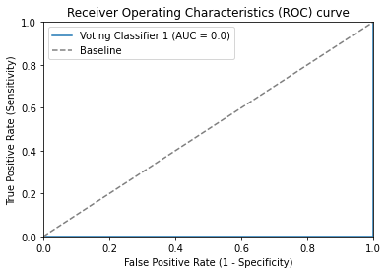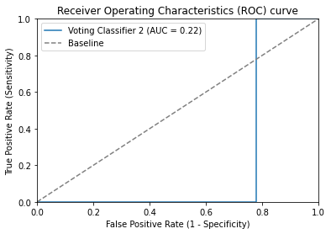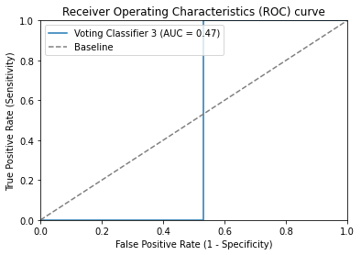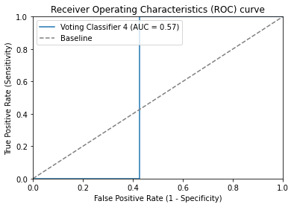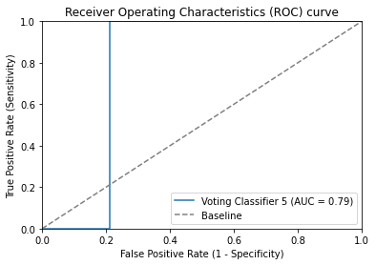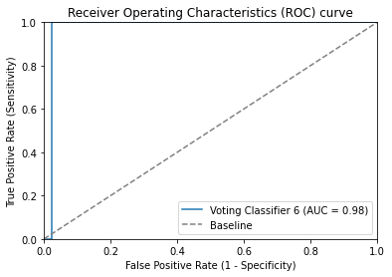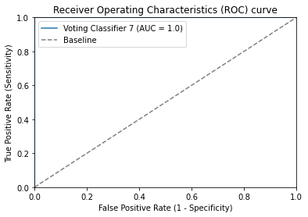

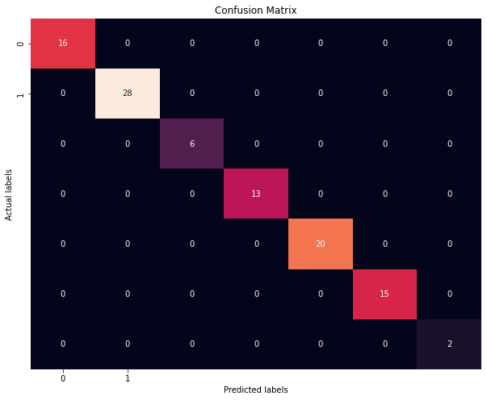

**Qxford scale Traditional**

| **Model** | **Class** | **Precision** | **Recall** | **F1-Score** | **Support** | **Accuracy** | **Macro Avg** | **Weighted Avg** | **Execution Time (seconds)** |
| --- | --- | --- | --- | --- | --- | --- | --- | --- | --- |
| Decision Tree Classifier | 1 | 1.00 | 1.00 | 1.00 | 16 | 1.00 | 1.00 | 1.00 | 0.1778 |
| 2 | 1.00 | 1.00 | 1.00 | 19 | 1.00 |
| 3 | 1.00 | 1.00 | 1.00 | 28 | 1.00 |
| 4 | 1.00 | 1.00 | 1.00 | 32 | 1.00 |
| 5 | 1.00 | 1.00 | 1.00 | 5 | 1.00 |
| Logistic Regression | 1 | 0.56 | 0.56 | 0.56 | 16 | 0.61 | 0.66 | 0.61 | 0.042 |
| 2 | 0.52 | 0.58 | 0.55 | 19 | 0.53 |
| 3 | 0.53 | 0.32 | 0.4 | 28 | 0.53 |
| 4 | 0.69 | 0.97 | 0.81 | 32 | 0.53 |
| 5 | 1 | 0.2 | 0.33 | 5 | 0.53 |
| Random Forest Classifier | 1 | 0.86 | 0.75 | 0.8 | 16 | 0.83 | 0.87 | 0.84 | 170.4759 |
| 2 | 0.86 | 0.95 | 0.9 | 19 | 0.87 |
| 3 | 0.81 | 0.75 | 0.78 | 28 | 0.87 |
| 4 | 0.81 | 0.94 | 0.87 | 32 | 0.87 |
| 5 | 1 | 0.4 | 0.57 | 5 | 0.87 |
| Support Vector Machine (LinearSVC) | 1 | 0.31 | 1.00 | 0.48 | 16 | 0.49 | 0.5 | 0.46 | 0.013 |
| 2 | 0 | 0 | 0 | 19 | 0.44 |
| 3 | 0.5 | 0.04 | 0.07 | 28 | 0.44 |
| 4 | 0.67 | 0.97 | 0.79 | 32 | 0.44 |
| 5 | 1 | 0.2 | 0.33 | 5 | 0.44 |
| Gradient Boosting Classifier  (Proposed) | 1 | 0.83 | 0.94 | 0.88 | 16 | 0.88 | 0.9 | 0.89 | 8.127 |
| 2 | 0.89 | 0.89 | 0.89 | 19 | 0.9 |
| 3 | 0.95 | 0.68 | 0.79 | 28 | 0.9 |
| 4 | 0.84 | 1.00 | 0.91 | 32 | 0.9 |
| 5 | 1.00 | 1.00 | 1.00 | 5 | 0.9 |
| Voting Classifier  (Proposed) | 1 | 1.00 | 1.00 | 1.00 | 16 | 1.00 | 1.00 | 1.00 | 0.2646 |
| 2 | 1.00 | 1.00 | 1.00 | 19 | 1.00 |
| 3 | 1.00 | 1.00 | 1.00 | 28 | 1.00 |
| 4 | 1.00 | 1.00 | 1.00 | 32 | 1.00 |
| 5 | 1.00 | 1.00 | 1.00 | 5 | 1.00 |

Top of Form

1. **Decision Tree Classifier with optimum max depth:**

The performance of the model is summarized in the following table:

| **Class** | **Precision** | **Recall** | **F1-Score** | **Support** |
| --- | --- | --- | --- | --- |
| 1 | 1.00 | 1.00 | 1.00 | 16 |
| 2 | 1.00 | 1.00 | 1.00 | 19 |
| 3 | 1.00 | 1.00 | 1.00 | 28 |
| 4 | 1.00 | 1.00 | 1.00 | 32 |
| 5 | 1.00 | 1.00 | 1.00 | 5 |
| Accuracy |  | 1.00 |  | 100 |
| Macro Avg | 1.00 | 1.00 | 1.00 | 100 |
| Weighted Avg | 1.00 | 1.00 | 1.00 | 100 |

Execution Time: 0.1778 seconds

1. **Logistic Regression:**

The performance of the model is summarized in the following table:

| **Class** | **Precision** | **Recall** | **F1-Score** | **Support** |
| --- | --- | --- | --- | --- |
| 1 | 0.56 | 0.56 | 0.56 | 16 |
| 2 | 0.52 | 0.58 | 0.55 | 19 |
| 3 | 0.53 | 0.32 | 0.40 | 28 |
| 4 | 0.69 | 0.97 | 0.81 | 32 |
| 5 | 1.00 | 0.20 | 0.33 | 5 |
| Accuracy |  | 0.61 |  | 100 |
| Macro Avg | 0.66 | 0.53 | 0.53 | 100 |
| Weighted Avg | 0.61 | 0.61 | 0.58 | 100 |

Execution Time: 0.0420 seconds

1. **Random Forest Classifier with hyperparameters tuning:**

The performance of the model is summarized in the following table:

| **Class** | **Precision** | **Recall** | **F1-Score** | **Support** |
| --- | --- | --- | --- | --- |
| 1 | 0.86 | 0.75 | 0.80 | 16 |
| 2 | 0.86 | 0.95 | 0.90 | 19 |
| 3 | 0.81 | 0.75 | 0.78 | 28 |
| 4 | 0.81 | 0.94 | 0.87 | 32 |
| 5 | 1.00 | 0.40 | 0.57 | 5 |
| Accuracy |  | 0.83 |  | 100 |
| Macro Avg | 0.87 | 0.76 | 0.78 | 100 |
| Weighted Avg | 0.84 | 0.83 | 0.82 | 100 |

Execution Time: 170.4759 seconds

1. **Support Vector Machine (LinearSVC):**

The performance of the model is summarized in the following table:

| **Class** | **Precision** | **Recall** | **F1-Score** | **Support** |
| --- | --- | --- | --- | --- |
| 1 | 0.31 | 1.00 | 0.48 | 16 |
| 2 | 0.00 | 0.00 | 0.00 | 19 |
| 3 | 0.50 | 0.04 | 0.07 | 28 |
| 4 | 0.67 | 0.97 | 0.79 | 32 |
| 5 | 1.00 | 0.20 | 0.33 | 5 |
| Accuracy |  | 0.49 |  | 100 |
| Macro Avg | 0.50 | 0.44 | 0.33 | 100 |
| Weighted Avg | 0.46 | 0.49 | 0.37 | 100 |

Execution Time: 0.0130 seconds

**Novel Qxford**

1. **Gradient Boosting Classifier with dimensionality reduction:**

The performance of the model is summarized in the following table:

| **Class** | **Precision** | **Recall** | **F1-Score** | **Support** |
| --- | --- | --- | --- | --- |
| 1 | 0.83 | 0.94 | 0.88 | 16 |
| 2 | 0.89 | 0.89 | 0.89 | 19 |
| 3 | 0.95 | 0.68 | 0.79 | 28 |
| 4 | 0.84 | 1.00 | 0.91 | 32 |
| 5 | 1.00 | 1.00 | 1.00 | 5 |
| Accuracy |  | 0.88 |  | 100 |
| Macro Avg | 0.90 | 0.90 | 0.90 | 100 |
| Weighted Avg | 0.89 | 0.88 | 0.88 | 100 |

Execution Time: 8.1270 seconds

1. **Voting Classifier:**

The performance of the model is summarized in the following table:

| **Class** | **Precision** | **Recall** | **F1-Score** | **Support** |
| --- | --- | --- | --- | --- |
| 1 | 1.00 | 1.00 | 1.00 | 16 |
| 2 | 1.00 | 1.00 | 1.00 | 19 |
| 3 | 1.00 | 1.00 | 1.00 | 28 |
| 4 | 1.00 | 1.00 | 1.00 | 32 |
| 5 | 1.00 | 1.00 | 1.00 | 5 |
| Accuracy |  | 1.00 |  | 100 |
| Macro Avg | 1.00 | 1.00 | 1.00 | 100 |
| Weighted Avg | 1.00 | 1.00 | 1.00 | 100 |

Execution Time: 0.2646 seconds

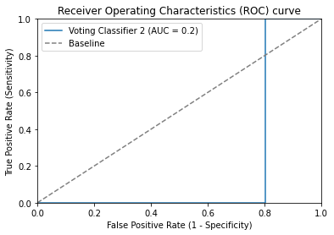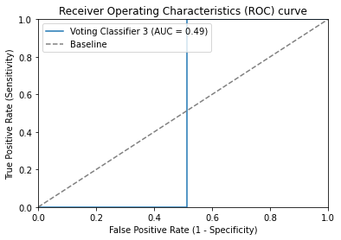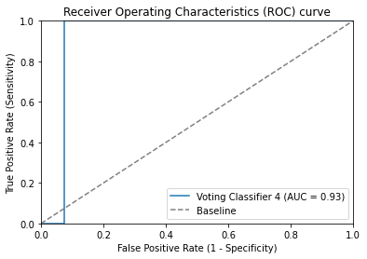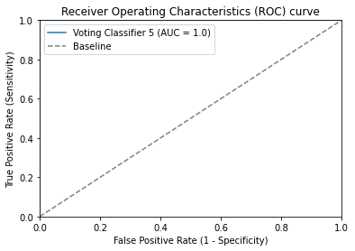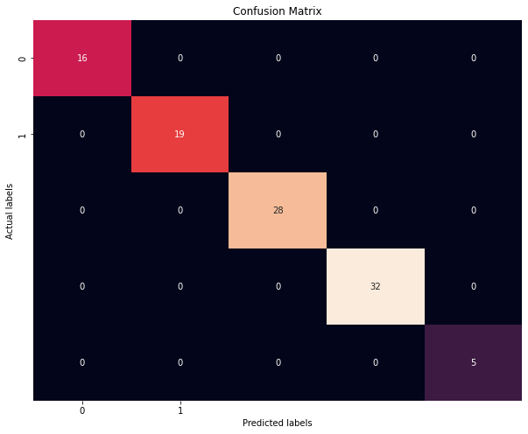

**Number of samples: 100**

**Number of features: 7**

|  |  |  |  |  |  |  |  |  |
| --- | --- | --- | --- | --- | --- | --- | --- | --- |
| **Feature** | **Mean** | **Median** | **Standard Deviation** | **Min** | **25%** | **50%** | **75%** | **Max** |
| Status | 0.50 | 0.50 | 0.50 | 0.00 | 0.00 | 0.50 | 1.00 | 1.00 |
| Age | 37.56 | 38.00 | 2.30 | 30.00 | 36.00 | 38.00 | 40.00 | 40.00 |
| BMI | 27.03 | 26.88 | 2.11 | 22.53 | 25.16 | 26.88 | 29.24 | 31.25 |
| PFM Strength | 0.56 | 0.52 | 0.30 | 0.07 | 0.23 | 0.52 | 0.84 | 0.99 |
| FSFI | 24.77 | 25.05 | 5.95 | 12.60 | 20.61 | 25.05 | 28.10 | 36.61 |
| Pelvic Tilt | 12.63 | 12.00 | 3.58 | 4.00 | 10.00 | 12.00 | 16.00 | 19.00 |
| VLQ | 3.46 | 3.50 | 1.83 | 1.00 | 2.00 | 3.50 | 5.00 | 7.00 |

Here's the provided information formatted as a table:

|  |  |
| --- | --- |
| **Feature Selection Method** | **Selected Features** |
| F-value selector | PFM strength, FSFI, pelvic tilt, VLQ, Qxford scale |
| Mutual information selector | PFM strength, FSFI, pelvic tilt, VLQ, Qxford scale |
| RFE with logistic regression | age, FSFI, pelvic tilt, VLQ, Qxford scale |
| PCA | VLQ, PFM strength, pelvic tilt, FSFI, Qxford scale |
| Select from model with random forests | PFM strength, FSFI, VLQ |
| Variance thresholding | age, BMI, FSFI, pelvic tilt, VLQ, Qxford scale |
| RFE with random forests | PFM strength, FSFI, pelvic tilt, VLQ, Qxford scale |
| Feature importance with random forests | VLQ, PFM strength, pelvic tilt, FSFI, Qxford scale |

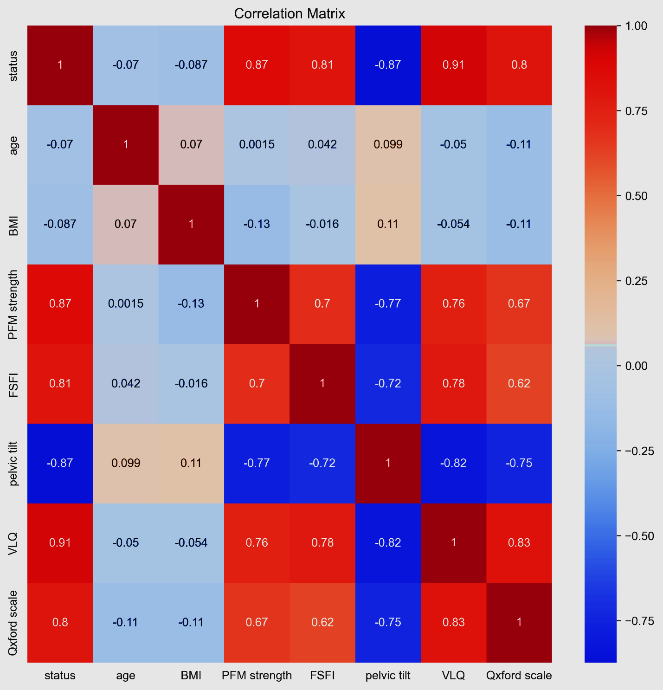

**Pearson Correlation**

|  |  |  |
| --- | --- | --- |
| **Value** | **Feature 1** | **Feature 2** |
| +0.826 | Qxford | VLQ |
| -0.823 | VLQ | pelvic tilt |
| +0.782 | FSFI | VLQ |
| -0.750 | Qxford | pelvic tilt |
| -0.725 | FSFI | pelvic tilt |
| +0.624 | FSFI | Qxford |
| -0.115 | BMI | Qxford |
| +0.114 | BMI | pelvic tilt |
| -0.113 | Qxford | age |
| +0.099 | age | pelvic tilt |
| +0.070 | BMI | age |
| -0.054 | BMI | VLQ |
| -0.050 | VLQ | age |
| +0.042 | FSFI | age |
| -0.016 | BMI | FSFI |