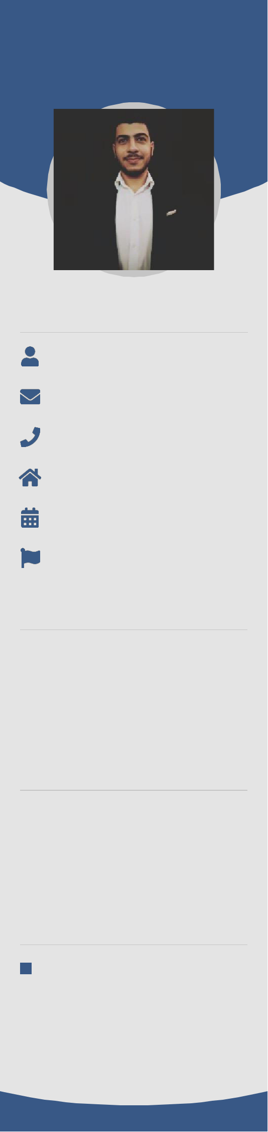**Tarek Lichaa El Khoury**

Software Developer

Personal details

Tarek Lichaa El Khoury

[tarekelkhoury99@gmail.com](mailto:tarekelkhoury99@gmail.com)

+96170401158

Blat-near garage afif

February 26th, 1999

Lebanese

Skills

Confident - ambitious - devoted - patient - observative - fast learner.

Adaptation under pressure

Languages

french

english

arabic

Hobbies

Team sports in general, Guitar, Swimming

Education

|  |  |  |  |
| --- | --- | --- | --- |
| **Bachelors in Computer Science** | | **2017 - 2020** |  |
| Lebanese University - Faculty of Science, Fanar | |  |  |
| **Baccalaureate General En SV** | |  |  |
| Saint Famille Maronites **–** Saint Joseph, JBEIL | |  |  |
| Employment | |  |  |
|  | |  |  |
| **Web Developer** | | **Feb 2021 - May 2021** | |
| Broaden |  |  |  |
| **Software Developer** | | **Jun 2021 - Present** | |
| Netiks, Beirut | |  |  |
| Certificates | |  |  |
|  | |  |  |
| **Microsoft Certified: Azure Developer** | | **Present** | |
| **Associate** | |  |  |
| **Microsoft Certified: DevOps Engineer** | | **Present** | |
| **Expert** |  |  |  |
| Coding Languages | |  |  |
|  |  |  |  |
| **•** | **C# (2.5 years)** |  |  |
| **• Xamarin iOS + Android (2.5 years)** | |  |  |
| **•** | **SiteCore (2.5 years)** |  |  |
| **•** | **JQuery (2.5 years)** |  |  |
| **•** | **Bootstrap (2.5 years)** |  |  |
| **• Sql Server (2.5 years)** | |  |  |
| **• Html, Js , Css (2.5 years)** | |  |  |
| **•** | **Php (4 months)** |  |  |
| **•** | **Java (4 months)** |  |  |
| **• Android Studio (4 months)** | |  |  |
| **•** | **MySQL (4 months)** |  |  |
| **•** | **C++ (2 months)** |  |  |
| **• Web Services (2.5 years)** | |  |  |
| **• .Net Core (2.5 years)** | |  |  |
| **• .Net Framework (2.5 years)** | |  |  |
| **•** | **Python (4 months)** |  |  |

**•** **Power Apps (2 months)**

**Tarek Lichaa El Khoury**

Software Developer

Personal details

Tarek Lichaa El Khoury

[tarekelkhoury99@gmail.com](mailto:tarekelkhoury99@gmail.com)

+96170401158

Blat-near garage afif

February 26th, 1999

Lebanese

Skills

Confident - ambitious - devoted - patient - observative - fast learner.

Adaptation under pressure

Languages

french

english

arabic

Hobbies

Team sports in general, Guitar, Swimming

Projects

**Lebanese Banking Sector Mobile And Online Banking Applications**

Banking applications that consist of payments, transfers and full client managements as well as services. Admin and client portals included. Full notification implementation. I used .Net for the implementation of the online banking application, as well as worked with the implementation of the services necessary to communicate with the bank to retrieve accounts and what not as well as send transfer requests and manage their response. For the mobile applications included I**’**ve worked with Xamarin for Android and iOS to develop a fully functioning online banking mobile application. For a specific bank with a custom request, I**’**ve worked with SiteCore Framework to develop a fully customized website for the bank, with a fully functioning content management system, where the clients can have full control of their website with a user friendly interface, can manage the flow of users on their website, can display customized banners and components following custom rules created by me.

**Custom AI Product**

This was a custom product for my company where I cannot fully disclose the features of it, but during it I have worked on azure machine learning (designing pipelines, running endpoints,..) as well as learned to code in python.

**Power Apps Projects**

I have recently embarked on some personal projects while learning to work with power apps, where I created many canvas apps using it.