Ref: UNDP/ PAL10-00091323

22 May2016

**Dear Mr. Ziad Al Rawni,**

**Subject: Renewable energy for All – Gaza Strip**

**Progress Report**

With reference to the contribution agreement between the Islamic Relief Canada and UNDP’s Programme of Assistance to the Palestinian People for the “Renewable energy for All – Gaza Strip” effective 11 October 2015, I am pleased to submit herewith the Narrative and Financial Annual Progress Report.

The report summarizes the progress of the project as of 31 July 2017 and provides an overview of the achievements, challenges, lessons learned, financial status and way forward.

I thank the Islamic Relief Canada for its contributions to UNDP and look forward to strengthening our partnership in support of the Palestinian People.

Sincerely Yours,

Khaled Shahwan

Deputy Special Representative (OiC)

UNDP/PAPP

Att. Mr. Ziad Al Rawni

Chief Executive Officer

Islamic Relief Canada

Canada

1. **Programme Summary**

|  |  |
| --- | --- |
| **Project Title** | Renewable energy for All – Gaza Strip (PAL10-00091323) |
| **Donor** | The Islamic Relief Canada (IRC) |
| **Executing Agency:** | United Nations Development Programme/Programme of Assistance to the Palestinian People (UNDP/PAPP) |
| **Country** | Occupied Palestinian territory |
| **Implementing Partner(s)** | Ministry of Health and Palestinian Energy And Natural Resources Authority - PENRA. |
| **Project Start Date** | 3 May 2016 |
| **Project End Date** | 31 December 2017 |
| **Reporting Period** | October, 2015 – July, 2017 |
| **Programme Budget:** | USD 571,914.00 |
| **Received Amount** | USD 400,339.80 |
| **Spent Amount** | USD 302,597.29 |
| **UNDP Contact Person** | Roberto Valent  Special Representative of the Administrator  UNDP/PAPP  Email: [roberto.valent@undp.org](mailto:roberto.valent@undp.org)  Tel.: 00972-2-6268200  Fax: 00972-2-626-822 |
| **UNDP Officer in Charge:** | * Iman Al-Husseini, Programme Specialist   Mohammad Mezyad, Project Manager |

***Table of Content***

Contents

I. Programme Summary 2

II. Executive summary 4

III. Background 5

IV. Achievements Review: 6

V. Lessons Learned 9

VI. Conclusions and Way Forward 9

VII. Financial Status 9

VIII. Annex I : Photo Gallery 10

1. **Executive summary**

The health sector in the Gaza Strip experiences a chronic energy crisis since 2006, and particularly after 2014 summer hostilities on Gaza which led to massive destruction of the social and public infrastructure including hospitals and health facilities. The proposed project responds to the immediate need for providing emergency support to the Health Sector in the Gaza Strip. Maintaining good quality of the physical structure of health premises is one of the main domains that reflect the appropriateness of the health care system. Thus, the project contributes to developing a source of renewable energy in order to provide continuous access to electricity in main three hospitals in the northern and southern areas of the Gaza Strip.

The project aims at addressing the urgent need of the health sectors to continuous source of power in order to maintain and improve health services delivery to the residents of Gaza Strip. Minimizing the energy gap and providing electricity for longer hours is one of the vital initiatives to keep the performance of service delivery rolling. Funded by Islamic Relief Canad, this initiative will provide renewable source of energy as a sustainable solution to the current crisis. Solar photovoltaic (PV) panels offer a cost-effective and environmental friendly solution for urban, rural and remote areas. UNDP technical team is working in close cooperation with the concerned national stakeholders, namely, Ministry of Health (MOH) and the Palestinian Energy and Natural Resources (PENRA), the regulator of energy sector. The intervention is in line with the National Development Plan 2014-2017 and the (PENRA) plans regarding the use of renewable energy.

The targeted hospitals are: The Indonesian Hospital in Beit Lahia, Al-Aqsa Hopital in Deir El-Balah and Beit Hanoun Hospital which offer multiple health services to the people in these communities. The installation of the solar system in the Indonesian Hospital in Beit Lahia (30 KW) and Al-Aqsa Hopital in Deir El-Balah (50 KW) are in the commissioning phase after the installation of the PV panels, batteries and circuit breakers. As for Beit Hanoun Hospital (30 KW), the PV solar panels have just entered Gaza Strip, where the other materials are in the manufacturing process. It's worth to mention that the project includes the application of energy efficiency principle that will operate the facilities on optimal basis of power consumption.

1. **Background**

Health sector has been severely affected during 2014 hostilities on Gaza. Damages to medical facilities and personnel, along with shortages of medicine, equipment and power supplies, caused the near collapse of the health sector where a number of health facilities directly hit. During the hostilities, nearly half of all health facilities were unable to provide services due to damage or danger, leaving functioning facilities overwhelmed by increased demand and inadequate resources. The targeted hospitals have sustained partial damages, which reduced access to health care services. These hospitals serve around 350,000 people in the targeted communities.

The current electricity deficit is 75% of 450 MW which is the current demand of Gaza strip, and this is expected to increase in the near future. As the electricity supplied from Egypt and Israel is fixed at 22 MW and 120 MW, respectively, the only way to improve supply and to reduce deficit is by increasing the weekly amount of industrial fuel to Gaza’s power plant to 3.5 million liters. This should increase the output of the power plant to from 80 MW to 120 MW.

The current 75% deficit is translated to 16-hours daily cuts of electricity, depending on the availability of fuel. This pattern may still get worse due to faults in the electricity distribution networks or to loss of feeding lines, during escalations. Electricity supply was only returned to the pre-war staggered schedule (eight hours on/ 12 hours off) in April 2015, seven months after the cease-fire.

Unfortunately, the main electricity network lines that serve residential, commercial and industrial areas also serve vital facilities in the Gaza Strip such as hospitals, water facilities and water pumping stations. Hence, they are all under a direct risk of sudden electricity outages. During peak hours all residential and public service facilities are served on an equal basis. This results in tremendous shortages which, in turn, affect the provision of proper health, education, industrial and other services in Gaza. UNDP carried out an assessment of health facilities in Gaza Strip guided by WHO in 2010 that revealed weak infrastructure in some of the hospitals and clinics and bad physical infrastructure to suit the purpose of carrying out safe health care services.

1. **Achievements Review****:**

|  |  |  |  |  |  |  |  |  |  |  |  |  |  |  |  |  |  |
| --- | --- | --- | --- | --- | --- | --- | --- | --- | --- | --- | --- | --- | --- | --- | --- | --- | --- |
| **Indicated output** | Activities | Schedule Status | | | | | | | | | | | | Activities status | | Achievements | |
| 2016 | | | | 2017 | | | | | | | |  | |  | |
| Q3 | | Q4 | | Q1 | | Q2 | | Q3 | | Q4 | |  | |  | |
| **Output 1: Installation of 50 KW Solar System at Al-Aqsa Hospital in Deir El-Balah.** | Design & Capacity Development of Palestinian Energy and Natural Resource Authority (PENRA) | X | |  | |  | |  | |  | |  | | completed | | Needs Assessment was carried out jointly by UNDP, MoH and PENRA which indicated the targeted departments as well as measuring the consumption of these departments.  Targeted units are: Operations Theatre, Cardiac Unit, Intensive Care, Dialysis Unit and Reception  The assessment indicated the need for a lab for examining the solar system equipment and materials to PENRA.  This has been completed where the lab equipment was supplied and installed. | |
| Construction of Rooms on top of hospital for solar system |  | | X | |  | |  | |  | |  | | Completed | | The contractor had completed the construction of battery rooms for the solar system at the top of the hospital roof. All civil activates have finished and the rooms were ready. | |
| Supply and installation of solar system |  | |  | | X | | X | | X | |  | | Completed | | All the PV solar components were supplied into the Gaza Strip and installed in the roof top of the hospitals where all PV panels, batteries, inverters and cables were installed in the battery rooms.  Currently, the system is in the commissioning phase upon the installation of the circuit breakers and is expected to be operational by mid-August 2017. | |
| **Output 2: Installation of 30 KW Solar System at Indonesian Hospital in Beit Lahia** | Design & Capacity Development of Palestinian Energy and Natural Resource Authority (PENRA) | X |  | |  | |  | |  | |  | | completed | | Needs Assessment was carried out jointly by UNDP, MoH and PENRA which indicated the targeted departments as well as measuring the consumption of these departments.  Targeted Departments: Operations Theatre, Cardiac Unit, Intensive Care, and Reception | |
| Construction of Rooms on top of hospital for solar system |  | X | |  | |  | |  | |  | | Completed | | The contractor had completed the construction of battery rooms for the solar system at the top of the hospital roof. All civil activates have finished and the rooms were ready. | |
| Supply and installation of solar system |  |  | | X | | X | | X | |  | | Completed | | All the PV solar components were supplied into the Gaza Strip and installed on the roof top of the hospitals where all PV panels, batteries, inverters and cables were installed in the battery rooms.  Currently, the system is in the commissioning phase upon the installation of the circuit breakers and is expected to be operational by mid-August 2017. | |

|  |  |  |  |  |  |  |  |  |  |
| --- | --- | --- | --- | --- | --- | --- | --- | --- | --- |
| **Output 3: Installation of 30 KW Solar System at Beit Hanoun Hospital in Beit Hanoun.** | Design & Capacity Development of Palestinian Energy and Natural Resource Authority (PENRA) |  |  | X |  |  |  | completed | Needs Assessment was carried out jointly by UNDP, MoH and PENRA which indicated the targeted departments as well as measuring the consumption of these departments.  Targeted Departments: Operations Theatre, Labs, and Reception |
| Construction of Rooms on top of hospital for solar system |  |  |  | X |  |  | Completed | The contractor had completed the construction of battery rooms for the solar system at the top of the hospital roof. All civil activates were finished and the rooms were ready. |
| Supply and installation of solar system |  |  |  | X |  |  | Ongoing | PV panels were supplied into the Gaza Strip and installed on the roof top of the hospital, meanwhile the batteries, inverters and cables are still waiting the coordination to enter the Gaza Strip. |

1. **Lessons Learned**
2. The estimated cost of the project showed significant decrease in prices after following tendering. Such surplus was utilized based on MoH priorities after approval of the donor
3. Entry of solar panels and equipment requires prolonged procedures and restrictions. UNDP uses its access and coordination mechanism to facilitate entry of such materials.
4. **Conclusions and Way Forward**

The project is of crucial importance to ensure effective operation of the Palestinian health sector and sustainability of health services delivery. So far, the installation of the solar system has been completed in two hospitals: Al Aqsa and the Indonisian Hospitals which are expected to be functional by mid-August 2017. On the other hand, the finalization of the solar system in Beit Hanoun hospital is pending the entry the required solar system equipment, where UNDP access coordination team is following up, despite the Israeli restrictions and prolonged approval mechanism of such materials. Overall, the project remains highly relevant and needed under the current conditions of the Gaza Strip.

1. **Financial Status**

Under preparation by Finance Team.

.

1. **Annex I : Photo Gallery**

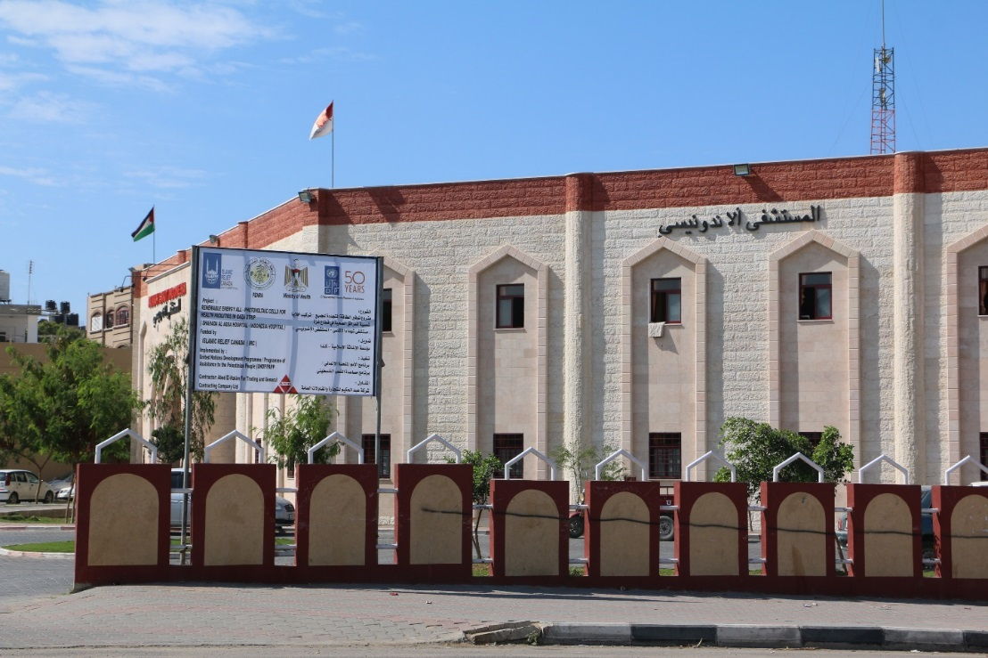

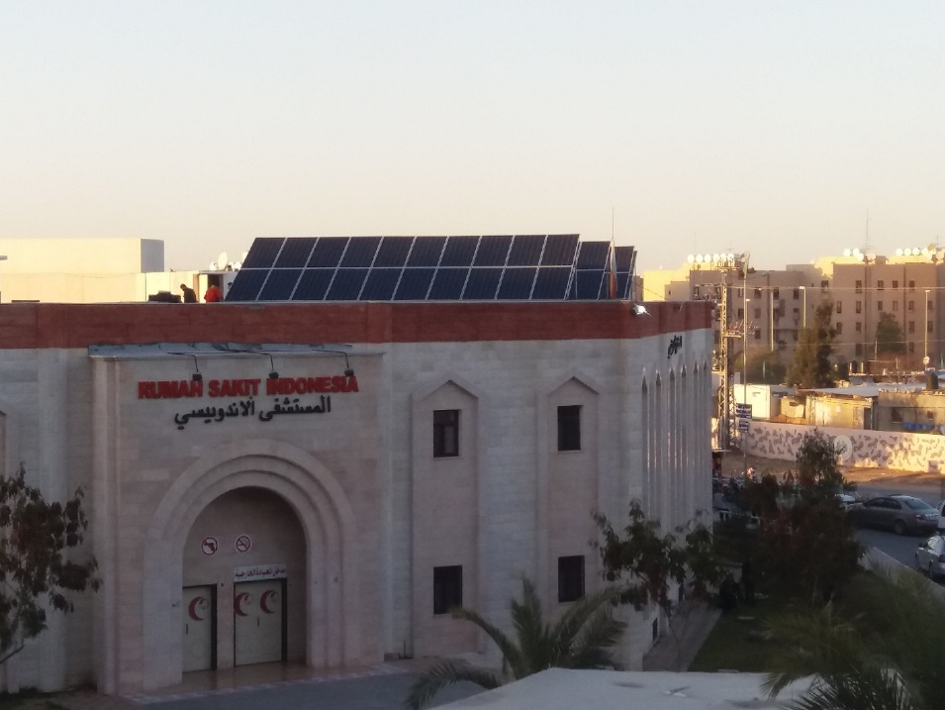

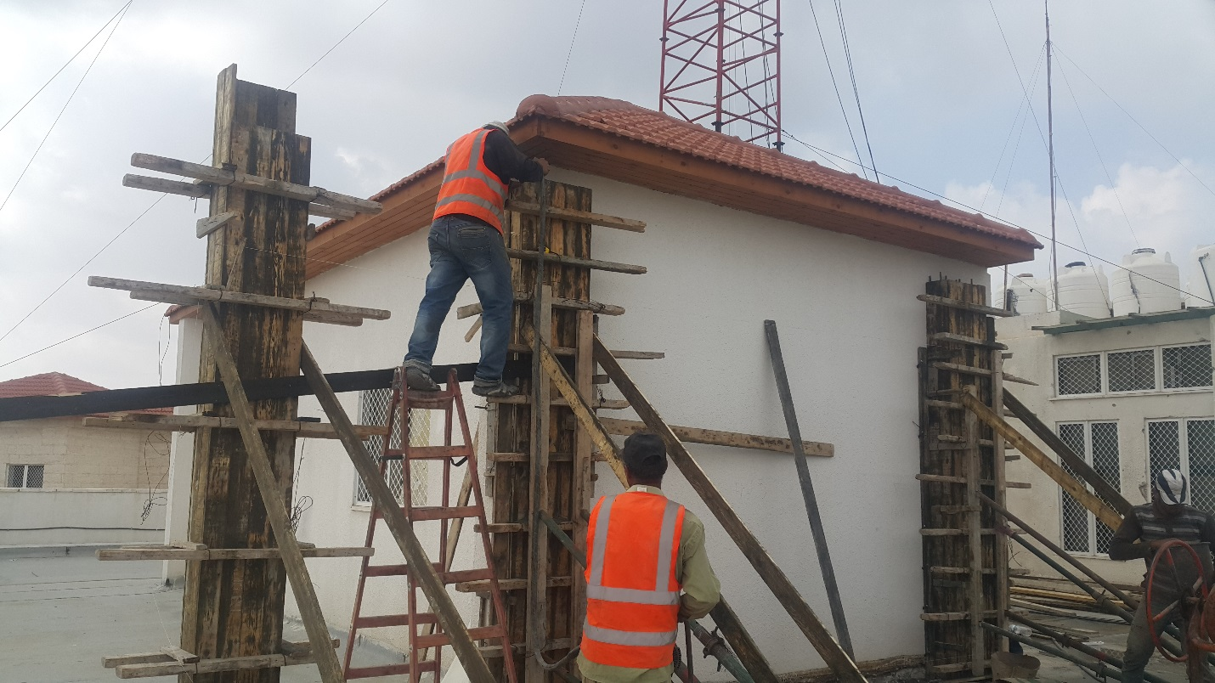

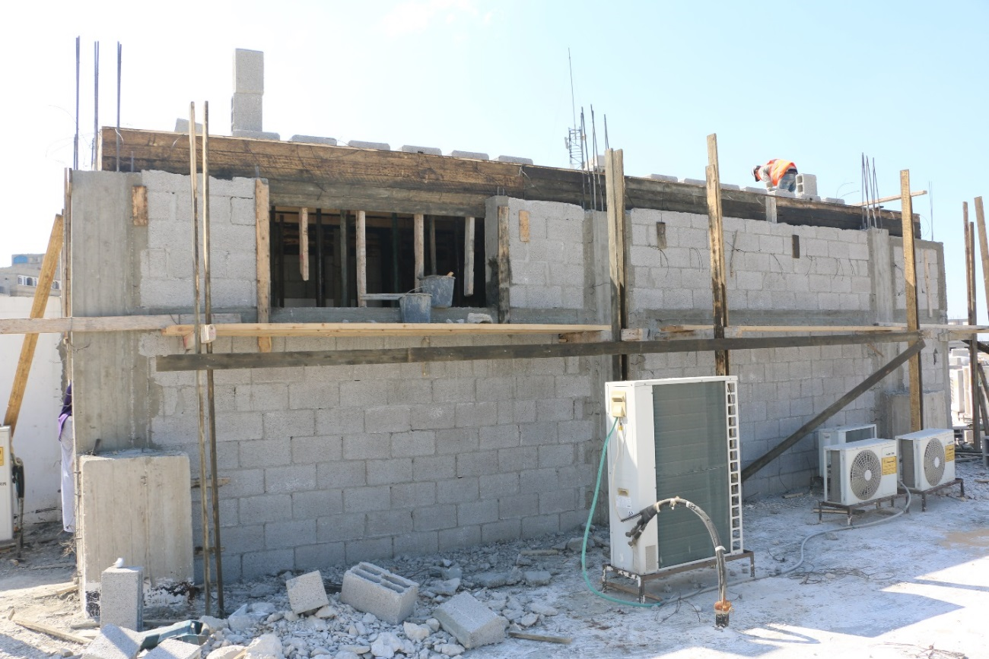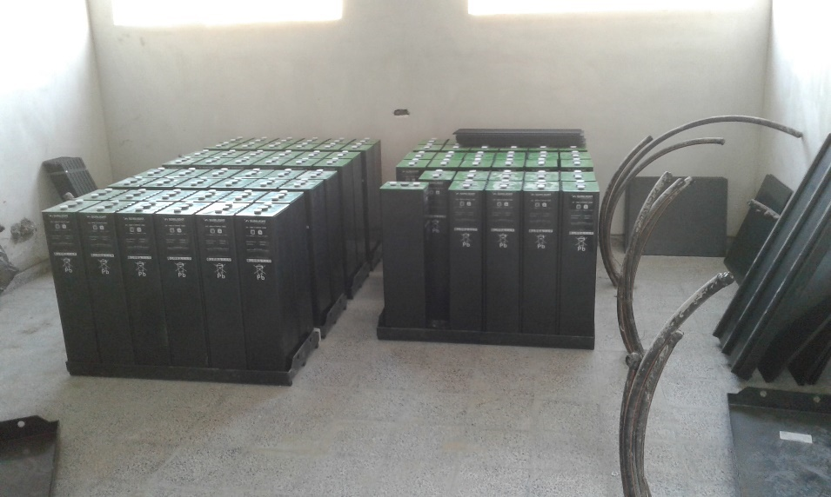

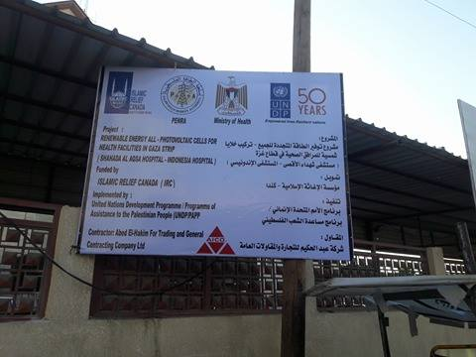

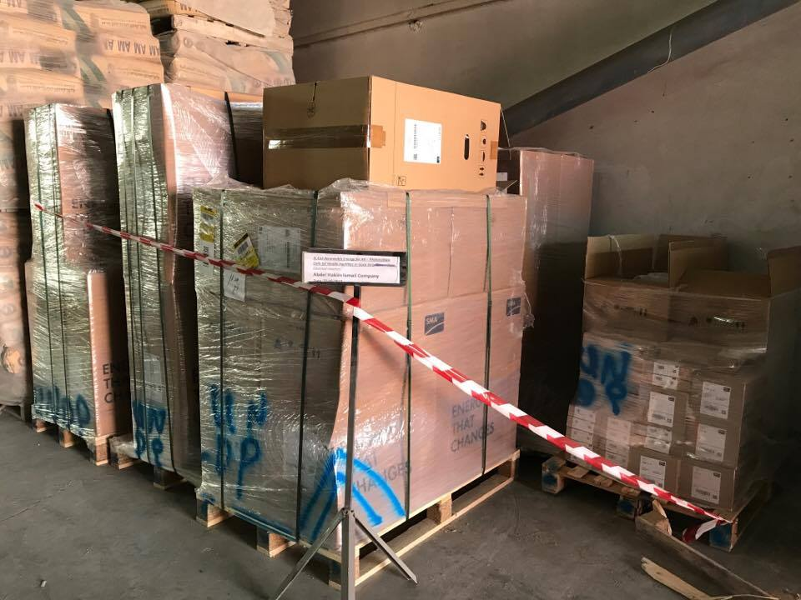



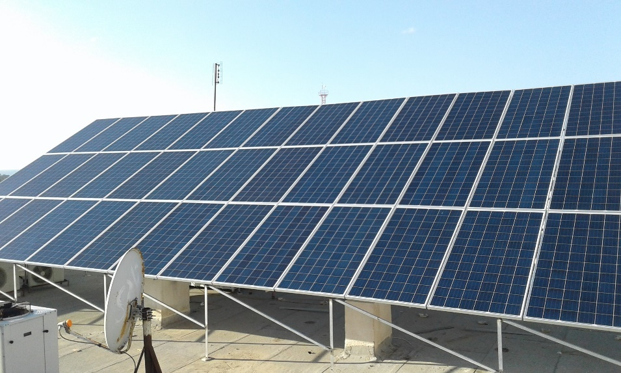

Al-Aqsa Hospital:

