**50H MODEL MOTOR**

GENERATOR SET

FROM 60 TO 50 Hz

FREQUENCY CONVERTER

***FEATURES***

• Precise 50 Hz output frequency

• Common frame design

• Low audible noise

• Easy to operate

• Exceptional MTBF

• Minimal maintenance required

***DESCRIPTION***

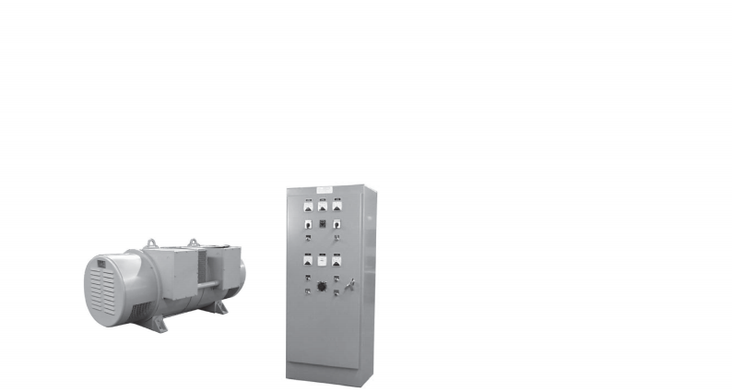**50H Model motor** generator sets consist of an Inductionor or, a synchronous motor and a synchronous generator mounted on a common shaft. These units deliver an output frequency of precisely 50 Hz from noload to full-load. 50H Model motor generator sets are rated for continuous duty and they provide a clean source of 50 Hz power isolated from switching transients, voltage luctuations and power line noise. They have high overload capability and are most commonly utilized in military applications where a rugged and reliable 60-50 Hz frequency converter is required. Alternatively, they are also utilized in American manufacturing facilities to provide a source of precise 50 Hz power for large-scale operations. They are dependable in harsh environments and are ideally suited for applications where continuous run time is a necessity.

**50H Model motor** generator sets are designed to be installed inside where a 75-80 dBA noise level is acceptable. As an option, 50H Model motor generator sets can be mounted in a weather-resistant enclosure, a sound-reduced enclosure, a cargo container or a trailer. Each 50H Model motor generator set is equipped with a standard control system that is either wall-mounted or free standing. The components in the control system perform the functions necessary to operate, monitor and protect the system.

***SPECIFICATIONS***

**Motor**

• Induction or Brushless synchronous

• Continuous duty, Class F insulation, open drip-proof

• Selection of 60 Hz, 3-phase input voltages to include: 208V, 230V or 460V

**Generator**

• Brushless synchronous

• Continuous duty, Class F insulation, open drip-proof

• Selection of 50 Hz output voltages to include: 120/208V, 220/380V or 277/480V, 3-phase

• Rated at 0.8 power factor to insure proper handling of inductive loads

**Mechanical Construction**

• Motor and generator mounted on rigid steel base

• Flexible coupling drive system

• Complete OSHA coupling guard

• Forklift or pallet jack provisions

**Standard Control Systems**

Each motor generator set is equipped with a separate wall-mounted or loor-standing control panel. The standard package includes the following components:

**Motor Controls**

• Motor starter with adjustable overload

• Start/Stop push buttons with terminal strip for remote start/stop

• Control power transformer with fusing

• Variable transformer for power factor control, with protective relay for motor out-of-step and ield failure protection

• Analog meter package to include ammeter and run time meter

• Pilot lights to indicate “Motor Run” and “60 Hz Line Energized”

**Generator Controls**

• Analog meter package to include voltmeter, ammeter and frequency meter

• Voltmeter and ammeter phase selector switches (3-phase systems)

• Voltage regulator, ±1% regulation accuracy, with automatic buildup and rheostat for control of regulated voltage

• Output circuit breaker, molded case, to protect generator against short circuit or prolonged overload

• Pilot light to indicate“50 Hz Load On”

• Over voltage protection package to include output circuit breaker shunt trip

* Picture may not represent Actaul Product

**50H MODEL MOTOR**

GENERATOR SET

***PERFORMANCE***

CHARACTERISTICS

**• Voltage regulation :** ±1% from no-load to full-load at rated power factor

**• Voltage steady state stability:** ±0.5% from no-load to full-load at rated power factor

**• Voltage adjustment range :** ±10% in stepless increments of nominal output voltage

**• Frequency regulation :** Precise 50 Hz output from no-load to full-load

**• Voltage transient :** When a full-load at rated power factor is applied or released, the resultant instantaneous droop or overshoot

**• Voltage recovery time :** After a full-load is applied or released, the output voltage will return to the regulation band within 500 milliseconds

**• Harmonic distortion:** Less than 3% max. total distortion factor and less than 2.5% max. single phase when measured line-to-line

**• Ambient operating conditions:** Temperature at 40°C, relative humidity at 95% (higher temperature rating for outdoor use available upon request)

**• Duty cycle:** Motor generator set and controls are rated for continuous duty

***MOTOR* *GENERATOR***

OPTIONS

• Weather-resistant, NEMA 3R enclosure

• Oversized generator to support motor starting transients

• Thermal bearing and winding protection

• Input disconnect or circuit breaker

• Input phase protection relay

• Generator reconnection switch to allow selection of multiple output voltages

• Digital meter package

• Remote meter package with start/stop controls



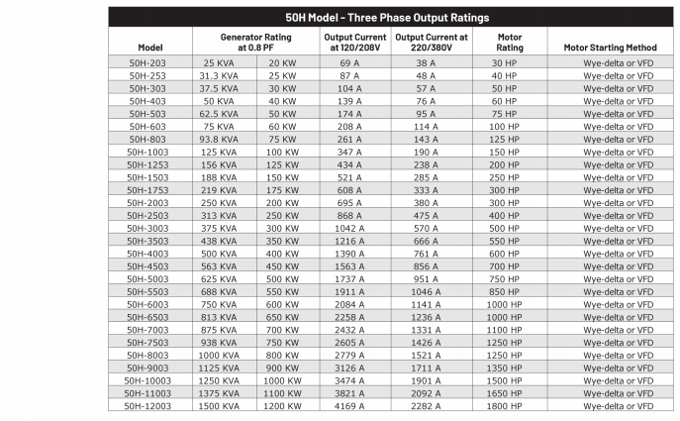* We reserve the right to change any rating/specification without notice