**400G MODEL MOTOR**

GENERATOR SET

**60-400 Hz**

**FREQUENCY CONVERTER**

***FEATURES***

• Precise 400 Hz output frequency

• Common frame design

• Easy to operate

• Exceptional MTBF

• Minimal maintenance required

***DESCRIPTION***

**400G Model motor** generator sets consist of a synchronous motor or Induction motor, and a synchronous generator mounted on a common shaft. These units deliver an output frequency of precisely 400 Hz from noload to full-load.

**400G Model** motor generator sets are rated for continuous duty and they provide a clean source of 400 Hz power isolated from switching transients, voltage luctuations and power line noise.

**They are widely** used at naval and airforce bases, missile and ground support installations, radar and communications test sites, airports and university laboratories. 400G motor generator sets have high overload capability and their rugged design make them ideally suited for military applications where continuous run time in a harsh environment is required.

**400G Model motor** generator sets are designed to be installed inside where an 80-85 dBA noise level is acceptable. As an option, 400G Model motor generator sets can be mounted in a weather-resistant enclosure, a sound-reduced enclosure, a cargo container or a trailer. Each 400G Model motor generator set is equipped with a standard control system that is either wall-mounted or free standing. The components in the control system perform the functions necessary to operate, monitor and protect the system

***SPECIFICATIONS***

**Motor**

• Induction or Brushless synchronous

• Continuous duty, Class F insulation, open drip-proof

• Selection of 60 Hz, 3-phase input voltages to include : 208V, 230V or 460V

**Generator**

• Brushless synchronous

• Continuous duty, Class F insulation, open drip-proof

• Standard output voltage to include: 120/208V, 3-phase

• Rated at 0.8 power factor to insure proper handling of inductive loads

**Mechanical Construction**

• Motor and generator mounted on rigid steel base

• Flexible coupling drive system

• Complete OSHA coupling guard

• Forklift or pallet jack provisions

**Standard Control Systems**

Each motor generator set is equipped with a separate wall-mounted or loor-standing control panel. The standard package includes the following components:

**Motor Controls**

• Motor starter with adjustable overload

• Start/Stop push buttons with terminal strip for remote start/stop

• Control power transformer with fusing

• Variable transformer for power factor control, with protective relay for motor out-of-step andield failure protection

• Analog meter package to include ammeter and run time meter

|  |  |
| --- | --- |
|  | **Generator Controls**  • Analog meter package to include voltmeter, ammeter and frequency meter  • Voltmeter and ammeter phase selector switches (3-phase systems)  • Voltage regulator, ±1% regulation accuracy, with automatic buildup and rheostat for control of regulated voltage  • Output circuit breaker, molded case, to protect generator against short circuit or prolonged overload  • Pilot light to indicate“400 Hz Load On”  • Over voltage protection package to include output |
| * Picture may not represent Actaul Product |  |





**400G MODEL MOTOR**

GENERATOR SET

***PERFORMANCE***

CHARACTERISTICS

• **Voltage regulation :** ±1% from no-load to full-load at rated power factor

• **Voltage steady state stability :** ±0.5% from no-load to full-load at rated power factor

• **Voltage adjustment range :** ±10% in stepless increments of nominal output voltage

• **Frequency regulation :** Precise 400 Hz output from no-load to full-load

• **Voltage transient :** When a full-load at rated power factor is applied or released, the resultant instantaneous droop or overshoot

• **Voltage recovery time :** After a full-load is applied or released, the output voltage will return to the regulation band within 500 milliseconds

• **Harmonic distortion :** Less than 3% max. total distortion factor and less than 2.5% max. single phase when measured line-to-line

• **Ambient operating conditions :** Temperature at 40°C, relative humidity at 95%

• **Duty cycle :** Motor generator set and controls are rated for continuous duty

***MOTOR GENERATOR***

OPTIONS

• Weather-resistant, NEMA 3R enclosure

• Oversized generator to support motorstarting transients

• Thermal bearing and winding protection

• Input disconnect or circuit breaker

• Input phase protection relay

• Line drop compensation

• Digital meter package

• Remote meter package with start/stop controls



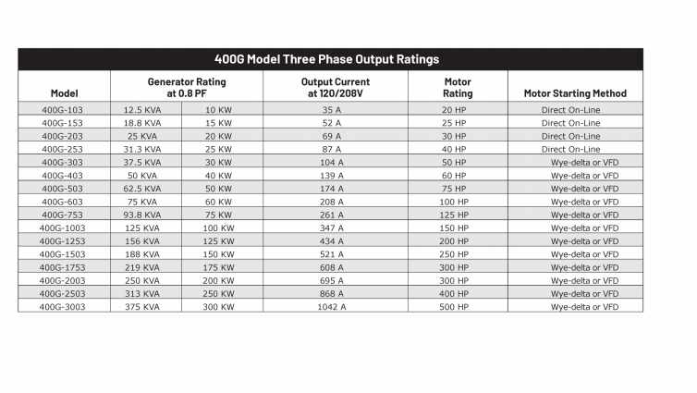

* We reserve the right to change any rating/specification without notice



