

Faculty of Computers and Artificial Intelligence

Computer Science Department

2021/2022

**CS 396 Selected Topics in CS-2**

**Research Project**

Report Submitted for Fulfillment of the Requirements and ILO’s for Selected Topics in CS-2 course for Fall 2021

Team ID No. 50

|  |  |  |  |
| --- | --- | --- | --- |
|  | ID | Name | Grade |
|  | 20180300 | طارق زكي محمد احمد الاسود |  |
|  | 20180541 | محمد مصطفى عبدالعال فرج |  |
|  | 20170331 | علي علاء الدين محمود |  |
|  | ٢٠١٧٠١٥٦ | بطرس غالى زهرى حكيم |  |
|  | 201900314 | روماني عاطف عطية جرجس |  |
|  | 20180354 | على عادل على ابوالوفا |  |
| 7. | 20180514 | محمد عاطف محمود |  |
| 8. | 20150251 | ساره خالد جوده جمعه |  |

Delivered to:

**Dr. Wessam El-Behaidy**

**Eng. Salma Doma**

**Eng. Ahmed Nady**

* **Paper Details**
* Paper Name: A Deep Learning Approach for COVID-19 & Viral Pneumonia Screening with X-ray Images.
* Authors : FAIZAN AHMED, SYED AHMAD CHAN BUKHARI, and FAZEL KESHTKAR.

CCS Concepts: • Computing methodologies → Activity recognition and understanding; Active learning settings;

Additional Key Words and Phrases: Deep learning, convolutional neural networks, computer vision, medical imaging, COVID-19

ACM Reference format: Faizan Ahmed, Syed Ahmad Chan Bukhari, and Fazel Keshtkar. 2020. A Deep Learning Approach for COVID-19 & Viral

Pneumonia Screening with X-ray Images. Digit. Gov.: Res. Pract. 2, 2, Article 18 (December 2020), 12 pages.

https://doi.org/10.1145/3431804

* **Project Description**

Covid-19 has taken the world with a storm in 2019, many countries were completely taken by surprise and weren’t prepared to fight the disease as the medical staff of every hospital was stretched thin and there wasn’t enough resources to diagnose patients early enough to decrease their symptoms and treat them, that’s why there has been an increase in research on how to diagnose and treat possible infected individuals and this project aim at helping medical staffs around the world to use deep learning techniques to diagnose possible infected individuals with Covid-19, pneumonia or healthy.

# **Datasets used** : **COVIDx CXR-2**

It includes 30,000 CXR images from a multinational cohort of over 16,600 patients, but only 3000 where used due to our limited access to hardware strong enough to process large amounts of data.

## **Training (**3 directories)

* Covid-19
* pneumonia
* normal

## **Validation (**3 directories)

* Covid-19
* Pneumonia
* normal

## **Testing (**3 directories)

* Covid-19
* pneumonia
* normal

dimension of images after resizing = (200, 200)

* **Implementation details**

Dataset was uploaded from kaggle to google colab where it was prepared and preprocessed and upload on google drive, 3000 images were randomly picked from the dataset where each class has a 1000 image.

The images were resized to a fixed size (200, 200) converted to greyscale.

* Training (1800)
* Validation (600)
* Testing (600)
* **Diagrams**

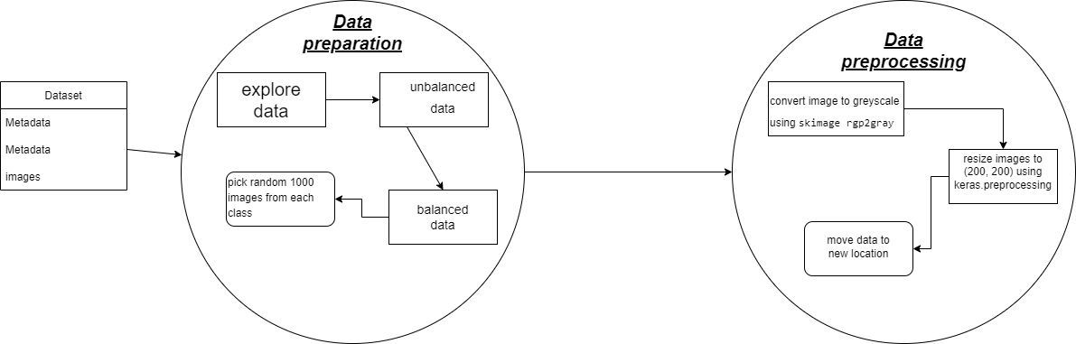

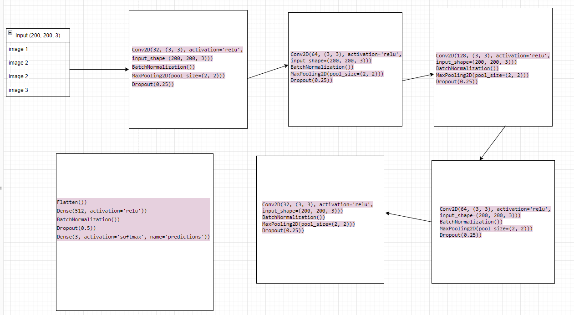

* **Our Model**

The proposed model contains five convolutional layers, with each being followed by batch normalization and max pooling layers, along with dropout.

Processing the final convolutional layer is a fully connected layer with 512 neurons, followed by the last layer with three neurons representing each category of X-ray.

ReLU was used as the activation function for each layer and softmax was used for the final dense layer.

The number of filters in each convolutional layer was gradually increased from 32 to 64 to 128 then back down to 64 and 32 with the strides for each layer being 3 × 3.

The developed model consists of 453,027 parameters and uses categorical crossentropy for the loss function, rmsprop for the optimizer in the paper but we replaced it with adam because it improves the accuracy, and a batch size of 32.

The learning rate was initially set to 0.0001 and to prevent the accuracy from plateauing during training, a learning rate reduction by a factor of 0.5 was performed if the validation accuracy does not increase for two

Steps but we changed it to 10.

**Hyperparameters and architectures tested before reaching the final model**

***Layer details and Hyperparameters:***

conv2d_20 (Conv2D) (None, 198, 198, 32) 896

batch_normalization_24 (BatchNormalization) (None, 198, 198, 32) 128

max_pooling2d_20 (MaxPoolin g2D) (None, 99, 99, 32) 0

dropout_24 (Dropout) (None, 99, 99, 32) 0

conv2d_21 (Conv2D) (None, 97, 97, 64) 18496

batch_normalization_25 (BatchNormalization) (None, 97, 97, 64) 256

max_pooling2d_21 (MaxPooling2D) (None, 48, 48, 64) 0

dropout_25 (Dropout) (None, 48, 48, 64) 0

conv2d_22 (Conv2D) (None, 46, 46, 128) 73856

batch_normalization_26 (BatchNormalization) (None, 46, 46, 128) 512

max_pooling2d_22 (MaxPooling2D) (None, 23, 23, 128) 0

dropout_26 (Dropout) (None, 23, 23, 128) 0

conv2d_23 (Conv2D) (None, 21, 21, 64) 73792

batch_normalization_27 (BatchNormalization) (None, 21, 21, 64) 256

max_pooling2d_23 (MaxPooling2D) (None, 10, 10, 64) 0

dropout_27 (Dropout) (None, 10, 10, 64) 0

conv2d_24 (Conv2D) (None, 8, 8, 32) 18464

batch_normalization_28 (BatchNormalization) (None, 8, 8, 32) 128

max_pooling2d_24 (MaxPooling2D) (None, 4, 4, 32) 0

dropout_28 (Dropout) (None, 4, 4, 32) 0

flatten_4 (Flatten) (None, 512) 0

dense_4 (Dense) (None, 512) 262656

batch_normalization_29 (BatchNormalization) (None, 512) 2048

dropout_29 (Dropout) (None, 512) 0

predictions (Dense) (None, 3) 1539

Total params: 453,027

Trainable params: 451,363

Non-trainable params: 1,664

***Callbacks details and Hyperparameters:***

EarlyStopping: monitor val_accuracy , patience=10, mode=max and restore the best weights=True.

ReduceLROnPlateau: monitor val_loss, patience = 10, verbose = 1, factor = 0.5,

min_lr =0.00001 and mode = "min".

ModelCheckpoint: monitor val_accuracy, mode="max", save the best model only=True, verbose=1.

* **Testing results**

**Training and Validation loss:**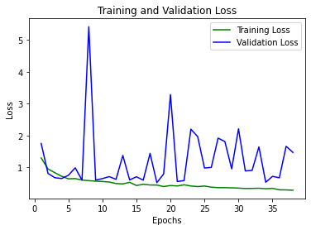

**Training and Validation accuracy:** 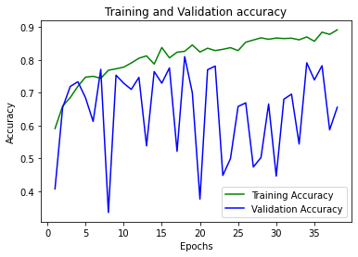

**Recall, Percision, f1-Score:**

precision recall f1-score support

COVID-19 0.81 0.89 0.85 200

normal 0.80 0.89 0.84 200

pneumonia 0.82 0.65 0.72 200

accuracy 0.81 600

macro avg 0.81 0.81 0.80 600

weighted avg 0.81 0.81 0.80 600

**Confusion matrix:**

