UTSHOB | Event Planning and Surplus Food Redistribution System

Project Overview
UTSHOB is a web application that helps users plan event budgets, find restaurants, caterers, and venues, and distribute suitable surplus food after events. It connects event hosts, service providers, community organizations, and volunteers across Bangladesh’s eight divisions. Food donations support orphanages, people experiencing homelessness, and people who rely on begging.
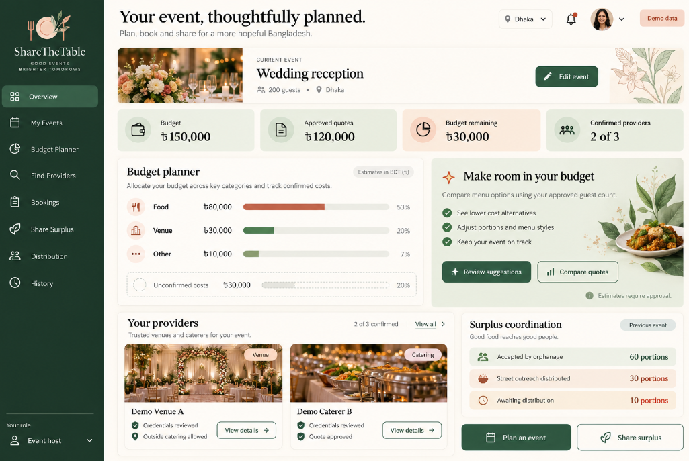
Mock Up of Share The Table
Problem Statement
Event hosts often struggle to estimate costs, compare providers, and manage changing guest numbers. These changes can cause overspending and unnecessary food preparation. After events, surplus food may go unused because donors, organizations, and volunteers lack a coordinated collection process.
Proposed Solution
A centralized platform will record event requirements, provide AI-assisted budget suggestions, recommend suitable providers, and manage quotations and bookings. It will also track food preparation, publish surplus donations, and coordinate collection and distribution. All records will be stored and managed through real database CRUD operations.

Module 1: Event Budget and Food Planning
1. Event Requirement Management
The system shall allow event hosts to:
- Create, view, edit, cancel, and reschedule events.
- Specify the date, location, guest count, budget, menu preferences, and required services.
- Select locations across Bangladesh’s eight divisions.
- Search previous events and view requirement changes.
- Copy a previous event into a new draft, subject to updated prices and availability.
2. Budget Management
The system shall:
- Provide an editable expense breakdown for food, venue, decoration, transport, and other costs.
- Compare estimated expenses with provider quotations.
- Identify missing charges and alert users when costs exceed the budget.
- Preserve accepted quotations and update the budget only after a revision is approved.
- Maintain previous budget versions and approved changes.
3. Food Quantity and Preparation Planning
The system shall:
- Calculate food requirements using guest counts and caterer-defined portions.
- Track cooking batches as planned, started, completed, or cancelled.
- Suggest adjustments to unstarted batches when guest numbers change.
- Preserve quantities already being prepared or completed.
- Consider available food and batches underway before suggesting additional preparation.
- Record consistent units and label estimated portion conversions.
4. Gemini API Integration
The system shall:
- Suggest budget allocations based on event requirements.
- Recommend cost-saving alternatives for user review.
- Suggest food-planning improvements using available event records.
- Clearly identify AI suggestions and unconfirmed prices as estimates.
- Require approval before applying suggestions.
- Allow manual planning when the API is unavailable.

Module 2: Provider Discovery and Booking
1. Provider Profiles and Credential Review
The system shall:
- Allow restaurants, caterers, venue owners, and event planners to create provider profiles.
- Record packages, prices, service areas, capacity, and availability.
- Allow providers to submit trade licences and applicable credentials.
- Require administrator review before providers can accept bookings.
- Display the specific credentials reviewed without guaranteeing food quality.
- Restrict new bookings when required documents expire and flag existing bookings for review.
2. Provider Recommendations and Nominatim API Integration
The system shall:
- Support location searches through the Nominatim API.
- Allow users to confirm or correct locations and enter addresses manually.
- Filter providers by budget, date, location, guest count, services, and preferences.
- Recommend up to 10 matching registered providers per category.
- Explain why each provider matches and show fewer results when necessary.
- Display review counts and identify providers with limited history.
- Flag venue-capacity conflicts and restrictions on outside catering.
3. Quotation and Booking Management
The system shall:
- Allow customers to request and compare itemized quotations.
- Maintain quotation revisions and record customer approval.
- Confirm venue and other provider bookings separately.
- Prevent overlapping venue reservations, including setup and cleanup periods.
- Support booking cancellation and rescheduling.
- Notify customers when a provider cancels and suggest alternatives.
- Require customer approval before confirming replacements or changing the budget.
4. Collaboration, Reviews and Booking History
The system shall:
- Allow customers and selected providers to share menus and event requirements.
- Record approvals and change requests.
- Allow one customer review per completed booking.
- Support complaint reporting and provider responses.
- Provide searchable quotation, booking, cancellation, and review history.

Module 3: Surplus Food Distribution and Impact — Member 3
1. Surplus Food Listing Management
The system shall:
- Allow authorized hosts and food providers to create surplus listings.
- Record food type, quantity, unit, preparation details, packaging, reported storage conditions, pickup location, and collection deadline.
- Record declared ingredients and allergens where available, identifying missing information.
- Prevent the host and caterer from listing the same surplus twice.
- Close expired listings to new reservations.
- Prevent food rejected for safety concerns from being automatically reassigned.
2. Community Requests and Food Reservations
The system shall:
- Allow orphanage and outreach coordinators to record food requirements.
- Record receiving capacity, collection capacity, and collection availability.
- Match suitable surplus with nearby organizations.
- Allow quantities to be divided between organizations.
- Prevent simultaneous reservations from exceeding available stock.
- Release eligible uncollected quantities after cancellation.
- Require coordinator-approved allocation changes if available food falls below reserved quantities.
3. Collection, Confirmation and Impact Records
The system shall:
- Assign volunteers or organization-arranged collectors.
- Track pickups, partial collections, cancellations, and missed collections.
- Record collected, received, accepted, rejected, and distributed quantities separately.
- Allow an authorized orphanage coordinator to confirm accepted quantities.
- Allow an authorized outreach coordinator to record aggregate street-distribution quantities and remaining food.
- Require no accounts or photographs from street recipients.
- Mark disputed deliveries for review and exclude disputed quantities from confirmed totals.
- Report orphanage acceptance separately from street distribution without double counting.
- Award contribution points once per qualifying confirmed action and correct points when records change.
- Provide searchable donation, distribution, waste, and dispute history.
4. Telegram Bot API Integration
The system shall:
- Send subscribed users pickup assignments and reminders.
- Notify relevant users of cancellations, shortages, and distribution updates.
- Record notification failures and support retries.
- Keep tasks accessible through the dashboard if Telegram delivery fails.
- Prevent notification retries from creating duplicate tasks.

Shared Requirements: User Access and Record Management
These requirements support all three modules and are separate from the 12 assessed features.
- The system shall provide signup, login, logout, and role-based dashboards for event hosts, service providers, organization coordinators, volunteers, and administrators.
- The system shall enforce role and record-level permissions in the backend so users can access only their own, assigned, or explicitly shared records.
- The system shall require administrator approval for provider and organization accounts before operational access is granted.
- The system shall prevent repeated submissions from creating duplicate bookings, donations, reservations, confirmations, or reward points.
- The system shall preserve completed and cancelled records and maintain a history of important changes, including who changed them, when, and why.
- The system shall notify affected parties when an event is cancelled or rescheduled, recheck booking availability, and preserve records of prepared food and existing donations for review.
- The system shall exclude unconfirmed or disputed quantities from confirmed impact totals until resolved. Food rejected for safety concerns shall not be automatically reassigned.
- The system shall distinguish quantities collected from quantities accepted or distributed and shall prevent the same food from being counted more than once.
- The system shall store and manage application records through real CRUD operations using MongoDB, Express.js, React, and Node.js (MERN).

Proposed Technical Implementation
- Frontend: React and Tailwind CSS.
- Backend: Node.js and Express.
- Database: PostgreSQL.
- External APIs: Gemini, Nominatim, and Telegram Bot API.
- Maps: Leaflet with OpenStreetMap.
- Authentication: Role-based access for event hosts, providers, community organizations, volunteers, and administrators.
- Version Control: Git and GitHub with individual contribution history.
- Deployment: Public demonstration with synthetic records stored through real database CRUD operations. Hosting and API limits will be checked against the no-payment requirement.
Subscriptions and real payments remain future enhancements.

