FedUA-Net: Uncertainty-Aware Federated Learning
for Multi-Modal Medical Imaging
Md Tareque Jamil Josh, Fernanda Miyuki Yamada, Gabriel Peixoto de Carvalho, and Hiroki Takahashi¹
Abstract— Hospitals cannot share patient scans due to privacy laws, and they often use different imaging modalities and diagnostic tasks. Standard FL methods are not designed for this heterogeneous setting, as they assume all hospitals handle the same task. We propose FedUA-Net, a framework that lets hospitals with Brain MRI, Breast Ultrasound, and Chest X-ray collaborate without sharing patient data. It uses a shared visual backbone with private local modules, equal client weighting to reduce the influence of client dataset size, and uncertainty calibration to flag ambiguous scans for doctor review. On 29,145 scans across 11 disease classes, FedUA-Net reaches 93.30% accuracy, outperforms FedAvg and FedBN, performs competitively with Ditto, improves the weakest site from 85.47% to 88.60%, and reduces expected calibration error (ECE) by 39%. These results show that hospitals with different modalities can collaborate under FL with calibrated, uncertainty-aware outputs.

I. Introduction
Deep learning needs large multi-hospital datasets, but privacy laws like HIPAA and GDPR prevent centralizing patient scans [1]. Federated learning (FL) addresses this by sharing model weights instead of raw data [1]. In practice, hospitals often handle different tasks, such as brain tumor MRI, breast ultrasound and chest X-ray, with disjoint disease categories, which standard FL methods are not designed for. Deep networks also tend to be overconfident, which is risky in clinical use [4]. Personalized FL methods such as Ditto [6] handle client heterogeneity but lack built-in uncertainty handling, and size-proportional aggregation lets large sites dominate small hospitals. FedUA-Net addresses these problems.

II. FedUA-Net Framework
As shown in Fig. 1, FedUA-Net works on three principles. (1) Each hospital uses a shared backbone network (EfficientNetV2-S with CBAM [3]) but keeps its own normalization layers and disease classifier private [2]. (2) The server weights all hospitals equally, so a large site cannot dominate a small specialist clinic, and each hospital fine-tunes the model on its own data after federation. (3) After training, temperature scaling [4] corrects overconfident predictions, and conformal prediction [5] produces prediction sets with a statistical coverage guarantee. Clear scans get a single diagnosis; uncertain ones are sent for doctor review.
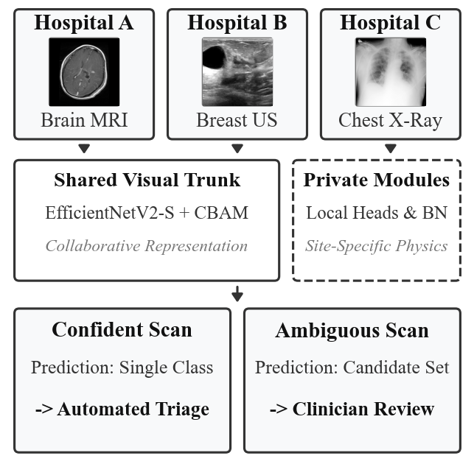
Fig. 1. Three hospitals contribute different scan types. A shared backbone learns common features while each site keeps private modules. Outputs are either a direct diagnosis or a candidate set for clinician review.

III. Results
We use 29,145 scans: Brain MRI (7,200 scans, 4 classes), Breast Ultrasound (780 scans, 3 classes) and Chest X-ray (21,165 scans, 4 classes), with 3 random seeds.
- TABLE I Performance comparison (3-seed mean ± std)
Method | Overall Acc. (%) | Site B Acc. (%)
FedAvg [1] | 92.36 ±0.92 | 85.47 ±3.1
FedBN [2] | 92.34 ±0.99 | 85.47 ±3.4
Ditto [6] (SoTA) | 93.93 ±0.51 | 90.60 ±2.3
FedUA-Net (Ours) | 93.30 ±1.13 | 88.60 ±3.6
Table I shows FedUA-Net reaches 93.30% accuracy (93.05% macro-F1) and raises Site B (546 training scans) from 85.47% to 88.60%, approaching Ditto. With sample-weighted aggregation, Site B drops to 54-56% for FedAvg and FedBN. Temperature scaling cuts ECE by 39% (5.04% to 3.07%). Adaptive conformal sets reach 99.1% coverage at a 90% target with about two labels per scan; least-ambiguous sets meet it with one label, referring 8-16% of scans.

Conclusion
FedUA-Net shows that hospitals with different modalities and tasks can collaborate under FL with competitive accuracy and uncertainty-aware triage.

References
[1] B. McMahan et al., "Communication-efficient learning from decentralized data," in Proc. AISTATS, 2017.
[2] X. Li et al., "FedBN: Federated learning on non-IID features via local batch normalization," in Proc. ICLR, 2021.
[3] S. Woo et al., "CBAM: Convolutional block attention module," in Proc. ECCV, 2018.
[4] C. Guo et al., "On calibration of modern neural networks," in Proc. ICML, 2017.
[5] A. Angelopoulos & S. Bates, "Conformal prediction: A gentle introduction," Found. Trends ML, 2023.
[6] T. Li et al., "Ditto: Fair and robust federated learning through personalization," in Proc. ICML, 2021.

¹ Md Tareque Jamil Josh is with the Faculty of Informatics, The University of Electro-Communications (UEC Tokyo), Japan, and also with Daffodil International University (DIU), Dhaka, Bangladesh. F. M. Yamada and H. Takahashi are with the Graduate School of Informatics and Engineering, UEC Tokyo, Japan. G. P. de Carvalho is with Osaka University, Japan (e-mail: j2695005@gl.cc.uec.ac.jp).

