// Profile Picture

// Start Edit Profile

// Other templates in variables

// Start making posts

// Finish search in main

// Continue DM

// Solve the issue in nice

// Search for program to arrange css code based on html order e.g html, body etc

// Search for program to delete unused css elements

Status Post Event

If I am the user this should be used to create quick posts else it should be used as a contact me

Delete traces of “ <a href="https://twitter.com/AysnrTrkk" class="follow-me" target="_blank">

<span class="follow-text">

<svg viewBox="0 0 24 24" stroke="currentColor" stroke-width="2" fill="none" stroke-linecap="round" stroke-linejoin="round" class="css-i6dzq1"><path d="M23 3a10.9 10.9 0 0 1-3.14 1.53 4.48 4.48 0 0 0-7.86 3v1A10.66 10.66 0 0 1 3 4s-4 9 5 13a11.64 11.64 0 0 1-7 2c9 5 20 0 20-11.5a4.5 4.5 0 0 0-.08-.83A7.72 7.72 0 0 0 23 3z"></path></svg>

Follow me on Twitter

</span>

<span class="developer">

<img src="https://pbs.twimg.com/profile_images/1253782473953157124/x56UURmt_400x400.jpg" />

Aysenur Turk — @AysnrTrkk

</span>

</a>”

Use this color for the above to write like the user name iin dm

And whether the user is active or their last seen

The room’s which the user is in has been fetched but the details of the other users in the room has not been

**Currently working on dm**

**Ctrl+kx = insert snippet**

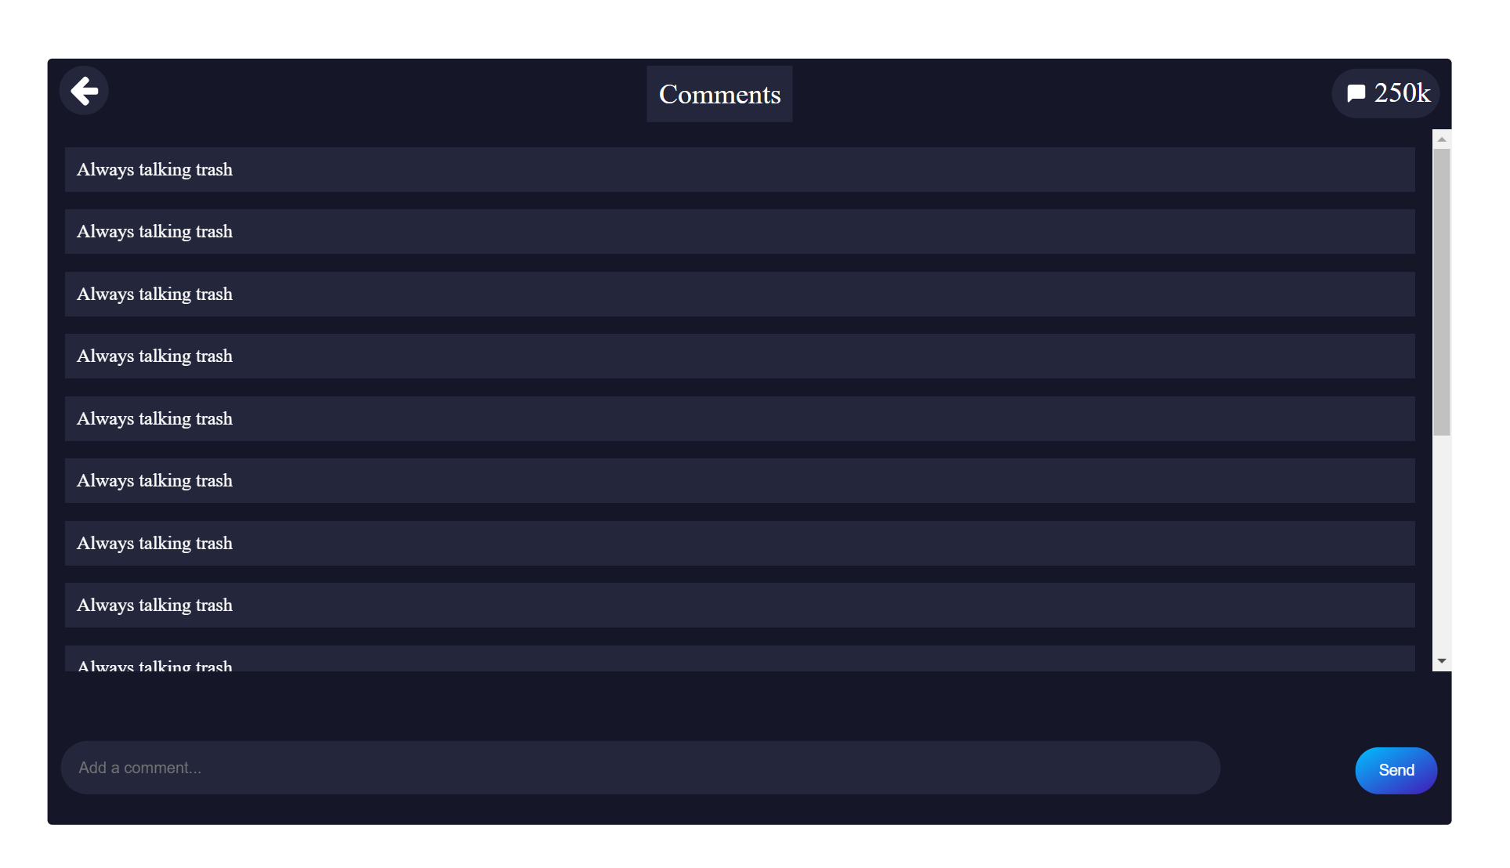**Can use for dm**