# Ceramichub - Complete Tile Range Catalogue 2025

## 1. Glazed Vitrified Tiles

• Product Images (not included in this version)  
• Sizes & Thickness: 600x600mm, 800x800mm, 600x1200mm  
• Finish Types: Glossy, Matte, Rustic  
• Usage Areas: Living Room, Kitchen, Commercial Spaces  
• Features: Stain-resistant, Low water absorption, High durability  
 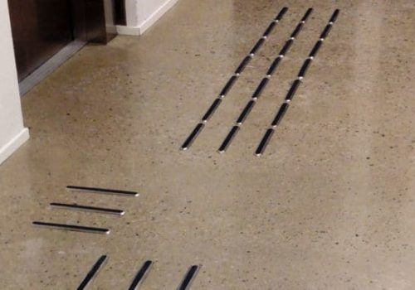

## 2. Ceramic Tiles

• Product Styles: Wall Tiles, Floor Tiles  
• Designs & Patterns: Digital Printed, Stone-look, Wood-look  
• Applications: Bathrooms, Kitchens, Outdoor Walls  
• Maintenance: Easy to clean, Resistant to mild acids and alkalis  
 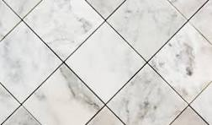

## 3. Polished Vitrified Tiles

• Finish: High Gloss, Mirror-like Polish  
• Applications: Showrooms, Hotels, Luxury Homes  
• Resistance: Scratch-resistant, Water-resistant, Long-lasting shine  
• Product Specs: 600x600mm, 800x800mm with nano-coating layer  
 