

____________________________________________________________

HACETTEPE UNIVERSITY

Computer Science and Engineering Department

____________________________________________________________

IST292 Homework 1.

Vuqar Kerimov - SECRET
General Description and Details Of Homework.
The data is about weekly studying hours of randomly selected 50 students from Faculty of Engineering

Mean

The mean is the average of all numbers and is sometimes called the arithmetic mean. To calculate mean, add together all of the numbers in a set and then divide the sum by the total count of numbers.

Median

In the data center, means and medians are often tracked over time to spot trends, which inform capacity planning or power cost predictions.The statistical median is the middle number in a sequence of numbers. To find the median, organize each number in order by size; the number in the middle is the median.

Mode

The mode is the number that occurs most often within a set of numbers. For the server power consumption examples above, there is no mode because each element is different.
Statistics
V5
N | Valid | 50
N | Missing | 0
Mean |  | 9.871113872486267
Median |  | 9.871706497276964
Mode |  | 5.11570889758818ª

Histogram

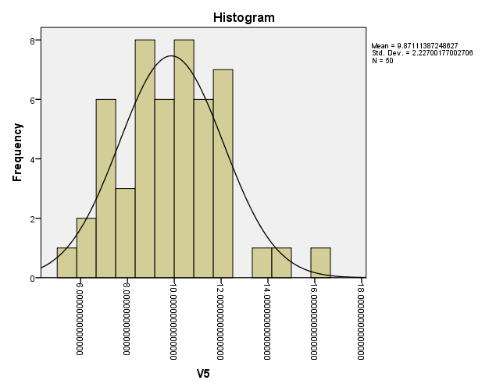

Boxplot

Values, the left axis of the shape corresponds to the scale on. So the box itself shows the IQR (interquartile range). the box The line inside is drawn at 50%. Above the box The lines that extend below and are referred to as giler boundary çiz. At the end of the upper limit the maximum score is marked. The minimum value can be found at the end of the lower limit.

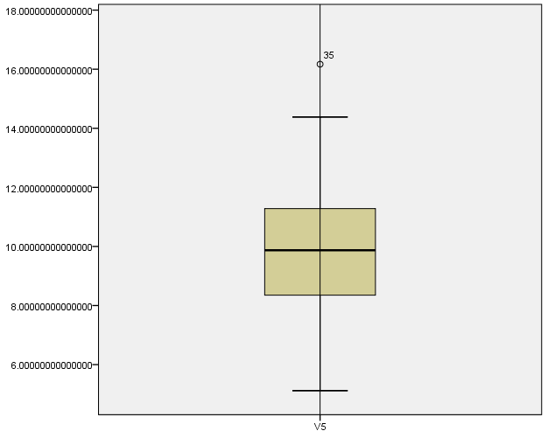

Frequency
A frequency is the number of times a given datum occurs in a data set. The total of the frequency column, 50, represents the total number of included in the sample.

Relative frequency
A relative frequency is the fraction or proportion of times an answer occurs. To find the relative frequencies, divide each frequency by the total number of in the sample - in this case, 50. Relative frequencies can be written as fractions, percents, or decimals.

Skewness
Skewness is the extent to which the data are not symmetrical. Whether the skewness value is 0, positive, or negative reveals information about the shape of the data.

Positive or right skewed distributions
Positive skewed or right skewed data is so named because the "tail" of the distribution points to the right, and because its skewness value will be greater than 0 (or positive).

Kurtosis
Kurtosis indicates how the peak and tails of a distribution differ from the normal distribution. Use kurtosis to help you initially understand general characteristics about the distribution of your data.

Negative kurtosis
A distribution with a negative kurtosis value indicates that the distribution has lighter tails and a flatter peak than the normal distribution.

Positive kurtosis
A distribution with a positive kurtosis value indicates that the distribution has heavier tails and a sharper peak than the normal distribution.
Statistics
V5
N | Valid | 50
N | Missing | 0
Skewness |  | .251
Std. Error of Skewness |  | .337
Kurtosis |  | .320
Std. Error of Kurtosis |  | .662

Max and Min
The maximum value in the data set is the largest mathematical value in the data set. The minimum value in the data set is the smallest mathematical value in the data set. An outlier is a value that is much larger or smaller than the other values in a data set, or a value that lies outside the given data.
Case Processing Summary
 | Cases
 | Valid |  | Missing |  | Total
 | N | Percent | N | Percent | N | Percent
V5 | 50 | 100.0% | 0 | 0.0% | 50 | 100.0%

Descriptives
 |  |  | Statistic | Std. Error
V5 | Mean |  | 9.871113872486270 | .314945610660116
V5 | 95% Confidence Interval for Mean | Lower Bound | 9.238206972261258
V5 | 95% Confidence Interval for Mean | Upper Bound | 10.504020772711280
V5 | 5% Trimmed Mean |  | 9.819502777011165
V5 | Median |  | 9.871706497276964
V5 | Variance |  | 4.960
V5 | Std. Deviation |  | 2.227001770027063
V5 | Minimum |  | 5.11570889758818
V5 | Maximum |  | 16.17022400504910
V5 | Range |  | 11.05451510746092
V5 | Interquartile Range |  | 2.95516705286305
V5 | Skewness |  | .251 | .337
V5 | Kurtosis |  | .320 | .662
Percentiles
 |  | Percentiles
 |  | 5 | 10 | 25 | 50 | 75 | 90 | 95
Weighted Average(Definition 1) | V5 | 6.266494037830872 | 6.931095870647736 | 8.334318743939225 | 9.871706497276964 | 11.289485796802275 | 12.329405361529570 | 14.023388312999371
Tukey's Hinges | V5 |  |  | 8.351943439950010 | 9.871706497276964 | 11.282231144994200
Extreme Values
 |  |  | Case Number | Value
V5 | Highest | 1 | 35 | 16.17022400504910
V5 | Highest | 2 | 12 | 14.38194932025410
V5 | Highest | 3 | 13 | 13.73002021615460
V5 | Highest | 4 | 49 | 12.44066287115480
V5 | Highest | 5 | 32 | 12.33057677863330
V5 | Lowest | 1 | 46 | 5.11570889758818
V5 | Lowest | 2 | 22 | 5.83569218891661
V5 | Lowest | 3 | 14 | 6.61896827785163
V5 | Lowest | 4 | 21 | 6.75330914998831
V5 | Lowest | 5 | 33 | 6.92984537439228

V5 Stem-and-Leaf Plot

Frequency Stem & Leaf

2,00 5 . 18
4,00 6 . 6799
4,00 7 . 0447
7,00 8 . 2233459
9,00 9 . 111456679
9,00 10 . 134577779
7,00 11 . 0023679
5,00 12 . 00334
1,00 13 . 7
1,00 14 . 3
1,00 Extremes (>=16,2)

Stem width: 1,000000
Each leaf: 1 case(s)

Frequencies

V5
 |  | Frequency | Percent | Valid Percent | Cumulative Percent
Valid | 5.11570889758818 | 1 | 2.0 | 2.0 | 2.0
Valid | 5.83569218891661 | 1 | 2.0 | 2.0 | 4.0
Valid | 6.61896827785163 | 1 | 2.0 | 2.0 | 6.0
Valid | 6.75330914998831 | 1 | 2.0 | 2.0 | 8.0
Valid | 6.92984537439228 | 1 | 2.0 | 2.0 | 10.0
Valid | 6.94235033694684 | 1 | 2.0 | 2.0 | 12.0
Valid | 7.03579638950967 | 1 | 2.0 | 2.0 | 14.0
Valid | 7.42252864246717 | 1 | 2.0 | 2.0 | 16.0
Valid | 7.49655526694389 | 1 | 2.0 | 2.0 | 18.0
Valid | 7.75328627184419 | 1 | 2.0 | 2.0 | 20.0
Valid | 8.20007242067861 | 1 | 2.0 | 2.0 | 22.0
Valid | 8.28144465590687 | 1 | 2.0 | 2.0 | 24.0
Valid | 8.35194343995001 | 1 | 2.0 | 2.0 | 26.0
Valid | 8.38676163104328 | 1 | 2.0 | 2.0 | 28.0
Valid | 8.49019620134239 | 1 | 2.0 | 2.0 | 30.0
Valid | 8.57596378145043 | 1 | 2.0 | 2.0 | 32.0
Valid | 8.94884881769137 | 1 | 2.0 | 2.0 | 34.0
Valid | 9.11033080822646 | 1 | 2.0 | 2.0 | 36.0
Valid | 9.14756155214369 | 1 | 2.0 | 2.0 | 38.0
Valid | 9.15081079841983 | 1 | 2.0 | 2.0 | 40.0
Valid | 9.43178759253106 | 1 | 2.0 | 2.0 | 42.0
Valid | 9.59472056687219 | 1 | 2.0 | 2.0 | 44.0
Valid | 9.66801398363182 | 1 | 2.0 | 2.0 | 46.0
Valid | 9.69685963376749 | 1 | 2.0 | 2.0 | 48.0
Valid | 9.79290545202755 | 1 | 2.0 | 2.0 | 50.0
Valid | 9.95050754252638 | 1 | 2.0 | 2.0 | 52.0
Valid | 10.13178350295790 | 1 | 2.0 | 2.0 | 54.0
Valid | 10.34045595511700 | 1 | 2.0 | 2.0 | 56.0
Valid | 10.49392781879200 | 1 | 2.0 | 2.0 | 58.0
Valid | 10.53150720221370 | 1 | 2.0 | 2.0 | 60.0
Valid | 10.70188644541380 | 1 | 2.0 | 2.0 | 62.0
Valid | 10.71732460273360 | 1 | 2.0 | 2.0 | 64.0
Valid | 10.72281239621010 | 1 | 2.0 | 2.0 | 66.0
Valid | 10.76088321583530 | 1 | 2.0 | 2.0 | 68.0
Valid | 10.96571945199440 | 1 | 2.0 | 2.0 | 70.0
Valid | 11.00479820297810 | 1 | 2.0 | 2.0 | 72.0
Valid | 11.07490376432180 | 1 | 2.0 | 2.0 | 74.0
Valid | 11.28223114499420 | 1 | 2.0 | 2.0 | 76.0
Valid | 11.31124975222650 | 1 | 2.0 | 2.0 | 78.0
Valid | 11.61495000371410 | 1 | 2.0 | 2.0 | 80.0
Valid | 11.72587293234340 | 1 | 2.0 | 2.0 | 82.0
Valid | 11.98677272879000 | 1 | 2.0 | 2.0 | 84.0
Valid | 12.03849321354760 | 1 | 2.0 | 2.0 | 86.0
Valid | 12.09505581662990 | 1 | 2.0 | 2.0 | 88.0
Valid | 12.31886260759600 | 1 | 2.0 | 2.0 | 90.0
Valid | 12.33057677863330 | 1 | 2.0 | 2.0 | 92.0
Valid | 12.44066287115480 | 1 | 2.0 | 2.0 | 94.0
Valid | 13.73002021615460 | 1 | 2.0 | 2.0 | 96.0
Valid | 14.38194932025410 | 1 | 2.0 | 2.0 | 98.0
Valid | 16.17022400504910 | 1 | 2.0 | 2.0 | 100.0
Valid | Total | 50 | 100.0 | 100.0

1

