RPAchallenge.com “Input Forms”

PDD Process Design Document

Author: Christian Prior-Mamulyan

Version: v0.9.1

Status: review

Sign-off: date, by whom

Table of Contents

1. Introduction 2

1.1. Purpose 2

1.2. Objectives 2

1.3. Key Contacts 2

1.4. Minimum Pre-Requisites for the Automation 2

2. AS-IS Process Description 3

2.1. Overview 3

2.2. Applications Used in the AS-IS Process 3

2.3. Users and their Permissions observed in the AS-IS Process 4

2.4. Process Map 4

2.5. Clickpath of the AS-IS Process steps 6

2.6. Input Data Description 12

2.7. Other Sources of Process Documentation 12

3. TO-BE Process Description 12

3.1. TO-BE Process Map 13

3.2. Parallel Initiatives 13

3.3. In Scope for RPA 13

3.4. Out of Scope for RPA 13

3.5. Exceptions Handling 14

3.6. Applications Errors and Exceptions Handling 14

3.7. Reporting 14

4. Appendix 14

# Introduction

## Purpose

The Process Definition|Design Document (PDD) is a communication document between:

The RPA Business Analyst and the Subject Matter Expert/Process Owner. The purpose is to ensure that the RPA Business Analyst has the correct understanding of the process and has represented it accurately.

The RPA Business Analyst and the RPA Development team (represented by the RPA Solution Architect and the RPA Development Lead). The purpose is to ensure that the process is documented appropriately and to a sufficient level of detail so that the RPA Solution Architect can then create the solution based in this PDD.

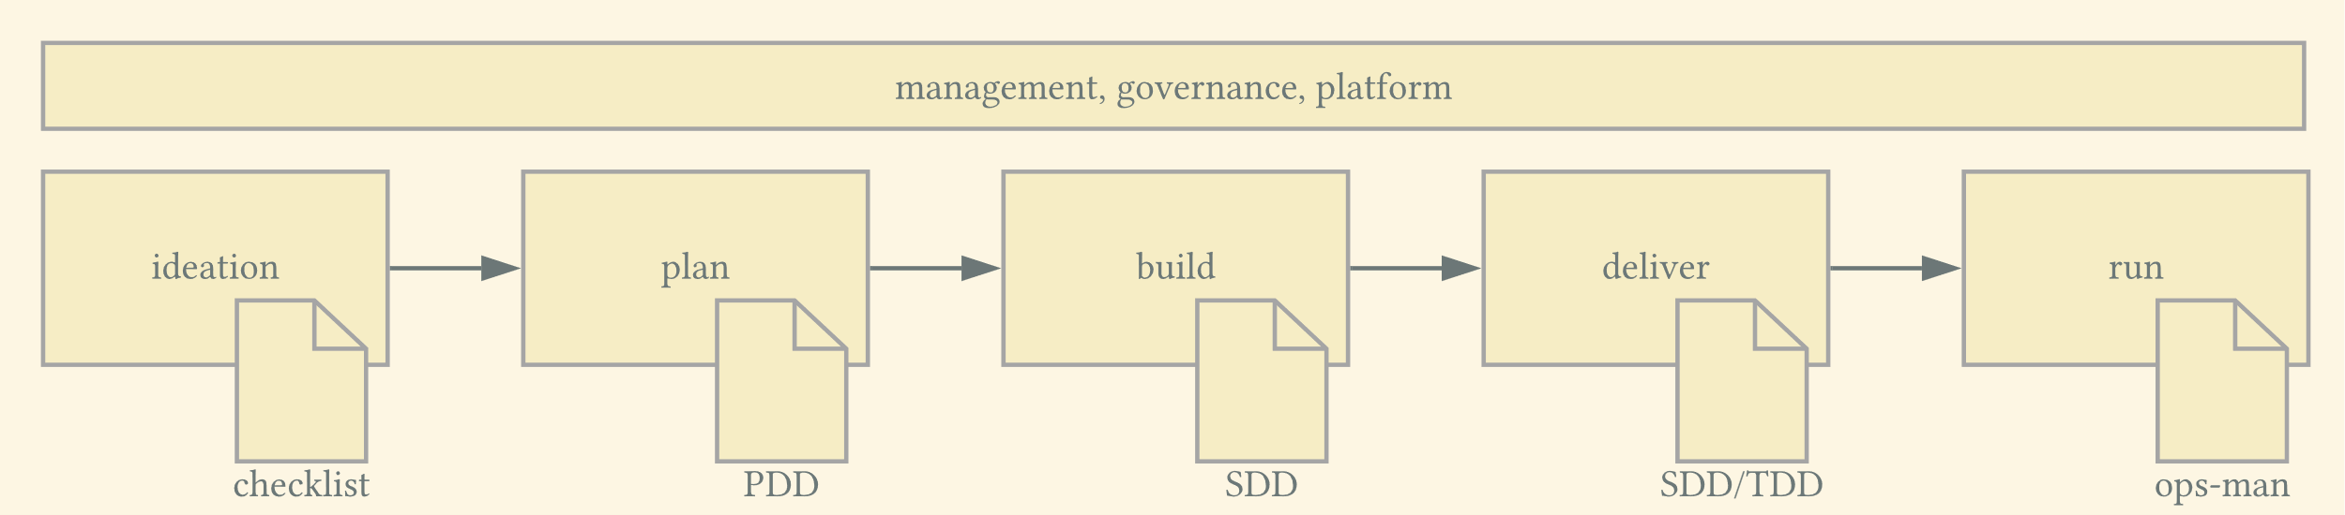

The PDD builds upon a checklist of a previous candidate selection phase and is written for processes that advanced past the status of being just candidates for automation.

## Objectives

The daily task shall be automated to free up time, make holiday substitution easier and to reduce potential errors in the manual process execution.

## Key Contacts

| Name | Organization/Department | Role | Contact Data |
| --- | --- | --- | --- |
| tbd | tbd | Sponsor |  |
| tbd | tbd | Process Owner |  |
| tbd | tbd | Subject Matter Expert |  |
| tbd | tbd | RPA Business Analyst |  |
| tbd | tbd | RPA Solution Architect |  |
| tbd | tbd | RPA Developer |  |
| Tbd | UiPath | System Owner |  |

## Minimum Pre-Requisites for the Automation

Any process re-engineering needs to be finished before the automation is build and needs to be reflected in this document.

During the build phase the subject matter expert must be available for the developer to some degree, details will be discussed in a kickoff meeting at the beginning of the build phase.

Any access and/or credentials for systems, user accounts or documents required in the TO-BE process need to be aligned and available at the beginning of the build phase.

The automation will be built to run on platform include vendor and preliminary sizing information here , procurement is responsibility of …

# AS-IS Process Description

## Overview

| Item | Description |
| --- | --- |
| Process Name | Choose wisely, will be used in many documents and therefore be long-lived |
| Organization/Department | YouTube channel UCnI56C3TyCVT76ako1zCnog |
| How many departments/teams/org units are stakeholders in the process? | 1 |
| How many persons are performing this process? | 1 |
| Process schedule and frequency | Daily Attention: If the requirements ask for “daily” it typically means workdays. Inquire about local bank holidays, 31st of December and similar |
| Human execution time | 7 min |
| Peak period? | None |
| Frequency during peak period | - |
| Process Maturity | Well-defined process, few to no decisions, handling of exceptions clearly defined.  Condensed version of checklist |
| Risk profile | No risk associated with the process.  Taken from checklist |
| Complexity | Low  Condensed version of checklist |
| Input data | 10 rows in an MS Excel file with 7 columns each, fully digital Condensed version of checklist |
| Output data | - |

## Applications Used in the AS-IS Process

None of the applications are scheduled for upgrades or replacements in the upcoming 12 months.

| Name | Version | Type | Comment |
| --- | --- | --- | --- |
| MS Edge | 108.0.1462.76 | Desktop App |  |
| MS Excel | Office 2019 | Desktop App |  |
| rpachallenge.com | Unknown | Web Application | No test environment. Unknown update cycles. Very rare updates. |
| ? |  | Check if Citrix/RDP, APIs or DB queries are involved | Has test environment? |

## Users and their Permissions observed in the AS-IS Process

| Username | Permission | Leading Identity System | Comment |
| --- | --- | --- | --- |
| tutor | Personal Windows user | Active Directory JC | Owner of the account is the Process Owner |
| ? |  |  | If there is filesystem access double-check access permissions |
| ? | Proxy access to the internet |  | Be inquisitive what permissions might be granted on Active Directory level |

## Process Map

### High level

The requesting business department or an inexperienced RPA Business Analyst might try to get away with a too high-level diagram, and not follow up with a more detailed. This high-level diagram is good for a quick introduction to the topic – IF the reader trusts that it is complete.

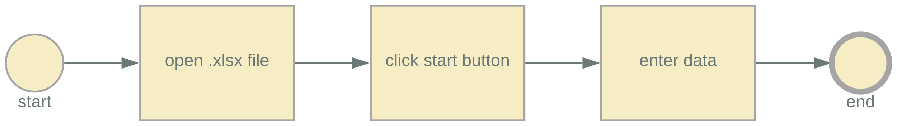

### Detailed level

The detailed AS-IS map shows each program that is opened and a loop with a decision. When the RPA Business Analyst is talking to the requesting business department about these details this will create a consciousness for completeness, accuracy and the decisions that the RPA process is supposed to make. Remember, RPA is suitable for repetitive task with clear business rules. And last but not least creating a detailed diagram prepares for discussing exception handling later in this PDD.

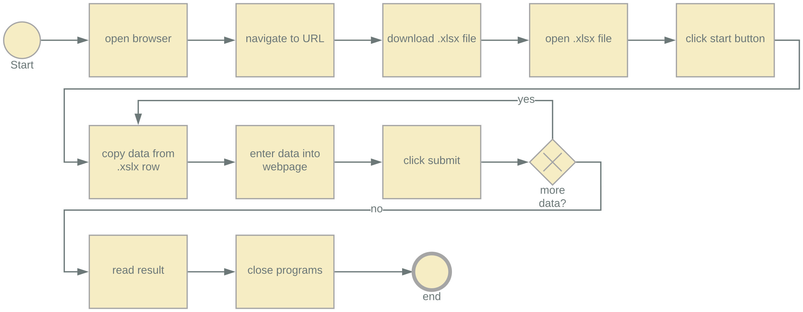

.

## Clickpath of the AS-IS Process steps

Screenshots will typically have red boxes to highlight relevant parts. Because this very document will be shared publicly with a variety of document reader software the sometimes fragile red boxes are omitted in favor of a cropped part.

The clickpath by screenshots is commonly replaced or amended by a video recording of the process demonstration. Special care should then be taken to make the video accessible, preferably on a platform like MS Stream where a link to a specific time can be set – just a big video file on a network share is likely to be of minor use.

| ID | Description | Screenshot | next |
| --- | --- | --- | --- |
| 1 | Open the website |  | 2 |
| 2 | Click the “DOWNLOAD EXCEL” button |  | 3 |
| 3 | The .xlsx file is downloaded |  | 4 |
| 4 | Open the file to the side |  | 5 |
| Preparation finished | | | |
| 5 | Click the START button |  | 6 |
| 6 | The button changes to “ROUND 1” |  | 7 |
| 7 | Enter the 1st row from the .xslx file and click SUBMIT |  | 8 |
| 8 | Enter the 2nd row from the .xslx file and click SUBMIT |  | 9 |
| 9 | Proceed with the other rows  The click on SUBMIT in ROUND10 will finalize the data entry. |  | 10 |
| 10 | Copy the success rate and the duration. |  |  |
| end | | | |

## Input Data Description

The input data is stored in an .xlsx file with just 1 sheet named “Sheet1”. It contains in the first line the headings. There are 7 columns in total:

1. First Name
2. Last Name
3. Company Name
4. Role in Company
5. Address
6. Email
7. Phone Number

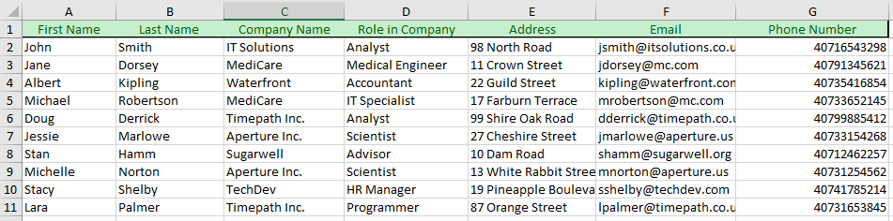



## Other Sources of Process Documentation

UiPath Academy, Course "Get Started with RPA Development", currently available for v2020.10 https://academy.uipath.com/courses/get-started-with-rpa-development-v202010

Checklist of this process from ideation phase.

# TO-BE Process Description

At PDD phase and in collaboration between the requesting business department and the RPA Business Analyst the PDD will not have SDD-level of refinement. It would typically require a good RPA Business Analyst to spot the technical challenge of the data entry field selectors.

Please answer the following questions:

| Item | Description/Answer |
| --- | --- |
| Until which step can the process safely be interrupted? | 9 |
| What shall trigger the automated process, a fixed schedule? | Each working day between 03:00 and 07:00 |
| What are the requirements regarding repeated input data? | Must only run once per day |
| Add other questions important to your setup |  |

## TO-BE Process Map

This notation is not 100% correct BPMN but the exception handling on the process border is easy to explain. It prepares nicely not just the following exception handling but at the beginning of development the testcase definition as well (to focus on non-happy-path testcases is almost trivial). The following diagram is still not implementation-specific as it would become in a SDD.

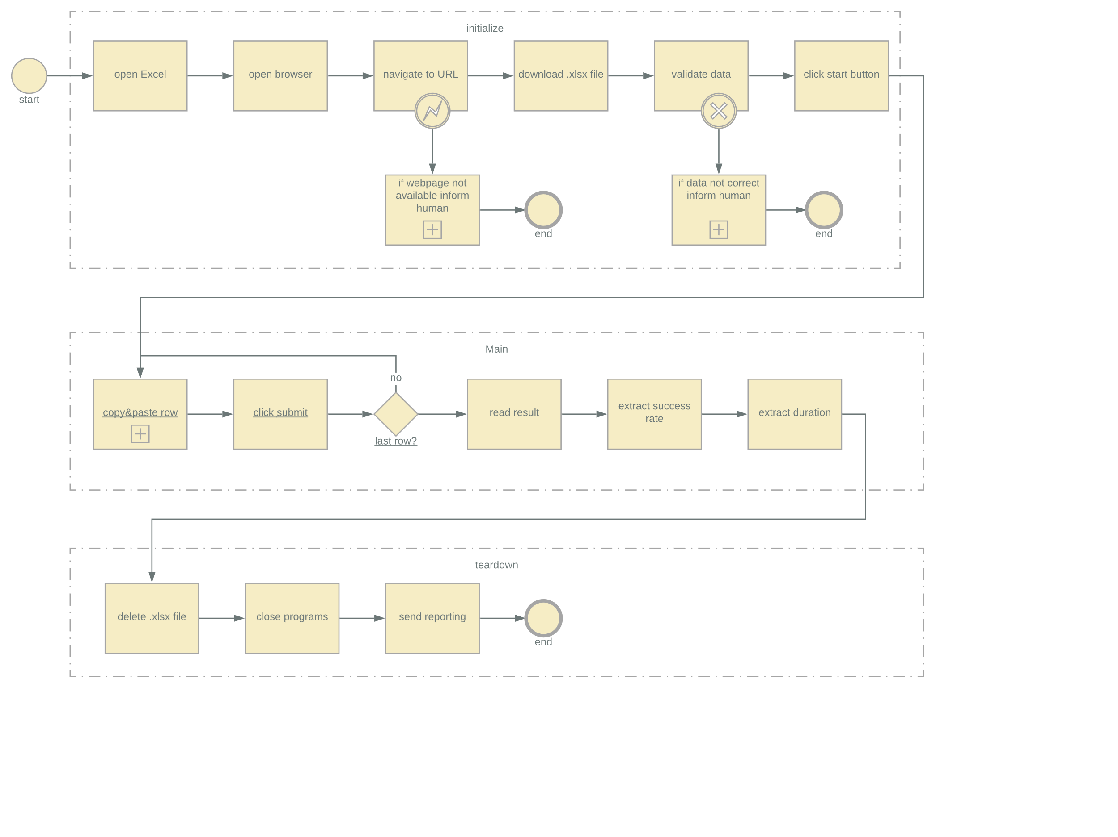

## Parallel Initiatives

There are no known parallel initiatives: No process re-engineering is taking place, and the systems are planned to be continued. The input data is not known to change in the next months.

## In Scope for RPA

* Download of input data file
* Data entry into webpage
* Error handling
* Minimal reporting: At least a notification in case of failures

## Out of Scope for RPA

To archive the .xlsx file.

## Exceptions Handling

Known exceptions: The scenario was already encountered and there are clear actions and workarounds.

Unknown: The scenario was not encountered before, cannot be predicted.

The mismatch between the following tables and the diagram is intentional – because that reflects reality! ;)

### Known Business Exceptions

|  |  |  |  |
| --- | --- | --- | --- |
| Exception Name | Step | Situation | How to Handle |
| BRE01 wrong file | 4 | The .xlsx file does not contain the sheet “Sheet1” | Handover to human |
| BRE02 bad data | 7 | One of the columns is empty | Do not enter into the fields, just press SUBMIT |
| BRE03 wrong email | 7 | The email is incorrect | Do not enter into the fields, just press SUBMIT |

### Unknown Business Exceptions

|  |  |  |  |
| --- | --- | --- | --- |
| Exception Name | Step | Situation | How to Handle |
| BRE04 |  |  | Handover to human |
| BRE05 |  |  |  |

## Applications Errors and Exceptions Handling

### Known Applications Errors and Exceptions

|  |  |  |  |
| --- | --- | --- | --- |
| Exception Name | Step | Situation | How to Handle |
| EXP01 | 1 | The website is down | Retry after 5 min for 15 min |
| EXP02 | 3 | It is not possible to open the file because the virus scanner blocks it | Download it again for a maximum of 2 times |

### Unknown Applications Errors and Exceptions

|  |  |  |  |
| --- | --- | --- | --- |
| Exception Name | Step | Situation | How to Handle |
|  | any |  | Handover to human |

## Reporting

When the process has finished send an email to the department’s mailbox.

Again, the above requirement reflects real-life PDDs – and the RPA Solution Architect should refine it.

# Appendix

-