S. Tariere Okoya-Koren

vba-challenge-screenshots

Multi-Year 2016

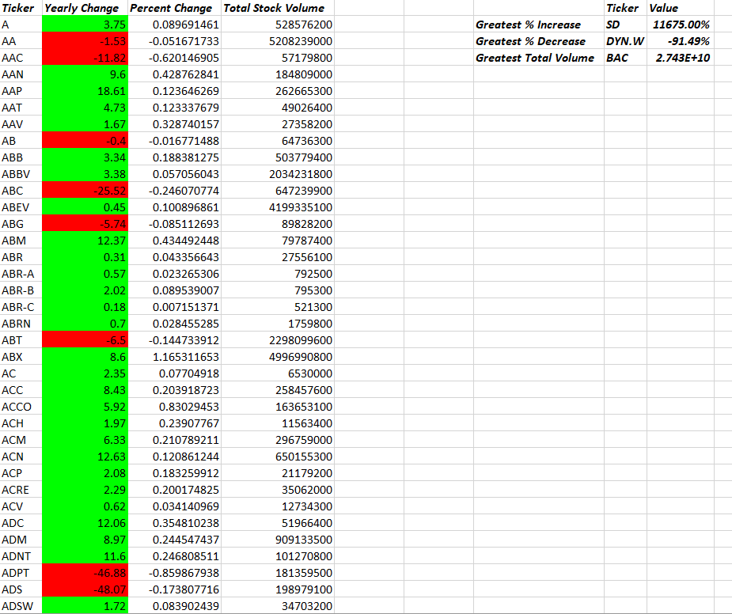

Multi-Year 2015

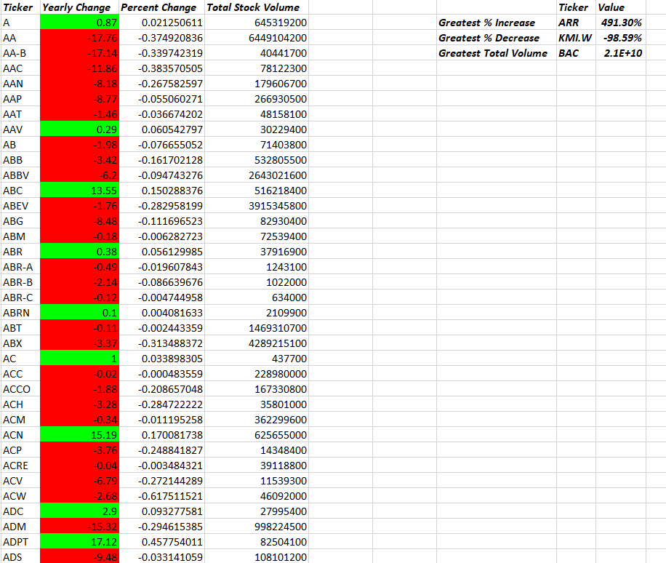

Multi-Year 2014

