SEN22106E – Computer Programming II Laboratory
Final Project – Analysis Document
Inventory Tracking System

Student: Tarik Emir Yilmaz
Student No: 2321051014
Date: June 5, 2026

1. Project Overview
This project is an Inventory Tracking System built with Java Swing, JDBC, and File API. It allows users to manage products, track stock movements, and organize items by category.
The application has three layers:
- User Interface Layer: Java Swing screens
- Object Layer: Product, ElectronicProduct, FoodProduct, and manager classes
- Data Access Layer: DAO classes that connect to MySQL using JDBC

2. Objects Used and Their Purpose

Class | Type | Purpose
Product | Entity Bean (@Entity, Serializable) | Base class for all products. Holds barcode, name, category, quantity, price, and critical level.
ElectronicProduct | Entity Bean (@Entity, extends Product) | Adds brand name and warranty duration (months) for electronic products.
FoodProduct | Entity Bean (@Entity, extends Product) | Adds expiry date and supplier name for food products. Has isExpired() check.
InventoryManager | Manager / Service | Central class that handles all business logic. Uses UserDAO, ProductDAO, and StockDAO.
InventoryManager.User | Inner Class | Holds username, password, and full name. Used for session management.
InventoryManager.StockMovement | Inner Class | Holds stock movement data: product, barcode, type, amount, note, date.
ProductDAO | Data Access | Handles all product CRUD operations in the database using JDBC.
StockDAO | Data Access | Saves and retrieves stock movements from the database.
UserDAO | Data Access | Handles user login, registration, and category management in the database.
DBConnection | Singleton | Manages a single MySQL connection. Creates tables and default data on startup.
FileManager | File Operations | Handles binary file (ObjectOutputStream) and text file (BufferedWriter) operations.

3. Screens

Screen | Type | Description
LoginScreen | Login Screen | User login and registration. Shows username/password fields and status messages.
MainScreen | Main Screen | Shows all products in a JTable. Has category filter (JComboBox), summary labels, and navigation buttons.
ProductScreen | Data Entry | Add, update, delete products. Uses JList, JComboBox (category + type), JSpinner for quantity.
StockScreen | Data Entry | Stock in/out operations. Uses JComboBox (product selection), JSpinner (amount), JTable (history).
QueryScreen | Query Screen | Search products with multiple filters: name, category, type, price range, critical stock checkbox.
CategoryDetailScreen | Master-Detail | Select a category in JComboBox, products of that category load in JTable automatically.

4. Special Business Rules
The following rules are based on the relationship between objects and the database.

Rule 1 – Duplicate Barcode is Not Allowed
File: ProductDAO.addProduct()
The barcode column has a UNIQUE constraint in the database. If the user tries to add the same barcode twice, a SQLIntegrityConstraintViolationException is caught and an error message is shown.

Rule 2 – Stock Exit is Blocked if Quantity is Not Enough
File: InventoryManager.stockOut()
Before decreasing stock, the system checks the current quantity. If the requested amount is greater than available stock, an exception is thrown and the operation is cancelled.

Rule 3 – Critical Stock Warning
File: Product.isBelowCritical(), StockScreen.doMovement()
Each product has a critical level set by the user. After every stock movement, the system checks if quantity <= criticalLevel. If yes, a red warning label appears and a dialog is shown.

Rule 4 – Products Are Not Lost When Category is Deleted
File: UserDAO.removeCategory()
When a category is deleted, all products in that category are first moved to 'General' category. Then the category is deleted. The 'General' category itself cannot be deleted.

Rule 5 – Expiry Date Check for Food Products
File: FoodProduct.isExpired(), FoodProduct.getExtraInfo()
The isExpired() method compares the expiry date with today's date. If the product is expired, the text 'EXPIRED' appears in the Extra Info column of all product tables.

Rule 6 – Stock Movements Are Saved in Two Places (Bonus)
File: InventoryManager.stockIn() / stockOut(), StockDAO, FileManager
Every stock entry or exit is saved both to the MySQL database (stock_movements table) and to a text file (stock_log.txt) at the same time.

5. Database Model

5.1 Tables

Table | Description
users | Stores username, password, full name. Used for login and registration.
categories | Stores unique category names (e.g. Electronic, Food, General).
products | Main product table. Stores barcode, name, category, type, quantity, price, critical level.
electronic_products | Sub-table for electronics. Linked to products by product_id (FK). Stores brand and warranty.
food_products | Sub-table for food. Linked to products by product_id (FK). Stores expiry date and supplier.
stock_movements | Stores every stock in/out record with product name, barcode, type, amount, note, and date.

5.2 Relationships

From | To | Type | Note
products | electronic_products | 1 to 0..1 | One product can have at most one electronic detail row. CASCADE DELETE.
products | food_products | 1 to 0..1 | One product can have at most one food detail row. CASCADE DELETE.
products | stock_movements | 1 to many | One product can have many stock movement records.
categories | products | 1 to many | One category can have many products.

5.3 Database Diagram
The diagram below shows all tables and their relationships as generated by MySQL Workbench:

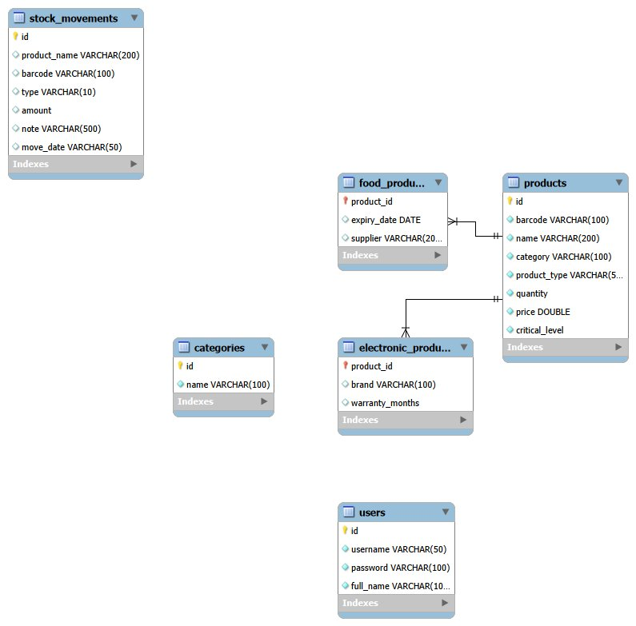

6. File Operations

File | API Type | Description
products_backup.dat | Binary (ObjectOutputStream / ObjectInputStream) | The full product list is serialized and saved as a binary file. Loaded on startup if the database is unavailable.
stock_log.txt | Text (BufferedWriter / BufferedReader) | Every stock movement is appended as a line. Can be read line by line.
inventory_report.txt | Text (BufferedWriter) | An inventory report with total value, average price, and critical products list.

The Product class and its subclasses implement java.io.Serializable so they can be written to and read from binary files.

7. Technologies Used

Technology | Purpose
Java Swing | All user interface components (JFrame, JTable, JList, JComboBox, JSpinner, etc.)
JDBC (MySQL Connector/J) | Connecting to MySQL and running PreparedStatement queries safely
MySQL 8.x | Main data storage. 5 tables with CASCADE DELETE foreign keys.
Java Serialization | Writing and reading the product list as a binary file (ObjectOutputStream / InputStream)
Java IO (Text) | Writing stock log and inventory report as text files (BufferedWriter / Reader)
Maven | Dependency management (mysql-connector-java)
JPA (javax.persistence) | Entity Bean annotations (@Entity, @Table, @Id, @Column) added to Product, ElectronicProduct, and FoodProduct. persistence.xml defines the persistence unit named InventoryPU.

Note: According to the project requirements, the object layer is optional for JDBC-based projects. In this project, the Product, ElectronicProduct, and FoodProduct classes serve as the object layer, transferring data between the database and the user interface.

8. Screen Navigation

From | To | Action
LoginScreen | MainScreen | Successful login (btnLogin)
MainScreen | ProductScreen | Click btnProducts
MainScreen | StockScreen | Click btnStock
MainScreen | QueryScreen | Click btnQuery
MainScreen | CategoryDetailScreen | Click btnCategoryDetail
MainScreen | LoginScreen | Click btnLogout
Any sub-screen | MainScreen | Click btnBack

The InventoryManager object is passed between screens through constructor parameters. This allows screens to share data without using global variables.

9. Test Scenarios

# | Test | Expected Result | Related Rule
1 | Add product with existing barcode | Error: 'This barcode already exists' | Rule 1
2 | Stock out more than available | Error: 'Not enough stock' | Rule 2
3 | Reduce stock below critical level | Red warning label + dialog popup | Rule 3
4 | Delete a category that has products | Products moved to 'General' category | Rule 4
5 | View a food product with past expiry date | 'EXPIRED' shown in Extra Info column | Rule 5
6 | Do a stock movement, then check log file | New line added to stock_log.txt | Rule 6
7 | Login with wrong username or password | Error message shown in lblStatus | Login validation
8 | Change category in CategoryDetailScreen | JTable updates immediately | Master-Detail rule

