Data Structures Programming
Project #2
Movie Recommendation System using Heap-Based Collaborative Filtering

Submitted to:
Data Structures Course

Due Date: 31 May 2026

Prepared by:
Tarık Emir Yılmaz — 2321051014
Şilan Eroğlu — 2321051030

1. Introduction
This report presents the design and implementation of a Movie Recommendation System using Heap-Based Collaborative Filtering. The system recommends movies to users by analyzing the preferences of similar users from a dataset. The similarity between users is computed using cosine similarity, and a max-heap data structure is used to efficiently retrieve the most similar users.

2. System Overview
The system reads a user-movie rating matrix from CSV files, computes cosine similarity between users, stores users in a max-heap ordered by similarity, and retrieves the top X most similar users. For each of these users, the top K highest rated movies are listed, resulting in X * K total recommendations.

The application provides two recommendation modes:
- Target User Recommendation: Select a predefined target user from a combo box and receive movie recommendations based on similar users.
- Movie-Based Recommendation: Manually rate 5 movies and receive recommendations based on users with similar taste.

3. Data Structures

3.1 User-Movie Matrix
The user-movie rating matrix is stored using an ArrayList of UserEntry objects. Each UserEntry holds the user ID, a double array of ratings, and a similarity score. This structure allows efficient sequential access when computing similarities.

3.2 Movie Title Map
Movie titles are stored in a LinkedHashMap<Integer, String> where the key is the movie ID and the value is the movie title. LinkedHashMap preserves insertion order and provides O(1) lookup by movie ID.

3.3 Max-Heap (Node-Based)
The most critical data structure in the system is the max-heap. As required, the heap is implemented using nodes (not arrays). Each node contains a UserEntry and pointers to its left child, right child, and parent.

Key operations:
- insert(UserEntry): Adds a new user to the heap and performs bubbleUp to restore the heap property.
- extractMax(): Removes and returns the root (most similar user), replaces it with the last node, and performs heapifyDown to restore the heap property.
- getNodeAt(index): Navigates to the node at a given index using the binary representation of the index, enabling O(log n) insertion and extraction.

4. Algorithms

4.1 Cosine Similarity
Cosine similarity is computed between two rating vectors using the following formula:

similarity(A, B) = (A . B) / (||A|| * ||B||)

Where A . B is the dot product and ||A||, ||B|| are the Euclidean norms. If either vector has zero norm, the similarity is defined as 0 to avoid division by zero.

4.2 Recommendation Algorithm
The recommendation process follows these steps:
- Step 1: Compute cosine similarity between the target user and every user in main_data.csv.
- Step 2: Insert each user with their similarity score into the max-heap.
- Step 3: Extract the top X most similar users from the heap using extractMax().
- Step 4: For each of the X users, collect their rated movies and sort them by rating in descending order.
- Step 5: Take the top K movies from each user and add them to the recommendation list.
- Step 6: Display the resulting X * K movie recommendations by name.

5. Class Design
Class | Responsibility
UserEntry | Holds user ID, rating array, and similarity score.
MaxHeap | Node-based max-heap for storing and retrieving users by similarity.
DataLoader | Reads main_data.csv, target_user.csv, and movies.csv files.
RecommendationEngine | Computes cosine similarity and generates X*K movie recommendations.
MainFrame | Swing GUI with two tabs: Target User Recommendation and Movie Recommendation.

6. GUI Design

6.1 Target User Recommendation Tab
The first tab allows the user to:
- Select a target user from a combo box populated from target_user.csv.
- Enter the value of X (number of similar users) and K (number of movies per user).
- Click 'Get Recommendations' to compute and display X * K movie recommendations.

6.2 Movie Recommendation Tab
The second tab allows the user to:
- Select 5 different movies from a combo box containing 10 randomly selected movies from movies.csv.
- Enter an integer rating between 1 and 5 for each selected movie.
- Enter the value of X and K.
- Click 'Get Recommendations' to compute and display X * K movie recommendations based on the entered ratings.

7. Program Output

7.1 Target User Recommendation — Example 1
Target User: User 609 | X = 5 | K = 2 | Total recommendations: 10

The system returned the following 10 recommendations:
- 1. How to Make an American Quilt (1995)
- 2. Love & Human Remains (1993)
- 3. Heat (1995)
- 4. Restoration (1995)
- 5. How to Make an American Quilt (1995)
- 6. Heat (1995)
- 7. How to Make an American Quilt (1995)
- 8. Heat (1995)
- 9. How to Make an American Quilt (1995)
- 10. Heat (1995)
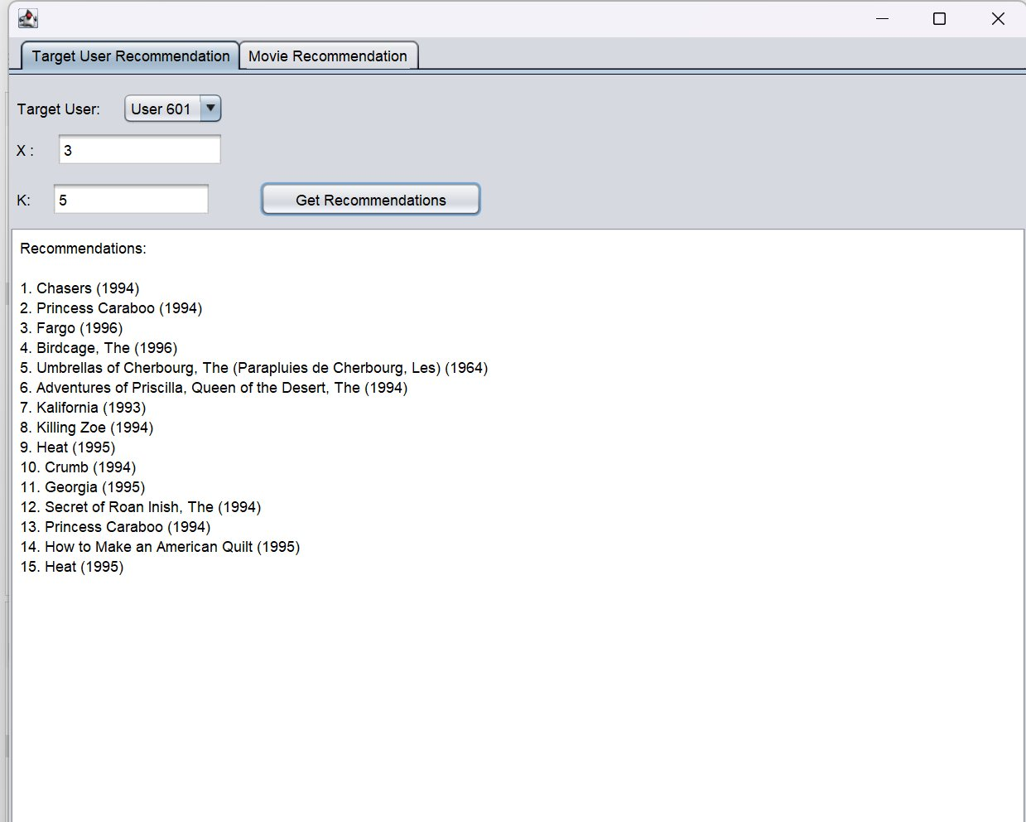

7.2 Movie Recommendation Tab — Example
Selected movies and ratings:
- Victor/Victoria (1982) — Rating: 3
- Ring, The (1927) — Rating: 5
- War of the Roses, The (1989) — Rating: 5
- Hamlet (1964) — Rating: 1
- Desperado (1995) — Rating: 2

X = 3 | K = 4 | Total recommendations: 12

The system returned the following 12 recommendations:
- 1. Richard III (1995)
- 2. Dunston Checks In (1996)
- 3. Desperado (1995)
- 4. Clerks (1994)
- 5. Twelve Monkeys (a.k.a. 12 Monkeys) (1995)
- 6. Restoration (1995)
- 7. Beautiful Girls (1996)
- 8. Muppet Treasure Island (1996)
- 9. Restoration (1995)
- 10. Georgia (1995)
- 11. Bio-Dome (1996)
- 12. Things to Do in Denver When You're Dead (1995)
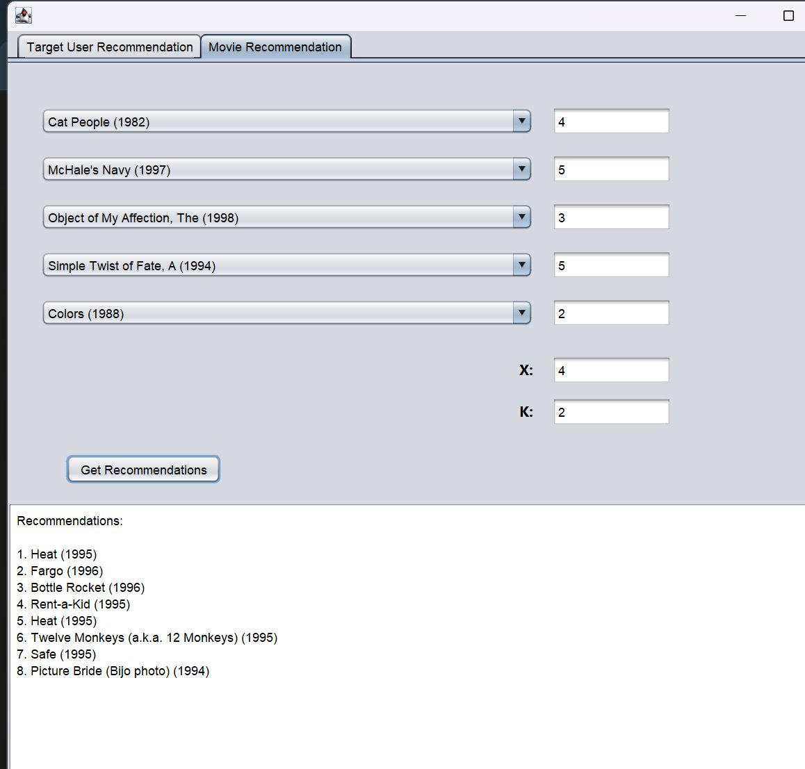

8. Conclusion
The Movie Recommendation System was successfully implemented in Java using heap-based collaborative filtering. The node-based max-heap ensures that insertion and extraction operations run in O(log n) time. Cosine similarity provides an effective metric for measuring user preference alignment. The Swing GUI provides a user-friendly interface for both target-user-based and movie-rating-based recommendation modes.

The system fully satisfies all project requirements: it reads the user-movie matrix from CSV files, computes cosine similarities, maintains a node-based max-heap, retrieves X * K recommendations, and displays movie names instead of IDs.

