**Labor Day Homework**

I have realized that last class was confusing for you, since we have not done enough example. Hopefully, this homework will clear the muddy points in the lecture.

The homework is pretty straightforward. Look at each code snippet below. Walk through the code on your mind (or using paper and pen), and guess the output. Write down your guess. Then type the code on your computer and run the program. Write down the real output. Please note that each question is separate, which means variables in one question are not related to ones in another question.

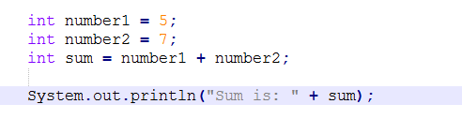1)

* What is the output (Use your guess):
* What is the computer output (Type it on your computer):

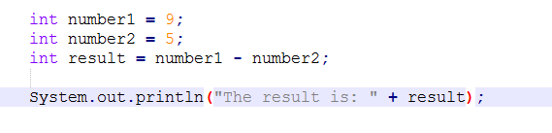2)

* What is the output (Use your guess):
* What is the computer output (Type it on your computer):

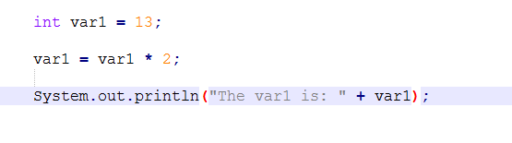3)

* What is the output (Use your guess):
* What is the computer output (Type it on your computer):

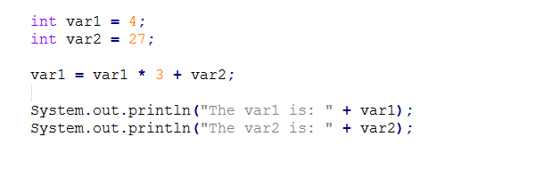4)

* What is the output (Use your guess):
* What is the computer output (Type it on your computer):

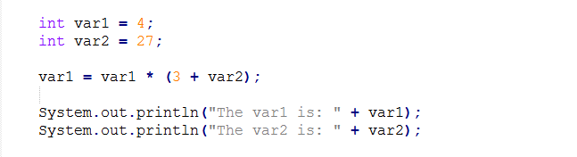5)

* What is the output (Use your guess):
* What is the computer output (Type it on your computer):

6)

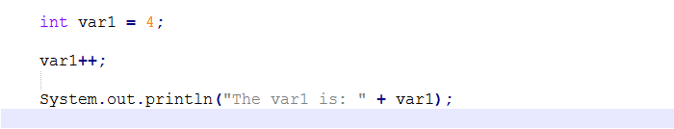

* What is the output (Use your guess):
* What is the computer output (Type it on your computer):

7)

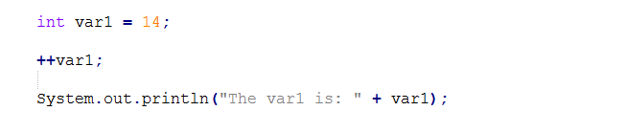

* What is the output (Use your guess):
* What is the computer output (Type it on your computer):

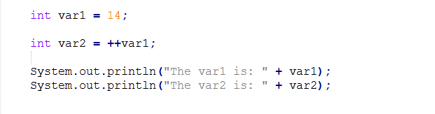8)

* What is the output (Use your guess):
* What is the computer output (Type it on your computer):

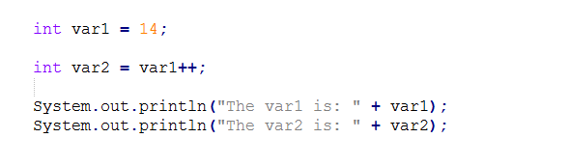9)

* What is the output (Use your guess):
* What is the computer output (Type it on your computer):

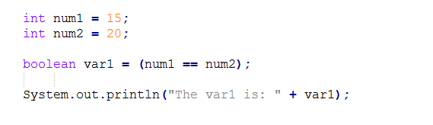10)

* What is the output (Use your guess):
* What is the computer output (Type it on your computer):

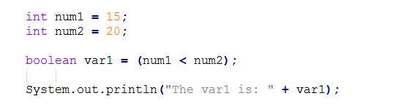11)

* What is the output (Use your guess):
* What is the computer output (Type it on your computer):

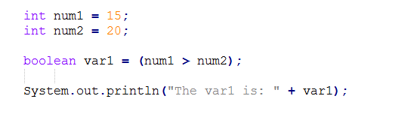12)

* What is the output (Use your guess):
* What is the computer output (Type it on your computer):

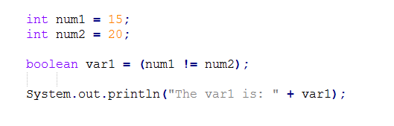13)

* What is the output (Use your guess):
* What is the computer output (Type it on your computer):

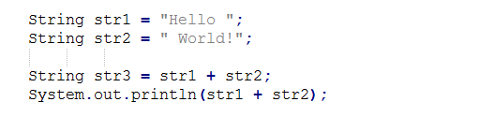14)

* What is the output (Use your guess):
* What is the computer output (Type it on your computer):

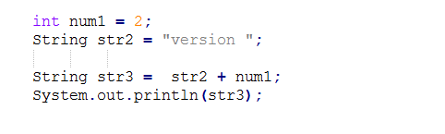15)

* What is the output (Use your guess):
* What is the computer output (Type it on your computer):

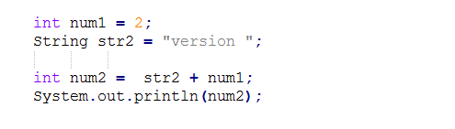16)

* What is the output (Use your guess):
* What is the computer output (Type it on your computer):

17)

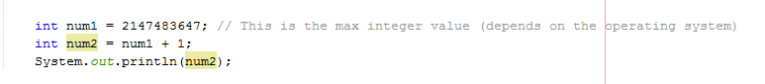

* What is the output (Use your guess):
* What is the computer output (Type it on your computer):

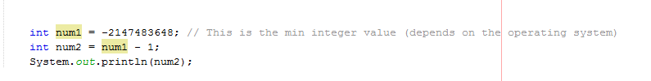18)

* What is the output (Use your guess):
* What is the computer output (Type it on your computer):