------------------------------- 1 --------------------------------------------------------

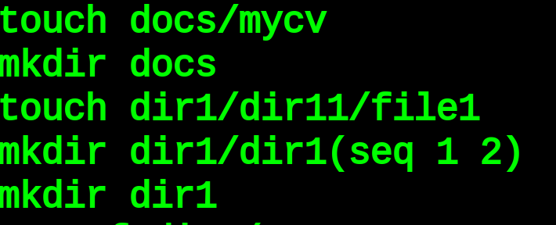
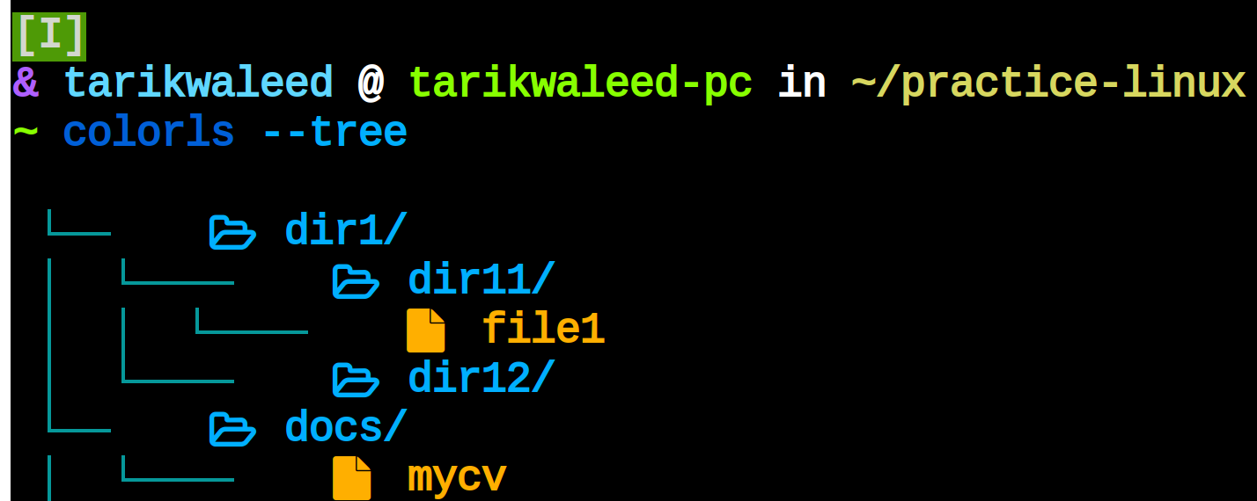

------------------------------- 2 --------------------------------------------------------

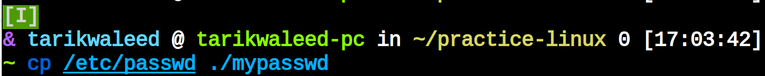
------------------------------- 3 --------------------------------------------------------

------------------------------- 4 ------------------------------------------------------
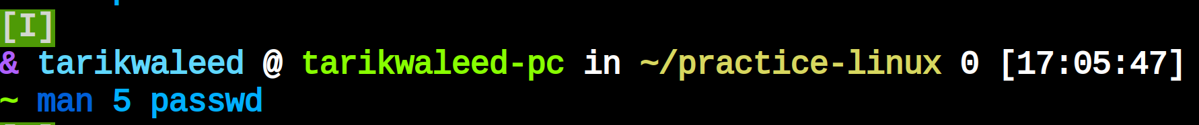
------------------------------- 5 ------------------------------------------------------
------------------------------- 6 ------------------------------------------------------
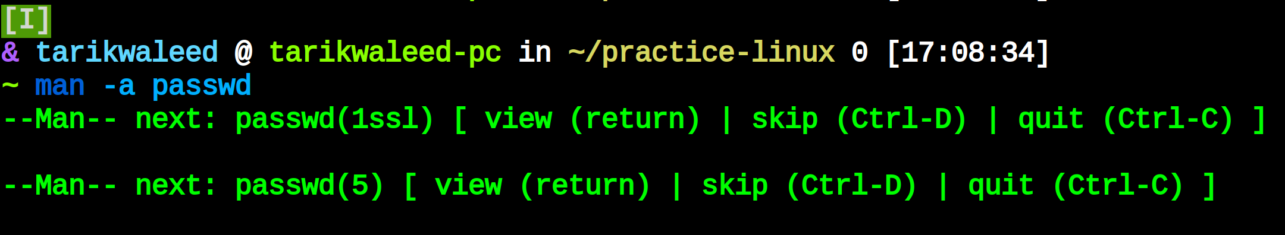
------------------------------- 7 ------------------------------------------------------
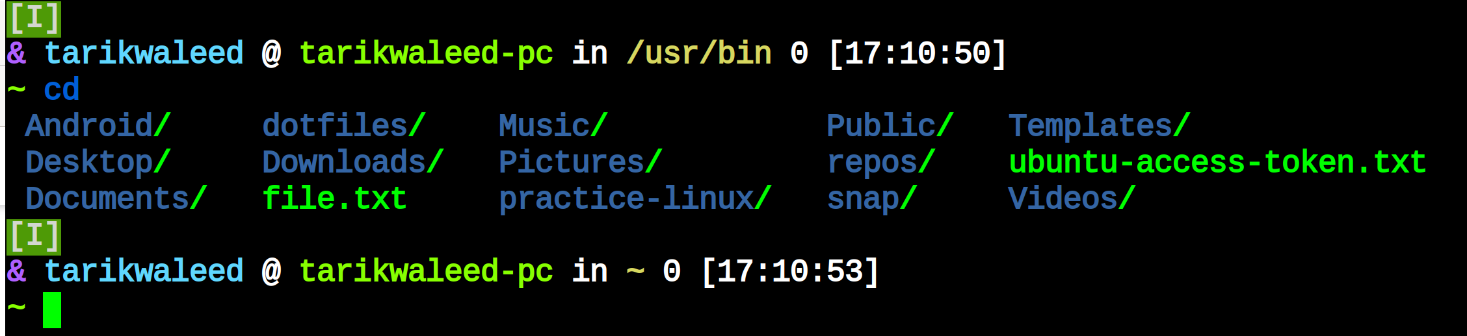
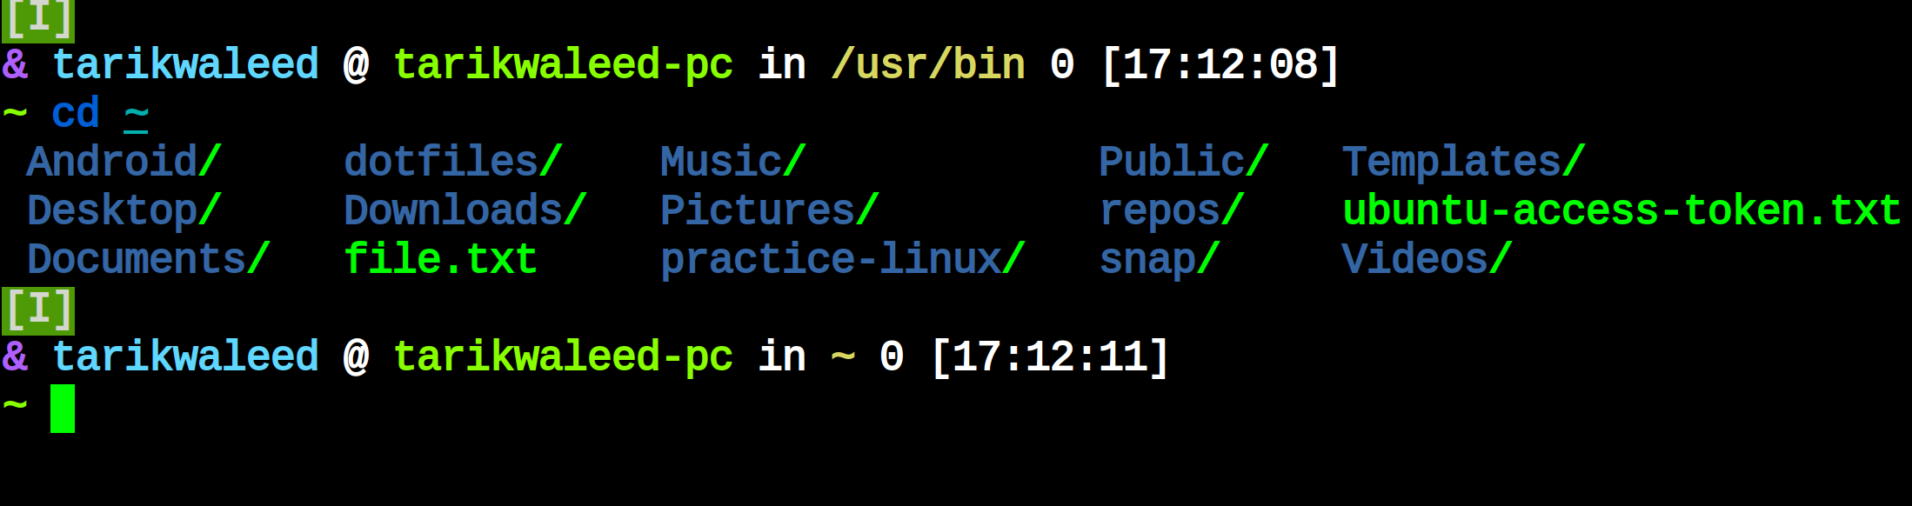
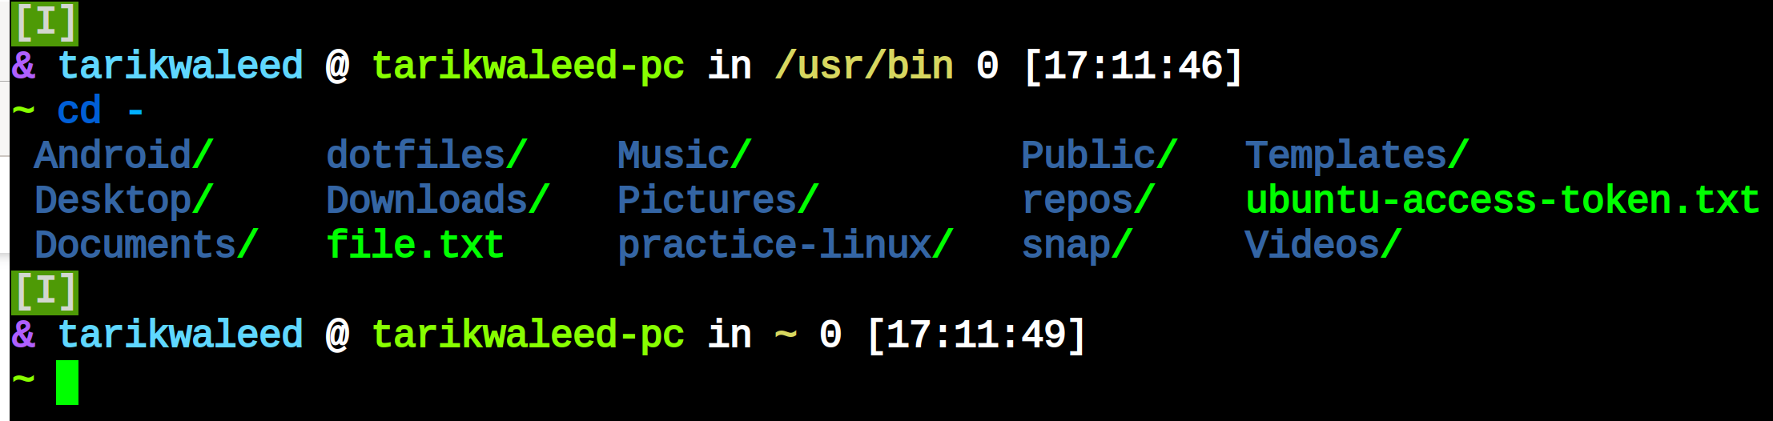
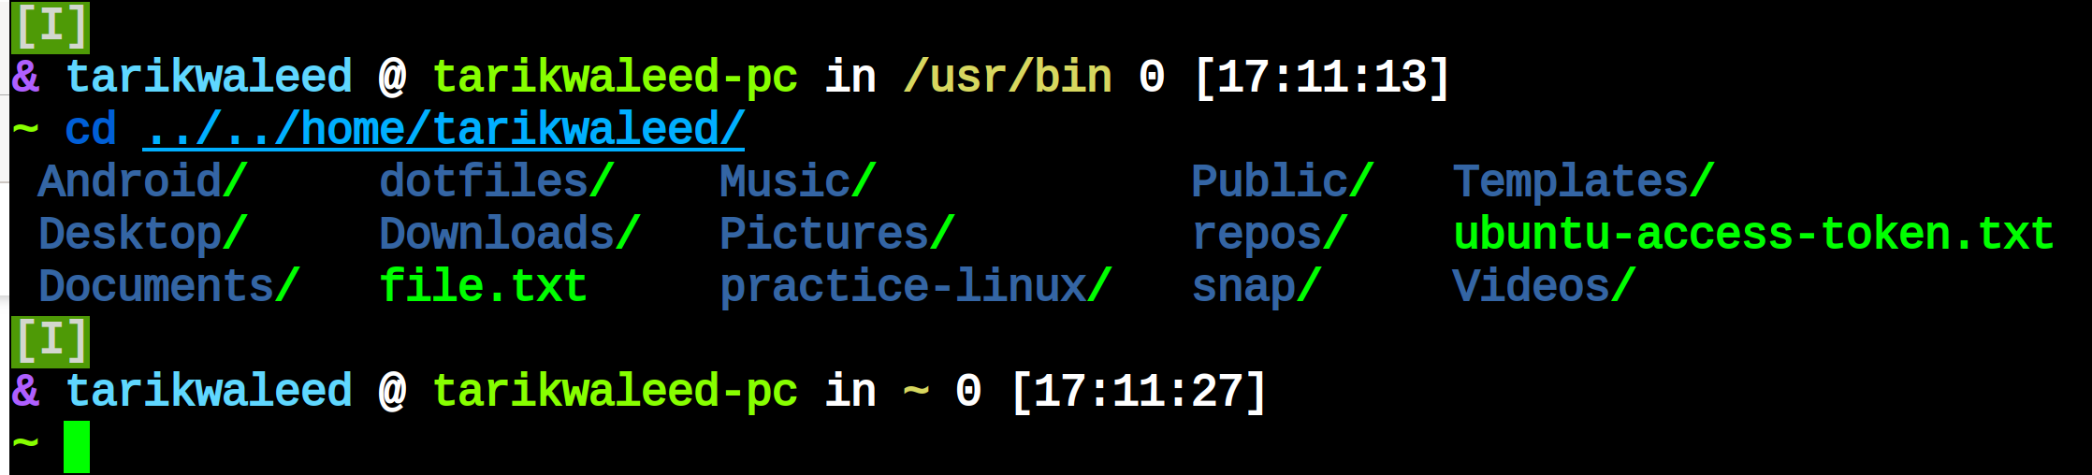

------------------------------- 8 ------------------------------------------------------\

../../etc/passwd

------------------------------- 9 ------------------------------------------------------
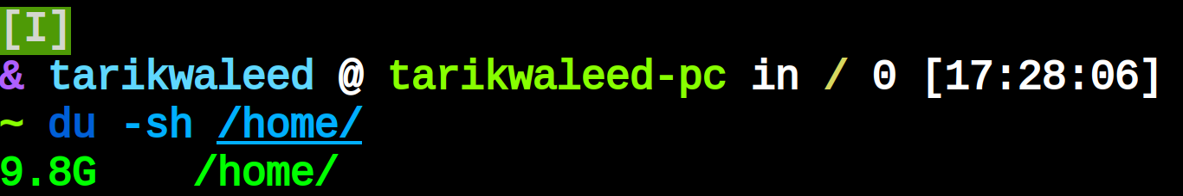
------------------------------- 10 ------------------------------------------------------

------------------------------- 7 ------------------------------------------------------

------------------------------- 11 ------------------------------------------------------

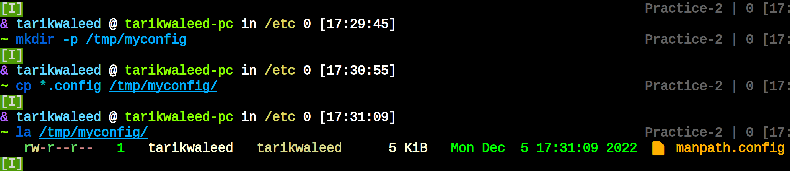
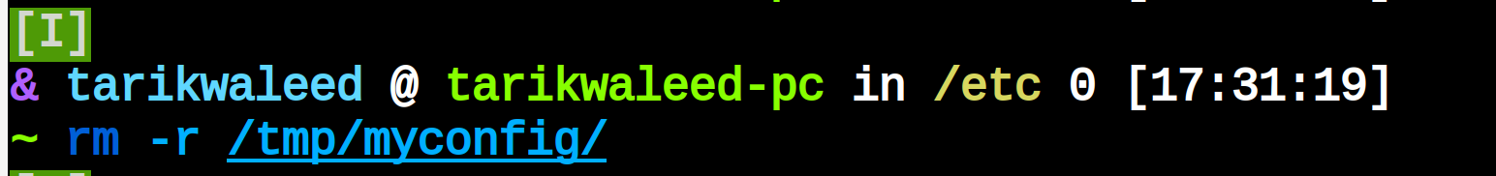
------------------------------- 12 ------------------------------------------------------
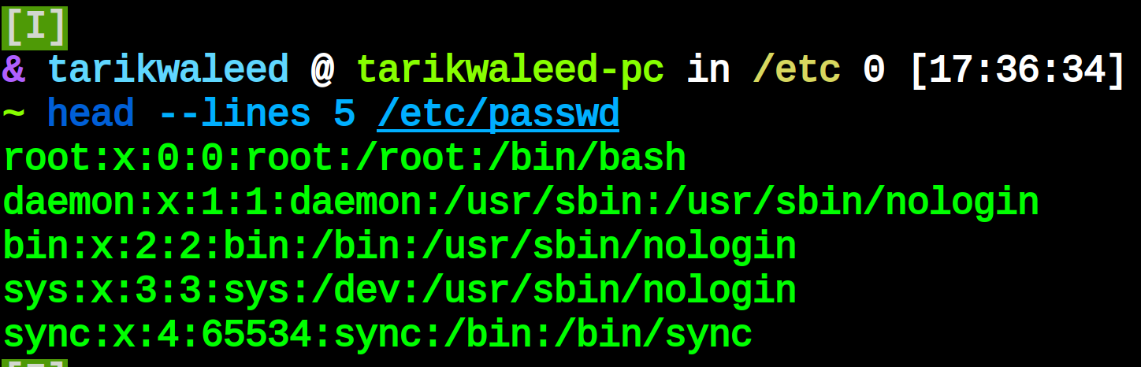
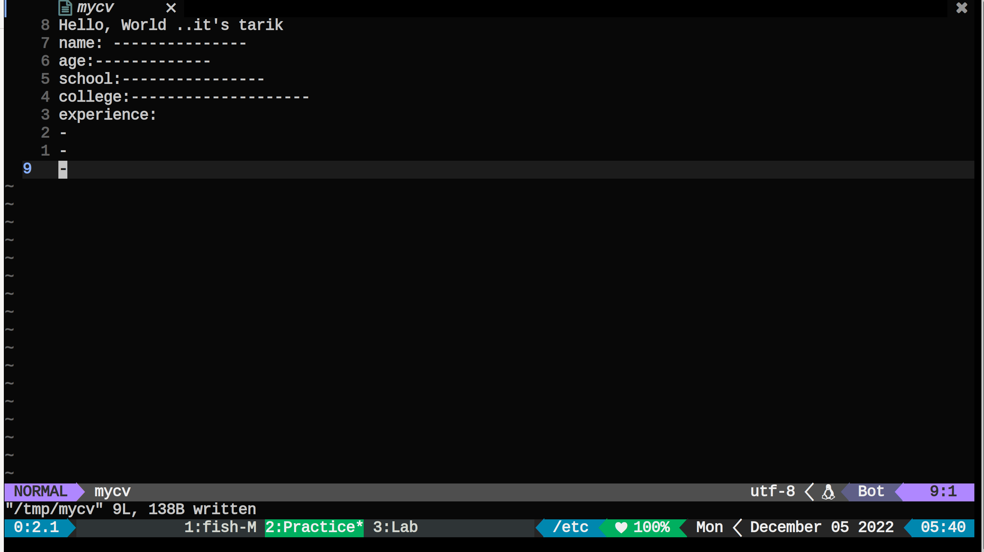
------------------------------- 13 ------------------------------------------------------

